DIPLOMATIC CAR FOR SALE
(from the Embassy of the Republic of Poland)
BMW 730LI

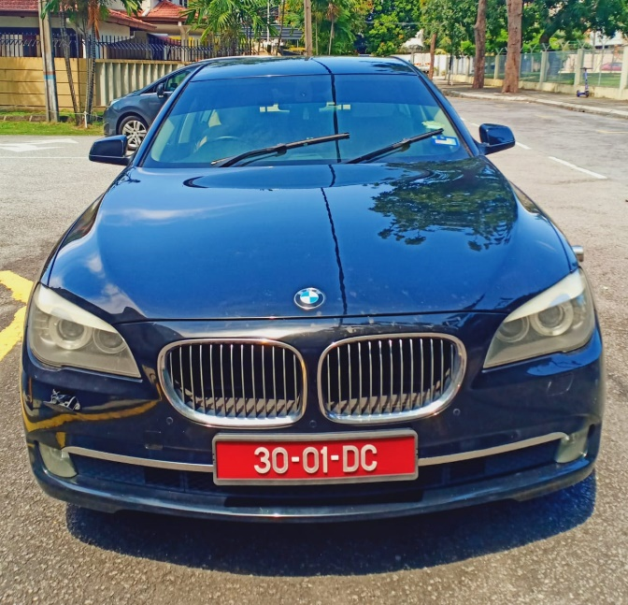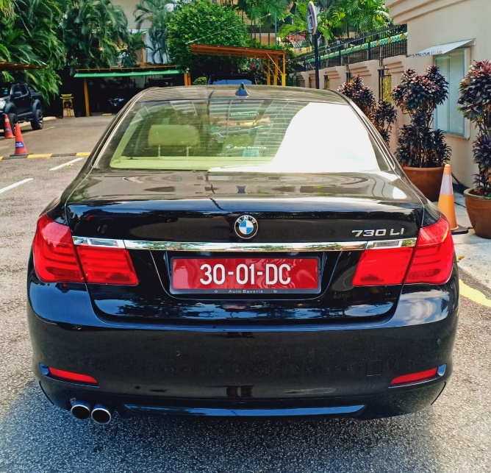
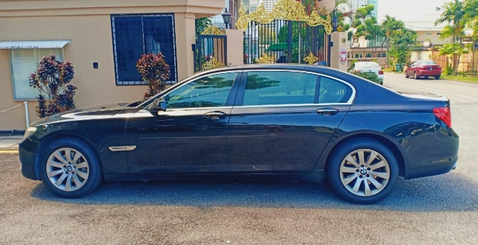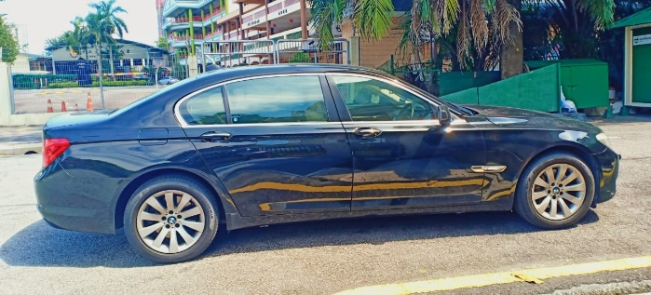
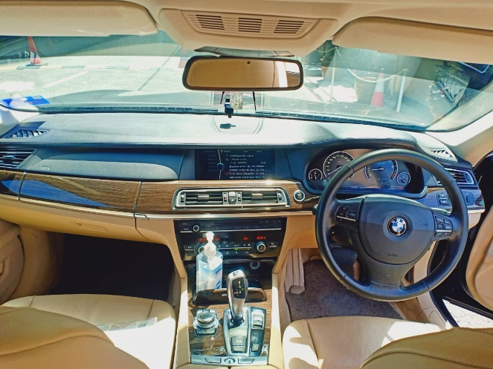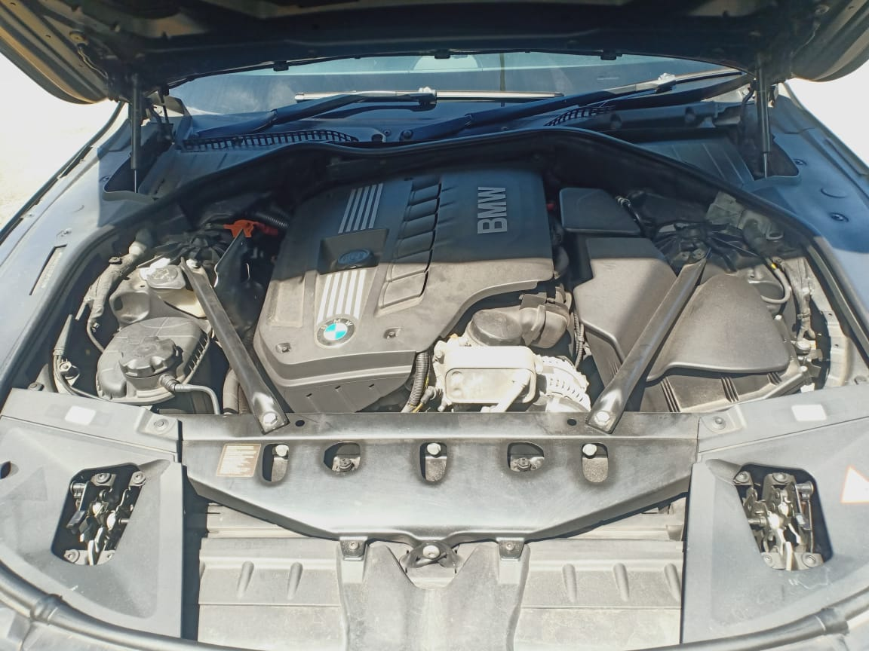
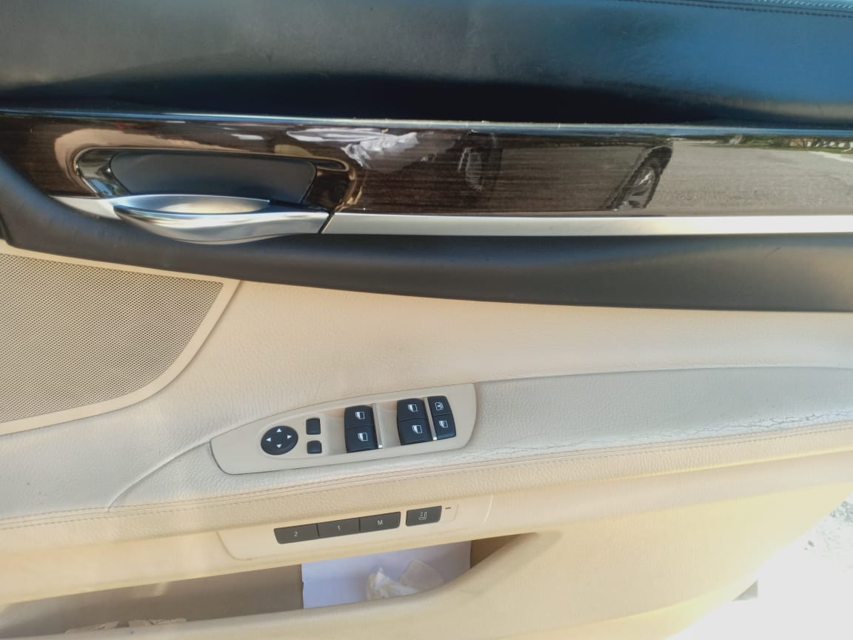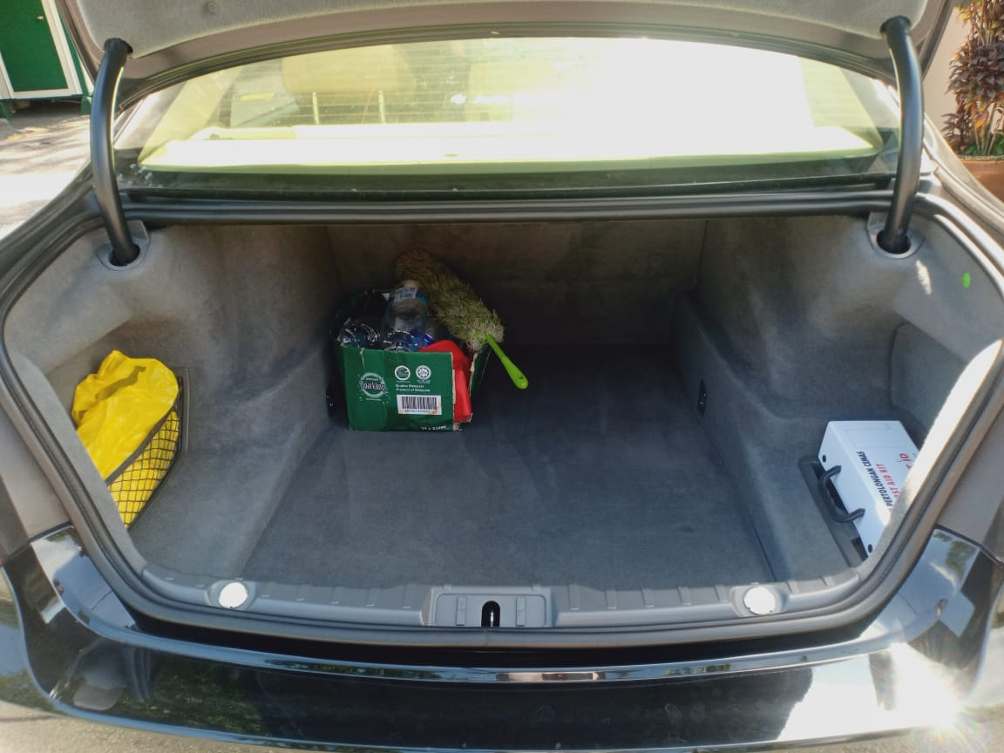

- Year of manufacture: 2011
- Mileage: 155 102 km
- Engine: 2996 cm³
- Gearbox: automatic
- Colour: black
- The car vibrates when speeding up - probably due to a gearbox malfunction. The starting price was reduced by the estimated cost of repairing the malfunction. Besides the above mentioned issue the vehicle is well-maintained and regularly serviced.
Starting price: RM 28 000.00
Please contact us if you are interested!
e-mail: urszula.bilska@msz.gov.pl
mobile: +60 12 645 19 50
or Adriana.bartnik-malek@msz.gov.pl

