APPLICATION
REGARDING PLANNED SCIENTIFIC RESEARCH
IN THE POLISH MARITIME AREAS

The application should be presented to the Polish authorities (Ministry of Foreign Affairs - Legal and Treaty Department) no later than 3 months prior to the expected date of starting the research.

- Requested time of the planned cruise in the Polish maritime areas - from date/until date (this time will be visible in the text of the permission):
- Expected date of entering the Polish marine areas:
- Expected date of leaving the Polish marine areas:
- Authority managing research and responsible for the cruise (name and contact data):
- Owner of the vessel – provide, if different than in point 4:
- Particulars of the vessel:
- Name:
- Flag:
- Home port:
- External identification mark:
- Length overall:
- Maximum draught:
- Gross tonnage:
- Call sing:
- IMO number:
- MMSI number:
- Automatic Identification System (AIS):
- E-mail:
- Number of satellite phone (if available):
- Crew:
- Surname and name of the captain:
- Surname and name of the chief researcher (contact data):
- Number of the crew members, scientific staff separately:
- Working language on the vessel/working language of scientific staff:
- Data on the cruise:
- Cruise number:
- Date and name of the Polish port-of-call (if the ship is planning to call at a port):
- Any special logistic requirements at the port-of-call:
- Scientific research and research methods:
- Type of samples taken (e.g.: geological, water, plankton, fish, radioactivity, isotopes):
- Methods by which samples were obtained, including: dredging, drilling, trawling and CTD:
- Places of publishing the data, research (other than the report):
- Short description of the planned cruise, containing the information about any potential past and future cruises related to the planned cruise, as well as the information about any potential published research related to the planned cruise:
- Details on research equipment:
- Working time/date, type/name, immersion/depth:
- Will equipment, research installations and/or accessories be removed after research or will remain:
- Explosives:
- Type and commercial name:
- Chemical composition:
- Depth of commercial class and distribution:
- Size:
- Depth of detonation:
- Frequencies of detonations:
- Position, coordinates of latitude and longitude:
- Dates of detonations:
- List of the points of measurement in the Polish maritime areas, taking into account the coordinates of latitude and longitude of each point of measurement, as well as the coordinates of positions of equipment left for research purposes, in tabular format:

No | Point of measurement/Position of equipment | Longitude | Latitude | Activity
1
2
3
4
5
…

- Map of the cruise in the Polish maritime areas, taking into account the route of the cruise:
examples below

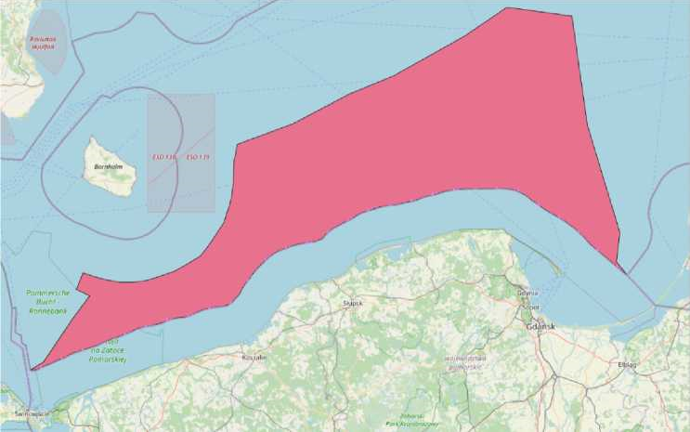

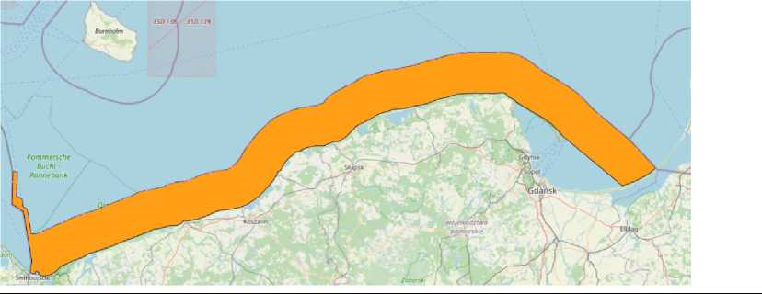

- Daily plan of the cruise in the Polish maritime areas, taking into account the type of work planned - scientific research:
- Cooperation with the coastal state – Poland (in compliance with the attachment hereto – Guidelines concerning the Polish representative participation in scientific research within the Polish marine areas, conducted by foreign states, legal entitles and natural persons, as well as relevant international organizations):
- Polish scientist's first name and last name (contact data):
- Short description of the manner of the Polish scientist's participation in the cruise (e.g. cooperation in the form of documents' exchange, telephone contact, presence on the board during the cruise):
- Is it possible for other Polish scientists to visit the vessel at the Polish port (name of the port/s):
- Is it possible to board the vessel by the Polish representative (enter ‘YES’ or ‘NO’ and in case of a 'NO' answer, justification should be provided):
- Additional information of the applicant:

