un2023 water conference side event

Transdisciplinary Ecohydrology for acceleration of SDG – methodology of science and patterns of implementation
23th March, 2023, 09:30 – 10:45 (EDT)
ECOSOC, United Nations Headquarters in New York, Conference Room 6

Enhancement of sustainability potential by transdisciplinary Ecohydrology and Advanced Nature-Based Solutions.
Time |  | Programme | Note
09:30 – 10:20 | 25 min | Opening address  Marek Gróbarczyk, Secretary of State, Ministry of Infrastructure of the Republic of Poland  Rationale by session Chairman:  Maciej Zalewski, Professor, European Regional Centre for Ecohydrology of the Polish Academy of Sciences under auspices of UNESCO, Vice-Chairman of the European Partnership - Water Security for the Planet “Water4All”  Abou Amani, Director of the UNESCO IHP Secretariat, Division of Water Sciences, - Ecohydrology success story of the UNESCO IHP  Antonio Lo Porto, European Partnership - Water Security for the Planet “Water4All”
 | 25 min | Opening Lecture:  Andras Szollosi-Nagy, former Director of the UNESCO IHP Secretariat, Division of Water Sciences  Keynote Lecture:  Karl Wantzen, University of Tours - lecture on River Culture
10:20 – 10:40 | 20 min | Panel Discussion:  Moderator:  Luis Chicharo – UNESCO Chair on Ecohydrology: Water for ecosystems and societies, University of Algarve  Panelists:  - Ignasius Sutapa – Asia Pacific Centre for Ecohydrology (APCE)  - Yohannes Zerihun Negussie – African Regional Centre for Ecohydrology, Directorate for Ecohydrology, Ministry of Water and Energy, Addis Ababa (ARCE)  - Eduardo Mario Mendiondo – UNESCO Chair on Urban Waters Secretary, University of Sao Paulo  - Dongah Ko – UNESCO IHP National Committee of the Republic of Korea  - Katarzyna Izydorczyk – Director, European Regional Centre for Ecohydrology  - Marco Albarracin – Salesian Polytechnic University, Ecuador, Development and Innovation Research Centre in Engineering  - Przemysław Gruszecki – Director, Department of the Water Environment Management, State Water Holding Polish Waters  - Stefano Fazi – Water Research Institute, National Research Council of Italy (IRSA-CNR)
10:40 – 10:45 | 5 min | Closing remarks

PARTNERS:
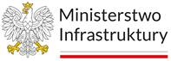 | 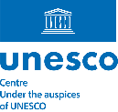 | 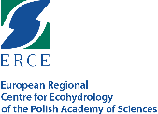 | 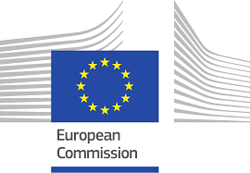 | 