ENVIRONMENTAL AND SOCIAL IMPACT ASSESSMENT (ESIA)

Appendix 13.7 Invasive Alien Spiecies Management Plan (IASMP)

DRAFT VERSION

Contract 5.10.1. Construction of the Kamieniec Ząbkowicki Reservoir - Preparation of design documentation, including obtaining administrative permits and the provision of Author’s Supervision, as well as the preparation of bidding documents necessary to select a Contractor for future works under the future Poland’s Building Climate Resilience in Water Management Project

Wrocław, October 2026
Table of Contents
1. Introduction 2
2. Information on Individual Invasive Species 6
2.1. Japanese knotweed (Reynoutria SP) 6
2.2. Rugosa rose (Rosa rugosa) 11
2.3. Purple jewelweed (Impatiens glandulifera) 15
2.4. Giant goldenrod (Solidago gigantea) and Canadian goldenrod (Solidago canadensis) 16
2.5. Garden lupin (Lupinus polyphyllus) 20
2.6. Wild cucumber (Echinocystis lobata) 21
2.7. Redroot pigweed (Amaranthus retroflexus) 24
2.8. Common Foxglove (Digitalis purpurea) 27
2.9. Dwarf serviceberry (Amelanchier spicata) 28
2.10. Steeplebush (Spiraea tomentosa) 31
2.11. Spotted loosestrife (Lysimachia punctata) 34
2.12. Yellow oxeye (Telekia speciosa) 36
2.13. Sosnowski's hogweed (Heracleum sosnowskyi) 37
2.14. Giant hogweed (Heracelum mantegazzianum) 42
2.15. Monkeyflower (Mimulus guttatus) 46
2.16. Cutleaf coneflower (Rudbeckia laciniata) 47
3. Utilization of IAS Biomass 48
3.1. Legal Measures 48
3.2. Biomass Management 51
3.2.1. Burial 55
3.2.2. Collecting biomass into piles at locations designated in accordance with established criteria and leaving it to decompose naturally 57
3.2.3. Transport to an Appropriate Facility as Biowaste 58
3.2.4. Transporting Biomass in Black Plastic Bags 59
3.3. Monitoring Activities 60
List of Tables 66

1. Introduction
This document serves as an appendix to the project’s Biodiversity Management Plan (BMP). Its purpose is to present basic information on invasive alien plant species that may be encountered in connection with the implementation of the project, as well as to define guidelines for managing them—from preventive measures, through proper biomass management, to effective monitoring and reporting.
The appendix primarily covers the main invasive plant species whose presence has been recorded in the wider vicinity of the project area, according to data from GBIF—the Global Biodiversity Information Facility. Nature surveys conducted to obtain the environmental permit, as well as surveys carried out during the preparatory phase, revealed the presence of several invasive alien species within the project area. However, the possibility of introducing additional non-native organisms from neighboring areas cannot be ruled out, particularly as a result of soil movement, material transport, the operation of construction equipment, or other activities carried out as part of the project.
Methods for preventing the spread of and controlling invasive plants are based on the Guidelines for Dealing with Invasive Plants of Alien Origin—a handbook prepared for the General Directorate for Environmental Protection (GDOŚ), educational materials from the Botanical Garden of the University of Warsaw regarding invasive plants, as well as other codes of conduct related to invasive alien species (IAS). Knowledge resources on IAS available in the CABI Compendium were also utilized.
This appendix is practical and illustrative in nature. Its primary purpose is to enable construction site employees to identify suspicious plants and immediately report their presence to their supervisor. The measures described include both preventive measures aimed at reducing the risk of introducing and spreading IAS, as well as recommendations regarding the temporary storage of removed biomass, its further management or disposal, and monitoring the effectiveness of the measures taken.
The proposed eradication methods, methods for the temporary storage of removed plants on the construction site, and final methods for the removal or disposal of biomass must be adapted on a case-by-case basis by the environmental supervision botanist and the site manager, taking into account the species, extent of occurrence, stage of plant development, local habitat conditions, and applicable regulations.
It is also recommended to use the current resources of the General Directorate for Environmental Protection (GDOŚ) to obtain current and new compendia on the control of invasive alien species. Currently, 10 compendia have been prepared and are available at: https://www.gov.pl/web/gdos/kompendia-zwalczania-wybranych-igo. They cover control measures for selected invasive alien species listed in this annex, such as: hogweeds (Heracleum sosnowskyi, Heracleum mantegazzianum), knotweeds (Reynoutria / Fallopia japonica, Reynoutria / Fallopia sachalinensis, Reynoutria / Fallopia × bohemica), balsams (Impatiens glandulifera, Impatiens capensis), steeplebush (Spiraea tomentosa), and wild cucumber (Echinocystis lobata).
Chapter 3 presents recommendations regarding the management of biomass from invasive alien species, including principles for mitigating the risk of further spread of plant material.
The list of invasive alien species included in this appendix is open-ended and will be updated during the implementation of the Project. If additional invasive alien species (IAS) not described in this document are identified within the project area or in its immediate vicinity, this appendix will be updated with relevant information regarding their identification, potential risks, recommended preventive measures, methods for handling biomass, and monitoring guidelines. Any new sightings of suspected species should be reported immediately to the project manager and the botanist responsible for environmental supervision. The distribution of invasive species confirmed in the field is shown in the figure below.
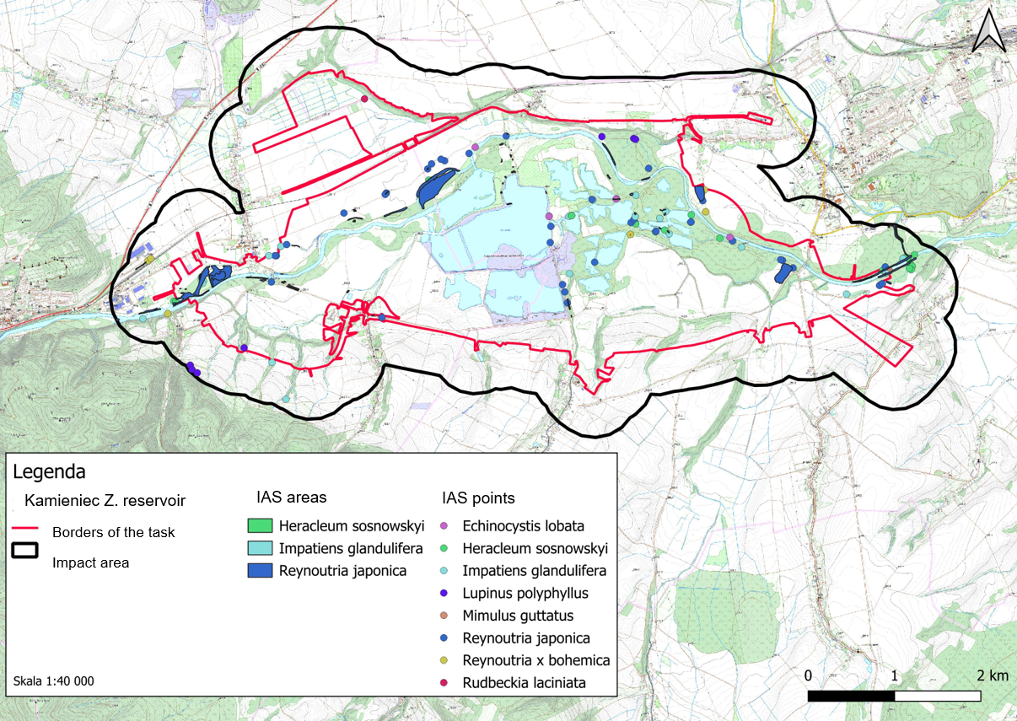

2. Information on Individual Invasive Species

2.1. Japanese knotweed (Reynoutria SP)
Species Characteristics
Asian knotweeds are perennials—rhizomatous geophytes—with stout stems that grow up to 3 m (Reynoutria japonica), 3.5 m (Reynoutria ×bohemica), and even 4 (4.5) m (Reynoutria sachalinensis) in height, with similar growth habits (Fig. 2). This is particularly evident in the hybrid knotweed R. ×bohemica, which, as a hybrid of the Japanese knotweed R. japonica and the Giant knotweed R. sachalinensis, exhibits many morphological traits that are intermediate between those of its parent species. In their secondary range, knotweeds exhibit a wide range of habitats, from anthropogenic habitats (including roadsides, railroad embankments, various types of urban and post-industrial wastelands, parks, cemeteries, and home gardens) to natural habitats (e.g., riverbanks, forest edges, and thickets) .
Individual taxa can most easily be distinguished by the shape of their leaves. The leaves of Giant knotweed are soft to the touch, very large—up to 35 cm long and 20 cm wide—and have a heart-shaped base. The underside of the leaves is distinctly hairy, covered with scattered, long, and soft hairs.
The leaves of the pointed knotweed are stiff, much smaller—up to 15 cm long and 10 cm wide—truncate at the base, and distinctly tapering at the tip. The underside of the leaves is glabrous, covered only with unicellular, very short structures called papillae.
The leaves of the intermediate knotweed (a hybrid) vary greatly in size and shape, with their size decreasing toward the tip. They often have a slightly heart-shaped base, and the tip of the leaf is pointed. The underside of the leaves is covered with hairs, which are particularly visible along the veins when the leaf is bent.
Knotweeds are perennials that typically exceed 2 m in height, and their daily growth can reach 3 cm. Stems sprout very quickly from the rhizomes, especially in the spring.
Their very strong rhizomes pierce through asphalt, break through walls and concrete, and spread in a radius ranging from 7 to over 20 meters from the parent plant. The rhizomes grow to a depth of 2–3 m, which is why knotweed is so difficult to remove—a fact that, of course, entails enormous costs for controlling these plants.
They are characterized by a strong and rapid ability to regenerate even from small fragments of rhizome or shoot, just a few centimeters in size. Available sources indicate that as little as 5–7 g of rhizome is sufficient for the plants to regenerate. Some researchers claim that as little as about 0.7 g of rhizome is enough for a new plant to form.
Knotweed rhizomes are easily transported by water, which facilitates the overgrowth of river valleys by these plants and the formation of massive clusters of knotweed, primarily sharp-leaved knotweed, as well as intermediate knotweed. Plant fragments are also transported with contaminated soil, e.g., during road construction, road shoulder paving, or other works, as well as with soil brought into gardens .
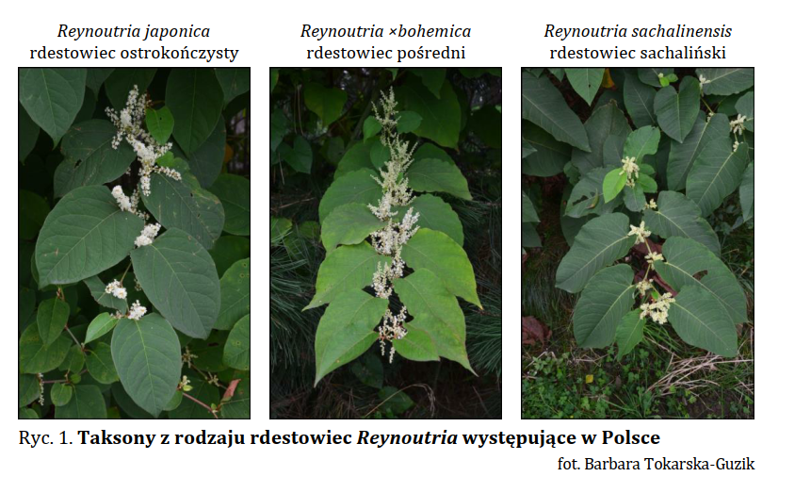
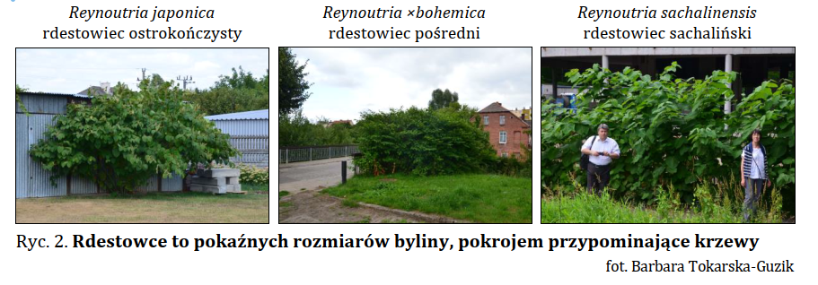
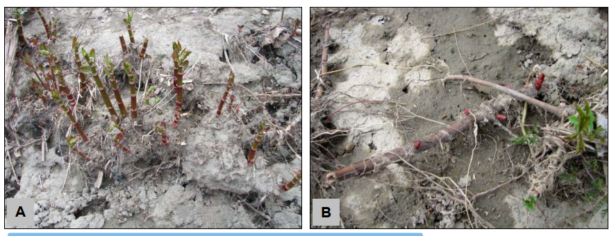
A – a thickened structure (“carp”; Eng. shoot clump) from which this year’s shoots emerge; also visible are the sites of dead shoots from previous growing seasons; B – a fragment of a horizontal rhizome with buds, exposed after a flood
photo: Barbara Tokarska-Guzik
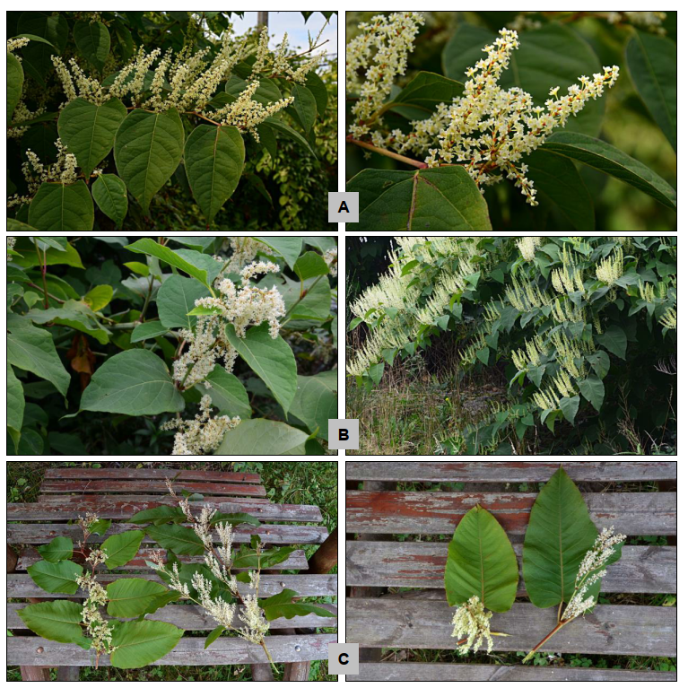A – a flowering shoot of Japanese knotweed (R. japonica); on the right, a close-up of male-sterile (“pistillate”) flowers; B – flowering shoots of the hybrid knotweed R.×bohemica; on the left, inflorescences with male-sterile (“pistillate”) flowers; on the right, those with male-fertile (“staminate”) flowers; C – flowering shoots (left) and individual inflorescences (right) of the Giant knotweed (R. sachalinensis); in both photographs, the inflorescences on the left bear male-sterile (“pistillate”) flowers, and those on the right bear male-fertile (“staminate”) flowers
Photo: Barbara Tokarska-Guzik
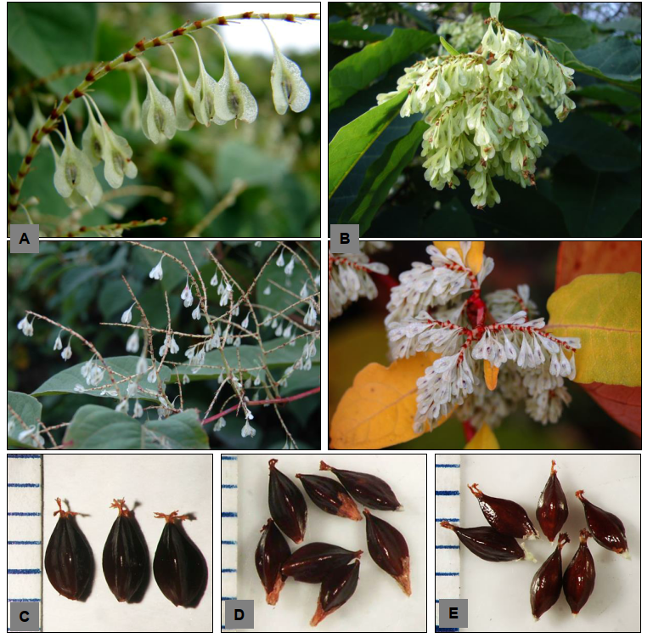Winged fruits (nuts) on the shoots of knotweeds: R. japonica (A) and Giant knotweed (R. sachalinensis (B), as well as shelled nuts of R. japonica (C), R. ×bohemica (D), and Sakhalin knotweed (R. sachalinensis) (E)
Photos by Barbara Tokarska-Guzik (A and B, top), Katarzyna Bzdęga (remaining)
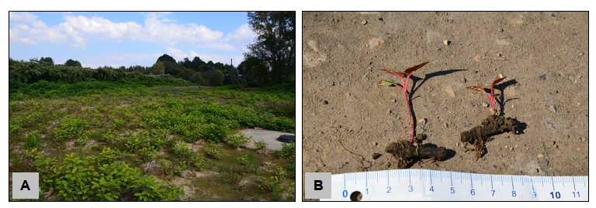A – a section of the area where knotweed is regenerating after earthwork (sewer construction); B – plants can regenerate from small fragments of rhizomes
Photo: Barbara Tokarska-Guzik
Eradication methods
According to the GDOŚ Guidelines for the Control of Knotweed in Poland (GDOŚ, 2015), the eradication of knotweed populations is carried out using various methods, depending on the size of the population and its location (e.g., in protected areas, river valleys, and built-up areas). The control strategy is also based on the biology of these plants. They are perennials with a highly developed underground rhizome system that reproduce primarily vegetatively. For these reasons, controlling them primarily involves the mechanical removal of the plants (both above-ground and underground parts) and/or treating them with chemicals.
The methods used include: mechanical, chemical, mixed/combined (mechanical-chemical), and biological.
When selecting a method, the following should be considered first and foremost:
- its impact on the natural environment (environmental costs) and, furthermore,
- its expected effectiveness
- financial costs
The duration and frequency of treatments are related to the chosen method and depend on the size and location of the population .
In the case of Japanese knotweed, it is recommended to:
- accurately determine how far the rhizomes have spread. This can be done by digging a series of test pits and examining them thoroughly
- erecting a clearly visible fence to mark the area(s) where the species is present, including the underground rhizome network. The signs should warn people about the presence of knotweed and the risk of spreading its rhizomes and plant fragments.
- if stockpiled soil is contaminated with knotweed, it should also be marked with appropriate signs and isolated with a fence,
- Avoid using tracked vehicles in areas where the species is present
- Soil should not be moved from areas designated as invasive plant clusters, except for disposal purposes. Soil from sites where Japanese knotweed is present that contains seeds and rhizomes of this species should be sent for disposal.
- Given the documented limited effectiveness of using mechanical methods alone to control knotweed, consideration should be given to incorporating selective chemical treatments into an integrated control strategy. Such treatments must use only plant protection products authorised for sale and use in Poland and must be applied in accordance with the current product label, particularly regarding the authorised uses, application rates, treatment conditions, and required buffer distances from water bodies and other protected features. Before treatment, it must be verified whether the site is located within a water-intake protection zone, an area subject to specific nature conservation measures, or an area covered by any other legal restrictions. Where chemical treatment cannot be carried out legally and safely, long-term integrated mechanical control measures should be applied, accompanied by systematic monitoring of regrowth.
Recommendations regarding biomass management are provided in Chapter 3.

2.2. Rugosa rose (Rosa rugosa)
Characteristics of the Species
Rugosa rose is a shrub with upright, thorny shoots and intensely fragrant flowers. It reproduces primarily through underground shoots (stolons), as well as through seeds contained in fleshy fruits. The seeds are dispersed by water (the fruits can be carried by water for up to 40 weeks) and by birds.
It prefers sunny locations and sandy, fresh, or dry soils. It is resistant to air pollution, salinity, drought, and frost. The Rugosa rose forms dense clumps that cast heavy shade on the ground and limit the growth of native vegetation. It can rapidly take over coastal dunes, posing a threat there to both native plant species—such as sand willow and sea buckthorn—and to insects associated with this habitat. It can hybridize with native rose species. It is difficult to eradicate.
It poses a particular threat to coastal dunes and salt marshes, as well as inland dunes and xerothermic grasslands.
In its secondary range, the Rugosa rose occurs in more diverse habitats: on various types of dunes, rocky beaches, cliffs, sandy grasslands, forest edges, as well as along roads and railroad tracks, at landfills, and in other anthropogenic habitats .
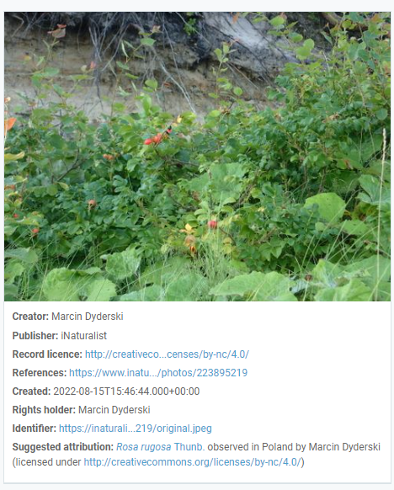
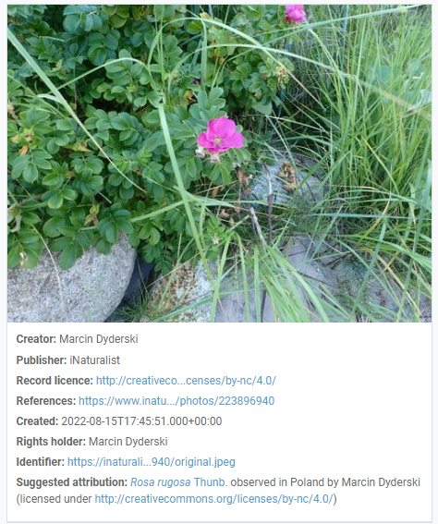
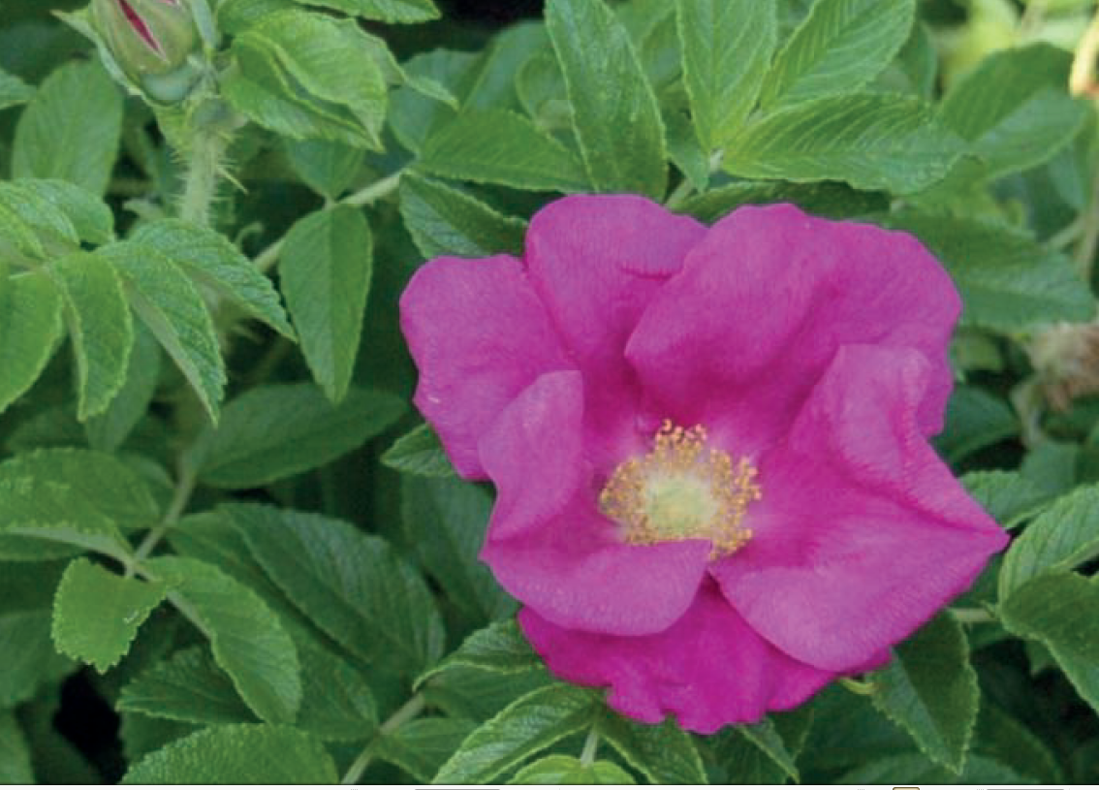GDOŚ Guidelines 2016. Photo credit: B. Rohm
Eradication methods
- Mowing limits its spread if done repeatedly (a single mowing rejuvenates the thickets). After the above-ground parts are removed, it regrows easily, often forming denser thickets.
- Digging up young plants (leaving even fragments of roots can cause new shoots to emerge).
- As a last resort, chemical control of the plant in areas where herbicide use is permitted. The plant, along with its underground parts, is destroyed by herbicides containing glyphosate, preferably in August .
- Controlling cut or mowed plants with glyphosate proves effective if repeated, using a brush or weed marker on small areas, or backpack or tractor-mounted sprayers on larger areas. Even if all above-ground tissue is destroyed, vigorous shoot growth often reoccurs the following year, requiring further control, although it is believed that glyphosate applied in August also damages rhizomes and roots (Bruun, 2005)
Recommendations regarding biomass management are provided in Chapter 3.

2.3. Purple jewelweed (Impatiens glandulifera)
Characteristics of the species
Purple jewelweed (Impatiens glandulifera): grows up to 3 m tall. Its stem is reddish and hollow inside. The leaves are lanceolate, serrated, and have glands at the base (hence the name). The flowers are showy, about 3–4 cm in size, pink or purple, ending in a short spur, and arranged in abundant clusters. The fruit is a capsule that bursts open explosively into five valves.
Ripe fruits of the purple jewelweed spontaneously eject seeds up to 6 m away, which aids in the species’ dispersal. Seeds can also be carried by water over long distances, allowing the plant to colonize new, often very distant, areas. Most impatiens seeds germinate simultaneously in early spring, which promotes invasion by limiting other plants’ access to light
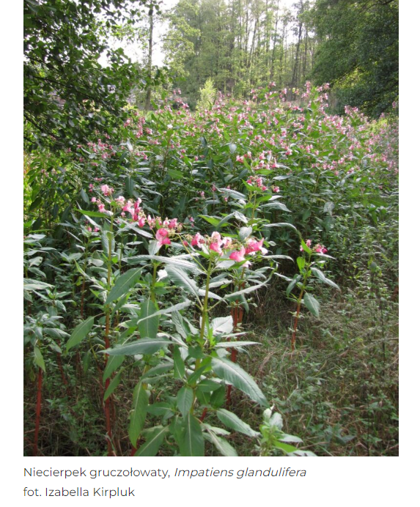
Eradication methods
Below is a general overview of control measures for this species. When selecting a method, it is recommended to consult the Compendium of Impatiens Control Methods published by the General Directorate for Environmental Protection (GDOŚ) in 2022. . The Compendium provides an overview of control methods for Orange touch-me-not and Purple jewelweed recommended for use in Poland.
- It is an annual plant, so you must not allow it to produce flowers or fruit (they ripen very quickly!). The best method is to pull up entire plants, and the following year—to remove the young seedlings that appear in the spring. After removing the plants, continue to monitor the area to ensure no new plants appear in subsequent years.
- Any control method should aim to prevent the plant from producing seeds. The best results are achieved by using mechanical control at the end of the season, i.e., when the plants are flowering or beginning to flower. Early cutting of plants below the first node can control populations, although this is labor-intensive. In Germany, several mechanical methods were tested (Hartmann et al., 1995), and mowing with or without removal of plant material, mulching, or tillage proved effective. For larger areas infested with the species and where soil conditions permit, agricultural machinery can be used. Where the soil is wet and soft, heavy machinery will damage the soil and create open spaces ideal for re-establishment. For smaller areas, manual brush cutters can be used, and plants can also be pulled out by hand. In such cases, care must be taken to ensure that the pulled-out plants do not have a chance to regrow where they were deposited. To achieve lasting success, the area should be monitored for regrowth.
Recommendations regarding biomass management are provided in Chapter 3.

2.4. Giant goldenrod (Solidago gigantea) and Canadian goldenrod (Solidago canadensis)
Species Characteristics
Canadian goldenrod (Solidago canadensis) and Giant goldenrod (Solidago gigantea) are two invasive alien species found in Poland that were introduced to Europe from North America. These plants are very similar to one another—unlike Canadian goldenrod, Giant goldenrod has a stem that is hairy along its entire length (the stem of Giant goldenrod is hairy only within the inflorescence).
Canadian goldenrod is a perennial herb that grows up to 150 cm tall. The stems are glabrous at the base and, from the middle upward, coarsely and sparsely hairy. The stem bears alternate, lanceolate leaves that are long-pointed, sharply toothed, 6–13 cm long, and hairy along the veins on the underside. The flowers are yellow. They are arranged in small, basket-like inflorescences, with a calyx up to 2.8 mm long, grouped into pyramidal panicles 15–30 cm long. The fruit is an achene bearing a short calyx pappus up to 2.5 mm long. Canadian goldenrod blooms from July through October, with peak blooming from mid-August through late September. Plants bloom every year starting in their first year of life.
Giant goldenrod is a perennial reaching a height of 50 to 250 cm. It has a stiff, erect stem, glabrous at the base, waxy, and slightly hairy below the inflorescence. The stems often take on a reddish-purple color, although this trait is not observed in plants growing in the shade or in dense stands. The leaves are lanceolate in shape, with a pointed tip and sharply serrated margins. The upper surface of the leaf blade is glabrous, while the underside has hairs along the leaf veins. The flowers are yellow, small, and arranged in bell-shaped flower heads mounted on short pedicels. The flower heads are grouped into one-sided panicle-like inflorescences, visible from a distance. It blooms in August and September.
In their secondary range, goldenrods exhibit a wide ecological amplitude and a broad habitat spectrum. They are highly tolerant of soil conditions but require full sunlight.
Goldenrod is found particularly in unused meadows and pastures, as well as in abandoned croplands, along roadsides, forest edges, field margins, and in habitats disturbed by humans
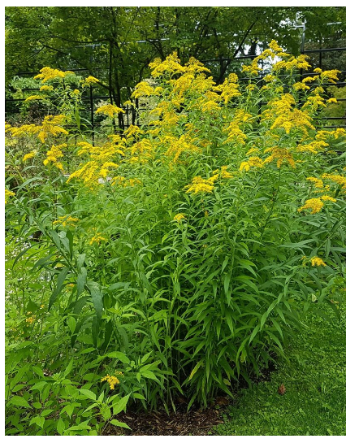
Solidago gigantea https://www.ogrod.uw.edu.pl/
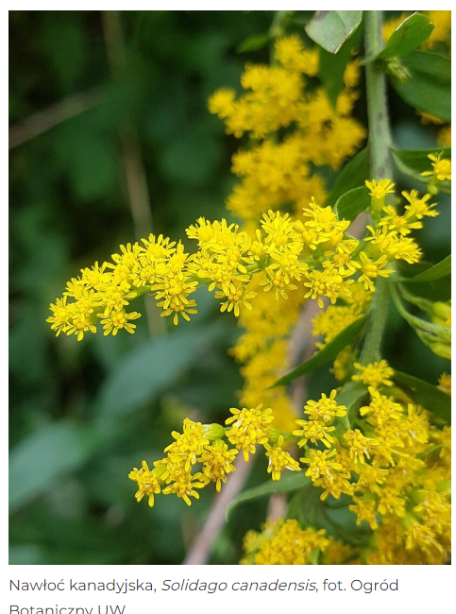
Solidago canadensis https://www.ogrod.uw.edu.pl/
Eradication methods
- Controlling goldenrod is a difficult and labor-intensive process.
- If the plant is not yet widespread in a given area, individual clumps should be dug up.
- However, if larger areas are affected—such as meadows or fallow land—and habitat conditions do not allow for the use of heavy equipment to plow up the rhizomes, the simplest way to limit goldenrod’s spread is to mow regularly (even several times a year) before the flowering period. .
- In the early stages of expansion, spot control of plants (pulling or digging them up) yields good results
- Germinating and young plants are sensitive to soil-applied herbicides, but later, during the growing season, soil-applied herbicides are ineffective. Glyphosate, 2,4-D, and several contact herbicides are suitable for controlling plants up to 10–15 cm in height .
Recommendations regarding biomass management are provided in Chapter 3.

2.5. Garden lupin (Lupinus polyphyllus)
Characteristics of the species
Garden lupin (Lupinus polyphyllus) is a perennial plant with ornamental flower clusters. This plant enriches the soil because it lives in symbiosis with bacteria that fix atmospheric nitrogen. It reproduces mainly by seed, but also through rhizomes (underground stems). Lupine prefers sunny locations and can grow even in poor soils. It affects native vegetation through competition, as well as by degrading growing conditions for plants adapted to grow in soils with low nitrogen content.
In the wild, it spreads in open forests, along roadsides, and in meadows .
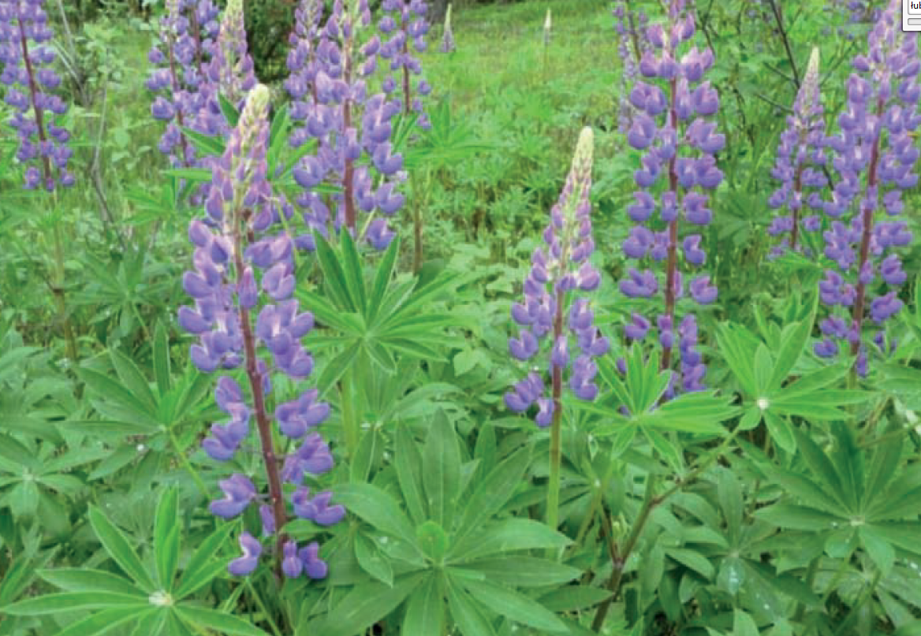
GDOŚ Guidelines 2016. Photo credit: B. Tokarska-Guzik
Eradication methods
- Regular mowing or digging up young plants ,
- Manual removal can be used for small stands (Timmins and Mackenzie, 1995). Regular mowing or grazing before seed maturation is recommended for larger stands to reduce seed production (NOBANIS, 2015). However, mowing does not eradicate the plant. L. polyphyllus’s ability to reproduce vegetatively can hinder mechanical control methods (Pergl, 2015) .
- Chemical control. Spraying with a herbicide such as glyphosate can be effective (NOBANIS, 2015; Anderson et al., 2014; USDA-NRCS, 2015)

2.6. Wild cucumber (Echinocystis lobata)
Characteristics of the species
Wild cucumber (Echinocystis lobata) is an annual plant with a climbing, twining stem that grows up to several meters in length and is equipped with numerous branched tendrils of leaf origin. Thanks to these tendrils, the plant can efficiently climb other plants or artificial supports, such as fences, poles, etc.
It can be found along fences, hedges, roadsides, near landfills, in community gardens, cemeteries, on fallow land, and along field boundaries. From all these places, it easily spreads further, colonizing the banks of drainage canals, rivers, lakes, wet meadows, and the edges of riparian forests / floodplain forests.
The fruit of the spiny restharrow is a fleshy capsule that, when ripe, splits open at the top and releases relatively large seeds.
The wild cucumber belongs to the group of so-called “transformers,” that is, plants that transform the communities they have colonized.
The seeds remain viable for over a year and, once dried, are easily dispersed by wind or water. This is particularly dangerous when the spiny restharrow appears near reservoirs and watercourses.
The spiny restharrow is particularly easy to spot during its flowering period (July through September), when it produces numerous white-green flowers—male flowers clustered in multi-flowered panicles and female flowers growing singly or in pairs in the axils of the same leaves as the male inflorescences.
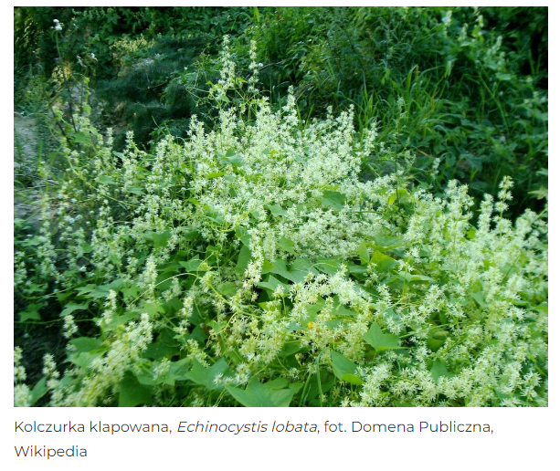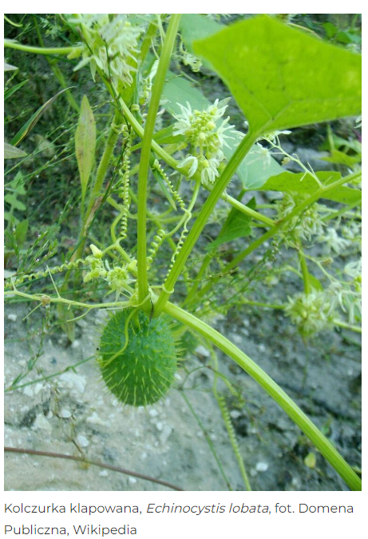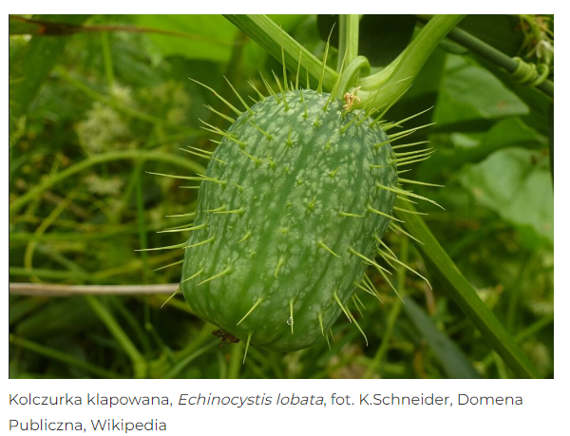
Eradication methods
E. lobata is also sometimes unintentionally introduced and spread by humans. Seeds can be carried along with transported soil, especially during work related to riverbank stabilization or the modernization of flood control levees. According to the CABI Compendium, “To date, no large-scale, targeted efforts to control E. lobata have been undertaken. Indirectly, this plant may be removed during control measures targeting other invasive species, such as knotweed (Reynoutria spp.) along waterways. Given the nature of such natural habitats, measures to protect ecologically valuable areas should involve pulling up, cutting down, or mowing wild-growing wild cucumber (Dajdok and Kącki, 2009). The use of chemical agents must be adapted to local conditions and regulations (in many countries, the use of chemicals such as herbicides near water bodies is prohibited) ”.
Polish sources mention the following methods for controlling the species:
- Controlling thistle generally involves mechanical removal: pulling up or mowing the plants before they produce seeds. The best results are achieved by pulling up seedlings in the spring (they begin to sprout in late April or early May). They are easy to identify and can be effectively eliminated.
- These treatments should be repeated annually for several seasons. Mowing or pulling up the plants during fruiting must be combined with proper disposal (e.g., burning in an authorized location). Chemical methods are also effective, such as spraying or applying preparations containing glyphosate to the leaves .
- The compendium of methods for controlling Wild cucumber published by the General Directorate for Environmental Protection (GDOŚ) in 2022 recommends methods such as pulling before flowering, pulling during flowering, cutting during flowering, and pulling and cutting before flowering. The compendium provides a detailed description of each method, including the characteristics of the areas where a particular method should be preferred. It also compares the methods, taking into account organizational issues (how the activity is carried out, duration, safety for people), economic issues (labor intensity, implementation costs), and environmental issues (impact on the natural environment and ecosystem).
Recommendations regarding biomass management are provided in Chapter 3.

2.7. Redroot pigweed (Amaranthus retroflexus)
Characteristics of the Species
Redroot pigweed (Amaranthus retroflexus) is common in the lowlands of Poland. It also occurs in lower mountain elevations. It is very commonly found in ruderal habitats, such as roadsides, fences, wastelands, landfills, and rubble piles. It is a common weed in gardens, root crops, and, somewhat less frequently, in cereal crops. It is a light-loving and nitrogen-loving species.
Redroot pigweed is an annual plant, highly variable in terms of height (10 to 120 cm), growth habit, degree of branching, and leaf size. Its stem is furrowed and coarsely hairy (hence the Polish species name Szarłat szorstki). Its flowers are clustered in corymbs, arranged in broad, spike-like inflorescences at the top of the stem and on lateral branches. Some of the corymbs are located in the leaf axils. The flowers are unisexual, but the plants are monoecious. Redroot pigweed typically blooms from July through October.
The fruit is a capsule that splits open along a transverse slit and opens with a lid. The seeds are very numerous, small (about 1 mm in diameter), lenticular, black, and shiny. A single vigorous plant can produce between 230,000 and 500,000 seeds. They are dispersed by wind, animals, and as contaminants on crop seeds or agricultural machinery. Recent studies suggest that germination is stimulated by light and high temperatures. The seeds can remain viable in the soil for many years. .
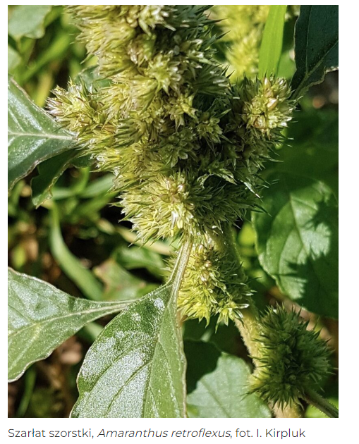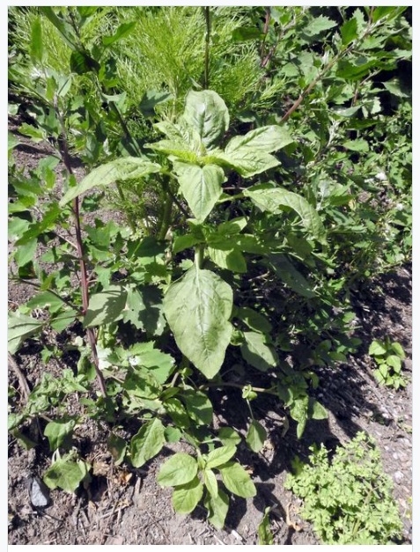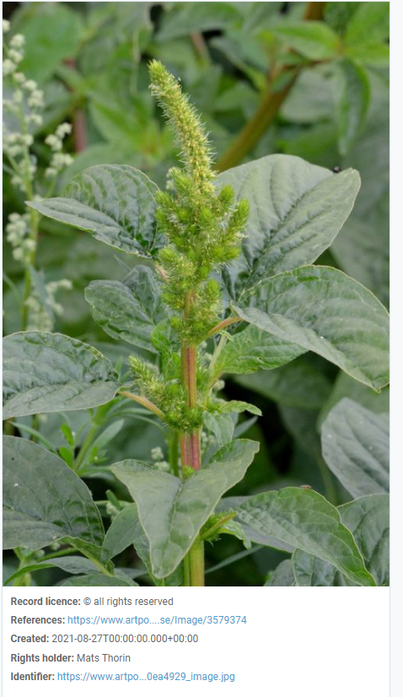

Eradication methods
Redroot pigweed is an annual plant that typically blooms from July through October. Seeds are spread by wind, animals, and as contaminants in crop seeds or on agricultural machinery.
- We should control the plant’s presence and prevent it from spreading. Since it is an annual, it should not be allowed to produce flowers or fruit.
- Control usually involves mechanical removal: pulling up or mowing the plants before they release seeds. These measures should be repeated annually for several seasons.
- Seedlings can be controlled by tillage, but older plants often regenerate after mechanical damage and produce inflorescences. Soil solarization under plastic mulch can control A. retroflexus if high temperatures are maintained under the mulch for an extended period (Mas and Verdu, 1996) .
- A. retroflexus is easily controlled by most herbicides that inhibit photosynthesis, such as atrazine, simazine, metribuzin, linuron, and bromoxynil. It is also highly susceptible to synthetic auxin herbicides, such as 2,4-D or dicamba, as well as sulfonylurea and imidazolinone herbicides, such as imazethapyr, thifensulfuron-methyl, rimsulfuron, and nicosulfuron. Most other herbicides used to control broadleaf weeds are also effective, including acifluorfen, fomesafen, and pendimethalin (Weaver and McWilliams 1980; Bauer et al. 1995; Carey and Kells 1995; Mamarot and Rodriguez, 1997). In heavily infested fields, it is necessary to use soil-applied herbicides or sequential post-emergence treatments due to the intermittent germination of these rosales throughout the growing season. A. retroflexus can be controlled using the soil fumigant methyl iodide (Zhang et al., 1997)
Recommendations regarding biomass management are provided in Chapter 3.

2.8. Common Foxglove (Digitalis purpurea)
Characteristics of the species
Common foxglove (Digitalis purpurea) is a biennial or perennial plant. It reproduces via numerous small seeds. It prefers sunny or partially shaded sites and moist soils with a neutral or slightly acidic pH. By forming dense stands, it can limit the growth of native plants.
In the wild, it spreads in sunny areas: in forests, particularly in spruce forests and acidic beech forests, e.g., on clear-cut areas and forest glades, in mountain pine thickets, and in meadows. Common foxglove is classified in Poland as a naturalized, invasive species . The main types of natural habitats / wildlife habitats of Community importance that this species invades are 3220; 9110; 9410 . According to the Code of Good Practice “Horticulture and Invasive Plants of Alien Origin” (GDOŚ 2016), the species is regionally invasive and is gradually occupying new sites. Classified in Poland as a Category II invasive species. The GDOŚ Code contains the following recommendations regarding the cultivation of purple foxglove:
“Areas where this species should not be cultivated:
- near forests and watercourses,
- in open landscapes,
- in protected areas and their buffer zones.
It is recommended to refrain from cultivation or to implement the following measures to minimize the risk of the plant spreading beyond the cultivation site:
- regular mowing, pulling up, or digging out young plants from areas adjacent to the cultivation site,
- cutting off flower heads after they have bloomed and disposing of them,
- removing the plant after the growing season ends” .

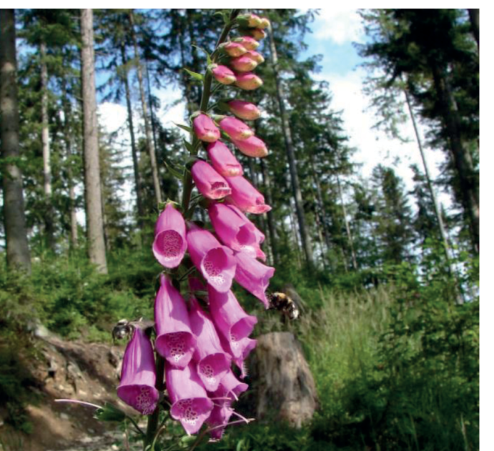
Photo credit: B. Tokarska-Guzik
Eradication methods
- Control of common foxglove typically involves mechanical removal: pulling up or mowing the plants before seeds are released.
Recommendations regarding biomass management are provided in Chapter 3.

2.9. Dwarf serviceberry (Amelanchier spicata)
Characteristics of the species
Dwarf serviceberry (Amelanchier spicata) is a tall shrub or small tree. It reproduces by seed. The fruits are readily eaten by birds, and the seeds are dispersed over considerable distances. It prefers acidic, sandy soils. It may impact native ecosystems by limiting the growth of other plants.
In the wild, it occurs primarily in forested areas, in thickets, and near urban areas .
This species is described as rhizomatous, with vigorous regrowth, and capable of forming dense thickets (Flora of North America 2020; Go Botany Native Plant Trust (New England) (2020)). Its potential for vegetative spread via rhizomes makes it difficult to eradicate the species if it goes undetected for more than a few years, by which time it will have established a wide range and a firm foothold.
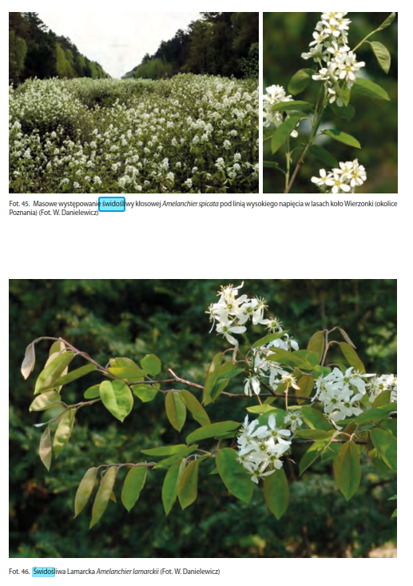
Source: B. Tokarska-Guzik, Z. Dajdok, M. Zając, A. Zając, A. Urbisz, W. Danielewicz: Plants of Foreign Origin in Poland, with Particular Emphasis on Invasive Species. Warsaw: General Directorate for Environmental Protection, 2012. ISBN 978-83-62940-34-9
Eradication methods
- Controlling the dwarf serviceberry typically involves regular mowing or pulling up young plants.
- The plant’s vegetative spread and regrowth make it difficult to control, as repeated manual cutting will be necessary. Kabuce & Pieder (2010) and references cited by them describe the rapid regrowth of shoots from stems that were cut the previous year (52% of shoots regenerate); shoots can produce fruit in their third or fourth year .
Recommendations regarding biomass management are provided in Chapter 3.

2.10. Steeplebush (Spiraea tomentosa)
Characteristics of the species
Steeplebush is an upright shrub reaching a height of up to 3 m (on average 0.8–1.5 m), with unbranched shoots and numerous underground stolons. The shoots are covered with a woolly, rust-colored tomentum, and the leaves are ovate (3–7 cm long), dark green on top, gray-green underneath, and covered with a dense tomentum. The flowers form pink, conical panicles (up to 15 cm long), located at the tips of this year’s shoots. The fruits are small, capsule-like, and the seeds are light and winged; the seed capsules may remain on the shoots even in winter. It most commonly occurs in low and transitional peatlands, moist heathlands, and less frequently in alder forests, riparian forests, marshy birch forests, or abandoned meadows. The flowers of the Steeplebush, composed of 5 sepals, 5 petals, 5 pistils, and numerous stamens, are pink and arranged in terminal, conical panicles up to 20 cm long. Flowering lasts from July to August, and the seeds ripen in late October and early November. The shrub’s fruit is a multi-chambered capsule composed of 5 dry chambers that split along the ventral seam, each containing 2 to 10 seeds; thus, a single flower can produce up to 50 seeds per year. Mature seeds, which are approximately 2 mm long and 0.2 mm wide, have a high germination rate and are adapted for dispersal by water (hydrochory). Under favorable conditions, Steeplebush reaches maturity in its third or fourth growing season. Removing spiraea is generally difficult; most often, the rhizomes remain in the ground, crumbling and breaking apart. Even in the case of individual clumps (regardless of the substrate), they are so compact that uprooting them poses significant difficulties .
The shrub’s expansion may also be facilitated by regularly repeated practices such as mowing or pulling up riparian vegetation and dredging watercourses, combined with the removal of silt and its storage on the slopes of the watercourses. Habitats containing patches of exposed soil are particularly vulnerable to the establishment of invasive species, especially when eutrophication occurs simultaneously. Highly sunlit communities are the most susceptible to its spread. Steeplebush therefore most commonly colonizes wetland ecosystems, particularly linear microhabitats such as the edges of ditches, ponds, and natural watercourses. It also frequently invades unmowed meadows, where its populations become densely clustered (approximately 60% of this plant’s sites in meadow communities consist of aggregations that take the form of intermittent or dense stands). Its occurrences are also found on forest edges, pond shores, and boundary lines, in areas beneath high-voltage power lines, and along the banks of natural watercourses .

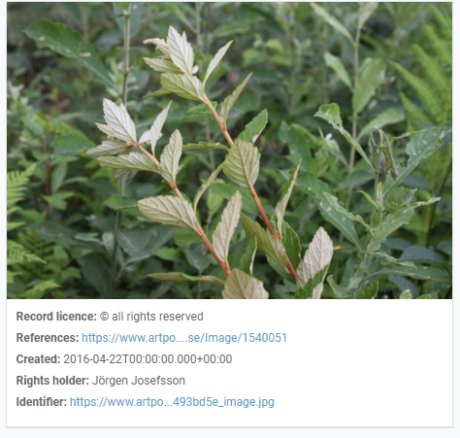
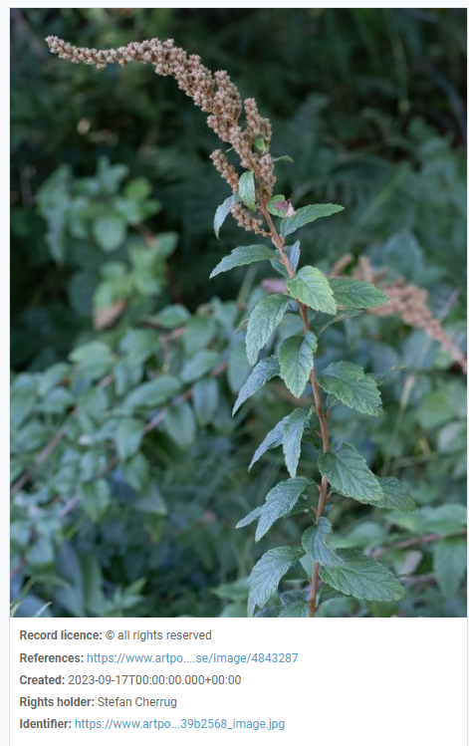
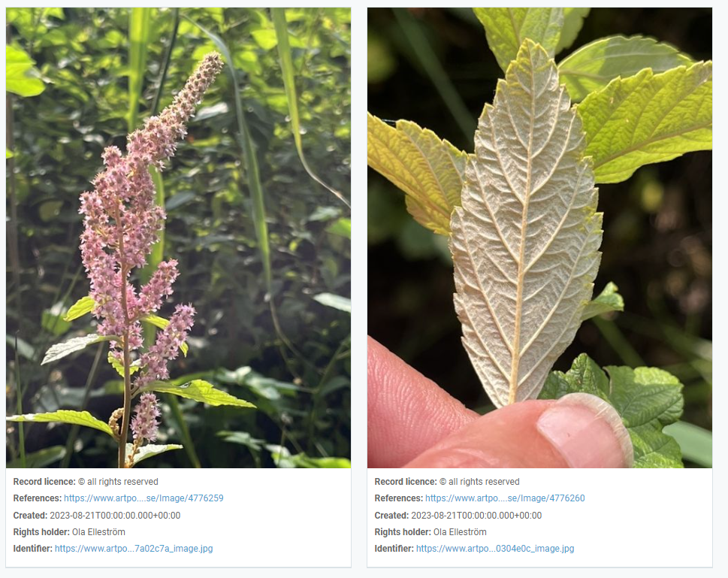
Eradication methods
Measures taken to date to eliminate, control, or isolate the species in question. Due to the characteristics of the steeplebush—primarily its very high reproductive potential and its ability to regenerate rapidly after mechanical damage—limiting the spread of this species is exceptionally difficult.
In Poland, efforts to control it are primarily undertaken in the Drawska Forest. Mowing and hand-pulling have been tested as methods for controlling the spiraea. Mowing with a mechanical scythe proved completely ineffective, as the shrub regrows, restoring its original density within a few months. Mowing its shoots twice also failed to yield positive results.
However, uprooting individual shrubs proved effective, provided that their density is not high (patches with single, scattered individuals) and the treatment is repeated 4 to 5 times over subsequent years. In the case of dense populations of the species, the effectiveness of control is low. The reduction in density resulting from a single treatment was no greater than 20% to 40%, and a visible effect was achieved only after repeating the procedure five times. It was also observed that specimens that were uprooted and turned over— —with the root ball facing upward usually die, and leaving them in piles slightly limits regrowth; provided that the treatment is repeated in subsequent years, this appears to be a rational alternative to uprooting and removing the remains outside the species’ range. In some cases, the thinning of the shrub population was also influenced by a rise in the groundwater level. In the Lower Silesian Forests, however, the secondary waterlogging of one of the peatlands did not lead to a deterioration in the condition of the Steeplebush .
When selecting a control method, it is also recommended to consult the Compendium of Control Methods published by the General Directorate for Environmental Protection (GDOŚ) in 2022 . The Compendium provides an overview of the methods for controlling the Steeplebush recommended for use in Poland.
Recommendations regarding biomass management are provided in Chapter 3.

2.11. Spotted loosestrife (Lysimachia punctata)
Characteristics of the species
Spotted loosestrife (Lysimachia punctata) is a perennial with ornamental yellow inflorescences. It reproduces via underground stems (rhizomes) and seeds. It prefers fresh or moist soils. It can form dense clumps and thereby limit the growth of native vegetation.
This plant occurs in moist meadows, peatlands, riparian herbaceous communities (herb thickets), thickets, and riparian forests / floodplain forests .
Lysimachia punctata is classified in Poland as a naturalized, invasive species . The main natural habitats of European Community interest into which the species invades are: 6430 . According to the Code of Good Practice in Horticulture Regarding Invasive Plants of Foreign Origin (GDOŚ 2016), the species is regionally invasive and is gradually occupying new sites. It is classified in Poland as a Category I invasive species. The GDOŚ Code contains the following recommendations regarding the cultivation of the species:
“Areas where this species should not be cultivated:
- near forests, peatlands, and watercourses,
- in open landscapes,
- in protected areas and their buffer zones.
It is recommended to refrain from cultivation or to implement the following measures to minimize the risk of the plant spreading beyond the cultivation site:
- regularly digging up young plants from areas adjacent to the cultivation site (since they can regrow from rhizome fragments),
- cutting off the inflorescences after flowering and disposing of them,
- removing the plant after the growing season ends”.

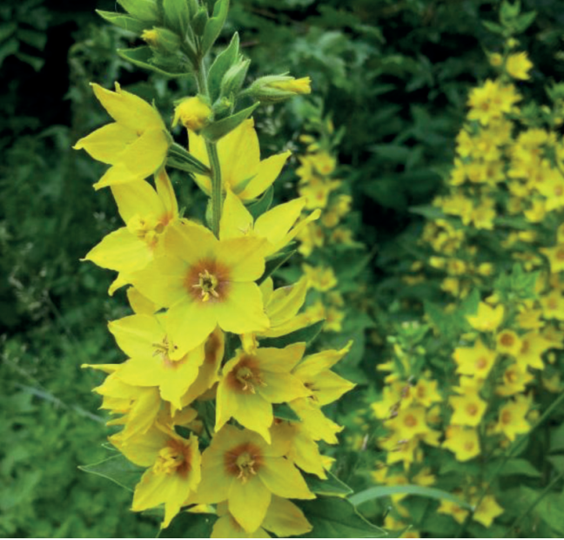
Source: GDOŚ Guidelines 2016 (Photo credit: Stefan Didam-Schmallenberg (“Selbst fotografiert – own work”) [GFDL (http://www.gnu.org/copyleft/fdl.html) or CC-BY-SA-3.0-2.5-2.0-1.0 (http://creativecommons.org/licenses/by-sa/3.0)], undefined
Eradication methods
- Control typically involves regularly digging up young plants from areas adjacent to the cultivation site (since they can regrow from rhizome fragments).
Recommendations regarding biomass management are provided in Chapter 3.

2.12. Yellow oxeye (Telekia speciosa)
Characteristics of the Species
Telekia speciosa is a perennial with yellow flowers. It reproduces by seed. The plant is tolerant of shade and prefers loamy, moist, and nitrogen-rich soils. It forms dense, tall stands (up to 2 m) and thereby limits the growth of native plants and alters the vegetation structure.
It spreads, among other places, on clear-cut areas, at forest edges, on degraded land, and along transportation routes. It poses a threat particularly to vegetation along riverbanks and lakeshores (including herbaceous plants) and to wet meadows.
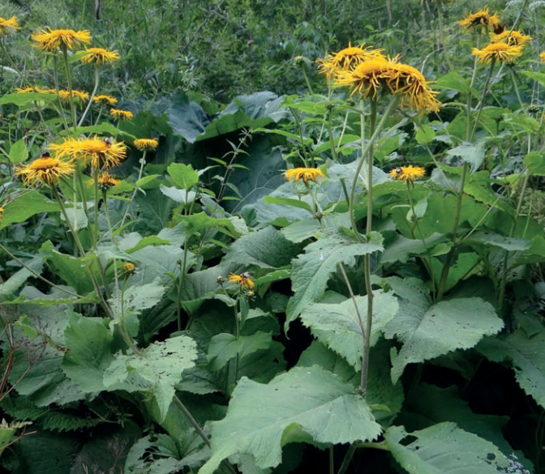
Code: Photo credit: Jerzy Opioła (Own work) [CC BY-SA 4.0 (http://creativecommons.org/licenses/by-sa/4.0)]
Eradication methods
- Control typically involves regular mowing of the plants during the growing season (before fruit set).
Recommendations regarding biomass management are provided in Chapter 3.

2.13. Sosnowski's hogweed (Heracleum sosnowskyi)
Characteristics of the species
H. sosnowskyi is a single-stemmed biennial or perennial plant. Its height is often reported as 100–300 cm, although in the original description from its native range it is “only” 100–150 cm (Mandenova, 1950). The stem is striated and sparsely hairy with purple spots. The leaves of mature plants are divided to varying degrees, either into three approximately equal parts, which may be further subdivided (ternate), or into more than three leaflets arranged in rows along the central leaf stalk (pinnately divided). The leaf margins have short, rounded teeth. The upper surface of the leaves is glabrous, while the underside is slightly hairy. The flowers are white, sometimes pinkish. The outer petals are radiate, 9–10 mm long. The flowers are arranged in slightly convex, compound umbels 30–50 cm in diameter. The umbels have 30–75 rays with short hairs. Flowering usually occurs from June to August. The fruits are ovoid or oval; 9–16 mm long, 5–9 mm wide, and densely hairy when immature. Mature fruits have wings with numerous spines located on small spherical or ovoid swellings. The fruits have very distinct oil channels that do not extend to the base of the fruit (Nielsen et al., 2005). The entire plant ( ) contains photosensitizing furanocoumarins, which can cause burns and/or blisters on human skin (following contact with the plant sap and subsequent UV exposure).
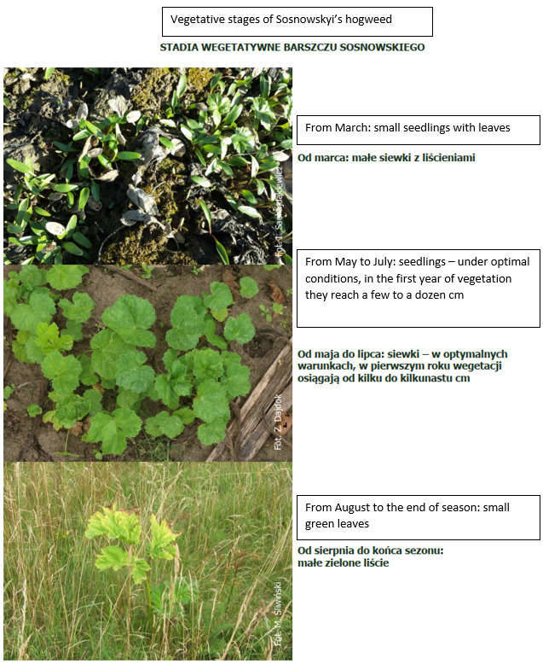
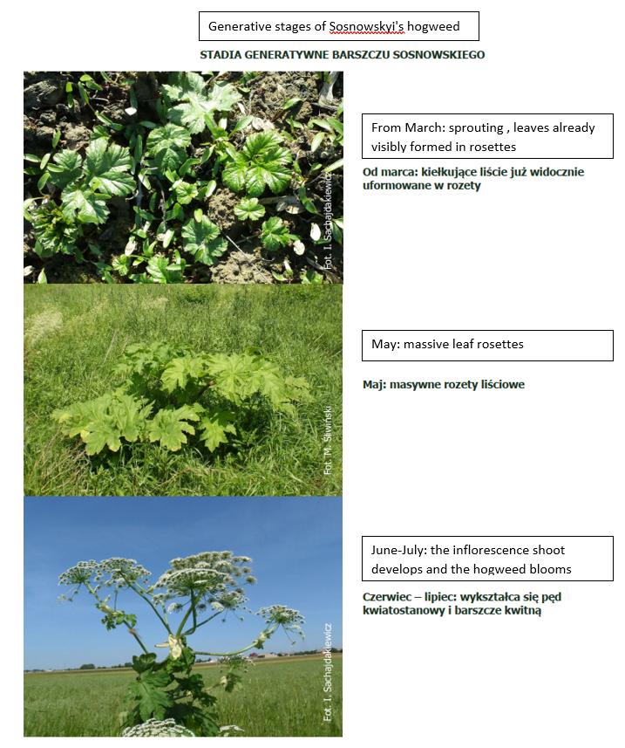
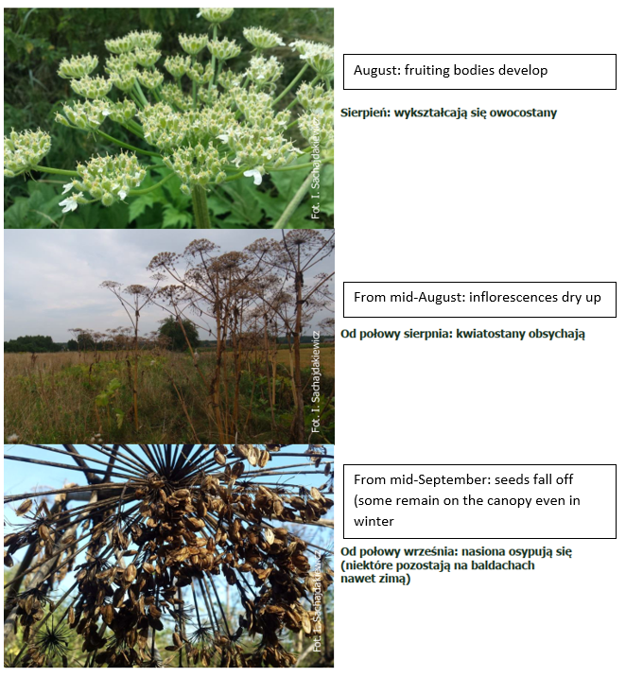
Source: Compendium. Methods for Controlling Caucasian Hogweed, GDOŚ, Warsaw 2022 (https://www.gov.pl/web/gdos/kompendia-zwalczania-wybranych-igo)
Eradication methods
The overview of control and eradication methods presented below is based on the CABI Compendium. It is also recommended to consult the Compendium of Methods for Controlling Carpathian Hogweed published by GDOŚ in 2022. .
Physical/Mechanical Control Methods
- Manual and mechanical methods for controlling H. sosnowskyi include techniques such as cutting roots, cutting down plants, mowing, removing seed heads, and plowing. With the exception of root cutting, mechanical control does not result in the immediate eradication of plants. Eradication occurs after 2–3 treatments per year over several growing seasons as a result of the depletion of nutrient reserves.
- Root pruning (or digging up) is effective but labor-intensive and is recommended for individual plants or small stands (<200 plants). It is typically performed with a standard spade with a sharp blade. Pruning should be carried out in early spring and repeated in mid-summer. It is recommended that the root be cut at least 10 cm below soil level (or up to 25 cm if additional layers of soil may be covering the plants). The cut plant parts are pulled out of the soil and either destroyed or left to dry out.
- For large infested areas, mechanical mowing—for example, with a flail mower—is effective. The plants regrow quickly, and mowing should be repeated 2–3 times during the growing season to prevent regrowing plants from accumulating nutrients in their roots and subsequently flowering and setting seeds.
- If the population is small or located in a place unsuitable for mechanical mowing—such as along rivers or on slopes—the plants can be cut by hand using a scythe or a brush cutter. One mowing strategy is to cut only flowering plants in the middle of the flowering phase. This will prevent the production of new seeds, and the vegetative plants will shade each other. If carefully repeated, this strategy should eliminate the population within a few years with minimal labor.
- Removing the flower heads can be just as effective as cutting down the entire plants, but this control method often fails to prevent seed production due to the plants’ high regenerative potential. Plants that have had their inflorescences removed can easily regenerate and produce new flowers and viable, normal-sized seeds that germinate well. This method should be considered solely as a stopgap measure for controlling plants in locations where no other control efforts have been made previously. The timing of removal is critical, because if the treatment is applied too early in the season (before full inflorescence), regeneration is very vigorous and an even greater number of seeds are produced. If the treatment is applied too late (at the start of seed set), there is a risk that seeds will ripen even on cut umbels that remain on the ground. Cut umbels must be collected and destroyed. Umbel removal is most effective when the terminal umbels are just beginning to bloom. Even then, some regrowth occurs, and treated sites must be monitored during seed maturation to prevent the release of seeds resulting from regrowth (Nielsen et al., 2005; Pyšek et al., 2007).
- Plowing can control H. sosnowskyi infestations on agricultural land. Deep plowing (up to 24 cm) significantly reduces hogweed seed germination by burying the topsoil (where most seeds are concentrated). The best results are achieved when mechanical or chemical methods are applied prior to plowing (Nielsen et al., 2005).
Chemical control methods
- H. sosnowskyi (like other invasive Heracleum species) is susceptible to systemic herbicides such as glyphosate, triclopyr, and imazapyr. Glyphosate is the most commonly used compound, but due to the risk of toxicity to fish and algae, an unsprayed buffer zone 2 m wide should adjoin every river or other body of water (Marcher, 2001).
- Triclopyr has no effect on germinating grasses and is useful for controlling a range of broadleaf species. Imazapyr has residual activity in the soil that prevents further germination, but it may also affect non-target species (EPPO, 2008).
- Before applying herbicides, familiarize yourself with UE policies as well as national regulations and guidelines. Spraying should be carried out in dry and calm weather. If herbicides are to be used, it is strongly recommended that they be applied in early spring, when plants reach a height of 20–50 cm and access to the center of the colony is still possible. Before the end of May, a follow-up spray may be necessary to control new seedlings. This second spray can be replaced by mowing or pruning.
Integrated Pest Management (IPM)
- An integrated pest management strategy should be preferred, focusing on optimal management in terms of effectiveness, ecology, and economy. Such a program should include clearly defined objectives (e.g., eradication or containment), identification of all plant locations within a given area and habitats susceptible to invasion, and availability of resources. The choice of control method(s) depends on many factors, and often a combination of two or more methods may be more effective. Regardless of the control method, management typically requires repeated and proper application to achieve satisfactory results. To optimize efforts, plant control should begin at the start of the growing season and continue for several years until the seed bank in the soil is depleted and the root system dies off. Due to the likely downstream spread of seeds, it is important to ensure that infestations upstream have been controlled before attempting to control the species (Caffrey and Madsen, 2001; Nielsen et al., 2005, 2007; EPPO, 2008).
Recommendations regarding biomass management are provided in Chapter 3.

2.14. Giant hogweed (Heracelum mantegazzianum)
Characteristics of the Species
Heracleum mantegazzianum is a single-stemmed perennial that grows from a yellow, branched root system 40–60 cm deep and up to 15 cm in diameter at the crown when mature. The root is somewhat contractile, pulling the crown to about 10 cm below the soil surface. During the growing season, the plant forms a rosette of leaves that enlarges from year to year. The leaves are alternate; the lowest ones reach up to 3 m in length and up to 1.7 m in width, and are trifoliate or pinnately compound with coarsely serrated margins. The upper leaves on the flowering stem gradually become smaller. The upper surface of the leaf is glabrous, but the underside and petiole are covered with hairs. When it finally blooms, usually after 3–5 years, a single hollow stem appears, up to 2–5 m tall and 10 cm in diameter. The stem is striated, with purple spots, and covered with pustular bristles. The main inflorescence is a terminal compound umbel up to 80 cm in diameter with about 100 uneven, hairy rays, each 10–40 cm long. There are also up to eight satellite umbels that tower above the main one, while others develop on the branches below. The main umbel is hermaphroditic; the lower ones, which mature earlier, may be male only. The flowers, borne on 10–20 mm long pedicels, are white or pinkish with petals up to 12 mm long. The numerous fruits are flattened, elliptical, 6–18 mm long and 4–10 mm wide, narrowly winged; larger fruits occur on the main inflorescence, and smaller ones on the satellite inflorescences; they range from glabrous to hairy and are divided into two columns, each with 3–5 elongated oil channels. For the first few years, the aboveground growth dies back every winter. After flowering, the plant dies back completely (according to Tiley et al., 1996). Nielsen et al. (2005) provide excellent illustrations of H. mantegazzianum and related species.
Both Sosnowski's hogweed (see item 15 above) and Giant hogweed are large perennials, typically reaching a height of 2–3 m (maximum 450–500 cm). The two species are similar to one another, and the morphological differences noted in the literature are difficult to observe in practice. Due to the difficulty in distinguishing between them and their similar invasive and toxic properties, they are often confused or treated as a single species. Both species ( ) are usually identified based on the morphological characteristics of their leaves, flowers, and fruits . Detailed information on distinguishing between hogweed species is included in the cited GDOŚ Compendium of Methods for Controlling Caucasian Hogweeds. (Compendium. Methods for Controlling Caucasian Hogweeds, GDOŚ, Warsaw 2022 (https://www.gov.pl/web/gdos/kompendia-zwalczania-wybranych-igo).
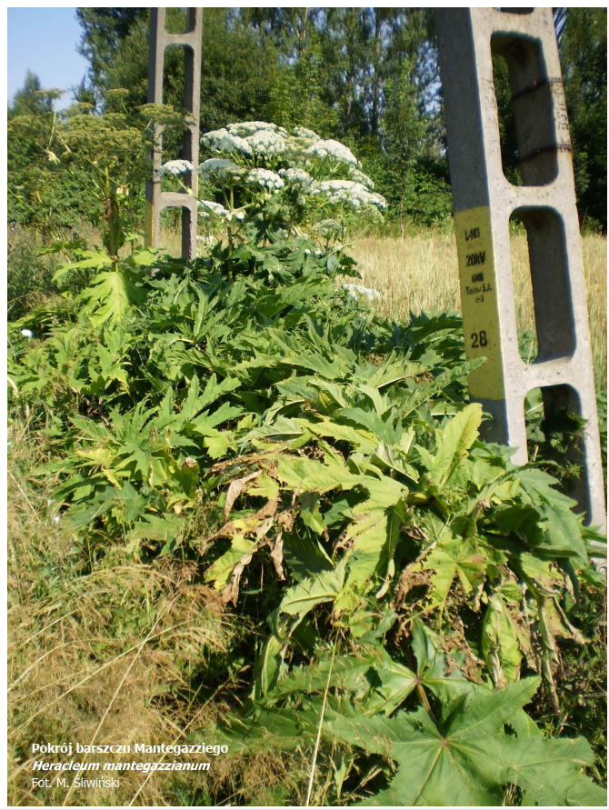
Source: Compendium. Methods for Controlling Caucasian Hogweeds, GDOŚ, Warsaw 2022 (https://www.gov.pl/web/gdos/kompendia-zwalczania-wybranych-igo)

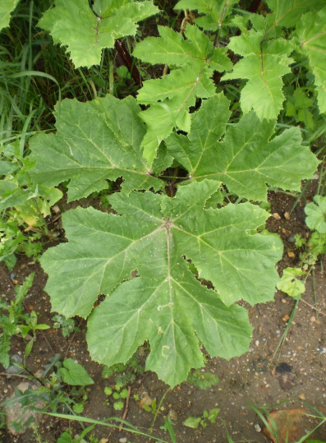 | 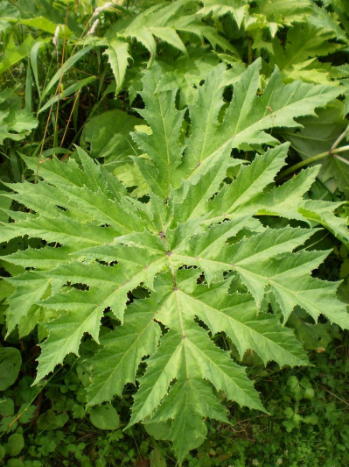
Sosnowskyi’s hogweed | Giant hogweed
Source: Compendium. Methods for Controlling Caucasian Hogweeds, GDOŚ, Warsaw 2022 (https://www.gov.pl/web/gdos/kompendia-zwalczania-wybranych-igo)
Eradication methods
The overview of control and eradication methods presented below is based on the CABI Compendium. It is also recommended to consult the Compendium of Methods for Controlling Carpathian Hogweed published by GDOŚ in 2022.
Physical/Mechanical Control Methods
- Manual removal (while wearing gloves) can be effective for young seedlings but is impractical for larger plants.
- Mechanical cutting is often used to clear riverbanks, but it does not provide long-term effectiveness because the plant quickly regrows from underground. It may also contribute to prolonging the flowering of shoots that would otherwise die back after flowering. Mowing in May and June is slightly more effective at reducing seed production and/or regrowth than mowing in March, but a single mowing cannot be relied upon to prevent potential seed dispersal. Even four mowings per year over two years failed to eradicate the plant (Nielsen et al., 2007). There is a trade-off between early cutting and high regrowth versus later removal of flower heads, which more effectively reduces fertility but requires dealing with more developed fruits that are capable of ripening even on cut flower heads (Pyšek et al., 2007c).
- Digging up or plowing to destroy the crown (below 10 cm soil depth) or otherwise severing the taproot from the crown (“root cutting”) can completely destroy the plant (Pyšek et al., 2007e).
Chemical Control Methods
- In the United Kingdom, herbicides recommended for controlling H. mantegazzianum include glyphosate, triclopyr, and imazapyr, but all must be applied early in the season (March through May) for best results. Imazapyr has residual activity in the soil that prevents further germination, but it may also have subsequent effects on non-target species. Glyphosate is the most commonly used compound, typically applied in April or May when plants are 20–50 cm tall; however, due to the risk of toxicity to fish and algae, a 2-meter unsprayed buffer zone must be maintained adjacent to any river or other body of water.
- Instead of spraying, the herbicide can be injected into the stem to prevent water contamination (Grguric, 2018), and the herbicide should generally be viewed as only one of the first steps in an integrated control program. As a biochemical alternative to synthetic pesticides, mulch treated with pyrolytic liquid derived from birch wood can be used to control H. mantegazzianum seedlings (Hagner et al., 2020).
Recommendations regarding biomass management are provided in Chapter 3.

2.15. Monkeyflower (Mimulus guttatus)
Characteristics of the Species
The monkeyflower (mimulus guttatus) is a perennial herbaceous plant whose stems typically reach a height of 30–60 cm, although according to some authors they can grow up to 150 cm. The stem is glabrous or sparsely glandular-hairy. The leaves are arranged oppositely; those on the lower part of the stem are petiolate, while those on the upper part are sessile. The leaf blades are rounded in shape and have serrated margins. The flowers grow singly in the axils of the upper leaves, forming a loose cluster. The calyx, fused from five sepals, becomes loose during fruiting and takes on a bell-shaped form. The corolla, 2.5–4.5 cm long, is bright yellow and consists of five petals forming two lips: the upper lip, formed by the fusion of two petals, and the lower lip, formed by the remaining three. The inner surface of the lower lip is characteristically speckled with red spots. Within the species’ natural range, the flowers of the Monkeyflower are pollinated primarily by bees and bumblebees. The fruit is a capsule containing up to several hundred seeds, which are dispersed mainly by water and wind. This species exhibits broad tolerance to light and temperature conditions, but requires high soil moisture for proper development. For this reason, plant communities in which it occurs are most commonly found along water’s edges, in the fringe zones of springs, and near seepages.
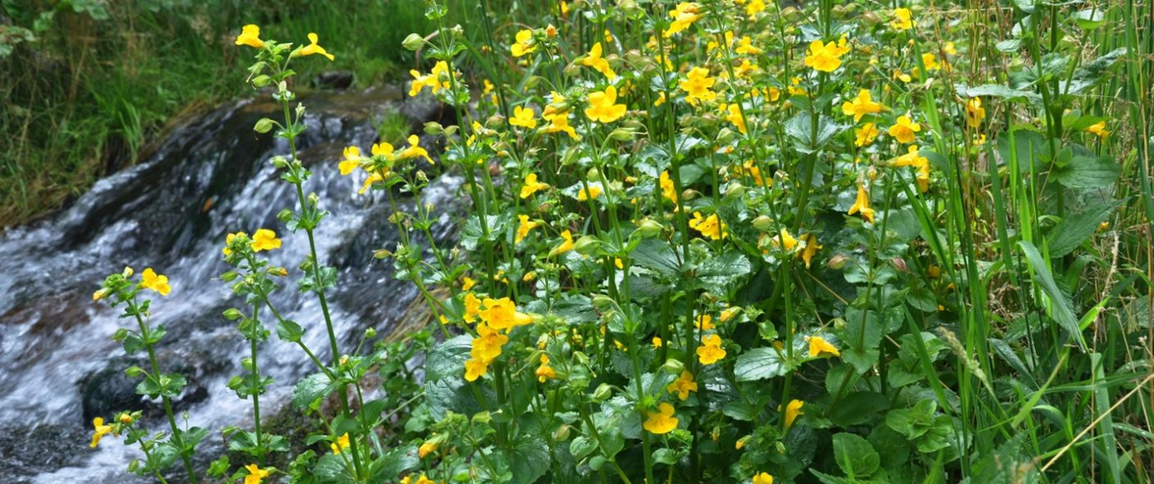
Source: https://www.gov.pl/web/gdos/mimulus-guttatus---kroplik-zolty, photo by Zygmunt Dajdok.
Eradication methods
Mechanical removal of individual plants is considered an effective method for eliminating Monkeyflower from the environment. Due to the species’ specific distribution, which is limited to particular riparian habitats, its population size typically allows for manual removal. The positive effects of such measures—in the form of population reduction and, consequently, a limitation on the Monkeyflower’s ability to compete with other native plants—are well-known and proven in Poland, including in the Karkonosze National Park.

2.16. Cutleaf coneflower (Rudbeckia laciniata)
Characteristics of the species.
The cutleaf coneflower is a stately perennial with short underground runners. Its stems are erect, branched, glabrous, covered with a bluish bloom, and reach heights ranging from 60 to 300 centimeters. There are three types of leaves on the rudbeckia’s stems: the lower ones are pinnately lobed, composed of 5–7 ovate, incised leaflets; the middle ones are 3–5-lobed; and the uppermost ones are undivided. The flower heads, 7–12 cm in diameter, are showy, with decorative yellow ray flowers and dark olive-colored disk flowers. The calyx is transformed into a pappus (calyx fluff), and the phyllaries (scales growing at the base of the flowers at the bottom of the flower heads in plants of the Asteraceae family) have truncated or rounded tips. The plant blooms from July through August. The fruits are glabrous and tetrahedral. It belongs to a group of species that partially reproduce apomictically (i.e., seed formation without fertilization). Of the numerous seeds produced, only about 50% germinate. Vegetative reproduction via underground runners plays a more important role in the plant’s dispersal. The species can occupy a wide range of habitats, but most often colonizes moist areas, both natural and anthropogenic.
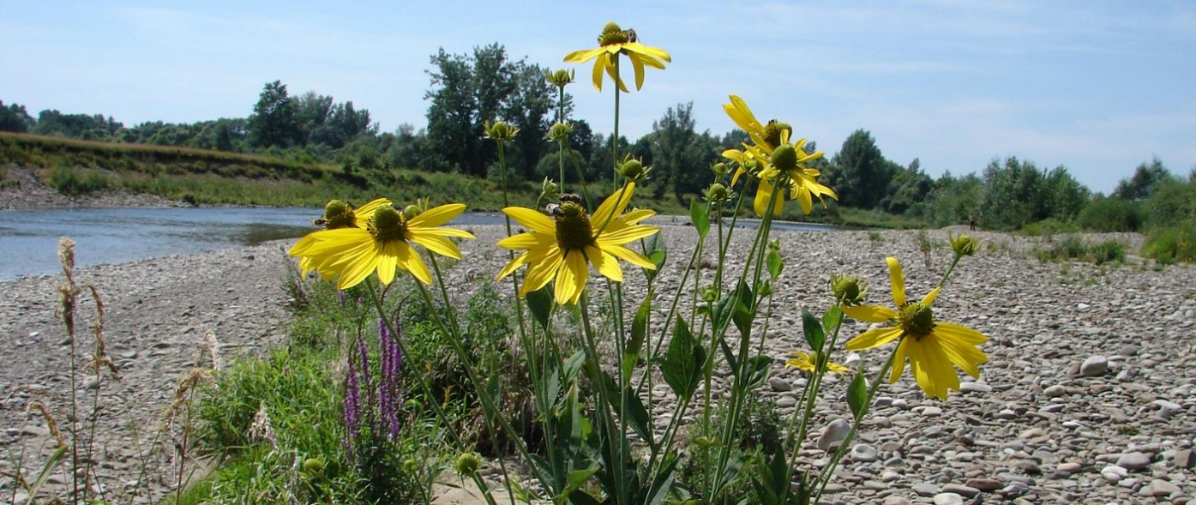
Source https://www.gov.pl/web/gdos/rudbeckia-laciniata---Cutleaf coneflowerhttps://www.gov.pl/web/gdos/rudbeckia-laciniata---Cutleaf coneflower, photo by Barbara Tokara-Guzik.
Eradication methods
Removing the aboveground parts, even when repeated over many years, only slightly reduces the species’ abundance and the viability of its individuals. Although it significantly inhibits flowering immediately after treatment, it stimulates the growth of underground parts and is not an effective method for removing the species; on the contrary, it stimulates the growth of underground parts, which ultimately leads to massive flowering and fruiting. The most effective method is the removal of stolons. Because this is a time-consuming process, it is recommended for use on small areas. Furthermore, this method disturbs the habitat, which affects the germination of seeds present in the soil (seeds of this species germinate exclusively in disturbed areas). Planting pioneer tree species, such as those of the alder (Alnus) and willow (Salix) genera, yields good results in limiting the species’ occurrence; by increasing shading, they cause rudbeckia to gradually retreat. An important part of such measures is the removal of plants that restrict tree growth.

3. Utilization of IAS Biomass

3.1. Legal Measures
The table below presents the invasive species included in this document in light of current Polish law and their invasiveness status on a scale developed in the publication *Plants of Foreign Origin in Poland with Special Emphasis on Invasive Species*.
This scale takes into account the range of occurrence in Poland, determined by the number of locations, population size, types of occupied habitats, population dynamics trends, and the resulting ecological, social, and economic threats (detailed description on pp. 175–176 in Tokarska-Guzik et al., 2012).
Table1 List of alien species classified by degree of domestication and invasiveness in Poland (Tokarska-Guzik et al., 2012). Plant species posing a threat to Poland are marked in bold (Journal of Laws 2022, item 2649), while those posing a threat to the UE are underlined (UE 2022/1203).
Species | Invasiveness Level
Domesticated, invasive
Knotweed (Reynoutria SP) | IV (highest)
Rugosa rose (Rosa rugosa) | IV (highest)
Purple jewelweed (Impatiens grandulifera) | IV (highest)
Giant goldenrod (Solidago gigantea) | IV (highest)
Canadian goldenrod (Solidago gigantea) | IV (highest)
Garden lupin (Lupinus polyphyllus) | III (high)
Wild cucumber Echinocystis lobata | IV (highest)
Redroot pigweed (Amaranthus retroflexus) | I (short)
Common Foxglove (Digitalis purpurea) | II (medium)
Dwarf serviceberry Amelanchier spicata | IV (highest)
Steeplebush (Spiraea tomentosa) | IV (highest)
Spotted Loosestrife Lysimachia punctata | I (short)
Yellow oxeye (Telekia speciosa) | II (medium)
Sosnowski's hogweed (Heracleum sosnowskyi) | IV (highest)
Giant hogweed (Heracleum mantegazzianum) | IV (highest)
Monkeyflower (Mimulus guttatus) | III (high)
Cutleaf coneflower (Rudbeckia laciniata) | IV (highest)

In accordance with Polish law (Journal of Laws 2022, item 2649), measures against invasive plant species include:
- "physical measures—digging up, pulling out, mowing, cutting down, damaging, collecting, plowing under, or shading these plants; cutting or collecting parts from which these plants can reproduce; grazing animals; altering water conditions, covering, mulching, removing the topsoil or bottom sediments, fencing off, creating buffer zones for these plants, or keeping them in isolated facilities.”
- chemical agents—the use of plant protection products placed on the market pursuant to an authorization issued by the minister responsible for agriculture, as referred to in Regulation (EC) (EC) No. 1107/2009 of October 21, 2009, concerning the placing of plant protection products on the market and repealing Council Directives 79/117/EEC and 91/414/EEC (UE 1107/2009), or a parallel trade authorization as referred to in Article 52 of Regulation No. 1107/2009, or the use of other chemical agents in accordance with separate regulations concerning biocidal products.
"Control measures against invasive plant pests in accordance with applicable law (Journal of Laws of 2022, item 2649) should be carried out under the following conditions:
- Physical and chemical factors must be adapted to the characteristics of the specific MSR and to the location and timing of these activities;
- Physical and chemical agents should be applied individually or in combination until the objective of these activities is achieved;
- Physical and chemical agents should be applied in such a way as to prevent the accidental spread of these MSRs, including as a result of the movement of substrate containing their samples;
- Work clothing, tools, machinery, and means of transport should be cleaned of IAS after use;
- Whenever possible, at the early stages of their development, and especially before flowering or fruiting;
- Physical control methods should be used first; if physical control methods alone are not effective, chemical control methods should be used.

Removed IAS plant biomass is handled in different ways, depending on whether it is planned to be managed at the site of removal or whether it must be transported off-site. In cases where:
- it remains at the site of removal—it is left on the ground, wherever:
a) if the removed IAS plants contain seeds—the seeds or plant parts containing seeds must be buried to a depth of at least 2 m (an exception to this list is knotweed, unless a geomembrane is used);
b) if the removed IAS plants contain parts other than seeds from which the plants can reproduce—these parts must be isolated from the soil and protected against spreading;
- if they are to be transported away from the disposal site—and if they are capable of reproduction—they must be secured during transport and processed, in particular through composting, anaerobic digestion, landfilling, or thermal treatment, including drying or incineration in authorized facilities.

Given the significant variation among individual legal acts regarding the formal classification of specific species as invasive alien species requiring preventive measures (Journal of Laws 2022.2649), and at the same time the availability of relevant scientific knowledge about such species and their impact on the environment (Tokarska-Guzik et al., 2012), we have adopted a broad approach to identifying invasive species (as defined in the Regulation on Invasive Alien Species (UE 1143/2014)) in the Biodiversity Action Plan. Poland’s list of invasive species subject to formal measures is very limited; however, other non-native species that are widely recognized as invasive in Poland based on scientific research and/or globally recognized lists of invasive alien species (such as the CABI Compendium of Invasive Alien Species or the Global Invasive Species Database) may also occur within the Project’s area of influence. Therefore, in addition to species formally recognized as invasive, all species that could potentially occur within the Project area and that exhibit invasive traits (including rapid growth and reproduction, high adaptability, absence of natural enemies, and threats to native flora) have been taken into account.
If species posing a threat to the European Union or Poland (listed in Table 1) are identified, in accordance with the Act on Alien Species (Journal of Laws 2023.1589), “anyone who detects the presence in the environment of an IAS posing a threat to the Union or Poland shall immediately report this fact to the commune head, mayor, or city president with jurisdiction over the location where the IAS was detected in the environment.”
The details of the report are described in the aforementioned Act. The report is forwarded to the competent administrative authorities—the locally competent Regional Directorate for Environmental Protection or the locally competent Maritime Office, depending on whether the species is found in the coastal, technical, or protective zone (designated in accordance with the Act on the Maritime Areas of the Republic of Poland and Maritime Administration (Journal of Laws 2024.1125).

3.2. Biomass Management
The final decision regarding the choice of the target method for handling biomass (on-site management at the IAS site or transfer of biomass to processors outside the facility) must be confirmed on-site by specialists working on the project. An analysis of the local conditions at the control site (e.g., size, location) is crucial for deciding whether the biomass can be left on-site or transported off-site. Furthermore, whenever making the aforementioned decision, as part of optimizing operations and minimizing the risk of IAS spread, the following factors must be taken into account:
- the type of biomass, depending on the timing of the control measures—i.e., the plant’s developmental stage (above-ground shoots from the current growing season, roots, inflorescences and/or fruits, seeds)—and the method used. A proper assessment minimizes the risk of spreading the species if, for example, inflorescences/fruits or seeds are present;
- the amount of biomass obtained from the area occupied by the invasive plant species, its distribution pattern (biomass from individual plants, plants occurring in scattered or small clusters, large patches, dense clusters, and patches), and the age structure of the patch (number of young and mature/flowering plants).
- Leaving the biomass at the species’ site (without stacking it) leads, on the one hand, to its accumulation, which may temporarily limit plant growth and prevent the rapid use of the land for other purposes. On the other hand, this may promote faster drying of the biomass;
- the possibility of designating a site for biomass storage (e.g., land use, site size, and the presence of sunlit areas conducive to biomass drying) or accessing the site with equipment for biomass removal (if applicable);
- characteristics of the site where the species was controlled (including habitat conditions, the presence of valuable natural habitats / wildlife habitats, as well as ownership, legal, and transportation-related factors, etc.), which determine the method of handling biomass both on-site and the method of preparing it for transport off-site;
- knowledge of how the species spreads and the associated need for safety measures when handling biomass on the facility’s premises, as well as how to prepare it for potential transport off-site;
- any restrictions arising from applicable laws

In accordance with the provisions of the Waste Act (Journal of Laws 2023.1587) and Directive 2008/98/EC of the European Parliament and of the Council, the management of biomass should follow the following hierarchy:
1. Use of biomass as a raw material at the point of generation.
2. Transfer of biomass for management off-site as biowaste, which is subject to further treatment in accordance with the following hierarchy:
- recycling, including organic recycling, i.e., composting or biofermentation, which produce organic matter or methane,
- processing, i.e., incineration in incinerators or co-incinerators with energy recovery,
- disposal, i.e., incineration in incinerators without energy recovery or landfilling, if disposal by other means was not possible.
In accordance with the principle of proximity, which means that waste should be transferred to the nearest authorized facilities for treatment or disposal, so that the environmental impact caused by transportation does not outweigh the choice of technology for combating invasive alien species (Journal of Laws 2023.1587) , the following sites are available if it is necessary to manage invasive alien species outside the facility’s premises:
- Recycling: Nysa Waste Disposal and Recovery Facility, 156 Domaszkowice St., 48-303 Nysa, approximately 54 km.
- Processing: There are no facilities nearby that meet the required licensing or distance criteria.
- Disposal: Nysa Waste Treatment and Recovery Facility, 156 Domaszkowice St., 48-303 Nysa, approximately 54 km.
The list of facilities and activities for transporting IAS away from the site of generation should be considered only if on-site disposal of biomass is not technically feasible or is unlikely to be effective—that is, if the requirement to utilize the biomaterial at the disposal site cannot be met. In accordance with the hierarchy established by Polish law, a given waste disposal facility should be considered only if it is not possible to transport the biowaste to a recycling facility.
A specialist determines the appropriate location for managing material resulting from control measures related to invasive alien species (IAS). Based on expert knowledge combined with an in-depth understanding of local environmental conditions, disposal or management sites are designated that minimize the risk of invasive species spreading again and ensure the protection of native ecosystems. When conducting independent environmental monitoring and designating a site for the management of biomass intended for disposal, one must consider the potential impact on surface and groundwater quality, soil, air, and the living conditions of plants and animals.
It is also unacceptable to manage IAS biomass in the immediate vicinity of natural habitats / wildlife habitats unaffected by alien species (a buffer zone of at least approximately 50 meters must be maintained). The management of invasive alien species biomass should be conducted as far as possible from habitats and watercourses not affected by the invasion (50 meters is the minimum distance—if this condition cannot be met, biomass management at the site of elimination should be abandoned). Piling or burying should also take place on as flat a surface as possible to limit the movement of water and plant material. On-site biomass management is also not possible in cases where the amount of biomass generated may be so large that on-site storage could negatively impact the environment—for example, by leading to changes in soil composition or microflora (unlikely in this case)—or where the area is not large enough, and the storage of biomass is not safe for the surrounding environment. If it is not possible to manage the biomass at the site where remediation activities are being conducted, it is permissible to manage it in an immediately adjacent area, provided it fully meets the criteria described above (biomass may be moved short distances within the same work zone; a minimum buffer zone of 50 m from natural habitats / wildlife habitats must always be maintained).

Table 2 Methods for managing biomass generated as a result of measures against invasive species
Method Name | Species
If the biomaterial is left at the site of removal
Burying (if individuals with flowers/seeds/fruits* are observed) | Rugosa rose  Purple jewelweed Impatiens grandulifera  Giant goldenrod Solidago gigantea  Canadian goldenrod (Solidago canadensis)  Garden lupin (Lupinus polyphyllus)  Wild cucumber Echinocystis lobata  Redroot pigweed Amaranthus retroflexus  Common Foxglove (Digitalis purpurea)  Dwarf serviceberry Amelanchier spicata  Steeplebush (Spiraea tomentosa)  Spotted Loosestrife Lysimachia punctata  Yellow oxeye (Telekia speciosa)  Sosnowski's hogweed (Heracleum sosnowskyi),  Giant hogweed (Heracleum mantegazzianum)  Reynoutria SP (Reynoutria)  Monkeyflower (Mimulus guttatus)
Collecting biomass into piles in locations designated in accordance with established criteria and leaving it to decompose naturally (however, this is not “composting” as defined by the Act, as it does not result in the production of compost—a product for use outside the compost pile) (if no individuals with flowers, seeds, or fruits are observed) | Rugosa rose (Rosa rugosa)  Purple jewelweed Impatiens grandulifera  Giant goldenrod Solidago gigantea  Canadian goldenrod (Solidago canadensis)  Garden lupin (Lupinus polyphyllus)  Wild cucumber Echinocystis lobata  Redroot pigweed Amaranthus retroflexus  Common Foxglove (Digitalis purpurea)  Dwarf serviceberry Amelanchier spicata  Steeplebush (Spiraea tomentosa)  Spotted Loosestrife (Lysimachia punctata)  Yellow oxeye (Telekia speciosa)  Sosnowski's hogweed (Heracleum sosnowskyi),  Giant hogweed (Heracleum mantegazzianum)  Cutleaf coneflower (Rudbeckia laciniata)
When biomaterial is transported off-site for disposal
Transport to an appropriate facility as biowaste | Rugosa rose (Rosa rugosa)  Purple jewelweed Impatiens grandulifera  Giant goldenrod Solidago gigantea  Canadian goldenrod (Solidago canadensis)  Garden lupin (Lupinus polyphyllus)  Wild cucumber Echinocystis lobata  Redroot pigweed Amaranthus retroflexus  Common Foxglove (Digitalis purpurea)  Dwarf serviceberry Amelanchier spicata  Steeplebush Spiraea tomentosa  Spotted Loosestrife (Lysimachia punctata) Yellow oxeye (Telekia speciosa)  Sosnowski's hogweed (Heracleum sosnowskyi),  Giant hogweed (Heracleum mantegazzianum)  Reynoutria SP.  Monkeyflower (Mimulus guttatus)
Transport of biomass in black plastic bags | Garden lupin (Lupinus polyphyllus)  Wild cucumber Echinocystis lobata  Rough pigweed (Amaranthus retroflexus)  Common Foxglove (Digitalis purpurea)  Spotted loosestrife (Lysimachia punctata)  Yellow oxeye (Telekia speciosa)  Reynoutria SP  Cutleaf coneflower (Rudbeckia laciniata)
* If the number of plants is too large to properly separate them all, or if such separation poses a risk of spreading invasive alien species, the entire biomass should be buried.

3.2.1. Burial
Burying involves activities related to the disposal of IAS biomass underground. Burying is permitted only if it does not adversely affect the quality of surface and groundwater, soil, air, or the living conditions of plants and animals. The material must be buried at the site where it was removed (alternatively, disposal in an area immediately adjacent to it within the same work zone is permitted). Plant parts and soil that may contain seeds or other vegetative parts from which these plants could regrow must be buried. If a plant contains vegetative parts from which it can regrow, it should be additionally secured with material that isolates it from the ground and tightly sealed with as little air as possible. The material, such as geotextile, should be undamaged, tightly sealed, UV-resistant, of appropriate size, and durable for at least 50 years. The site should be marked and inspected twice a year (two months after burial and after the end of the growing season—except when burial was performed at the end of the growing season, in which case only one inspection is required), and then once a year for the following three years (in the middle of the growing season) to ensure that the material has been properly secured. This procedure (burial) should be carried out especially when the biomaterial contains flowers, seeds, or fruit.
Table3 Minimum depth required for the proper implementation of remedial measures through burial. Plant species that can reproduce vegetatively and that must be protected with geotextile are highlighted in bold.
Species | Depth below ground level
Reynoutria SP (knotweed) | Min. 5 m
Purple jewelweed (Impatiens grandulifera),  Garden lupin (Lupinus polyphyllus),  Wild cucumber (Echinocystis lobata)  Redroot pigweed (Amaranthus retroflexus),  Common Foxglove (Digitalis purpurea),  Sosnowski's hogweed (Heracleum sosnowskyi),  Giant hogweed (Heracleum mantegazzianum)  Monkeyflower (Mimulus guttatus) | Min. 2 m
Rugosa rose (Rosa rugosa),  Giant goldenrod (Solidago gigantea),  Canadian goldenrod (Solidago canadensis),  Dwarf serviceberry Amelanchier spicata,  Steeplebush (Spiraea tomentosa),  Spotted yellowroot (Lysimachia punctata),  Yellow oxeye (Telekia speciosa),  Knotweed (Reynoutria SP.)  Cutleaf coneflower (Rudbeckia laciniata) | Min. 2 m + geotextile membrane

A geomembrane can be used to bury the knotweed at a depth of at least 2 m below ground level instead of 5 m. The geomembrane used to line the walls and bottom of the excavation should be: undamaged, large enough to minimize the need for seams, capable of containing the entire volume of plant biomass, UV-resistant, and capable of remaining intact for at least 50 years.

3.2.1.1. Management of Contaminated Soil
It is assumed that there will be small clumps of invasive species and that the volume of excavated soil will be less than 400 m³ (in accordance with the technical parameters of soil specified in the Polish Standard PN-B-03020:1981 ), most cohesive and non-cohesive soils within the planned project area have a density of approximately 2.65 g/cm³. Based on this, it can be assumed that 1,000 metric tons of soil will occupy approximately 400 m³ of volume, which can be calculated on-site (e.g., the excavation area must not exceed 20 m × 10 m × 2 m), it is permissible to screen the soil using screens, such as a drum screen (with a minimum mesh size of less than 0.5 cm), to separate plant material from the soil and place it in stockpiles.
The screened soil should be inspected by a specialist to determine whether it can be reused or should be considered contaminated and buried along with the appropriate plant material (this does not apply to soil where knotweed grew). If the volume of excavated soil exceeds 400 ^{m³}(or may contain parts of Japanese knotweed), it must be secured in accordance with the transportation guidelines in Section 3.2.3 and transported for disposal to an appropriate licensed facility.

3.2.2. Collecting biomass into piles at locations designated in accordance with established criteria and leaving it to decompose naturally
This process involves gathering cut or uprooted plants into piles (heaps) at the work site. The collected biomass should be isolated from the ground and placed on an impermeable material or surface, such as tarps, and additionally covered from above—for example, with a mesh (15x15 mm)—to prevent accidental dispersal by wind or animals, among other factors. The collection of material into piles must take place at the site of its removal, and the piles should be properly labeled, e.g., “Warning! Invasive plants. Leave in the designated area; do not move to new locations.”
The piles should be located as far as possible from protected species or valuable natural habitats / wildlife habitats (alternatively, they may be placed in an area immediately adjacent to such sites). For plants that have parts capable of vegetative reproduction, be sure to place these parts at the very top of the pile to minimize the risk of their interaction with the soil. This is possible if the plants were collected at the right time and have not yet produced flowers, seeds, or fruits. If flowers, seeds, or fruits are found, they must be separated from the rest and buried (Journal of Laws 2022.2649) at a depth consistent with the information provided in Table 3. If the number of specimens is too large to properly separate all plants, or if such separation poses a risk of spreading IAS propagules, the entire waste should be considered to contain them and must be buried.
The number and size of the piles created depend on the amount of biomass collected, which is determined, among other factors, by the size of the area occupied, the spatial structure of the population (distribution and density of individuals), and the storage location of the biomass.
For example, 1 hectare of land 100% covered with common thistle can yield approximately 8 metric tons of biomass, while an area 62% covered with Purple jewelweed may yield nearly 13 metric tons of biomass. To standardize the process and ensure that the collected plant material is properly sealed, it must be placed on an impermeable surface, such as tarps with an area ^{of} 25 ^{m²}, and compacted very carefully, aiming to form piles approximately 3 m high, which will accelerate the decomposition process. As a result, the biomass is able to decompose (the end of the process can be identified by the absence of living plant parts capable of self-regeneration; furthermore, the absence of substances that emit an unpleasant odor indicates the completion of decomposition processes) almost completely within one year (for example, Reynoutria sp. and Heracleum sp. dry out and decompose within 3–4 months of placement, but species containing woody parts, such as Rosa rugosa or Solidago sp., require more time. The completion of decomposition processes should be determined by a specialist monitoring the condition of the piles.)
Fully decomposed material may remain at the decomposition site after the impermeable liner is removed, in order to keep the biomass in the natural cycle and enrich the soil with organic matter. The stacked plant material should be monitored monthly for any contact between the vegetative parts of the plants and the substrate, the progress of decomposition, and other possible disturbances, such as those caused by animals or wind. If regrowth is observed, along with entanglement in the nets or other signs indicating the viability of the plants’ regenerative organs, the pile should be divided into two parts to thin it out and allow it to dry.
Additionally, to limit the potential transport of propagules via water and reduce its impact on the piles, it is recommended to use impermeable (waterproof) protective materials as a preventive measure during periods of heavy rainfall (covering the piles and removing the material once the rain has stopped), in accordance with weather forecasts.

3.2.3. Transport to an Appropriate Facility as Biowaste
If on-site methods are not feasible, the plant material should be transported to a facility with the appropriate authorization to dispose of this type of waste (the facilities listed in the document have met all requirements). The transportation company providing personnel and vehicles for transport should also hold the appropriate certifications to handle this type of waste. Vehicles used to transport contaminated soil should be filled to no more than 20 cm below the top edge. The remaining space should be tightly filled and secured with an appropriate membrane, creating a temporary compartment to prevent material loss during transport, particularly spillage (Journal of Laws 2016, No. 1742).
After each transport and loading, the vehicle must be thoroughly cleaned on the outside, especially in areas where propagules of invasive plants may be present, such as tire treads, wheel wells, and the vehicle body where the biomass was transported. Cleaning should be performed by trained personnel capable of identifying any plant parts capable of reproduction. A pressure washer and a stiff-bristled brush should be used for cleaning, and all residues from the cleaning process must be removed and secured as IAS waste and treated in the same manner as the transported waste. This means securing the remaining material in black plastic bags (the volume of residue should be minimal if all procedures were followed) and delivering it to recycling or disposal facilities.
To prevent the further spread of invasive species, vehicle cleaning should take place exclusively on an impermeable surface—such as a sealed membrane or hard concrete—when transporting waste off-site, which will retain any contaminants and prevent them from entering the sewer system, ditches, or waterways.
Note: In the case of hogweed, an important aspect of conducting remediation, biomass management, or monitoring activities is providing additional personal protective equipment, such as protective coveralls, gloves, and face masks, to safeguard human health.

3.2.4. Transporting Biomass in Black Plastic Bags
Packing plant biomass into plastic bags and transporting it to a waste incineration facility is a possible method for disposing of such waste, but it requires special attention and caution.
First and foremost, it is important to remember that this method is safe only for certain types of plants. This applies to plants that do not have woody or hard parts that could damage the bag during transport or storage. An exception here is knotweed, which, despite having stiff stems, can be broken quite easily. A prerequisite for transporting them is that they be properly shredded so that they cannot puncture the bag.
Table 4 List of plants that may be stored and transported for burning in black bags. Plant species that pose a threat to Poland are marked in bold* (Journal of Laws of 2022, item 2649).
Species
Knotweed (Reynoutria SP)
Garden lupin, Lupinus polyphyllus (large-leaved lupine)
Wild cucumber (Echinocystis lobata)
Redroot pigweed (Amaranthus retroflexus)
Common Foxglove (Digitalis purpurea)
Spotted loosestrife (Lysimachia punctata)
Yellow oxeye (Telekia speciosa)
Cutleaf coneflower (Rudbeckia laciniata)
*Plants marked in bold may not be transported within the country. An exception is made if a permit is obtained following corrective measures agreed upon with state authorities (Journal of Laws 2023.1589)
Collected biomass must be stored on an impermeable surface, similar to when collected in windrows. Bags containing biomass should be placed side by side; under no circumstances should they be stacked on top of one another. This practice minimizes the risk of bag damage and the escape of their contents. A natural process of biomass decomposition begins inside the sealed bags. Bags containing biomass may be stored on-site until a sufficient amount of waste has been collected to make transport to the incineration plant cost-effective. If there is enough biomass to transport immediately after pest control measures have been carried out, this should be done as quickly as possible. It should be noted, however, that storing biomass for a long time can cause leachate to form at the bottom of the bag. For this reason, if the presence of leachate is confirmed, the bags must be transported with caution. The bags of biomass are then sent to a waste incineration plant. It should be noted that transporting biomass over long distances to an incineration plant generates high environmental costs, such as greenhouse gas emissions from transportation. This is inconsistent with the principle of proximity, which states that waste should be processed as close as possible to where it is generated. In this case, the nearest incineration plant is located approximately 90 km from the Project Area, and the environmental impact caused by transportation may outweigh the benefits of the chosen method for controlling invasive alien species (Journal of Laws 2023.1587). The advantage of this method is that there is no need to place great emphasis on cleaning and inspecting vehicles, as the transported material is packaged and secured (compared to the method described in Section 3.2.3).

3.3. Monitoring Activities
To effectively monitor changes in the populations of invasive species and the impact of eradication measures on native species, a qualified specialist is needed. Such a specialist should have a solid theoretical and practical background, including the ability to identify both invasive and native species, especially those under protection. Regular data collection will enable an accurate assessment of the effectiveness of the measures taken and allow for possible modifications to the control strategy.
Determining the effectiveness of the control measures involves estimating changes in the total area occupied by invasive alien species relative to the treated area. Areas occupied by invasive alien species are delineated using a GPS receiver and plotted on a map background (e.g., an orthophoto map) with a resolution of at least 2–5 m. Patches smaller than 5 × 5 m are recorded as 5 × 5 m patches. The assessment is conducted for the entire area covered by the measures in a manner that ensures the representativeness of the observations.
The first environmental monitoring should be conducted in the first year of remediation activities, always before they begin (initial—baseline—monitoring). Its results will be used to verify the scope of the remediation activities. In subsequent years, this monitoring will also be conducted before remediation activities begin.
Assessment of the measures takes place annually, but monitoring of the condition of the area covered by the remedial measures should involve weekly inspections to check the condition of the fenced area, animal interference (e.g., the creation of rooted areas), and other possible disturbances. These activities should be carried out by a designated specialist.
To consolidate the scope of monitoring activities, the table below provides a summary of monitoring activities for various aspects of invasive species management.
Table 5 Elements of invasive species monitoring
Subject of Monitoring | Interval | Scope
Regular inventory of the project’s user interface | Twice a year during the growing season. | Until the project is completed.
Buried biomass | Two months after burial or the start of the growing season. Then monthly until the end of the growing season. | 3 years from the time the biomass was buried.
Biomass in piles | Once a week after the pile is set up. | Until decomposition is complete (see subsection 3.2.2).
Confirmed area of IAS occurrence | Once a month during the growing season/once a week during or after control measures are carried out. | Until the IAS is deemed to have been eradicated.

The results of environmental monitoring are summarized annually after all control measures have been implemented (at the end of the growing season). The effectiveness of the control measures implemented ( ) is assessed by comparing the occurrence of IAS during the baseline monitoring conducted in the first year of the measures (the area occupied by IAS individuals) with the monitoring results in subsequent years. The monitoring results serve as the basis for deciding whether to continue the control measures and for updating the scope and methodology of these measures in the following year.
To assess the overall effectiveness of the implemented mitigation measures following the treatments carried out in the previous year, the area (difference compared to the previous period) occupied by IAS specimens will be used in relation to the area treated.
Table 6 Assessment of the effectiveness of control measures for invasive alien species and follow-up actions based on the assigned rating (this assessment should take place at the end of the growing season after all control measures have been implemented)
Assessment | After assignment | Follow-up
0 | The change in the proportion of area occupied by IAS has increased or decreased by 10% | Re-evaluate the control methods and select the one with higher effectiveness.
1 | The change in the proportion of area occupied by IAS decreased from 11% to 25%. | Increase efforts in natural monitoring and, depending on the cause, recommend stricter implementation of corrective actions or change the method.
2 | The change in the proportion of area occupied by IAS decreased from 26 to 60%. | Continue remedial measures.
3 | The change in the proportion of area occupied by IAS decreased from 61 to 95%. | Continue remedial measures.
4 | The percentage of area occupied by IAS decreased from 96 to 100%. | Refrain from taking corrective actions in the following year. Repeat monitoring at the end of the growing season. If a score of 4 is obtained again, the IAS site should be considered eradicated at that location.

If other invasive plant species are detected in an area where control measures are being carried out to eradicate a specific invasive species, it is necessary to extend the scope of these measures to include the newly detected species as well. If the methods used to control the primary target species are also effective against other invasive plant species, they should be applied. On the other hand, if additional, more specific control methods are required, they should be taken into account as early as the planning stage, and subsequently during implementation, as well as during subsequent monitoring and ecological surveillance. If species other than those listed in this annex are recorded, the list of species, as well as the control/eradication methods and biomass management measures, will be updated as soon as possible.
Environmental monitoring, aimed at verifying the proper conduct of activities carried out by the contractor with regard to the specifics of the method used, may be entrusted to a specialist or may be conducted in-house by the entity undertaking the remedial actions. If necessary, the person(s) conducting environmental supervision shall indicate the need to adjust the manner in which the activities are carried out—for example, regarding the timeline for their completion, the equipment used, taking into account the presence of protected species, or the handling of biomass.
The assessment of the impact of remedial measures on local vegetation (the degree of its regeneration)—that is, the impact on so-called “non-target” species—is conducted for:
- The entire area—if the vegetation in the area is uniform,
- divided into distinct patches with uniform vegetation or with the same mosaic character; the distinct patches should not be smaller than 500 m².
Based on the observed changes in the percentage coverage of the area or its designated parts by “non-target” species (shrubs, herbaceous vascular plants, and bryophytes), the impact of the implemented remedial measures on “non-target” species was assessed.
Table 7 Assessment of the effectiveness of remedial measures on non-target species and follow-up actions based on the assigned rating (this assessment should take place at the end of the growing season after all remedial measures have been implemented)
Assessment | After assignment | Continuation
+3 very significant positive impact | Change in the vegetation cover of non-target species in the control area or in its designated parts exceeding +50%. | Continuation of mitigation measures
+2 high positive impact | Change in the vegetation cover of “non-target” species in the mitigation area or in its designated parts ranging from +26 to +50%. | Continuation of mitigation measures
+1 slight positive impact | Change in the vegetation cover of “non-target” species in the mitigation area or in its designated parts from +6 to +25%. | Continuation of mitigation measures
0 no impact | Change in the vegetation cover of “non-target” species in the mitigation area or in its designated parts ranging from +5 to  -5% | Continuation of mitigation measures
-1 low negative impact | Change in the vegetation cover of “non-target” species in the mitigation area or in its designated parts ranging from -5 to  -25% | Continuation of mitigation measures.
-2 major negative impact | Change in the vegetation cover of “non-target” species in the area subject to mitigation measures or in its designated parts, ranging from -26 to  -50% | Consider changing the control method next year or exercise particular diligence in environmental monitoring; if this is not possible, develop and implement (while exercising particular diligence in environmental monitoring) measures to minimize adverse impacts on non-target species.
-3 very high negative impact | A change in the vegetation cover of non-target species in the control area or in designated parts thereof exceeding -50%. | In the following year, the selection of control methods or method variants should be re-evaluated, and alternatives with a lesser impact on non-target species should be chosen.

Table 8 List of questions for verifying control measures and identifying the need for mitigation measures.
Code | Content
K1 | Will the work be carried out during the birds’ breeding season, and if so, does it pose a threat to the nests?  - directly within IAS occurrence patches  - near IAS
K2 | If so, are there any possible ways to prevent hatching?
K3 | Have the measures listed in section K2 been implemented?
K4 | Have other protected animals—amphibians, reptiles, mammals, or insects—been identified in the area where work is planned or underway (either directly or indirectly, based on signs of their presence, such as burrows, hiding places, droppings, etc.)?
K5 | If so, is it possible to reduce the impact of the work, and if so, how?
K6 | Have the measures listed in section K5 been implemented?

The answers to the verification questions (Table 8) should serve as the basis for assessing the effectiveness of the measures taken and identifying the need for further interventions to mitigate negative impacts on “non-target” species. The detection, during routine nature observations, of plants or animals that are protected species or threatened with extinction in Poland requires the conduct of detailed ecological studies in the same year and their continuation in subsequent years of corrective action implementation. Templates for monitoring forms can be found in the thematic guides published by the Chief Inspectorate for Environmental Protection (e.g., Bzdęga et al., 2022).
To summarize and simplify the information provided, the following diagram outlines the procedure for managing IAS plant biomass within the planned project area during a single growing season.

Implementing remedial measures based on the characteristics of invasive alien plant species (starting with baseline monitoring if this is the first year of remedial measures).
Is biomass management possible in the area where control measures are being implemented?
YES
NO
Does the biomass contain flowers/fruits/seeds?
YES
NO
Biomass management by burial, as shown in Table 3
Biomass management by piling it in windrows and allowing it to decompose naturally.
Transferring IAS biomass outside its site of occurrence as biowaste to designated facilities in accordance with the hierarchy described in Section 3.2.
Decision to continue or terminate remediation measures based on the results of monitoring conducted at the end of the growing season (Table 6, Table 7)

List of Tables
Table1 List of alien species classified by degree of domestication and invasiveness in Poland (Tokarska-Guzik et al., 2012). Plant species posing a threat to Poland are marked in bold (Journal of Laws 2022, item 2649), while those posing a threat to the UE are underlined (UE 2022/1203). 48
Table 2 Methods for managing biomass generated as a result of measures against invasive species 53
Table3 Minimum depth required for the proper implementation of remedial measures through burial. Plant species that can reproduce vegetatively and that must be protected with geotextile are highlighted in bold. 54
Table 4 List of plants that may be stored and transported for burning in black bags. Plant species that pose a threat to Poland are marked in bold* (Journal of Laws of 2022, item 2649). 58
Table 5 Elements of invasive species monitoring 59
Table 6 Assessment of the effectiveness of control measures for invasive alien species and follow-up actions based on the assigned rating (this assessment should take place at the end of the growing season after all control measures have been implemented) 60
Table 7 Assessment of the effectiveness of remedial measures on non-target species and follow-up actions based on the assigned rating (this assessment should take place at the end of the growing season after all remedial measures have been implemented) 61
Table 8 List of questions for verifying control measures and identifying the need for mitigation measures. 62

“Guidelines for Combating Knotweed in Poland,” GDOŚ, 2015
https://www.ogrod.uw.edu.pl/
“Guidelines for Controlling Japanese Knotweed in Poland,” GDOŚ, 2015
INNSA Code of Practice: Managing Japanese Knotweed, 2017
Code of Good Practice: Horticulture and Invasive Alien Plants (GDOŚ Guidelines 2016)
GDOŚ Guidelines 2016 / https://www.ogrod.uw.edu.pl/
CABI Compendium (https://www.cabidigitallibrary.org/doi/full/10.1079/cabicompendium.47835)
https://www.ogrod.uw.edu.pl/
Compendium. Methods for Controlling Orange Touch-Me-Not and Purple Jewelweed, GDOŚ, Warsaw 2022 (https://www.gov.pl/web/gdos/kompendia-zwalczania-wybranych-igo)
https://www.ogrod.uw.edu.pl/
CABI Compendium (https://www.cabidigitallibrary.org/doi/full/10.1079/cabicompendium.28766)
https://projekty.gdos.gov.pl/files/artykuly/127094/Solidago-candensis_nawloc-kanadyjska_KG_WWW_icon.pdf /https://projekty.gdos.gov.pl/files/artykuly/127095/Solidago-gigantea_nawloc-pozna_KG_WWW_icon.pdf
Educational materials from the Poznań University of Life Sciences (https://puls.edu.pl/materia-y-prasowe/ogloszenia/admin/naw-o-kanadyjska-adna-cho-bardzo-niebezpieczna)
(https://projekty.gdos.gov.pl/files/artykuly/127095/Solidago-gigantea_nawloc-pozna_KG_WWW_icon.pdf)
CABI Compendium (https://www.cabidigitallibrary.org/doi/full/10.1079/cabicompendium.50599)
GDOŚ Guidelines 2016
Ibid
CABI Compendium (https://www.cabidigitallibrary.org/doi/full/10.1079/cabicompendium.31710)
Ibid
https://www.ogrod.uw.edu.pl/
https://www.cabidigitallibrary.org/doi/full/10.1079/cabicompendium.113998
https://www.ogrod.uw.edu.pl/
Compendium. Methods for controlling the wild cucumber , GDOŚ, Warsaw 2022 (https://www.gov.pl/web/gdos/kompendia-zwalczania-wybranych-igo)
Ibid
CABI Compendium (https://www.cabidigitallibrary.org/doi/full/10.1079/cabicompendium.4652)
Ibid
GDOŚ Guidelines 2016
B. Tokarska-Guzik, Z. Dajdok, M. Zając, A. Zając, A. Urbisz, W. Danielewicz: Plants of Foreign Origin in Poland with Particular Reference to Invasive Species. Warsaw: General Directorate for Environmental Protection, 2012. ISBN 978-83-62940-34-9
Appendix 2, “Invasive alien plant species at the national, regional, or local levels, and potentially invasive plants,” to the above publication.
GDOŚ Guidelines 2016
Ibid
GB Non-native Species Secretariat (NNSS) Risk Assessment Summary Sheet (https://www.nonnativespecies.org/assets/Uploads/Amelanchier-spicata-RA-final_topub.pdf)
Ibid
Kujawa-Pawlaczyk, J. 2009. Steeplebush (Spiraea tomentosa L.) In: Dajdok, Z. and Pawlaczyk, P. (eds.) Invasive Plant Species of Poland’s Wetland Ecosystems. pp. 105–112. Published by the Naturalists’ Club, Świebodzin
Wiatrowska, B., and Danielewicz, W. 2016. Environmental factors influencing the invasion of Steeplebush (Spiraea tomentosa L.) in the Lower Silesian Forests. Sylwan 160 (8): 696–704
https://projekty.gdos.gov.pl/files/artykuly/127098/Spiraea-tomentosa_tawula-kutnerowata_KG_WWW_V1_icon.pdf
Compendium. Methods for Controlling Steeplebush, GDOŚ, Warsaw 2022 (https://www.gov.pl/web/gdos/kompendia-zwalczania-wybranych-igo)
GDOŚ Guidelines 2016
B. Tokarska-Guzik, Z. Dajdok, M. Zając, A. Zając, A. Urbisz, W. Danielewicz: Plants of Foreign Origin in Poland, with Particular Emphasis on Invasive Species. Warsaw: General Directorate for Environmental Protection, 2012. ISBN 978-83-62940-34-9
Appendix 2, “Invasive Alien Plant Species at the National, Regional, or Local Levels, and Potentially Invasive Plants,” to the above publication.
GDOŚ Guidelines 2016
Ibid
GDOŚ Guidelines 2016
CABI Compendium (https://www.cabidigitallibrary.org/doi/full/10.1079/cabicompendium.108958)
Compendium. Methods for Controlling Caucasian Hogweed, GDOŚ, Warsaw 2022 (https://www.gov.pl/web/gdos/kompendia-zwalczania-wybranych-igo)
CABI Compendium (https://www.cabidigitallibrary.org/doi/full/10.1079/cabicompendium.108958)
Ibid
Ibid
CABI Compendium (https://www.cabidigitallibrary.org/doi/full/10.1079/cabicompendium.26911)
Compendium. Methods for Controlling Caucasian Hogweed, GDOŚ, Warsaw 2022 (https://www.gov.pl/web/gdos/kompendia-zwalczania-wybranych-igo)
Compendium. Methods for Controlling Caucasian Hogweed, GDOŚ, Warsaw 2022 (https://www.gov.pl/web/gdos/kompendia-zwalczania-wybranych-igo)
CABI Compendium (https://www.cabidigitallibrary.org/doi/full/10.1079/cabicompendium.26911)
Ibid
A general description of procedures for managing invasive species based on GDOŚ manuals for invasive species management (https://www.gov.pl/web/gdos/kompendia-zwalczania-wybranych-igo)
Geotechnical parameters of soils according to Polish Standard PN-B-03020:1981

