TENDER DOCUMENT

Lot 4280 & Lot 4299,
Jalan Ru, Ampang, Kuala Lumpur

This consists of the following sections:

Sections:-
- Particulars of Property
- Tender Rules
- Tender Form (1 copy – 4 pages)
- Draft Sale and Purchase Agreement

NOTE:

- This document is merely for the purpose of providing basic information. The Vendor and/or Savills accept no responsibility for the accuracy of the information contained in this Tender Document or information given. All prospective tenderers should conduct and shall be deemed to have conducted their own independent investigations and assessment of the property and information contained herein.

- The Vendor and/or Savills reserve the right to withdraw at any time the Property from the proposed sale by tender without assigning any reason.

- There is no charge for the Tender Document.

- The Tender Closing Date is on 1.12.2026 at 5 pm.

- For enquiries, please call Exclusive Marketing Agent:-

SAVILLS (MALAYSIA) SDN BHD (199501004315)
Level 6, Corporate Tower 9, Pavilion Damansara Heights,
No. 3, Jalan Damanlela, Bukit Damansara, 50490 Kuala Lumpur, Malaysia.

Kevin Goh (E 3057)  +6012-211 0828  kevin.goh@savills.com.my | Roseline Tsen (PV 2803)  +6019-2200 858  roseline.tsen@savills.com.my

Tel. : 603 8691 8888

SECTION 1: PARTICULARS OF PROPERTY

Section 1 : Particulars of Property

Lot 4280 & Lot 4299 on Jalan Ru, Desa Pahlawan, Ampang, Kuala Lumpur are prime freehold residential land measuring approximately 16,500 square feet combined (circa 1500 m²). Situated just off Jalan Ampang, Kuala Lumpur, it sits among existing bungalow houses that are primarily occupied by ambassadorial staff of the various country embassies located within the Ampang Hilir area.

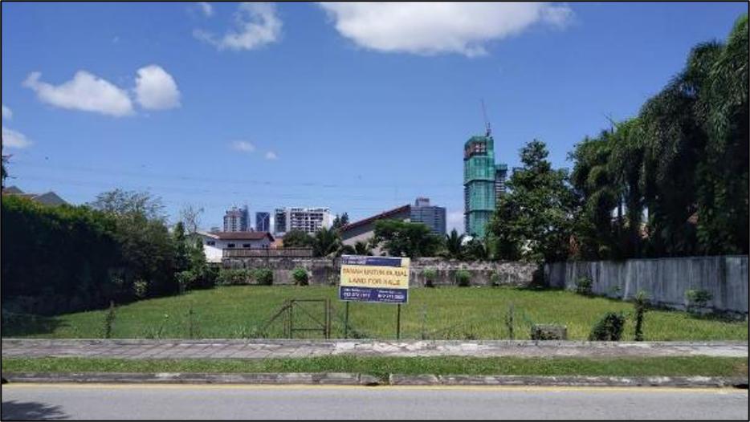

Subject Property : Lot 4280 & Lot 4299, Jalan Ru, Desa Pahlawan, Ampang, Kuala Lumpur

Brief Property Details

Description : The property is a freehold residential land comprising of 2 adjacent parcels of land, Lot 4280 & Lot 4299. It is located along Jalan Ru and nestled among the bungalows of various ambassadorial residences and expatriate-oriented housing.

Site

The site has a titled land area of 1,477.054 square meters and 55.895 square meters for Lot 4280 and Lot 4299 respectively. The combined land area measures 1,532.949 square meters (approx. 16,500.52 square feet).

The land is generally flat and lies about the same level with the frontage road.

Location : The property fronts Jalan Ru, a secondary road connecting to Jalan Ampang and Jalan Ampang Hilir. It is located east of the city centre.

Zoning : Residential

Accessibility : The property can be accessed via Jalan Ampang and Jalan Ampang Hilir. It is also connected to 2 major highways, namely MRR2 and AKLEH.

Surroundings : The immediate surroundings of the property are residential houses and converted commercial title bungalows along Jalan Ampang.

Nearby amenities include specialist hospitals and shopping malls, i.e. Gleneagles Hospital, KPJ Ampang Puteri Hospital, Tesco Ampang, Ampang Point, Galaxy Ampang Mall and Great Eastern Mall. Recent developments such as D’Rapport, M City and the International School of Kuala Lumpur’s newly built campus are also in the vicinity. Other amenities such as McDonalds, KFC and KK Mart are located nearby. Taman Tasik Ampang Hilir is located to the south of the property.

Title Particulars

 | Lot 4280 | Lot 4299
Title No. | GM 150 | GM 155
Lot No. | Lot 4280 | Lot 4299
Locality | 4th Mile Ampang Road | 4th Mile Ampang Road
Town | Mukim Ampang | Mukim Ampang
District | Kuala Lumpur | Kuala Lumpur
State | Wilayah Persekutuan Kuala Lumpur | Wilayah Persekutuan Kuala Lumpur
Tenure | Freehold | Freehold
Title Land Area | 1,477.054 sq. meters  (15,898.876 sq. feet) | 55.895 sq. meters  (601.648 sq. feet)
Annual Rent | RM488.00 | RM30.00
Category of land use | Building | Building
Occupancy | Nil | Nil



LOCATION PLAN
(Source: Google Maps)

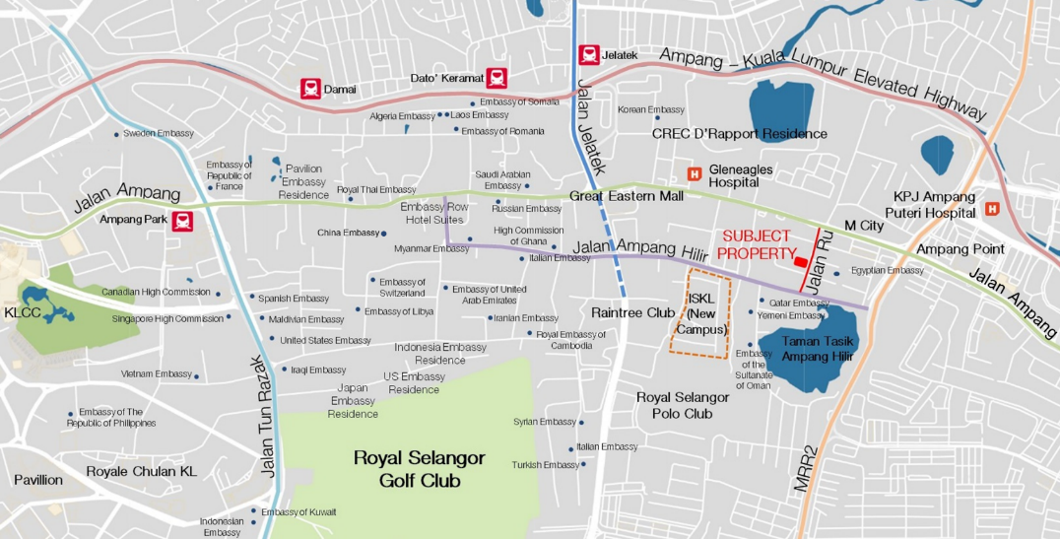

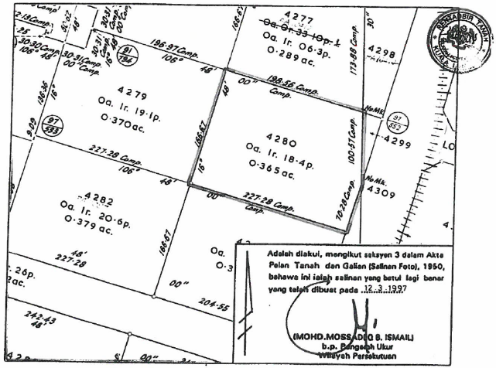

SITE PLAN – LOT 4280

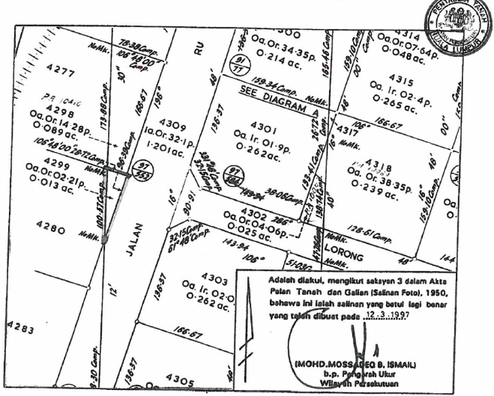

SITE PLAN – LOT 4299

APPENDIX B

Photographs

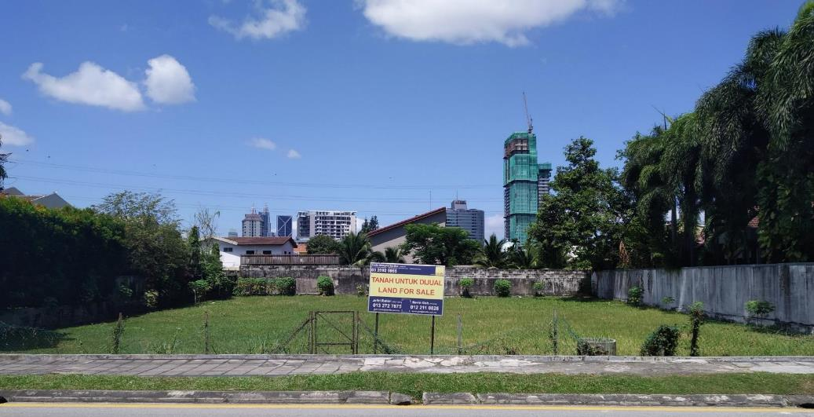

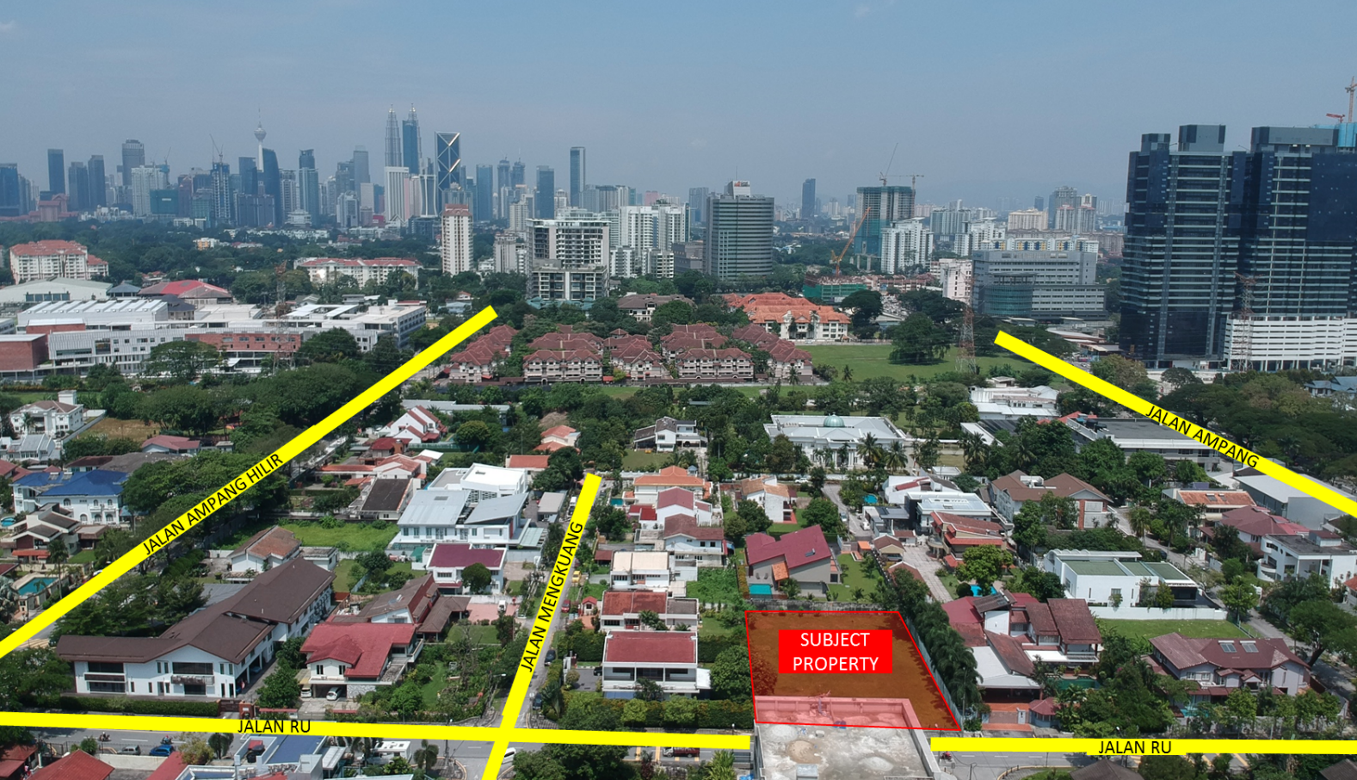

AERIAL VIEW OF THE LAND ALONG JALAN RU

SIDE VIEW OF THE LAND TOWARDS JALAN AMPANG

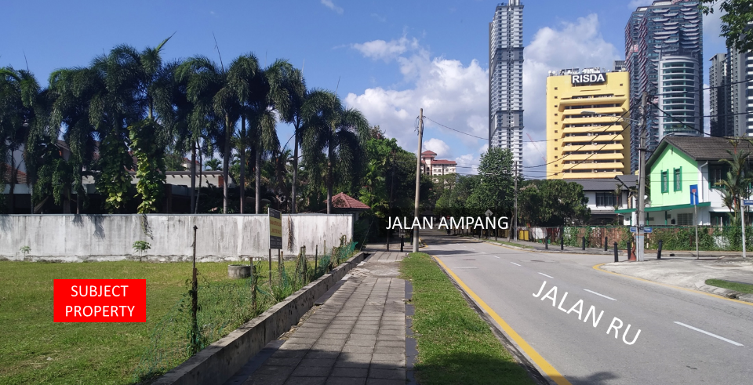

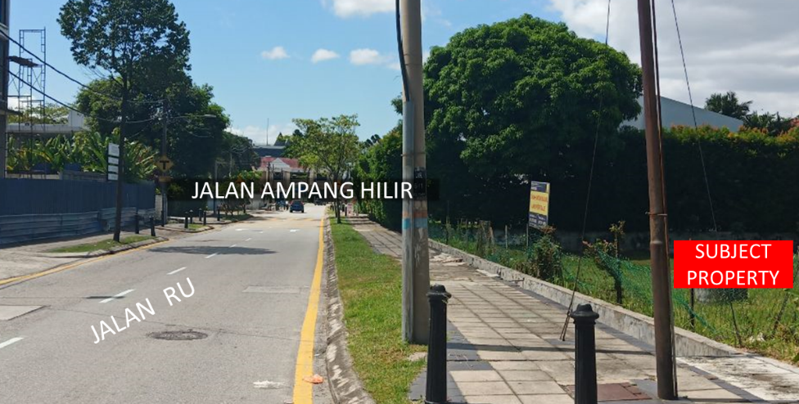
SIDE VIEW OF THE LAND TOWARDS JALAN AMPANG HILIR

APPENDIX C

Copies of Land Titles

LAND TITLE – LOT 4280

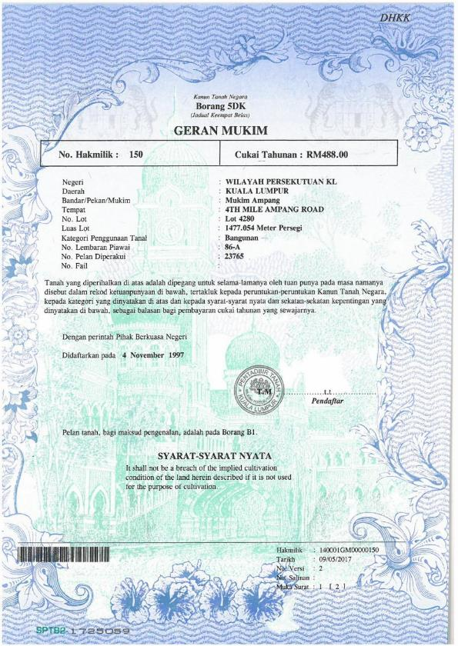

LAND TITLE – LOT 4280
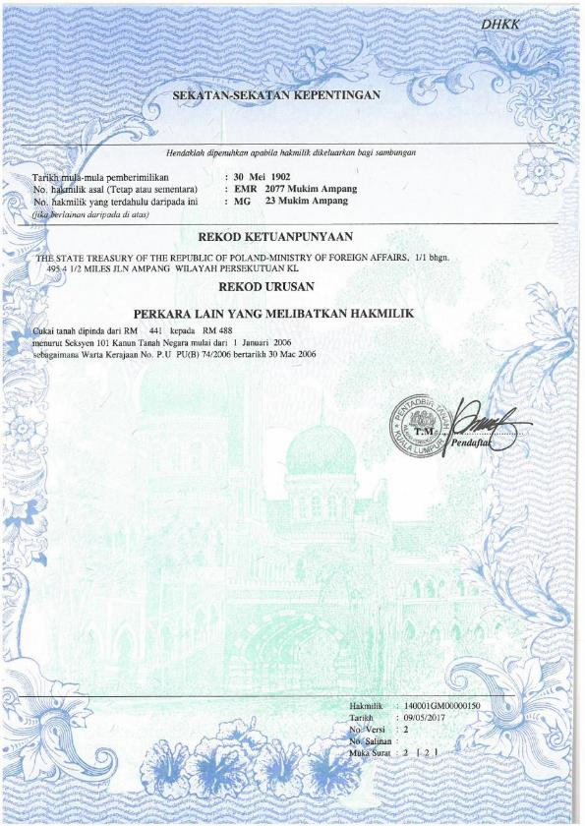

LAND TITLE – LOT 4280
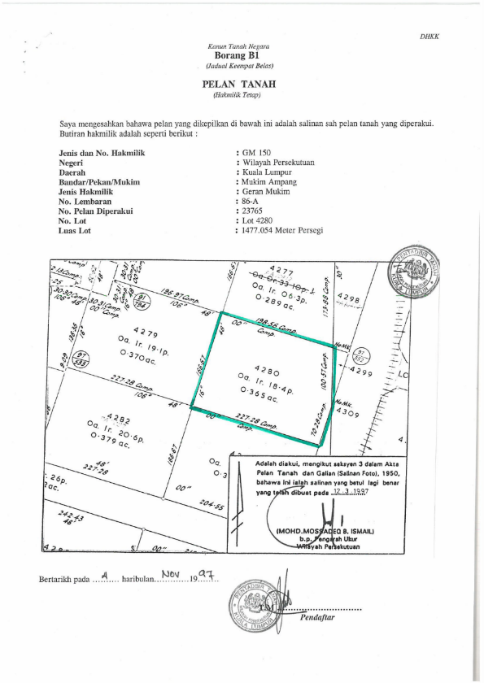

LAND TITLE – LOT 4299

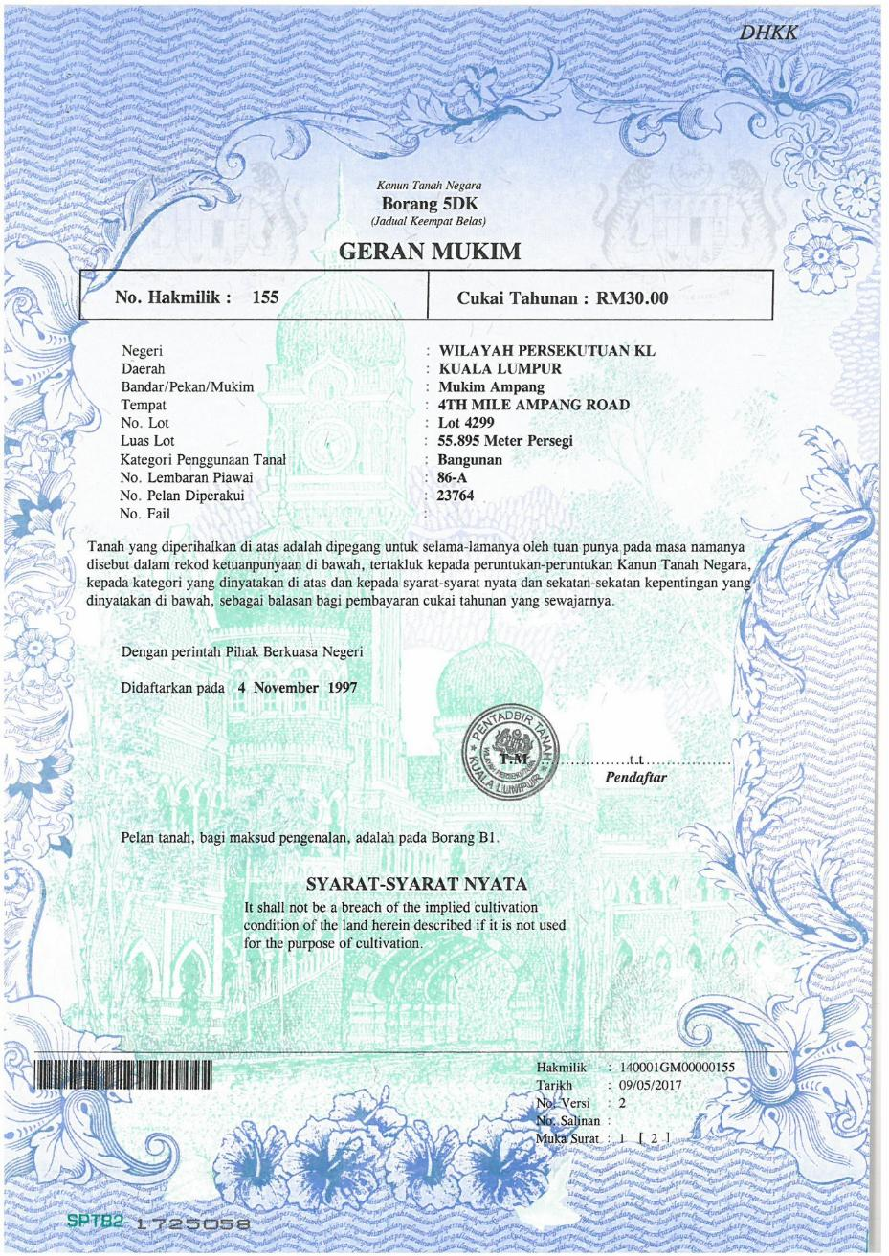

LAND TITLE – LOT 4299
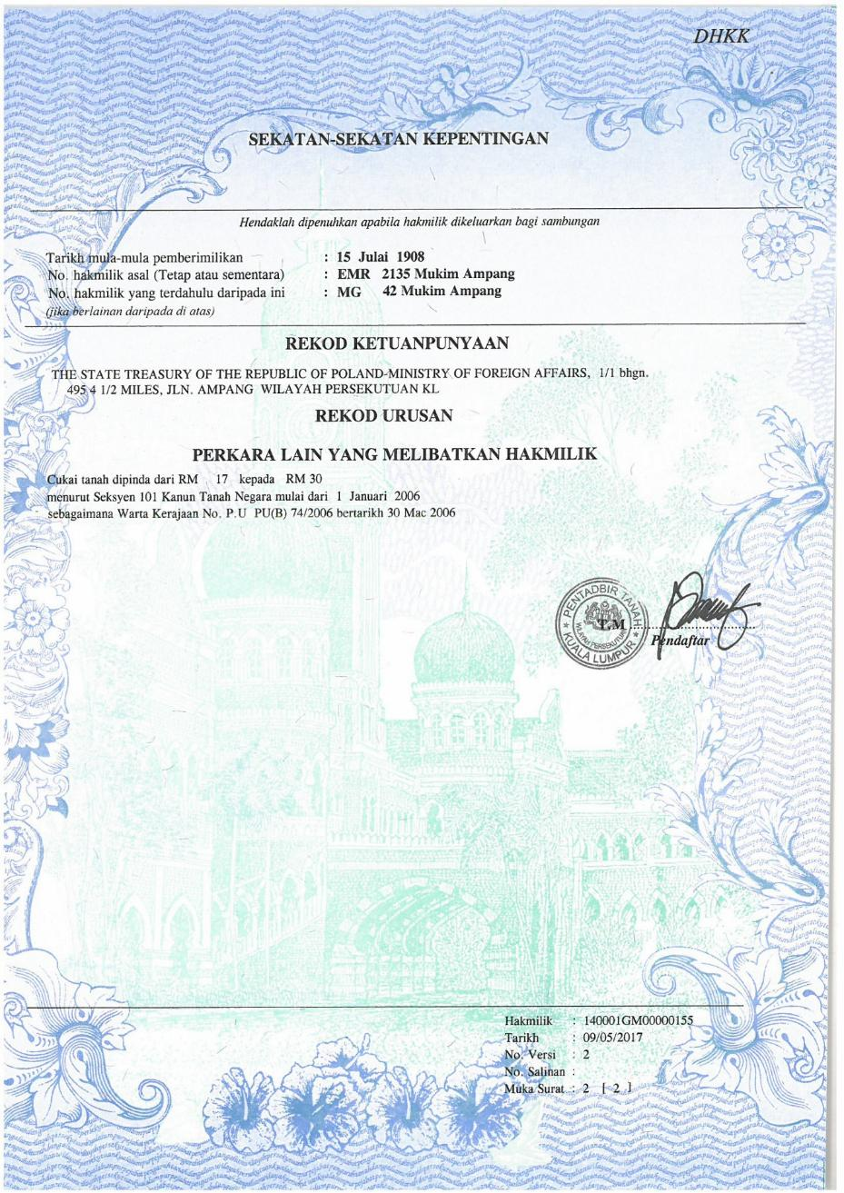

LAND TITLE –LOT 4299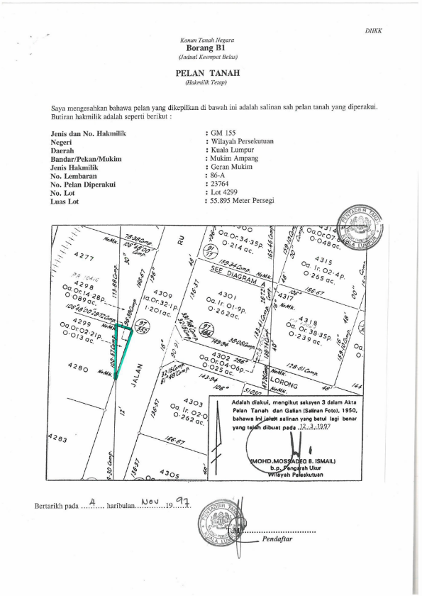

APPENDIX D

Quit Rent & Assessment – Exemption Letter

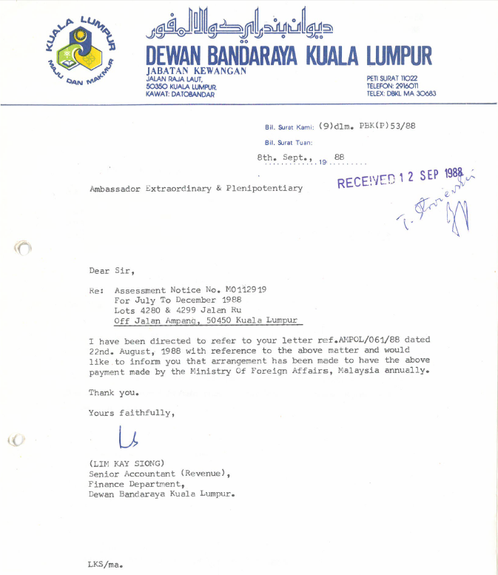
EXEMPTION LETTER FOR QUIT RENT & ASSESSMENT

APPENDIX D

Quit Rent & Assessment

SECTION 2

Tender Rules

EMBASSY OF THE REPUBLIC OF POLAND IN KUALA LUMPUR

TENDER RULES

Sale of the Property known as lot 4280 and lot 4299, 4th Mile Ampang Road, Ampang District, Kuala Lumpur, Wilayah Persekutuan KL, GM150 and GM155

I. General Provisions

§ 1
Subject of the Tender

(1) The subject of the tender is the Property located at Jalan Ru (4th Mile Ampang Road), Desa Pahlawan, Ampang, Kuala Lumpur, Wilayah Persekutuan Kuala Lumpur, Malaysia, with a total area of ​​1,532.949 sq. m (of which lot 4280 has an area of ​​1,477.054 sq. m and lot 4299 has an area of ​​55.895 sq. m), registered in the land register under the following numbers: (a) 140001GM00000150 (lot 4280) and (b) 140001GM00000155 (lot 4299) (hereinafter referred to as the "Property"), together with all rights, components, and legal affiliations, as long as they are the property of the Vendor.
(2) The owner and Vendor is the State Treasury of the Republic of Poland (hereinafter referred to as the "Vendor").
(3) A description of the Property is contained in the Tender Document, of which these Tender Rules form a part.

§ 2
Type and Basis of the Tender

The sale of the Property shall be conducted by way of an open written tender, in accordance with the rules set forth in these regulations.

II. Tenderers’ Procedure

§ 3
The Tender Deposit

(1) A condition for participation in the Tender is the submission of a Tender Deposit in the amount of RM 182,000.00 (one hundred and eighty-two thousand Malaysian Ringgit), specified by the organizer as 2% of the Starting Price of the Property. The Tender Deposit must be submitted in the form of a bank draft made payable to Savills (Malaysia) Sdn Bhd.
(2) The Tender Deposit is not refundable under the following circumstances, if the bidder whose bid is accepted:
(a) refuses to enter into the Sale and Purchase Agreement in accordance with the terms of the draft Sale and Purchase Agreement constituting an attachment to the Tender Document;
(b) fails to pay the full purchase price for the Property by the designated deadline.
(3) The Tender Deposit shall be refunded without interest promptly after the cancellation or conclusion of the tender, but no later than 3 days following the occurrence of any of the following events:
a) annulment of the tender;
b) closing of the tender;
c) cancellation of the tender;
d) conclusion of the tender with a negative result;
(4) The Tender Deposit payment made by the bidder who wins the tender shall be credited towards the purchase price of the Property.
(5) Each bank draft shall be issued by a licensed bank in Malaysia, crossed “A/C Payee Only” and made payable to Savills (Malaysia) Sdn Bhd. By submitting a bank draft, each Bidder irrevocably agrees that it shall not countermand, stop payment of or otherwise obstruct the payment of the bank draft.
(6) Upon the selection of the winning Bidder, Savills (Malaysia) Sdn Bhd, as payee, shall be entitled to present the bank draft submitted by the winning Bidder for payment and to deposit the same into its client account, without requiring any further consent from the winning Bidder.
(7) As the Earnest Deposit under the Sale and Purchase Agreement is payable prior to the execution of the Sale and Purchase Agreement Savills (Malaysia) Sdn Bhd shall, within seven (7) days after the bank draft of the winning Bidder has cleared, remit the Tender Deposit in full, without any deduction, set-off or withholding, to the party designated in the draft Sale and Purchase Agreement annexed to the Tender Document, whereupon the Tender Deposit shall be applied as the Earnest Deposit and credited towards the deposit payable under the Sale and Purchase Agreement.
(8) The bank drafts submitted by unsuccessful Bidders shall not be presented for payment and shall be returned to them in their original form in accordance with point (3) above.
(9) In the case of a joint bid submitted by Bidders, the Tender Deposit shall be submitted by any of the parties.
(10) The tender organizer, being a foreign institution, shall refund or settle the Tender Deposit without interest.

§ 4
Form and content of the bid

(1) All bids must be submitted in writing (exclusively in paper form), in English, in a sealed envelope. The envelope must bear the Bidder’s full company name and be labeled:
“Tender Document – ​​Lot 4280 & Lot 4299 Jalan Ru, Ampang, Kuala Lumpur”
The envelope must not contain any additional information or enclosures.
(2) Each bid submitted in a sealed envelope must contain the following information:
a) Bidder’s identity:
- for natural persons – full name, exact residential or permanent address, telephone and fax numbers, and e-mail address;
- for legal entities or commercial business entities – full company name, details of all authorized representatives (including full names), exact registered office address (street), and a current printout/extract from the register in which the legal entity is recorded;
- if the Bidder belongs to a group or holding company – a full description including the headquarters address;
– for a community of Bidders – an indication of the consortium's existence, providing the same details listed above for each consortium member;
b) Specification of the Property to which the bid relates;
c) Indication of the offered purchase price in Malaysian Ringgit; the price must be stated exclusive of registration costs, other purchase-related costs, and any taxes associated with the acquisition of the Property; the offered purchase price may not be lower than the Starting Price referred to in § 5;
d) a statement signed by the Bidder confirming that he has read the Tender Rules and the appendices, accepts the provisions contained therein without reservation, and undertake, immediately upon acceptance of his bid, to purchase the Property in accordance with the terms of the draft Sale and Purchase Agreement (which constitutes an appendix to the Tender Document) at the offered purchase price;
e) the date of the bid;
f) the personal signature(s) of the Bidder(s); in the case of legal entities, the personal signature(s) of the representative(s) in the number required for authorization purposes;
g) in the case of a bid submitted by a person authorized by the Bidder, his full identity details as specified in point (a), as well as the original power of attorney or a certified copy of the power of attorney for the person authorized to represent the Bidder;
h) proof of payment of the Tender Deposit in the form of a bank draft for the amount of RM 182,000.00 (in words: one hundred eighty-two thousand Malaysian ringgit) (the "Tender Deposit");
i) accurate and complete information regarding the Bidder's details to which the bank draft is to be returned;
j) a copy of the document confirming the Bidder's identity, and—in the event that the bid is submitted by a representative of the Bidder—also a copy of the document confirming the representative's identity.
(3) The individual pages of the bid and all attachments must be permanently and inseparably bound together.
(4) Bids may only relate to the entire Property, which comprises two titles of ownership. Partial or variant bids are not permitted.
(5) Incomplete bids will not be considered.

§ 5
Starting Price

The Starting Price for the Property located at Jalan Ru, (4th Mile Ampang Road), Desa Pahlawan, Ampang, Kuala Lumpur, Wilayah Persekutuan Kuala Lumpur, Malaysia is RM 9,100,000 (in words: nine million one hundred thousand Malaysian ringgit). The Starting Price constitutes the minimum price for a bid submitted in the tender, and any bid submitted below this price will be rejected.

§ 6
Deadline for submission of bids

(1) Bids will be considered only if received no later than 1.12.2026. by 5 pm
and delivered to Savills (Malaysia) Sdn Bhd, Level 6, Corporate Tower 9, Pavilion Damansara Heights, No. 3, Jalan Damanlela, Bukit Damansara, 50490 Kuala Lumpur.

(2) A bid submitted within the deadline specified in the tender documents may not be subject to subsequent amendments or supplements, even if the documents resulting from such amendments or supplements are also submitted within the deadline specified in the tender documents.

III. Bid selection procedure

§ 7
Date of opening

(1) The opening, verification, and evaluation of the bids, as well as the selection of the winning bidder, shall take place
on 2.12.2026 at 12.30 pm.
at the premises of the Embassy of the Republic of Poland in Malaysia, address: No. 10, Lorong Damai 9, 55000 Kuala Lumpur
by the Tender Committee appointed by the Director General of the Foreign Service of the Ministry of Foreign Affairs of the Republic of Poland.
(2) Opening of the bids takes place in the presence of Bidders or their representatives holding written powers of attorney. A Bidder present must possess a document confirming his identity, and a Bidder’s representative must also possess a document confirming his authority to represent the Bidder. The examination and evaluation of bids, as well as the selection of the winning Bidder, take place without the presence of the public.
(3) The presence or absence of a bidder on the day of the bid opening has no influence on the selection of the bid.

§ 8
Criteria for verification and evaluation of the bids

(1) All bids are subject to preliminary verification and evaluation regarding compliance with formal criteria. Incomplete bids will be rejected without the need for further verification of their content.
(2) From among the bids meeting all criteria regarding form and deadline, the Tender Committee selects the most advantageous one. The bid offering the highest price for the property will be selected as the most advantageous.
(3) If it is determined that several bidders have offered prices difference between which does not exceed 5%, the Tender Committee continues the tender process via an oral auction. Bidders whose bid prices differ by no more than 5% comparing to the highest bid may participate in the oral auction. The oral auction takes place immediately after the examination of bids; however, in the absence of Bidders eligible to participate in the auction, it takes place no later than the next business day—i.e. on 3.12.2026 at 12.30 pm of which the auction participants are notified. An auction participant is required to possess a document confirming his identity. The starting amount for the subsequent stage of the tender—namely, the oral auction—shall be the highest bid obtained during the written tender phase; the minimum bid increment shall be 1% of the Starting Price. Failure by a Bidder to appear at the oral auction shall be deemed a withdrawal from participation in the tender.
(4) The Tender Committee reserves the right to conclude the tender proceedings without selecting a winning bid.
(5) Decisions made by the Tender Committee shall be binding upon all bidders and shall not be subject to legal challenge or any other form of appeal.

§ 9
Post-selection procedure

(1) The winning bidder shall be notified promptly about the selection of his bid.
(2) All other Bidders shall be notified immediately following the selection of the winner, and their Tender Deposits shall be returned to them.
(3) Immediately following the selection of the bid, the Vendor shall undertake to finalize arrangements regarding the technical details of the Sale and Purchase Agreement with the winning Bidder (hereinafter referred to as the "Buyer").
(4) The Vendor reserves the right, without having to state any reason and without incurring any liability, to:
(i) cancel the Tender or modify its terms or the tender announcement prior to the deadline for the submission of bids;
(ii) close the Tender without selecting any of the bids, even if they meet formal requirements; or
(iii) demand the annulment of the Sale and Purchase Agreement concluded through the tender process.

IV. Sale and Purchase Agreement

§ 10
Date of Conclusion of the Sale and Purchase Agreement

The Sale and Purchase Agreement, in accordance with the terms of the draft Sale and Purchase Agreement attached to the Tender Document, shall be concluded no later than the date specified by the Vendor. Failing which, the Vendor reserves the right, at its sole discretion, to withdraw its acceptance; in such case, the Vendor shall be entitled to retain the Tender Deposit in the amount of RM 182,000 (one hundred eighty-two thousand Malaysian Ringgit), whereupon Savills (Malaysia) Sdn Bhd shall remit the sum of RM 182,000 (one hundred eighty-two thousand Malaysian Ringgit) to the Vendor, (or, where the Tender Deposit has already been remitted pursuant to § 3 point (7), the party holding the Tender Deposit shall release the same to the vendor) and the winning Bidder shall have no claims of any kind against the Vendor, provided that this provision shall be without prejudice to any other rights or remedies available to the Vendor against the winning Bidder under law or custom.

§ 11
Conduct of the Auction and Sale Procedure

The Vendor engages the services of an authorized law firm regarding the sale of the Property and related preparations, including tender proceedings: ABD. AZIZ CHEN & CO Advocates & Solicitors, W-11-20, Level 11, Menara Melawangi, No. 18, Jalan Persiaran Barat, 46050 Petaling Jaya, Selangor.
Contact person: Tan Soek Phee
All communication regarding the tender and sale should be directed to Savills (Malaysia) Sdn Bhd, Level 6, Corporate Tower 9, Pavilion Damansara Heights, No. 3, Jalan Damanlela, Bukit Damansara, 50490 Kuala Lumpur. This also applies to any inquiries regarding the tender, etc., which should be directed to Savills (Malaysia) Sdn Bhd rather than the Embassy of the Republic of Poland in Kuala Lumpur.

Contact details for Savills (Malaysia) Sdn Bhd can be found on the cover page of the Tender Document.

§ 12
Property Inspection

Visits to the property located at Jalan Ru (4th Mile Ampang Road), Desa Pahlawan, Ampang, Kuala Lumpur, Wilayah Persekutuan Kuala Lumpur, Malaysia, are permitted only by appointment. Individuals without an appointment will not be admitted. Appointments must be arranged exclusively through Savills (Malaysia) Sdn Bhd, Level 6, Corporate Tower 9, Pavilion Damansara Heights, No. 3, Jalan Damanlela, Bukit Damansara, 50490 Kuala Lumpur. Subject to prior notification, Bidders may be accompanied during visits by architects, planners, and other persons assisting them in the preparation of their bid and decision-making process.

§ 13
No reimbursement of costs and expenses

Bidders shall have no claim to reimbursement of costs or expenses of any kind incurred in connection with their participation in this tender procedure.

§ 14
Personal data protection

Information clause regarding the processing of personal data by the foreign mission – the Embassy of the Republic of Poland in Malaysia, Kuala Lumpur
This information ensures compliance with the obligations specified in Articles 13 and 14 of Regulation (EU) 2016/679 of the European Parliament and of the Council of 27 April 2016 on the protection of natural persons with regard to the processing of personal data and on the free movement of such data, and repealing Directive 95/46/EC, hereinafter referred to as the "GDPR."
1. The controller of personal data, within the meaning of Article 4(7) of the GDPR, is the Minister of Foreign Affairs, with its registered office in Warsaw, Al. J. Ch. Szucha 23, while the entity performing the duties of the personal data controller is the head of the Embassy of the Republic of Poland in Malaysia, with its registered office at No. 10, Lorong Damai 9, Off Jalan Damai, 55000 Kuala Lumpur, Malaysia.
2. Contact details of the Data Protection Officer (DPO):
Registered office address: Al. J. Ch. Szucha 23, 00-580 Warsaw, Poland
Email address: iod@msz.gov.pl
3. Personal data will be processed on the basis of: Article 6, paragraph 1, letter c of the GDPR – processing of personal data of individuals representing the Contractor for the purpose of concluding and performing the Contract; Article 6, paragraph 1, letter f of the GDPR – the Ordering Party's legitimate interest in the proper performance of the subject matter of the Contract with respect to individuals designated for contact, supervision, acceptance, and performance of the Contract; Article 6, paragraph 1, letter c of the GDPR – processing is necessary to fulfill the legal obligation incumbent on the controller to ensure the security of a diplomatic mission abroad and to verify whether the Contractor has met the requirement to employ individuals under an employment contract or employee insurance.
4. The scope of data processed includes:
a) first name and last name,
b) work telephone number,
c) work email address,
d) for persons entering the diplomatic mission and subject to security checks – the PESEL number, and if not available, the date and place of birth and the type and number of the identity document.
5. The data was provided to the diplomatic mission abroad by the Contractor.
6. The data will be processed until the completion of the Sale and Purchase Agreement and then archived in accordance with the provisions of the Act of 14 July 1983 on National Archival Resources and Archives (Journal of Laws of 2020, item 164, Journal of Laws of 2025, item 1173) and the regulations applicable at the Ministry of Foreign Affairs and the diplomatic mission issued pursuant to that Act.
7. Only authorized employees of the Embassy of the Republic of Poland in Malaysia, based in Kuala Lumpur, and the Ministry of Foreign Affairs have access to the data.
8. Data is protected in accordance with the provisions of the GDPR. Data may only be shared with third parties and entities authorized to process it under the law. A separate category of recipients to whom data may be shared are entities with which the Ministry of Foreign Affairs/diplomatic mission has concluded a service agreement, e.g., IT services. Data may be transferred to competent state authorities responsible for the security of diplomatic missions abroad. Data may be transferred to a third country or international organization only after meeting the conditions specified in the GDPR.
9. Data subjects have the right to control the processing of their personal data, as defined in Articles 15-19 of the GDPR, in particular the right to access and rectify their personal data, the right to erasure, the right to restrict processing, and, where applicable, Article 21 (the right to object).
10. Personal data will not be processed by automated means in a way that could influence decision-making that could produce legal effects or significantly impact processing in any other similar manner. Data will not be subject to profiling.
11. The data subject has the right to lodge a complaint with the supervisory authority at the following address:
Prezes Urzędu Ochrony Danych Osobowych President of the Personal Data Protection Office
ul. Moniuszki 1A, 00-014 Warszawa, Polska 1A Moniuszki Street, 00-014 Warsaw, Poland

§ 15
Governing Law

Unless otherwise provided herein, the tender regulations are governed by the law of the Republic of Poland. For the avoidance of doubt, however, it is noted that the The Sale and Purchase Agreement —which constitutes the subject matter and objective of the tender—is governed exclusively by Malaysian substantive law.

SECTION 3

TENDER FORM

PART 1 OF THE OFFER FORM

To:

Datuk Paul Khong (Group Managing Director)
Savills (Malaysia) Sdn Bhd
Level 6, Corporate Tower 9, Pavilion Damansara Heights
No. 3, Jalan Damanlela, Bukit Damansara
50490 Kuala Lumpur

Dear Sir/Madam,

I/We, .........................................................................................................................................................................., currently of .........................................................................................................................................................................., hereby submit an irrevocable offer to purchase the property offered for sale as described in the Tender Document for the sum of:

Lot 4280 & Lot 4299 Jalan Ru, Ampang, Kuala Lumpur | Purchase price:  RM ……………………….……………………………………………………………  (Malaysian Ringgit: .……………………………… ….. ……….  ……………………………………………………………………………...…..…..)

The price offered above does not include taxes or any other fees or costs prescribed by local law in connection with the acquisition of the property.

In the event that this bid is accepted by the Vendor in accordance with the aforementioned terms and provisions of the Tender Document and the Sale and Purchase Agreement—the content of which I/we have fully read and understood—I/we hereby agree to be bound by all the aforementioned terms of the Tender Document and hereby undertake to pay the Purchase Price and to execute and finalize the purchase of the property in accordance with the terms of the Sale and Purchase Agreement contained in the Tender Document and to be executed between us.

We enclose a bank draft no. ………………………………………… for the amount of RM 182,000.00 (one hundred and eighty-two thousand Malaysian Ringgit), payable to "Savills (Malaysia) Sdn Bhd," as the Tender Deposit, in accordance with the provisions of the Tender Document.

Dated ………………………………, ……………………………… 2026.

Yours faithfully,

________________________
Authorized signature and stamp
Name :……………………………….
Designation :……………………………….
Tel. No. :……………………………….

PART 2 OF THE TENDER FORM

Bidder’s details - *To be completed if applicable

- * Individual

For natural persons, please complete the information below (see § 4 of Section 2 – Tender Rules):
A. Name : ………………………………………...
B. Citizenship : ………………………………………...
C. NRIC Number/Passport Number : ………………………………………...
D. Address : ………………………………………...
………………………………………...
………………………………………...
E. Tel. No. : ………………………………………...
F. Fax No. : ………………………………………...
G. Mobile No. : ………………………………………...
H. E-mail address : ………………………………………...

II. * Company

For legal entities or business entities, please complete the details below regarding each authorized representative and provide proof of authorization for all representatives (see § 4 of Section 2 – Tender Rules):
A. Name : ………………………………………...
B. Registration number : ………………………………………...
C. Authorized representative :………………………………………...
D. Registered address : ………………………………………...
………………………………………...
………………………………………...
E. Tel. No. : ………………………………………...
F. Fax No. : ………………………………………...
G. E-mail address : ………………………………………...
H. Company address :………………………………………...
………………………………………...
………………………………………...

III. * Investment group / Holding company

If the Bidders belong to a group or holding entity, please provide the information below for each member of the group or consortium and indicate or provide proof of group affiliation (see § 4 Section 2 – Tender Rules):

A. Entity name : ………………………………………...
B. Entity description : ………………………………………...
………………………………………...
………………………………………...
………………………………………...
C. Registration number : ………………………………………...
D. Contact person/authorized representative : ………………………………………...
E. Registered address : ………………………………………...
………………………………………...
………………………………………...
F. Tel. no. : ………………………………………...
G. Fax no. : ………………………………………...
H. E-mail address : ………………………………………...
I. Company address : ………………………………………...
………………………………………...
………………………………………...

IV. Bidder details for the return of the Tender Deposit

Required for the return of the Tender Deposit submitted in the form of a bank draft, in the event that the Bidder does not win the tender (see § 4 Section 2 – Tender Rules):

A. Bidder name : ………………………………………...
B. Address : ………………………………………...
: ………………………………………...

PART 3 OF THE TENDER FORM

I/We …………………………………………………………………………………………………………………………………. of ………………………………………………………………………………………………………………………………………………….
Hereby confirm that I/we have reviewed all documents comprising this Tender Document, fully understand their content, and accept the rules set forth therein.

Hereby confirm that I/we hold full authorization from the Company to submit this bid and sign these tender documents on its behalf.

I/We hereby declare that I/we have reviewed and accept the terms contained in the information clause pursuant to Art. 13 and 14 of the GDPR (set out in full in the Tender Document in point 2 below – Tender Regulations, § 14 Personal Data Protection) regarding the processing of personal data.

…………………………………………...
Signature

…………………………………………...
Date:

…………………………………………...
Signature

…………………………………………...
Date:

…………………………………………...
Signature

…………………………………………...
Date:

Attachments to the tender form:

Attachment 1 - Proof of payment of the Tender Deposit in the form of a bank draft;
Attachment 2 (for legal entities) - Current extract from the relevant register of legal entities, including a list of all management board members authorized to represent the entity and the method of representation;
Attachment 3 - Photocopy of the bidder’s identity document;
Attachment 4 - Photocopy of the identity document of the proxy/representative (if the bid is signed by a proxy/representative);
Attachment 5 - Power of attorney or a certified copy thereof (if the bid is signed by an authorized representative).

SECTION 4

DRAFT SALE AND PURCHASE AGREEMENT

(A SOFTCOPY CAN BE PROVIDED UPON REQUEST)

