10th European CAF Users’ Event

under the Polish Presidency of the Council of the EU

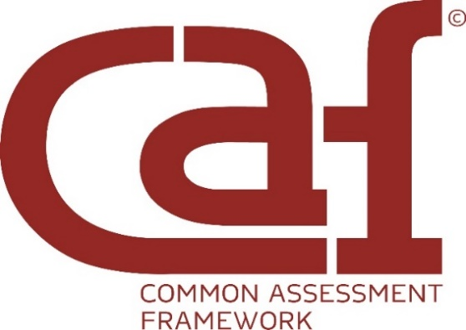
“Smart Governance: People-Centred, Efficiency-Driven”

Agenda
9 April 2025 Official welcome at the Chancellery of the Prime Minister
Al. Ujazdowskie 1/3, 00-583 Warsaw

18:00 – 20:00 Opening of the 10th European CAF Users’ Event
Welcome and cocktail party
10 April 2025 10th European CAF Users’ Event
Conference Centre at the national stadium “PGE Narodowy”,
Al. Ks. J. Poniatowskiego 1, Warsaw

08:30 – 09:30 Registration/Coffee
09:30 – 09:50 Welcome words

Ms Anita Noskowska-Piątkowska, Head of the Civil Service
in Poland

Mr Marco Ongaro, EIPA Director General
09:50 – 10:20 In days of uncertainty: the need of shaping a resilient and future-proof civil sector in Europe – keynote speech

Ms Cecilia Wikström, Chair of EIPA's Board of Governors
10:20 – 10:35 The CAF Network and its European Resource Centre: Navigating challenges and driving change successfully
Ms Gracia Vara Arribas, Head of the European CAF Resource Centre, EIPA
Ms Tihana Puzic, Deputy Head of the European CAF Resource Centre, EIPA
10:35 – 10:45 How to best explore the 18 Golden CAF best practices?
Introduction to the break-out sessions
Ms Katarzyna Dudzik, Polish CAF National Correspondent
10:45 – 11:15 Family photo and coffee break
11:15 – 12:35 Breakout session no 1: Empowering people (co-creation,
co-decision making)
Session 1: Leadership and constancy of purpose, values. Room: tbc
Facilitator: Katarzyna&Loredana
- Application of the CAF in a Directorate General of a Federal Ministry. Federal Ministry Arts, Culture, Civil Service and Sport. Austria
- Strategic approach of employers to increase public services relevancy and employment rate in the Brussels Region. ACTIRIS. Belgium
- Systemic implementation of the Common Assessment Framework: fostering digital innovation in project management to improve team collaboration, efficiency, and decision-making. Region of Crete. Greece

Session 2: People involvement: cooperation and co-creation. Room: tbc
Facilitator: Mimi&Kenan
- CAF’s implementation in Municipality of Volos. Greece
- Apulia region as CAF competency center for local municipalities. Italy
- Development and implementation of a stakeholder engagement management project. Poland
Session 3: Organizational culture: wellbeing & Work-Life Balance. Room: tbc
Facilitator: Isabelle&Margarida
- Conciliar + Project - Implementation of Portuguese Standard 4552:2022
– Reconciliation of Professional, Personal and Family Life. Unidade Local de Saúde da Região de Aveiro, EPE. Portugal
- CAF as a Change Engine: Driving Towards Continuous Improvements. Ministry of Higher Education, Science and Innovation (MHESI). Slovenia
- Staff development and involvement. National Institute for Agrarian and Veterinary Research. Portugal
12:35 – 12:45 Finding the way to plenary session & small refreshment
12:45 – 13:30 Panel discussion: Shaping the Future: Quality as the Cornerstone
of Public Sector Succes
- Mr Gregor Virant, Head of the SIGMA Programme
- Ms Małgorzata Bywanis-Jodlińska, Director of the National School of Public Administration, Poland
- Ms Maja Handjiska Trendafilova, ReSPA Director
Moderator: Ms Gracia Vara Head of the European CAF Resource Centre

13:30 – 14:30 Lunch
14:30 – 15:50 Breakout session no 2: Transformative processes
Session 4: Public Sector Excellence - A Vision for digital transformation and Innovation Room: tbc
Facilitator: Greta&Witold
- Leertrac. GITO Overijse. Belgium
- chIPA: Digital Communication Revolution, powered by IPA. Institute of Public Administration. Bulgaria
- Implementation of robotic process automation technology in the Polish Financial Supervision Authority. Polish Financial Supervision Authority. Poland
Session 5: Result orientation: continuous innovation and improvement. Room: tbc
Facilitator: Slaven&Michael
- Standardization of the improvement of local self-government units and assessment of digital readiness. Civil Service Agency BiH (BiH CSA)/ Civil Service Agency of Federation of BiH (FBiH CSA)/ Civil Service Agency Republic of Srpsa
(RS CSA)/Public Administration Reform Coordinator’s Office (PARCO) /UNDP. Bosnia and Herzegovina
- Using the power of digitalisation for shared process and quality knowledge management: Croatian digital tool eSUK (https://kvaliteta.gov.hr). Ministry of Justice, Public Administration and Digital Transformation. Croatia
- CAF Efficiency platform – CAFficiency. Human Resource Management Service. Serbia

Session 6: Social responsibility: attractiveness of the public sector. Room: tbc
Facilitator: Barbara&Begona
- Creating a culture of a quality development in the regional administration Lovech, Republic of Bulgaria. Regional Administration – Lovech. Bulgaria
- Facilitating the Exchange of Best Practices Among Employees Across Various Branches. LEPL Public Service Hall (Under the Ministry of Justice of Georgia). Georgia
- Línea Madrid: Preferential Attention for People Over 65. Ayuntamiento de Madrid (Madrid City Council). Spain
15:50 – 16.00 Getting back to plenary & small refreshment
16:00 – 16:30 Reflections and reporting back for the future
- Mr Nick Thijs, Senior Advisor, Team leader Service Delivery and Digital Government, OECD/SIGMA
- Ms Tihana Puzić, Deputy Head of the European CAF Resource Centre, EIPA
- Ms Gracia Vara, Head of the European CAF Resource Centre, EIPA
16.30 – 16:45 Closing remarks
Ms Marta Kuzawińska, Director of the Civil Service Department Chancellery of the Prime Minister, Warsaw Poland

Mr Marco Ongaro, EIPA Director General
17.00 End of the 10th European CAF Users’ Event

