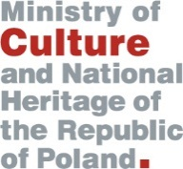
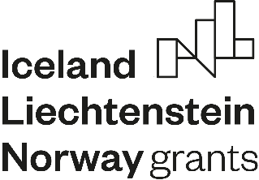

Application Form

for matchmaking seminar within the Programme “Culture”

Outcome 1 “Cultural heritage management enhanced ”

Participant data:

Organization:

Name and Surname:

Job title:

Correspondence address:

Mobile phone/:

Fax:

E-mail:

Do you cooperate with an institution from the Donor States (Norway, Iceland, Lichtenstein): (to be selected)

NO – if a new partnership will be created as a result of the seminar

YES – if the already existing partnership need to be strengthened

If yes, please complete the Donor States Project Partner data:

Organization:

Name and Surname:

Job title:

Correspondence address:

Mobile phone/:

Fax:

E-mail:

Estimated Project budget:

Description of the idea

on the project (max 150 characters):

Registration deadline: 31 October 2019. All application forms should be sent to the following e-mail address: msuchecka@mkidn.gov.pl

The seminar is free of charge, however travel and accommodation costs shall not be covered by the Ministry of Culture and National Heritage.

Program Operator reserves the right to contact only selected organizations.

