REPORT FROM PUBLIC CONSULTATION
CONDUCTED IN THE FORM OF CORRESPONDENCE

Project / Contract: Odra-Vistula Flood Management Project (OVFMP) – Works contract 1B.5/2 Reconstruction of bridge to ensure a minimum clearance – Road bridge 2.45 km Warta River, Kostrzyn n/Odra

Organizer of the meeting: The Consultant acting on behalf of the State Water Management Polish Waters Regional Water Management Authority in Szczecin – SWECO Consulting Sp. z o.o.

Leader: Attorney-at-law Mariusz Ciaś – Real property expert in the Consultant's real property team.

Participants: According to the attendance list (personal data has been anonymized).

Taking into account the fact of co-financing 1B.5/2 Reconstruction of bridge to ensure a minimum clearance – Road bridge 2.45 km Warta River, Kostrzyn n/Odra (hereinafter: Task) implemented as part of Odra-Vistula Flood Management Project (hereinafter: OVFMP) from funds from the World Bank, and thus the necessity to apply the operational policy of the World Bank OP 4.12, a draft Land Acquisition and Resettlement Action Plan (hereinafter LA&RAP) was prepared.

This document was the subject of public consultations organised in the form of correspondence. The purpose of consultations was to enable all interested persons, institutions and other entities to become acquainted with the LA&RAP, as well as to provide the opportunity to submit applications, comments, complaints and queries regarding its content.
Due to the constraints on social life in Poland caused by the emergence of the SARS-CoV-2 virus causing COVID-19 disease, it was decided, taking into account the recommendations of the World Bank and the need to ensure the safety of those interested, that there would be no public consultation meeting. In order to carry out the obligation to conduct public consultations and to provide the opportunity to read the LA&RAP document and to submit conclusions and comments, it was decided to conduct consultations in the form of correspondence.
The publication of the RAP began on June 22, 2020 by sending to the PAP the documentation including extracts from the LA&RAP. In addition, notices about the possibility to read the LA&RAP document, submit comments and applications and about the webinar organized, in Polish and English, were published in the local press – Kurier Szczeciński and on the websites of: RZGW in Szczecin, Project website, Odra-Vistula Flood Management Project Coordination Unit, “wszczecinie.pl” website. Below is the text of the notice, which appeared in the places indicated above.

Website: www.kostrzyn.pl

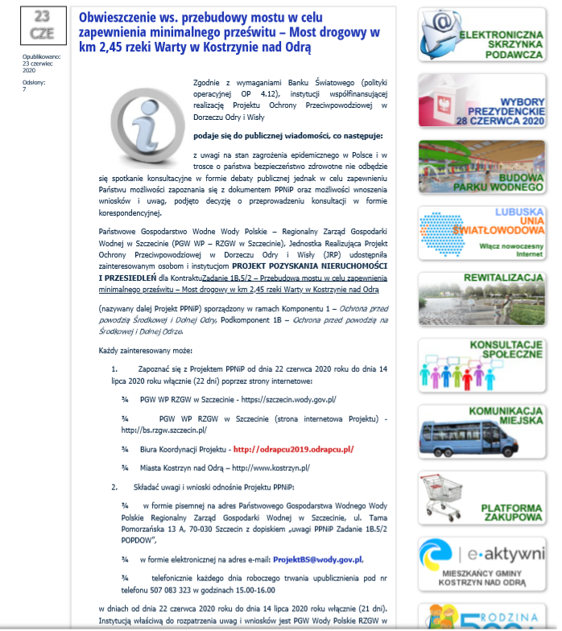
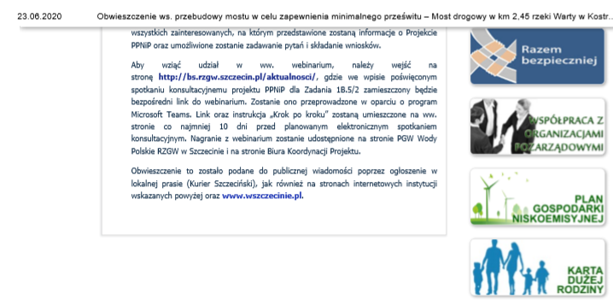

Local press: Kurier Szczeciński
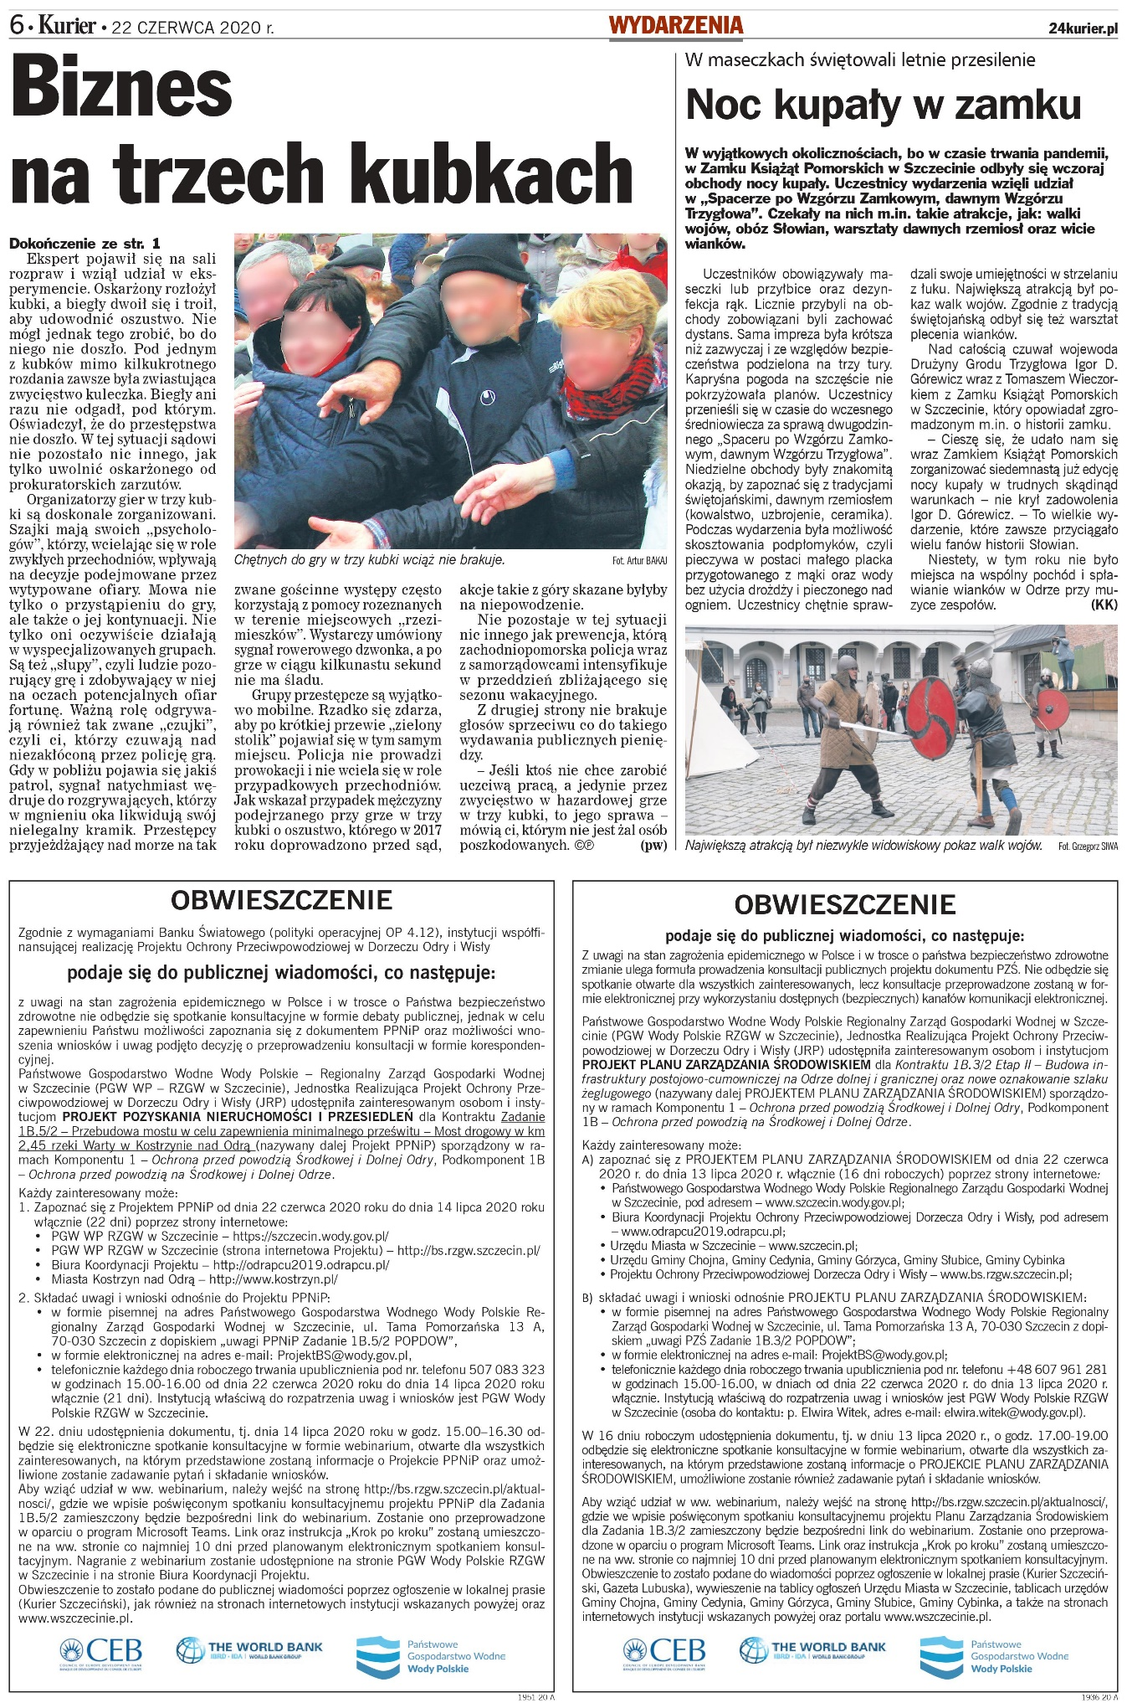

Website: wszczecinie.pl
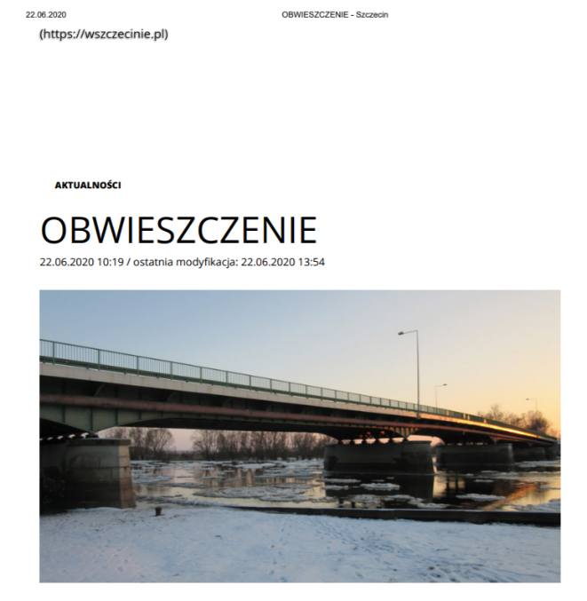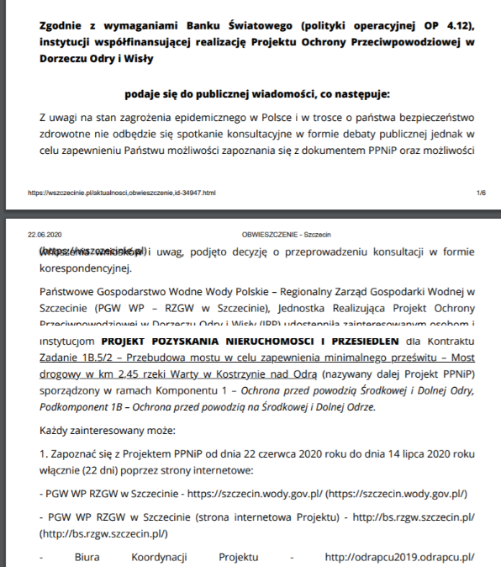
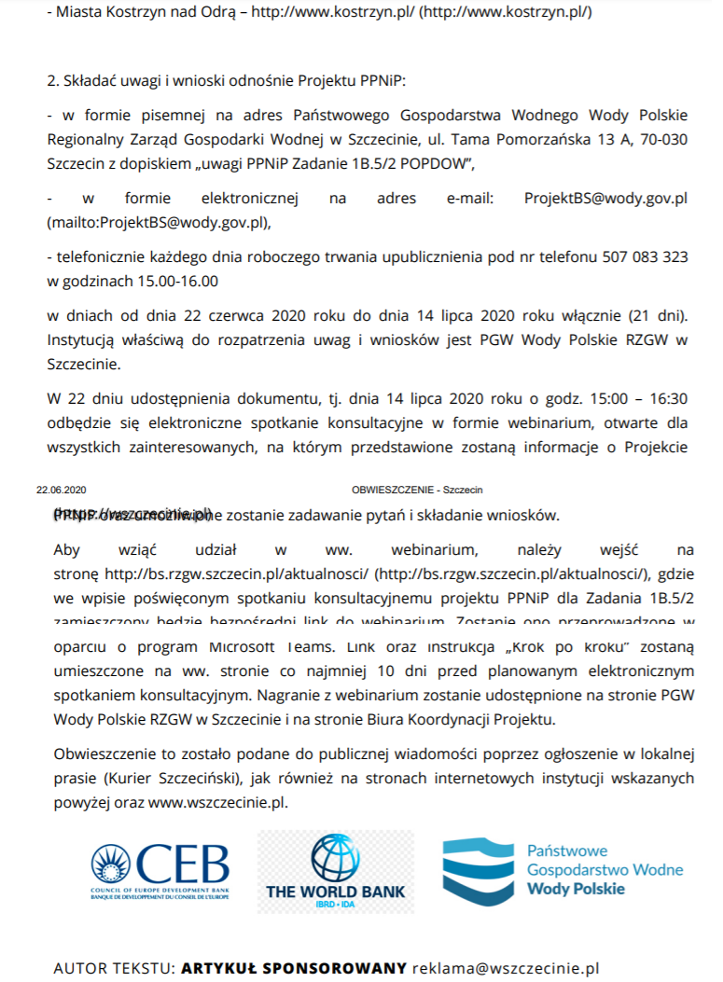

Project website: bs.rzgw.szczecin.pl
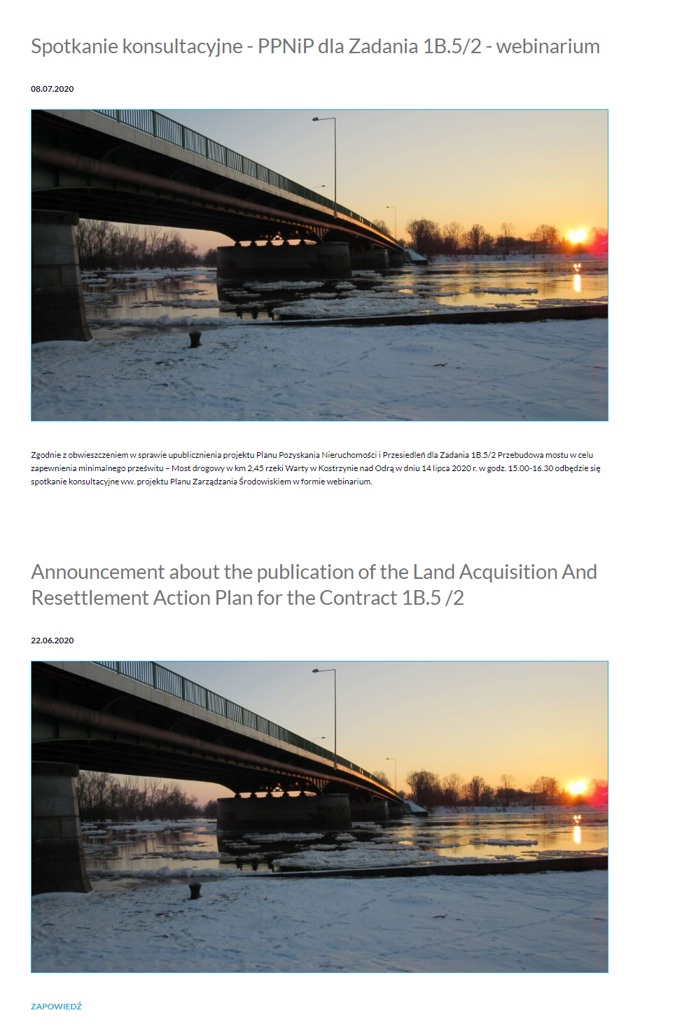
Project Coordination Unit website: odrapcu2019.odrapcu.pl
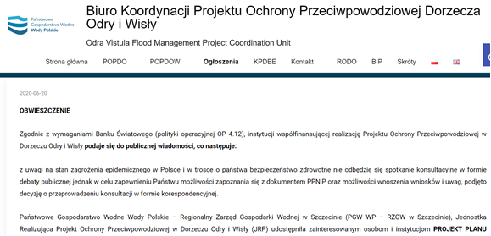
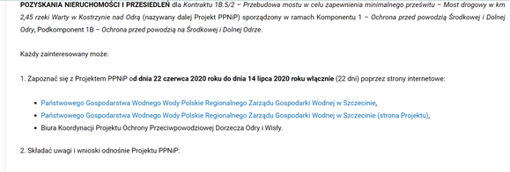
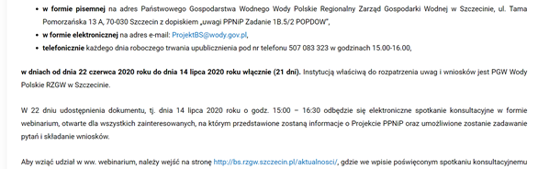
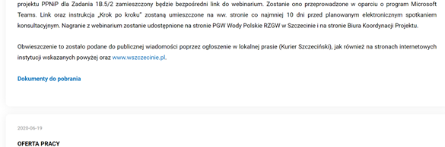
Due to the restrictions imposed on Poland due to the emergence of SARS-CoV-2 virus causing COVID-19 disease and thus the lack of access to offices for stakeholders, PAPs were provided via the Polish Post Office with a LA&RAP extract together with a cover letter with information on the possibility of submitting comments and applications, an indication of websites through which it is possible to get acquainted with the entire LA&RAP, as well as information about the webinar, i.e. on the following websites:
- RZGW in Szczecin: https://szczecin.wody.gov.pl/,
- RZGW in Szczecin (Project website): http://bs.rzgw.szczecin.pl/,
- Project Coordination Unit: http://odrapcu2019.odrapcu.pl/.
In addition, it was pointed out that if you wish to read the entire document and if there are any technical problems resulting in the inability to get acquainted with the electronic version of the LA&RAP Draft, there is a possibility of transferring the whole document to the indicated address.
Seven days after the documents were submitted, the process of direct telephone conversations with PAPs began, the aim of which was to present the impact of the project on their situation and to provide information on the properties occupied for the purposes of the Task, as well as to clarify any doubts regarding the content of the LA&RAP.
During the development of the LA&RAP Draft for the Task, 7 PAPs were identified – five natural persons being the owners of the property, a limited liability company being the owner of the property and the City and Municipality of Kostrzyn nad Odra.
Below is presented the interview with person(s) affected by the Project (PAP) identified during the development of the PAP document and the information obtained during them.
- Limited liability company – property owner
The person with whom the interview was conducted, i.e. the President of the Executive Board, indicated that he has read the submitted document. After reading it, questions arose about the possibility of the Employer acquiring the entire property or “land for land” compensation. It was indicated that each application is analysed individually, with the occupied part of the property constituting a small area compared to the whole plot, which may result in difficulties in buying the property.
The President of the Executive Board of the Company indicated that he planned to conduct hotel business on the project plot, and the acquired part of the property prevents him from doing so, and thus the property loses its value for him.
PAP also indicated that there is a high probability that he will not be able to participate in the webinar organized and expressed a request for a personal meeting with the person developing LA&RAP. The Consultant indicated that such a meeting could be organized and that members of the project team would also participate in order to indicate in detail the planned type and scope of work. It was subsequently agreed that all information regarding the acquisition of property and forms of compensation would also be provided at the meeting.

- Natural person – property owner
The Consultant contacted PAP, who in the course of the development submitted an application for the purchase of the entire property. During the conversation, PAP indicated that due to remaining in constant contact with the Consultant's representative, there are no doubts as to the content of the LA&RAP. They were also asked to confirm that the findings to date on the application remain valid. Consultant confirmed the above.
- Natural person – property owner
The Consultant contacted PAP. During the interview, it was indicated that in the present case the daughter of the owner is authorized to represent PAP (the appropriate power of attorney was given to the Consultant).
The Consultant's representative informed, in connection with the question, about possible forms of compensation, while emphasizing that the land occupied as part of the project constitutes a small percentage of the total property. Subsequently, it was indicated that each case is analysed individually, depending on the impact of the project on a specific property and the situation of the owner of the plot. The attorney of the PAP has requested the submission of the entire LA&RAP draft and maps indicating the development of the area including the property owned by the PAP. The Consultant provided maps and the document by e-mail.
The attorney, having examined the document, sent an e-mail indicating the impact the project will have on the property, according to PAP. Contact was also requested to establish the conditions for compensation, clarify the procedures for the acquisition of the property and the restrictions. The consultant contacted the PAP's attorney again and it was agreed that all information would be provided at the webinar and the organized teleconference, and in the event of such a need, an individual meeting would be organized.
- Natural person – property owner
The Consultant contacted PAP and obtained information that the owner of the property became initially acquainted with the LA&RAP draft. It was therefore proposed to provide key information, in particular on the impact of the project on acquired or limited properties.
PAP indicated that it is important for him that during and after the completion of the project, access to his property from the public road is ensured, because the content of the document indicates that it may be difficult or impossible. The Consultant informed that access to the property will certainly be provided, both for the duration of the works and after their execution. At the same time, it was indicated what, in accordance with the Road Act and the Operational Policy of the World Bank, are the possibilities of compensation in the event of the Task's impact on the property. Participation in the webinar was also encouraged in order to ensure the participation of project team members, who will explain in detail any doubts related to the works planned within the Task.
- Natural person – property owner
The Consultant contacted PAP and obtained information that the owner of the property became initially acquainted with the LA&RAP draft. It was therefore proposed to provide key information, in particular on the impact of the project on acquired or limited properties.
PAP asked for information regarding the restriction in the manner of using the property and the possibility for the Employer to acquire the entire property. The Consultant has indicated that, under the applicable legislation, such an application is indeed possible, but only if the work carried out prevents the owner from continuing to use the property as before or according to its previous purpose. Thus, it would be necessary to analyse the situation of PAP individually in order to assess whether the described situation actually occurred.
Subsequently, PAP asked for planned renovations, construction and reconstruction of the network, including sewage and sanitary systems. The Consultant encouraged participation in a webinar, which will also be attended by members of the project team, in order for them to clarify any doubts regarding the planned works.

The Consultant was unable to contact the other PAPs by phone.

The public release of the document ended after 22 days, i.e., on July 14, 2020.
An online consultation meeting in the form of a webinar was held on July 14, 2020 from 3 p.m. to 4.30 p.m. Subsequently, at 4:30 p.m., due to the willingness to have direct conversations with the PAP, a teleconference was organized, during which each of the invited participants had the opportunity to speak freely, ask questions and submit any proposals and comments.

Report from the webinar and teleconference
organised on July 14, 2020

The webinar was held on July 14, 2020 from 3 p.m. to 4.30 p.m. A link to the webinar, as well as step-by-step instructions showing what steps you need to take to attend an online meeting, were available on the Project website.
7 people took part in the meeting, including two people from the Consultant Team, a representative of the PIU – RZGW in Szczecin and two people from the Project Coordination Unit. In addition, three PAPs participated – the property owner's attorney and two owners. After the webinar, attention was drawn to the lack of one entry on the attendance list, however, the fact of PAP's participation also results from a letter submitted after the webinar, in which it is indicated that the content was listened to.
The meeting was opened and chaired by the Real property expert. At the outset, the purpose of the meeting was indicated, and its formula clarified, in particular in the scope of asking questions. Subsequently, the participants were informed about the process of drafting the LA&RAP, with an indication of the entity developing the document from the Consultant's team and entities checking and accepting the final version to be forwarded to the World Bank.
The chair presented the subject of the planned project, indicating the necessity to reconstruct a road bridge 2.45 km Warta River, Kostrzyn n/Odra in order to ensure a minimum clearance. Subsequently. the participants were informed about the World Bank's Policy, its application, as well as the resulting principles and guidelines.
In addition, the issues of expropriation of the property or a part thereof, as well as restrictions on the use of the property or a part thereof under the Road Act, including the procedure for determining the right to compensation, as well as its amount, were raised. It was also indicated what the possible purchase of the entire property depends on when acquiring or limiting the property. Finally, the current schedule for the Project was presented, showing the most important dates from the point of view of PAPs, i.e. date of the RCC, obtaining the WB “no objection” clause for the RAP final document, acquisition of the property and payment of compensation.
After the webinar, a teleconference was launched in which interested PAPs participated. A member of the Consultant's project team provided detailed information on the scope and type of works planned on individual properties. A member of the Real property team informed each participant about possible forms of compensation and the impact of the taken area on the ability to purchase the entire property. Issues related to the impact of conducting business in the taken area on the entitlement and amount of compensation were also raised.
Possible solutions were also presented to PAPs and it was requested that any doubts or requests be submitted in writing.
Information about the webinar is available on the websites listed below:
- RZGW in Szczecin: https://szczecin.wody.gov.pl/,
- RZGW in Szczecin (Project website): http://bs.rzgw.szczecin.pl/,
- Project Coordination Unit: http://odrapcu2019.odrapcu.pl/.
as well as on the www.facebook.pl portal on the wszczecinie.pl profile.

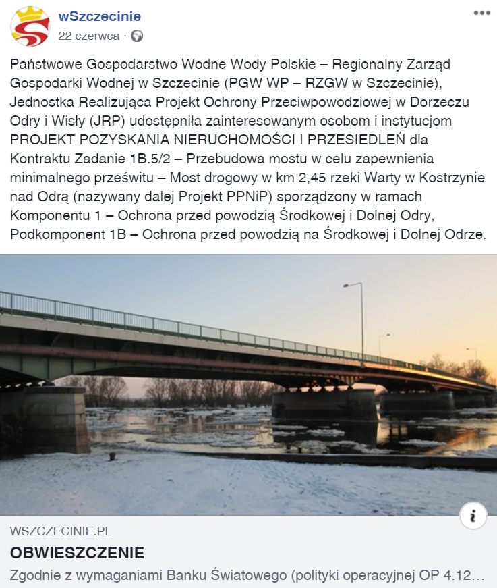

After the webinar, one of the PAPs submitted a letter in which he indicated that after listening to the webinar and analysing the presented materials, in his opinion the proposed solutions would negatively affect the property owned by him, and the implemented project would lower the standard of living, and submitted proposals for the Employer to purchase the entire property or to provide access to the plot from the municipal road. It has been pointed out that, as compensation, he proposes the purchase of the expropriated plot of land with which the property owned by PAP borders.
Due to the detailed issues related to the design documentation contained in the letter, the reply to the above letter was discussed by the members of the real property team with the members of the project team. The PAP was informed that in order to address his concerns with respect to the design documentation, changes were made to the longitudinal profile of the ramp, thus providing a safe way for vehicles to enter traffic on the national road. Solutions have also been put in place to address concerns about property flooding. It has been pointed out that in order to collect stormwater from the pedestrian and cycling route and part of the exit, linear drainage has been designed to collect these waters. The stormwater from the national road will be collected through a channel unit by street inlets and then by the designed stormwater drainage system. It was also pointed out that the limitation of the property will be small in percentage terms in relation to the entire plot (2.18%). The PAP was also informed in writing about the procedure concerning the application for the purchase of the entire property, including the appeal procedure in the event of the Employer's refusal to conclude the purchase agreement.

Appended:
- attendance list (anonymized).

