Annex No. 1
List of assets offered for sale, with photographs
No. | Item | Inventory No. | Estimated wear/date of purchase | Unit value / reserve price (EUR) | Technical condition | Asset category (surplus / worn-out) | Photographs of the item's current condition
1 | Winger queen bed, 160x200 | 008-0703 | Date of purchase: 27.07.2023 | 114 EUR | Good | Surplus | 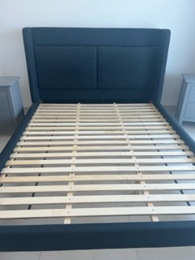
2 | IKEA HOGWIND ceiling lamp | 008-0744 | Date of purchase: 08.05.2024 | 50 EUR | Good | Surplus | 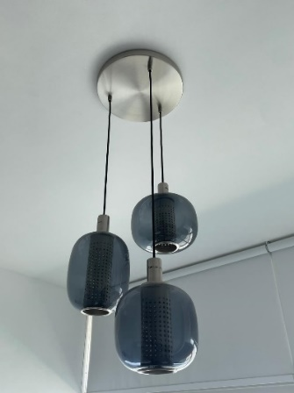
3 | Two-door cabinet | 008-0139 | Date of purchase: 22.12.2009 | 22 EUR | Good | Surplus | 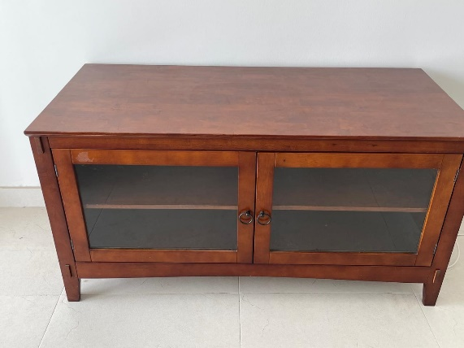
4 | IKEA Friheten corner sofa, Bomstad black faux leather | 008-0455 | Date of purchase: 19.08.2018 | 183 EUR | Good | Surplus | 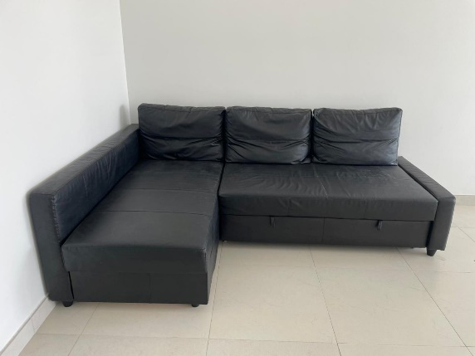
5 | IDNAS chest of 4 drawers, brown | 008-0722 | Date of purchase: 12.09.2024 | 160 EUR | Good | Surplus | 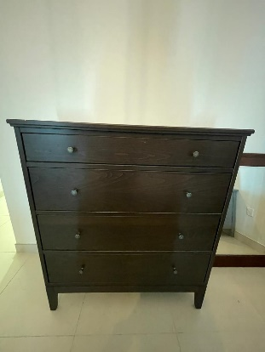
6 | IKEA GRINDFALLET ceiling lamp | 008-0745 | Date of purchase: 08.05.2024 | 11 EUR | Good | Surplus | 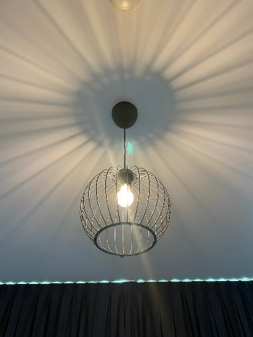
7 | Console table with mirror, brown | 008-0716 | Date of purchase: 20.09.2023 | 114 EUR | Good | Surplus | Console table with mirror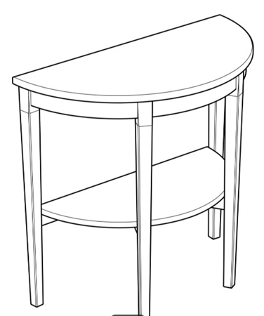
8 | IKEA Kura bed, 90x200 | 008-0704 | Date of purchase: 07.07.2023 | 103 EUR | Good | Surplus | 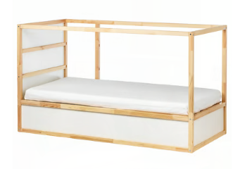
9 | Hailey full bed, white | 008-0695 | Date of purchase: 20.07.2023 | 91 EUR | Good | Surplus | 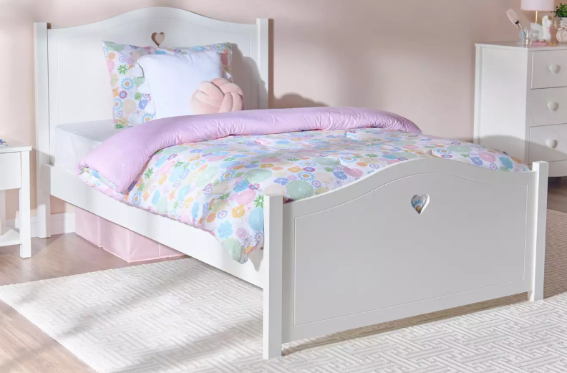
 |  | Total value |  | 848 EUR

