ENVIRONMENTAL AND SOCIAL IMPACT ASSESSMENT (ESIA)

Appendix No 13.4 Climate Change and Climate Resilience Assessment

DRAFT VERSION

Contract 5.10.1. Construction of the Kamieniec Ząbkowicki Reservoir - Preparation of design documentation, including obtaining administrative permits and the provision of Author’s Supervision, as well as the preparation of bidding documents necessary to select a Contractor for future works under the future Poland’s Building Climate Resilience in Water Management Project

Wrocław, October 2026
Table of Contents
1. Introduction 3
2. Impact of the Project on Greenhouse Gas Emissions 4
3. Assessment of the Project’s Vulnerability to Climate Change and Climate Risk Assessment 11
3.1 Analysis of Climate Trends and Scenarios in the Project Area 11
3.2. Assessment of the project’s vulnerability to climate change and risk assessment for individual components of the Project 19
List of Tables 47
List of Figures 47

- Introduction
Poland is experiencing progressive climate change, the primary manifestation of which is a rise in average air temperature. The consequences of global warming include, among others: a longer growing season, a decrease in the number of frost days and days with snow cover, as well as more frequent hot days and heat waves. Analyses conducted as part of the KLIMADA 2.0 project also point to the growing significance of extreme events, such as droughts, heavy rainfall, storms, and flash floods. However, these changes do not imply a uniform increase in annual precipitation totals—longer periods without precipitation, interspersed with heavy downpours, are becoming increasingly common.
In the Kłodzko Valley, the effects of these changes may be particularly noticeable. This area is characterized by a mountainous-valley terrain, and its topography, along with the relatively short and steep catchment areas of the Nysa Kłodzka’s tributaries, promote rapid surface runoff. In the event of intense or prolonged rainfall, especially torrential downpours, this can lead to a rapid rise in water levels, flash flooding, and flooding in river valleys—a risk exacerbated by the concentration of buildings and transportation and technical infrastructure in the valley bottoms. At the same time, during the summer months, one must take into account the possibility of precipitation deficits, high temperatures, and atmospheric and soil drought, which affect the availability of water resources, the condition of vegetation, the functioning of ecosystems, agricultural production, as well as the comfort and safety of residents. A characteristic feature of the local impact of climate change is therefore the coexistence of seemingly contradictory threats: periodic water shortages and sudden floods caused by intense rainfall.
The construction of a retention reservoir on the Nysa Kłodzka River is being carried out in response to these conditions. Its primary objective is to mitigate the effects of flood events by retaining a portion of the flood wave’s volume, reducing peak flows, and ensuring controlled water discharge through the structure. The project thus constitutes a climate change adaptation measure. At the same time, like any hydrotechnical structure, it requires proper design and operation so that the infrastructure itself is resilient to current and projected climate change, and its construction and operation do not generate unjustified impacts on the climate.
Therefore, the following were conducted in this appendix for the project in question:
- an assessment of greenhouse gas (GHG) emissions from the reservoir calculated using the G-res Tool (UNESCO/IHA),
- an assessment of vulnerability to climate change and a climate risk assessment (CRVA).
- Impact of the Project on Greenhouse Gas Emissions
This analysis presents a preliminary assessment of greenhouse gas emissions associated with the planned construction and operation of the Kamieniec Reservoir. The calculations were performed using the G-RES tool, which is designed to estimate the greenhouse gas footprint of water reservoirs, taking into account biogenic emissions, conditions prevailing prior to flooding of the area, the impact of anthropogenic activities in the catchment area, and emissions associated with infrastructure construction. Input data for the model were entered based on information available at the current stage of project preparation. The reservoir’s technical and operational parameters, mode of use, hydrological conditions, and characteristics of the catchment area are based on currently available forecasts, documentation, and design assumptions. Similarly, data regarding the scope of construction work, the quantities and types of materials - including concrete, steel, and earth and backfill materials - as well as the distances and methods of their transport, are currently estimates.
Based on the results of modeling conducted using the G-RES tool, it has been estimated that the Kamieniec Reservoir will be a source of net greenhouse gas emissions associated with the reservoir’s operation at a level of approximately 672 metric tons of CO₂e per year. Per unit area, this corresponds to 80 g CO₂e/m²/year. The modeled emissions after the reservoir is filled, before applying adjustments to determine the net footprint, were estimated at 1,352 t CO₂e/year, or approximately 160 g CO₂e/m²/year. From this value, emissions occurring prior to the reservoir’s creation—amounting to 109 metric tons of CO₂e per year—and emissions attributed to independent anthropogenic sources in the catchment area, estimated at 571 metric tons of CO₂e per year, were subtracted. As a result, the model’s net footprint of the reservoir alone is 672 metric tons of CO₂e per year.
Emissions associated with the reservoir’s construction were estimated at approximately 578,523 metric tons of CO₂e. After adding this component to the net emissions associated with the reservoir’s operation, the total greenhouse gas footprint amounts to approximately 6,457 metric tons of CO₂e per year. The cumulative footprint over the entire analysis period amounts to approximately 645,714 metric tons of CO₂e. Of this total, approximately 67,200 metric tons of CO₂e are attributable to the net emissions of the reservoir itself, while the vast majority—approximately 578,500 metric tons of CO₂e—consist of construction emissions. This means that emissions associated with the project’s implementation dominate the overall life-cycle balance, accounting for approximately 90% of the total GHG footprint. The assessment of construction emissions was performed using a more detailed G-RES module, covering, among other things, earthworks, backfill materials, concrete work, steel components, equipment, and road infrastructure.
In accordance with the functional breakdown adopted in the model, 80% of the total footprint was attributed to flood protection, 15% to hydropower, and 5% to recreation. The remaining functions, such as water supply, irrigation, navigation, fishing, and ensuring environmental flow, were not assigned a share of emissions. With regard solely to net emissions associated with the reservoir, this amounts to approximately 538 metric tons of CO₂e/year attributed to flood protection, 101 metric tons of CO₂e/year to hydropower, and 34 metric tons of CO₂e/year to recreation. After accounting for appropriately allocated construction emissions, the total values amount to approximately 5,166 t CO₂e/year for flood protection, 969 t CO₂e/year for hydropower, and 323 t CO₂e/year for recreation. For the hydropower function, an installed capacity of 3 MW and a very low power density of 0.3 W/m² were assumed. However, the report does not specify the annual electricity production, so the unit emission intensity expressed in g CO₂e/kWh was not determined. The absence of this value prevents a direct comparison of the hydropower footprint with other energy generation technologies. The allocated values presented should therefore not be interpreted as an indicator of the emissions intensity of the energy produced.
The reservoir’s positive net greenhouse gas footprint is primarily driven by CO₂ emissions. Modeled CO₂ emissions after filling of the reservoir amount to approximately 781 t CO₂e/year, while emissions prior to impoundment were estimated at 31 t CO₂e/year. This results in net CO₂ emissions of approximately 750 t CO₂e/year, or 89 g CO₂e/m²/year. Surface diffusion emissions of CO₂ were determined to be 92 g CO₂e/m²/year. The slight difference between this figure and the net value results from subtracting baseline emissions occurring before the reservoir was created. For CH₄, post-impoundment emissions were estimated at 571 metric tons of CO₂e per year, and pre- impoundment emissions at 78 metric tons of CO₂e per year. At the same time, the entire 571 metric tons of CO₂e per year of post- impoundment methane emissions were potentially attributed to independent anthropogenic sources in the catchment area. After applying methodological adjustments, a net CH₄ value of –78 t CO₂e/year was thus obtained, which is approximately –9 g CO₂e/m²/year. A negative result does not mean that the reservoir will physically absorb methane. It is a mathematical result of the adopted method for determining net emissions, in which baseline emissions and the portion attributed to anthropogenic sources - not directly related to the reservoir’s creation - are subtracted from post- impoundment emissions. Consequently, the result for CH₄ is particularly sensitive to assumptions regarding the contribution of independent anthropogenic sources. An analysis of methane release pathways indicates that the dominant mechanism is diffusion through the water surface, with an estimated rate of 58 g CO₂e/m²/year. Bubble emissions amount to approximately 9 g CO₂e/m²/year. Based on these values, it can be assumed that diffusion accounts for approximately 86%, and bubble release accounts for approximately 14% of the surface CH₄ emissions included in the model. Total CH₄ emissions after impoundment were presented in the report as approximately 68 g CO₂e/m²/year; the slight discrepancy compared to the sum of the individual emission pathways is due to rounding.
CH₄ emissions from degassing at the outflow were assumed to be zero. The report indicates that the water level or conditions related to the thermocline were not fully defined in the calculation module; therefore, the degassing mechanism was not quantitatively accounted for. At the same time, the input data specify a depth of 3 m for the main water intake and a thermocline depth of 5.2 m. A shallow water intake may limit the significance of degassing compared to deep-water abstraction; however, it does not constitute evidence of the complete absence of this process under actual conditions. The zero value should therefore be interpreted as a model assumption resulting from the data configuration, rather than as confirmation of the absence of field emissions.
The total gross surface emissions after impoundment are approximately 160 g CO₂e/m²/year, of which 92 g CO₂e/m²/year is attributable to CO₂ and approximately 68 g CO₂e/m²/year to CH₄. After subtracting pre- impoundment emissions and independent anthropogenic sources, a net footprint of 80 g CO₂e/m²/year was obtained. The overall positive result is therefore due to the predominance of positive net CO₂ emissions, amounting to 89 g CO₂e/m²/year, over the calculated negative net CH₄ value, which is –9 g CO₂e/m²/year. The distinction between gross and net emissions is crucial for interpreting the results, as the net figure does not represent the actual total flux of gases released into the atmosphere.
The comparative results presented in the report indicate the analyzed site’s position relative to the global reservoir database; however, they do not establish formal thresholds that would allow it to be unambiguously classified as a low-, medium-, or high-emission reservoir. Such an assessment can only be indicative. Based on a net surface emission of 80 g CO₂e/m²/year, the analyzed facility can be considered relatively low-emitting in terms of net operational emissions. However, this does not mean that gross emissions—especially CH₄ emissions—are insignificant. Additionally, when construction is taken into account, the total life-cycle footprint is significantly larger and dominated by the investment construction component.Comparing the results obtained for the Kamieniec Reservoir with values published for other facilities requires methodological caution. The figure of 80 g CO₂e/m²/year represents the model’s net footprint, averaged over the 100-year analysis period and reduced by emissions occurring prior to impoundment and emissions attributed to independent anthropogenic sources in the catchment area. Most field studies, however, report gross emissions, which refer to the measurement period and are not adjusted in accordance with the G-RES methodology. For this reason, the gross emissions from the Kamieniec Reservoir—amounting to approximately 160 g CO₂e/m²/year—are more appropriate for comparison with the measured results than the net value of 80 g CO₂e/m²/year. This distinction is consistent with the principles of G-RES, which was developed to determine the change in emissions attributable to reservoir formation, rather than solely the total flux of gases released from its surface . One of the most important references is the global synthesis by Deemer et al., covering data from 267 reservoirs. The authors estimated global emissions from reservoir surfaces at approximately 0.8 Pg CO₂e/year, with very high variability among individual reservoirs. In terms of CO₂ equivalents, approximately 79% of the global climate impact was attributed to methane. The study also showed that parameters related to ecosystem productivity, including the availability of nutrients, are often better predictors of emissions than the age or geographic location of the reservoir alone . Compared to this synthesis, the Kamieniec Reservoir exhibits a different gross emission profile. In this case, methane accounts for approximately 42% of gross emissions after filling, while CO₂ accounts for approximately 58%. The share of CH₄ is thus significantly lower than the average contribution of this gas to the global climate impact of reservoirs as presented by Deemer et al. This does not mean, however, that methane emissions are negligible. The result is partly a consequence of assuming zero emissions from degassing and a relatively small contribution from bubble emissions, as well as the different nature of the indicators analyzed. The values for the Kamieniec Reservoir are model estimates, whereas Deemer’s global dataset includes results obtained using various field methods for reservoirs of varying age, climate, and trophic status. Measurements conducted in Perialpine and Alpine reservoirs provide an additional point of reference. Diem et al. found that the analyzed sites emitted an average of approximately 1,030 ± 780 mg CO₂/m²/day, which, when converted, corresponds to approximately 376 ± 285 g CO₂/m²/year. The modeled diffusive CO₂ emission from the Kamieniec Reservoir, amounting to 92 g CO₂/m²/year, is therefore approximately four times lower than the average value obtained in this study . This comparison indicates a relatively low areal CO₂ emission; however, it should be noted that the Alpine studies involved measurements taken under specific seasonal and hydrological conditions, whereas the G-RES result is a model value averaged over a long period.
Even greater differences are observed with regard to methane. The gross CH₄ emission from the Kamieniec Reservoir, amounting to 68 g CO₂e/m²/year, corresponds (with a GWP₁₀₀ of 34) to approximately 2.0 g CH₄/m²/year, or about 5.5 mg CH₄/m²/day. By comparison, in the shallow Wohlen reservoir in Switzerland, located in a temperate zone, average emissions exceeding 150 mg CH₄/m²/day were measured. Using the same GWP factor, this would correspond to over 1.86 kg CO₂e/m²/year . Methane emissions from the Kamieniec Reservoir are therefore at least approximately 27 times lower than the value observed at this particularly high-emission site. The difference in the emission structure is also significant: ebullition clearly dominated at the Wohlen reservoir, whereas in the model for Kamieniec, approximately 86% of CH₄ emissions were attributed to diffusion, and only about 14% to bubbling. This site was approximately 90 years old at the time of the study, yet it remained a very strong source of CH₄. The authors attributed the high emissions, among other factors, to the shallowness of the reservoir, sediment accumulation, and the strong temperature dependence of ebullition. This means that the predicted decline in emissions with reservoir age should not be treated as a rule without exceptions. Under certain morphometric and trophic conditions, intense methane emissions can persist even in older reservoirs, a fact that should be kept in mind.
The dynamics of emissions following impoundment are well illustrated by the results of long-term studies of the boreal Eastmain-1 reservoir in Canada. In the first year after impoundment, net CO₂ emissions there were estimated at 2,270 mg C/m²/day, which corresponds to approximately 3.0 kg CO₂/m²/year. After three subsequent years, the value decreased to approximately 835 mg C/m²/day, or about 1.1 kg CO₂/m²/year. Even this reduced value remained more than ten times higher than the 92 g CO₂/m²/year of diffusion emissions estimated for Kamieniec. Studies of Eastmain-1 confirmed a sharp decline in CO₂ emissions in the first years after impoundment, and subsequent measurements indicated that emissions had relatively stabilized after about seven years. A comparison with Eastmain-1 does not imply that emissions from the Kamieniec Reservoir immediately after impoundment will be equally high. The G-RES results for Kamieniec are long-term in nature, whereas the values for Eastmain-1 refer to specific years following impoundment. The Canadian example confirms, however, that the 100-year average may mask significantly higher emissions during the initial phase of operation. Long-term studies of Eastmain-1 also showed that CH₄ accounted for only about 1.2–6.8% of gross emissions, while diffusive CO₂ emissions accounted for about 80–90% of the footprint expressed in CO₂ equivalents. This means that the dominance of CO₂ projected for the Kamieniec Reservoir is consistent with the results observed in some boreal and temperate reservoirs .
The literature also confirms that emissions do not depend solely on age and climate zone. Barros et al., analyzing 85 hydroelectric reservoirs covering approximately 20% of the global area of such facilities, demonstrated a relationship between emissions and age and latitude, with the highest values generally occurring in young tropical reservoirs . However, a subsequent synthesis by Deemer and colleagues indicated that factors related to productivity, such as chlorophyll concentration and the inflow of nutrients, may be better predictors of emissions than reservoir age. In this context, the hyper-eutrophic status of the Kamieniec Reservoir and the significant proportion of agricultural land in the catchment area are factors that may increase the risk of methane formation. The inflow of phosphorus and organic matter promotes biomass production, and its decomposition under anoxic conditions can lead to methanogenesis. At the same time, the short water retention time and the shallow location of the intake may limit methane accumulation in deeper layers and its subsequent release during outflow. The model result should therefore be interpreted as the result of the interaction between factors that increase and limit emissions, rather than as a simple consequence of the reservoir’s location within a specific climate zone.
Construction emissions, amounting to approximately 578,500 metric tons of CO₂e, warrant special mention, as they account for nearly 90% of the project’s total carbon footprint. A review of life-cycle analyses of dams conducted by Song and colleagues indicates that, in the case of small run-of-river power plants, emissions associated with the construction and maintenance of infrastructure may dominate. In large reservoir projects, however, emissions resulting from the decomposition of submerged biomass and organic matter are often the main component of the balance . The dominance of the construction component in the case of the Kamieniec Reservoir is therefore not impossible; however compared to typical reservoir projects, result this should be treated as preliminary and subject to significant uncertainty. The values regarding the volume of earthwork, concrete and steel consumption, transport distances and used in the G-RES model are currently estimates. Accurate data will not be available until the detailed construction design phase of the project. Once this data is obtained, it will be advisable to recalculate construction emissions, taking into account verified quantities of materials and work, actual routes and modes of transport, adopted project boundaries, and the relevant emission factors. The current result should therefore not be interpreted as the final value of the construction’s carbon footprint, but rather as a preliminary estimate that will be refined as design work progresses. The significance of this result is further underscored by the hydroelectric power plant’s very low power density of 0.3 W/m². In hydropower analyses, power density is one of the key parameters, as a large reservoir surface area relative to low power output results in higher emissions per unit of energy produced. Comparative studies indicate that facilities with higher power density and shorter retention times typically achieve more favorable emission results per unit of production.
Although the report for Kamieniec does not specify annual energy production, it is possible to determine a theoretical lower limit for emission intensity. At a capacity of 3 MW, the maximum possible production—assuming full-capacity operation throughout the year—is 26.28 GWh. If hydropower is assigned 969 metric tons of CO₂e/year, the minimum theoretical intensity is approximately 36.9 g CO₂e/kWh. This value cannot be reduced without changing the assumptions regarding emissions or their allocation, as it corresponds to a capacity utilization factor of 100%. With an example capacity factor of 40%, the intensity would increase to approximately 92 g CO₂e/kWh, and at 50%, it would be approximately 74 g CO₂e/kWh. These are approximate calculations. For comparison, the median life-cycle emissions intensity for hydropower, as presented in IPCC reports, is approximately 24 g CO₂e/kWh. However, values for individual projects vary widely, and results for tropical reservoirs or facilities with low power density can be many times higher . In the case of Kamieniec, even the theoretical lower limit of 36.9 g CO₂e/kWh exceeds this median. This is primarily due to high construction emissions attributed to the hydropower function and the plant’s low capacity. However, without data on actual or projected energy production, it is not possible to determine the final emissions intensity or conduct a full comparison with other power plants. If the calculation were to include only the portion of the reservoir’s operational emissions attributed to hydropower—amounting to 101 t CO₂e/year—the theoretical lower bound for emissions intensity would be approximately 3.8 g CO₂e/kWh, and with a capacity utilization factor of 40%, it would be approximately 9.6 g CO₂e/kWh. A comparison of both results shows that the relatively high LCA intensity is determined not by the reservoir’s modeled biogenic emissions, but primarily by the construction component.
In summary, the gross surface emissions of the Kamieniec Reservoir, amounting to approximately 160 g CO₂e/m²/year, can be considered relatively low compared to the global variation among reservoirs and significantly lower than the values recorded in many young boreal and tropical reservoirs. CO₂ emissions are also lower than the average obtained in studies of Perialpine and Alpine reservoirs. CH₄ emissions remain a significant component of the balance, but are significantly lower than in particularly high-emitting temperate-zone reservoirs, such as Wohlen. The classification of Kamieniec as a site with relatively low surface emissions is therefore justified with regard to gross and net operational emissions, but should not be automatically applied to the entire life cycle of the project.
- Assessment of the Project’s Vulnerability to Climate Change and Climate Risk Assessment

3.1 Analysis of Climate Trends and Scenarios in the Project Area
Information on climate trends and scenarios for Poland can be found in the KLIMADA 2.0 project . In accordance with the European Commission’s Technical Guidelines on climate impact assessment, it is recommended to use the RCP 6.0 or RCP 8.5 scenarios for the climate assessment of projects. For projects with a longer lifecycle, as well as those that cannot be modernized during their operational period (such as bridges or new rail lines), it is recommended to account for expected fluctuations in climate variables based on the RCP 8.5 scenario . The description of climate change scenarios was prepared using data from the KLIMADA 2.0 project for the RCP 4.5 or RCP 8.5 scenarios. The moderate RCP 4.5 scenario assumes a further increase in CO₂ concentrations , reaching 540 PPM by the year 2100, and a radiative forcing of 4.5 W/m², while the extrapolative RCP 8.5 scenario corresponds to an increase in CO₂ concentrations to 940 PPM by the year 2100 and a continuous rise in radiative forcing to 8.5 W/m².
In the report on temperature and precipitation changes in Poland, prepared as part of the KLIMADA 2.0 project , changes in future climate conditions are described by approximating the temporal trend with a 10-year moving average and—in spatial terms—as differences for selected indices between the decades 2051 –2060 and 2011–2020. Based on daily values of four key parameters—average temperature, minimum temperature, maximum temperature, and precipitation—a set of climate indices was calculated to assess exposure to changes in thermal and precipitation conditions, including both average and extreme conditions.
According to the findings presented in the report, an increase in average temperature is projected in both scenarios—RCP 4.5 and RCP 8.5. In the RCP 8.5 scenario, this increase is more significant. In Poland, the greatest changes are projected for the winter months (December, January, February) and the summer months (June, July, August), with the largest temperature increases projected for eastern and northeastern Poland. The temperature increase by 2060 ranges from approximately 1 °C (RCP4.5) to 1.2 °C (RCP8.5). The rise in the annual average temperature results from an increase in the number of hot days and a decrease in the number of cold days. As a result of rising temperatures during the cooler months, the number of days with frost will decrease. This information is illustrated in the maps and charts below.
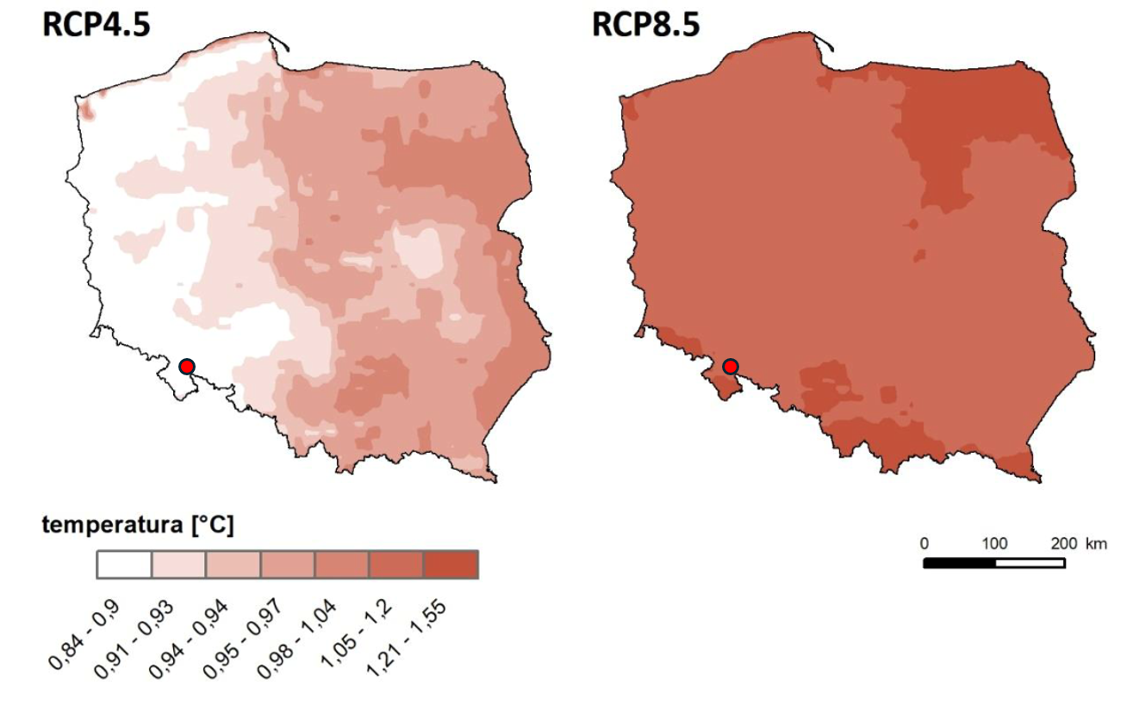
Figure 1 Difference in annual average temperature at a height of 2 m, according to the RCP4.5 (left panel) and RCP8.5 (right panel) scenarios, between the decades 2051–2060 and 2011–2020
Source: Summary Report: Changes in Temperature and Precipitation in Poland under Future Climate Conditions by 2100, IOŚ-PIB, January 2020
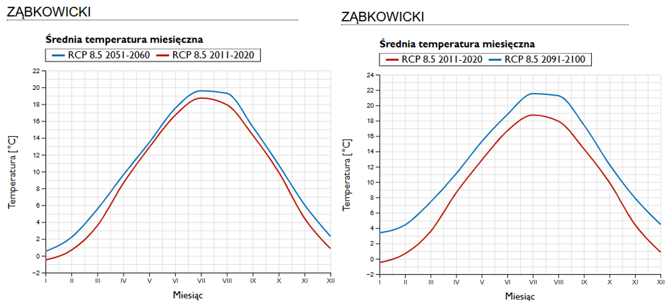
Figure 2 Comparison of average monthly temperatures for the 2011–2022 decade and the 2051–2010 and 2091–2100 decades according to the RCP 8.5 climate scenario for the project area (Ząbkowice County)
Source: KLIMADA 2.0 Project (https://klimada2.ios.gov.pl/klimat-scenariusze-portal/)
In both climate scenarios, the distribution and frequency of extreme temperatures during the summer will change. For daily maximum temperatures in the coming decades, the number of hot days (with a daily maximum temperature above 30°C) shows an upward trend. In the RCP4.5 scenario, the greatest changes will affect the southern and southeastern parts of the country. In contrast, under the RCP8.5 scenario, the greatest changes will affect the southern and southwestern parts of the country. The number of hot days will increase on average from 3 days (under the RCP4.5 scenario) to 6 days (under the RCP8.5 scenario). The graph below shows the moving average of hot days for the project area.
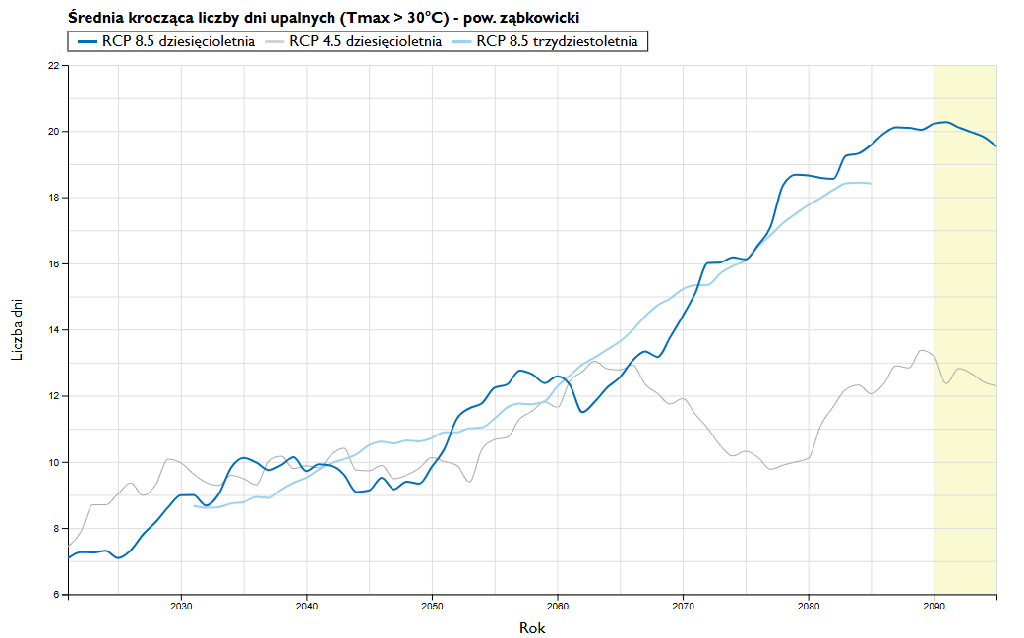
Figure 3 Moving average of the number of hot days (maximum temperature above 30 °C) according to the RCP8.5 and RCP4.5 climate scenarios for the project area (Ząbkowice County)
Source: KLIMADA 2.0 Project (https://klimada2.ios.gov.pl/klimat-scenariusze-portal/)
Climate scenarios indicate that the number of freezing days will decrease nationwide, with the greatest reduction occurring in the northeastern part of the country. The number of days with freezing temperatures by 2060 will decrease by an average of about 10 days (for the RCP4.5 and RCP8.5 scenarios) compared to the 2011–2020 decade.
For both scenarios, a noticeable decrease in the number of days with ground frost is also observed. By 2060, the number of days with ground frost will decrease by approximately 18 days (in the RCP4.5 scenario) to 25 days (in the RCP8.5 scenario).
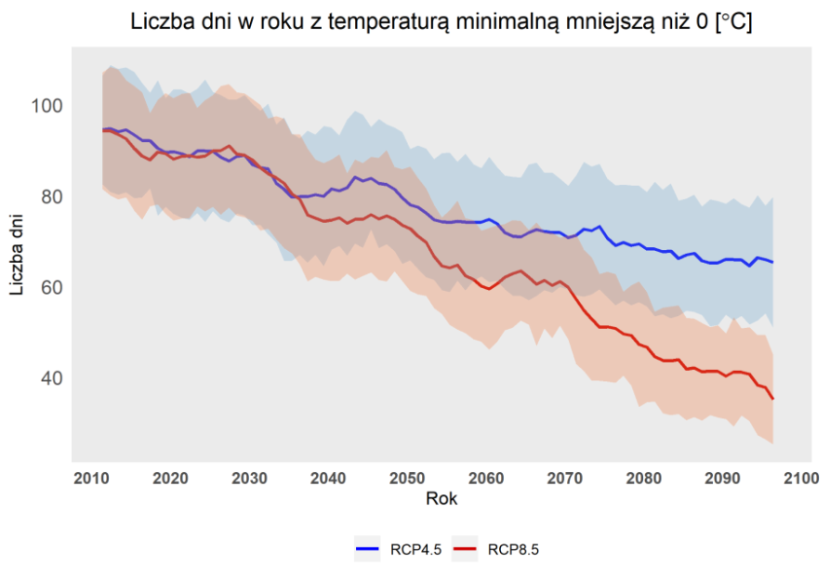
Figure 4 Change in the number of frost days (min. temp below zero C) averaged across Poland for the period 2006–2100, as a 10-year moving average, based on the calibrated climate model ensemble from the EURO-CORDEX repository (EUR_11) for the RCP4.5 and RCP8.5 scenarios
Source: Summary Report: Changes in Temperature and Precipitation in Poland under Future Climate Conditions through 2100, IOŚ-PIB, January 2020
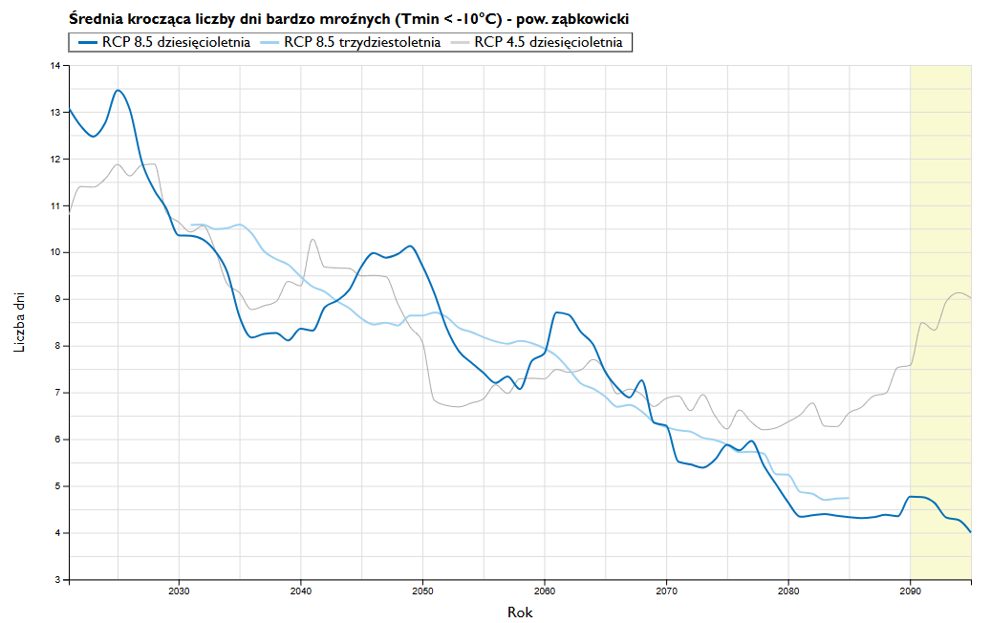
Figure 5 Moving average of the number of very cold days (maximum temperature below -10 °C) according to the RCP8.5 and RCP4.5 climate scenarios for the project area (Ząbkowice County)
Source: KLIMADA 2.0 Project (https://klimada2.ios.gov.pl/klimat-scenariusze-portal/)
With regard to threats to infrastructure, it is important to point out the downward trend in the number of days when the temperature crosses 0°C and the number of days with black ice.
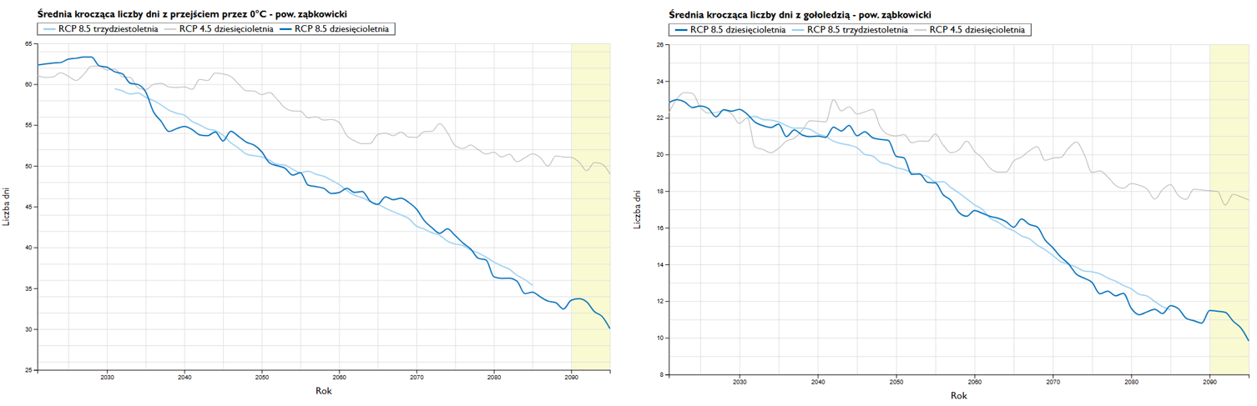
Figure 6 Moving average of the number of days with black ice and when the temperature crosses 0°C according to the RCP8.5 and RCP4.5 climate scenarios for the project area (Ząbkowice County)
Source: KLIMADA 2.0 Project (https://klimada2.ios.gov.pl/klimat-scenariusze-portal/)
Forecasts of precipitation changes are less clear-cut, as both the cumulative amount of precipitation and the distribution of precipitation intensity throughout the year are important.
Both climate scenarios predict an increase in annual precipitation. For the RCP8.5 scenario, this increase is more significant than in the RCP4.5 scenario. In Poland, the increase in annual precipitation will primarily affect the eastern part of the country, as well as mountainous areas and the coast. The smallest projected increase, in both scenarios, concerns the central-western part of the country. By 2060, an increase in annual precipitation is projected, ranging on average from approximately 30 mm (RCP4.5) to over 50 mm (RCP8.5).
The total number of days with precipitation will increase slightly. Cyclical variability in annual precipitation totals is projected over periods of several decades.
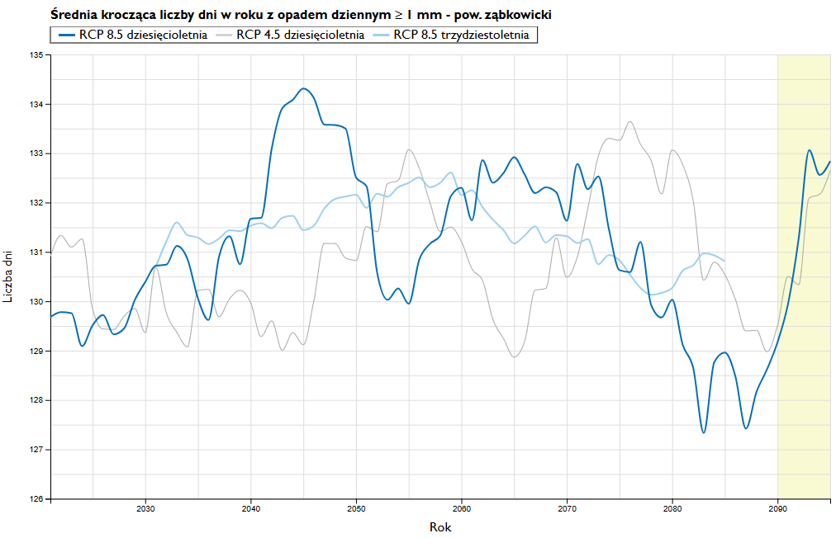
Figure 7 Moving average of the number of days per year with daily precipitation ≥ 1 mm according to the RCP8.5 and RCP4.5 climate scenarios for the project area (Ząbkowice County)
Source: KLIMADA 2.0 Project (https://klimada2.ios.gov.pl/klimat-scenariusze-portal/)
The increase in annual precipitation is primarily due to a rise in the number of days with extreme precipitation, although the upward trend also applies to the precipitation intensity index.
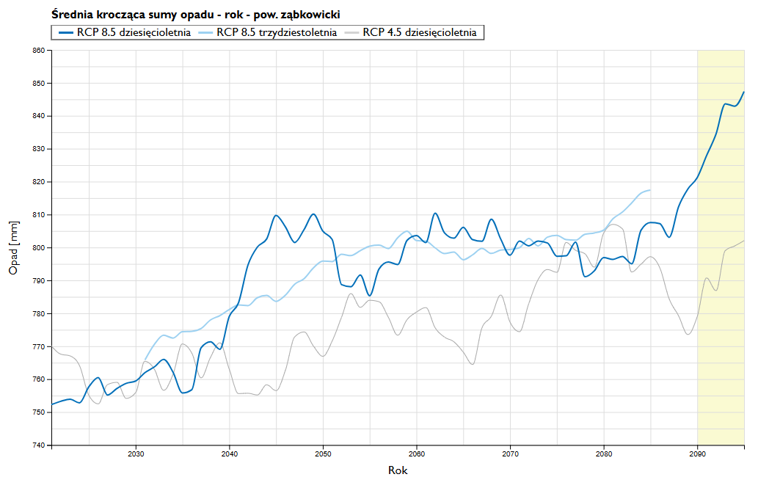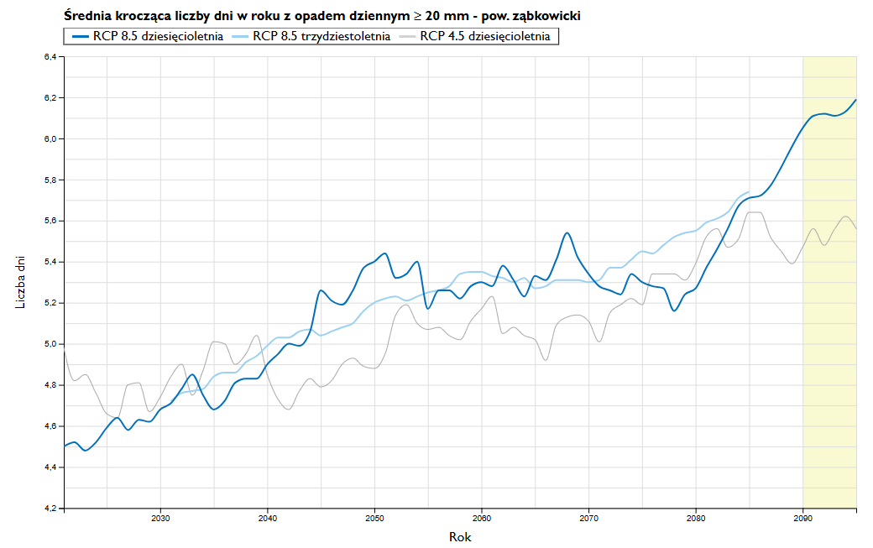
Figure 8 Moving average of total precipitation (left graph) and moving average of the number of days per year with daily precipitation > 20 mm (right graph) according to the RCP 8.5 and RCP 4.5 climate scenarios for the project area (Ząbkowice County)
Source: KLIMADA 2.0 Project (https://klimada2.ios.gov.pl/klimat-scenariusze-portal/)
Both climate scenarios for Poland indicate a clear trend of decrease in the number of days with snow cover and snow depth.
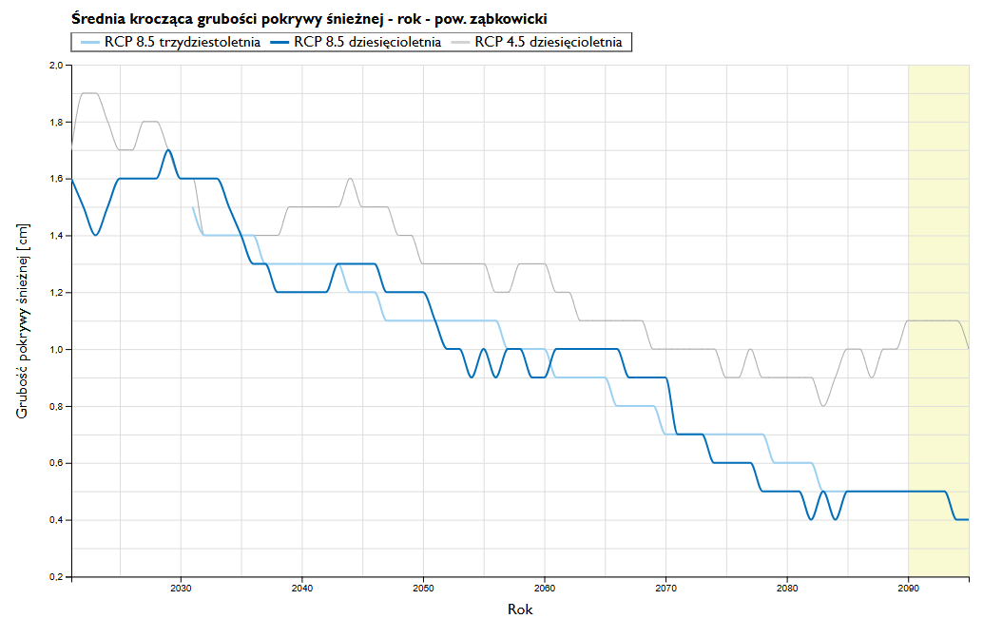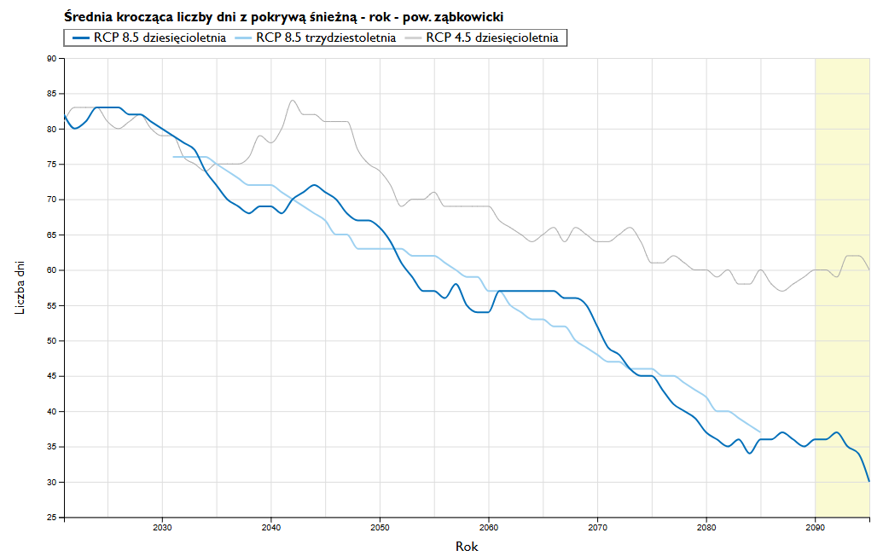
Figure 9 Moving average of the number of days per year with snow cover (left graph) and moving average of snow cover depth (right graph) according to the RCP 8.5 and RCP 4.5 climate scenarios for the project area (Ząbkowice County)
Source: KLIMADA 2.0 Project (https://klimada2.ios.gov.pl/klimat-scenariusze-portal/)
Climate scenarios do not indicate a significant change in average wind speeds; nevertheless, in the coming decades there will be changes in the proportion of high-speed winds, with a slight increase in the number of such extreme events.
Climate change projections for the project region indicate:
- an upward trend in average monthly and annual temperatures, with this increase being more significant in the RCP8.5 scenario. The greatest changes are projected for the winter months (December, January, February) and summer months (June, July, August);
- a projected increase in the frequency of droughts and prolonged heat waves (with daily maximum temperatures above 30°C);
- a projected decrease in the number of freezing and very freezing days;
- a downward trend in both the number of days with snow cover and the average snow depth;
- a decreasing trend in the number of days when the temperature crosses 0°C and days with black ice;
- a projected increase in precipitation intensity;
- cyclical variability in annual precipitation totals over periods of several decades and a general upward trend in annual precipitation totals (as a result of increased precipitation intensity). The increase in precipitation totals primarily affects the eastern part of Poland, but increased precipitation is also evident in mountainous areas and along the coast.

Assessment of the project’s vulnerability to climate change and risk assessment for individual components of the Project
A climate risk analysis was conducted for this Task in accordance with the guidelines set forth in:
- EUROPEAN COMMISSION: Technical Guidance on the Climate Proofing of Infrastructure in the Period 2021–2027 (2021/C 373/01) – hereinafter referred to as the GUIDELINES)
- Guide to the Assessment of Investments in Terms of Climate Impact and Climate Change Adaptation during the 2021–2027 UE Programming Period, August 2023 (Update to the “Guide to Preparing Investments with Regard to Climate Change, Mitigation, Adaptation, and Climate Resilience to Natural Disasters”) – hereinafter referred to as the GUIDE
- Approach to Climate Proofing for Flood and Disaster Risk Management Projects, JASPERS, December 2023
- Case Study: Climate Proofing of a Flood Protection Project, JASPERS, December 2023
The analysis was performed using a tool within the Excel spreadsheet environment, which collects basic information about a given investment, documents the preselection phase, indicates whether the investment requires detailed analysis, and provides solutions to streamline and systematize the conduct of detailed analyses in both pillars, namely:
- Pillar I – climate neutrality,
- Pillar II – climate resilience.
According to the provisions of the GUIDE, the climate resilience analysis should cover at least the following climate factors:
- floods (damage to environmental protection infrastructure, prolonged inability to use damaged infrastructure after the flood subsides). The constructed infrastructure (or purchased equipment) should be protected against flooding as effectively as possible or located outside flood-prone areas (reference to flood hazard maps and flood risk maps prepared in accordance with the Floods Directive No. 2007/60/EC),
- rising temperatures (which may, for example, cause drought and thereby create problems with water supply) and prolonged periods of low temperatures;
- heavy or prolonged rainfall (causing, for example, flooding due to failure of the sewage network),
- storms (resulting, for example, in damage to power and control systems),
- strong winds (causing, for example, damage to energy infrastructure and power outages),
- other phenomena characteristic of the region, such as landslides.
The purpose of this assessment is to ensure an adequate level of infrastructure climate resilience throughout its entire operational life. These effects include extreme events such as major river floods and so-called flash floods, including urban floods, cloudbursts, droughts, heat waves, fires, storms, and landslides, as well as long-term events such as projected sea-level rise and changes in average precipitation levels, soil moisture, air humidity, etc. .
Assessment of the vulnerability of individual Task components and assessment of infrastructure exposure to climate-related hazards, along with a risk assessment

STAGE 1 (PRESELECTION)
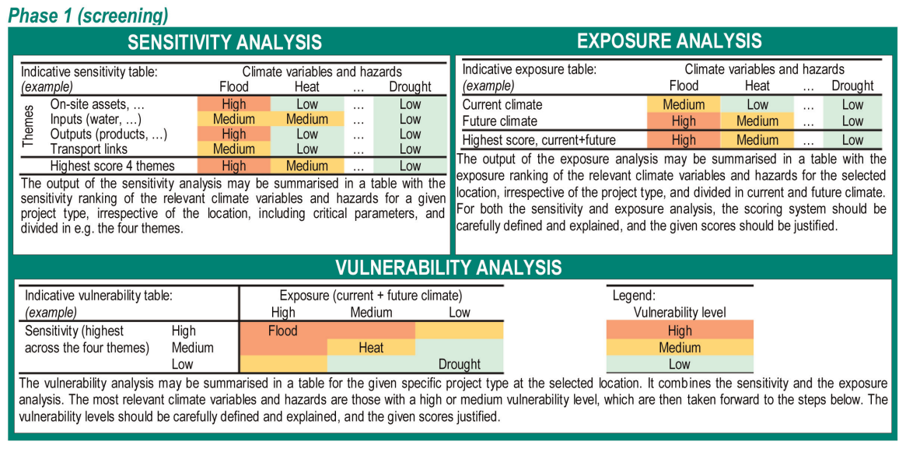
Source: EUROPEAN COMMISSION: Technical Guidance on the Climate-Proofing of Infrastructure in the Period 2021–2027 (2021/C 373/01)
The preselection stage is based on three analyses:
- Sensitivity – relates to the type of project regardless of its location
- Exposure – relates to the project’s location, regardless of its type
- Vulnerability – a combination of sensitivity and exposure
Based on the GUIDELINES AND GUIDE and the recommendations in the document “Approach to climate proofing for flood and disaster risk management projects,” Task sensitivity levels were determined in the context of four key issues covering the main components of the value chain:
- assets and processes at the project site/production site,
- means of production/inputs (water, energy, labor, etc.),
- products/outputs (goods, markets, demand, service levels),
- transport links.
The assessment of the vulnerability of individual task components and the assessment of infrastructure exposure to climate-related hazards are presented below for the main types of infrastructure. For this Task, a sensitivity analysis was conducted taking into account the project’s primary hydrotechnical components: the head dam, side dams and flood embankments.

Sensitivity Analysis
Table 1 Sensitivity - main dam with discharge facilities and fish passage, water retention in the reservoir
Climatic factor | Sensitivity | Comments*
Gradual increase in air temperature |  | Potential change in the operating conditions of the wetland system
Extreme increase in air temperature |  | Potential change in the operating conditions of the wetland system  Unlikely to affect flood control structures; however, depending on their design and the materials used, they may be susceptible to cracking.  Possible problems with power supply and overheating of electrical equipment
Gradual changes in precipitation |  | Potential impact of increased humidity or drought conditions on available storage capacity, especially if subsequent storms occur more frequently.
Extreme rainfall |  | Increased facility maintenance costs (significant impact): Heavy rainfall may increase sediment supply in the upper reaches of the river, which may necessitate more frequent sediment removal.  Possible impacts during the construction phase (will negatively affect the completion date and/or the total construction cost)  Possible power outages caused by flooding of the transmission grid (moderate impact).  Possible flooding of access roads (moderate impact)
Average wind speed |  | No impact
Maximum wind speed |  | Potential damage to buildings and infrastructure.  Strong winds may affect above-ground power distribution networks serving facilities (moderate impact)
Humidity |  | No impact
Solar radiation |  | No impact
Relative sea level rise |  | Potential for gradual changes in water levels downstream. This could lower the standard of flood protection.
Sea water temperature |  | No impact (No correlation between coastal changes and river flood control infrastructure)
Water availability |  | In the event of extremely low flows beyond the design drought conditions, the reservoir’s water-storage function may be impaired, and it may not be possible to maintain the planned releases.
Storms |  | Impacts similar to those of extreme rainfall
Floods (coastal and river) |  | Exceeding design conditions may result in failure or structural damage / impact during the construction phase (will negatively affect the completion date or the total cost of their construction)  Increased costs: post-flood maintenance of the structure  Possible power outages caused by flooding of the transmission grid and possible flooding of access roads (moderate impact)
Ocean pH level |  | No impact (no link between coastal changes and river flood control infrastructure)
Coastal erosion |  | Significant impact on infrastructure integrity
Soil erosion |  | Significant impact on infrastructure integrity
Soil salinization |  | No impact
Wildfires |  | Significant impact - a fire can destroy operational facilities
Air quality |  | No impact
Ground instability / landslides |  | Significant impact on infrastructure integrity
Urban heat island |  | No impact
Length of the growing season |  | No impact
Cold waves |  | Prolonged freezing of the system - possible impact on the functionality of moving objects.  Potential increase in electricity demand.
Frequency of temperature crossing 0°C |  | Damage to concrete structures and electrical power supply (above-ground infrastructure is more susceptible to temperature fluctuations).
*Taking into account the provisions of the GUIDE and the entries in Table 4.2 of the study “Approach to climate proofing for flood and disaster risk management projects” (JASPERS, August 2023) and Table 4.1 of the study “Case Study: Climate proofing of a flood protection project,” JASPERS, December 2023

Table 2 Vulnerability – side dams / flank dams, levees
Climate factor | Vulnerability | Comments*
Gradual increase in air temperature |  | No effect
Extreme increase in air temperature |  | It is unlikely that rising temperatures will affect flood control embankments; however, depending on the design and materials used, they may be susceptible to cracking (e.g., clay embankments)
Gradual changes in precipitation |  | No effect
Extreme rainfall |  | Possible impact with potential scouring of raised embankments / impact during the construction phase (will negatively affect the completion date or the total cost of construction)
Average wind speed |  | No effect
Maximum wind speed |  | Significant impacts if any trees on the embankments fall and damage the levees, which could result in a breach or failure. flood control levees are built to withstand wind speeds, so there is no direct impact
Humidity |  | No significant impact; increased costs of maintaining green spaces; potential impact of changes in soil moisture on earthen embankments
Solar radiation |  | No effect
Relative sea-level rise |  | Possibility of a gradual change in water levels downstream. This could lower the standard of flood protection
Sea water temperature |  | No effect
Water availability |  | No effect
Storms |  | Impacts similar to those of extreme rainfall
Floods (coastal and river) |  | Exceeding design conditions may result in failure or structural damage to the levee / impact during the construction phase (will negatively affect the completion and/or the total cost construction)
Ocean pH |  | No effect
Coastal erosion |  | Significant impact on infrastructure integrity
Soil erosion |  | Significant impact on infrastructure integrity
Soil salinization
Wildfires |  | Significant impact - fire can destroy the structure
Air quality |  | No effect
Ground instability / landslides |  | Significant impact on infrastructure integrity
Urban heat island |  | No effect
Length of the growing season |  | No effect
Cold waves |  | Unlikely to affect the structure of the levees
Frequency of temperatures crossing 0°C |  | Minor damage to concrete structures and earthen embankments
*taking into account the provisions of the GUIDE and Table 4.2 of the study “Approach to climate proofing for flood and disaster risk management projects” (JASPERS, August 2023) and Table 4.1 of the study “Case Study: Climate proofing of a flood protection project,” JASPERS, December 2023

Table 3 Vulnerability – river channel reconstruction
Climate factor | Vulnerability | Comments*
Gradual increase in air temperature |  | No impact
Extreme increase in air temperature |  | No impact
Gradual changes in precipitation |  | A potential impact on channel morphology and sediment distribution may occur in response to changes in rainfall patterns
Extreme rainfall |  | Potential changes to the channel bed and sediment deposition/erosion
Average wind speed |  | No impact
Maximum wind speed |  | No impact
Humidity |  | Potential drying of riverbanks that could affect their stability
Solar radiation |  | No impact
Relative sea-level rise |  | Possibility of a gradual change in water levels downstream. This could lower the standard of flood protection / flood risk management.
Sea water temperature |  | No impact (No correlation between coastal changes and river flood control infrastructure)
Water availability |  | No impact
Storms |  | No significant impact
Floods (coastal and river) |  | Exceeding design parameters may result in a change in the channel bed
Ocean pH |  | No impact (no link between coastal changes and river flood control infrastructure)
Coastal erosion |  | Significant impact on the integrity of the infrastructure
Soil erosion |  | Potential reduction in channel capacity due to increased sediment inflow into the river system
Soil salinization |  | No impact
Wildfires |  | Potential loss of riparian vegetation that could destabilize earthen levees
Air quality |  | No impact
Ground instability / landslides |  | A significant impact could result in changes to the channel bed.
Urban heat island |  | No impact
Length of the growing season |  | No impact
Cold spells |  | No impact
Frequency of temperatures crossing 0°C |  | No significant impact. Minor damage to concrete structures or culverts
*taking into account the provisions of the GUIDE and the entries in Table 4.2 of the study “Approach to climate proofing for flood and disaster risk management projects” (JASPERS, August 2023) and Table 4.1 of the study “Case Study: Climate proofing of a flood protection project,” JASPERS, December 2023

Exposure levels were determined based on available data, including:
- Klimada 2.0 Project
- Landslide Protection System (SOPO)
- Flood Hazard Maps / FRMP Update for the Vistula River Basin (FRMP)
- Topographic Objects Database (BDOT)
The exposure assessment was prepared for two time horizons: the current climate and the future climate. The time horizon of 2091–2100 was adopted as the “future climate” due to the nature of the planned investment. The analyses assumed climate change according to the pessimistic scenario, i.e., RCP 8.5.
Table 4 Exposure
Climate Factor | Exposure
Climate Factor | Current climate | Future climate | Final Level
Gradual increase in air temperature | low | medium | medium
Extreme rise in air temperature | medium | high | high
Gradual changes in precipitation | low | medium | medium
Extreme rainfall | medium | high | high
Average wind speed | low | low | low
Maximum wind speed | low | medium | medium
Humidity | low | low | low
Solar radiation | low | low | low
Relative sea level rise | not applicable | not applicable | not applicable
Sea water temperature | not applicable | not applicable | not applicable
Water availability | low | medium | medium
Storms | low | medium | medium
Floods (coastal and river) | high | high | high
Ocean pH | not applicable | not applicable | not applicable
Coastal erosion | not applicable | not applicable | not applicable
Soil erosion | low | medium | medium
Soil salinity | not applicable | not applicable | not applicable
Wildfires | low | medium | medium
Air quality | medium | medium | medium
Ground instability / landslides | Moderate* | Moderate* | Moderate*
Urban heat island | low | low | low
Length of the growing season | low | low | low
Frost waves | medium | low | medium
Frequency of temperature crossing 0°C | medium | medium | medium
*Applies exclusively to the Suszka area, where local ground displacement and landslides were recorded in the 1970s (a left-bank side dam / flank dam is located in this area)
Vulnerability Analysis
In accordance with the Guidelines, vulnerability (V) was calculated as follows:
V = S × E,
where:
- S denotes the degree of vulnerability of the assets,
- E denotes exposure to underlying (reference) climatic conditions / effects / impacts.
Compiling the results of sensitivity and exposure analyses—which combine an assessment of both the characteristics of the planned infrastructure (sensitivity) and the local conditions determining the occurrence and intensity of climate-related and environmental hazards (exposure)—enables a vulnerability analysis to be conducted. In accordance with the GUIDELINES, a high level of vulnerability, as determined for a given climate factor, requires the Project Owner / Investor to conduct detailed risk assessment analyses, taking into account the probability of occurrence and the negative impact of a given climate phenomenon or factor.

BARRIER
Pillar 2 of the CP - Climate Change Adaptation -> Climate Change Adaptation
 |  | Gradual increase in air temperature | Increase in extreme air temperatures | Gradual changes in precipitation | Extreme rainfall | Average wind speed | Maximum wind speed | Humidity | Solar radiation | Relative sea level rise | Sea water temperature | Water availability | Storms | Floods (coastal and river) | Ocean pH | Coastal erosion | Soil erosion | Soil salinity | Wildfires | Air quality | Land instability / landslides | Urban Heat Island | Length of the growing season | Cold waves | Temperature crossing 0
Sensitivity |  | 2 | 2 | 2 | 3 | 1 | 2 | 1 | 1 | 2 | 1 | 1 | 2 | 3 | 1 | 3 | 3 | 1 | 3 | 1 | 3 | 1 | 1 | 2 | 2
Exposure |  | 2 | 3 | 2 | 3 | 1 | 2 | 1 | 1 | 0 | 0 | 2 | 2 | 3 | 0 | 0 | 2 | 0 | 2 | 2 | 1 | 1 | 1 | 2 | 2
VULNERABILITY |  | 4 | 5 | 4 | 6 | 2 | 4 | 2 | 2 | 2 | 1 |  | 4 | 6 | 1 | 3 | 5 | 1 | 5 | 3 | 4 | 2 | 2 | 4 | 4
 | Detailed analyses under Pillar 2 (i.e., risk analysis) should be conducted for the following factors: |  |  |  |  |  |  |  |  |  |  |  |  |  |  |  |  |  |  |  |  | SCALE |  | Not applicable
 | Increase in extreme air temperatures |  |  |  |  |  |  |  |  |  |  |  |  |  |  |  |  |  |  |  |  | SCALE |  | Low
 | Extreme rainfall |  |  |  |  |  |  |  |  |  |  |  |  |  |  |  |  |  |  |  |  | SCALE |  | Moderate
 | Floods (coastal and river) |  |  |  |  |  |  |  |  |  |  |  |  |  |  |  |  |  |  |  |  | SCALE |  | High
 | Soil erosion
 | Water availability Wildfires
SIDE DAMS / EARTHEN EMBANKMENTS
Pillar 2 of the CP - Climate Change Adaptation -> Climate Change Adaptation
 |  | Gradual increase in air temperature | Increase in extreme air temperatures | Gradual changes in precipitation | Extreme rainfall | Average wind speed | Maximum wind speed | Humidity | Solar radiation | Relative sea level rise | Sea water temperature | Water availability | Storms | Floods (coastal and river) | Ocean pH | Coastal erosion | Soil erosion | Soil salinity | Wildfires | Air quality | Land instability / landslides | Urban heat island | Length of the growing season | Cold waves | Temperature crossing zero
Sensitivity |  | 1 | 1 | 1 | 2 | 1 | 3 | 1 | 1 | 2 | 1 | 1 | 2 | 3 | 1 | 3 | 3 | 1 | 3 | 1 | 3 | 1 | 1 | 1 | 1
Exposure |  | 2 | 3 | 2 | 3 | 1 | 2 | 1 | 1 | 0 | 0 | 2 | 2 | 3 | 0 | 0 | 2 | 0 | 2 | 2 |  | 1 | 1 | 2 | 2
VULNERABILITY |  | 3 | 4 | 3 | 5 | 2 | 5 | 2 | 2 | 2 | 1 | 3 | 4 | 6 | 1 | 3 | 5 | 1 | 5 | 3 |  | 2 | 2 | 3 | 3
 | Detailed analyses under Pillar 2 (i.e., risk analysis) should be conducted for the following factors: |  |  |  |  |  |  |  |  |  |  |  |  |  |  |  |  |  |  |  |  | SCALE |  | Not applicable
 | Extreme rainfall |  |  |  |  |  |  |  |  |  |  |  |  |  |  |  |  |  |  |  |  | SCALE |  | Low
 | Maximum wind speed |  |  |  |  |  |  |  |  |  |  |  |  |  |  |  |  |  |  |  |  | SCALE |  | Average
 | Floods (coastal and river) |  |  |  |  |  |  |  |  |  |  |  |  |  |  |  |  |  |  |  |  | SCALE |  | High
 | Soil erosion
 | Wildfires Ground instability/landslides
RIVER CHANNELS – RECONSTRUCTION
Pillar 2 of the Climate Policy – Climate Change Adaptation -> Climate Change Adaptation
 |  |  | Gradual increase in air temperature | Increase in extreme air temperatures | Gradual changes in precipitation | Extreme rainfall | Average wind speed | Maximum wind speed | Humidity | Solar radiation | Relative sea level rise | Sea water temperature | Water availability | Storms | Floods (coastal and river) | Ocean pH | Coastal erosion | Soil erosion | Soil salinity | Wildfires | Air quality | Land instability / landslides | Urban heat island | Length of the growing season | Cold waves | Temperature crossing zero
Sensitivity |  | 1 |  | 1 | 2 | 2 | 1 | 2 | 2 | 1 | 2 | 1 | 1 | 1 | 3 | 1 | 3 |  | 1 | 2 | 1 | 3 | 1 | 1 | 1 | 1
Exposure |  | 2 |  | 3 | 2 | 3 | 1 | 2 | 1 | 1 | 0 | 0 | 2 | 2 | 3 | 0 | 0 | 2 | 0 | 2 | 2 |  | 1 | 1 | 2 | 2
VULNERABILITY |  | 3 |  | 4 | 4 | 5 | 2 | 4 | 3 | 2 | 2 | 1 | 3 | 3 | 6 | 1 | 3 |  | 1 | 4 | 3 |  | 2 | 2 | 3 | 3
 | Detailed analyses under Pillar 2 (i.e., risk analysis) should be conducted for the following factors: |  |  |  |  |  |  |  |  |  |  |  |  |  |  |  |  |  |  |  |  |  | SCALE |  | Not applicable
 | Extreme rainfall |  |  |  |  |  |  |  |  |  |  |  |  |  |  |  |  |  |  |  |  |  | SCALE |  | Low
 | Floods (coastal and river) |  |  |  |  |  |  |  |  |  |  |  |  |  |  |  |  |  |  |  |  |  | SCALE |  | Moderate
 |  |  |  |  |  |  |  |  |  |  |  |  |  |  |  |  |  |  |  |  |  |  | SCALE |  | High

Stage 2: Risk Analysis
An risk analysis was conducted for the climate-related risk factors to which the Task is highly vulnerable.
The risk assessment module is a structured method for analyzing climate hazards and their impacts, providing the information necessary for decision-making. This process involves assessing the likelihood of occurrence and the severity of impacts associated with the hazards identified during the preselection stage, as well as evaluating the significance of such risks for the Task’s implementation.
In the climate risk analysis, each risk factor with high vulnerability was subjected to an analysis of the scale of impacts in the context of:
- damage to fixed assets,
- safety and health,
- the natural environment,
- social impacts,
- financial impacts,
- impact on reputation.
In accordance with the GUIDELINES outlined in the introduction to the climate change adaptation analysis, the following scale of probability of climate impacts was applied:
- rare (probability of occurrence within a year: < 5%)
- unlikely (probability of occurrence within a year: 5%–20%)
- moderate (probability of occurrence within a year: 20%–50%)
- likely (annual probability of occurrence: 50%–80%)
- almost certain (probability of occurrence within a year > 80%)
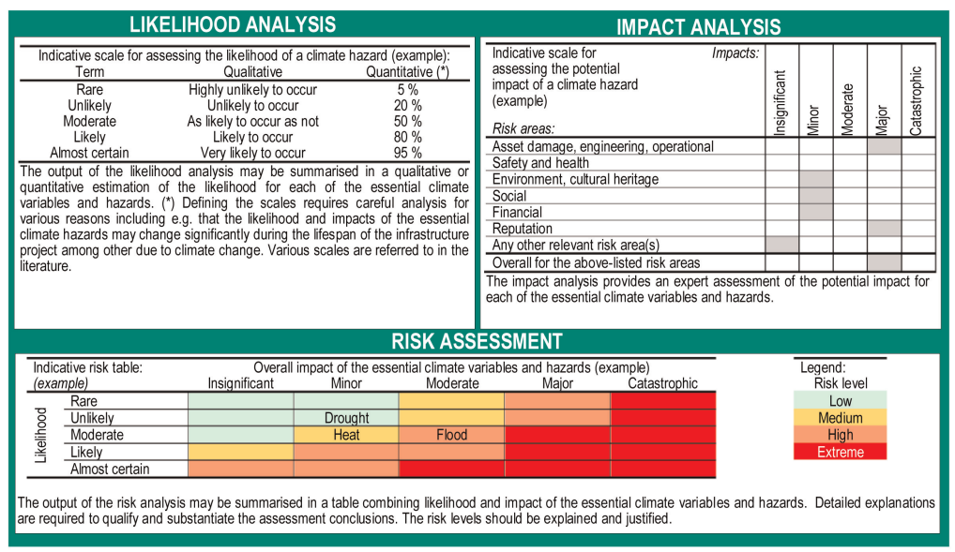
Source: EUROPEAN COMMISSION: Technical Guidance on the Climate-Proofing of Infrastructure in the Period 2021–2027 (2021/C 373/01)

DAM
Risk factor | Property damage, engineering, operational activities | Safety and health | Environment | Social | Financial | Reputation | Cultural Heritage and Cultural Sites | OVERALL IMPACT
Increase in extreme air temperatures | Minor | Minor | Insignificant | Insignificant | Minor | Minor | Insignificant | Minor
Extreme rainfall | Major | Major | Moderate | Major | Major | Major | Moderate | Major
Floods (coastal and river) | Catastrophic | Catastrophic | Major | Catastrophic | Catastrophic | Catastrophic | Major | Catastrophic
Soil erosion | Moderate | Minor | Minor | Moderate | Moderate | Moderate | Insignificant | Moderate
Water availability | Minor | Moderate | Moderate | Moderate | Minor | Moderate | Insignificant | Moderate
Wildfires | Major | Major | Moderate | Moderate | Major | Moderate | Insignificant | Major

Task No. | CONSTRUCTION OF THE RESERVOIR  KAMIENIEC ZĄBKOWICKI | Project Name | Main dam / head dam
No. | Risk factor—high vulnerability | Probability | Impact | Is it necessary to identify adaptation options?
1 | Increase in extreme air temperatures | Moderate | Minor | No need to identify adaptation options
2 | Extreme rainfall | Moderate | Major | Identification of adaptation options required
3 | Floods (coastal and river) | Rare | Catastrophic | Identification of adaptation options required
4 | Soil erosion | Moderate | Moderate | Identification of adaptation options required
5 | Water availability | Unlikely | Moderate | No need to identify adaptation options
6 | Wildfires | Unlikely | Major | Identification of adaptation options required

SIDE DAMS / EARTHEN EMBANKMENTS
Risk factor | Property damage, engineering, operational activities | Safety and health | Environment | Social | Financial | Reputation | Cultural Heritage and Cultural Sites | OVERALL IMPACT
Extreme rainfall | Moderate | Minor | Insignificant | Moderate | Minor | Moderate | Insignificant | Moderate
Maximum wind speed | Moderate | Minor | Insignificant | Moderate | Minor | Moderate | Insignificant | Moderate
Floods (coastal and river) | Catastrophic | Catastrophic | Major | Catastrophic | Catastrophic | Major | Moderate | Catastrophic
Soil erosion | Moderate | Minor | Minor | Moderate | Moderate | Moderate | Insignificant | Moderate
Wildfires | Moderate | Moderate | Moderate | Moderate | Moderate | Minor | Insignificant | Moderate
Ground instability/landslides | Catastrophic | Catastrophic | Major | Catastrophic | Catastrophic | Major | Moderate | Catastrophic

CONSTRUCTION OF THE RESERVOIR  KAMIENIEC ZĄBKOWICKI | Project Name | SIDE DAMS, EMBANKMENTS
Risk factor—high vulnerability | Probability | Impact | Is it necessary to identify adaptation options?
Extreme rainfall | Moderate | Moderate | Identification of adaptation options is required
Maximum wind speed | Unlikely | Moderate | No need to identify adaptation options
Floods (coastal and river) | Rare | Catastrophic | Identification of adaptation options is required
Soil erosion | Moderate | Moderate | Identification of adaptation options is required
Wildfires | Unlikely | Moderate | No need to identify adaptation options
Land instability/landslides | Unlikely | Catastrophic | Identification of adaptation options is required

RIVER CHANNELS – RECONSTRUCTION
Risk factor | Property damage, engineering, operational activities | Safety and health | Environment | Social | Financial | Reputation | Cultural Heritage and Cultural Sites | OVERALL IMPACT
Extreme rainfall | Moderate | Insignificant | Minor | Moderate | Minor | Moderate | Insignificant | Moderate
Floods (coastal and river) | Major | Major | Moderate | Major | Moderate | Major | Insignificant | Major

Task No. | CONSTRUCTION OF THE RESERVOIR  KAMIENIEC ZĄBKOWICKI | Project Name | Watercourse Channels—Reconstruction
No. | Risk factor—high vulnerability | Probability | Impact | Is it necessary to identify adaptation options?
1 | Extreme rainfall | Moderate | Moderate | Identification of adaptation options is required
2 | Floods (coastal and river) | Rare | Major | Identification of adaptation options is required

The results of the risk analysis are presented in a risk matrix, which provides a visual summary of the climate risk analysis resulting from the multiplication of the impact scores and the probability of occurrence for individual climate impacts.

RISK MATRIX
Probability | Almost certain | 5
Probability | Likely | 4
Probability | Moderate | 3 |  | Rise in extreme air temperatures (DAM) | Soil erosion (DAM, EMBANKMENTS)  Extreme rainfall (RIVER CHANNELS, EMBANKMENTS) | Extreme rainfall (DAM)
Probability | Unlikely | 2 |  |  | Wildfires (EMBANKMENTS)  Maximum wind speed (EMBANKMENTS)  Water availability  (DAM) | Wildfires (DAM) | Slope instability / landslides (EMBANKMENTS)
Probability | Rare | 1 |  |  |  | Floods (RIVER CHANNELS) | Floods (DAM, EMBANKMENTS)
 |  |  | 1 | 2 | 3 | 4 | 5
 |  |  | Insignificant | Minor | Moderate | Major | Catastrophic
 |  |  | Impact / Effect

No need to present adaptation options
No need to present adaptation options
Requirement to present adaptation options
Requirement to present adaptation options
With regard to the project in question, a substantial risk associated with the following climate-related risk factors has been identified:
- Floods and extreme rainfall (DAM, EMBANKMENTS, RIVER CHANNELS)
This risk applies to all components of the Task. The risks particularly concern the assets and on-site operations due to the potential damage of infrastructure by flooding. With regard to the reservoir components, particularly the main dam / head dam or side dams, the risks apply to all analyzed impact categories (i.e., damage to fixed assets, safety and health, the natural environment, social impacts, financial impacts, and impact on reputation). In the event of a major dam/reservoir failure, the consequences could reach catastrophic levels. One of the most dangerous mechanisms that could lead to damage—and, in extreme cases, to the failure of an earthen dam—is the overflow of water over the dam’s crest. Prolonged or extreme rainfall intensifies erosion processes, including internal erosion and suffusion in the soil. These processes can result in the loss of structural stability.
Flooding or inundation caused by heavy rains can also hinder earthwork and construction activities, pose a threat to construction machinery and equipment, and even endanger the health and lives of construction workers.
- Soil Erosion (SIDE DAM, EMBANKMENTS)
The need to identify adaptation options was determined due to the risk associated with the scouring of embankments or the loss of stability of dam components. These risks pertain in particular to the “assets and on-site processes” category due to potential damage to infrastructure. This risk is associated with and intensifies in connection with extreme rainfall events. The risks apply to all analyzed impact categories (i.e., damage to fixed assets, safety and health, the natural environment, social impacts, financial impacts, and impact on reputation). Soil erosion may lead to damage to and scouring of the dam body and the reservoir embankments.
- Wildfires (DAM)
With regard to the dam, a risk of hazards caused by wildfires has been identified. These can cause damage to or destruction of building structures or power/control systems, meaning they primarily affect the areas of “assets and processes at the project site” and “project outputs/results (quality of services provided).” In extreme situations, they may cause uncontrolled water discharge from the reservoir.
- Ground Instability / Landslides (EMBANKMENTS)
Locally, in the area around the village of Suszka, local landslides were recorded in the 1970s. It was assumed that local landslides or slope failures could potentially occur on the high banks of the reservoir. This risk is indicated primarily in relation to the naturally high left bank located within the reservoir basin. The occurrence of these phenomena could cause the high banks of the reservoir basin to lose stability.
Summary:
Due to the Task’s location in the Nysa Kłodzka River valley, extreme hydrological and meteorological phenomena are of the greatest significance, particularly intense and prolonged precipitation, sudden rises in water levels, and floods. All of these phenomena are intensified by ongoing climate change. Soil erosion, which reduces the durability of structures, is a critical factor affecting the durability and stability of earthen flood control structures, particularly earthen embankments. The phenomenon of erosion is exacerbated by heavy rains, periods of drought, and heat waves. In conjunction with processes related to groundwater flow (sufosion, internal erosion), these factors also threaten the stability of structures by affecting their foundation levels. The possibility of localized landslide hazards cannot be ruled out either.
Analysis of Proposed Adaptation Options
- Assessment of climate-related hazards shows that fundamental adaptation measures should focus on reducing the likelihood of structural failures that could cause the complete loss of, or major damage to, the dam, spillway facilities, hydropower plant, and other reservoir infrastructure. Such failures may result from dam or foundation instability, uncontrolled or excessive seepage, internal erosion and suffusion, surface erosion, deterioration of structural elements, malfunction of gates or other closure equipment—including fire-related failures—or flood related conditions beyond those assumed in the original design. Anticipated climate change is expected to increase the severity and probability of all these hazards.
- The structures will be designed taking into account the design and control river flows specific to the facility’s assigned hydrotechnical structure importance class
- The main discharge facilities and emergency discharge facilities have been designed to ensure the highest possible level of hydraulic safety for the reservoir. Their combined capacity, at a water level up to the extraordinary impoundment level, has been selected so that even in the event of the emergency unavailability of some of the gates, it is possible to safely discharge a flow corresponding to the control water level.
- An additional safeguard against water overflowing the dam crest is the significant height and volume reserve maintained above the extraordinary impoundment level. In the event of a flood exceeding the values specified in the standard requirements, the reservoir capacity between the extraordinary impoundment level and the dam crest elevation provides additional capacity for the temporary storage of excess water. At the same time, as the impoundment level rises, the discharge capacity of the discharge facilities increases, which further enhances the reservoir’s ability to discharge inflowing water.
- The risk of a structural failure, including that caused by climatic factors, will be mitigated as early as the design stage through proper sizing of the structure, ensuring the required stability of the structure and the foundation, installing protective measures and anti-seepage screens, ensuring the continuity of sealing elements, and properly shaping the interface zones between concrete structures and earthen dam bodies.
- A key safety element will be a control and monitoring system covering, among other things, the observation of displacements and deformations, seepage, water pressures in the subsoil and dam bodies, and the technical condition of structures and equipment. Regular inspections will enable the early detection of irregularities and the implementation of preventive measures.
- In order to minimize the possibility of water overtopping the dam crest during extreme flood events and to reduce the likelihood of other emergency situations, the following measures are specifically provided for:
- The dam crest is elevated by 3.0 m above the maximum impoundment level for the design flood, with a minimum elevation of 1.3 m required by regulations, and by 2.0 m above the extraordinary impoundment level, with a minimum elevation of 0.3 m required by regulations. The adopted values therefore provide a significant additional safety margin beyond the minimum requirements;
- Construction of a parapet along the dam crest, 1.2 m above the dam crest elevation, providing additional protection against the possibility of water overflow, particularly when the reservoir surface is waving;
- Extending the upper edge of the dam body’s sealing elements on the downstream side to the dam crest elevation, which will ensure the continuity of the anti-seepage protection even in the event of water levels exceeding the maximum operating levels;
- Equipping the reservoir with maintenance-free emergency discharge facilities which operation will not depend on decisions or actions taken by operating personnel. In emergency situations, the flood wave will be discharged through these devices automatically, without human intervention. This solution significantly reduces the risk arising from a delayed response, an incorrect decision, or a failure to act on the part of the operating staff in an extreme situation;
- Setting the capacity of emergency discharge facilities at an extraordinary impoundment level to a level corresponding to the full design flow, thereby ensuring that these facilities are capable of independently handling very high flows even if the use of the main discharge facilities is restricted;
- Verification of the reservoir’s operating conditions, including in the event of simultaneous flood flow and failure of the discharge structures. Analyses were conducted for both the design flow and the control flow, adopting a more rigorous approach than the minimum scope of verification required by regulations, which mandate consideration of such a situation only for the design flow;
- Verification of the capacity of the spillway structures and the downstream area to safely dissipate the energy of the flowing water through model tests. The adopted solutions were tested both on a physical model and through mathematical modeling, which enabled an assessment of flow conditions, energy dissipation, and the impact of the flow on the structure and the downstream area;
- Equipping the structure with a system of automatic control and measurement devices, enabling real-time reading and recording of parameters relevant to the facility’s safety. The system will allow for continuous monitoring of the structure’s behavior and rapid detection of changes that may indicate the onset of undesirable or emergency conditions.
- Design and installation of fire protection systems in accordance with applicable regulations.
The adopted solutions form a multi-level safety system in which the safety of the reservoir does not depend on a single device or a single method of water management. The appropriate elevation of the dam crest, an additional parapet, automatic emergency devices, increased discharge capacity of the discharge facilities, provisions for the failure of primary equipment, and continuous monitoring of the facility ensure that the possibility of water overflowing the dam crest has been limited to a level corresponding to exceptional, extremely unlikely events.
- During the design of the reservoir, special attention was given to minimizing the risk of suffusion and soil erosion. To eliminate the possibility of such phenomena occurring, the following measures are incorporated into the design:
- A continuous sealing system for the dam body and foundation, including filter screens and appropriately shaped connections to the filter screens of concrete structures. Particular attention was paid to the contact zones between the earthen dam body and the abutments, the main and emergency discharge facilities, and other structures, as these areas may constitute potential preferential filtration paths.
- The dam body was designed using appropriately selected and compacted soil materials. The arrangement of individual zones will be designed to limit the possibility of soil particle migration under the influence of seepage flow. In areas requiring protection, filtration and transition layers will be installed to retain soil particles while allowing for the controlled drainage of seepage water. This solution prevents internal erosion and the development of suffusion.
- Filtration water will be collected and discharged in a controlled manner through the proposed drainage system, which will limit the potential for pore pressure buildup in the dam body and foundation, as well as the occurrence of uncontrolled seepage on the dry slope.
- Slopes and embankment surfaces exposed to water will be additionally protected against surface erosion. On the downstream side, protective measures will be selected taking into account the effects of wave action, water level fluctuations, and flow currents, while on the spillway side, proper drainage of stormwater will be ensured and the surface will be protected against local scouring.
- Monitoring of seepage phenomena will also be a key element of the safety system. Monitoring and measurement equipment will enable observation of water levels and pressures within the dam body and the subsoil, as well as control over the magnitude and nature of seepage flows. This will allow for the rapid detection of any changes that may indicate the development of adverse processes.
The adopted design solutions ensure that the risk of suffusion, internal erosion, and scouring of the dam body will be minimized. Ensuring the continuity of seals, the proper arrangement of filters and drains, adequate soil compaction, and constant monitoring of the structure’s behavior is intended to prevent the emergence of mechanisms that could lead to damage to the dam body; the potential occurrence of such phenomena should be assessed as extremely unlikely.
- All reservoir spillway structures have been designed to ensure their stability, durability, and resistance to hydraulic loads occurring both during normal reservoir operation and under flood flow conditions:
- The main discharge facilities and hydroelectric power plant complex, as well as the emergency discharge facilities, have been designed as massive reinforced concrete structures capable of withstanding significant loads resulting from water pressure, dead weight, the operation of gate mechanisms, and the dynamic effects of flowing water. The sufficiently large mass and stiffness of the structure limit the possibility of excessive displacement, rotation, shifting, or loss of stability of the structure.
- Given the nature of the structure and the need to ensure a high level of safety, spillways are designed to be founded on piles. Pile foundations allow loads to be transferred to deeper, sufficiently load-bearing soil layers and limit the impact of any weaker or more deformable soil layers located directly beneath the foundations. This solution will also reduce the risk of excessive and uneven settlement, which could lead to cracks, leaks, or undesirable displacements of individual structural segments. This is particularly important for structures equipped with closures and mechanical devices that require the structure to maintain its proper geometry throughout its entire service life.
- Pile foundations will increase the structure’s resistance to the effects of potential local soil erosion in the vicinity of the discharge facilities and the downstream station. Even in the event of a partial lowering of the riverbed elevation or loosening of the near-surface soil layers, the structure’s primary loads will be transferred to deeper soil layers via the piles.
- An additional safety measure will be the proper protection of the subgrade against seepage. Anti-seepage barriers located beneath the structures will be connected to the dam’s barriers, ensuring the continuity of the sealing system and limiting the possibility of preferential seepage paths forming beneath the foundations and at the points where the structures meet the dam body.
- The capacity of the discharge facilities and the downstream area to safely convey flows and dissipate the energy of the water has been verified through hydraulic calculations and model tests using physical and mathematical models. This will help reduce the risk of excessive velocities, cavitation, localized scouring, and other phenomena that could adversely affect the structure and its foundation.
The use of a massive reinforced concrete structure, pile foundations, continuous anti-seepage protection, and appropriately designed protective measures at the downstream end means that the risk of loss of stability, excessive settlement, scouring, or damage to the spillway structures should be assessed as extremely unlikely.
- When designing the left-bank flank dam, special attention was given to the area around the village of Suszka, where local landslides were recorded in the 1970s. For this reason, this area was treated as a zone requiring detailed investigation and increased monitoring during the design phase and future operation of the reservoir. The Suszka area will also be subject to special monitoring using control and measurement devices capable of detecting any potential displacements, deformations, and changes in groundwater conditions in the subsurface. This will allow for ongoing assessment of the site’s stability and early detection of any adverse changes. The combination of detailed geological and hydrogeological surveys, appropriate terrain shaping, and continuous monitoring during operation will minimize the risk of landslides recurring in this area.
- Additionally, to reduce the risk of slope instability, appropriate bank shaping has been planned, including grading the slope to angles that ensure the required stability, as well as the installation of appropriate reinforcements and erosion control measures. The slope design has been adapted to the geological and geotechnical conditions of the subsoil and to the variable hydrological conditions associated with the filling and emptying of the reservoir. These solutions will reduce the likelihood of local landslides, slope failures, and erosion, including under conditions of fluctuating water levels in the reservoir.
- To properly assess the subsoil conditions for the entire project, geological-engineering and hydrogeological documentation is being prepared. These studies aim to determine the geological structure, soil and water conditions, and geotechnical parameters of the subsoil, as well as to identify any zones of weakness and areas prone to loss of stability. The results of this assessment will form the basis for adopting appropriate design solutions, including the shaping of slopes, their potential reinforcement, and the method of drainage.
- Other non-technical measures / contingency planning
- Verification of emergency conditions during the design phase: To assess the potential consequences of a possible disaster and its impact on the areas located downstream of the reservoir, two emergency scenarios leading to uncontrolled outflow of water from the reservoir were analyzed. The first scenario assumes the simultaneous opening of the gates and a sudden increase in outflow from the reservoir. The second scenario involves damage to the earthen dam body resulting from the development of uncontrolled seepage, leading to hydraulic failure, progressive internal erosion of the dam body material, the formation of a breach, and, consequently, the uncontrolled emptying of the reservoir. Hydraulic calculations were performed for the assumed scenarios, based on which the maximum flow rate of the wave resulting from the event was determined. The analysis specifically included determining the extent of potential flooding, water level elevations, flow depth and velocity, and the impact of the wave on existing buildings, technical and transportation infrastructure, and other structures located downstream of the reservoir, including the remaining structures of the cascade of reservoirs on Nysa Kłodzka river. In both scenarios, the retention capacity of the Otmuchów and Nysa reservoirs—which are located downstream of the proposed reservoir—is of critical importance for ultimately mitigating the consequences of a failure. The Otmuchów reservoir will absorb a significant portion of the emergency wave’s volume, while the remainder will be retained in the Nysa reservoir. As a result, based on the assumed calculation parameters, no significant impact from a wave caused by the failure of the Kamieniec Ząbkowicki Reservoir dam or its sudden uncontrolled emptying is anticipated downstream of the Nysa reservoir.
- Application of the World Bank’s ESS4 standard requirements regarding the safety of impoundment structures, including independent verification throughout the entire project cycle (establishing Independent Dam Safety Panel of Experts) and the preparation of dam safety plans, including Emergency preparedness plan (EPP). Following ESS4 for dams classified as large dams, the EPP “will specify the roles of responsible parties when dam failure is considered imminent, or when expected operational flow release threatens downstream life, property, or economic operations that depend on river flow levels. It will include the following: clear statements on the responsibility for decision making relating to dam operations and for the related emergency communications; maps outlining inundation levels for various emergency conditions; flood warning system characteristics; and procedures for evacuating threatened areas and mobilizing emergency forces and equipment. The plan for emergency communication will include the mechanism through which potentially affected downstream communities will be informed. The broad framework plan and an estimate of funds needed to prepare the plan in detail will be prepared and provided to the Bank during project preparation. The plan itself will be prepared during implementation and is provided to the Panel and Bank for review not later than one year before the projected date of initial filling of the reservoir”.
- Adaptive options regarding the construction phase and the method of carrying out the work
- During the construction phase, appropriate technical supervision will be ensured, including the compliance of the earth work construction technology with the design specifications and the continuous monitoring of embankment parameters (size, settlement, cross-sectional geometry, and compaction status of the embankment body).
- The Construction Contractor will be required to develop a flood protection management plan for the construction site for the duration of the work and to organize and establish detailed operating procedures for the Flood Response Teams, which will be appointed to safeguard the work in the event of a flood threat. In the event of a flood during the construction phase, while a flood wave is passing through, construction machinery, building materials, and other infrastructure elements or construction site equipment may be located within flood range. Flood waves of this kind are extreme events; nevertheless, the arrival of a flood wave can be predicted in advance, allowing for preventive measures—such as evacuating equipment and people from the danger zone. However, these actions require detailed planning and coordination.

List of Tables
Table 1 Sensitivity - main dam with discharge facilities and fish passage, water retention in the reservoir 22
Table 2 Vulnerability – side dams / flank dams, levees 23
Table 3 Vulnerability – river channel reconstruction 24
Table 4 Exposure 26

List of Figures
Figure 1 Difference in annual average temperature at a height of 2 m, according to the RCP4.5 (left panel) and RCP8.5 (right panel) scenarios, between the decades 2051–2060 and 2011–2020 12
Figure 2 Comparison of average monthly temperatures for the 2011–2022 decade and the 2051–2010 and 2091–2100 decades according to the RCP 8.5 climate scenario for the project area (Ząbkowice County) 13
Figure 3 Moving average of the number of hot days (maximum temperature above 30 °C) according to the RCP8.5 and RCP4.5 climate scenarios for the project area (Ząbkowice County) 14
Figure 4 Change in the number of frost days (min. temp below zero C) averaged across Poland for the period 2006–2100, as a 10-year moving average, based on the calibrated climate model ensemble from the EURO-CORDEX repository (EUR_11) for the RCP4.5 and RCP8.5 scenarios 15
Figure 5 Moving average of the number of very cold days (maximum temperature below -10 °C) according to the RCP8.5 and RCP4.5 climate scenarios for the project area (Ząbkowice County) 16
Figure 6 Moving average of the number of days with black ice and when the temperature crosses 0°C according to the RCP8.5 and RCP4.5 climate scenarios for the project area (Ząbkowice County) 16
Figure 7 Moving average of the number of days per year with daily precipitation ≥ 1 mm according to the RCP8.5 and RCP4.5 climate scenarios for the project area (Ząbkowice County) 17
Figure 8 Moving average of total precipitation (left graph) and moving average of the number of days per year with daily precipitation > 20 mm (right graph) according to the RCP 8.5 and RCP 4.5 climate scenarios for the project area (Ząbkowice County) 18
Figure 9 Moving average of the number of days per year with snow cover (left graph) and moving average of snow cover depth (right graph) according to the RCP 8.5 and RCP 4.5 climate scenarios for the project area (Ząbkowice County) 18

Prairie Y.T. et al. (2021), “A new modeling framework to assess biogenic GHG emissions from reservoirs: The G-res Tool,” *Environmental Modelling & Software*, 143, 105117, DOI: 10.1016/j.envsoft.2021.105117.
Deemer, B.R., et al. (2016), “Greenhouse Gas Emissions from Reservoir Water Surfaces: A New Global Synthesis,” *BioScience*, 66(11), 949–964, DOI: 10.1093/biosci/biw117.
Diem, T., et al. (2012), “Greenhouse gas emissions (CO₂, CH₄, and N₂O) from several perialpine and alpine hydropower reservoirs by diffusion and loss in turbines,” *Aquatic Sciences*, 74, 619–635, DOI: 10.1007/s00027-012-0256-5.
DelSontro T. et al. (2010), “Extreme Methane Emissions from a Swiss Hydropower Reservoir: Contribution from Bubbling Sediments,” *Environmental Science & Technology*, 44, 2419–2425.
Teodoru C.R. et al. (2012), “The net carbon footprint of a newly created boreal hydroelectric reservoir,” *Global Biogeochemical Cycles*, 26, GB2016, DOI: 10.1029/2011GB004187.
Barros, N., et al. (2011), “Carbon emissions from hydroelectric reservoirs linked to reservoir age and latitude,” *Nature Geoscience*, 4, 593–596, DOI: 10.1038/ngeo1211.
Song C. et al. (2018), “Cradle-to-grave greenhouse gas emissions from dams in the United States of America,” *Renewable and Sustainable Energy Reviews*, 90, 945–956. https://doi.org/10.1016/j.rser.2018.04.014
IPCC (2019), 2019 Refinement to the 2006 IPCC Guidelines for National Greenhouse Gas Inventories, Volume 4, Chapter 7: Wetlands.
https://klimada2.ios.gov.pl/klimat-scenariusze/
Guide to Assessing Investments for Climate Impact and Climate Change Adaptation during the 2021–2027 UE Programming Period. Update to the “Guide to Preparing Investments with Regard to Climate Change, Mitigation, Climate Change Adaptation, and Climate Resilience to Natural Disasters” (2017)
Executive Summary: Changes in Temperature and Precipitation in Poland Under Future Climate Conditions Through 2100, IOŚ-PIB, January 2020
Guide to Assessing Investments for Climate Impact and Climate Change Adaptation during the 2021–2027 UE Programming Period. JASPERS 2020 045 PL MSE CAP: Support for the Polish Ministry of Climate, August 2023

