ENVIRONMENTAL AND SOCIAL IMPACT ASSESSMENT (ESIA)

Stakeholder Engagement Plan

Contract 5.10.1. Construction of the Kamieniec Ząbkowicki Reservoir - Preparation of design documentation, including obtaining administrative permits and the provision of Author’s Supervision, as well as the preparation of bidding documents necessary to select a Contractor for future works under the future Poland’s Building Climate Resilience in Water Management Project

VERSION | DATE | AUTHORS | REVIEWED BY | CLIENT’S APPROVAL | DESCRIPTION
I | 02/17/2025 | Paulina Kupczyk-Kuriata  Jagoda Strzałba-Głód

Wrocław, October 2026
Table of contents
1 List of abbreviations 3
2 Dictionary 4
3 Introduction 5
4 Objectives of the Stakeholder Management Plan 7
5 Identification and analysis of stakeholders 9
5.1 Methodology 9
5.2 Parties affected by the project 10
5.2.1 Parties affected by the land acquisition 10
5.2.2 Other parties affected by the negative impacts of the project 10
5.2.3 Beneficiaries of flood protection 11
5.3 Other interested parties 11
5.3.1 Public administration institutions of the municipal and poviat level 11
5.3.2 Public administration institutions of the provincial and national level 11
5.3.3 Managers of technical infrastructure 12
5.3.4 Non-governmental and social organizations 12
5.3.5 Economic and cultural entities 12
5.3.6 Media 12
5.4 Disadvantaged or vulnerable individuals and groups 13
6 Stakeholder Engagement Program 13
6.1 Summary of stakeholder engagement activities carried out at the stage of preparing the SEP 13
6.2 Summary of project stakeholders' needs and stakeholder engagement methods, tools and techniques 14
6.3 Proposed strategy for considering the views of vulnerable groups 17
7 Responsibility for implementing stakeholder engagement 17
8 Grievance redress mechanism (GRM) 18
9 Monitoring and reporting 18
10 Appendices 20
10.1 Appendix 1 - Grievance Redress Mechanism (GRM) 20
10.2 Appendix 2 – Template for consultation meeting minutes 21

List of abbreviations
Abbreviation | Meaning
ARMA | Agency for Restructuring and Modernization of Agriculture
BIP | Public Information Bulletin
WB | World Bank
DŚU | Decision on Environmental Conditions
DODR | Lower Silesian Centre for Agricultural Advisory
DUW | Lower Silesia Provincial Office
RLB | Register of Land and Buildings
ESF | Environmental and Social Framework
ESS1 | Environmental and Social Standard 1: Assessment and Management of Environmental and Social Risks and Impacts
ESS3 | Environmental and Social Standard 3: Resource Efficiency and Pollution Prevention and Management
ESS4 | Environmental and Social Standard 4: Community Health and Safety
ESS5 | Environmental and Social Standard 5: Land Acquisition, Restrictions on Land Use and Involuntary Resettlement
ESS10 | Environmental and Social Standard 10: Stakeholder Engagement and Information Disclosure
ESIA | Environmental and Social Impact Assessment
ESMP | Environmental and Social Management Plan
FAQ | Frequently Asked Questions
GDOŚ | General Directorate for Environmental Protection
GRM | Grievance Redress Mechanism
PIO | Project Implementation Office separated within the structure of SWH PW Regional Water Management Authority in Wrocław
IMiGW | Institute of Meteorology and Water Management - National Research Institute
CAP | Code of Administrative Procedure (act of June 14, 1960, Journal of Laws 2024.572, consolidated text, as amended)
KGW | Rural Women's Association
LMR | Land and Mortgage Register
KOWR | National Support Centre for Agriculture
KSM “Byczeń” | “Byczeń” Mineral Resources Mine, Machynia, Rupińska-Nowowiejska s.j.
SAC | Supreme Administrative Court
NGO | Non-Governmental Organization
EIA | Environmental Impact Assessment
PAP | Project Affected Persons
SWH PW | State Water Holding Polish Waters
PNRI | Investment Project Implementation Permit
POM | Project Operations Manual
PKP PLK | Polish State Railways - Polskie Linie Kolejowe S.A.
OPIE | Operational Programme Infrastructure and Environment (2014-2020)
LARAP | Land Acquisition and Resettlement Action Plan
SEP | Stakeholder Engagement Plan
PZW | Polish Angling Association
RDOŚ | Regional Director for Environmental Protection
GDPR | Regulation (EU) 2016/679 of the European Parliament and of the Council of April 27, 2016 on the protection of natural persons with regard to the processing of personal data (General Data Protection Regulation)
RZGW WR | Regional Water Management Authority in Wrocław
Special Flood Act | Act of July 8, 2010 for preparation for the implementation of investments in flood protection structures (Journal of Laws 2024.274, consolidated text, as amended)
Tauron | TAURON Dystrybucja S.A.
REMA | Act of August 21, 1997 on real estate management (Journal of Laws 2024.1145, consolidated text)
UOOŚ | Act of October 3, 2008 on the provision of information on the environment and its protection (Journal of Laws 2024.1112, consolidated text)
PAC | Provincial Administrative Court
Task | Construction of the Kamieniec Ząbkowicki reservoir on Nysa Kłodzka River
RIPID | Road Investment Permit Implementation Decision

Dictionary
Term | Definition
Investor | SWH PW Regional Water Management Authority in Wrocław
Stakeholder | Individuals or groups who: (a) are affected or may be affected by the impacts of the Task (parties affected by the Task); and (b) may have an interest in the Task (other interested parties)
Meaningful consultation | A two-way process of information exchange that begins at an early stage of the Project and is conducted continuously, free from manipulation or coercion, ensuring that stakeholders have the opportunity to express their opinions and influence project decisions including siting and design.
Reservoir's impact area | The geographical area subject to direct, indirect or cumulative impacts of the Task. Direct impacts occur contemporaneously at the project location; indirect impacts are reasonably foreseeable but later in time or further in distance; cumulative impacts result from the combination of the Task's effects with those of other past, present or foreseeable developments. The spatial extent of these impacts will be determined through the environmental and social impact assessment process and updated as the Task advances. Further stakeholder engagement will be differentiated according to the nature and severity of impacts, with intensive engagement with persons directly affected.
Area of Reservoir implementation | The area where the investment will be physically implemented, covering approx. 10.35 km² within the administrative boundaries of the municipalities of Bardo (3.76 km²) and Kamieniec Ząbkowicki (6.59 km²).
Cut-off date | The final date of the PNRI decision or the ZRID decision, depending on the applicable procedure for implementing the Project or part thereof. If a decision is declared immediately enforceable, the cut-off date is deemed to be the date on which such enforceability is declared. The cut-off date serves to identify and enumerate all persons present within the project area together with their assets, occupancy, and rights, whether with or without formal legal title, and to ensure that eligible affected persons receive compensation in accordance with the replacement cost principle. As of this date, the PAP list of those entitled to compensation and assistance is closed. Heirs and legal successors of persons holding rights prior to the cut-off date remain eligible. Persons who settle in the project area, construct assets, or commence use of land after the cut-off date are not eligible for compensation.
Vulnerable individuals or group(s) | Those who may be more likely to be adversely affected by project impacts and/or more limited than others in their ability to take advantage of project benefits. Such individuals or groups are also more likely to be excluded from, or unable to participate fully in, the mainstream consultation process and may therefore require specific measures and/or assistance. Relevant considerations include age (the elderly and minors, including where they may be separated from family or other dependants), disability, digital exclusion, and other factors identified through screening and engagement with the community..
Grievance | Any expression of verbal or written, named or anonymous – in the form of a complaint, question, suggestion, request, opinion or grievance concerning the preparation or implementation of the Task, which requires a response, explanation or corrective action by the project team.
GRM register | A database containing all reports about grievances and feedback filed through project GRM channels along with information about the entities reporting, the status of consideration, actions taken, and results.
Task | Construction of the Kamieniec Ząbkowicki Reservoir – a project implemented by PGW Wody Polskie/RZGW Wrocław with funding from the World Bank, to which this LARAP applies.

Introduction
The Task is being implemented with participation of the World Bank's funding and is therefore subject to the requirements of the World Bank's Environmental and Social Framework (ESF). This Stakeholder Engagement Plan (SEP) was elaborated in line with the requirements of Environmental and Social Standard No. 10 (ESS10: Stakeholder Engagement and Information Disclosure) and forms an integral part of the Task's environmental and social management system.
The overriding objective of the investment Task entitled Construction of the Kamieniec Ząbkowicki reservoir on Nysa Kłodzka River is to reduce flood risk in the Nysa Kłodzka Valley. This will be achieved by limiting the flood flow at the inlet to the Topola reservoir and, consequently, by reducing the outflow from the Nysa reservoir.
The primary effect of the Reservoir's construction will be flood protection for the Nysa Kłodzka valley downstream of the Reservoir, covering a section of approx. 6 km to the Topola reservoir, including the towns of Kamieniec Ząbkowicki, Byczeń, Bartniki and Topola, as well as transport infrastructure and forest and agricultural areas.
The Kamieniec Ząbkowicki Reservoir will be located in the Province of Lower Silesia, in the Poviat of Ząbkowice Śląskie, within the administrative boundaries of two municipalities: Bardo and Kamieniec Ząbkowicki. The planned area of the Reservoir is approx. 10.35 km², of which 3.76 km² is located within the boundaries of the municipality of Bardo, and 6.59 km² within the boundaries of the municipality of Kamieniec Ząbkowicki. The parameters indicated may be modified in the course of further design works.

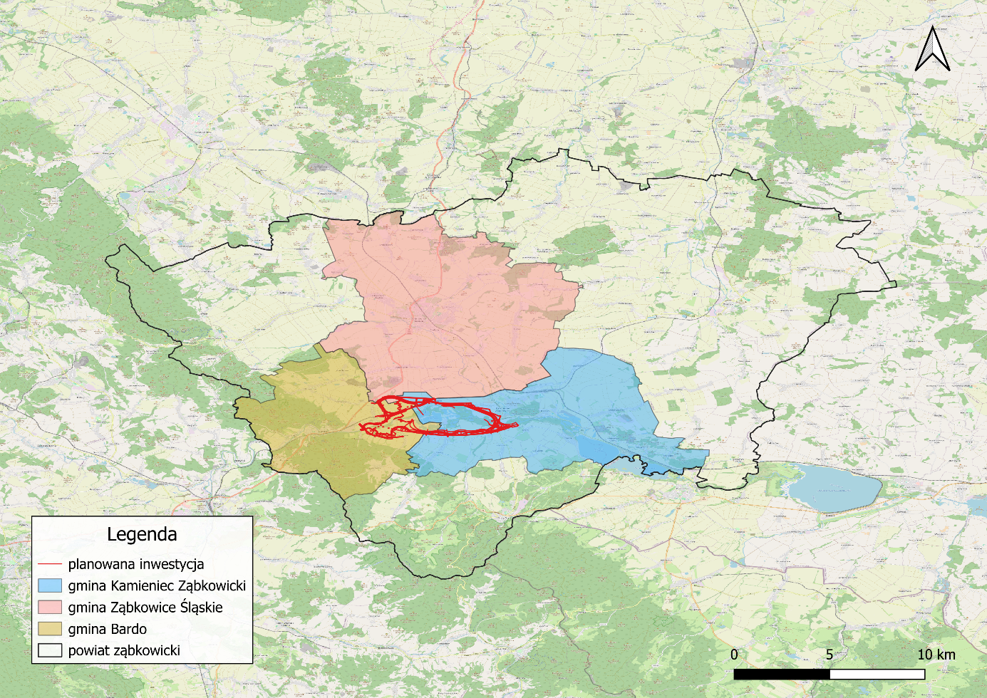
planned investment
Kamieniec Ząbkowicki municipality
Ząbkowice Śląskie municipality
Bardo municipality
Poviat of Ząbkowice
Symbols
Figure 1 Location of the Task against the background of administrative division
The area of the Reservoir's direct impact stretches from the lower part of the town of Bardo (Bardo-Przyłęk) to the confluence of the Nysa Kłodzka River with the Odra River, with the scale of impact decreasing downstream along the river. A total of approx. 6,300 people live within the direct impact area and will directly benefit from the flood protection function of the Reservoir – approx. 1,000 in the municipality of Bardo and approx. 5,300 in the municipality of Kamieniec Ząbkowicki. The positive impacts of the Task related to minimizing flood risk also extend to the municipalities of Paczków, Otmuchów and Nysa, located within the impact area of the Nysa Kłodzka's cascade of reservoirs.
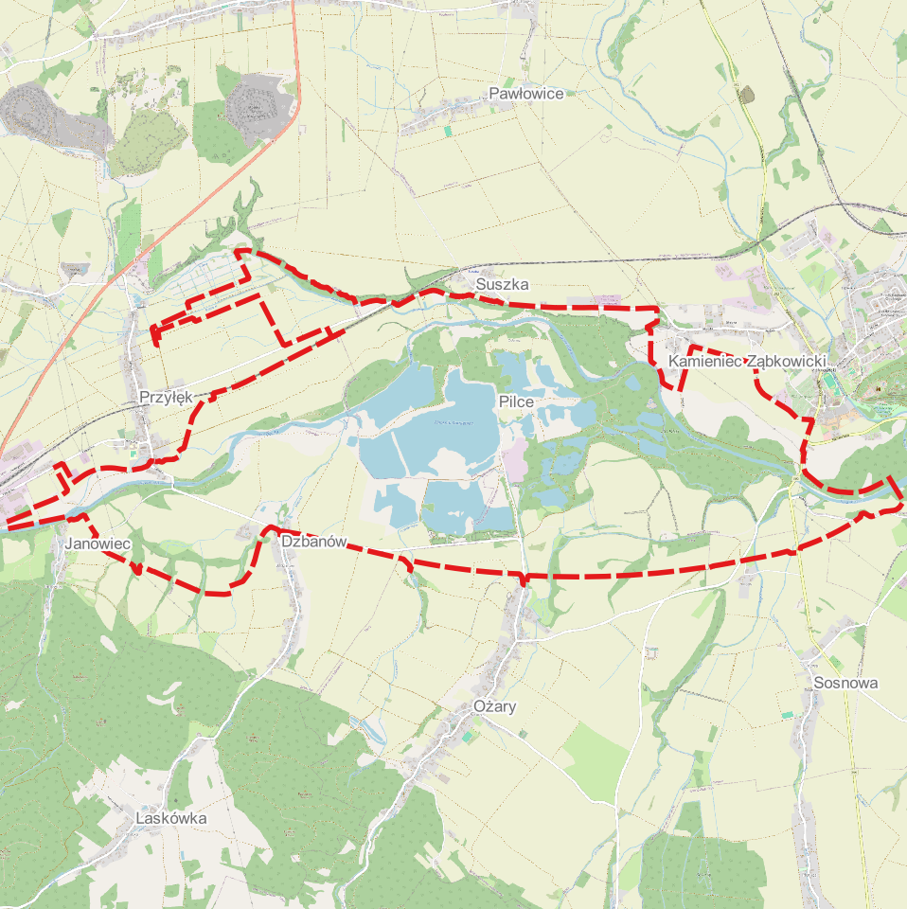 | 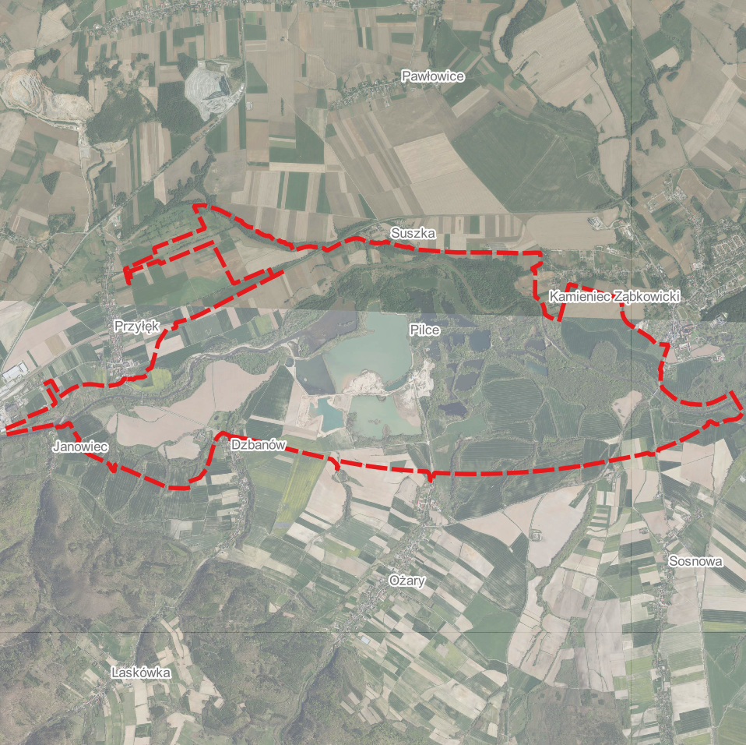
Figure 2 Illustrative location map - own work

The site of the planned Reservoir is located in a valley that has been largely degraded as a result of many years of aggregate extraction. According to the current design concept, there are three residential buildings located within the limits of the Reservoir's bowl, one of which is uninhabited and used exclusively for economic and recreational purposes. There are also remains of the former village of Pilce (evacuated and demolished after the 1997 flood) and a number of archaeological sites within the area of the Reservoir's bowl. Protected areas are located in the Reservoir's immediate neighborhood, including Natura 2000 sites (in particular PLH020062 Bardzkie Mountains, approx. 150 m from the project boundaries), nature reserves and a landscape park.

Objectives of the Stakeholder Management Plan
This Stakeholder Engagement Plan (SEP) defines the strategy, scope and methods of communication and public consultation for the investment Task encompassing the construction of the Kamieniec Ząbkowicki reservoir. The document was developed to ensure that the investment process complies with the World Bank's Environmental and Social Standards, in particular ESS10 (Stakeholder Engagement and Information Disclosure) .
Stakeholder engagement within this Task is a continuous process, conducted for the entire time of the Task preparation and implementation. As a result, the SEP will be subject to regular review and updating, in line with the progress of design and construction works, the evolution of the social context, or the emergence of new stakeholder groups or new social and environmental risks. Any significant changes to the SEP will be published on the Investor's website and at information points located in the municipal offices of Kamieniec Ząbkowicki and Bardo.
This SEP aims t achieve the following operational objectives:
- Ensuring meaningful consultation, consisting in creating conditions for a two-way dialogue process that begins at an early stage of the Task and is conducted on a continuous basis, free from manipulation or coercion.
- Providing stakeholders with realistic information about the implementation schedule, scope of impact, and potential benefits of the investment in order to avoid misinformation and unrealistic expectations among the community.
- Early identification of potential conflicts and social tensions through ongoing monitoring of public sentiment and proactive communication.
- Implementation and maintenance of a functional Grievance Redress Mechanism (GRM) that is accessible, transparent, and culturally appropriate for all stakeholder groups.

All communication and consultation activities carried out will be based on the following principles, :
- Inclusiveness – the consultation process is designed to ensure the participation of all identified stakeholder groups, with particular attention to vulnerable groups such as the elderly, disabled or digitally excluded. Stakeholders will be provided with timely, relevant, understandable and accessible information and consulted in a culturally appropriate manner, free of manipulation, interference, coercion, discrimination and intimidation. The choice of communication methods (e.g. face-to-face meetings alongside online information) aims to eliminate barriers to access to the decision-making process.
- Transparency – information provided to stakeholders is accurate, complete and communicated in understandable language (free from excessive technical jargon). Key documents and decisions concerning the impact of the Task on people and the environment will be made public well in advance, allowing stakeholders to familiarize themselves with them before the consultation.
- Responsiveness - responses to stakeholder requests and enquiries are provided within agreed timeframes. Each grievance will be analyzed, and information on how it will be taken into account (or justification for why it cannot be taken into account) will be communicated to the person who submitted it.
- Non-discrimination – in the stakeholder engagement process, all participants are treated equally, regardless of gender, age, financial status, political views or attitude towards investment. Stakeholders are provided with a safe space to express their opinions, free from repression and intimidation.
This Stakeholder Engagement Plan (SEP), prepared as part of the broader set of environmental and social risk management instruments for this Task, will be disclosed prior to appraisal to ensure timely access to information for all interested and affected stakeholders. The document will be made publicly available on the Investor's official website and at designated information points within the municipalities of Bardo and Kamieniec Ząbkowicki, in a language accessible to stakeholders. Disclosure will take place at least 30 days of the planned public consultations to allow stakeholders adequate time to review the document and prepare comments. Community-level consultations will subsequently be organized in accessible locations within the project area, enabling local residents, institutions, and other interested parties to provide feedback, ask questions, and raise concerns, which will be duly recorded and considered in the further refinement of the Project's environmental and social risk management measures.

Identification and analysis of stakeholders

Methodology
The stakeholder identification for this Task is informed by a specific historical context that is essential for understanding the social and environmental landscape of the project area. The village of Pilce, located within the planned Reservoir bowl, was severely damaged during the catastrophic flood of July 1997, which destroyed or damaged approximately 50 households and all social infrastructure (church, cemetery, fire station). Following the flood, the decision was taken to resettle the 221 inhabitants of Pilce and demolish the village in connection with the planned construction of the Kamieniec Ząbkowicki Reservoir. The resettlement and expropriation was carried out under national financing and was not undertaken in anticipation of, or in preparation for, World Bank co-financing, which was considered only following the 2024 flood, approximately 25 years after the events in question.
The resettlement process took place between 1998 and 2000, based on Polish administrative expropriation procedures. A subsequent flood in 2024 caused damages estimated at approximately PLN 13 billion in the region and the evacuation of 107 people in the municipality of Kamieniec Ząbkowicki, confirming the urgency of the investment. Both events (the 1997 resettlement and the 2024 flood) have shaped the attitudes, expectations and concerns of local communities and constitute a key reference point for stakeholder engagement within this Task.
The identification of the Task's stakeholders was made in accordance with ESS10 requirements and comprises three categories: project affected parties (chapter 5.2), other interested parties (chapter 5.3) and disadvantaged or vulnerable individuals and groups (chapter 5.4), who may be found within either of the first two categories.
The identification was based on two analytical perspectives. The first takes into consideration the historical context of the Task, in particular the experiences of local communities related to the impacts from the 1997 and 2024 floods and the resettlement of the inhabitants of the village of Pilce who has been resettled from the planned reservoir as explained above. The second focuses on the Reservoir's spatial and temporal impacts stemming from the technical and engineering design, covering groups of directly and indirectly affected by its location and scope of impact. Prior to the Bank's approval of the Project, active consultations with stakeholders will be undertaken to inform and validate this analysis, in accordance with ESS10 requirements for meaningful engagement at the earliest possible stage.
This analysis is preliminary and will be updated regularly as the Task implementation progresses.

Parties affected by the project
The parties affected by the project are local communities, their members and other entities that may be directly adversely affected by the Task. Project Affected Persons (PAP) are those experiencing direct impacts from land acquisition or restrictions on land use resulting in: (a) physical displacement (relocation, loss of residential land or loss of shelter); and/or (b) economic displacement (loss of land, assets, access to assets, income sources or livelihood activities). This includes individuals carrying out economic or livelihood-generating activities within the area affected by the planned Reservoir, irrespective of land ownership status (e.g. the aggregate extraction business). Collectively, these impacts are referred to as involuntary resettlement. PAP also encompasses persons with unresolved legacy claims stemming from past land acquisition associated with the Project, to be identified through the due diligence process. Two groups of stakeholders were distinguished within this category: project affected persons (PAP) in terms of involuntary occupation of properties and parties affected by other adverse impacts of the project.

Parties affected by the land acquisition
This group includes entities whose properties will be occupied permanently or temporarily for the purpose of Task implementation. They have the status of Project Affected Persons (PAP) within the meaning of ESS5. Three categories can be distinguished here:
- Owners of properties intended for expropriation – this group includes owners of developed properties and other land properties intended for expropriation.
- Tenants and users of agricultural plots in the Reservoir area – entities conducting agricultural activities on land in the Reservoir area whose sources of income may be directly affected by the implementation of the Task, regardless of the ownership status of the land used.
- “Byczeń” Mineral Resources Mine – an entity conducting the extraction and processing of aggregate on land within the planned Reservoir area, whose operations and associated livelihoods will be directly affected by the Task, together with its current workforce.

Other parties affected by the negative impacts of the project
This category of stakeholders comprises:
- Groundwater users and owners of individual wells – persons whose access to water may change as a result of modifications to the groundwater level associated with the construction and operation of the Reservoir.
- Communities exposed to construction-related impacts – households, businesses, land users and other parties in the vicinity of construction works exposed to temporary adverse impacts including dust, noise, vibration, traffic disruption, changes in access routes, and temporary disturbances to livelihoods. This group includes in particular residents of the localities closest to the construction site: Ożary, Suszka, Dzbanów, Janowiec and Przyłęk
Former residents of the village of Pilce – people resettled from the village of Pilce after the 1997 flood (in 1998, the village had a population of 221), now living mainly in Kamieniec Ząbkowicki and other towns in the region. The 2026 due diligence confirmed that the resettlement process was fully concluded and that no outstanding claims have been identified. No basis for new claims has been identified through the DD process. This group may nonetheless be affected by the Task through the physical transformation and inundation of the area they previously inhabited.

Beneficiaries of flood protection
- Residents of the towns between Kamieniec Ząbkowicki and Topola (approx. 5,300 people in Kamieniec Ząbkowicki, Byczeń, Bartniki and Topola) – direct beneficiaries of the Reservoir's flood protection function.
- Property owners in the immediate neighborhood of the Reservoir's bowl, including residents of the towns of Suszka, Ożary and Dzbanów – potential beneficiaries of the increased tourist attractiveness of the region and property values following the creation of the Reservoir.
- Residents of the Bardo municipality – a community located within the Reservoir protection area (approx. 1,000 people in the area of the Reservoir's direct flood protection).
- Residents of the municipalities of Paczków, Otmuchów and Nysa – indirect beneficiaries of the Task, located in the area of the Nysa Kłodzka’s cascade of reservoirs.

Other interested parties

Public administration institutions of the municipal and poviat level
- Authorities of the municipalities of Kamieniec Ząbkowicki and Bardo;
- Village administrators of Ożary, Suszka, Dzbanów, and Przyłęk;
- Poviat Starosty in Ząbkowice Śląskie.

Public administration institutions of the provincial and national level
- Lower Silesia Provincial Office / Province Governor of Lower Silesia;
- Regional Director for Environmental Protection in Wrocław;
- Lower Silesia Provincial Monuments Conservator – Branch in Wałbrzych;
- National Support Centre for Agriculture (KOWR);
- Agency for Restructuring and Modernization of Agriculture (ARMA);
- Marshal of Lower Silesia Province;
- Marshal of Opolskie Province;

Managers of technical infrastructure
- General Directorate for National Roads and Motorways (GDDKiA);
- Poviat Roads Administration in Ząbkowice Śląskie;
- PKP Polskie Linie Kolejowe S.A.;
- TAURON Dystrybucja S.A.;
- Water Supply and Sewage Utility Ltd. in Nowa Ruda;
- Forestry of Bardo Śląskie.

Non-governmental and social organizations
- Local and national environmental organizations;
- Rural Women's Association, in particular KGW "Dzbanowianki" in Dzbanów;
- Polish Angling Association – PZW Branch in Ząbkowice Śląskie;
- Local religious institutions, in particular the Roman Catholic parishes of Kamieniec Ząbkowicki and Suszka,
- local non-governmental organizations.

Economic and cultural entities
- local entrepreneurs in the tourism and catering industry;
- Lower Silesian Centre for Agricultural Advisory (DODR);
- Municipal Centre of Culture in Kamieniec Ząbkowicki;
- Centre of Culture in Bardo.

Media
Local media (Portal Nysa, Gazeta Ząbkowicka, Ekspres Miejski) and regional media (TVP3 Wrocław, Radio Wrocław, Nowa Trybuna Opolska).

Disadvantaged or vulnerable individuals and groups
Within the communities affected by investment implementation, the following groups were identified as particularly vulnerable to exclusion from the consultation process, with an indication of the main barriers to access to information and the decision-making process:
- older people (70+) – limited access or no access to digital channels; mobility restrictions; hearing and vision problems; multiple health conditions limiting their ability to participate in meetings;
- persons with disabilities – access barriers due to mobility restrictions in accessing consultation venues; lack of alternative forms of information transfer adapted to their needs;
- digitally excluded persons – lack of access to information published in electronic channels, including project documents available on the Task website;
- single parents/guardians – care responsibilities limiting their ability to attend meetings.
Vulnerable groups will be subject to further verification and covered by dedicated solutions aimed at minimizing identified barriers to access to information and facilitating meaningful engagement. This verification will be carried out as part of the ESIA process and updated prior to the commencement of public consultations.

Stakeholder Engagement Program

Summary of stakeholder engagement activities carried out at the stage of preparing the SEP
The preparation of this SEP was initiated simultaneously with the first stakeholder engagement activities. The meetings listed below were conducted as an integral part of the SEP preparation process, informing the stakeholder identification and analysis presented in chapter 5. All meetings were conducted in Polish.
The GRM will be presented and disclosed at the first public consultations following adoption of this SEP.
No. | Action | Date | Venue | How announced | Meeting lead | Participants | Key concerns raised | How feedback was incorporated
1 | Information meeting | January 2026 | Municipal Office of Kamieniec Ząbkowicki | Direct invitation by PIO | PIO | Representatives of Kamieniec Ząbkowicki Municipality | Schedule of design works; municipality's role in implementation; scope of project impact on local communities | Incorporated into stakeholder mapping and engagement strategy
2 | Information meeting | January 2026 | Town and Municipal Office of Bardo | Direct invitation by PIO | PIO | Representatives of Bardo Municipality | Schedule of design works; municipality's role in implementation; scope of project impact on local communities | Incorporated into stakeholder mapping and engagement strategy
3 | Working meeting | February 2026 | Municipal Office of Kamieniec Ząbkowicki | Direct invitation by PIO | PIO / technical expert | Representatives of ZWiK sp. z o.o. in Nowa Ruda, Kamieniec Ząbkowicki Municipality | Impact of the Reservoir on infiltration water intake; changes in groundwater levels; measures to minimize risk to water supply | ZWiK identified as key stakeholder; groundwater impact flagged as E&S risk for ESIA
4 | Working meeting | February 2026 | KSM headquarters in Byczeń | Direct invitation by PIO | PIO / technical expert | Representatives of KSM "Byczeń" | Conditions for continuing extraction; occupation of KSM properties; future of operations and workforce | KSM and its workforce formally identified as PAP; incorporated into ESIA and LARAP scope

Summary of project stakeholders' needs and stakeholder engagement methods, tools and techniques
The table below outlines the engagement process and methods to be used throughout the sub-project cycle, including the sequence of activities, consultation topics and target stakeholders. SWH PW, the Regional Water Management Authority in Wrocław, as the Investor, does not tolerate repression or retaliatory measures against project stakeholders who express their views on the Task.
Project stage | Target stakeholders | Subject of consultation / message | Method | Responsibility | Schedule | Frequency
Early design | Authorities of the municipalities of Kamieniec Ząbkowicki and Bardo; local village administrators within the impact area | Presentation of the Task concept and preliminary design options; scope and schedule of design works; opportunities for stakeholder input prior to design finalization; role of the municipalities and village administrators in implementation process | Working meetings with authorities of municipalities; meetings with village administrators | PIO | Prior to design finalization | Once after first presentation of Task concept; then as required
Early design/design | All residents within the impact area | Presentation of Task; alternatives considered and key differences between options; basis for selection of preferred option; information about GRM | Launch of the Task's website; Task's Facebook page; notice boards; information leaflets for households; telephone and e-mail helpline; information point | PIO | Upon launch of individual information channels | Once per channel launch
Design | Permitting authorities (DUW, RDOŚ, Conservator of Monuments) | Information required for permitting procedures (DŚU, PNRI, archaeological clearance); statutory consultations as required under Polish law | Formal meetings; official correspondence | PIO | As required by statutory deadlines | As required
Design | Land management and support institutions | Technical arrangements; land management procedures | Formal meetings; official correspondence | PIO | As required by procedural needs | As required
Design | All residents within the impact area; PAP; RDOŚ as lead EIA authority; authorities of the municipalities of Kamieniec Ząbkowicki and Bardo; local and national environmental NGOs and civil society organizations | Consultations on the draft ESIA and ESMP – environmental and social impact assessment findings; measures to mitigate environmental and social impacts; monitoring plan; GRM | Consultation meeting; information point; website; Facebook; posters on notice boards and poster poles; announcements in local media; information for village administrators | PIO | Draft ESIA and ESMP available 21 days prior to consultation meeting; meeting announced 14 days prior the meeting; prior to Bank Appraisal | Once; repeated if significant revisions made
Design | PAP; all residents within the impact area | Consultations on the draft LARAP – valuation and compensation rules; appeal procedures; entitlement matrix; GRM | Consultation meeting for PAP; information point; website; Facebook; posters; announcements in local media; information for village administrators; individual invitations by post for PAP | PIO | Draft LARAP available 60 days prior to consultation meeting; meeting announced 14 days prior; individual invitations for PAP; prior to Bank Appraisal | Once; repeated if significant revisions made
Pre-construction | PAP – owners of properties intended for expropriation; tenants and users of agricultural plots; KSM "Byczeń" and its workforce | Expropriation procedures; valuation and compensation rules; cut-off date; rights of owners and users; schedule of activities; GRM | Written correspondence to PAP (individual invitations and information package); individual field visits to PAP; dedicated consultation meeting for PAP | PIO | Systematically, after determining the scope of property occupation; prior to key decisions regarding expropriations | Individual visits on dates agreed with PAP
Construction | All residents; PAP; authorities of municipalities | Progress in Task implementation; current construction impacts; management of environmental and social impacts and mitigation measures in accordance with ESMP | Website; Facebook; status meetings with local authorities and village administrators; information point; presentation at a Municipal Council session | PIO | Prior to: mobilisation of equipment and workers; land preparation; embankment construction; reservoir filling | At each key construction milestone; minimum quarterly during civil works
All stages – cross-cutting | All stakeholders | Management of GRM – receiving and processing grievances, complaints, enquiries and suggestions | Telephone and e-mail; information point; physical suggestion box; written correspondence; communication via village administrators and municipalities | PIO | From project launch | Continuous
All stages – cross-cutting | Local and regional media | Key milestones in Task implementation | Press announcements | Spokesperson of PGW WP/ PIO | For key events: submission of application for IPIP; obtaining the DŚU; obtaining the IPIP; commencement of construction | Per key event
Construction | All residents; PAP | Technical safety of the Reservoir; monitoring and early warning systems | Information meeting; information materials; website; Facebook | PIO | Prior to filling the Reservoir for the first time | Once; updated as required
Operation | All stakeholders | Handover of the Reservoir for use; results of Task implementation | Closing event; announcement for media; final report | PIO | After completion of construction works | Once
Operation | All residents | Operational reporting and monitoring | Website, Facebook | PIO / Investor | As required by operational schedule | As required
All stages – cross-cutting | Vulnerable groups | All consultation topics relevant to each stage | Home visits; large-print materials; accessible venues; telephone helpline | PIO | Parallel to all engagement activities | Continuous

Proposed strategy for considering the views of vulnerable groups
The project will gather and consider the comments and suggestions of vulnerable groups and disadvantaged persons, using engagement methods tailored to the specific needs and barriers of each of these groups. The following measures are envisaged to remove barriers to full participation and access to information:
Barrier | Measures applied
Digital exclusion | All information also available in paper form; information point (personal visits possible); telephone helpline; information on notice boards and notice poles.
Visual impairment | Written materials in large font, high contrast, leaflets on matte paper; presentations with large, legible slides
Hearing impairment | Meetings in rooms with good acoustics and a microphone; moderator speaking clearly and at a moderate pace; key information repeated; facilitation with sign language where needed
Limited mobility | Meetings in architecturally accessible venues; seats for all participants; if unable to attend, information provided by family or by letter.
Domestic and caregiving responsibilities | Tolerance for children attending meetings (ability to leave and return); children's corner (coloring books, crayons)
Information overload | Concise and to-the-point materials; infographics; simple language without technical and legal jargon

Responsibility for implementing stakeholder engagement
Stakeholder engagement activities for the Project will be implemented through a structured approach, with all communication and consultation activities coordinated by the Project Implementation Office (PIO).The implementation solutions for stakeholder engagement in the project are as follows: communication and consultation activities are coordinated by the PIO. A permanent information point will be launched in the municipality of Kamieniec Ząbkowicki, prior to the commencement of the first public consultations, serving as the main place for direct contact with residents. Digital channels (website, Facebook) will be launched at the same time and complement direct and traditional communication. The village administrators and municipal authorities of Kamieniec Ząbkowicki and Bardo also act as intermediaries in the flow of information to local communities by posting announcements on local notice boards, publishing project information on municipal websites and social media channels, forwarding project communications to residents, relaying community concerns and questions back to PIO, and providing space for project information points.
Stakeholder engagement activities will be documented through:
- minutes and memos from consultation meetings, together with attendance lists,
- individual documentation of visits to the PAP,
- register of GRM notifications along with their processing status,
- monitoring of media and information channels.

Grievance redress mechanism (GRM)
The Grievance Redress Mechanism (GRM) for the Task entitled Construction of the Kamieniec Ząbkowicki reservoir on Nysa Kłodzka River is an integral part of the system for managing grievances on environmental , social and any other issues related to the Task. As a rule, it is intended to provide all stakeholders with an effective, transparent and free-of-charge system for submitting requests, opinions, comments, complaints and reservations related to the preparation and implementation of the Task. The GRM is also a source of feedback from stakeholders.
The Grievance Redress Mechanism defines the procedure for submitting grievances by the Task stakeholders (including, among other things, the form of grievances submitted) and the deadlines for their consideration. It also defines the rules for recording and tracking all grievances related to the Task, regardless of whether they are resolved through the GRM mechanism or by external authorities (courts, administrative bodies, law enforcement agencies).
Grievances may be submitted through the following channels:
- in person at the project information point in Kamieniec Ząbkowicki and Bardo;
- by telephone or e-mail helpline;
- in writing by post to the PIO address;
- via the physical suggestion box at the information point;
- anonymously through any of the above channels.
All grievances are registered in the GRM register within 24 hours of receipt, assigned a unique reference number, and acknowledged to the submitting party. Simple cases may be resolved through an expedited track within 5 working days. Standard grievances are resolved within 30 days; complex cases within 60 days, with the possibility of extending this deadline by agreement with the submitter. Submitters are informed of the outcome and retain the right to escalate unresolved grievances. The GRM is free of charge and submitters are protected from any form of retaliation.
The Grievance Redress Mechanism (GRM) constitutes Appendix no. 1 to this SEP and forms an integral part thereof.

Monitoring and reporting
Monitoring of the SEP implementation is carried out on an ongoing basis by the Project Implementation Office (RZGW WR). It is based on the verification of documentation produced in the course of activities related to the SEP implementation.
The basic monitoring tools are:
- Documentation of meetings and consultations
Every activity engaging stakeholders (open meetings, meetings with authorities, negotiations with landowners) is documented in the form of a memo, minutes or attendance list. These documents constitute basic evidence of the implementation of the schedule.
- Grievance Redress Mechanism – reporting table
A central database (in spreadsheet format) where all grievances concerning the Project are recorded, along with their processing status.
- Monitoring of media and information channels
Periodic verification of the availability and accuracy of information on the Task website, in the Public Information Bulletin (BIP) and analysis of the reach of media communications.
In order to evaluate the effectiveness of SEP implementation, a set of key indicators was adopted, focusing on measurable aspects of process implementation (execution) and system responsiveness (stakeholder management).
1. (Quantitative) performance indicators:
- Compliance with the schedule of planned communication activities
- Timeliness of consultation notices
- The number of consultation meetings held and the number of participants in these meetings.
- Number of engagement activities conducted, by project phase
- Number of grievances received, by category
- GRM efficiency: number of requests processed and closed on time.
- Completeness of documentation (minutes, attendance lists) for activities carried out (goal: 100%).
2. (Qualitative) effectiveness and quality indicators:
- Summary of key stakeholder concerns raised during the reporting period and PIO response actions taken

The Stakeholder Engagement Plan is an ‘living’document. Its update does not take place in fixed time cycles, but is initiated by specific circumstances related to the preparation of the Task for implementation (task-based approach). The reasons for updating the SEP are as follows:
- when the communication methods adopted in the SEP prove ineffective (e.g. low attendance will force a change in the format of meetings).
- formal transition from the preparatory stage to the implementation stage, which involves defining new target groups.
- change in the scope of the Task resulting in the occupation of new areas not included in the original stakeholder analysis.
A budget allocation for the implementation of stakeholder engagement activities under this SEP will be presented separately prior to Bank Appraisal, covering costs of consultation meetings, information materials, information point operation, GRM management and monitoring will be disclosed as part of the project financing documentation prior to Bank Appraisal.

Appendices

Appendix 1 - Grievance Redress Mechanism (GRM)

Appendix 2 – Template for consultation meeting minutes

CONSULTATION MEETING MINUTES
Kamieniec Ząbkowicki flood protection reservoir
PART I. GENERAL INFORMATION
Minutes number
Date of meeting
Start / end time | : – :
Place of meeting
Type of meeting | ☐ information meeting ☐ consultation meeting ☐ individual visit to PAP ☐ other: _______________
Target stakeholder group
Organizer / host
Total number of participants
PART II. PARTICIPANTS
The attendance list is attached separately to these minutes (Appendix 1). If a participant declines to sign the attendance list, note this under 'Comments'.
No. | Name and surname | Institution / organization / town | Role / function | Comments
1.
2.
3.
4.
5.
For a larger number of participants, add further rows or attach additional pages.
PART III. INFORMATION MATERIALS AND PRESENTATIONS
No. | Title of material / presentation | Author / prepared by | Format
1.
2.
3.
The materials are attached to these minutes as appendices (Appendix 2 et seq.).
PART IV. PROGRESS OF THE MEETING AND ISSUES DISCUSSED
Purpose and agenda of the meeting
Key issues discussed during the meeting
Questions and comments from participants
Answers and explanations provided by the organizer
Submitted proposals and motions
PART V. PHOTOGRAPHIC DOCUMENTATION AND FINAL REMARKS
Photographic documentation | ☐ yes (Appendix ___) ☐ no ☐ refusal of participants
Audio/video recording | ☐ yes (Appendix ___) ☐ no ☐ refusal of participants
Final remarks and other relevant information
PART VI. SIGNATURES
Minutes taken by:  Name and surname: ___________________________  Position: ________________________________  Signature: ____________________________________  Date: _____________________________________ | Approved by:  Name and surname: ___________________________  Position: ________________________________  Signature: ____________________________________  Date: _____________________________________
PART VII. LIST OF APPENDICES
No. | Appendix description | Number of pages/pcs.
1 | Attendance list of participants
2 | Information materials / presentation
3 | Photographic documentation (if applicable)
4 | Other (please specify): ___________________________
These minutes form part of the documentation of the Stakeholder Engagement Plan (SEP) implemented by SWH PW Regional Water Management Authority in Wrocław in accordance with the requirements of the World Bank's ESS10 Environmental and Social Standard.

