

Delegations will find attached document SWD(2021) 166 final - PART 2/3.

Encl.: SWD(2021) 166 final - PART 2/3



## 3.4. Economic development

This section describes the economic situation of rural regions, with a focus agriculture and tourism.

### GDP per head in rural regions is lower than in urban regions but catching up

**GDP per head is generally lower in rural and intermediate regions than in urban regions**. In the EU-27, average GDP per head in rural regions was **75% of the EU average**, in intermediate regions it was 88% while in urban regions, it was 125%. The gap is particularly large in eastern and central European Member States, like Slovakia, Romania, Hungary or Bulgaria where some urban regions (notably the capital city regions) developed at an extremely fast pace of economic growth.

Figure 28 GDP per head (PPS), 2018

(Index EU-27=100, by urban-rural regional typology)

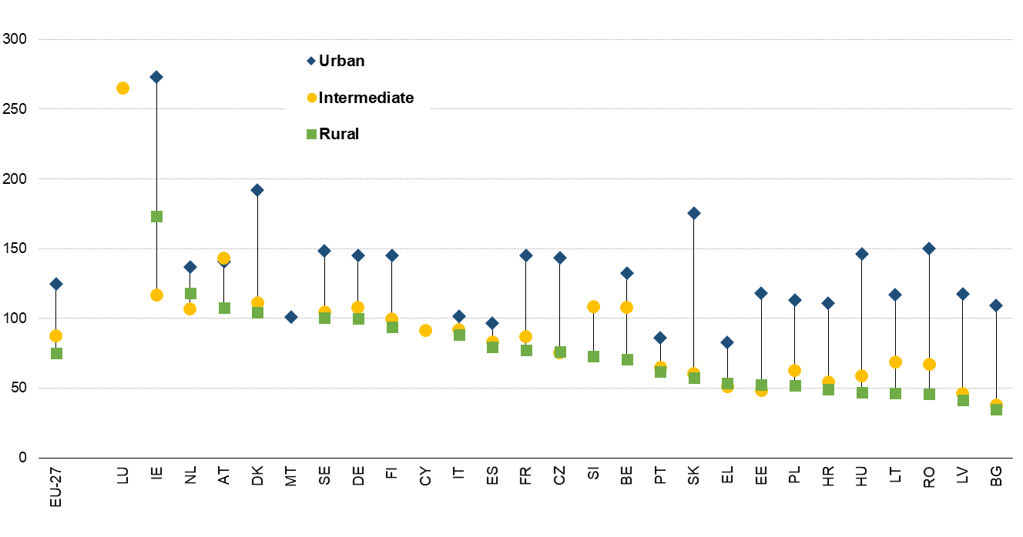

Source: Eurostat online data table (nama_10r_3gdp) and JRC ARDECO database.

Note the high value for GDP per head in Irish urban regions is due in part to the move of intellectual property rights.

Although significantly lower than the cities in terms of wealth, rural regions have been catching up in relative terms with the rest of the Union. GDP per head in rural regions increased from **70% of the EU-27 average in 2000 to 75% in 2018**. Intermediate regions practically stayed at 88% of the EU average while in urban regions, GDP per head decreased from 130% to 125%. As a result, rural regions reduced the gap with urban regions by 10 index points during this period. In half of the 24 Member States[1] with urban and rural regions, urban regions grew faster, while in the other half rural regions grew faster. In eastern Member States, growth in urban regions was much higher than in rural regions, but overall rural regions still converged to the EU average. However, there are considerable intra-regional differences.

Figure 29 Change in GDP per head (PPS), 2000-2018

(Change in index EU-27=100, by urban-rural regional typology)

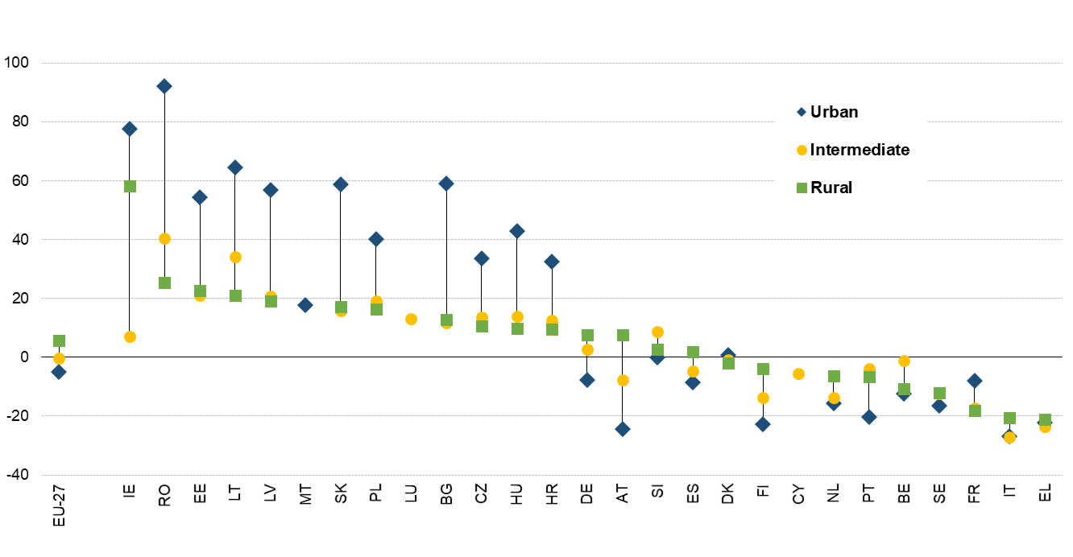

Source: Eurostat and JRC ARDECO database

The performance of rural and intermediate regions is also affected by how distant they are from a city. In particular, GDP per head in remote regions tends to be lower than in other regions and has not converged to the EU average. In 2018, **GDP per head in rural remote regions was only 69% of the EU average** and it decreased by 1.8 index point between 2000 and 2018. In contrast, **GDP per head in rural regions close to a city** increased by 8.5 index points during the same period and was at **78% of the EU average** in 2018. The catching up of rural regions can also be seen in the real GDP per head growth rates, which was higher in rural regions than in intermediate or urban regions (Table 10). Growth rates in intermediate and rural regions close to a city were higher than in the remote intermediate and rural remote regions.

Table 10 Selected economic indicators by urban-rural regional typology, including remoteness



Source: Calculations based on Eurostat (online data code: urt_10r_3gdp)

Also OECD showed that predominantly rural regions in OECD countries converged, with average annual growth rates higher for rural regions than for urban regions.[2] But since the 2008 financial crisis, their growth has fallen sharply, contributing to growing regional inequalities[3]. The crisis revealed the **higher vulnerability of remote rural regions and those near smaller towns, compared to those close to big cities**. OECD anticipates the impact of COVID-19 to be 10-fold that of the 2008 financial crisis. COVID-19 emphasised rural weaknesses in terms of service provision, connectivity and their lower share of jobs fit for telework. [4]

Rural areas are also often perceived as disadvantaged. Through interviews in seven Member States and the UK, the IMAJINE project[5] found that this perception can be reinforced by the media and linked to the perception that rural areas offer fewer economic opportunities. However, there are differences between countries. The gap in perception of economic opportunities between urban and rural areas was greatest in Poland, Romania and France, with little difference in Spain and the Netherlands. In Germany and Italy, rural areas were perceived to be better for economic opportunities than cities.[6]

### Agriculture, forestry and fishery provide a significant share of employment in rural regions, while the structure of rural economies is changing and agriculture modernising

In 2018, agriculture, forestry and fishery accounted for 5% of total employment within the EU. **In rural regions, however, this sector provided 12% of all jobs** compared to only 1% in urban regions. Its importance is particularly high in rural regions in less developed Member States. For example, it accounted for more than 30% of total employment in the rural regions of Bulgaria and Romania.

Figure 30 Employment by sector in rural regions, 2018

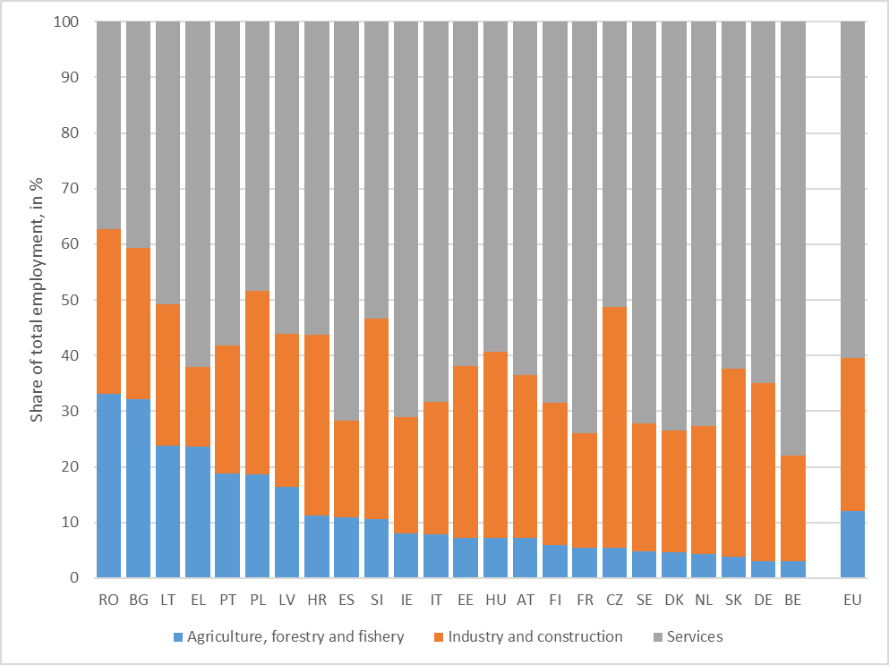

Source: Eurostat and ARDECO database

Note: Cyprus, Luxembourg and Malta do not have a rural region and are thus not show on this graph.

In the EU, the share of the agriculture, forestry and fishery sector in rural regions’ employment went from 21% to 12%.between 2000 and 2018.The share of industry and construction remained practically unchanged, while the share of services increased by almost 10 percentage points (pp). This change in the economic structure is particularly significant in certain rural regions of Eastern Europe. This contrasts with the changes observed in urban regions where employment shifts at a much slower pace from industry and construction to services.

This highlights the fact that rural regions in a number of less developed Member States are undergoing a rapid restructuring. This trend is driven by the combination of the modernisation of agriculture and the growth of employment in industry and services. This trend is likely to continue.

Figure 31 Change in employment by sector in rural regions, 2000-2018

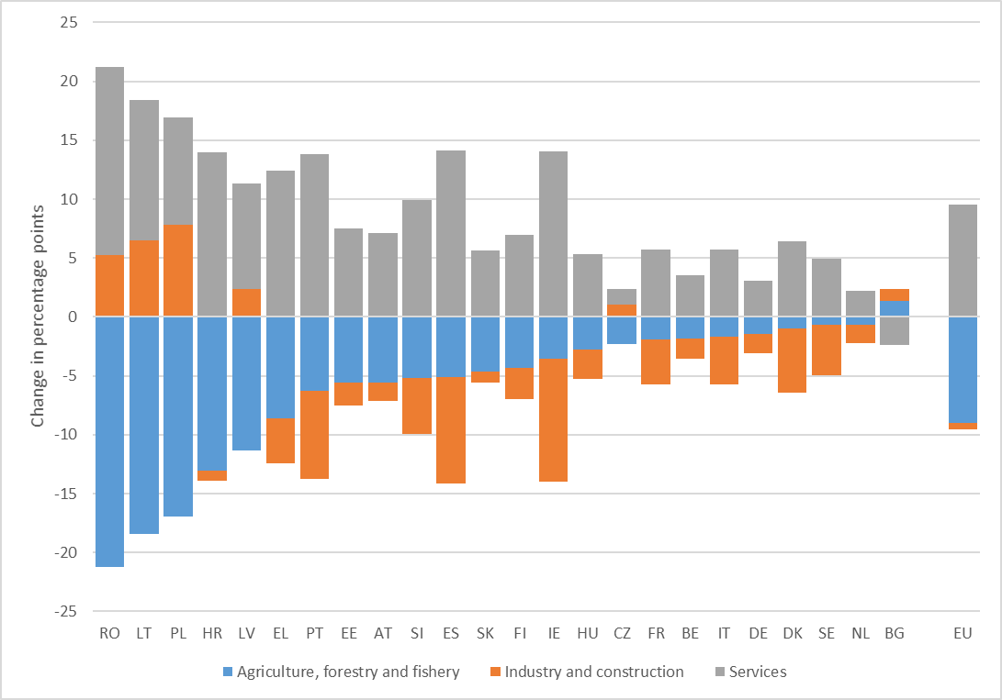

Source: Eurostat and JRC ARDECO database

Gross value added (GVA) in rural regions follows a similar structure and trend as employment does. Agriculture, forestry and fisheries in rural regions represent 4% of GVA in rural regions at the EU level in 2018.

Figure 32 GVA by sector in rural regions, 2018

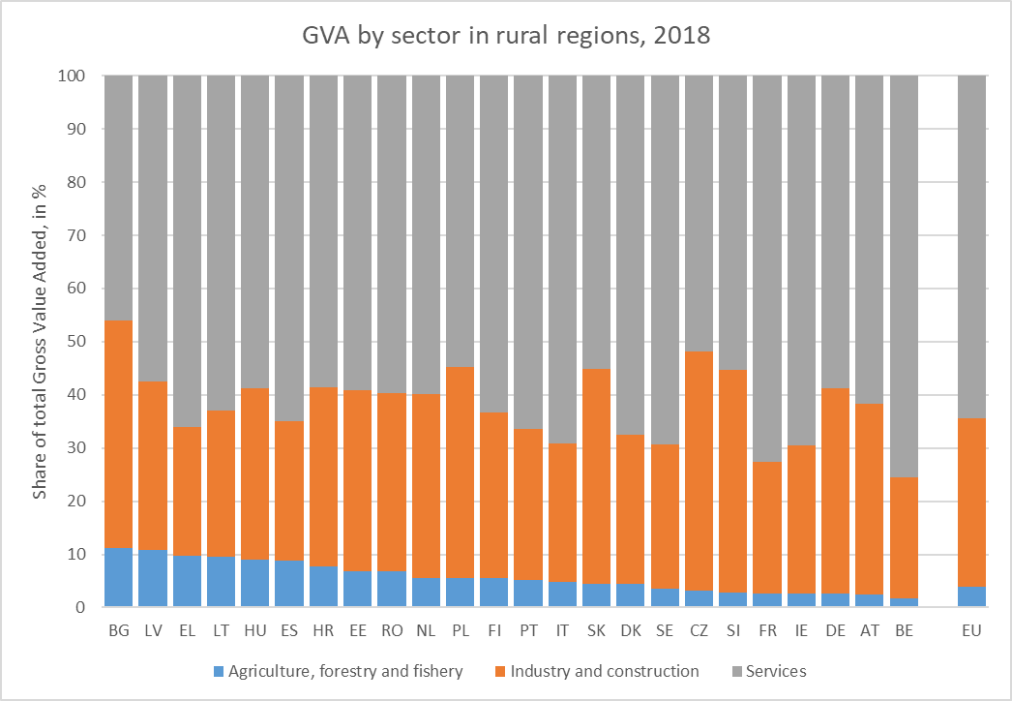

*Source: Eurostat and JRC ARDECO database*

Whereas, eleven Member States have 10% or more of their employment in rural regions in agriculture, forestry and fisheries, for GVA this is only the case for 3 Member States (Figure 32).

The changes in the sectoral GVA shares in rural regions are smaller as compared to changes in employment shares. At the EU level, the share in GVA for agriculture, forestry and fisheries dropped by 1.7 percentage points (pp), industry dropped by 0.4 pp, while services grew by 2.1 pp. Rural regions in a few Member States, however, experienced bigger reductions in the GVA share of agriculture, forestry and fisheries. Notably, rural regions in Romania, Lithuania and Bulgaria saw reductions of more than 10 pp (Figure 33).

Figure 33 Change GVA by sector in rural regions, 2000-2018

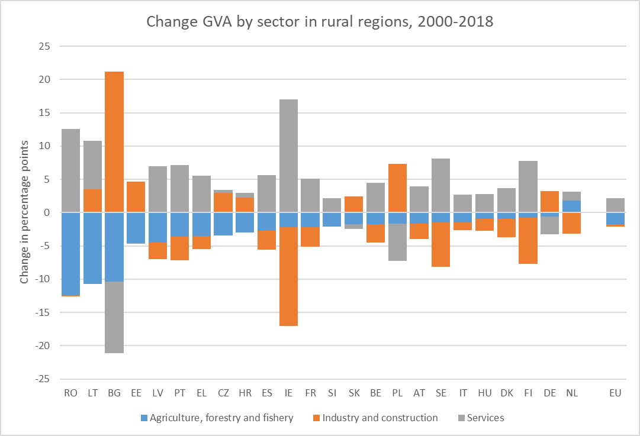

*Source: Eurostat and JRC ARDECO database*

### Tourism is important for rural economies

**Tourism is an important activity and contributes significantly to economic growth, including in remote and rural areas[7]**. At the EU level, the number of tourism nights per inhabitant in rural regions is three times higher than in urban regions. Tourism nights spent relative to the residential population are particularly high in the rural regions of Austria, the Netherlands, Greece, Denmark and Croatia.

Figure 34 Share of nights spent per resident by urban-rural regional typology, 2018

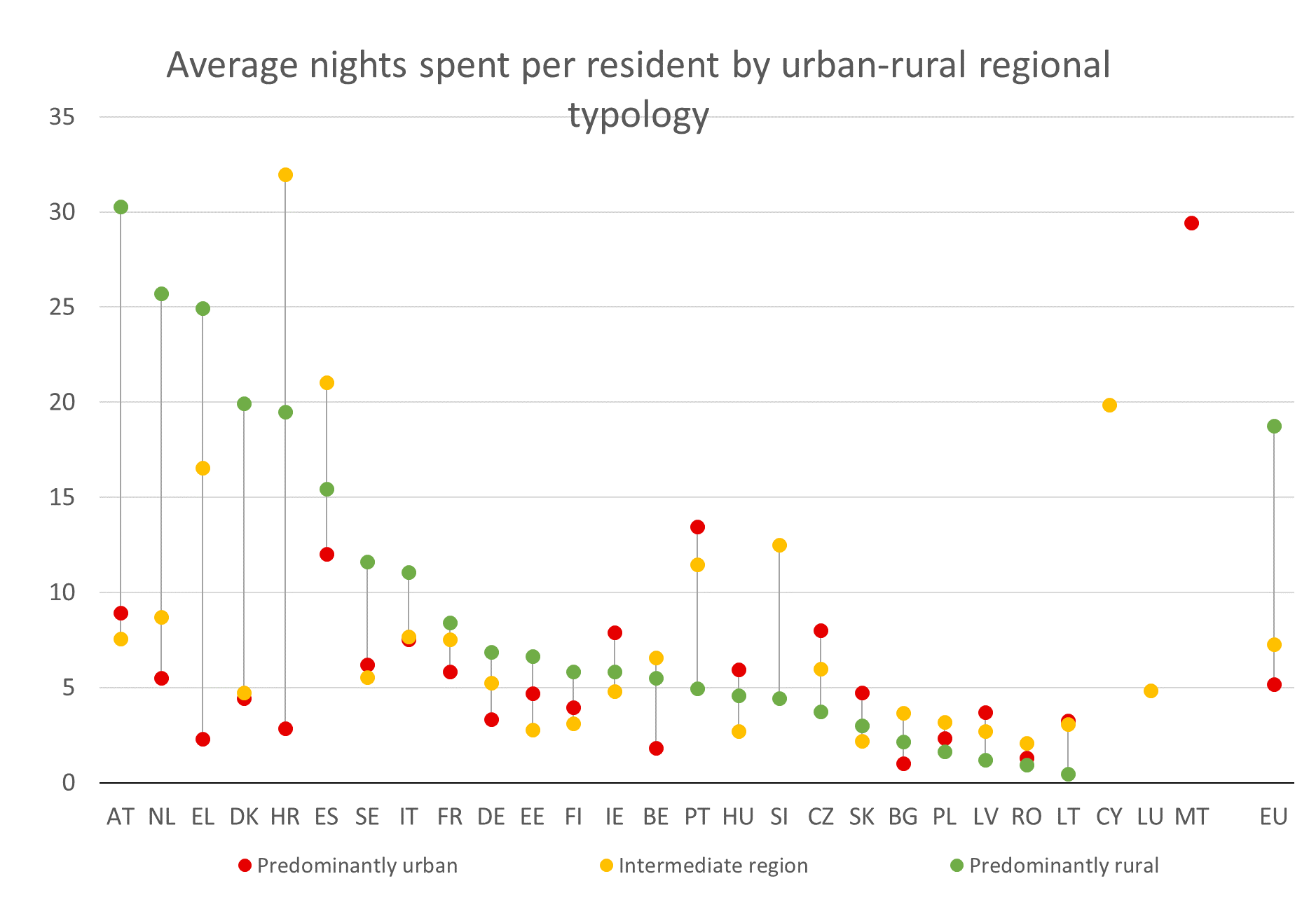

Source: Elaboration of the authors on data produced by the JRC Unit of Territorial Development

Tourism expenditure per inhabitant is generally higher in rural regions[8], which indicates that this sector is a more important source of income than in other types of regions.  However, tourism in rural regions also tends to be more seasonal than in urban and intermediate regions, which implies that tourism activities must often be complemented with others.

Figure 35 Nights spent per capita by regional urban-rural typology and season, 2018

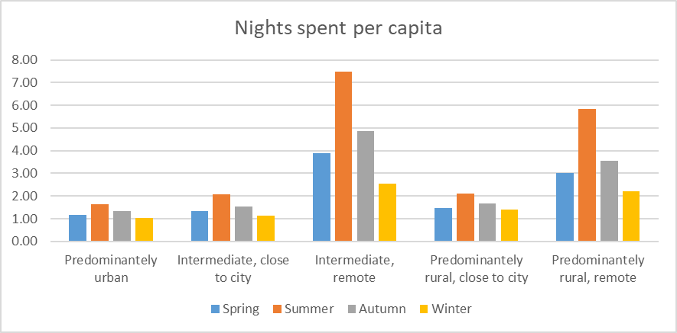

Source: Elaboration of the authors on data produced by the JRC Unit of Territorial Development.

Tourism capacity in rural regions considerably varies across the EU. The number of rooms available is much higher in the rural regions of northern Spain, France, alpine Austrian and Italian regions, Cyprus, western Ireland, Denmark and Bulgarian eastern regions. In contrast, eastern European countries like Romania and Poland, parts of Hungary, Germany, Finland and Lithuania have lower rural accommodation capacity.

|  |
| --- |
| Map 7 Number of rooms in rural areas per capita by NUTS-3 regions, 2018  C:\Users\dijksle\AppData\Local\Microsoft\Windows\INetCache\Content.Word\TourismRuralRoomsCapita.png |
|  |
| Source: Elaboration of the authors on data produced by the JRC Unit of Territorial Development. |

The development of new business in cultural and creative industries (e.g. wine producers, tourism operators, forestry-wood industry) can support innovation and contribute to rural development. Cultural tourism might be facing challenges in many rural areas, due to lack of cultural infrastructure and tourist services, accessibility, advanced digital technologies that could help to the promotion this kind of tourism.

### Farming is restructuring, but its importance for rural areas remains

**Farming and rural areas are closely related** in multiple ways, including since the vast majority of EU agricultural land is located in rural areas (85%) and 43% of the land in rural areas is dedicated to agriculture.[9]

Agriculture provides jobs not only to farmers but often also to the whole farming household. The overwhelming majority of the EU's farms are family farms (95.2 % in 2016).[10] The number of farms in the EU has dropped by 4 million in just over a decade: from 14.2 million in 2005 to 10.3 million in 2016. [11] This reduction is mainly due to the restructuration occurring mostly in the Member States that joined the EU in 2004 or after and affects mostly the very small and small farms. Declining farm numbers have led to an increase in the size of farms and in output per farm. The resulting economies of scale and mechanisation implied a drop in employment in the agricultural sector.

Over the last fifteen years, 29% of jobs in agriculture disappeared[12](in particular non-salaried), even though the trend seems to be levelling off. Bulgaria, Slovakia and Estonia have more than halved their annual work units.  Some agricultural sectors face labour shortages or vulnerability (revealed during COVID-19 pandemic) and working in farming in general faces a lack of attractiveness.  Seasonal jobs in agriculture are increasingly taken by workers coming from another EU country or from non-EU countries, a shift that is not fully captured by official statistics[13].

Figure 36 Evolution of the number of jobs in agriculture (in 1000 AWU)

(salaried and non-salaried)

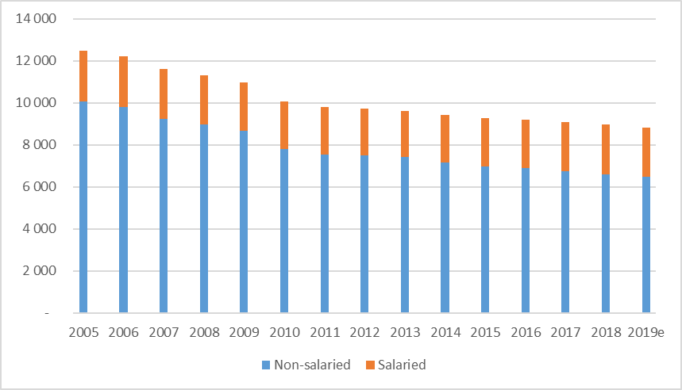

Source: Eurostat (online data code: aact_ali01)

The decline in the size of the agricultural workforce is expected to slow down at −1% per year, reaching 7.9 million annual work units[14] in 2030. In particular, the number of agricultural workers hired could continue rising in relative share, in relation to the trend towards reduced family labour.[15]

**Farming income is significantly below the average wage in most Member States**. In 2019, EU farmers earned less than half (48.8%) of what could be gained in other jobs. However the gap between the agricultural income per worker and the average wage in the economy has decreased over time (in 2008, farmers earned only 33.5% of the average wage in the economy)[16].

After the crisis year 2009, the EU average agricultural *factor* income per full-time work unit[17] has recovered in real terms. In 2019, it was 29% higher than in 2010. However, this trend varies from one Member States to another. In Bulgaria the factor income per full-time work unit was more than double compared to the reference year, whereas in Malta, Finland, Belgium and Austria it decreased by 5% or more.

**Farming is characterised by a low share of young and female managers[18]**. One third of farms managers are over 65. Over the period 2005-2016, the share of farms run by managers below 35 years old decreased from 6.9% to 5.1%. Female managers were only 29% in 2016, but their share is increasing.  Women run on average smaller farms than men do and the income they generate is on average smaller.[19]. The gender imbalance among farmers is particularly strong in the Netherlands, Malta, Denmark and Germany, where less than 10% of managers are women. On the other side of the spectrum, in Lithuania and Latvia, nearly half of all farms are managed by a woman.[20]

Figure 37 Share of farm managers by sex and age class in EU27 in 2016

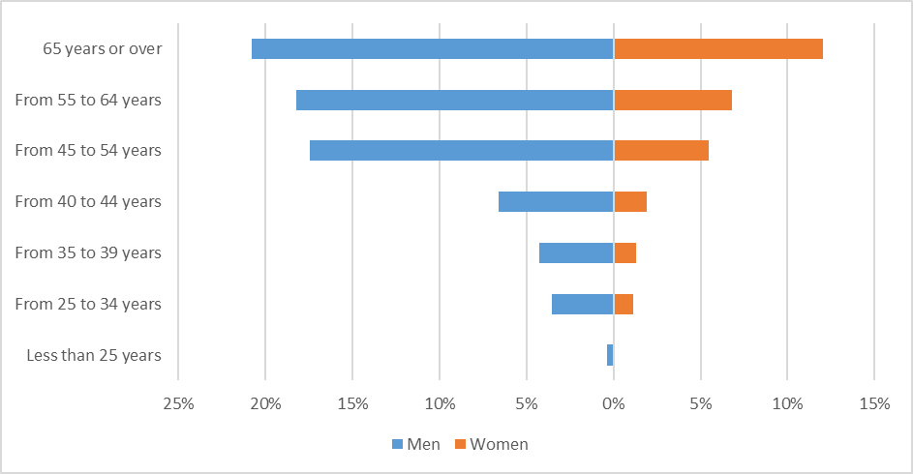

Source: Eurostat (online data code: ef_m_farmang)

While knowledge requirements in farming are constantly increasing, more than two-thirds (68%) of EU farmers have not received any agricultural training other than their own practical experience. In Romania, Greece and Bulgaria this share surpasses 90%. The oldest farmers are least likely to have received any kind of training[21].

### Conclusions

GDP per head in rural regions was considerably lower than the EU average (70%) in 2000, but faster economic growth has allowed to reduce in relative terms the gap in relative terms to the EU average (75% in 2018). Over this period, rural regions close to a city grew faster than the EU average, but remote rural regions grew slightly slower than the EU average, with GDP per head dropping from 70% to 69% of the EU average.

The economies of rural regions are going through a structural transformation with employment shifting out of agriculture, forestry and fisheries and into industry and increasingly services. This process is already further along in other regions, which have lower employment share in agriculture, forestry and fisheries and smaller reductions in the employment share of that sector. This implies that this process is likely to continue but start to slow down as the economic structure of rural regions start to resemble those of intermediate and urban regions.

Despite its declining employment, agriculture remains important for and intrinsically linked to life in rural areas, with benefits also for residents in urban ones. This holds for food security, but also for the provision of eco-system services, the wider socio-cultural life in rural areas and the contribution to other economic sectors, in particular tourism. High importance of tourism in rural areas may imply a high population variation over the year, which needs to be considered in demographic analyses and basic services assessment.

The green transition will require farmers to adapt to take the advantages that it offers, notably growth opportunities in new sectors such as the sustainable bioeconomy and circular economy. Also, consumer demand for sustainable products (with higher nutritional value, better animal welfare, without chemical pesticides, etc.) represents a key opportunity, which may help small family farms. Increasing cooperation and productivity is critical in that perspective. The development of innovative technologies (such as precision farming) can also help farmers to reach at the same time both economic and environmental objectives. Attracting Europe’s next generation of farmers is a key challenge.

## Social inclusion

Social inclusion, including in EU rural areas, covers a wide range of social topics and societal groups including poverty, challenges of the youth and older people, the gender balance, people with disabilities, population with migrant background (EU mobile citizens and non-EU migrants), marginalised Roma communities, and, in many rural territories, the small farmers. This section describes the social situation of rural areas by touching upon a range of these aspects and groups.

### The risk of poverty or social exclusion in rural areas is slightly higher than in towns and suburbs and cities

Although the absolute number of individuals at risk of poverty and social exclusion is slightly higher in cities and towns and suburbs than in rural areas, **in terms of percentage of population at risk of poverty or social exclusion[22] the figures are higher in rural areas (22.4%), compared to cities (21.3%) and towns** and suburbs **(19.2%)[23]**.

At-risk-of-poverty rate in rural areas varies significantly between Member States (Figure 38).

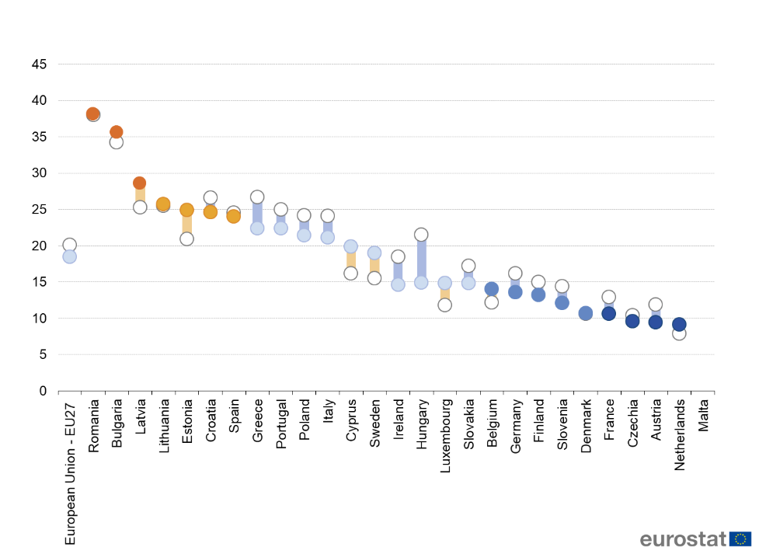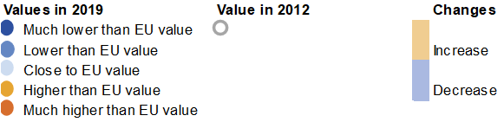

Figure 38 At-risk-of-poverty rate in rural areas in 2012 and 2019 (% of population)

Source: Eurostat (online data code: ilc_li43)

Note :Value for Malta is missing due to low reliability

Challenges related to demography, remoteness, education, and labour market may interact and generate “vicious circles”, which may reproduce and amplify the phenomenon of poverty of rural areas.[24]

**In 2019, in the EU 7.3% of the rural population aged less than 60 years lived in households where the adults worked less than 20% of their total work potential** during the past year (households with very low work intensity). This proportion was lower compared to 2012 (9.8%). Bulgaria, Greece, Ireland and Spain had registered the highest rates both in 2012 and 2019, Austria and Czechia the lowest rates. In most Member States the rate of households with very low work intensity decreased between 2012 and 2019 in rural areas. At the EU level there is no substantial difference between rural areas and cities[25].

The rate for people in rural areas suffering from **severe material deprivation[26]** was 5.7% for EU-27in 2019[27]. The rate has declined in all Member States in the past 9 years, with the biggest improvements registered in Bulgaria and Romania where, however, they remain high. At the EU level there is no difference between rural areas and cities but this is a result of very heterogeneous picture where different Members States show different patterns. The changes in the gap are similarly heterogeneous but in most cases these are showing a convergence pattern – closing the gap between rural areas and cities.[28]

While in most Member States rural areas have a lower **housing cost overburden rate[29]** than cities, 7% of the EU rural population is living in a household where total housing costs (net of housing allowances) represent more than 40% of the total disposable household income (net of housing allowances)[30] compared to 11.8% of the city population.

The EU average for self-reported unmet needs for medical examination (Figure 39) in rural areas is low – below 2%.

Figure 39 Self-reported unmet needs for medical examination in rural areas in 2012 and 2019. (%, share of people aged 16 years or over)

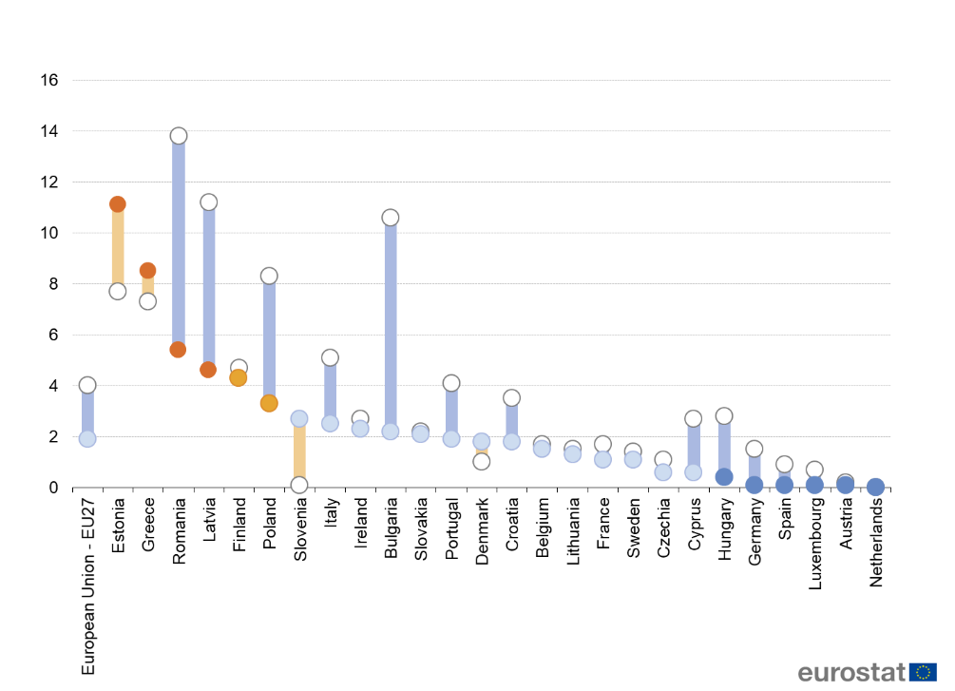

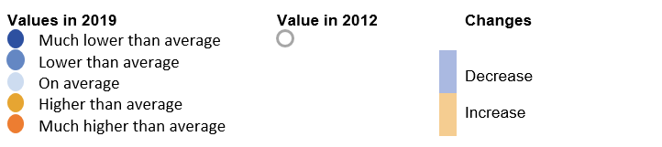

Source: Eurostat (online data code: hlth_silc_21)

*Note: Unmet needs for medical examination due to it being too expensive, too far to travel and/or because of waiting lists. Ireland, France, Italy and Slovakia: 2018. EU27: estimate. Netherlands: not significant. Malta: data not available.*

### Different societal groups are particularly affected by challenges linked to social inclusion

As regards **elderly people**, the loneliness and isolation of people of more than 60 years old is an increasing problem in rural communities in Europe.[31] Poor access to social care and health care, transport and housing services exacerbates the phenomenon of loneliness and isolation affecting the well-being and social engagement of elderly people in rural areas.[32] As the Green Paper on Ageing recognises, elderly workers face also difficulties when it comes to employment. Besides, the potential of many healthy, active elderly people to work remains untapped and underemployed resources also in rural areas.[33]

Many **Roma**, the largest ethnic minority of the EU, live often in high concentration in rural areas. Progress in Roma integration has been limited, in 2016, four fifths of the Roma were estimated to be at risk of poverty, compared to less than one fifth for the general population of the EU.[34], **90% of Roma children are still at risk of poverty and social exclusion**.[35] Paid employment, access to tap water, life expectancy rates show a similar negative picture.[36] 43% of Roma are in paid employment compared to 73.1% of the general population, 44% of Roma children attend schools where most or all children are Roma, 70% of Roma have access to tap water compared to 97.6% of the general population, 61% of Roma face housing deprivation compared to 17.9% of the general population, and the life expectancy gap at birth between the general population and Roma is significant.[37] Roma women, continue to face far worse situation than Roma men or women in the general population in key areas such as health, education and employment[38]. In countries with a larger share of Roma people[39], they represent a growing proportion of the school-age population and the future labour force[40]. The COVID-19 pandemic has revealed the extreme exposure of excluded and marginalised rural Roma communities and other vulnerable people to both short-term negative health impacts and to medium-term socioeconomic impacts[41].

**Children at risk of poverty** living in marginalised rural communities are among the hardest hit by the COVID-19 pandemic. Distance learning has been difficult for too many children at risk of poverty living in households without IT facilities or electricity and adequate support from parents[42]. This can be also effected by the fact, that the overall level of digital skills in the EU was lowest among adults who were living in [rural areas](https://ec.europa.eu/eurostat/statistics-explained/index.php?title=Glossary:Rural_area) (48% had basic or above basic digital skills in 2019)[43].

It is hard to estimate the **share of persons with** physical, developmental, intellectual and other **disabilities** in the rural population. In 2019 the share of people having a long-standing illness or health problem was 36.7%[44] in rural areas (EU 27), and 26.1% face long-standing limitations in usual activities due to health[45] (self-perceived, in rural areas, EU-27).

Also people working in agriculture can face social challenges, in particular when it comes to small farmers or women in farming. Work in agriculture is often precarious, and cases of infringements regarding labour rights, exploitation and forced labour have been reported across the EU.[46] Family labour (or non-salaried workers) is of great importance when it comes to inclusion of agricultural workers in the social fabric, though trends are showing a growing share of salaried workers in total agriculture workforce.[47]

Results from the IMAJINE[48] survey show that migrants moving into rural areas can find it a little less easy to settle into the region than migrants to urban areas. Asked to indicate how easy or difficult it was to adapt to life in their new region on a scale of 0 (very difficult) to 10 (very easy), respondents who had moved to areas of open countryside gave a mean score of 6.87 and respondents who had moved into villages or small towns gave a mean score of 7.09, compared to a mean score of 7.22 given by respondents who had moved into a city.

The country reports and profiles of MATILDE regions show a huge diversity of migrants in rural and mountain areas, with regard to their socio-demographic profile, countries and regions of origin, as well as in their motivation for migrating, and their aspirations to stay, which differences need to be recognized in the rural development and increase the need for more personalised social services and developments.[49]

The COVID-19 pandemic has further aggravated the situation of migrants (including in rural areas) as they are overrepresented among the people infected by COVID-19 virus. The pandemic is having consequence on employment, e.g. in 2020 the employment gap between non-EU born and native-born people widened in the EU; and further possible consequences on health, education and social inclusion. Moreover, migrants are at a disadvantage as they are overrepresented in temporary employment, overrepresented among the low wage workers and in jobs that are less transferable to telework. [50]

### Social inclusion in rural areas is linked to challenges and opportunities stemming from other thematic domains

Social inclusion is closely related to the availability of and access to infrastructure and services which can pose specific difficulties for vulnerable groups.

Average distances to services for the elderly population are slightly higher in rural areas, and slightly lower in urban areas, compared to the distances for the non-elderly population.[51] Schools in rural areas often struggle to provide quality education due to their geographic isolation and small size, which increases the risks of suffering from insufficient infrastructure, limited educational offer and a lack of experienced teachers. Certain vulnerable groups (elderly, young, people with disabilities, with migrant background, marginalised Roma communities) often lack access to social and health care services. This makes it difficult for those people to receive the health and medical care they need, while it increases social and health inequalities. In addition, the lack of infrastructures both tangible (e.g., transport, broadband) and intangible (such as social fabric and culture in communities) affects social inclusion and economic development.[52]

At the same time, the demographic, the green and digital transitions holds several opportunities for rural areas, including for its more vulnerable societal groups. Adding to a lower cost of living and low levels of air pollution etc. the new silver (focusing on the ageing society), circular (with the target of zero waste emission) and social economy models can have a key role for the future with strong social aspects focusing on local networks, competences, resources like cultural heritage.

A higher level of digital skills and availability of ICT tools in rural areas could help improve access to blended and distance learning opportunities for all and to e-services. Next generational digital technology can enable specialised, personalised education and leadership to young rural populations from different backgrounds and supporting co-business and development of networks. Rural areas also have the chance to use the results of the technology in basic services (e-services, e-government, e-health) which makes basic services for special needs (for example for people with disabilities, with migrant background etc.) easier to organise.[53]

Interviews with domestic and international migrants in Greece, Ireland, the Netherlands, Poland, Romania and the UK realised by IMAJINE have emphasised the **significance of environmental and lifestyle factors** in attracting migrants to rural regions. These may operate **in combination with economic factors**, as in the case of labour migrants from the 2004 and 2007 accession states (including Poland and Romania) to countries in western and southern Europe, for whom environmental factors can influence decisions about where to locate in destination countries. And the environmental amenities of rural regions were cited by several interviewees as reasons to stay as well in destination regions, even where the initial driver of migration had been economic[54].

Results from the IMAJINE survey (Figure 40) of 18 000 residents in eight European countries indicate stable rural communities.

Figure 40 Respondents who have considered moving region or country, by type of area of residence

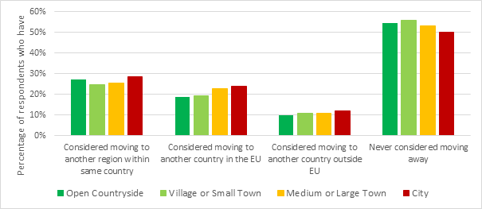

Source: IMAJINE WP4 survey.

### Conclusions

There is a lack of public awareness of the rural poverty problem and of the need to address it[55]. Some authors[56] argue about a non-effective policy proofing from rural points of view. For these and other reasons, rural poverty is often neglected[57].

The standard of living (measured in terms of GDP per capita or disposable household income) is generally lower in rural than in urban areas. Depending on the social indicator looked at women, young and old people as well as groups such as small farmers, people with migrant or Roma background and people with disabilities are particularly affected and thus qualify as more vulnerable parts of (rural) society.

Making sure nobody is left behind requires clearly differentiating between individuals' and vulnerable persons´ special and social needs that must be tackled at national level (support for temporary unemployed or assistance with re-training). Besides, for the more systemic issues affecting different segments of society (women, migrants, etc.) where a broader and intersectoral approach is needed, it is key to ensuring that investments in human capital do not leave aside rural areas and to encouraging joined-up policy making with other responses such as investment in infrastructure and services since they can contribute indirectly reducing poverty and social exclusion.

Listing the challenges in terms of rural social inclusion on a general level should also start with the recognition of the **lack of ‘ready to use’ basic data[58] for many topics using the same rural definition.**

## Local infrastructure

This section deals with local infrastructure in different types of areas, including rural ones.

### The proximity to a large number of people, which is among the factors influencing access to services and infrastructure, varies among types of areas and Member States

Rural areas have a low population density and a dispersed population. Nevertheless, the total number of people within a radius of 120 km differs between rural areas in different Member States and between rural areas close to a city and remote rural areas. For example, more than 14 million people live within 120 km of the rural areas close to a city in the Netherlands and Belgium (Figure 41). This is far higher than the city average in all other Member States. This proximity to a large number of people is one of the factors influencing how easily people can reach certain services and the availability of transport and digital infrastructure.

Figure 41 Population within 120 km by Degree of Urbanisation and remoteness, 2011

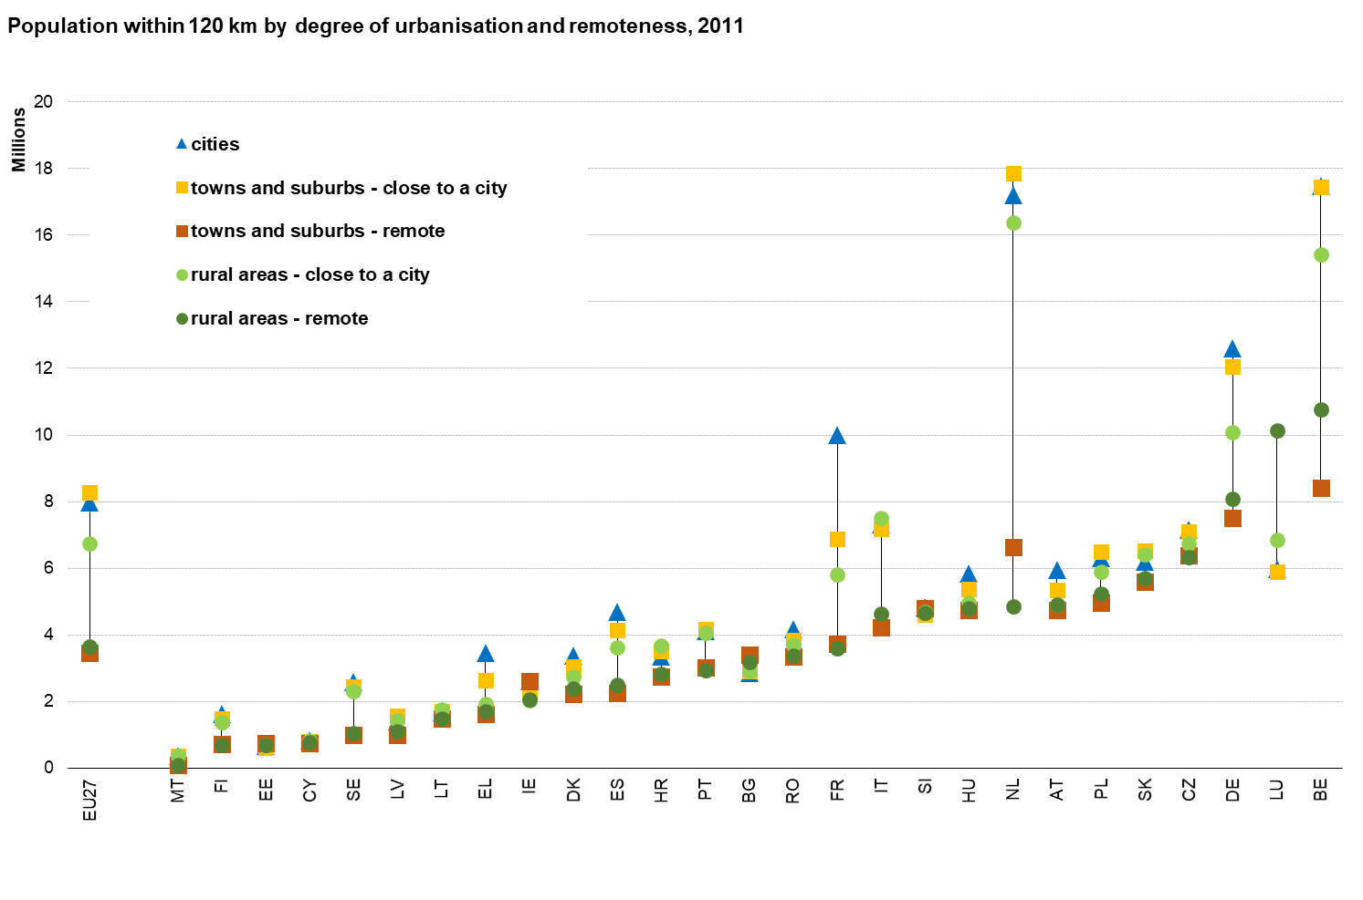

Source: REGIO calculations based on GEOSTAT 2011

### Rural residents have to drive longer distances to reach services

The average road distance to the nearest service follows a clear urban-rural gradient: the less urbanised and the more remote an area is, the longer is the distance to the nearest service. More specialised services require longer distances. For example, in remote rural areas the average distance to the nearest primary school is 8 km compared to 17 km for the nearest secondary school[59]. Distances tend to be longer in very sparsely populated areas, for example in northern Sweden and Finland, in mountainous areas, for example in the Alps and in areas where the road network is less developed, mostly in some eastern Member States.[60]

Figure 42 Average road distance to the nearest service, by Degree of Urbanisation with remoteness, 2016

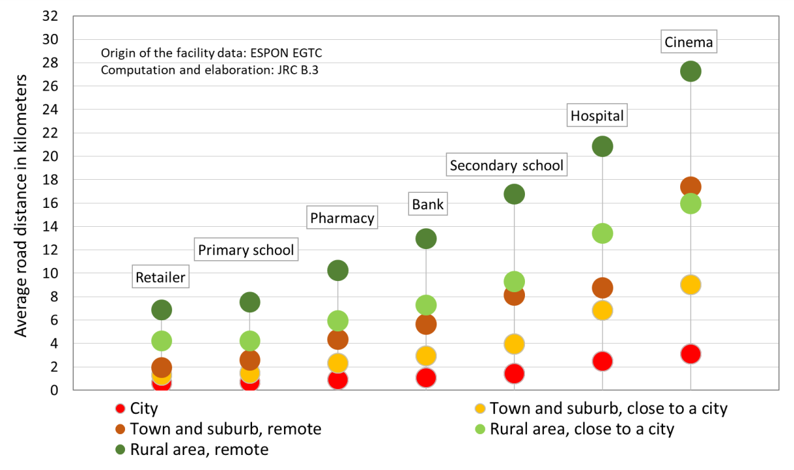

Source: JRC calculations based on ESPON study PROFECY

### Road performance is lower in rural areas, but road networks are longer

To assess how well a transport system works, the International Transport Forum (ITF), the OECD and the European Commission developed a new transport performance indicator[61]. It compares the number of people that can be reached within a certain amount of time to the number of people within a fixed distance. In essence, it measures how the share of nearby destinations that can be reached within a reasonable amount of time. Figure 43 shows what share of the population within 120 km can be reached in a 90 min drive[62]. It shows that rural areas close to a city consistently perform better than remote towns and suburbs and remote rural areas. Rural areas in most eastern Member States tend to perform less well compared to the rural areas in other Member States.

A good road performance requires a sufficiently dense road network and a network of high-speed roads connecting the main population centres. In southern and north-western Member States, the road performance tends to be similar or above the EU average. In most eastern Member States, however, the road performance tends to be lower than the EU average for each of the classes of the Degree of Urbanisation (Figure 43).

On the one hand, comparing road transport performance between similar areas in different countries can reveal some shortcomings. A lower road transport performance in a rural area compared to other rural areas that cannot be explained by geographical constraints, such as mountains, can be an indication of the need for more investment in the road network.

On the other hand, the comparison of road transport performance between different types of areas within the same country requires a careful assessment. The lower transport performance in rural areas as compared to cities does not automatically imply an underinvestment in road infrastructure in rural areas. Achieving a moderate road transport performance in rural areas requires far more kilometres of roads than in a city; indeed the length of local roads per residents in rural areas is 10 times higher than in a city (Figure 44)

Figure 43 Road performance by Degree of Urbanisation and remoteness, 2016

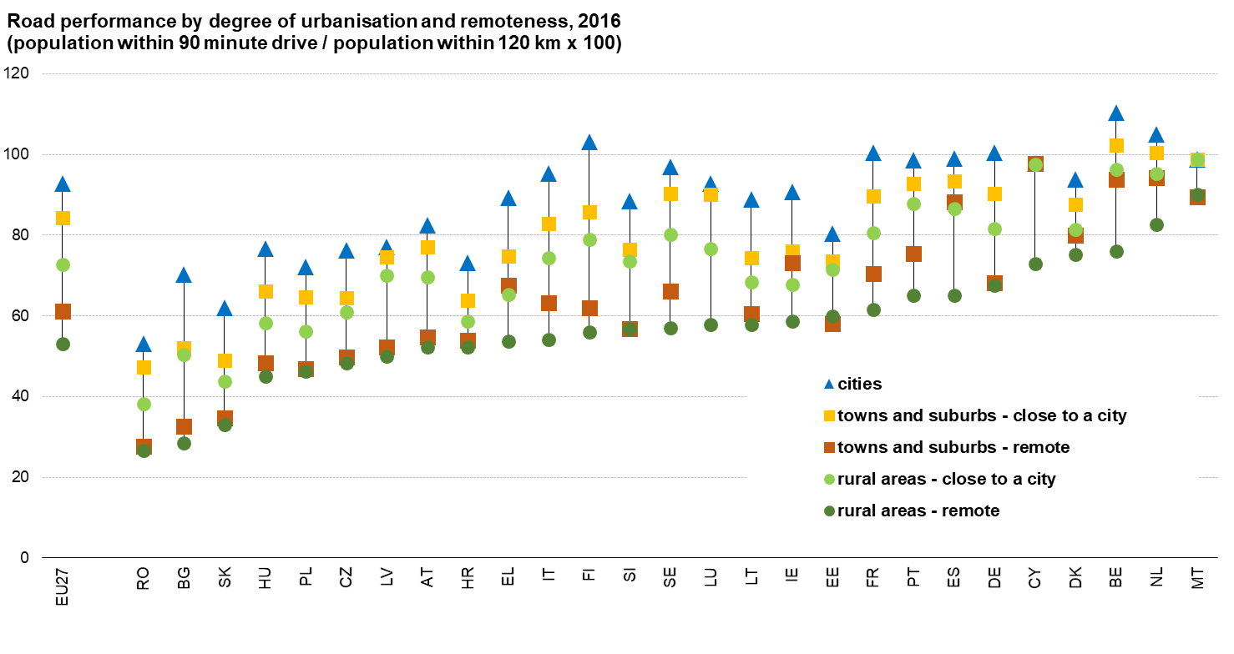

Source: REGIO calculations based on European Commission, Road Transport in Europe, 2019.

Figure 44 Length of local roads, 2019

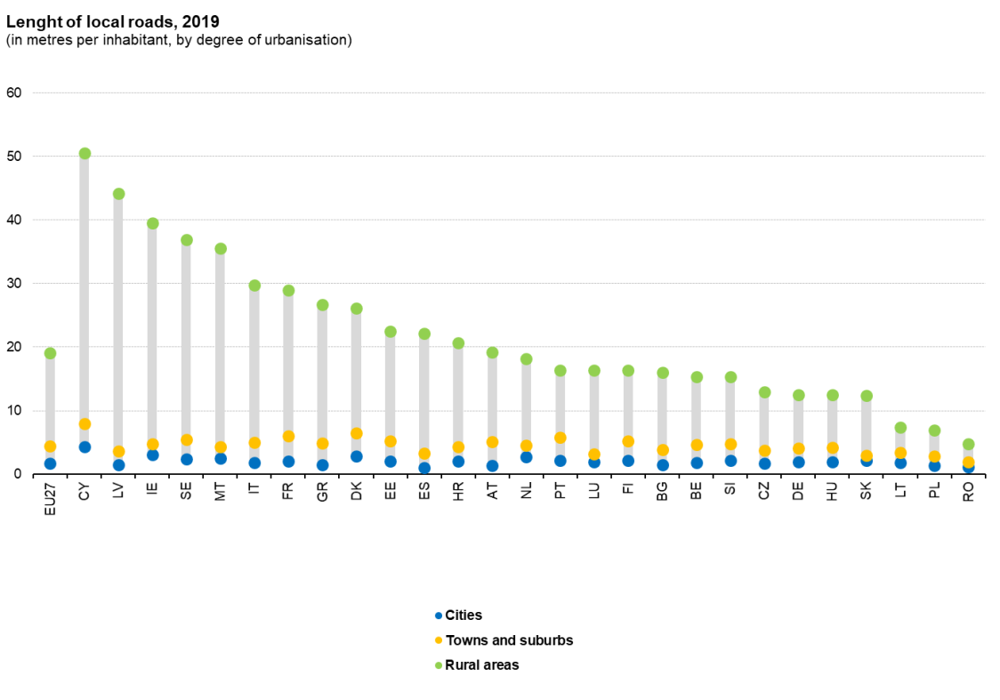

Source: JRC calculations based on TomTom data and GEOSTAT 2011

### Rail performance is low in most rural areas

The same performance indicator (see above for road performance) has also been calculated for rail trips[63] with a short walk at both ends of the rail trip (Figure 45). In the EU, rail performance in rural areas is only 1% compared to 8% in towns and suburbs and 16% in cities[64]. Rail services generally operate between cities, towns and suburbs and it is rare to find a train station in a rural area, especially one with frequent departures. Because of the higher construction and operation cost of rail services as compared to bus routes, rail requires a large number of users making it more complex for rural areas. In absence of comprehensive data on bus routes for all of the EU, it is not possible to assess to what extent bus routes compensate for the lack of rail in rural areas.

Figure 45 Rail performance by Degree of Urbanisation and remoteness, 2014

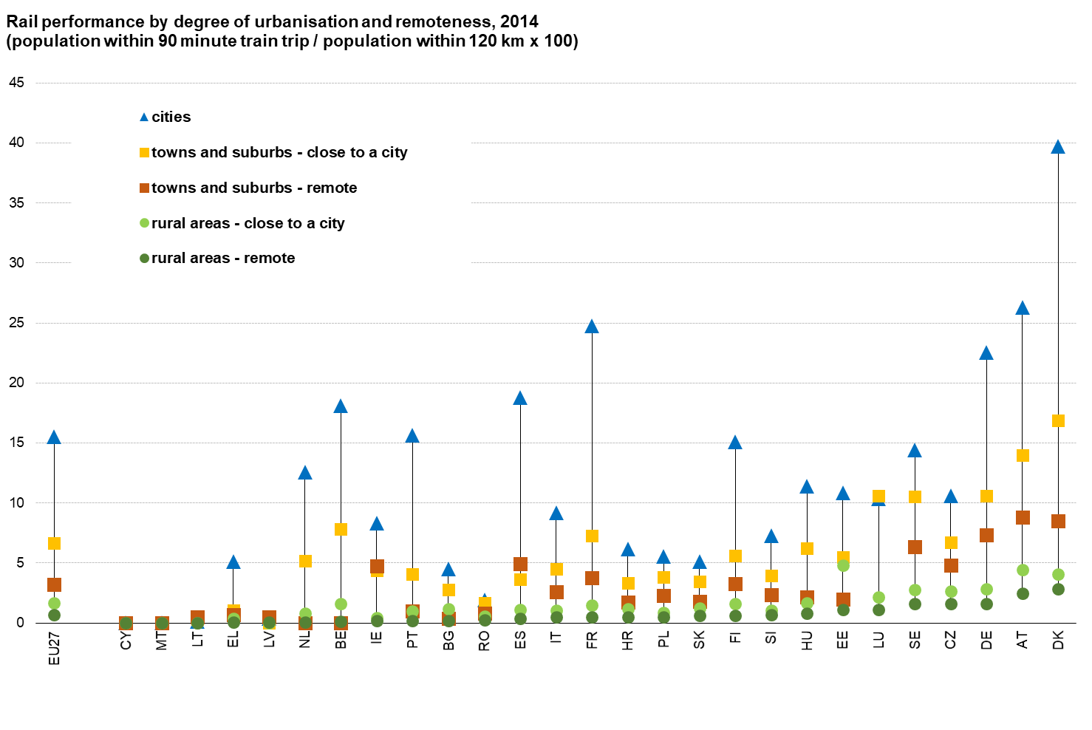

Source: REGIO calculations based on European Commission, Rail transport performance in Europe, 2020.

### Access to passenger flights is higher in rural areas close to a city

Access to passenger flights (i.e. within a 90 minute drive) is primarily determined by the proximity to cities in the EU (Figure 46). City residents have access to about 700 daily flights compared to only around 160 for remote rural areas and remote towns and suburbs. People living in rural areas close to a city have access to 430 daily flights, towns and suburbs close to a city have access to 600 flights. Among rural areas, however, there is a substantial amount of variation. In six Member States, rural residents can reach more than 300 daily flights, while in seven they can reach less than 100.

***Figure 46 Access to passenger flight by Degree or Urbanisation and remoteness, 2019***

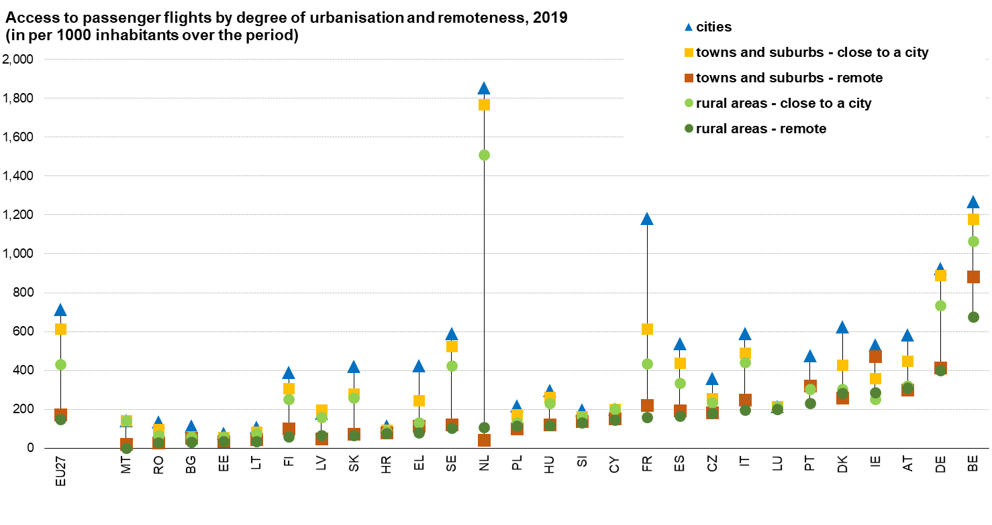

*Source: DG REGIO calculations*

### Fixed broadband covers almost everyone, but high-speed broadband access lags in rural regions

Almost all EU households (97%) had access to fixed broadband in 2020, although only 77% were connected. The access share was only slightly lower in rural regions (90%) with an even lower figure of connected rural households. Since 2011, next generation access (NGA) broadband connectivity has vastly improved in rural regions. In 2020 the EU-27 share of rural households with NGA broadband was 60% against an EU target[65] of 100% access to fast broadband internet in rural areas by 2025. EU average for all households was 87%.[66]

Regarding Very High Capacity Network (VHCN) total coverage showed a fast increase in the same period, while in rural regions growth was clearly lower, leading to a significant connectivity gap between total and rural coverage. [67].

In rural and remote regions, less than 40% of the households are covered by VHCN broadband compared to more than 62% in urban regions (Figure 47). Regions close to cities seem to benefit from the effect of proximity to main urban centers showing better access to NGA and VHCN than rural and remote regions[68].

Figure 47 Households' accessibility to fixed-line broadband coverage per Urban-Rural NUTS-3 typologies in the EU, 2019

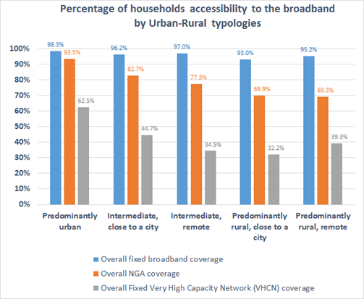

Source: JRC elaboration based on Point Topic ([www.point-topic.com](https://urldefense.com/v3/__http:/www.point-topic.com/__;!!DOxrgLBm!RK92i3TojbZ9rZ1rHZGma0angAB9NZjHNsz7UaUkbeyW7Dp6WOCUWMiFcRQsdPltAN3MNbgg$)) and Eurostat data

Some Member States have a high share of rural households with access to high-speed broadband. For example, in Denmark 85% of the households in remote rural regions have such access, compared to less than 20% in Bulgaria, Greece, France and Italy (Figure 48).97

Figure 48 Households' accessibility to VHCN broadband coverage in the EU, 2019

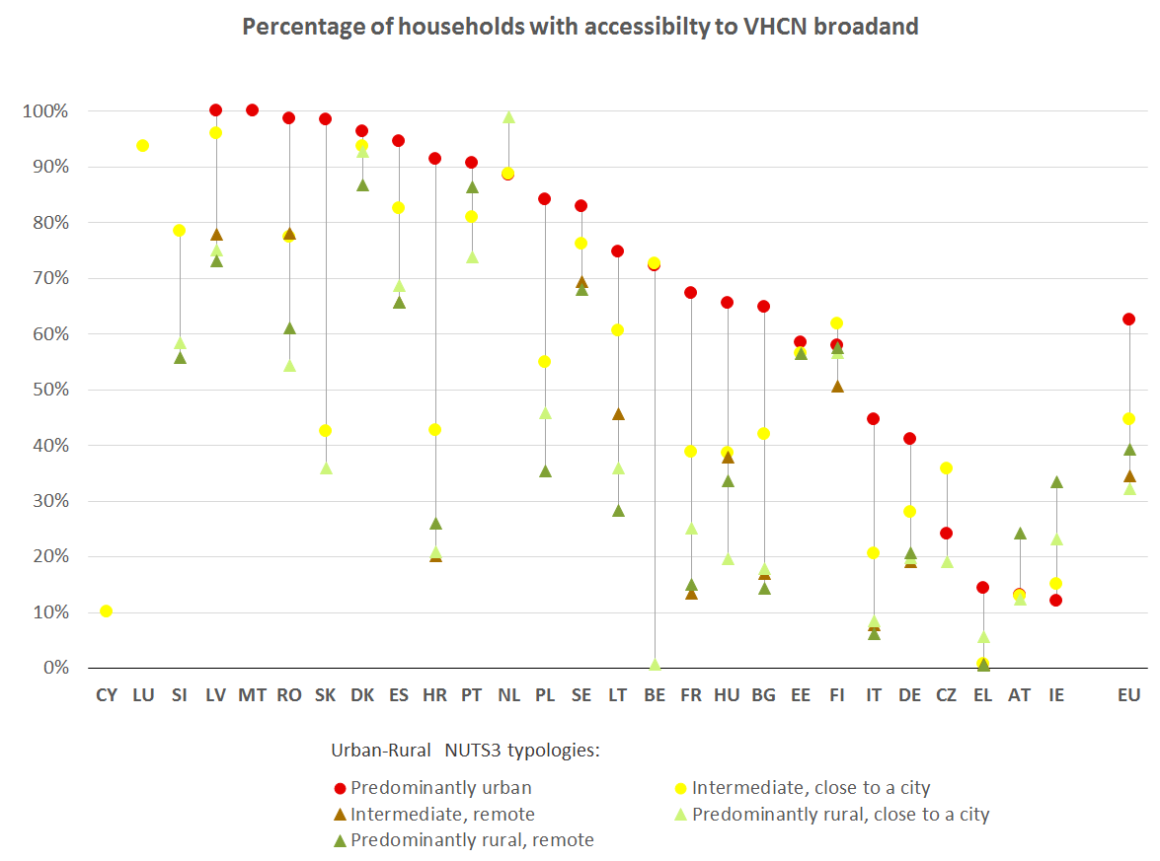

Source: JRC elaboration based on Point Topic ([www.point-topic.com](http://www.point-topic.com)) and Eurostat data

Despite recent improvements in NGA connectivity, the coverage of rural households with NGA broadband is still around 40% below the EU target[69]. Furthermore, the limited availability of VHCN broadband may increase the costs of doing business in rural areas relative to other parts of the EU.[70] In the future, new mobile technology, including 5G, may contribute to complement the VHCN coverage in a cost-effective way in rural regions. [71] Besides, an intelligent combination of terrestrial and space-based connectivity, ensuring high-speed broadband everywhere for resilient and cost-effective services and applications is also expected to contribute.

### Conclusions

Rural areas tend to have lower road and rail performance. Rural residents have to drive longer distance to reach different types of services and have access to fewer passenger flights. When looking at reachability of persons[72], rural areas close to a city consistently perform better than remote towns and suburbs and remote rural areas, while rural areas in most eastern Member States tend to perform less well compared to the rural areas in other Member States.

On the one hand longer distances and lower transport performance in rural areas relative to cities cannot be avoided due to more dispersed population. A service in a rural area has to draw from a much wider area to ensure it has sufficient users or clients than a service in a city.

On the other hand, to achieve the goal of ‘no one should be left behind’, access to basic quality services for rural population needs to be ensured, in particular for basic services such as retailer, doctor, pharmacy and bank. These services could be provided in villages to reduce the risk of isolation, especially of the most vulnerable population, such as elderly, children and those who do not have a driving licence or a car. Mobile service solutions, private-public partnerships, social enterprises can help to improve access to services in less populated areas.

Some rural areas manage to provide services within shorter distance and offer better transport performance than other rural areas. Whereas rural areas in southern and north western EU Member States tend to have a well performing road network, certain rural areas in eastern Member States may still need more investments in their road network.

Broadband is now almost universally available, including in rural regions. The coverage of high-speed broadband connections in rural regions, however, lags behind that in urban, despite recent growth in its rural coverage. Technological innovation and a combination of terrestrial and space-based connectivity, may facilitate the rolling out of Very High Capacity Networks in rural regions in a cost-effective way.

Finally, it should be noted that the analysis of availability of and access to basic infrastructure and services is subject to certain data constraints. For example, in absence of comprehensive data on bus routes for all of the EU, it is not possible to assess to what extent bus routes compensate for the lack of rail in rural areas.

## Local democracy

This section describes the trust of rural residents in different institutions, their level of political engagement and interests and voting behaviour.

### Rural residents are less likely to trust their national government and the EU than city residents

On average in 2018 and 2019, **50% of the rural residents tended to trust the EU** compared to 55% of the city residents (Figure 49). This trust gap between cities and urban areas appeared in virtually all Member States (23 out of 27). In four Member States, this gap was bigger than 10 percentage points (DE, FI, LU, HR). Nevertheless, the differences between Member States are far larger than between cities and rural areas within the same Member State. At the national level only 30% tends to trust the EU in Greece, compared to almost 80% in Lithuania, a gap of 50 percentage points.

Figure 49 Proportion of population who tends to trust the EU, average for 2018 and 2019

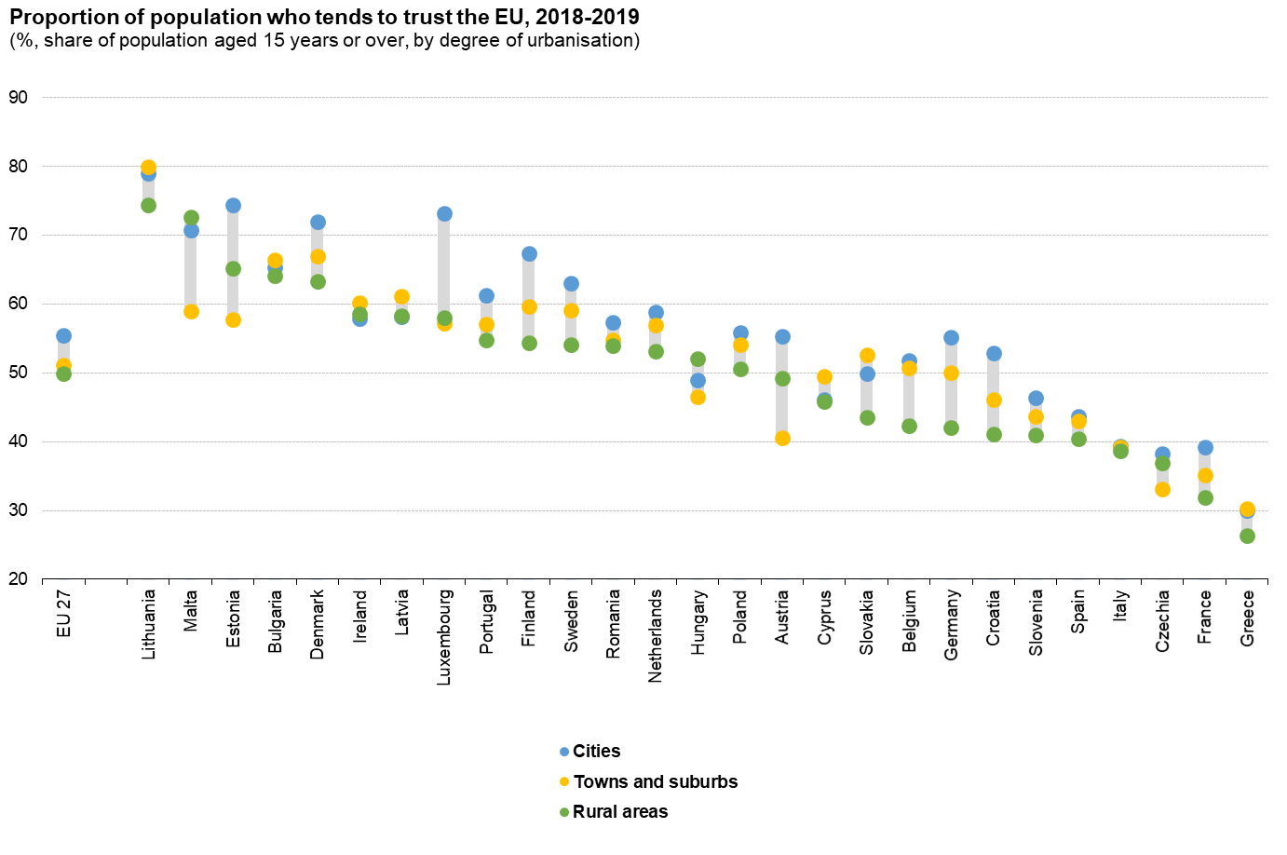

Source: JRC calculations, based on Eurobarometer (91.5, June 2019, ZA7576 - 91.2, March 2019, ZA7562 - 90.3, November 2018, ZA7489 - 89.1, March 2018, ZA6963) available at <https://www.gesis.org/en/eurobarometer-data-service/search-data-access/data-access>

This difference in trust can also be seen in voting patterns. On average, **rural voters are more likely to vote for parties that oppose EU integration** in European[73] and national elections[74] compared to voters in cities, towns and suburbs. Rural residents are also less likely to think their vote counts in the EU (50%) than city residents (54%) (Eurobarometer average for 2018 and 2019).

The trust gap between rural areas and cities is slightly smaller for the national government (Figure 50). **Only 37% of rural residents tend to trust their national government compared to 41% in cities.** Out of the 27 Member States, 17 Member States have a smaller share of rural residents than city residents who tend to trust their national government. For trust in the EU, a clear difference can be seen as rural trust was lower than city trust in 23 Member States. As with trust in the EU, the difference between Member States is bigger than within a Member State. For example, at least 75% of the rural population tends to trust their national government in Luxembourg compared to less than 20% in Greece and Croatia.

**At the same time, in relative terms trust in the EU tends to be higher than trust in their national government**. Trust in the EU is higher than in their national government in rural areas in 22 Member States. In half the Member States, the share of rural residents who trust the EU is at least 10 percentage points higher as compared to those who trust their national government.

Figure 50 Proportion of population who tends to trust their national government, average for 2018 and 2019

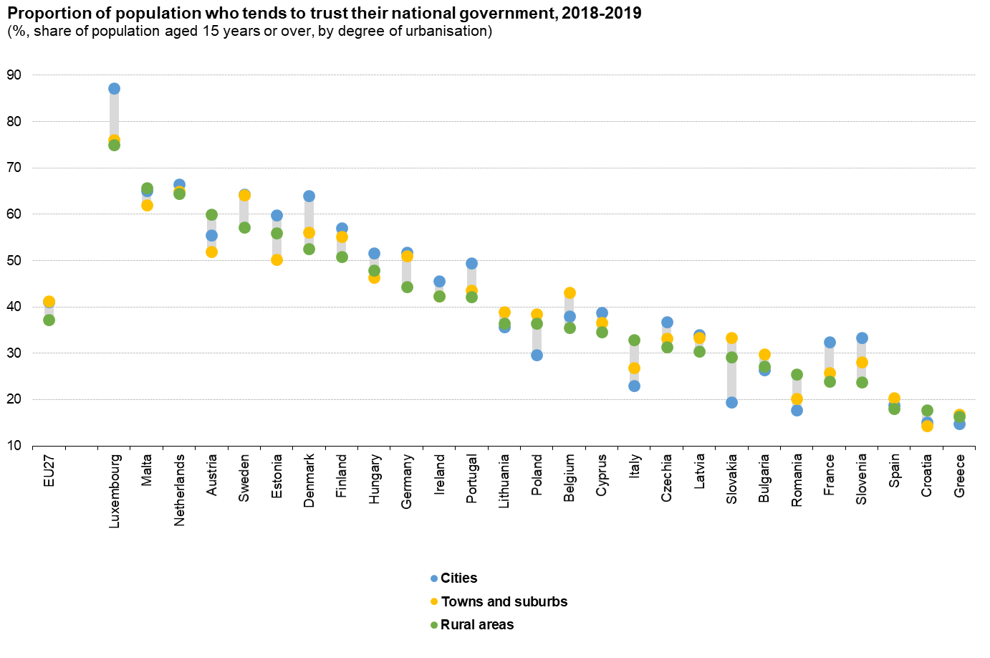

Source: JRC calculations, based on Eurobarometer (91.5, June 2019, ZA7576 - 91.2, March 2019, ZA7562 - 90.3, November 2018, ZA7489 - 89.1, March 2018, ZA6963) available at <https://www.gesis.org/en/eurobarometer-data-service/search-data-access/data-access>

### Rural residents are less satisfied with their national democracy and less likely to vote in national elections

The share of population who is satisfied with their national democracy is considerably higher than the share who trust in their national government. This may reflect that some people dislike the current government, but are happy with their democratic system. Nevertheless, **slightly fewer people in rural areas are satisfied with their national democracy as compared to cities (57% vs 60%)**. This pattern is consistent with lower satisfaction in rural areas as compared to cities in 20 out of the 27 Member States.

Figure 51 Proportion of population who is satisfied with national democracy, average for 2018 and 2019

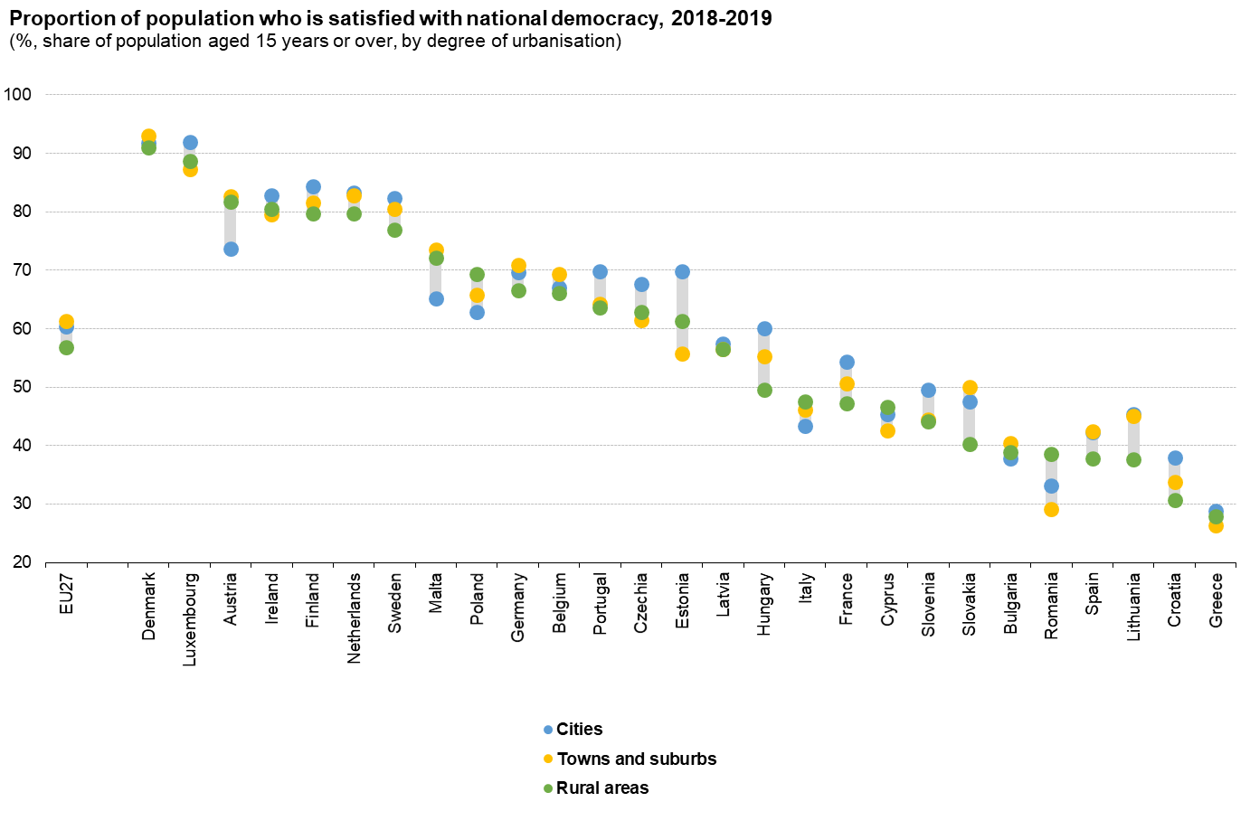

Source: JRC calculations, based on Eurobarometer (91.5, June 2019, ZA7576 - 91.2, March 2019, ZA7562 - 90.3, November 2018, ZA7489 - 89.1, March 2018, ZA6963) available at <https://www.gesis.org/en/eurobarometer-data-service/search-data-access/data-access>

Eligible voters in rural areas are less likely to vote in national elections as compared to those in cities (Figure 52). **Turnout in rural areas is 61% compared to 66% in cities in the most recent national election** between 2013 and 2018[75]. This pattern varies by Member State. For example, in Austria turnout was 11 percentage points higher in rural areas than in cities, while in Poland turnout was 13 percentage points lower in rural areas than in cites. In 12 Member States, turnout was higher in rural areas than in cities, but the difference was often small. As a result, overall turnout in cities is substantially higher than in rural areas.

Figure 52 Turnout in national election, 2013-2018

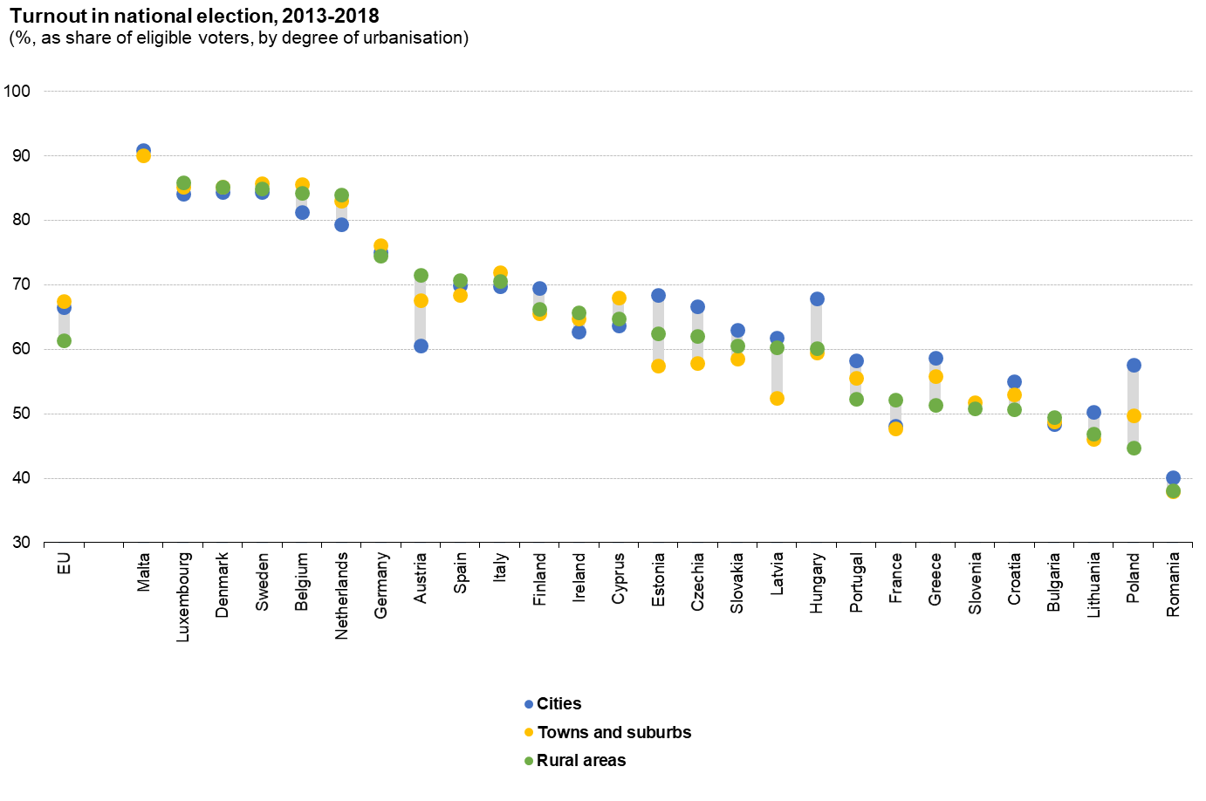

Source: Calculations based on Dijkstra, L., Poleman H., Rodrguez-Psoe A., The geography of EU discontent, 2018.

### Rural residents are more likely to trust local and regional authorities

Rural residents are more likely to trust local and regional authorities than city residents are (Figure 53). At the EU level, the difference is small: 57% in rural areas as compared to 55% in cities. The higher trust in rural areas is replicated in most Member States. In 20, a larger share of rural residents trusts local and regional authorities than city residents do. In some Member States, the gap between rural and city residents is particularly wide. For example, in Latvia and Bulgaria the share of rural residents who trust their local and regional authorities is more than 20 percentage points higher than share of city residents who do so.

**Rural residents are more likely to trust local and regional authorities (57%) than their national government (37%) or the EU (50%).** In all but one Member State (MT), rural resident are more likely to trust their local and regional authorities than their national government. The contrast with the EU is less pronounced, with 19 Member States where rural residents are more likely to trust their local and regional authorities than the EU. The proximity to local and regional politicians as compared to national and EU politicians may be one of the factors that explains this difference. As rural municipalities tend to have a smaller population, rural residents are more likely to know their politicians than city residents are.

Figure 53 Proportion of population who tends to trust regional or local authorities, average for 2018 and 2019

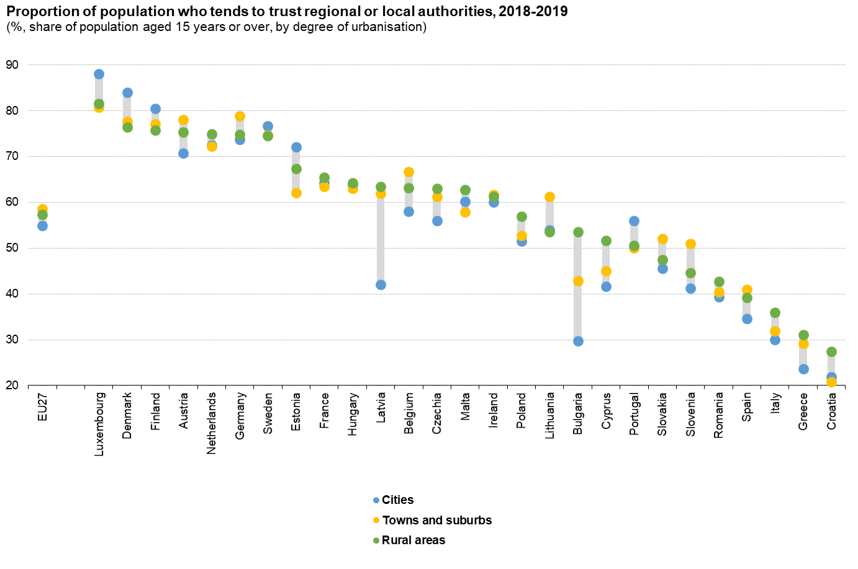

Source: JRC calculations, based on Eurobarometer (91.5, June 2019, ZA7576 - 91.2, March 2019, ZA7562 - 90.3, November 2018, ZA7489 - 89.1, March 2018, ZA6963) available at <https://www.gesis.org/en/eurobarometer-data-service/search-data-access/data-access>

In 2015, **11% of rural residents were active citizens**, meaning that they had attended meetings, signed petitions, or otherwise participated in activities related to political groups, associations or parties. This was slightly lower than the **15% of city residents**. This difference was highly consistent with a rural resident less likely to be active than city residents in 23 out of 27 Member States. Rural residents are less likely to discuss politics frequently than city residents (15% vs 18%, Eurobarometer average for 2018 and 2019).

Figure 54 Proportion of population that were active citizens, 2015

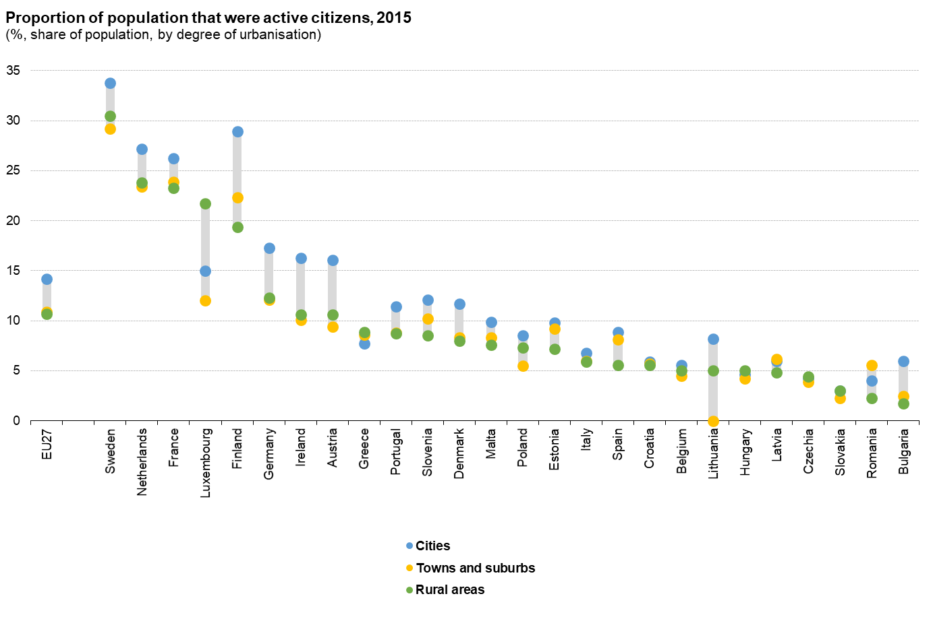

Source: Eurostat (online data code: iilc_scp20)

In contrast to active citizenship, **rural residents were more likely to participate in formal and informal voluntary activities** (formal 20% and informal 24%) than city residents were (17% and 22%) in 2015.

### Conclusions

The overall picture that emerges is that rural residents have a different political outlook than city residents.

Rural residents are more likely to trust local and regional authorities (57%) than their national government (37%) or the EU (50%), contrary to the city residents. Rural residents are less satisfied with their national democracy and less likely to vote in national elections. Rural residents are also less likely to think that their voice counts in the EU and are more likely to vote for parties that oppose EU integration than city residents are.

Rural residents tend less to be active citizens, i.e. to attend a meeting, sign a petition, or otherwise participate in activities related to political groups, associations or parties than city residents are. In contrast, they are more prone to participate in formal and informal voluntary activities than city residents.

In part, these differences are the result of the different demographic, social and economic characteristics of rural residents compared to city residents[76]. Even if these differences can be explained by the different socio-economic characteristics of the rural population, they still lead to a lower voter turnout and different voting patterns. Better consultations of rural constituencies, more discussions of how to address rural issues and making it easier for rural residents to engage with political parties or to vote online may help to address this gap.

## Bioeconomy

This section describes the current and future opportunities of the bioeconomy and reflects on the challenges related to its implementation.

### The EU bioeconomy offers many opportunities – it could reach up to EUR 3 trillion by 2050 - but there is a need to better integrate primary producers

The bioeconomy includes and interlinks land and marine ecosystems, all primary production sectors that use and produce biological resources and all industrial sectors that use biological resources and processes for the production of food, feed, bioenergy and bio-based products.

The bioeconomy is **one of the Union's largest and most important sectors** encompassing agriculture, forestry, fisheries, aquaculture, food, bio-energy and bio-based products generating **EUR 614 billion of value added and employing around 17.5 million people**.[77] The whole agri-food chain represents 75% of the employment of the EU bioeconomy, and two-thirds of its turnover.

**The relative contribution of primary sectors to the EU bioeconomy is significantly lower in terms of value added (33%) than in terms of the number of persons employed (55%)**.[78] In addition, primary producers (farmers and forestry owners) are not very well integrated vertically into the bioeconomy value chain. Therefore, they play the role of biomass suppliers rather than producers of bioproducts. The bioeconomy thus represents an opportunity for new actors to enter production with positive effects on rural employment, where larger-scale and small-medium multifunctional (agroecology, agrogorestry, carbon, integrated multi-trophic aquaculture) farms coupled with de-centralised smaller-scale biorefineries co-exist[79].

Regarding the **EU bioeconomy turnover trends until 2050, different scenarios exist**. In a low growth scenario, the primary production sectors (agriculture, forestry, fisheries) show a stable evolution over time. The food industry is also growing steadily while other traditional biobased sectors (paper, wood production, textiles) continue their decreasing trends in the EU, mainly due to increasing imports from more cost-competitive regions such as China. In a high growth scenario, the primary production sectors also show a stable evolution over time but other sectors are estimated to grow. In this case, the total annual turnover of the EU bioeconomy sector **could reach up to EUR 3 trillion by 2050**.[80]

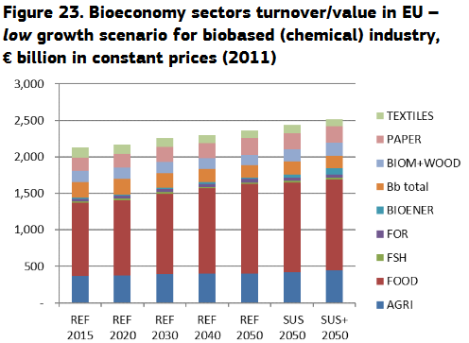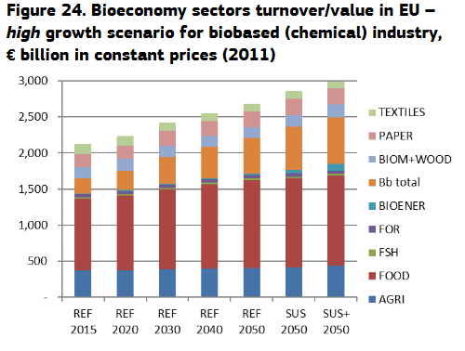

Figure 55 Bioeconomy sectors turnover/value in EU low growth (left) and high growth (right) scenario for biobased (chemical) industry, euros billion in constant prices (2011).

Source: M’Barek R., Philippidis G., Ronzon T., Alternative Global Transition Pathways to 2050, 2019.

Regarding employment, the further development of urban, coastal and rural areas across Europe is expected to lead to the creation of 400,000 new highly skilled jobs by 2035 in the bio-based sector and up to 700,000 by 2050, mostly in these areas.[81]

### Conclusions

Global challenges such as climate change, land and marine ecosystem degradation, coupled with a growing population and the COVID-19 crisis impose seeking new ways of producing and consuming resources that respect our planetary boundaries, moving away from a linear economy based on extensive use of fossil and mineral resources. To tackle these challenges, the way natural resources are managed needs to be improved and healthy ecosystems need to be maintained through a sustainable, regenerative and circular bioeconomy that will also have an important role in mitigating EU emissions and reaching climate neutrality in 2050.

**The bioeconomy is considered as a major tool for reviving rural areas, creating more innovative jobs in primary production and processing, contributing to generational renewal and fighting de-population of rural areas**. It can help rural regions to identify place-based, cross-cutting initiatives that enhance environmental conservation and regeneration while creating new jobs, improving food and water security, and promoting a transition to a climate-neutral and circular economy. There are also opportunities in terms of implementation of synergies in new biobased value chains across regions based on their smart specialisations.

**The sustainable bioeconomy has also the potential to support primary producers** in creating additional outlets for higher value added products, improving the resource efficiency of their activities and spurring innovation in the primary sector. **Primary producers should play a more central role into the value creation of the sustainable bioeconomy supply chain**, which should be achieved by increasing awareness and knowledge through targeted advisory services as well as supporting new business and cooperation models.

However, its **implementation in terms of research and innovation capabilities needs** further efforts to accelerate the transformation by bringing innovations faster into the market.

**Institutional capacity is a key factor.** Redirecting action and investment from current practices into fully-fledged circular development pathways in rural regions requires a cultural change and a new mix of skills in rural communities, coupled with proper incentives for local governments. Rural communities should be supported through training and education, both on the technical aspects as well as business models and management, so as to create new employment opportunities during the transition to a low carbon economy[82].

## Innovation, cooperation and networks

This section deals with the rural areas as spaces for innovation and identifies opportunities and challenges thereto.

### Rural areas are innovative, even more when they cooperate

Rural areas are commonly assumed to be less innovative than urban areas, because of their lower density of people and businesses, lower connectivity and accessibility, and a more limited presence of highly educated people, universities and research centres, criteria that are considered as key conditions for innovation.[83] Several studies nuance or contradict this assumption and highlight that **innovation types, patterns and enablers vary across countries, regions and rural and urban localities**.[84] This is something that current ways to measure **innovation** (including European innovation scoreboards[85] and indicators for Sustainable Development Goals[86]) **insufficiently capture** because they are applied at a too-wide geographical scale (NUTS-2), focused on forms of innovation that are more typical of dense regions and less well adapted to capture process, market, organisational or social forms of innovation that do not result in patents or science publications.[87]

The OECD highlights that **rural and urban regions alike have the potential to innovate and grow[88]**, while United Kingdom’s innovation agency NESTA stressed in a key report on rural innovation that many innovations in health, housing and transport have emerged primarily in response to growing demand in the primary sectors in rural areas (such as the need to transport materials or manage land-use that led to the development of geographic information systems widely used by drivers today) and that some rural areas have shown extraordinary success in transforming themselves into global centres of innovation (e.g. the technology park of Sophia-Antipolis (FR)). NESTA further argue that there is an **important relationship between rural natural resources and innovation.** They add that the **growing strategic importance of sustainable technologies** that rely on rural resources has enhanced this relationship and triggers a renewed political interest in the role of rural areas in the wider economy*.[89]*

**All forms of innovation happen in all rural sectors and fields of community life**. Examples include resource-efficiency driven innovations in farming, process optimisation in food and bio-based industries, social innovation changing value chain organisation, service provision or valorisation of cultural heritage. Technical and technological innovations in the sectors related to the management of natural resources also mostly happen in rural areas. A range of scientific publications have found **rural innovation to have some or all of the following characteristics**[90]:

* **Innovation is initially sparked by** internal and external **challenges** (e.g. withdrawal of the public sector from service provision, tougher environmental regulations) rather than by the creation of knowledge inside the rural area (as research centres are usually less numerous in rural areas).
* **Innovation tends to be more incremental:** it is more about repurposing, adapting, using differently existing knowledge or technology than about inventing brand new knowledge.
* **Social innovation typically plays a great role** alongsidetechnical or technological innovation, as solving many of the rural challenges requires inventing new ways of doing things, new ways of delivering services, new business models, and new ways of cooperating coming bottom-up from rural community members.
* **Cooperation and networking are essential:** as rural areas are less dense in people, businesses and knowledge creation facilities, people need to cooperate with one another internally as much as possible, and also to **cooperate and network** to source knowledge from people and institutions **outside** their local area, whether from urban centres or by exchanges with other rural areas, within the country, across borders or transnationally. Research has shown that active cooperation (including cross-border and international cooperation) can compensate for the lack of resources inside the rural area.

### Weaker enabling conditions make it challenging to express rural innovation potential

Challenges to rural innovation mostly relate to **weaker enabling conditions and environments** that prevent the full expression of rural innovation potential. These differ depending on the specific institutional, economic, social and environmental conditions of each area, which vary greatly across Europe.

**The effect of education levels in the area seems important for innovation capacity in a majority of sectors[91]**, although firms may source an important proportion of knowledge from within or from distant networks.[92] Education levels of people living in rural areas, in particular tertiary education, are improving but lower than the EU average, as mentioned in this document’s chapter on education, and several elements of human and social capital (e.g. skills, willingness to cooperate) can be weaker, depending on the regions.[93] A critical mass of innovation actors is also important, in particular research centres.[94] The capacity to profit economically from knowledge creation and exploitation varies greatly across Europe, with regions in west and north of Europe, being more advanced than eastern and northern Europe regions[95]. Compared to urban areas, the rural innovation eco-systems have fewer higher education institutions and specialised research facilities, resulting in fewer highly skilled researchers that can provide innovation input and interact with local businesses, via local clusters for example. Similarly, SMEs and entrepreneurs, who are generally smaller and with limited individual capacity to invest in R&D, may face less developed business and innovation support infrastructure and services, and less technology transfer or knowledge exchange actors. Innovation support services may be accessible but not designed to support the kind of innovations and innovation actors that are in rural areas[96]. Rural areas are often left out of innovation chains and with limited access to innovation capacities in the cities.[97]

**Limited infrastructure** and **low accessibility and digital connectivity also act as barriers** to cooperation, networking and sourcing of knowledge from outside **for innovation**, as they limit access of people and businesses to new markets and services (including innovation support services) and educational opportunities. This can also limit the attractiveness of rural areas as places to live and work for innovative people and businesses. As shown in this document’s chapter on infrastructure, access to digital infrastructure still bears challenges for rural regions. Beyond the infrastructure challenges, there are barriers in rural areas around digital skills and uptake of digital technologies by both people and businesses which need to be lifted simultaneously as the infrastructure is provided.[98]

The European investment bank (EIB) explored key characteristics of innovation in the agri-food and bio-based sectors, both of which they identify as important drivers of employment in rural areas. In agri-food, they identified a **risk-adverse behaviour and low innovation rates**. Less than 50% of all agri-food companies in the EU undertook innovation activities over the three years preceding the study, while only 9% innovated in core areas such as technology, products and processes. This figure contrasts with the need for innovation to help the sector respond to a raising food demand and sustainability challenges. For the EIB, this behaviour is driven mostly by market characteristics, competition that is generally more on price than on quality, innovation or environmental impact. Price competition, in combination with low margins and long payback periods, limits the appetite and possibilities for innovation and risk-taking. This also reduces the financing of agri-food innovation, which suffers from a **fragmented landscape** and **lack of specialised investors** with sufficient knowledge and willingness to take risks. The most frequently mentioned reason that finance was not obtained was an unclear or unproven business model. Other reasons were poor commercial outlook, limited financial track record and regulatory uncertainty. A visible financing gap exists regarding the scale-up of smaller agri-food innovators that earn EUR250 000 to EUR5 million per year. The agri-food innovators that reported difficulties in accessing finance were looking for loans of EUR 250 000 to EUR 1.5 million.[99] The EIB equally identified a financing gap in the bio-based industries sector, in particular for funding the scaling-up of innovation from pilots to demonstration or industrial scale plant, with uncertainties on regulation and demand development also playing a key role.[100] Access to finance is also highlighted as one of the key concerns of new entrants into farming, who tend to be promoters of green and social innovation.[101]

**Challenges to cooperation and networking** include, for joint projects carried by beneficiaries located in different regions or eligible under different programmes, administrative and legal obstacles, difficulties in accessing finance for cooperation (lack of alignment and coordination between various support programmes, or for the timing of calls for projects), distance, insufficient skills (including language in cross-border cooperation and networking or between different types of actors (e.g. scientists and businesses), in particular when it comes to facilitating interactive bottom-up innovation projects that are best suited to fit the needs of rural people and businesses). There can be also difficulties in identifying connectors or innovation intermediaries that can help link businesses across borders.[102]

### Green transition, digitalisation, social challenges: three powerful drivers for rural innovation, cooperation and networking

Opportunities for rural innovation come mostly from i) **dynamic developments in some sectors or technologies**, ii) the challenges related to rural difficulties that can act as **triggering factors for innovation**; and iii) the **efforts needed in response to the COVID crisis**.

There is a **renewed dynamism of research and innovation in the resource-based economy and the natural resources on which such innovation depends are mainly located in rural areas**.Public investments in agricultural research and development for example are raising since 2016 after a period of stagnation or decline.[103] This direction is further pushed by major policy objectives[104] responding to increasing concerns over dependence on fossil fuels, resource scarcity, climate change and biodiversity loss. The sectors linked to the resource-based economy include the bio-based economy, the circular economy, renewable energies, food, farming and forestry. Rural areas provide space for the development of renewables, which could turn into an important source of income for rural communities.[105] Ecosystem services and innovation around their valuation and valorisation through recreational activities is also an important field for rural innovation.[106] A majority of local innovation projects (53%) funded under the agricultural European innovation partnership (EIP-AGRI)[107] focus on **alternative types of farming** such as organic farming, agroecology, adapting circularity principles to farming, and bio-based production, in close connection with increasing investments in research activities on more sustainable farming. A significant proportion of them also address wider value chain innovation needs around food quality, processing and nutrition (22%) alongside circularity and bio-based sectors with e.g. projects on waste and by-products (9%) or energy management (5%).[108]

**Improved connectivity and digitalisation** are an opportunity to address many of the weaknesses linked to low density of people and businesses that hinder the emergence of rural innovation: they could improve skills, education, training, knowledge and information flows, opportunities for cooperation and networking, access to employment, access to services and access to markets and enabling technologies. This is true in the **primary and secondary sectors**, where digital innovation plays a central role in improving productivity, reducing environmental impact and connecting producers and consumers (digital farming, sensors in agri-food processes, modelling to optimise resource use and production and processing methods, web platforms for marketing and traceability). This also holds for the service sector, where digital technologies can help develop **e-services** (education, health, bank, mobility), and **e-governance and participatory processes**, as explored in smart villages[109]. Technology is transforming in particular the provision of health and care services. When used correctly, the latest technologies can improve both the quality of care and social cohesion. However, digitalisation can be beneficial for rural areas and communities only if the basic conditions in terms of infrastructure, skills and accessibility are met **quickly enough** to enable rural businesses to remain competitive, especially in remote areas, if the potential labour-saving effects of digitalisation are mitigated with the creation of new rural jobs and adequate training or re-skilling for workers, where necessary. A further condition is that relevant applications matching the specific needs of rural actors are developed through participatory and place-based approaches. Important opportunities come from **developing digital innovation hubs,** **local technology hubs, brokers or intermediaries** (e.g. local fablabs, smart villages etc.) that ease access to digital tools and needed skills for community actors or small entrepreneurs and SMEs that have no direct digital production process or activity.[110] Many actors of the social economy, for example social entrepreneurs, are involved in such programmes (open food networks, local taxi platform cooperatives, coops/community organising delivery, mobility, sustainable tourism like fairbnb) which help them use digital technologies to optimise profitability.

Public service decline, or specific shocks such as those experienced during the COVID-19 pandemic, can increase **pressure for rural businesses to be more innovative** or for rural people to find solutions themselves, especially through **social innovation**.[111] This has been observed e.g. in catering, child and health care, education and business development support[112]. In some cases, innovation triggered by rural challenges develops at the interface of rural and urban areas and in partnership. Innovative approaches providing benefits for rural and urban citizens alike have been observed for example for local food procurement[113], or integrated mobility systems organised through inter-municipal collaboration[114].

The improvement of **social capital** (i.e. collective norms, trust and networks) and the **diversification of rural populations through rural newcomers** (educated pensioners, remote workers, new entrants into farming etc.) is an opportunity to increase the average education levels of rural populations[115]. This is likely to accelerate with COVID-19 pandemic in the most attractive and well-connected areas. The need to cope with the impact of the COVID-19 pandemic brings opportunities around **evolution in working methods, distance learning and telework that could trigger skilled people to relocate in rural areas**, especially in the most accessible rural areas. COVID-19 pandemic also triggered a renewed interest for rural tourism at the expense of destinations abroad or in denser places, which could prove interesting for innovation in this sector.[116]

**Opportunities for cooperation** **and networking** stem from the sense of community that is common to many rural villages. This strong community spirit comes from the smaller size of the communities, common challenges faced, tradition, culture and values. This is embedded in the notion of social capital, recognised in literature as playing a key role in rural development and in rural innovation[117]. The COVID-19 pandemic has seen multiple examples (e.g. organising local food supplies, compensating for labour shortages on farm, caring for the elderly) of local rural communities coming forward with their own solutions to tackle challenges that emerged during the COVID-19 pandemic in a spirit of community solidarity, and a strong interest for sharing this knowledge and experiences facilitated also by digitalisation. [118]

### A swift improvement of enabling conditions is imperative for rural innovation to transform trends into positive outcomes

It is very hard to predict the impact that current trends will have on rural innovation, cooperation and networks. Several megatrends[119] are rather positive for the innovation potential of rural areas (increased interest in the sustainable bio-based sector and circular economy, evolution of working patterns with e.g. more telework, raising interest in healthy food and sustainable diets) and are likely to improve some of the enabling factors (digitalisation). However, these trends express themselves in very **variable ways in different rural areas in Europe and are likely to lead to varying results by 2040**. The way innovation develops in different territorial contexts is very variable[120] and the various dimensions of rural innovation are still largely under-researched. The outcome will depend on the pace of change and the capacity of rural territories to keep up with that pace depending on their local conditions.

The key drivers of rural change are, according to OECD, i) additive and distributive manufacturing; ii) digital connectivity; iii) cloud computing and the internet of things; iv) drones; v) driverless cars; vi) the future of education; vii) the future of health; viii) shifting values and preferences; ix) decentralised energy systems; and x) the future of food. Technologies that create more **deconcentrated and network-based distributive production systems** have the potential to reshape the geography of economic activity in favour of rural areas. Innovation will be critical for rural areas to benefit from these key drivers of change as will key infrastructures (transport, connectivity etc.). OECD also posits that “rural areas **will play a central role in meeting the major global opportunities** **and challenges** of the 21st century around climate change, new energy sources, circular and bioeconomy, food and nutrition security for a growing global population, reducing poverty and ensuring the sustainable provision of natural resources that will support the next production revolution”.[121]

The paradigm **shift to a green and circular economy** is a driver for a high level of technological and social innovation, which may give areas currently leading in these fields a clear head start. Regions and communities taking ownership of their economic development by using their local assets and designing their own economic model will benefit from the increased autonomy and the flexibility their approach provides them, notably in associated domains such as social development or environmental preservation.[122] Innovation in business models that are able to create and retain value in rural areas will be key.[123] Beyond developments in farming, forestry, food and bio-based sectors, developments in **smart mobility** and the use of technologies to better match supply and demand in ways that specifically answer rural needs (e.g. ride sharing and e-hitchhiking apps[124]) are important for the green transition.

**The “4th industrial revolution is however also expected to accelerate territorial differences”.[125]** Following current developments in the technology sectors such as artificial intelligence, nanotechologies, decentralised computing and robotics, the innovations will be far-reaching. This could prove problematic as most of the rural areas with demographic challenges may lack the skilled human capital or the infrastructure to develop competitive industrial centres, thus potentially creating “regions left behind”.[126] **Trends in the intensity of trade and in business model development** will also impact rural innovation, as many activities are included in international trade flows that frame their economic conditions and the means they have to invest in research and innovation.[127]

**Digitalisation** is likely to accelerate as a result of the COVID-19 pandemic and of ambitious policy agendas. Financial capacity to upgrade the infrastructure alongside action to address the digital skills divide and other key elements to support digitalisation will be key determinants of the situation in 2040[128].

**Education levels should improve overall** andare likely to increase faster in rural areas that will be able to benefit from the post-COVID-19 pandemic attraction to rural areas. However, **trends in the development of human and social capital are likely to be highly place-dependent.** Counter-urbanisation is predicted by some foresight experts[129] while scientists observe increasing trends of “multi-locality living” that should also **favour knowledge flows** to rural areas.[130] The possibility to attract people looking for a high quality of life in a more peaceful and healthy environment than in major cities may offer development paths for **strengthening human and social capital, hence innovation** and residential economies in rural regions, including those with disadvantages.[131]

### Conclusions

There is a wide need and potential for rural innovation to address the challenges rural communities are facing, help them seize opportunities and develop novel tailored solutions to improve the well-being of rural people while bringing social, environmental and economic progress for EU society as a whole, in particular with regard to the green transition.

Innovation is already happening to various degrees in different places, in all forms (from technological to social innovations) and in all sectors of rural life and economy, with incremental, challenge-driven, bottom-up innovation powered by cooperation and collective action playing a key role.

But the innovation potential remains only partially tapped due to weaker enabling conditions than those enjoyed by urban counterparts, and socio-economic situations that limit the capacity to take risks or the capacity to access finance.

To enhance their innovative activities, rural innovators need to benefit from an enhanced and supportive enabling environment or “innovation ecosystem” that guarantees access to physical and digital infrastructure and services, improved access to knowledge (including through dedicated rural research), advice and business development support, cooperation around collective projects, and improved connections and networking to source inspiration from good examples, foster entrepreneurship and build links with science. To build such a supportive environment or “innovation ecosystem” requires the full recognition of rural innovation potential and performance. This includes improved indicators that capture the specifics of rural innovation, and integrated strategies to enhance rural knowledge and innovation systems or use of tools and concepts for driving innovation, investments, talent attraction and generation of business opportunities such as living labs, smart villages or start-up villages.

## Climate, environment, ecosystem services, biodiversity, nature-based solutions

This section deals with challenges and opportunities of rural areas in the context of climate change, the need to look after natural resources and the potential of the sustainable bioeconomy, ecosystem services and nature-based solutions.

### Rural areas are affected by climate change, the depletion of natural resources and biodiversity decline and are part of the solution

Despite the Paris Agreement, current predicted global greenhouse gas (GHG) emissions trends are well above those consistent with a 2oC pathway. If current trends continue[132], global warming is already likely to reach 1.5oC between 2030 and 2050, with multiple effects including increasing the frequency of floods, droughts, wildfires, heatwaves and extreme weather events, shifting species distribution and the resilience of invasive species, causing sea levels to rise, and impacts on freshwater availability. **Whilst the specific impacts may vary across the highly diverse rural areas of the EU, the consequences of climate change represent a common challenge**.

Biodiversity is declining faster than at any time in human history[133]. Over the past 40 years, global wildlife populations have fallen by 60%[134]. Pollinators, on which 75% of global food crops rely[135][136], are in steep decline[137]. Water scarcity is an increasing problem in some areas of the EU, and the quality of freshwater also raises concerns[138].

Well-functioning ecosystems are essential for a healthy and sustainable environment, necessary to provide food, water and clean air, but also make an invaluable contribution to economic output.[139] Over half of global GDP depends on nature and the services it provides; construction, agriculture, and food and drink are the main three dependent sectors.[140] Well-functioning ecosystems also increase resilience, for example against pandemics such as COVID-19 pandemic.[141] Investment in natural capital is recognised as offering high economic returns and positive climate impact.[142]

**Rural land management contributes to both climate change and biodiversity decline[143] but can also be highly instrumental in addressing them**. Rural areas contribute to GHG emissions and climate change, particularly through land use management (emissions from fertilisers, livestock, soil carbon release, drainage of organic soils, deforestation). For example, 53% of the EU’s anthropogenic methane emissions come from agriculture[144], and nitrogen values in 65-75% of agricultural soils exceed critical levels beyond which eutrophication can be expected.[145] Land management can also contribute positively, for example raising the water table in peatland areas reduces GHG emissions, and high nature value farming systems support many rare species of plants and insects, and raising the water table in peatland areas reduces GHG emissions. Housing and mobility characteristics of rural communities also contribute to climate change differently from urban settlements (lower density housing in rural areas[146], longer distances travelled to reach services).[147]

Another challenge is linked to public perceptions of countryside and what constitutes valuable or acceptable landscapes. For example, wetland reedbeds may be perceived as less valuable than trees planted on drained land, or semi-natural scrub-rich extensive pasture may be considered “untidy” or “unproductive” compared to improved grassland. This can also affect farmers’ willingness to change land use in favour of more healthy ecosystems.

Competition for land use is a perpetual challenge, and one which is likely to intensify post-COVID-19 with increased scope for remote working and interest in moving to rural areas for a better quality of life. Whilst this can bring benefits in terms of revitalising rural communities, the balanced use of land and other resources should be taken into account, not only as regards agriculture, but also housing, roads, bioeconomy activities or renewable energy.

Land cover change, including loss of traditional farming landscapes and land and soil degradation are key causes of the loss of ecosystem services. Around 25-30% of agricultural soils in the EU are currently losing organic carbon, receiving more nutrients than they need, are eroding, compacted or suffer secondary salinization.[148]

It is important to ensure the future diversity of land use, rural-urban balance, biodiversity and the use of space for living and working, while minimising impact on existing natural habitats or to avoid fragmenting ecosystems, since it is hard to restore them once damaged.

**Many of the public goods essential for mitigating and adapting to climate change, and addressing biodiversity decline, originate in rural areas**. For example, water supplies for urban areas are purified as they filter through forests and soils upstream in the catchment area; riverside water meadows protect towns from seasonal flooding; afforestation, reforestation, sustainable forest management and restoration of wetlands sequester carbon from the atmosphere and protect existing carbon stocks.

Figure 56 Example of ecosystem services

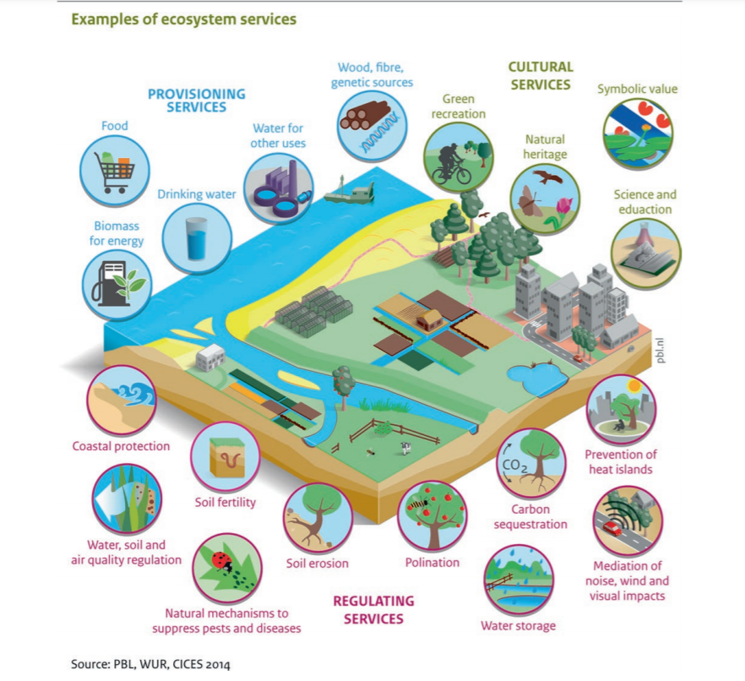

Source: PBL, WUR, CICES 2014, in de Knegt B., Indicators of Ecosystems Services for Policy Makers in the Netherlands, in Schröter M. et al., (eds.), Atlas of Ecosystem Services, Springer, 2019.

### Rural communities are potentially exposed to greater costs associated with climate and environment transition

Paradoxically, whilst being the source of climate and environment solutions that benefit society as a whole, **rural communities are also potentially exposed to greater costs associated with the climate and environment transition**. For example, longer travelling distances to access services such as hospitals, schools, shops and banks, coupled with greater dependency on private cars due to poor public transport, incurs higher travel costs.[149]

The climate and environment transition will lead to reduction or closure of many current resource extraction industries typically based in rural areas, such as coal mines and mineral extraction. Sustainable and climate friendly ways to use these former sites could include forestry or renewable energy, aiming to generate economic, social and environmental benefits.

The increasing incidence of flooding, droughts and wildfires presents particular difficulties for agriculture and forestry. Some of the problems such as soil degradation, water pollution, pollinator decline, invasive species, nutrient run-off, droughts and floods are already incurring economic costs, either through reduced yields/lost production, or the cost of addressing the resulting problems such as algal blooms. These costs make it harder for businesses and communities to find funds to invest in improved systems with higher environmental performance.

Even though many climate and environment-friendly investments and system changes are cost-effective in the longer term, short-term competition for resources and/or a long lead-in before a positive cash-flow is generated inhibit uptake of beneficial changes. Similarly, even where public support is provided, uncertainty over its long-term continuity can constrain uptake (e.g. for rewetting carbon-rich drained farmland). Providing appropriate incentives, pump-priming, and eliminating barriers for the take-up of nature-based solutions is a challenge that must be overcome in order to ensure wider implementation of beneficial approaches.

Techniques and methods recognised as beneficial may not be widely implemented due to lack of widespread knowledge and skills. For example, the transition to more sustainable agricultural systems such as agro-ecology or organic farming requires a high level of management and specialist understanding of ecological systems and processes.

### The green transition presents a wide range of potential opportunities for rural communities

The green transition to a climate neutral future with flourishing biodiversity presents a wide range of potential opportunities for rural communities to thrive, provided that there is an adequate enabling framework.[150] Communities should be encouraged to identify opportunities and be empowered to seize them.

There are many win-win solutions, which combine climate, environment and socio-economic benefits. For example, restoring soil health and natural landscapes damaged by human exploitation can be one of the most effective and cheapest ways to combat the climate crisis[151]. Nature-based solutions can generate significant business and employment opportunities[152]. Natural ecosystems, which are self-regenerating, can be a springboard for new integrated, resilient wealth-creating systems. The appeal of beautiful countryside, landscapes, wildlife and rural heritage to tourists is well known and many rural regions of the EU benefit from this. **The benefits of NATURA 2000 have been valued at between EUR 200-300 billion per year.**[153]

As the wider importance of nature conservation for a functioning economy, and its contribution to GDP and well-being, become more widely recognised, so the willingness of both public and private entities to make climate and environmentally beneficial investments should increase. Wise and effective investments are not “either-or”, but “both”, where the economy and the environment are not conflicting objectives, but complementary.

**The cost of reducing GHG emissions** **has been decreasing thanks to technological developments.**[154] Renewable energy costs have plunged in the last decade, becoming cheaper than fossil fuels in many countries, spurring a boom in clean power, for example solar and wind farms. Electric cars and domestic heating that is not dependent on fossil fuels could soon be cheaper than current fossil-fuel based energy and help to address energy poverty, especially when combined with measures to improve the energy efficiency of homes.

Achieving these climate and environment benefits is expected to generate jobs and economic opportunities for rural areas. This will include clean and affordable energy, the circular economy, sustainable and smart mobility, a pollution-free environment, thriving ecosystems and sustainable food systems, which will benefit both rural and urban citizens alike.

### Expected trends

Even if current climate pledges are fully honoured by all parties, climate change is still heading far from the 1.5oC pathway[155]. Scientists consider an increase of 2oC, compared to the temperature in pre-industrial times, as the threshold beyond which there is a much higher risk that dangerous and potentially catastrophic changes in the global environment will occur[156]. There is only a very short time left to avoid reaching irreversible tipping points.[157]

**Global biodiversity loss is projected to increase to 38-46% by 2050**.[158] The interaction of many factors leads to the decline of biodiversity and the degradation of ecosystems, including habitat and land use change[159], over-exploitation of natural resources, pollution and climate change.[160]

A range of other drivers linked to climate change and biodiversity will affect rural communities in the period up to 2040:

* There will be increasing production and supplies of renewable energy.
* Population shift to some rural communities will increase pressure on housing (both to provide for newcomers and to avoid existing community members, especially the young, being priced out of market).
* Water scarcity and increasing cost will affect economic activities requiring water, such as tourism and agriculture, driving shifts to systems requiring less water. Water scarcity will also increase environmental degradation such as wildfires in forests, moorland and peatland.

### Conclusions

The gravity of the climate crisis and ecological emergency must not be underestimated. These intrinsically linked issues, and the policy instruments designed to address them, have significant impacts on the social and economic wellbeing of rural areas and will continue to do so during the period up to 2040 and beyond.

The increasing incidence of flooding, droughts and wildfires presents particular difficulties for agriculture and forestry, with a need to adapt management practices and/or enterprises to increase resilience (e.g. growing more drought resistant crop varieties, improving soil health and avoiding soil erosion, planting trees for water management, increased fire prevention management such as grazing forest undergrowth).

Pollution from agriculture negatively affects a wide range of habitats and species. Changing agricultural practices to improve sustainability, in particular by reintroducing appropriate grassland management and reducing fertiliser use is recognised as one of the key actions needed to reduce pressure on the environment.[161]

Currently, the main policy measures encouraging environmentally beneficial land management are designed to compensate for costs incurred and income foregone, principally for compliance with WTO green box rules. If take-up on the scale required to meet the targets of the Green Deal is to be achieved, mechanisms are needed which reward the value of provision of public goods, not simply the cost of providing them. This must include the development of market-based mechanisms and the use of fiscal measures, since public funds are unlikely to be sufficient to meet needs. It is important to identify and promote win-win solutions that maintain and enhance natural capital without exploitation or degradation, whilst generating economic opportunities.

The focus in settlements should be on converting/reusing existing buildings, using brownfield sites, and ensuring that all new housing is climate neutral, both in construction and in use. Effective and coordinated planning systems, working with local communities, will be needed.

The transition to a safe green future for all also has to be people centred, leaving no-one behind, and recognising that rural communities have an important role to play in preserving and protecting the natural resources upon which our societal wellbeing depends. Implementing a just transition implies working with rural communities, establishing social dialogue and seeking consensus on how to mitigate the cost of measures, ensuring that those least able to pay do not bear disproportionate costs. It also requires adequate support, helping the most vulnerable to make the most of opportunities offered by the greening of the economy.

The implementation of an ambitious climate and nature restoration agenda through integrated systems thinking, including reform of economic and fiscal incentives, and effective multi-level governance, and valorising Copernicus Earth Observation data and applications, will enable rural communities to seize new opportunities and to move to an environmentally sustainable rural future.

## Integrated territorial development

This section deals with relationships between different types of rural and urban areas beyond administrative borders looking at challenges and opportunities for rural areas.

### Places are connected and interdependent in many ways

Administrative boundaries do not reflect well territorial realities, connections, and functional linkages. Communities interact in many ways and the geography and intensity of these interactions depend on the area looked at (close to metropolitan area, within a network of small towns, cross-border, remote, coastal, mountain). It also depends on the issue looked at (catchment area or sea basin for pollution or water supply, commuting zone/mobility area for labour market or access to services, ecological corridors for biodiversity protection etc.). Rural areas are thus interdependent with one another and with urban areas in multiple ways and at multiple scales, within a country and across boundaries.

**Urban-rural linkages** refer to the **complex set of bi-directional links** (e.g. demographic flows, labour market, economy and tax flows, public service provision (e.g. health, education), mobility, environmental or ecosystem and cultural services, leisure assets, food and bio-based products, land-use planning etc.) **that connect places**. They shape up in a space where urban and rural dimensions are physically and/or functionally integrated, blurring the distinction between urban and rural, and crossing traditional administrative boundaries. These linkages can express themselves between a city with an urbanised core and a peri-urban area or within a wider functional area covering a central city and adjacent rural hinterland, as exemplified by the JRC in metropolitan areas (e.g. Brno, CZ), medium-size cities (e.g. Goteborg, SE) and small towns and settlements in rural regions (e.g. Plasencia, ES).[162] Although with limited effect for remote areas, they can also connect geographically distant places through functional links (e.g. linking agricultural production areas to urban markets, river basins etc.).[163]

Border regions[164] are more likely to be rural regions. One third of the population of rural regions, lives in a border region (35%) compared to 21% of the total EU population. As a result, the rural population is more likely to live close to a national border. In many cases, the rural border regions are also remote, located far from capitals and other cities.

Rural areas are also playing a key role in the governance of macro-regions. Currently, there are **four macro-regional strategies[165] in place where rural areas are actively involved in defining joint challenges**, be it in sea basins, along river shores or mountain ranges, in which the various rural areas are connected, ecologically (e.g., Alpine range, Baltic sea), economically (tourism), or historically (e.g., Balkans). Especially two of these strategies cover a relatively high share of population living in rural areas: the Baltic (27 %) and the Danube (32 %) strategies.

### Spatial relations encounter different challenges

As shown in the previous chapters, spatial inequalities are present in terms of economy, employment, education or other thematic aspects.

**Challenges for rural-urban relations** include the tendency for urban areas to expand (urban sprawl in areas close to cities) and gentrification[166] (in close to city or remote areas with high amenities), that leads to the loss of productive, recreational and biodiversity space and can compromise long-term development prospects or push away rural residents (housing and land), and can trigger conflicts over land-use. In the context of COVID-19, the unplanned move of urban people to rural areas has put pressure on service provision capacity to non-permanent residents.[167]

Other challenges include urban services not being designed to meet needs of rural residents who need to access services in the city (e.g. mobility[168]), unsustainable transport and logistics, lack of connections between producers and consumers. While some of these challenges are being addressed in the context of functional urban areas[169], rural areas that are not included in these functional approaches, remote from the main decision centres and uneasily accessible are unlikely to benefit. Preconceived ideas and images of urban and rural areas, such as for example considering urban areas as engines of growth and rural areas as lagging behind, can be counterproductive.[170]

**In addition, challenges arise from the governance of these rural-urban relations.** These include a lack of coordination between authorities (in space and across administrative departments e.g. spatial planning), a mismatch between administrative boundaries and the challenge to address, lower power of rural citizens in decision-making bodies, vested or incompatible interests, rigid regulations, high transaction costs, lack of continuity or inconsistencies in policy frameworks or property rights, uncoordinated urban planning and wider spatial planning; lack of synergies in economic development and constraints on resources and infrastructures. Moreover, obstacles derive from possible power conflict, the defensive attitude of actors involved, wide disparities in growth, employment and living conditions between areas, lack of data able to represent the urban-rural region, or simply rejection of additional administrative burden.[171]

**Rural border regions** often have weaker transport connections, both across the border and within the national border regions. On average, rural border regions have lower road and rail performance compared to other rural regions. Furthermore, people living in rural border regionshave to drive further to access public services such as healthcare and education. For example, the distance to the nearest primary or secondary school or hospital is greater in rural border regions than in other rural regions.[172] In addition, interaction across the border is limited by legal and administrative border obstacles.[173] Moreover, the COVID crisis added a further layer of obstacles to border regions with the temporary closure of borders.[174]

Joint identified challenges for **rural populations under macro-regional strategies** include access to public services, connectivity, preservation of natural habitats, increasing competitiveness and innovative capacity. Rural regions exhibit notably lower transnational cooperation. This can indicate lower capacities to absorb European Structural and Investment Funds (ESIF) in the rural regions, or a weakly institutionalised cooperation in the rural areas. The rates of participation get higher where longer cooperation formats exist. Building networks comprising local actors from wide territories across administrative and linguistic borders demands investments in time and staff.

### Rethinking what’s vital to society brings opportunities to revalue rural areas

New approaches to territorial development are on the rise that place a greater emphasis on social and environmental objectives and on the territorial anchorage of economies, including a concern on resilience. The ROBUST project[175] identified five domains where innovative approaches have the potential to enhance **rural-urban synergies**: **social services** (focus on social welfare, services, accessibility); **social and spatial** **proximity relations** (reduction of physical and social distancing through e.g. short value chains; **circularity** (closing loops); **green economy** (rewarding beneficial ways to deliver ecosystem services) and **culture and heritage**. Innovations around procurement, short value chains, smarter ways to reward the provision of ecosystem services, regional branding, for instance, if managed in specific ways, can improve the recognition of the value of rural areas for urban citizens, the understanding of the specific needs of rural populations and the business models and governance arrangements[176]. These opportunities are mostly demonstrated in city-hinterland relations or at regional levels. They are less evident in the case of rural areas that are further away from the urban centres. Innovations that celebrate cultural heritage (food, historical routes, pilgrimage etc.) and seek to create value from it can bring benefits to rural areas in both close to city and remote areas[177]. New trends such as multi-locality living whereby people choose to distribute their lifetime between various places, sometimes far away from each other, also brings rural-urban relations within a much larger scale[178]. Digital as a distance remover and a way of engagement may also be an opportunity to invigorate multi-level governance of these territorial interactions and participatory processes.[179]

The OECD has worked on rural-urban partnerships in the context of networks of small towns.[180] However, the intensity of linkages between cities and remote areas and what they can provide is harder to evidence. Thus, the OECD suggests differentiating policy approaches for rural areas close to cities and for remote areas.[181] Another challenge in the representation and analysis of urban-rural functional linkages is to have access to appropriate data. Especially when the functional area is not corresponding to administrative supra-municipal entities, it is difficult to retrieve comparable and homogeneous data across multiple municipalities, with possible different areas of interest.[182]

Governance arrangements that foster integrated cooperation across borders at the macro-regional or transnational scale are also developing, in the EU context and outside of it. More and more regions are interested in participating in different cooperation formats, thus **opening new possibilities for rural regions to actively contribute**. These new networks are not implemented top-down but derive from and are implemented in strong connection with the regional and local level.

Cross-border cooperation offers many opportunities to EU rural areas.[183] The development of cross-border cooperation is likely to improve service provision as well as economic opportunities for rural border areas and people who live and work on both sides of these borders. Cross-border cooperation over time generally leads to more stable partnerships and cooperation tends to become deeper and spill over to new areas. As people interact more across the border they become aware of various obstacles. These can be for instance legal, administrative, infrastructural or cultural. In cross-border areas with intensive interaction obstacles tend to be addressed and opportunities tend to be explored to a greater extent than in cross-border areas with a lower interaction intensity. This includes the provision of cross-border services. The macro-regional strategies offer a comparatively new framework for cooperation activities involving actors from the local and regional level, that is likely to further enhance cross-border cooperation benefits.

### Conclusions

Improving the governance of territorial interactions is one of the ways forward to improve future rural prospects. Governance arrangements that facilitate cooperation and networks between authorities and/or other actors (citizens, NGOs, businesses etc.) are needed to better govern these linkages with adequate scales and formats depending on the issues at stake. These must consider the functional role, importance, challenges, and opportunities of each territory and enhance synergies, economic local or regional spill overs and the feeling of all citizens that they are included and have access to positive prospects. Territorial development also needs to be integrated across policy sectors and across levels of administration.

In recognition of the **importance of rural areas for urban areas**, a growing number of cities are including rural territories in the scope of their “Sustainable urban development strategies”. Opportunities arise from the emergence of a functional area approach in the design of urban strategies to **include more municipalities and rural territories in their scope.**[184] This marks a huge step out from traditional urban strategies at the scale of urban municipal boundaries or the neighbourhood, and facilitates pooling resources and establishing inter-municipal cooperation, as exemplified by the JRC in metropolitan areas (e.g. Brno, CZ), medium-size cities (e.g. Goteborg, SE) and small towns and settlements in rural regions (e.g. Plasencia, ES).[185] Although with limited effect for remote areas, this appetite for a more integrated approach between cities and hinterlands **can bring opportunities for rural people,** who are eager to improve their access to urban services, if it translates into efficient and equitable **governance arrangements where urban and rural citizens have an equitable voice** and that lead to equitable benefits: a key condition for sustainable rural-urban partnerships[186]. These arrangements develop with either a territorial focus (Community-led local development, Integrated Territorial Investments) or a thematic one (food procurement, regional mobility plans –e.g. Flanders- etc.) mainly in the context of proximity relations. However, they can benefit rural areas only if designed in partnership and respecting a number of conditions, such as a balanced representation of rural and urban parties and support for municipalities with smaller teams to take part and voice their needs, for example via bodies acting as facilitators.[187] More in general, in this context, it will be important to pay attention to the specific situation and needs of remote areas by considering - in line with the suggestion by the OECD – to differentiate policy approaches for rural areas close to cities and for remote areas.

## Women in rural areas

This section looks at the situation of women in rural areas highlighting the challenges and opportunities across different thematic aspects.

In rural areas women face several disadvantages.

**The employment rate of rural women was lower than the employment rate of urban women in 2019[188]** inthe majority of EU Member States. The countries recording the highest employment rate gap between rural and urban women, included Bulgaria (15.6 percentage points pp), Croatia (13.5 pp), Romania (12.2 pp), Poland (10.5 pp) and Lithuania (10.1 pp).

**The employment rate of rural women in 2019 was lower than the employment rate of rural men** in most Member States with the highest employment rate gapbetween ruralwomen and men attained in Italy (21 pp), Romania (20.9 pp), Bulgaria (19.9pp), Malta (18.5 pp) and Greece (17.8 pp). In 2019, 29.2% of all employed women in rural areas worked part-time compared to 6.7% of employed men in rural areas[189].

In the majority of EU Member States, the activity rate of **rural women tends to be lower than the activity rate for rural men.** The average activity rate gap between rural women and men amounted in 2019 to 12.5 pp for EU-27. The EU countries with the widest gender activity rate gap between rural women and men in 2019 included Malta (24.6 pp), Romania (23.4 pp), Italy (21 pp), Greece (19 pp) and Poland (17.8 pp). [190]

There are different drivers of rural gender inequality. Women living in rural areas are typically engaged in **informal employment**, taking role of carers in their families and in their rural communities (17.8% of women in rural areas provided informal care or assistance compared to 12.9% of men in rural areas[191]). Many of them are involved in agricultural work, but **do not receive a separate income from their husband** or other male members of the household. By assisting their employed spouses, they are **not entitled to social security** in their own right and **often do not hold property rights** to land or farms.[192]

Figure 57 Farm managers by age class and sex, 2016

[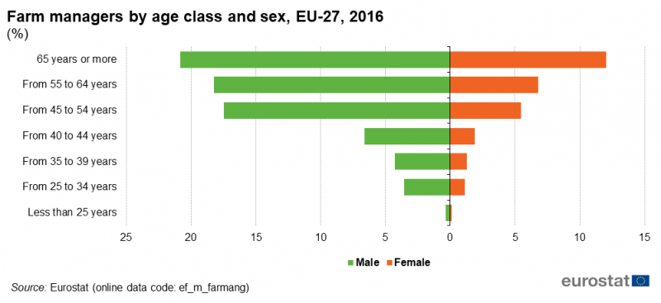](https://ec.europa.eu/eurostat/statistics-explained/images/5/52/Farm_managers_by_age_class_and_sex,_EU-27,_2016_(%25)_FP20.png)

Source: Eurostat (online data code: ef_m_farmang)

**Furthermore, the unequal impact of parenthood and caring responsibilities on women** remains one of the main drivers of their lower employment rates, with inflexible work-life-balance options and **underdeveloped care and social services,** particularly in rural areas, presenting major barriers to female employment. The unequal sharing of the care burden leads to a higher incidence of career disruptions among women, resulting in greater risks of poverty and financial dependency.[193]

In 2019, **the mean and median income level** was higher for rural men than for rural women in all Member States. The countries with the widest mean and median income gender gap between rural women and rural men included Belgium, Denmark, Austria, Sweden and Italy.[194] Lower income levels translate into lower pension entitlements for women. Women’s pensions in the EU are on average 28% lower than men’s.[195]

The various challenges faced by rural women referred to above very often lead to **women migrating out of rural territory** seeking better educational and professional opportunities in cities and urban areas. It has become evident that young and well-educated women are becoming the most likely to leave peripheral regions.[196] This trend negatively impacts the attractiveness of rural regions.

### Opportunities for women in rural areas

As the EU’s working age population has been shrinking for a decade and this is projected to continue,[197]**it is becoming inevitable to attract and retain women in work longer** and improve attractiveness of working places and productivity. There are a number **of opportunities for rural women** to increase labour market participation, to formalise their employment status, enhance their social security rights, improve their quality of life and prevent their out migration from rural regions.

The shift to distance working and learning stimulated by the COVID-19 outbreak has shown that digital technology can be very powerful. It has manifested that it is possible to link teachers/trainers and learners from different geographical locations and thus open up opportunities for providing better and higher quality education in rural and remote areas. This is conditional upon the access to broadband and technologies. **Digital technologies have potential to increase the participation of rural women in education and training.**

In general, the share of older people in the EU-27 living in predominantly rural regions and intermediate regions is higher than in predominantly urban regions.[198] Older people living in rural areas are more prone to the insufficient provision of social and health services.[199] The growing number of older people in rural areas coupled with the absence of the provision of services, brings **new opportunities in the ‘silver’ and care economies** creating new jobs in rural areas. **At the same time, better availability of formal long-term care and support for informal carers** can enable more women to enter and remain in the labour market and find opportunities in rural areas.

**Social enterprises and non-profit organisations** have the potential to deliver health and social care services, including for older people, while they could also create excellent employment opportunities for women benefiting from their local roots and their knowledge of the specific community needs.

**Climate change** adaptation and mitigation and the need to preserve natural resources can provide opportunities for women to become active in nature-based solutions and the bio-economy. Here a number of job opportunities may arise in the sphere of organic farming, or innovative start-ups in the circular economy. Targeted tailor made programmes to encourage rural women entrepreneurs and women in decision making, including politics, should be supported.

In general, the provision of incentives and enabling conditions to enhance women engagement in entrepreneurial activities in rural regions could contribute to closing employment, social exclusion and poverty gaps between rural men and women.

### Conclusions

Gender equality is a core value of the EU, **a fundamental right**[200] and a **key principle of the European Pillar of Social Rights.**[201] Equality is also an essential condition for an innovative, competitive and inclusive European economy as it brings more jobs and higher productivity.[202]

This implies promoting equal opportunities to thrive for rural women on equal footing with rural men by closing the gender gaps that still persist in the rural areas.

For rural women this will mean to find adequate responses to the challenges and take advantage of the opportunities driven by the current transition processes including climate change and demographic transformation. The automation and digitalisation have the potential to speed-up the development of rural areas for the benefit of the whole rural population. This will require up- and reskilling of rural population, in particular women, to acquire the necessary skills to meet the digitalisation demands in the relevant sectors of rural economies. Technology, for example, can facilitate the access to telemedicine, distance learning or other services and thus bridge the gap in the provision of services and create employment opportunities in rural and remote areas.[203]

1. Cyprus, Luxembourg and Malta consist of a single urban or intermediate region.
2. OECD, *Rural Well being: geography of opportunities*, OECD, 2020. <http://www.oecd.org/regional/rural-development/rural-well-being-d25cef80-en.htm>
3. See notably page 26 of the OECD report mentioned in footnote 2
4. OECD, *Policy implications of Coronavirus crisis for rural development*, OECD, 2020. <http://www.oecd.org/coronavirus/policy-responses/policy-implications-of-coronavirus-crisis-for-rural-development-6b9d189a> De Luca, C., Tondelli, S., Åberg, H., *The Covid-19 pandemic effects in rural areas*, TeMA – Journal of Land Use, Mobility and Environment 119-132, 2020. <https://doi.org/10.6092/1970-9870/6844> ENRD, *Rural responses to the COVID-19 crisis*. <https://enrd.ec.europa.eu/rural-responses-covid-19-crisis_en>
5. IMAJINE, *Integrative Mechanism for Addressing Spatial Justice and Territorial Inequalities in Europe*, Briefing Paper on Evidence from the IMAJINE Project for the EU Long Term Vision for Rural Areas, H2020, 2021. <http://imajine-project.eu/#home>
6. Woods M., *Briefing Paper on Evidence*, 2021.
7. Snowdon, P., Slee, B., Farr, H., *The Economic Impacts of Different Types of Tourism in Upland and Mountain Areas of Europe*, in Godde P. M., Price M. F., Zimmermann F. M (Eds.), *Tourism and development in mountain regions*, Wallingford, UK: CAB International, 2000.

   WTO, *Rural tourism in Europe: Experiences, development and perspectives,* World Tourism Organization, Madrid, 2004. <https://www.e-unwto.org/doi/epdf/10.18111/9789284407163>
8. Barranco, R., et al., *Tourism capacity, expenditure and seasonality in Europe: an evaluation per degree of urbanisation and remoteness*, Policy Brief. European Commission, JRC 124457, 2021.
9. LUISA Base Map 2018 (EC-JRC). 
10. Eurostat, *Farm Structure Survey*. <https://ec.europa.eu/eurostat/statistics-explained/index.php?title=Agriculture_statistics_-_family_farming_in_the_EU>
11. Eurostat (online data code: ef_m_farmleg). Changes in survey thresholds may also have led to some small farms to be excluded from the statistics. Therefore, the decline has to be interpreted with care.
12. Eurostat (online data code: AACT_ALI01). Data are in annual work units.
13. Kalantaryan S., Mazza J., Scipioni M., *Meeting labour demand in agriculture in times of COVID 19 pandemic*, 2020. <https://publications.jrc.ec.europa.eu/repository/bitstream/JRC120800/meeting_labour_demand_in_agriculture_in_times_of_covid_19_pandemic_online.pdf>
14. Eurostat, Glossary: Annual work unit (AWU). <https://ec.europa.eu/eurostat/statistics-explained/index.php?title=Glossary:Annual_work_unit_(AWU)>
15. EC, *EU agricultural Outlook*, 2020. <https://ec.europa.eu/info/sites/info/files/food-farming-fisheries/farming/documents/agricultural-outlook-2020-report_en.pdf>
16. Income based on Eurostat (online code: [aact_eaa04](https://ec.europa.eu/eurostat/databrowser/product/view/aact_eaa04?lang=en), [aact_ali01](https://ec.europa.eu/eurostat/databrowser/product/view/aact_ali01?lang=en) and [aact_eaa06](https://ec.europa.eu/eurostat/databrowser/product/view/aact_eaa06?lang=en)), adding back the compensation of employees to the entrepreneurial income and divided by the total number of annual working units.
17. Eurostat (online data code: [aact_eaa06](https://appsso.eurostat.ec.europa.eu/nui/show.do?query=BOOKMARK_DS-092704_QID_7EA4A651_UID_-3F171EB0&layout=TIME,C,X,0;GEO,L,Y,0;ITM_NEWA,L,Z,0;UNIT,L,Z,1;INDICATORS,C,Z,2;&zSelection=DS-092704ITM_NEWA,IND_A_EURO;DS-092704UNIT,I10;DS-092704INDICATORS,OBS_FLAG;&rankName1=UNIT_1_2_-1_2&rankName2=INDICATORS_1_2_-1_2&rankName3=ITM-NEWA_1_2_-1_2&rankName4=TIME_1_0_0_0&rankName5=GEO_1_2_0_1&sortC=ASC_-1_FIRST&rStp=&cStp=&rDCh=&cDCh=&rDM=true&cDM=true&footnes=false&empty=false&wai=false&time_mode=NONE&time_most_recent=false&lang=EN&cfo=%23%23%23%2C%23%23%23.%23%23%23)). Data for 2014-2016. The evolution of the real income of factors of production in agriculture per AWU is measured by means of an index called "Indicator A" in the Economic Accounts for Agriculture, the main data source for agricultural income in the EU. It represents the real net value added at factor cost of agriculture per total AWU, thus including both salaried and non-salaried workers converted to full-time equivalents. This index value shows changes in relation to a base year (2010). Data for 2014-2016.
18. Eurostat (online data code: [ef_m_farmang](https://ec.europa.eu/eurostat/databrowser/bookmark/59c34294-d9e3-42e7-8262-e4681c6d26b0?lang=en)). Data for 2016.
19. Farm accountancy data network (FADN).
20. Eurostat (online data code: ef_m_farmang).
21. Eurostat (online data code: ef_mp_training).
22. The at-risk-of-poverty rate is the share of people with an equivalised disposable income (after social transfer) below the at-risk-of-poverty threshold, which is set at 60 % of the national median equivalised disposable income after social transfers. The at risk of poverty and social exclusion indicator corresponds to the sum of persons who are: at risk of poverty or severely materially deprived or living in households with very low work intensity. Persons are only counted once even if they are present in several sub-indicators. Eurostat (online data code: ilc_peps13)
23. 2019 data for EU, Eurostat (online data code: ilc_li43)
24. Bertolini, P., Montanari, M., Peragine, V. *Poverty and social exclusion in rural areas*, 2008.
25. Eurostat (online data code: ilc_lvhl23)
26. Severe material deprivation rate is the inability to afford at least four out of nine predefined material items considered by most people to be desirable or even necessary to lead an adequate life.
27. Eurostat (online data code: ilc_mddd23)
28. Eurostat (online data code:ilc_mddd23)
29. The housing cost overburden rate is the percentage of the population living in households where the total housing costs ('net' of housing allowances) represent more than 40 % of disposable income ('net' of housing allowances).
30. Eurostat (online data code: ilc_lvho07d)
31. European Commission, *Peer Review on "Strategies for supporting social inclusion at older age”*, 2019.
32. Ibid.
33. Aurambout J.P. et al., *The demographic landscape of EU territories*, 2021.
34. FRA, *80% of Roma are at risk of poverty, new survey finds*, Press release 29 Nov, 2016. <https://fra.europa.eu/en/news/2016/80-roma-are-risk-poverty-new-survey-finds>
35. EPHA, *Tackle child poverty by expanding the scope of the EU Child Guarantee*, 2020. <https://epha.org/tackle-child-poverty-by-expanding-the-scope-of-the-eu-child-guarantee/>
36. FRA, *80% of Roma are at risk of poverty,* *new survey finds*, 2016.
37. FRA, *Poverty and employment: the situation of Roma in 11 EU Member States*, Roma Survey - Data in focus, 2014. <https://fra.europa.eu/sites/default/files/fra-2014-roma-survey-employment_en.pdf>
38. Challenges in Roma equality, inclusion and participation vary depending on the size of the Roma population and their share of the overall population, as well as on the wider economic context and the legacy of exclusion and discrimination.
39. Romania, Slovakia, Hungary, Bulgaria, Spain, Greece, Czech Republic. in FRA, *Poverty and employment*, 2014.
40. FRA, *Poverty and employment*, 2014.
41. European Commission, *Overview of the impact of coronavirus measures on the marginalised ROMA communities in the EU 2020.* <https://ec.europa.eu/info/sites/default/files/overview_of_covid19_and_roma_-_impact_-_measures_-_priorities_for_funding_-_23_04_2020.docx.pdf>
42. Goldmay K., *Coronavirus pushes Bulgaria’s Roma further into the shadows*, Politico, 23/11/2021. <https://www.politico.eu/article/coronavirus-pushes-bulgaria-roma-further-into-the-shadows/>
43. Eurostat*, Urban and rural living in the EU*. <https://ec.europa.eu/eurostat/web/products-eurostat-news/-/EDN-20200207-1?inheritRedirect=true#:~:text=In%202019%2C%20the%20overall%20level,for%20adults%20living%20in%20cities>
44. Eurostat [[hlth_silc_19]](https://appsso.eurostat.ec.europa.eu/nui/show.do?query=BOOKMARK_DS-638107_QID_-359E452F_UID_-3F171EB0&layout=DEG_URB,L,X,0;GEO,L,Y,0;TIME,C,Z,0;AGE,L,Z,1;SEX,L,Z,2;UNIT,L,Z,3;INDICATORS,C,Z,4;&zSelection=DS-638107AGE,Y_GE16;DS-638107INDICATORS,OBS_FLAG;DS-638107UNIT,PC;DS-638107SEX,T;DS-638107TIME,2019;&rankName1=UNIT_1_2_-1_2&rankName2=AGE_1_2_-1_2&rankName3=INDICATORS_1_2_-1_2&rankName4=SEX_1_2_-1_2&rankName5=TIME_1_0_0_0&rankName6=DEG-URB_1_2_0_0&rankName7=GEO_1_2_0_1&rStp=&cStp=&rDCh=&cDCh=&rDM=true&cDM=true&footnes=false&empty=false&wai=false&time_mode=ROLLING&time_most_recent=false&lang=EN&cfo=%23%23%23%2C%23%23%23.%23%23%23)
45. Eurostat [[hlth_silc_20]](https://appsso.eurostat.ec.europa.eu/nui/show.do?query=BOOKMARK_DS-638111_QID_B04C556_UID_-3F171EB0&layout=DEG_URB,L,X,0;LEV_LIMIT,L,X,1;GEO,L,Y,0;TIME,C,Z,0;SEX,L,Z,1;AGE,L,Z,2;UNIT,L,Z,3;INDICATORS,C,Z,4;&zSelection=DS-638111TIME,2019;DS-638111UNIT,PC;DS-638111INDICATORS,OBS_FLAG;DS-638111AGE,Y_GE16;DS-638111SEX,T;&rankName1=UNIT_1_2_-1_2&rankName2=AGE_1_2_-1_2&rankName3=INDICATORS_1_2_-1_2&rankName4=SEX_1_2_-1_2&rankName5=TIME_1_0_1_0&rankName6=DEG-URB_1_2_0_0&rankName7=LEV-LIMIT_1_2_1_0&rankName8=GEO_1_2_0_1&rStp=&cStp=&rDCh=&cDCh=&rDM=true&cDM=true&footnes=false&empty=false&wai=false&time_mode=NONE&time_most_recent=false&lang=EN&cfo=%23%23%23%2C%23%23%23.%23%23%23)
46. Hunt, J., *Making the CAP Fit: Responding to the Exploitation of Migrant Agricultural Workers*, International Journal of Comparative Labour Law, Vol.30 (2), 2014.
47. European Commission, *Background Document Socio-Economic challenges facing EU agriculture and rural areas*, 2017. <https://ec.europa.eu/info/sites/info/files/food-farming-fisheries/key_policies/documents/soc_background_final_en.pdf>
48. IMAJINE, *Integrative Mechanism for Addressing Spatial Justice and Territorial Inequalities in Europe*. <http://imajine-project.eu/#home>
49. MATILDE, *Classification of MATILDE regions. Spatial specificities and third country nationals distribution*, 2019. <https://matilde-migration.eu/wp-content/uploads/2020/08/MATILDE_D21_Classification_on_spatial_specificities_and_TCNs_distribution_040820.pdf>
50. Fasani F., Mazza J., *A Vulnerable Workforce: Migrant Workers in the COVID-19 Pandemic*, JRC report, 2020. <https://publications.jrc.ec.europa.eu/repository/handle/JRC120730>
51. Aurambout J.P., et al., *The demographic landscape of EU territories*, 2021.
52. OECD, *Rural Well-being*, 2020.
53. OECD, *Rural Well-being*, 2020.
54. IMAJINE, *D4.1 Summary of Pevious Surveys – Report*. <http://imajine-project.eu/wp-content/uploads/2020/11/Deliverable-4.1-Summary-of-Previous-Surveys-Report.pdf>
55. European Commission, *Poverty and social exclusion in rural areas*, Executive Summary, 2008.
56. Walsh K., Harvey B., *Employment and social inclusion in rural areas: a fresh start*, POBAL, 2013.
57. Bock B., Kovacs K., Shucksmith M., *Changing social characteristics, patterns of inequality and exclusion*, 2015.
58. More precisely there is a lot of basic data, and many of these are under utilised. For example, geospatial datasets (would allow calculation of accessibility of services), open data published by regional, national and European administrations, etc. What is lacking sometimes is European level harmonised methodologies on how to translate basic data into meaningful, relevant, comparable indicators and harmonised methods on how to overcome the diversity of data sources which in many cases were not collected for the purposes of indicator calculation
59. Kompil, M., et al., *Accessibility to Services of General Interest in Europe: an evaluation for degree of urbanisation and remoteness*, Policy Brief. European Commission, Joint Research Centre - JRC124457, 2021.- forthcoming.
60. European Commission, *Road Transport in Europe, introducing a new accessible framework*, Working Paper, 2019. <https://ec.europa.eu/regional_policy/en/information/publications/working-papers/2019/road-transport-performance-in-europe>
61. ITF, *Benchmarking Accessible in Cities: Measuring the Impact of Proximity and Transport performance*, 2019. <https://www.itf-oecd.org/benchmarking-accessibility-cities>
62. European Commission, *Road Transport in Europe*, 2019.
63. European Commission, *Rail transport performance in Europe: Developing a new set of regional and territorial accessibility indicators for rail*, 2020. <https://ec.europa.eu/regional_policy/en/information/publications/working-papers/2020/rail-transport-performance-in-europe>
64. European Commission, *Rail transport performance in Europe*, 2020.
65. In December 2020, the Commission provided each EU country with tailor-made recommendations, to assist in the drafting of the national CAP strategic plans. Among others, the recommendations aim to ensure the compliance with Green Deal ambitions and more specifically six Farm to Fork and Biodiversity strategy targets. These are quantified EU level targets on use and risk of pesticides, sales of antimicrobials, nutrient loss, area under organic farming, high diversity landscape features and access to fast broadband internet. For more information see <https://ec.europa.eu/info/food-farming-fisheries/key-policies/common-agricultural-policy/cap-strategic-plans_en> and in particular COM(2020) 846 final, *Recommendations to the Member States as regards their strategic plan for the Common Agricultural Policy*).
66. *Digital Economy and Society Index (DESI) report* available at: <https://ec.europa.eu/digital-single-market/en/broadband-connectivity>
67. *DESI report*, 2020. <https://ec.europa.eu/digital-single-market/en/broadband-connectivity>
68. Perpiña Castillo, C., et al*., Broadband accessibility and quality connection in Europe: an evaluation per degree of urbanisation and by urban-rural typology including remoteness*, Policy Brief. European Commission, JRC124456, 2021.
69. See beginning of this section.
70. DESI report, 2020.
71. OECD, *Rural Well-being*, 2020.
72. Share of the population within 120 km that can be reached in a 90 min drive
73. Aurambout J.P. et al., *The Demographic Landscape of EU territories*, 2021.
74. de Dominicis L, Dijkstra L., Ponarollo N., *The urban-rural divide in anti-EU vote: Social, demographic and economic factors affecting the vote for parties opposed to European Integration*, Working Paper, 2020. <https://ec.europa.eu/regional_policy/sources/docgener/work/2020_05_discontent_en.pdf>
75. Dijkstra, L., Poleman H., Rodriguez-Psoe A., *The geography of EU discontent*, Working paper 12/2018. <https://ec.europa.eu/regional_policy/sources/docgener/work/2018_02_geog_discontent.pdf>
76. Aurambout J.P., et al., *The Demographic Landscape of EU territories*, 2021.
77. Ronzon, T.; et al., *Developments of Economic Growth and Employment in Bioeconomy Sectors across the EU*, Sustainability 2020, 12, 2020. <https://doi.org/10.3390/su12114507>
78. European Commission, *A sustainable Bieoeconomy for Europe: strengthening the connection between economy, society and the environment*, Updated Bioeconomy Strategy, 2018. https://op.europa.eu/en/publication-detail/-/publication/edace3e3-e189-11e8-b690-01aa75ed71a1/language-en/format-PDF/source-149755478
79. Fritsche U., et al., *Future transitions for the Bioeconomy towards Sustainable Development and a Climate-Neutral Economy - Knowledge* Synthesis Final Report, Publications Office of the European Union, Luxembourg, 2020.
80. M’Barek R., Philippidis G., Ronzon T., *Alternative Global Transition Pathways to 2050: Prospects for the Bioeconomy*, Technical Reports, Publications Office of the European Union, 2019. https://ec.europa.eu/jrc/en/publication/alternative-global-transition-pathways-2050-prospects-bioeconomy
81. Biobased Indudustries Consortium, *Strategic Innovation & Research Agenda (SIRA)*, 2017. <https://biconsortium.eu/about/our-vision-strategy/sira>
82. Fritsche, U., et al., *Future transitions for the Bioeconomy towards Sustainable Development and a Climate-Neutral Economy - Bioeconomy opportunities for a green recovery and enhanced system resilience*, Borzacchiello, M.T., Sanchez Lopez, J. and Avraamides, M., (eds.), Publications Office of the European Union, Luxembourg, 2021.

    Chateau, Jean & Mavroeidi, Eleonora, *The jobs potential of a transition towards a resource efficient and circular economy*, OECD Environment Working Papers, No. 167. Paris, 2020. <https://doi.org/10.1787/28e768df-en>.
83. European Commission, *Regional Innovation Scoreboard* *2019.* <https://ec.europa.eu/growth/industry/innovation/facts-figures/regional_en>
84. Mahroum, S., et al., *Rural innovation,* National Endowment for Science, Technology and the Arts (NESTA), 2007. <https://www.nesta.org.uk/documents/236/rural_innovation.pdf>; ESPON KIT, *ESPON Knowledge Innovation Territory (KIT) – Final report – Executive summary*, ESPON 2013/2012. <https://www.espon.eu/sites/default/files/attachments/KIT_Final-Report_Executive-Summary.pdf>; OECD, *Rural-urban partnerships: an integrated approach to economic development*. 2013. <https://www.oecd.org/regional/rural-urban-partnerships-an-integrated-approach-to-economic-development.htm>; da Rosa A., et al,, *Smart Specialisation and Innovation in Rural Areas*, EUR - Scientific and Technical Research Reports, Publications Office of the European Union, 2014. <https://s3platform.jrc.ec.europa.eu/documents/20182/114990/JRC90000_S3_Innovation_RuralAreas.pdf/8731e203-42b2-4a14-9350-8c50456ea068>
85. European Commission, *Innovation scoreboard*. <https://ec.europa.eu/growth/industry/policy/innovation/scoreboards_en>
86. United Nations, *Sustainable development goals - Goal 9.* <https://sdgs.un.org/goals/goal9>
87. European Commission, *Innovation scoreboard*.
88. OECD, *Rural-urban partnership*, 2013.
89. Mahroum, S., et al., *Rural innovation*, 2007.
90. Polman, N., et al., *Classification of Social Innovations for Marginalized Rural Areas,* SIMRA Deliverable 2.1., 2017. <http://www.simra-h2020.eu/index.php/deliverables>; ESPON KIT, *Final report – Executive summary*, 2013/2012. Ubels, H., Haarsten, T., Bock, B., *Social innovation and community-focussed civic initiatives in the context of rural depopulation: for everybody by everybody?* Project Ulrum 2034, Journal of rural studies, 2019. <https://doi.org/10.1016/j.jrurstud.2019.02.019>; OECD, *Rural well-being,* 2020. Hjaldottir, R., Makkonen, T., Mitze, T., *Inter-regional innovation cooperation and structural heterogeneity: does being a rural, or border region, or both, make a difference?,* Journal of rural studies, 2019. <https://doi.org/j.jrurstud.2019.10.008>; Cofré-Bravo, G., Klerkx, L., Engler, A., *Combinations of bonding, bridging, and linking social capital for farm innovation: How farmers configure different support networks*, Journal of rural studies, 2019. <https://doi.org/10.1016/j.jrurstud.2019.04.004>
91. Garcia-Cortijo, M. C., Castillo-Valero, S., Carrasco, I., *Innovation in rural Spain.* *What drives innovation in the rural-peripheral areas of southern Europe?,* Journal of rural studies, 2019. <https://doi.org.10.1016/j.jrurstud.2019.02.027>
92. North, D., and Smallbone, D., *The Innovativeness and Growth of Rural SMEs during the 1990s*, Regional Studies, 34:2, 145-157, 2020. <https://doi.org/10.1080/00343400050006069>
93. Pisani, E., et al., *Social capital and local development: from theory to empirics,* Palgrave Macmillan, 2017. <https://doi.org/10.1007/978-3-319-54277-5>
94. Garcia-Cortijo, M. C., Castillo-Valero, S., Carrasco, I., *Innovation in rural Spain*, 2019.
95. ESPON KIT, *Final report – Executive summary*, 2013/2012.
96. INTERREG EUROPE, *The challenges and necessity of rural innovation* - Policy brief from the policy learning platform on research and innovation, 2019. <https://euagenda.eu/upload/publications/untitled-197653-ea.pdf>
97. INTERREG, *project RUMORE*. <https://www.interregeurope.eu/RUMORE>
98. EIP-AGRI, *EIP-AGRI Seminar: New skills for digital farming, 2020*. <https://ec.europa.eu/eip/agriculture/sites/agri-eip/files/eip-agri_seminar_new_skills_for_digital_farming_final_report_en_2020.pdf>; Bacco, F., Barsocchi, P., Brunori, G., et al., *Synthesis report on the taxonomy and inventory*, 2020.
99. EIB, *Feeding future generations: How finance can boost innovation in agri-food*, 2019. <https://www.eib.org/attachments/thematic/feeding_future_generation_summary_en.pdf>
100. EIB, *Access-to-finance conditions for Investments in Bio-Based Industries and the Blue Economy*, 2017. <https://www.eib.org/attachments/pj/access_to_finance_study_on_bioeconomy_en.pdf>
101. Helms, C., Pölling, B., Lorleberg, W., *Inventory of new entrant case studies,* NEWBIE, 2019, <http://www.newbie-academy.eu/wp-content/uploads/2019/09/Deliverable-2.2-Inventory-of-new-entrant-case-studies.pdf>
102. RUMORE, *“Fresh Fruit” Pilot Project in Central Macedonia*. <https://www.interregeurope.eu/rumore/news/news-article/6945/fresh-fruit-pilot-project-in-central-macedonia/>
103. Eurostat, *Share of the government budget appropriation or outlays on research and development,* Data Browser, 2019. <https://ec.europa.eu/eurostat/databrowser/view/tsc00007/default/table?lang=en>
104. See COM (2019) 640 Communication The European Green Deal.
105. OECD, *Rural Well being*, 2020.
106. RUBIZMO, *Anticipated Futures for Modern Rural Economies*, Short policy brief derived from deliverable 1.2, 2018. <https://rubizmo.eu/attachment/render/fbbb3655-bef5-4ed6-9a49-3db33baa2cf7>
107. For info see <https://ec.europa.eu/eip/agriculture/en/european-innovation-partnership-agricultural>
108. EIP-AGRI, *EIP-AGRI: 7 years of innovation in agriculture and forestry*, 2020.
109. ENRD, *Briefing on smart villages: how to ensure digital strategies benefit rural communities, 2015*. <https://enrd.ec.europa.eu/sites/enrd/files/enrd_publications/smart-villages_orientations_digital-strategies.pdf>
110. Brunori, G., et al., *Experts recommendations to boost digitalisation of agriculture, forestry and rural areas by 2040*, DESIRA, 2021, <https://desira2020.eu/wp-content/uploads/2021/02/DESIRA_LTVRA_General_fv.pdf>
111. Slee, B., Mosdale, L., *SIMRA Policy brief- How policy can help bring about social innovation in rural areas*, SIMRA, 2020. <http://www.simra-h2020.eu/wp-content/uploads/2020/02/2020-02-03-Policy-brief_Slee-Mosdale_FINAL.pdf>
112. SIMRA, *How to deliver rural services? Collection of examples of social innovation*, 2018. <http://www.simra-h2020.eu/wp-content/uploads/2018/03/Brochure-Rural-Services-web_last.pdf>; ENRD, *Business models for revitalising rural services, briefing working document*. <https://enrd.ec.europa.eu/sites/enrd/files/tg_smart-villages_briefing_business-models.pdf> ;
113. ROBUST, *Webinar: Public Procurement for a Sustainable Food Supply*, 2020. <https://rural-urban.eu/publications/webinar-public-procurement-sustainable-food-supply>
114. Bauchinger, L., et al. *Developing Sustainable and Flexible Rural–Urban Connectivity through Complementary Mobility Services*, Sustainability 2021. <https://doi.org/10.3390/su13031280>
115. Pisani, E., et al., *Social capital and local development: from theory to empirics,* Palgrave Macmillan, 2017. <https://doi.org/10.1007/978-3-319-54277-5>
116. Tondelli, S., de Luca, C., Elisabeth Aberg, H., *Thinking beyond the COVID-19 crisis: heritage-based opportunities for the regeneration of rural areas*, RURITAGE, 2020. <https://www.ruritage.eu/news-events/thinking-beyond-the-covid-19crisis-heritage-based-opportunities-for-rural-regeneration-eu-vison-paper/>
117. Pisani, E., et al., *Social capital and local development: from theory to empirics*, 2017.
118. European Network for rural development, *Rural responses to the Covid crisis*, 2020. <https://enrd.ec.europa.eu/rural-responses-covid-19-crisis_en> ; de Luca, C., Tondelli, S., & Åberg, H., *The Covid-19 pandemic effects in rural areas*, 2020.
119. i.e. trends that have an effect on a global scale.
120. ESPON KIT, *Final report – Executive summary*, 2013/2012.
121. OECD, *Edinburgh Policy Statement on Enhancing Rural Innovation*, OECD, 2018. <https://www.oecd.org/regional/Edinburgh-Policy-Statement-On-Enhancing-Rural-Innovation.pdf>
122. ESPON, *Policy brief on shrinking regions*, ESPON 2020, 2017. <https://www.espon.eu/sites/default/files/attachments/ESPON%20Policy%20Brief%20on%20Shrinking%20Rural%20Regions.pdf>
123. RUBIZMO, *Anticipated Futures for Modern Rural Economies*, 2018.
124. SMARTA Website <https://ruralsharedmobility.eu/>; European network for rural development, *Smart villages and rural mobility.* https://enrd.ec.europa.eu/sites/enrd/files/enrd_publications/smart-villages_brief_rural-mobility.pdf
125. Böhme, K., Lüer, C., & Toptsidou, M., *Towards a European geography of future perspectives: A story of urban concentration. In Territorial Cohesion*, Springer, 2019. <https://doi.org/10.1007/978-3-030-03386-6_9>; Réchard, D., et al., *Global trendometer. Essays on medium-and long-term global trends*, European Parliamentary Research Service, 2016. <https://espas.secure.europarl.europa.eu/orbis/sites/default/files/generated/document/en/EPRS_STU%282016%29573301_EN.pdf> ; Böhme K., Lüer C., Toptsidou M., *Towards a European Geography of Future Perspectives: A Story of Urban Concentration*, in: Medeiros E. (eds), *Territorial Cohesion. The Urban Book Series*, Springer, 2019. <https://doi.org/10.1007/978-3-030-03386-6_9>
126. COM (2021)118 Communication 2030 Digital Compass: the European way for the Digital Decade.
127. OECD, *Rural Well being*, 2020.
128. Bacco, F., Barsocchi, P., Brunori, G., et al., *Synthesis report on the taxonomy and inventory,* 2020.
129. Knowledge@Warton, *The Post-COVID-19 World Will be Less global and Less Urban*, Opinion, 2020. <https://knowledge.wharton.upenn.edu/article/post-covid-19-world-will-less-global-less-urban/>

     I-INTELLIGENCE, *Our post-COVID future*. <https://postcovidfuture.com/cities/>
130. Ovaska, U., et al., *Multilocality: Case Studies from Helsinki, Frankfurt/Rhein-Main, Wales, and the Metropolitan Region of Styria*, ROBUST, 2020. <https://rural-urban.eu/publications/multilocality-case-studies-helsinki-frankfurtrhein-main-wales-and-metropolitan-region>
131. ESPON KIT, *Final report*, 2013/2012. Gløersen, E., Balsiger, J., Cugusi, B., & Debarbieux, B., *The role of environmental issues in the adoption processes of European Union macro-regional strategies*, Environmental Science & Policy, 97, 58-66. 2019, <https://www.sciencedirect.com/science/article/pii/S1462901118312991>; Mayer, H., Baumgartner, D., Gloersen, E., & Michelet, J. F., *Theoretical basis for a coherent federal strategy for mountain and rural areas in Switzerland*, 2014, <https://archive-ouverte.unige.ch/unige:78571>
132. IPCC, *Special report. Global Warming of 1.5 ºC*, 2018. <https://www.ipcc.ch/sr15/>
133. IPBES, *Summary for policymakers of the global assessment report on biodiversity and ecosystem services of the Intergovernmental Science-Policy Platform on Biodiversity and Ecosystem Services*, 2019. <https://ipbes.net/sites/default/files/2020-02/ipbes_global_assessment_report_summary_for_policymakers_en.pdf>
134. WWF, *Living planet Report: Aiming Higher*, 2018. <https://www.wwf.eu/campaigns/living_planet_report_2018/#:~:text=LIVING%20PLANET%20REPORT%202018%3A%20Aiming%20higher&text=The%20Living%20Planet%20Report%202018,on%20Earth%20to%20the%20edge>
135. IPBES, *Summary for policymakers of the global assessment report on biodiversity and ecosystem services of the Intergovernmental Science-Policy Platform on Biodiversity and Ecosystem Services*, 2019.
136. IPBES, *Summary for policymakers of the assessment report of IPBES on pollinators, pollination and food production*, 2016. <https://ipbes.net/sites/default/files/spm_deliverable_3a_pollination_20170222.pdf>
137. IPBES, *Summary for policymakers of the global assessment report on biodiversity and ecosystem services of the Intergovernmental Science-Policy Platform on Biodiversity and Ecosystem Services*, 2019.
138. EEA, *The Problems of water stress*, 2020. <https://www.eea.europa.eu/publications/92-9167-025-1/page003.html>
139. OECD, *Biodiversity: Finance and the Economic and Business Case for Action*, report prepared for the G7 Environmental Ministers‘s Meeting 5–6 May 2019. <https://www.oecd.org/env/resources/biodiversity/biodiversity-finance-and-the-economic-and-business-case-for-action.htm>
140. WEF, *Nature Risk Rising: Why the Crisis Engulfing Nature Matters for Business and Economy*, New Nature Economy project, Geneva, 2020.
141. EEA, *COVID-19 measures have mixed impacts on the environment*, 2020. <https://www.eea.europa.eu/highlights/impact-of-covid-19-lockdown>

     Environmental Finance, *Investors turn to natural capital for resilience and reputation*, 2019. <https://www.environmental-finance.com/content/analysis/investors-turn-to-natural-capital-for-resilience-and-reputation.html>
142. Environmental Finance, *Investors turn to natural capital for resilience and reputation*, 2019. <https://www.environmental-finance.com/content/analysis/investors-turn-to-natural-capital-for-resilience-and-reputation.html>
143. EEA, *State of nature in the EU. Results from reporting under the nature directives 2013-2018*, EEA Report, n.10, 2020. <https://www.eea.europa.eu/publications/state-of-nature-in-the-eu-2020>
144. COM(2020)*663 Communication on an EU strategy to reduce methane emissions*.
145. EEA, *The European environment — state and outlook* 2020, 2020.
146. Timmons D., Zirogiannis N., Lutz M., *Location matters: Population density and carbon emissions from residential building energy use in the United States,* Energy Research & Social Science, Volume 22, 2016. <https://www.sciencedirect.com/science/article/pii/S2214629616301943#:~:text=Urban%20living%20in%20the%20United,in%20turn%20decreases%20carbon%20emissions>
147. OECD, *Delivering Quality Education and Health Care to All: Preparing Regions for Demographic Change*, OECD Rural Studies, OECD Publishing, Paris, 2021. <https://doi.org/10.1787/83025c02-en> .
148. European Commission, *Caring for Soil is Caring for Life, Report of the mission board on Soil health and Food*, Independent expert report, Publications office of the EU, 2020. <https://op.europa.eu/en/publication-detail/-/publication/4ebd2586-fc85-11ea-b44f-01aa75ed71a1>
149. OECD, *Delivering Quality Education and Health Care to All: Preparing Regions for Demographic Change*, 2021.
150. Dwyer J., *Fostering resilient agro food futures through a social ecological systems framework: Public private partnerships for the delivering ecosystems services in Europe, Ecosystems Services*, Volume 45, 2020. <https://www.sciencedirect.com/journal/ecosystem-services/vol/45/suppl/C>
151. Iribarrem A., Beyer H.L. et al., *Global priority areas for ecosystem restoration*, Nature 586, 2020. <https://www.nature.com/articles/s41586-020-2784-9>
152. BenDor T, et al., *Estimating the Size and Impact of the Ecological Restoration Economy*, PLOS ONE Journals, 2015.
153. EEP, *Natura 2000 and Jobs: scoping study*, 2017. <https://ec.europa.eu/environment/nature/natura2000/pdf/Natura_2000_and%20_jobs_executive_summary.pdf>
154. The Guardian, *Reaching UK net zero target cheaper than we thought, says climate adviser*, 2020. <https://www.theguardian.com/environment/2020/nov/12/reaching-uk-net-zero-target-cheaper-than-we-thought-says-climate-adviser?CMP=Share_iOSApp_Other>
155. SEI, *The production gap: the discrepancy between countries’ planned fossil fuel production and global production levels consistent with limiting warming to 1.5oC or 2oC*, 2019. <https://productiongap.org/wp-content/uploads/2019/11/Production-Gap-Report-2019.pdf>
156. EC, *Causes of climate change*. <https://ec.europa.eu/clima/change/causes_en>
157. IPCC, *Special report*, 2018.
158. IPIBES, *The assessment on land degradation and restoration*, Montanarella L., Scholes R., Brainich A. (eds.), Secretariat of the Intergovernmental Science-Policy Platform on Biodiversity and Ecosystem Services, Bonn, Germany, 2018. <https://www.ipbes.net/sites/default/files/2018_ldr_full_report_book_v4_pages.pdf>
159. EEA, *State of nature in the EU*, 2020.
160. IPBES, *Summary for policymakers of the global assessment report on biodiversity and ecosystem services of the Intergovernmental Science-Policy Platform on Biodiversity and Ecosystem Services*, 2019.
161. EEA, *State of nature in the EU*, 2020.
162. Fioretti, C., et al., *Handbook of Sustainable Urban Development Strategies*, Scientific and Technical Research Reports, Publications Office of the European Union, 2020, <http://publications.jrc.ec.europa.eu/repository/handle/JRC118841>
163. Woods, M., Heley, J., *Conceptualisation of Rural-Urban Relations and Synergies*, ROBUST deliverable 1.1, 2017. <http://www.rural-urban.eu/sites/default/files/D1-1%20Conceptualisation%20of%20Rural-Urban%20Relations%20and%20Synergies.pdf>; OECD, *Rural-urban partnerships*, OECD, 2013.
164. For a definition of a border region see <https://ec.europa.eu/eurostat/statistics-explained/index.php/Territorial_typologies_manual_-_border_regions>
165. European Commission, *Macro-Regional Strategies*. <https://ec.europa.eu/regional_policy/en/policy/cooperation/macro-regional-strategies/>
166. Process of changing the character of a neighbourhood through the influx of more affluent residents and businesses.
167. de Luca, C., Tondelli, S., & Åberg, H., *The Covid-19 pandemic effects in rural areas*, 2020. Ruiz-Martínez, I., Esparcia, J. *Internet Access in Rural Areas: Brake or Stimulus as Post-Covid-19 Opportunity?* Sustainability 2020 - 12 9619. <http://dx.doi.org/10.3390/su12229619>; European network for rural development, Rural responses to Covid- 19, <https://enrd.ec.europa.eu/rural-responses-covid-19-crisis_en>; RURALIZATION, *Webinar on the impact of Covid-19 on Young people in rural and urban eras*, <https://ruralization.eu/2020/06/12/ruralization-webinar-impact-of-covid-19-on-young-people-in-rural-and-urban-areas/>
168. SMARTA Website <https://ruralsharedmobility.eu/>
169. City and its commuting zone according to Eurostat, *What is a city? – Spatial units.* <https://ec.europa.eu/eurostat/web/cities/spatial-units>
170. Wiskerke, H., *Rural-urban relations, enhancing synergies*, presentation at ENRD Rural vision week, 2021. <https://enrd.ec.europa.eu/sites/default/files/han-wiskerke-ppt2-ws5.pdf>
171. Knickel K., Kobzeva M., *Interactions and dependencies between rural, peri-urban and urban areas and contemporary governance approaches*, ROBUST Synthesis Report Rapid Appraisals, deliverable 2.4, 2018. <http://www.rural-urban.eu/publications>
172. REGIO calculations based on <https://ec.europa.eu/regional_policy/en/information/publications/working-papers/2019/road-transport-performance-in-europe>, <https://ec.europa.eu/regional_policy/en/information/publications/working-papers/2020/rail-transport-performance-in-europe> and ESPON PROFECY data <https://www.espon.eu/inner-peripheries>.
173. COM (2017) 434 Communication Boosting Growth and Cohesion in EU Border Regions.
174. European Commission, *The effects of COVID-19 induced border closures on cross-border regions*, Publications office of the European Union, 2020. <https://op.europa.eu/en/publication-detail/-/publication/46250564-669a-11eb-aeb5-01aa75ed71a1/language-en>; - <https://op.europa.eu/en/publication-detail/-/publication/bf14de68-6698-11eb-aeb5-01aa75ed71a1/language-en>
175. ROBUST website, [www.rural-urban.eu](http://www.rural-urban.eu)
176. Wiskerke, H., *Rural-urban relations, enhancing synergies, presentation*, 2021.
177. Tondelli, S., de Luca, C., Aberg, H. E., *Thinking beyond the COVID-19 crisis: heritage-based opportunities for the regeneration of rural areas*, 2020.; Slee, B., Mosdale, L., *Policy brief- How policy can help bring about social innovation in rural area*s, 2020.
178. Ovaska, U., et al., *Multilocality:* *Case Studies from Helsinki, Frankfurt/Rhein-Main, Wales, and the Metropolitan Region of Styria*, 2020.
179. Brunori G., et al*., Expert's recommendations to boost sustainable digitalisation of agriculture, forestry and rural areas by 2040*, 2021.
180. OECD, *Rural-urban partnerships*, 2013.
181. OECD, *Rural Well being*, 2020.
182. Knickel K., Kobzeva M., *Interactions and dependencies between rural, peri-urban and urban areas and contemporary governance approaches*, ROBUST Synthesis Report Rapid Appraisals, deliverable 2.4, 2018. <http://www.rural-urban.eu/publications>
183. e.g. European Commission, *Pilot project* *AGROPOL, Development of a European cross border agribusiness model region : final report*, Publications office of the European Union, 2018. <https://op.europa.eu/en/publication-detail/-/publication/1f1b9793-81bb-11e9-9f05-01aa75ed71a1>
184. STRAT-Board database - <https://urban.jrc.ec.europa.eu/strat-board/#/where>
185. Fioretti, C., et al., *Handbook of Sustainable Urban Development Strategies*, Scientific and Technical Research Reports, Publications Office of the European Union, 2020, <http://publications.jrc.ec.europa.eu/repository/handle/JRC118841>
186. OECD, *Rural-urban partnerships*, 2013.
187. Bauchinger, et al., *Developing Sustainable and Flexible Rural–Urban Connectivity through Complementary Mobility Services,* 2021.

     ROBUST, *Webinar on public procurement for a sustainable food supply*, May 2020. <http://www.rural-urban.eu/publications/webinar-public-procurement-sustainable-food-supply>
188. Eurostat, *Employment rates by sex, age and Degree of Urbanisation*. <https://ec.europa.eu/eurostat/databrowser/product/page/LFST_R_ERGAU__custom_443889>
189. EP, *The professional status of rural women in the EU*, EP study, 2019. <https://www.europarl.europa.eu/RegData/etudes/STUD/2019/608868/IPOL_STU(2019)608868_EN.pdf>
190. Data from Eurostat for 2019 for persons aged 15-64 years (LFST_R_PGAUWSN)
191. Data from Eurostat for 2014 for persons above 15 years (HLTH_EHIS_IC1U)
192. EP, The professional status of rural women in the EU, 2019.
193. EP, *The professional status of rural women in the EU*, 2019.
194. Data from Eurostat for 2019 for persons above 18 years (ILC_DI17)
195. Eurostat online table ilc_pnp13; No data available on specific situation of rural women.
196. EP, *The professional status of rural women in the EU*, 2019.
197. Eurostat online tables demo_pjan and proj_19np
198. “In 2019, there were 90.4 million older people (aged 65 years or more) living in the EU-27. Of these, 39.7 % were living in intermediate regions and 38.2 % in predominantly urban regions, leaving 22.1 % in predominantly rural regions.” (p.28) in Eurostat, *Ageing Europe- Looking at the lives of older people in the EU*, 2020. https://ec.europa.eu/eurostat/web/products-statistical-books/-/KS-02-20-655
199. EASPD, *Provision of social care and support services in remote rural areas: Challenges and opportunities*, 2018. <https://www.easpd.eu/sites/default/files/sites/default/files/social_services_in_rural_remote_areas_-_easpd_report_march_2018.pdf>
200. See Articles 2 and 3(3) TEU, Articles 8, 10, 19 and 157 TFEU and Articles 21 and 23 of the *EU Charter of Fundamental Rights.*
201. The European Pillar of Social Rights expresses principles, the rights already present in the Union acquis. See Interinstitutional Proclamation (2017/C 428/09) *European Pillar of Social Rights*. https://eur-lex.europa.eu/legal-content/EN/TXT/?uri=CELEX%3A32017C1213%2801%29
202. “By 2050, improving gender equality would lead to an increase in the EU’s GDP per capita by 6.1% to 9.6%, which amounts to €1.95 to €3.15 trillion” in EIGE, *Economic case for gender equality in the EU*. https://eige.europa.eu/gender-mainstreaming/policy-areas/economic-and-financial-affairs/economic-benefits-gender-equality
203. OECD, *Delivering Quality Education and Health Care to All: Preparing Regions for Demographic Change*, OECD Rural Studies, OECD Publishing, Paris, 2021. <https://doi.org/10.1787/83025c02-en>