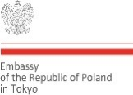Logo Województwa Małopolskiego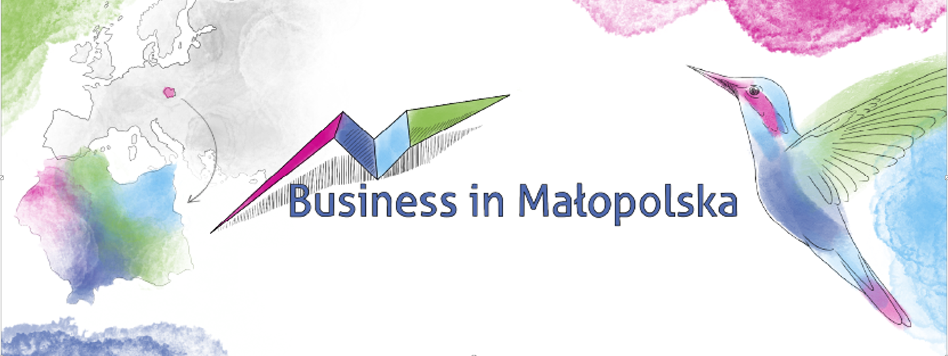

**INVEST IN MALOPOLSKA**

**PROMOTION OF THE INVESTMENT POTENTIAL OF THE MALOPOLSKA REGION ABROAD**

(MEETING ONLINE)

16th JUNE 2021, 15:00 – 16:40 a.m.

**REGISTRATION FORM**

INSTITUTION / COMPANY….…………………………………………………………………………………………………………………

NAME……………………………………..……………………………………………………………………………………………………………

SURNAME……………………….……………………………………………………………………………………………………………………

FUNCTION………………….…………………………………………………………………………………………………………………………

E-MAIL………………………….………………………………………………………………………………………………………………………

PHONE…………………………….……………………………………………………………………………………………………………………

COMPANY PROFILE…………………………………………………………………………………………………………..………………….

………………………….…………………………………………………………………………………………………………………………………

………………………….…………………………………………………………………………………………………………………………………

AREA OF INTEREST……………………………………………………………………………………………………………………………….

………………………….…………………………………………………………………………………………………………………………………

………………………….…………………………………………………………………………………………………………………………………

Please fill in the registration form and return it until **10th June 2021** to the following e-mail address: [agnieszka.dyga@umwm.malopolska.pl](mailto:agnieszka.dyga@umwm.malopolska.pl)

The link with the access to the meeting will be sent to you on your e-mail address in due time.