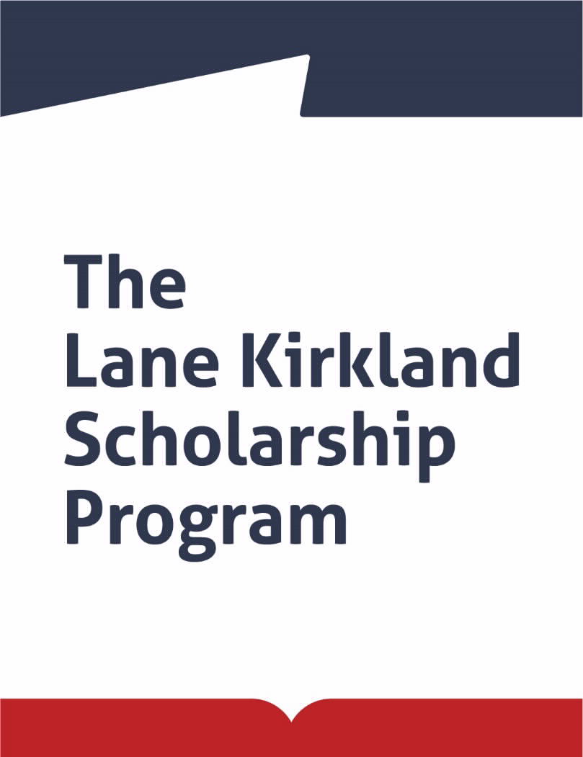

KIRKLAND RESEARCH PROGRAM

The
Polish-American Freedom Foundation
Founder of the Program
and
Leaders of Change Foundation
Program Administrator

announce an open competition for candidates from

Armenia, Azerbaijan, Belarus, Georgia, Kazakhstan, Kyrgyzstan, Moldova, Russia, Tajikistan, Ukraine, and Uzbekistan
for the 2021 KIRKLAND RESEARCH scholarships

Within the Kirkland Research Program, we offer a scholarship for a one-semester research stay in Poland during the 2021/22 academic year for candidates with a PhD degree who have an established academic position.

FIELDS:
- Economics and Management
- Administration / Management (i.e. business, NGOs, culture, education, or healthcare)
- Public Administration (Central or Local Government Administration)
- Law
- Social Sciences (Social Psychology, Sociology)
- Political Science and International Relations
- Environmental and Climate Protection
- Security and Cybersecurity
- Crisis Management
- Development Policy and Humanitarian Aid

Candidates who intend to return to their home country after the completion of the scholarship and implement the project they have prepared under the scholarship and the knowledge they have gained in Poland, are invited to submit applications.

Kirkland Research scholarship is a scholarship for a stay in Poland from mid-September to late January (first semester). Kirkland Research Program grantees participate in scientific seminars and work individually under the supervision of an academic advisor; this work is to result in the preparation of a scientific article. The requirement for obtaining a diploma for completing the Program is a scientific article approved for printing by the grantee’s academic advisor and the presentation, during the January convention of scholarship holders, of the results of this work.

The Kirkland Research Program is run in parallel with the Lane Kirkland Scholarship Program. Both Kirkland Research Scholarship grantees and the Kirkland Program grantees take part in the program during the autumn and winter semester: in September they participate in an introductory course, then in two grantees’ conventions (November and January), and, optionally, in various other courses and training prepared for Kirkland Program scholars between September and January.

ELIGIBILITY CRITERIA:

You must
- have citizenship and permanent residence in one of the countries covered by the Kirkland Research Program: Armenia, Azerbaijan, Belarus, Georgia, Kazakhstan, Kyrgyzstan, Moldova, Russia, Tajikistan, Ukraine, or Uzbekistan;
- be under 45 years of age;
- have experience in research and scientific work - minimum 4 years;
- have at least two years break from participation in any previous scholarship abroad that was longer than 6 months;
- have scientific achievements, including publications;
- have a knowledge of Polish or English at minimum B2 level. (In the case of having English at B2 level, Polish must be at least at A1 level)

The Program offer is addressed to candidates who have not participated in the Lane Kirkland Scholarship Program, have not completed their doctoral studies in Poland, and are not teaching at a Polish university.

FINANCIAL INFORMATION:
- stipend paid for four months (2200 PLN per month)
- accommodation provided during the four months stay in Poland
- reimbursement of travel expenses (arrival in Poland and return) according to limits set annually
- reimbursement of public transport costs
- scientific and didactic package up to PLN 3500
- health insurance for medical outpatient care, treatment costs in case of an emergency, and civil liability insurance
- participation in the introductory course and grantees conventions
SELECTION PROCESS:

The best candidates will be selected in a 3-stage evaluation process:
- Stage 1 - Review of applications with regard to eligibility criteria
- Stage 2 - Review by independent experts of candidates’ proposed projects of study
- Stage 3 - Interviews (planned for 30 March-30 April 2021).

The candidates who advance to Stage 3 will be notified by e-mail by the end of March 2021. Information on the final nominations will be mailed to the candidates in May 2021.

REQUIRED DOCUMENTS:

- You must fill-in the on-line application form, and include the following:

personal data questionnaire.

description of the candidate’s scientific activity.

research work project - justification for participation in the Kirkland Research Program, together with proposals for how the results of conducted research will be used (7500-12000 characters with spaces).
- Two letters of reference (in Polish, Russian, or English) confirming the candidate's achievements and qualifications to date, and the usefulness of the research to be conducted through participation in the Kirkland Research Program in the candidate's further development and work in her/his professional or social field, sent via e-mail. Recommendation letters must not be written by the candidate's family members and/or spouses/life partners.
- A copy of the PhD diploma, sent via e-mail.

APPLICATION PROCEDURE:

A description of the program and detailed application instructions can be obtained directly from the following website: www.kirkland.edu.pl. They can also be requested by e-mail from the Program Office.

Application forms should be filled out on-line.

After the on-line application has been submitted, the system will generate an application confirmation document that candidates must print. The application confirmation document must be signed, and together with an attached current photograph of the candidate should be scanned and sent by e-mail together with the two reference letters and a copy of the graduation diploma to the following address: kirkland@kirkland.edu.pl

APPLICATION DEADLINE:

The deadline for applications for the Kirkland Research 2021/22 scholarships is

1 March 2021

Applications received after the deadline will not be considered.

SCHOLARSHIP PROGRAM:

- Inauguration of the Program and introductory course (8-10 days, 2nd half of September 2021)
- Individual research work in one of the Polish academic centers: Warsaw, Kraków, Poznań, Wrocław, or Lublin (from October 2021 to January 2022)
- Preparation of a scientific article
- Grantees’ conventions: November 2021 and January 2022
- Participation in a Polish language course (throughout scholarship period)
- Presentation of the grantee’s research work results (January 2022)

THE PROGRAM PATRON
The Program is named after Lane Kirkland, the legendary trade union leader (AFL-CIO), member of the Polish-American Enterprise Fund Board of Directors, and promoter of the Polish-American Freedom Foundation. In the 1980’s, he wholeheartedly supported the Solidarity movement and backed it during its underground years. He also supported the aspirations for freedom of other peoples of Central and Eastern Europe. He was awarded the highest distinctions, including the American “Medal of Freedom” and the Polish “Order of the White Eagle.” He passed away in 1999.

CONTACT:

Leaders of Change Foundation
www.leadersofchange.pl

L. Kirkland Scholarship Program
Al. Jerozolimskie 133 m. 56, 02-304 Warsaw, Poland
E-mail: kirkland@kirkland.edu.pl
www.kirkland.edu.pl

POLISH-AMERICAN FREEDOM FOUNDATION (PAFF) – Program Founder

The Foundation launched its activity in 2000. The main goal of the Foundation is to advance democracy, civil society, equal opportunities and market economy, as well as share Polish experiences in transformation with Central and Eastern European countries. PAFF finances its activities from revenues generated by its endowment ($250 million), the source of which are assets of the Polish-American Enterprise Fund. Since 2000, the Foundation has disbursed over $224 million for its programs.

The Lane Kirkland Scholarship Program, launched in 2000 is a long-term endeavor of the Polish-American Freedom Foundation, since 2016 administered by the Leaders of Change Foundation. Additional information about the Polish-American Freedom Foundation and its programs can be found at: www.pafw.pl

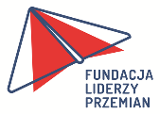 LEADERS OF CHANGE FOUNDATION (FLP) – Program Administrator

The Foundation was established in February 2016 by the Polish-American Freedom Foundation. The main activities of the Foundation include administration of the long-term programs financed by the Polish-American Freedom Foundation: the Lane Kirkland Scholarship Program and "Study Tours to Poland" Program. Together with the European Centre in Natolin and the German Marshall Fund, the Foundation also co-organizes, on behalf of the Polish-American Freedom Foundation, the Warsaw Euro-Atlantic Summer Academy (WEASA).
The Lane Kirkland Scholarship Program and Study Tours to Poland Program were transferred to the new Foundation, together with their experienced teams who have been responsible for their creation for many years. A combination of programs with similar profiles, and participation of new people in their co-creation constitute an opportunity to expand and enrich our activities. We would like to have a broad offer addressed to those who are willing to benefit from the experiences of active people from East Europe, the Caucasus region, and Central Asia. In collaboration with academic centers and institutions in the public and NGO sectors, we also hope to offer some new forms of internship and research stays in Poland.
We gather together people who believe in the power of change.
Additional information about the Foundation is available at www.leadersofchange.pl

