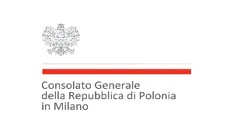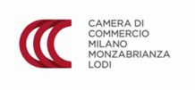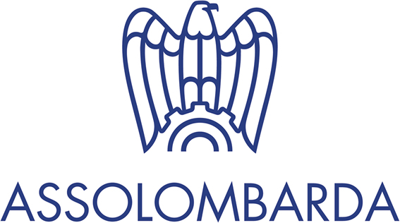

ITALY-POLAND: ECONOMIC ALLIANCE GOING BEYOND EUROPE
Milan, September 14, 2023
Palazzo Giureconsulti – piazza Mercanti, 2 – Sala Terrazzo

Programme
9.30 Registration
10.00 Opening addresses

Federico Maria Bega, Chief Strategy Officer, Promos Italia
Anna Golec-Mastroianni, Consul General of the Republic of Poland in Milan
Chiara Fanali, Director, International Affairs and Foreign Trade Department Assolombarda
Aleksander Siemaszko, Deputy Director, Department for International Trade and Cooperation, Ministry of Development and Technology, Poland

11.00 Round tables discussion
Italian subsidized finance instruments and Polish tools of support for enterprises
Representative, Simest (tbc)
Piotr Ciechowicz, Deputy President, Pomeranian Agency for Regional Development
Moderator: Roberto Corciulo, President, IC Partners

Best practices from Poland: testimonials from Italian and Polish companies. Focus on MedTech and Digital Finance sectors
MedTech Sector
Alicja Warmusz, Comarch Poland
Representative, MedTech Italian Company
FinTech Sector
Piotr Brewinski, Fintech Poland
Representative, Italian FinTech Company

Moderator: Alessandro Saglio, General Director, Confindustria Polonia

13.00 Conclusions
13.00-14.00 Networking and light lunch The event will be held in English

