Diplomatic Car For Sale
from Embassy of the Republic of Poland
KIA K5
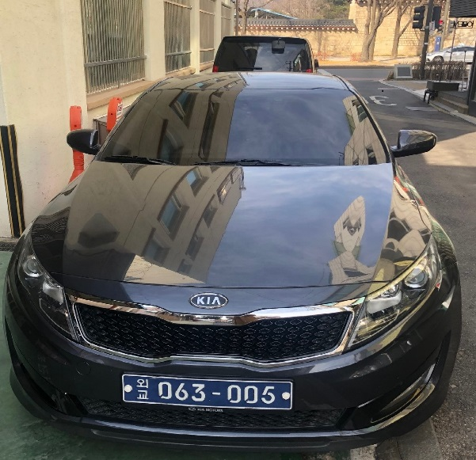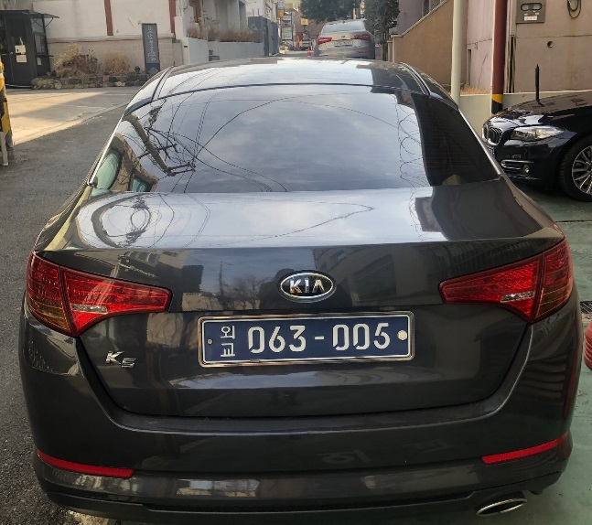
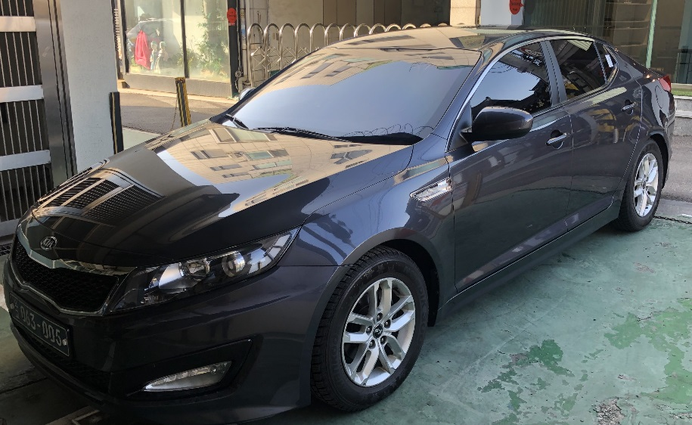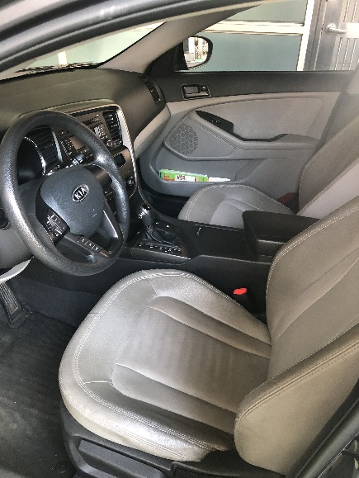
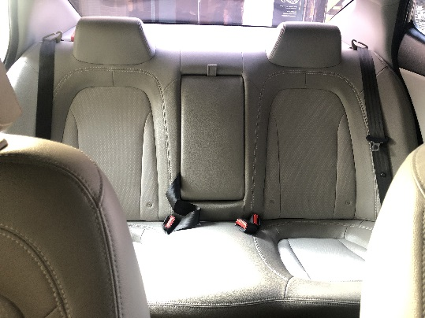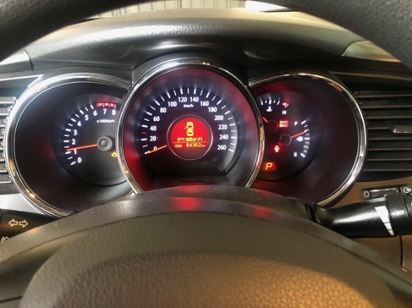
General information:
First Registration: 2011 Colour: grey
Gearbox: Automatic Engine : 1998 cm3
Seating capacity: 5

starting price: 1.800,00 EURO
Please contact us if you are interested!
e-mail: yoojung.lee@msz.gov.pl
telephone number : (02) 723-9681

