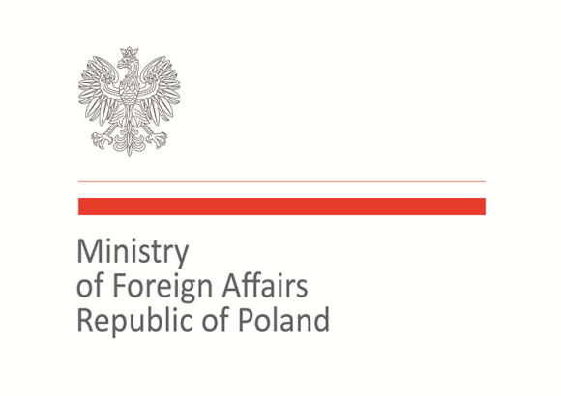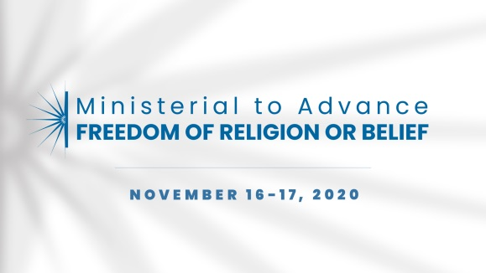

2020 Ministerial to Advance Freedom of Religion or Belief
Warsaw, November 16–17, 2020
Statement of Concern

Statement on advancement of interreligious, interfaith and intrareligious dialogues

As representatives of the international community, we commit to systematically encourage inclusive and sustained interreligious, interfaith and intrareligious dialogues. We acknowledge such cooperation and interactions are a powerful means of raising awareness, reconciliation and tolerance, as well as preventing conflicts and de-escalating violence and thus contributing to sustainable peace and development. We reiterate the responsibility of state to create the right conditions for and to facilitate intra- and interreligious dialogues.
The inter- and intrareligious dialogue and engagement of religious actors can be a valuable tool to combat intolerance and discrimination and to foster freedom of religion or belief. The basis of these dialogues should be the recognition of shared concerns that despite all differences can lead to constructive relationships and partnerships at local, national and international levels. Inter- and intrareligious dialogue are likely to be successful only if based on tolerance and the willingness to find common ground.
In fighting intolerance, hatred and prejudice based on religion or belief, more should be done to foster interreligious partnerships and collaboration with youth, women and vulnerable social groups. This is particularly important in the implementation of peacebuilding and sustainable development projects.
We commit to enhance inter- and intrareligious dialogue, based on knowledge, religious awareness and respect. We commit to engage with religious actors in combating intolerance and discrimination.

Co-signatories:
Armenia, Australia, Azerbaijan, Bangladesh, Brazil, Canada, Croatia, Cyprus, Georgia, Hungary, Italy, Japan, Jordan, Kazakhstan, Kosovo, Latvia, Malta, Morocco, North Macedonia, Poland, Romania, Slovakia, Togo, Trinidad and Tobago, Ukraine, United Arab Emirates, United Kingdom, United States of America, Uzbekistan

