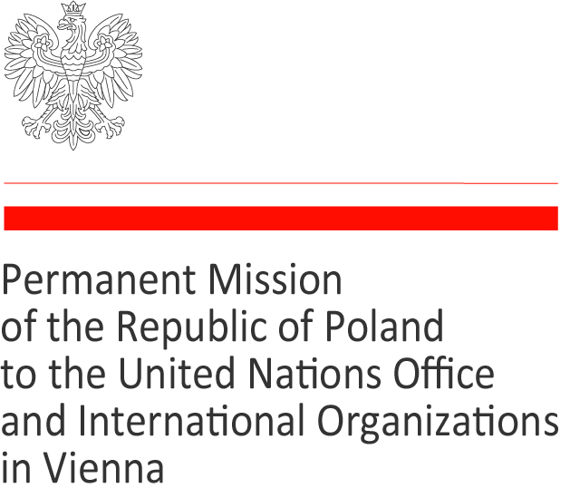

Address by H.E. Ambassador Dominika Krois,
Permanent Representative of the Republic of Poland
to the UN Office and the International Organizations in Vienna
at the inauguration of
the IAEA Marie Sklodowska-Curie Fellowship Programme
Vienna, March 9, 2020

Excellencies,
Director General,
Dear Rafael,

Thank you for your idea to assist women in their wish to embark on education and new opportunities!

Many of us, women present here, have experienced through our lives how difficult it is to cross barriers. Many of us are also first women representing their countries in this important place, Vienna International Center.

Let me express hope that also these young women who will have a chance to use the fellowship will contribute to the peaceful use of nuclear energy and peace in the world.

My country will support them in many ways.

Thank you also for choosing the name of Marie Sklodowska-Curie for the fellowship!
Hardly any other woman would be a better icon of women’s education and nuclear research!

The Marie Sklodowska-Curie fellowship will commemorate na extraordinary woman, an eminent scientist, who, as the only woman, received the Noble Prize twice – for her work on radium, polonium and for separating these elements in metallic state.

Who was she?

A Polish, a Frenchwoman, a tender mother, an outstanding scholar and an exceptionally humble person, but also a person who benefited from and contributed to the education and support of women.

Once she said that “in science we must be interested in things and not in persons” and throughout her life she worked to become a master of this credo.
Albert Einstein, who remained her friend for years, said that of all celebrated beings, she was the one, whom fame had not corrupted.

But who was she?

Maria Skłodowska was born in Warsaw in 1867, in times when Poland lost its independence and was partitioned between Austria, Russia and Prussia. She grew up in a family of teachers and petty nobility, a group that Poland used to draw her intellectual recruits from.

Indeed, both her parents chose university careers and became teachers. They both worshiped their profession and they both became school directors, which was very unusual at that time.

Maria Skłodowska is nine years old when she loses her mother. Very much affected by the loss of his wife, Maria’s father devotes himself entirely to his work and to his children’s education.

Maria begins her education early, in a private Polish school, and finishes in a governmental Russian one, in Warsaw.

She learns literature, languages, music and science, which soon becomes her love and passion.
She gets a huge support from her father, whose only failure is, as she notes in her autobiography, a lack of a laboratory.

She is only fifteen when she graduates from a high school as the best student. Her brother and one sister are leaving for Paris to study medicine. Maria and her other sister would like to become teachers.

As Warsaw University is closed by the Russian authorities after the 1830 November uprising in quest for the Polish independence, and Maria’s father is lacking funds to help her study in Paris, she resolves to earn her living and put aside some funds herself. At seventeen she becomes a governess in a noble family in a land property far away from Warsaw.

Since her duties with the pupils do not take all of her time, she organizes also a small school for children from the village, who could not be educated under the Russian government.

And in the evening she studies.

She studies literature, sociology, science, to finally turn to mathematics and physics. She writes: “At present I am reading Daniels’ physics, Spencer’s sociology and Berks’ works on anatomy and physiology, I read several things at a time because prolonged preoccupation with a single subject would wear out my mind. When I am absolutely incapable of productive reading I do trigonometry or algebra problems, because they require uncompromised attention and are refreshing.”

She is 24 when she finally starts realizing her dream and joy of learning. She moves to Paris and dives into an academic, social and patriotic life of Polish students dreaming of independence for their country.

Behind every great woman there is a man, that is the new saying. In 1895 she marries Pierre Curie, a passionate of science. He fully understands her passion for work. She continues to work in the laboratory, but also at the university, to become a teacher for young girls.

She adds the name Curie to her maiden name and becomes known as Marie Sklodowska-Curie. It is important for her to underline that she is Polish and she uses that name in her doctoral thesis!

But through that she also underscores that she is an independent woman, and that it is possible to reconcile a family life and a scientific career, and to reconcile being a woman and a scientist!

With her first daughter born, she divides her life between family, laboratory, where she explores magnetic property of steel and the Normal Superior School in Sevres, where she teaches young girls of 20, who would like to become teachers.

She embarks on doctoral studies to search for a particular activity of metals, especially uranium and thorium. She observes that some ores are much more radioactive than the calculation would have suggested and guesses the existence of other, much stronger radioactive substances, which she names radium, to stress its radioactivity and polonium – to commemorate her homeland.

In 1903 Marie Sklodowska-Curie obtains the doctoral degree, and in the same year the Curie couple, together with Henri Becquerel receive a Noble prize for the discovery of radioactivity and new radioactive elements. Her award diploma includes only her name Curie, which she opposes – wishing to have her full name Sklodowska-Curie in it.

This is corrected and she receives her second Noble prize in 1911, as Marie Sklodowska-Curie.

In 1906 she is offered the chair of the Faculty in Sciences of Paris, as Professor. It was an exceptional decision as up until then no woman had held such a position.

She pays particular attention to education in general, to the education of woman and to the education of her daughters. Together with her friends she creates a special program for children, who at home, for two years, are taught science, literature and physical education, which she considered very important in life.

During the World War I, having brought the radium supply of the Radium Institute into a safe place in Bordeaux, she returns to Paris, and helps organize more than 200 radiological installations and 20 radiological cars to examine the wounded in the Belgian and French Army.

She is appreciative that her discovery contributes to the cancer therapy and becomes beneficial for the mankind.

The Curie couple has always refused to draw material profits from their discoveries. They took out no patent and did not reserve any advantage in any industrial exploitation, and until their last days they were convinced of having done it right. But this decision was detrimental to the development of the research, as they had to struggle for their laboratory, means to work, and the state’s assistance.

And so in 1921, when the Institute is in a special need, it is the women who help!

Upon an invitation by a journalist, Mrs. Meloney, Marie Sklodowska-Curie made her first trip to the United States to give lectures, but also to acquire financial resources to purchase equipment and a single gram of radium.

Thanks to the generosity and dedication of American women, she is presented with the golden key to a box containing one gram of radium. It is the President of the United States who hands it in.

Excellencies, j’arrête ici pour permettre à mon collègue français de prendre la parole sur la vie française de Marie Sklodowska-Curie.

I am convinced that Marie Sklodowska-Curie would be very happy to help young women this time again.

She was born as Maria Skłodowska pronounced [ˈmarja skwɔˈdɔfska]; when she moved to France and got married, she started using the name of Marie Sklodowska-Curie.

