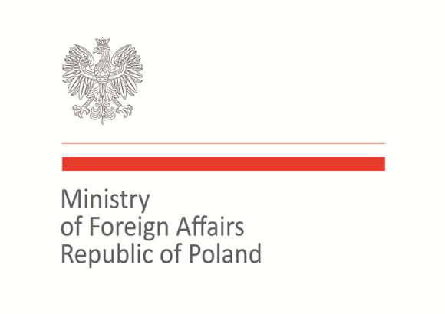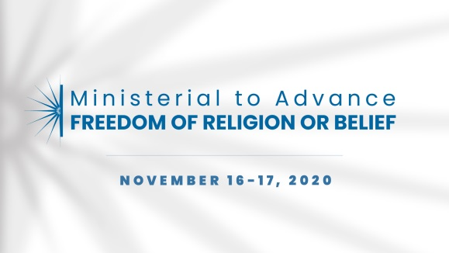

2020 Ministerial to Advance Freedom of Religion or Belief
Warsaw, November 16–17, 2020
Statement of Concern

Statement on religious actors' contribution to the peacebuilding

As members of the international community, we welcome an increasingly active and recognized role of faith-based actors in fostering resilience, preventing violent conflict, and sustaining peace.
Root causes of conflicts are multi-dimensional and context-specific, and it is important to adopt comprehensive, inclusive and holistic approaches to peacebuilding and conflict prevention. In this context, it should be acknowledged that religious leaders, both formal and community-based, and faith-based organizations play prominent roles in society and perform social functions which can aid in the peacebuilding process.
The religious leaders and institutions, being deeply rooted in and serving as important moral authorities in their communities, promoting respect for human rights and fundamental freedoms and being key contributors in building trust between and among social groups, might act as additional and genuine mediators along with traditional or political actors in de-escalating violence and the process of conflict resolution. Religious actors, as meaningful members of local civil society, can create conditions conducive to fostering peace education, inter- and intrareligious dialogue and humanitarian aid.
Therefore, we believe that it is important for religious actors and faith-based organizations, with the full participation of women leaders, to be present in mediation, conflict resolution and social reconstruction, as a vital part of an holistic approach to peacebuilding.

Therefore we commit to work collectively:
- In assisting ‘religion or belief-based’ actors in promoting peace by supporting expert training, networking activities, campaigns, human rights monitoring, electoral observation, conflict prevention and reconciliation projects;
- In supporting and encouraging religious actors in building networks of local leaders for peace;
- In promoting traditional and social media literacy by religious and traditional leaders in order to share peaceful messages with the youth.

Co-signatories:
Australia, Azerbaijan, Brazil, Cyprus, Hungary, Jordan, Kosovo, Malta, North Macedonia, Norway, Poland, Slovakia, Togo, Trinidad and Tobago, Ukraine, United Kingdom, United States of America, Uzbekistan

