Call for Applications for the Polonista NAWA 2026 Scholarship Programme Opens

The Polish National Agency for Academic Exchange announces the opening of the call for applications for the Polonista NAWA scholarship programme. The initiative offers foreign nationals interested in the Polish language and culture an opportunity to pursue studies or carry out research projects in Poland. The aim of the programme is to promote the Polish language and to popularise Polish studies and research internationally.
The programme provides a framework for projects in fields such as literary studies, Polish language teaching (glottodidactics), history, art history, and comparative studies. Thanks to this initiative, enthusiasts of Polish culture from around the world can undertake studies or conduct research at Polish academic institutions, fostering the exchange of experience and the integration of the academic community.
Under the programme, students and doctoral candidates may apply for scholarships for full or partial Polish studies lasting one or two semesters, with monthly financial support of PLN 2,000 for students and PLN 3,300 for doctoral candidates.
Foreign researchers are eligible to carry out research projects lasting from 3 to 12 months. Polish researchers and academic teachers may apply for mobility to foreign institutions offering Polish studies, Polish area studies, or Slavic studies with Polish as a language of instruction at least at the bachelor’s level.
So far, the programme has supported 281 participants from 26 countries, including Poland. The beneficiaries included 225 students and doctoral candidates as well as 56 researchers.
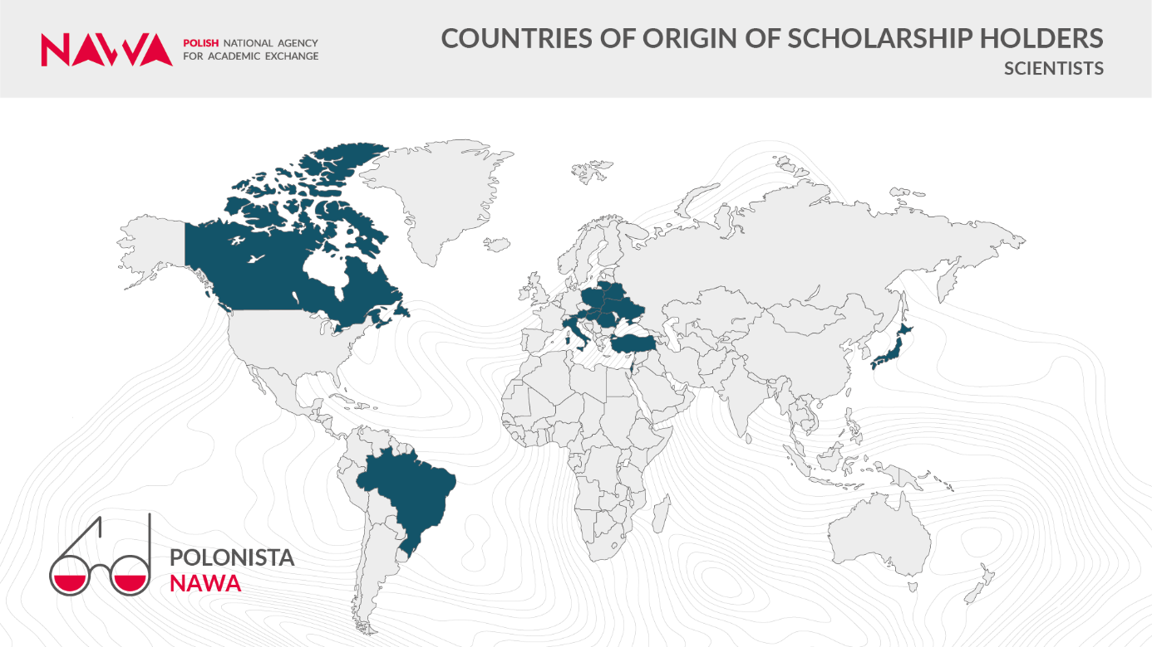
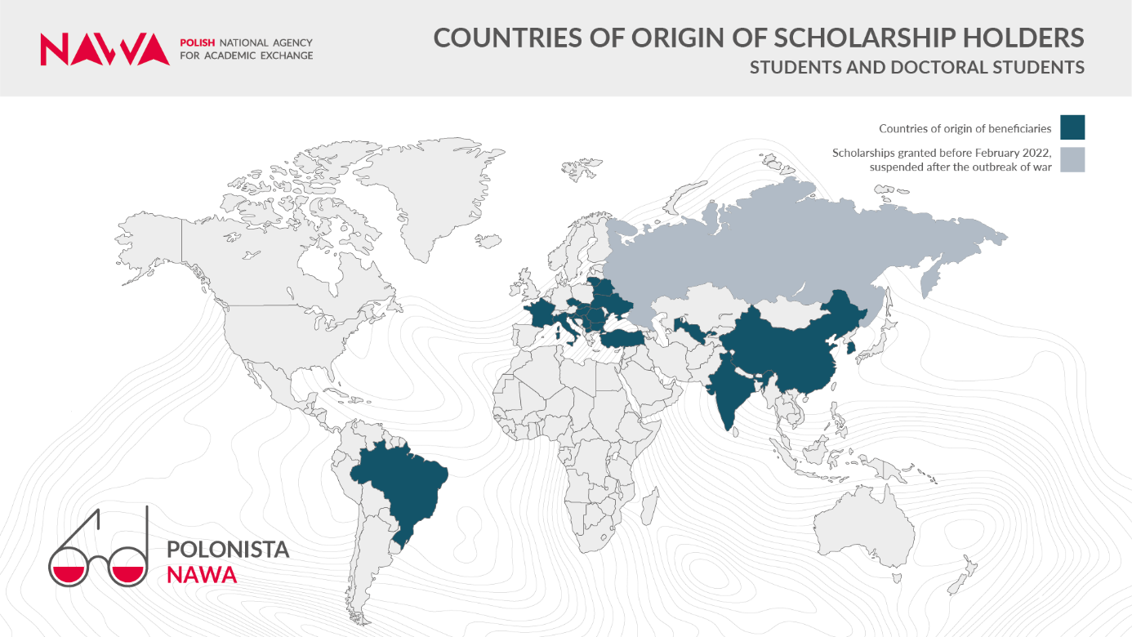
A total of 16 Polish higher education and research institutions have hosted programme beneficiaries to date. The academic centres most frequently chosen by students included the University of Warsaw, Adam Mickiewicz University in Poznań, the University of Silesia in Katowice, and Jagiellonian University in Kraków.
Researchers most often carried out their projects at Nicolaus Copernicus University in Toruń, Adam Mickiewicz University in Poznań, and the University of Silesia in Katowice.
Applications will be accepted until 3 April 2026.

Call for Recruitment for scientists
Detailed information about the programme is available on the NAWA

