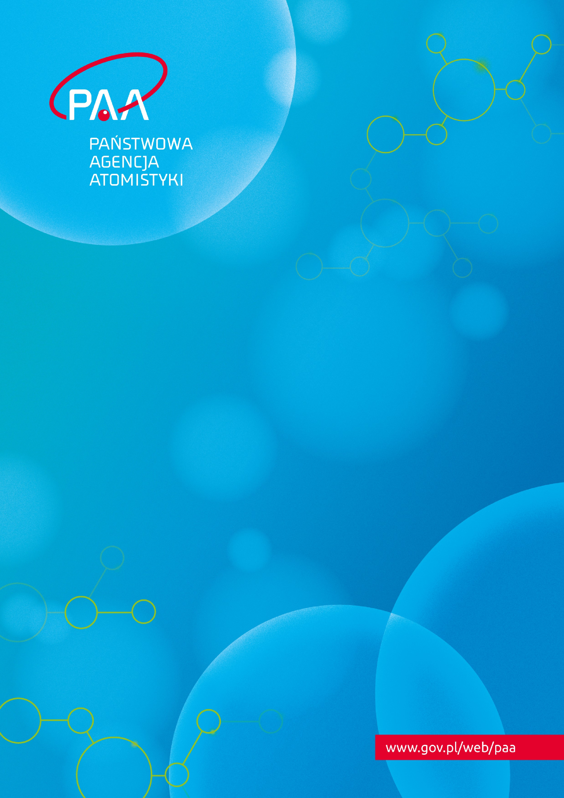

Dialogue of the President of the National Atomic Energy Agency with investors planning the construction of a nuclear facility

Policy

Policy - Dialogue of the President of the National Atomic Energy Agency with investors planning the construction of a nuclear facility

Prepared and edited by the National Atomic Energy Agency (PAA)
Policy approved by the President of the National Atomic Energy Agency (President of the PAA)

TABLE of contents
1. Introduction 4
2. Principles of dialogue 4
3. Instruments of dialogue – opinions by the President of the PAA 5
3.1 Formal rules for submitting applications for the opinions by the President of the PAA 5
4. Dialogue in the form of meetings 6
4.1 Principles for organising meetings 7
4.2 Preliminary technical meetings 7
4.3 Status, operational and technical working meetings 8
5. External communication of meetings with investors 9

Introduction
This document sets out the principles, forms and instruments of dialogue between the President of the National Atomic Energy Agency (PAA) (hereinafter referred to as the ‘President of the PAA’) and investors planning to carry out activities relating to exposure to ionizing radiation involving the construction of nuclear facilities in Poland (hereinafter referred to as the ‘investors’). The dialogue with investors prior to the submission of an application for a nuclear facility construction licence by the President of the PAA should be conducted in a manner aimed at streamlining the effectiveness of the future licencing process, while maintaining the highest nuclear safety standards.
This dialogue includes the possibility for the investor to use instruments such as opinions issued by the President of the PAA, or it can be conducted in the form of technical, operational and status meetings between representatives of the investor and the President of the PAA. Investors are encouraged to start this dialogue at the earliest possible stage of the investment process.

Principles of dialogue
The dialogue of the President of the PAA with investors is based on four main principles:
- Mutual transparency in terms of plans, established communication channels, meetings and their outcomes.
- Predictability of the investor's actions, consisting in providing advance information on any plans to apply for the opinions of the President of the PAA, as referred to in section 3 (Instruments of dialogue), and on all other undertakings that may involve the National Atomic Energy Agency (PAA).
- Acting in line with the anti-corruption principles and prevention of conflict of interest.
4. Documenting the conducted dialogue while protecting information constituting trade secret and other statutorily protected information.
In order to plan the necessary resources to cooperate with investors, at the end of each calendar year the President of the PAA shall ask investors with whom a dialogue has been initiated to provide information on their plans for the following year in areas requiring PAA’s involvement.

Instruments of dialogue – opinions by the President of the PAA
Prior to submitting an application for a licence to construct a nuclear facility, the investor may apply to the President of the PAA to issue:
- a general opinion (pursuant to Article 39b(1) of the Act of 29 November 2000 - Atomic Law (Journal of Laws of 2024, item 1277), hereinafter referred to as the ‘Atomic Law Act’), which may concern:
  - planned organisational and technical solutions for future activities,
  - draft documents to be submitted with the licence application.
- an advance opinion on the planned site of a nuclear facility or on certain aspects of the site of a nuclear facility (pursuant to Article 36a(1) of the Atomic Law Act).
Keeping in mind the effectiveness of the dialogue, in case of the intention to apply for any of the abovementioned opinions, investors are encouraged to communicate as early as possible:
- the intention to file an application for an opinion,
- the subject matter of such an application and its planned scope,
- the anticipated date of submission of the application,
- the estimated volume of documentation accompanying the application.
Investors can provide the above information in writing, by email or as part of the meetings described below.
Prior to submitting an application for a nuclear facility construction licence, investors are encouraged to consider applying for a general opinion by the President of the PAA with respect to the drafts of substantive documents that are subject to PAA assessment as part of the administrative proceedings initiated by the application for a nuclear facility construction licence. Once the investor has applied for nuclear facility construction licence, the President of the PAA will assess the completeness and the level of detail of the documentation submitted with the application. In order to allow for future streamlining of this review process, the President of the PAA encourages to submit an application for a general opinion at least nine months prior to the investor's planned application for a nuclear facility construction licence from the President of the PAA.
Other expectations regarding the purpose, details and preferred scope of applications for a general opinion by the President of the PAA are defined in a separate document.

3.1 Formal rules for submitting applications for the opinions by the President of the PAA
Language of documents
Applications for an opinion by the President of the PAA shall be submitted in Polish. If the application contains attachments, the language of the attached documents shall also be Polish, optionally - additionally English.
Trade secret or intellectual property information
If the application or the attachments to the application contain information that constitutes proprietary information, such information should be precisely indicated in the application or in the attached documents. In addition, for each piece of information that, in the opinion of the investor, constitutes a trade secret, the investor should:
- justify why the information is considered to constitute trade secret,
- demonstrate that due diligence was undertaken to maintain the confidentiality of the information constituting trade secret,
- demonstrate that the information constituting trade secret has not been made public or is not readily available to persons who normally handle this type of information.
As part of the justification that the information in question should be classified as a trade secret, the investor should demonstrate the cumulative existence of the following circumstances:
- the information is of a technical, technological or organizational nature for the company or has an economic value.
- the information has not been disclosed to the public.
- necessary steps have been taken to keep the information confidential.
The obligation to prove that the prerequisites for qualifying a given piece of information as trade secret have been met rests with the investor.
It is recommended for investors to submit to the President of the PAA documentation containing information constituting trade secrets separately, in a manner allowing for its separation from documents that do not contain such information.
The PAA employees are obliged to protect information covered by trade secrets of which they have become aware in the course of the proceedings.

Dialogue in the form of meetings
As part of the President’s of the PAA dialogue with investors, it is possible to organise meetings with representatives of the President of the PAA. Such meetings are organised at the investor's request and may concern the planned application for a nuclear facility construction licence or issues of nuclear safety, radiation protection, nuclear security or safeguards in the investor's planned activities.
The following types of meetings are envisaged:
- preliminary technical meetings (section 4.2) – may be organised with investors regardless of the stage of the investment,
- status, operational and technical working meetings (section 4.3) – may be organised with investors who have obtained the decision-in-principle for the investment within the meaning of Article 3a (1) of the Act of 29 June 2011 on the preparation of and carrying out of investments in relation to nuclear power facilities and accompanying investments (Journal of Laws of 2024 item 1410).
During technical, status and operational meetings, no binding positions of the President of the PAA relating to nuclear safety, radiation protection, nuclear security and safeguards are formulated.

4.1 Principles for organising meetings
The following rules apply to the organisation of meetings held as part of the dialogue between the President of the PAA and investors:
- meetings take place at the PAA headquarters on a mutually convenient date agreed at least seven days in advance; as a rule, the representatives of the President of the PAA decide on the final date of the meeting;
- the date, scope and agenda of the meeting are agreed each time well in advance by designated contact points on the part of the investor and of the President of the PAA;
- the investor should, through the designated contact point, provide a list of meeting participants in advance;
- materials or presentations which will be discussed at the meeting should be made available to the PAA’s contact point at least five days in advance; in justified cases, the investor may attach to the shared documents their equivalents in English;
- the language of the meetings is Polish; at the same time, in justified cases, at the investor’s request and as far as possible, meetings at level one and two may also be held in English;
- in justified cases, apart from the investor's representatives, third parties may participate in the meetings; such parties should be related to the investment being implemented and must have been previously notified and accepted by the President of the PAA;
- apart from the representatives of the President of the PAA, the meetings may be attended by representatives of organizations supporting the President of the PAA;
- upon agreement with the investor, representatives of other public administration authorities may participate in the meetings.

4.2 Preliminary technical meetings
The purpose of the preliminary technical meeting is to allow the investor to present the technology and investment plans. At the investor's request, representatives of the President of the PAA may present at such a meeting basic information on the licencing process for exposure-related activities involving the construction, commissioning, operation or decommissioning of a nuclear facility, as well as with regard to nuclear safety, radiation protection, nuclear security and safeguards requirements.

4.3 Status, operational and technical working meetings
Status, operational and technical working meetings have been assigned three levels:
- Level zero meeting
This is a status meeting at the level of the President of the PAA and the presidents or members of the investor's board of directors/executive board. The meeting may also be attended by those with substantive responsibility for the issues discussed. The status meeting should be an open discussion about strategic and scheduling topics and should serve to resolve issues identified during level one meetings. Level zero meetings generally take place twice a year, and their frequency may be increased depending on the needs and progress of the investment.
- Level one meeting
This is an operational meeting at the level of directors, project managers and persons with substantive responsibility for the issues discussed. This meeting may serve to present the investor's plans in areas requiring the PAA’s involvement such as the planned submission of an application for any of the opinions by the President of the PAA specified in section 3 or a licence for the construction of a nuclear facility. The investor may also provide clarifications or supplement information submitted with the application for the aforementioned opinions by the President of the PAA or present a position on issues not covered by the submitted application. Level one meetings may attempt to address issues identified during the level two meeting and may also establish topics for level two or level zero meetings.
- Level two meeting
This is a technical working meeting at the level of project managers and persons with substantive responsibility for the discussed issues. The purpose of the meeting is to discuss the substantive aspects of the submitted application for any of the opinions by the President of the PAA, specified in section 3, as well as other issues not covered by the scope of those opinions. Technical working meetings, which do not concern the investor's application for the aforementioned opinion by the President of the PAA, should lead to a joint identification of key technical, design or programme issues that may become the topic of the application for one of the opinions by the President of the PAA, specified in section 3. Based on the materials received prior to the meeting, representatives of the President of the PAA may present their observations, with particular emphasis on potential factors threatening the fulfilment of nuclear safety, radiation protection, nuclear security or safeguards requirements.
In a letter to the President of the PAA, the investor may present in advance the proposed thematic scope and frequency of status, operational and technical meetings for a given year.

External communication of meetings with investors
Information on status meetings is available on the PAA’s website. No photographic or video reports shall be made of the meetings.
If the investor is planning to communicate the findings of a technical, operational or status meeting as part of their own external communication, a draft of such communication should be forwarded through the investor's contact point to the spokesperson of the PAA.

www.gov.pl/web/paa/

