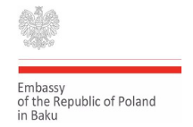
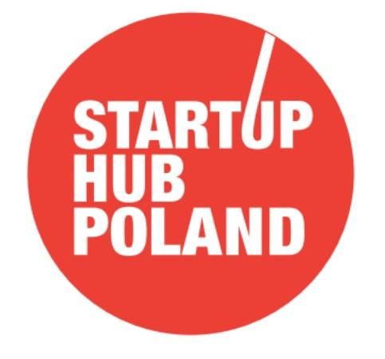

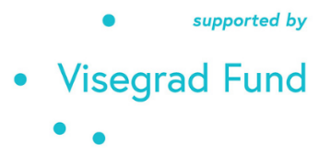

A new international program for Azerbaijani startups
Top disruptive young teams and companies from Azerbaijan can now pop on international investment stages like Warsaw, Prague, Budapest and Bratislava. It is all thanks to V4-Azerbaijan Tech Bridge, a new, 1,5-year long program for training innovators with global ambitions and exposing them to leading edge EU partners: accelerators, VCs, angels.
The goal of the V4-Azerbaijan Tech Bridge project is to establish and enhance cooperation between Visegrad Group (Czech Republic, Hungary, Poland, Slovakia) and Azerbaijan in the sphere of innovation by linking startup ecosystem players like innovation hubs, private investors, venture capital funds and innovation-seeking corporations from the EU with the potential of Azerbaijani startups and innovators.
The project will establish a new networking platform between partners from the Visegrad Group (investors, accelerators, angels, mentors, etc.) on the one hand, and startups and innovators from Azerbaijan on the other. The project will provide a series of meetings, training, excellence program, demodays, networking, post-acceleration and finally the V4-Azerbaijan Startup Summit in Baku in 2023. The project will consist of 8 online regional chapters in V4 top tech-cities designed to promote those 8 cities and whole V4 ecosystem in terms of opportunities for young, innovative talents from Azerbaijan. 20 most promising Azerbaijani startup teams will be invited to the Online Semi-Finals in Ganja so the Jury can select 10 excellent startups for the physicals startup gala in Baku (2023).
The project was initiated by the Embassy of the Republic of Poland in Baku and received funding from the International Visegrad (V4) Fund. The initiative will be implemented by a Consortium of 4 Partners from Visegrad Group: Startup Hub Poland Foundation (Poland, project leader), AI Startup Incubator (Czech Republic), CEU iLab (Hungary), CIVITTA (Slovakia) in cooperation with IdealHub Innovation and Technology Center from Azerbaijan.
The project enjoys the support of all Visegrad countries Embassies in Baku: the Embassy of Czech Republic, Embassy of Hungary, Embassy of Poland and the Embassy of the Slovakia.
Why Poland and the Visegrad Region
“CEE is one of the fastest-growing regions in the EU with lots of potential. As a participant of their V4 project, I was able to observe the thriving startup ecosystem first hand. These countries provide both exciting opportunities, including accelerator programs, mentorship, VC funding for early-stage startups, as well as advice from successful entrepreneurs, as they have had several large exits of startup companies and currently have few unicorns.” says Sanya Kumari, a startupper traveling between Azerbaijan and the US.
How it works?
By Feb 28th disruptive Azerbaijani startups can apply on the project website (startuphub.pl/V4-azerbaijan/) to join the first chapter of this brand new format, hosted by Startup Hub Poland in Warsaw. 10 selected teams will take part in 2 days short online bootcamp (10th & 11th March) leading to the Demoday on April 7th. The winner will be shortlisted for a big gala in Baku in June 2023 called V4-Azerbaijan Startup Summit in Baku.
"Starting from Warsaw the Visegrad Region will host 8 similar chapters all together. In the most vibrant technopolis in Czech Republic, Hungary, Slovakia and Poland, the fastest growing startup region in the European Union. There is a unicorn boom here as we speak and I see no reasons why Azerbaijan should not benefit from this melting pot" - says Maciej Sadowski, CEO of Startup Hub Poland.
The V4-Azerbaijan Tech Bridge, apart from 8 online chapters (10 different Azerbaijani startups every time; 80 all together) full of skillful workshops and networking, contains two events in Azerbaijan. On-line semifinals for 20 most motivated startups in Ganja in May 2023 and on-site Baku Finale called V4-Azerbaijan Startup Summit for top 10 teams. Organizers will invite several venture capital funds from the West investment chemosphere to Baku to celebrate and invest into Azerbaijani most excellent startups.
"Four leading startup organizations from the Visegrad Region will help Azerbaijani colleagues to appear flawlessly on the stage. This wide International project is designed to train all, but highlight those top notch ones. European investors are only discovering Azerbaijan right now. There is no better way to introduce this country to them as showcasing most descriptive business concepts which await support to become global players. On the other hand, this project will promote the startup ecosystems of the Visegrad Group countries as a convenient place to start and develop innovative projects proposed by talented Azerbaijani teams." - said Rafal Poborski, Ambassador of the Republic of Poland to Azerbaijan.
"There is a technological and investment spot emerging next to richest centers in Europe and attracting the greatest technological talents from abroad with its openness, infrastructure, global relationships and investment opportunities. It is the Visegrad region, the next place for every investor and good startups to be", says Katarzyna Skoneczna, Program Director I SHP. "There is business to make in CEE now, when the eyes of VCs are pointed at Poland and its neighbours." - Katarzyna concluds
The project starts in Warsaw with the boot camp for the first 10 startups booked for March 10th, 12:00 PM CET. But the open call for projects ends on February 28th Warsaw's midnight.
All Azerbaijani startups interested in investments and business partners from the EU should apply here.
Community partners, investors, media and all other stakeholders of the entrepreneurial stage in Azerbaijan are welcome to contact the organizers using this link.
Important dates:
- Feb 28th, 2022 by 11:59 PM Warsaw time (CET) - the deadline of the call for Azerbaijani startups for the Warsaw Chapter
- Mar 7th, 2022 - the expected release of selected 10 startups to the Warsaw Chapter
- Mar 10th, Mar 11th 2022 - two days on-line boot camp for first 10 startups
- Apr 2022 by March 2023 - 7 local chapters for remaining 70 startups (10 different startups per chapter)
- Apr 7th 2022 - Warsaw Chapter online demo day for 10 startups
- May 2023 - Semi Finals for 20 startups in Ganja (online)
- Jun 2023 - V4 Azerbaijan Startup Summit in Baku with 10 best of the best startups on-site demo day.

Read more at the Project website: startuphub.pl/V4-azerbaijan/
Take a look at program’s infographic: https://bit.ly/3oNYBPd

