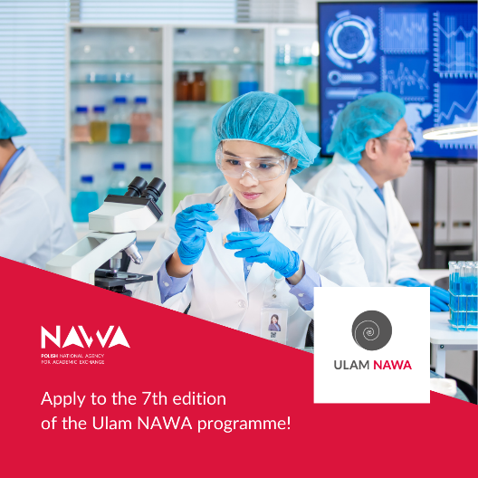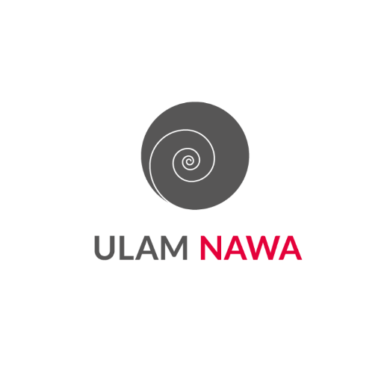
Call for the 7th edition of the Ulam NAWA program is underway!
Researchers at foreign universities and research centers with at least a PhD are invited to apply to for the next edition of NAWA's Ulam program.
The goal of the program is to increase the internationalization of Polish universities and scientific institutions. The Ulam NAWA program allows established as well as promising scientists to come to Poland, enables them to complete internships, as well as to establish and deepen scientific cooperation in Polish research and academic centers. Thanks to the program, it is possible to gradually increase the number of foreign scientists involved in scientific research and teaching in Poland, thus strengthening the potential of Polish units.
Terms and Benefits:
- Duration of stay: from 6 to 24 months;
- Financial support: PLN 11,500 per month;
- Additional benefits: a one-time arrival allowance and a family allowance for those with children;
- Purpose of stay: to conduct scientific research, carry out a postdoctoral fellowship or obtain materials for research and publication.
Key Dates:
- Deadline for application: from February 10 to May 12, 2025 (until 3:00 pm) in our ICT system;
- Start of stays in Poland: from February 1, 2026.
Additional Information:
If you have obtained a Seal of Excellence certificate under the Marie Skłodowska-Curie Actions Postdoctoral Fellowships program, you can also apply - we recognize this certificate as an acknowledgement of the quality of your application.
Haven't chosen a host center yet? Check out Polish research landscape: Key figures - Research in Poland.
Detailed information on the 2025 edition is available in Call for Proposals No. 8/2025.
The Project implementation period includes the period of mobility (the period of stay in the host center) plus 3 months. The Project must be implemented within the Program period.
The provision of 3 months added to the length of stay at the resort, was introduced to reduce the number of annexes for changes in dates, and, at the same time, to facilitate accounting for stays that often cannot start exactly on the first day of the month.
Under the program, it is possible to invite researchers from abroad, regardless of age, represented field or country of origin, including Polish scientists working permanently abroad (they can constitute up to 10% of the grantees in the intake). Universities and scientific and research institutes may invite to Poland specialists in their priority fields who will significantly develop the institution's research, strengthen didactics, or support the institution in preparing applications for prestigious grants.
Previous Editions
The largest group of Fellows are specialists from India, Germany, Italy and Spain, but last year's edition also featured participants from countries such as Slovenia, North Macedonia, New Zealand, Finland, Ethiopia and Belarus. One of the fellows boasts a Seal of Excellence certificate from the Marie Skłodowska-Curie Actions Individual Fellowships program. In addition, the awardees include a Chilean researcher from the University of Iceland, who has launched a study entitled "Non-Lorentzian limits, strings and black holes."

Links to audio and video materials:
Article on NAWA website - Polish.
https://nawa.gov.pl/nawa/aktualnosci/otwieramy-nabor-do-programu-ulam-nawa-2025
Article on NAWA website - English.
https://nawa.gov.pl/en/nawa/news/call-for-applications-for-ulam-nawa-2025-programme-opens
NAWA Podcast
https://www.youtube.com/watch?v=5jyCR4ZwWPQ
NAWA podcast trailer
https://www.youtube.com/watch?v=LWLgiRMvvnM&list=PLHHhTU16msktrHh9s6UxXs_6u2ZA40eMx&index=2
Article on Research in Poland website - in English
Call for applications for Ulam NAWA 2025 program opens - Research in Poland

Stanislaw Marcin Ulam (1909 -1984) was a well-known Polish mathematician. He earned his doctorate in 1933 at the Lviv Polytechnic Institute. Prof. Ulam was a member of the world-famous Lviv school of mathematics and co-author of the Scottish Book. Just before the outbreak of World War II, he traveled to the United States to join the Institute for Advanced Study in Princeton. He worked at a number of American universities as a professor, including the Ivy League-affiliated University of Colorado Boulder and the University of Wisconsin and Florida State University.

