A N N O U N C E M E N T
Consulate General of the Republıc of Poland, Eski Büyükdere Cad. No. 7, Giz 2000 Plaza Kat. 5,
MASLAK – SARIYER - ISTANBUL
invites tenders for selling diplomatic car TOYOTA CAMRY
in form of bidding – the contest of offers.

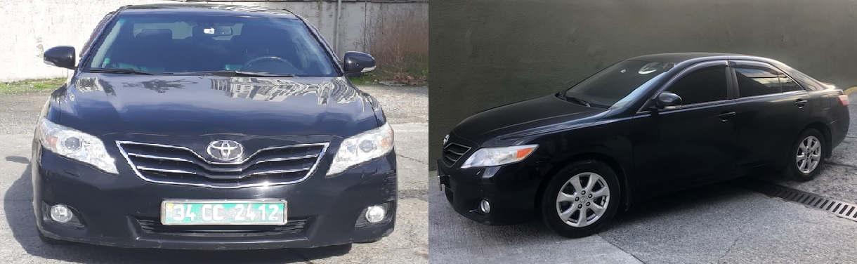

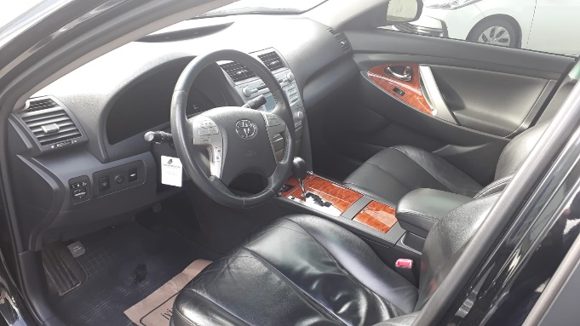
Technical information:
2398 m³ engine,
production year : 2009,
4 cylinder,
automatic gear,
automatic air-condition,
electric mirrors,
original radio with CD player,
mileage: 156 052 km,
tinted windows
additional winter tire set + wheels

STARTING PRICE: 2 800 USD

Conditions of taking part in the bidding:
- In order to take part in the bid it is necessary to pay a deposit of 280,00 USD (10% of the starting price) in the cash point of the Consulate (open every working day from 10:00 till 14:00) until 27.07.2020.

- It is possible to see the object of the bidding, after taking appointment in the Consulate General of the Republic of Poland, Eski Büyükdere Cad. No. 7, Giz 2000 Plaza Kat 5, MASLAK – SARIYER - ISTANBUL between 09.07-27.07.2020 on working days. Please be so kind to take an appointment by calling 0533 436 87 06 – Gökhan Araboğa or send an email to: istanbul@msz.gov.pl

- The offer should be prepared in writing – fullfilling attached form – attachment no. 1 and should include:

  - Name and surname or the company name, detailed address and telefon no.
  - Offered price (written in digits and in words) and conditions of payment
  - Declaration that the bidder is aware of the vehicle’s condition and is fully responsible for resigning from the opportunity to inspect the vehicle.
  - Deposit payment confirmation.

- Written offers with deposit payment confirmation should be delivered to the Consulate General of the Republic of Poland, Eski Büyükdere Cad. No. 7, Giz 2000 Plaza Kat 5, MASLAK – SARIYER - ISTANBUL in closed envelope marked: Bid on Toyota Camry – do not open, untill 27.07.2020, 14:00 o’clock.

- The envelopes will be opened in the presence of a commitee on 28.07.2020 at 11:00 o’clock in the office of the Consulate General of the Republic of Pland GIZ 2000 Plaza, Eski Büyükdere Cad. No. 7, Kat 5, MASLAK – SARIYER - ISTANBUL.

- The committee will choose the bidder who will offer the highest price.

- The deposit paid by the bidders, whose offers will be rejected will be paid back within 7 days after the bid. The deposit paid by the buyer will be included into the selling price.

- The deposit will not be paid back if the bidder who won the auction will not sign the selling agreement.

- The offer will be rejected if: it is delivered after the deadline, to the wrong place, if the deposit is not paid or if the data is incomplete, illegible or suspicious, in which case an explanation could lead to its recognition as a new offer.

- In case the same price is given by two or more bidders the bidding procedure will be continued as an auction. The date and the place of the auction will be given by the committee.

- The buyer will be informed about the date and place of signing the sale agreement. The date will not be later that 10 days after opening the bidding offers.

- The buyer is obliged to pay the full selling price not later than 7 days after the agreement is signed. The seller will inform about the date and the place of signing the agreement.

- The vehicle will be given to the buyer after paying the full amount and signing the agreement.

- All the costs, tax duties and other fees related to the purchase of the vehicle will be covered by the buyer. The buyer, entering the bid agrees to pay all the fees requested by Turkish, Polish authorities or
other countries where the car will go after sale.

- The Consulate General of the Republic of Poland reserves the right to postpone the term of the bid or to cancel it without giving any reason.

- The Consulate General of the Republic of Poland is not responsibe for any hidden defects of the vehicle.

Załącznik Nr 1
do ogłoszenia o sprzedaży samochodu służbowego
Formularz ofertowy
Oferta zakupu samochodu służbowego Toyota Camry skierowana do Konsulatu Generalnego RP w Stambule
Bidding offer (Toyota Camry) – Consulate General of the Republic of Poland in Istanbul
Nazwa oferenta (imię i nazwisko lub nazwa firmy): | ………….………………………………………………….
Full name of the tenderer or the company:

W przypadku firmy, imię, nazwisko i funkcja podpisującego: | ………….………………………………………………….
If a company, full name and position of the authorized signatory:

Adres zamieszkania lub adres siedziby firmy: | ………….………………………………………………….
Full address of the tenderer or the company:

Proponowana cena (waluta: USD): | ………….………………………………………………….
Offered price (in USD) – in figures:

Proponowana cena (waluta: USD) – słownie: | ………….………………………………………………….
Offered price (in USD) – in words:

Forma płatności: gotówka – przelew bankowy
(niepotrzebne skreślić)

Form of payment: in cash – by wire transfer
(delete as applicable)

Niniejszym oświadczam, że:

- zapoznałem/łam się ze stanem technicznym pojazdu i nie wnoszę do niego żadnych zastrzeżeń.
- z pełną odpowiedzialnością rezygnuję z oględzin pojazdu.

(niepotrzebne skreślić)

I hereby declare that:

- I am aware of the technical condition of the vehicle and make no representations.
- With full responsibility, I resign from the opportunity to inspect the vehicle.
(delete as applicable)

Data i miejsce: | ……………….………………………………………………….
Date and place:

Czytelny podpis: | ……………….………………………………………………….
Signature:

W przypadku firmy, pieczęć firmowa: | ……………….………………………………………………….
If a company, company stamp:

