DIPLOMATIC CAR FOR SALE
(from the Embassy of the Republic of Poland)
BMW 730LI

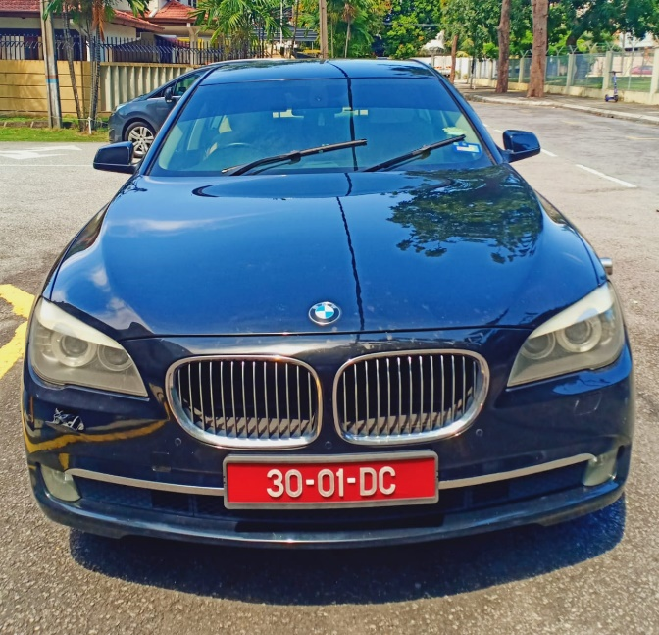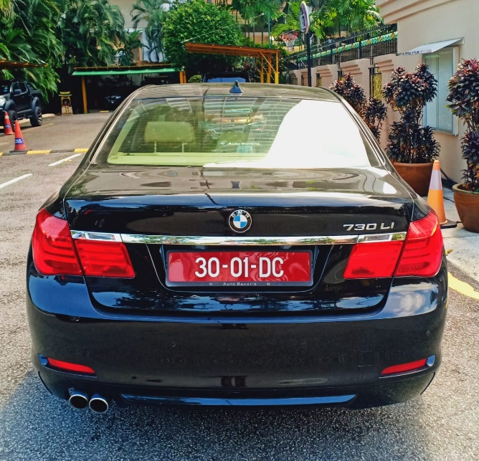
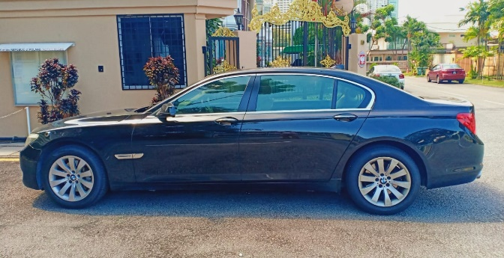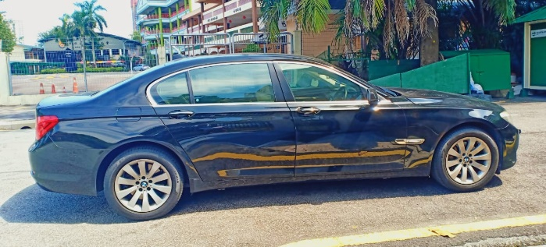
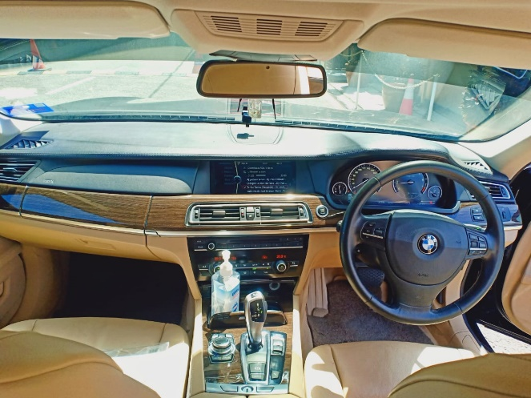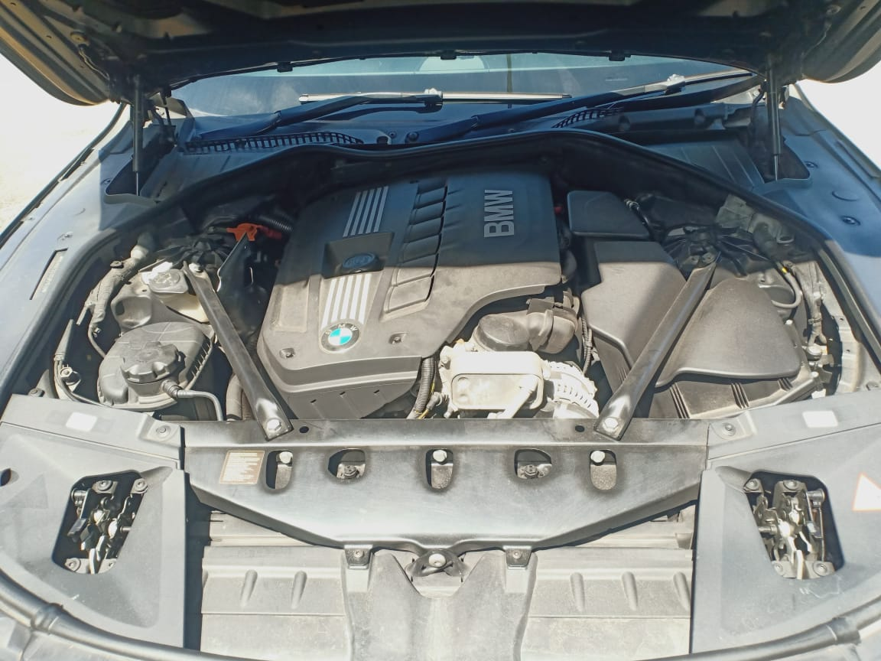
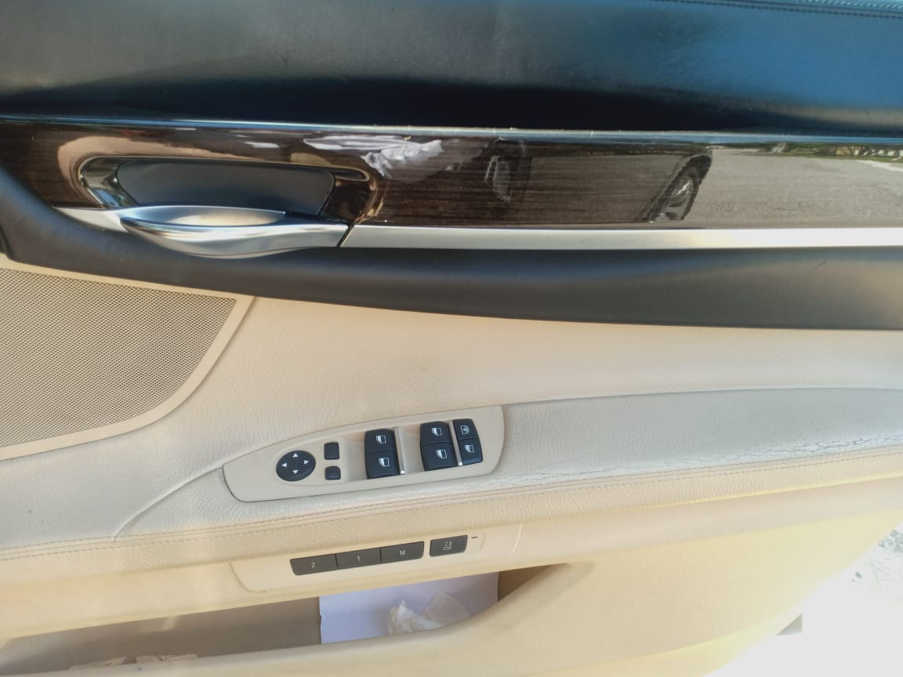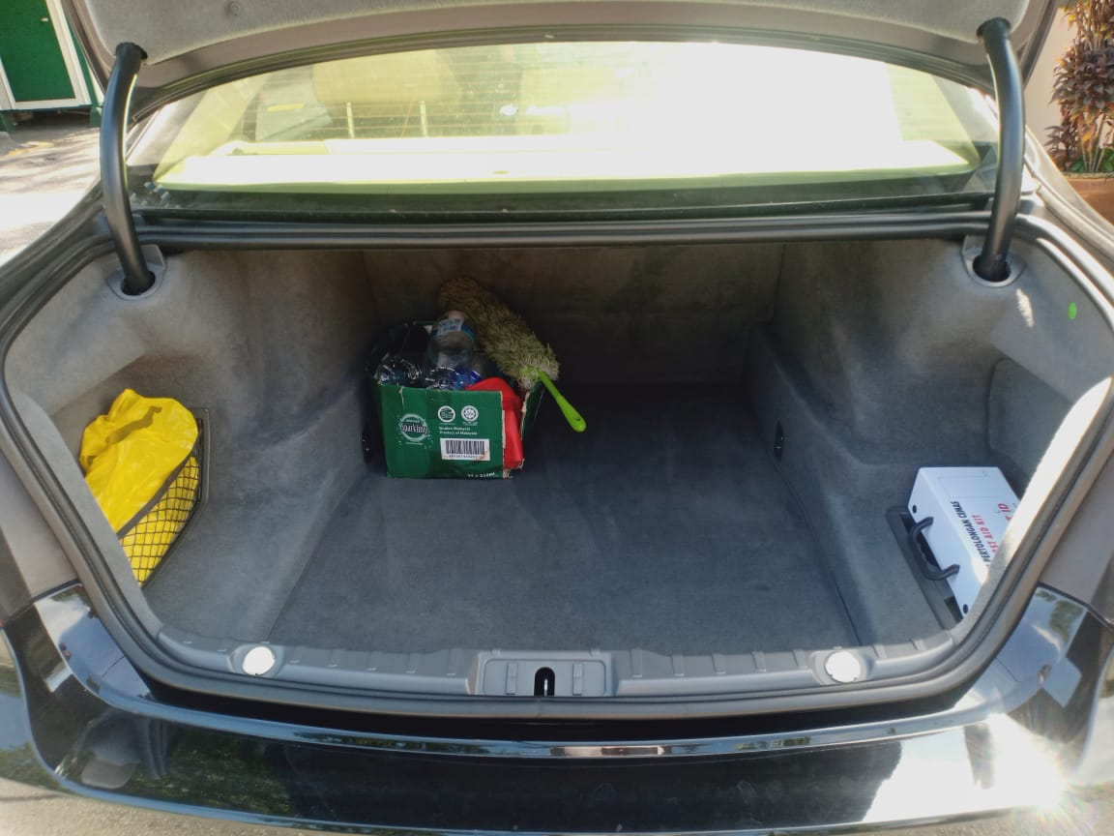

- Year of manufacture: 2011
- Mileage: 155 102 km
- Engine: 2996 cm³
- Gearbox: automatic
- Colour: black
- The car vibrates when speeding up - probably due to a gearbox malfunction.
Starting price: RM 10 000.00 RM

