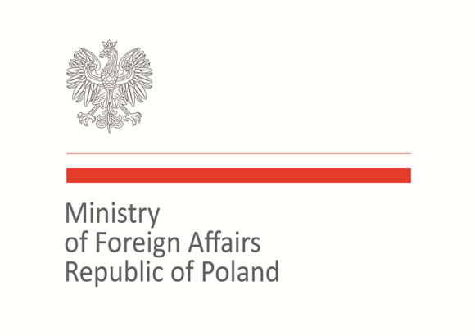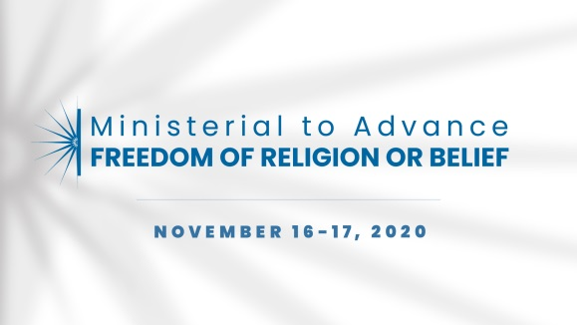

2020 Ministerial to Advance Freedom of Religion or Belief
Warsaw, November 16–17, 2020
Statement of Concern

Freedom of Religion or Belief as a pillar of democracy

As representatives of the international community, we recognize the positive connection between freedom of religion or belief and democracy. Freedom of religion or belief is closely linked to other democratic rights, including freedom of conscience, expression, association and the right to peaceful assembly. Religious communities strengthen the development of civil society and often act as advocates of democratic values.
The coexistence of religion and state is important for democracy, including for the building and development of tolerant and inclusive societies. Therefore, states as the guarantors of human rights should work to protect and promote freedom of religion or belief and cultivate religious diversity.
To effectively implement protection and promotion of human rights, including freedom of religion or belief, it is necessary to establish a close cooperation between states and civil society. There is a need to build a common platform that will combine the activities undertaken by governments and faith based organizations. Governments should develop cooperation with civil society and support non-governmental organizations. States and civil society representatives should work together in order to reach agreement and mutual acceptance on issues of common interest.

Therefore, we commit to work collectively:
- With religious communities and religion and faith-based organization to strengthen civil society, which is significant element for the advancement of democracy.
- To support all initiatives, including those of civil society, for the protection and promotion of FORB, inter alia through the creation and implementation of appropriate legal regulations, as well as adequate educational frameworks.
- To work on educating society, raising religious awareness, and protecting members of minority groups with beliefs different from those dominant in the society.

Co-signatories:
Australia, Azerbaijan, Brasil, Cyprus, Georgia, Hungary, Japan, Kazakhstan, Kosovo, Malta, North Macedonia, Poland, Romania, Slovakia, Slovenia, Togo, Trinidad and Tobago, Ukraine, United Kingdom, Uzbekistan

