Appendix no. 1

List of Embassy assets held for sale
No. | Name | Inventory No. | Bid price (KWD) | Photo
1 | Belvedere Carpert 3x5m | 809-0052 | 58 | 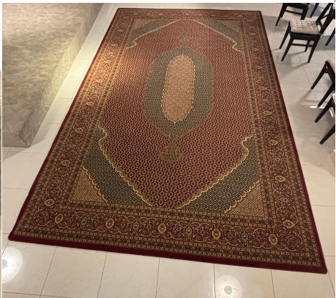
2 | Royal Carpet 3x5,2m | 809-0042 | 58 | 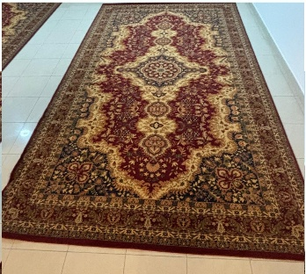
3 | Royal Carpet 3x5,2m | 809-0051 | 58 | 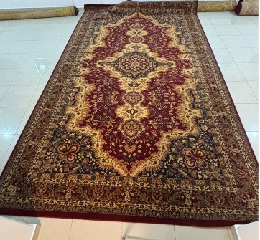
4 | Royal Carpet 3x5,2m | 809-0049 | 58 | 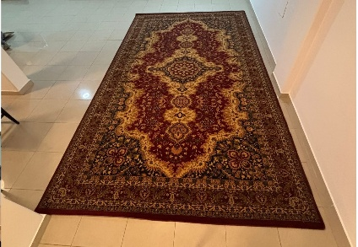
5 | Royal Carpet 3x5,2m | 809-0050 | 58 | 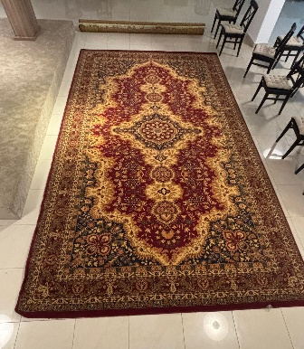
6 | Polish Carpet 3x4m | 008/227 a | 28 | 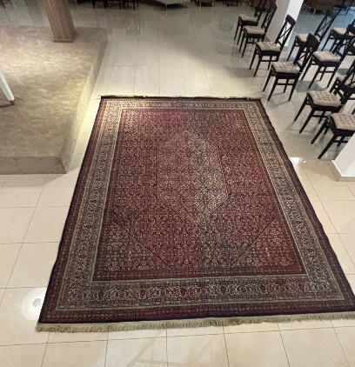
7 | Carpet „Uroczysko” 1,7x2,7 m | 008/431 | 22 | 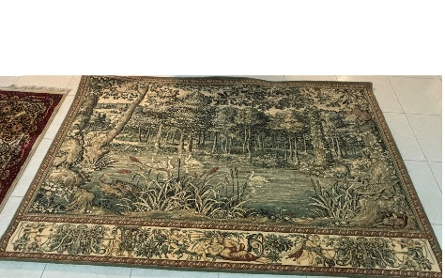
8 | Kalif Carpet 3x4m | 008/427 | 28 | 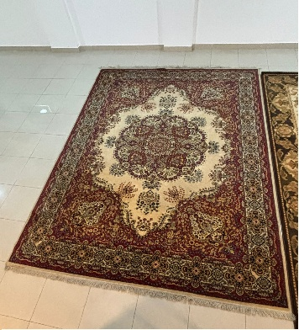
9 | Carpet Agnella 3x4m | 008/319 | 28 | 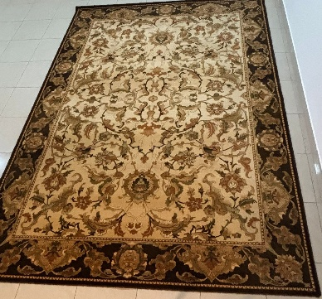
10 | Single bed | 809-0026 | 13 | 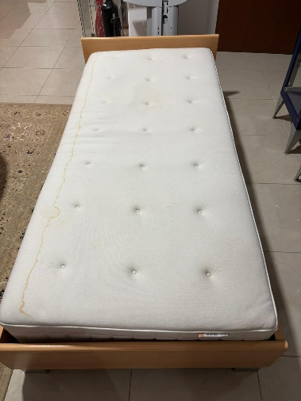
 |  | Total | 409,00

