Travel advice
This travel advice is intended to reduce the risk of Norwegians being infected abroad and of infected persons coming to Norway.
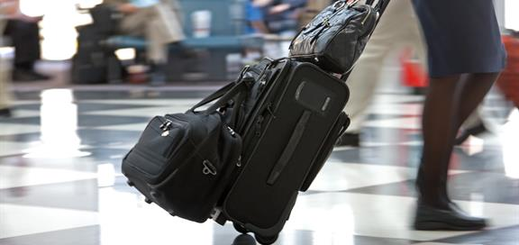
Photo: Mostphotos/Chad McDermott

Norway’s Institute of Public Health and the Ministry of Foreign Affairs provide travel advice related to the coronavirus. Their recommendations can change quickly.
- Please see the Institute of Public Health’s travel advice related to the coronavirus: https://www.fhi.no/en/op/novel-coronavirus-facts-advice/facts-and-general-advice/travel-advice-2019cov/. The purpose is to reduce the risk of Norwegians becoming infected and carrying the virus home to Norway.
- Please see the Ministry of Foreign Affairs’ travel advice related to the coronavirus. The Ministry issues travel advice when there are grounds to advise Norwegians against travelling to a specific country, area or region, or to leave such a place.

Why are flying and shipping restrictions being introduced?
The Norwegian Directorate of Health is not presently welcoming arrivals from areas where the risk of infection is high – meaning from countries about which the Institute of Public Health has issued travel advice. Exceptions are made for persons returning to Norway or who have residence in Norway. Measures are being implemented to prevent undesired entry. Travellers are being either returned or placed in quarantine. To operationalise this, the Directorate of Health will contact the affected countries and municipalities with airports and ferry ports. This applies to aircraft, cruise ships and other boat traffic.

I have been out of the country. Must I remain at home?
All who have been outside the Nordic countries are to stay at home for 14 days after arriving back in Norway, regardless of whether they have symptoms.

This means:
- Do not go to work.
- Avoid travel.
- Do not use public transport.
- Avoid places where close contract with others is likely.
- Avoid being in close proximity to others.
This policy has retroactive effect and is applicable from Thursday 27 February.

If I stay at home will I receive sick benefits?
You are entitled to sick leave if in a doctor’s opinion you must remain at home because you might be infected by the coronavirus. The same is true if the doctor is unsure whether you are carrying the virus.

The Norwegian Labour and Welfare Administration (NAV) can approve sick leave without personal examination in the case of an infectious disease with significance for public health. More information is available on NAV’s website.

How are tourists to comply with the recommendation to stay at home for 14 days after arriving in Norway?
All who plan to come to Norway must familiarise themselves with the situation here

If tourists come to Norway, they will be asked to return their home country.

Alternatively, they must contact the municipal health officer, who in turn must ensure that they follow the same recommendations as Norwegians who have been in areas with widespread coronavirus transmission.

What if I land at a Norwegian airport and plan to fly onwards within the country?
People free of illness and symptoms may fly to their final destination in order to be quarantined in their own home.

Persons with symptoms may be transported to their place of residence – by private car, for example – on the instructions of the municipal health officer. An emergency solution would be to hold the person in quarantine in the municipality where the airport is located.

What about Norwegians planning to return home from abroad. Should they remain in the other country?
Norwegians abroad must heed the recommendations of the local authorities. Questions regarding entitlement to financial reimbursement must be addressed to an individual’s own insurance company.

What about people in Norway who have been abroad, and who have been at work or school since returning home? Are they subject to quarantine?
Yes, the retroactive period is 14 days, meaning people must be quarantined if the date of arrival was within that period.

Are health professionals permitted to travel?
Decision taken under section 4-1, first paragraph, of the Health Preparedness Act on prohibiting international travel by health personnel who work in patient care: Health personnel who work in patient care are prohibited from travelling abroad. The prohibition applies to both official travel and private travel.

Why are health professionals prohibited from travelling?
This is done to maintain the necessary level of health and care services in the present situation.

How long will the prohibition last?
The decision applies to the period from 12 March to the end of April 2020.

What areas are experiencing widespread transmission of the coronavirus?
The Institute of Public Health continually updates an overview of countries and areas where transmission is widespread (https://www.fhi.no/en/op/novel-coronavirus-facts-advice/facts-and-general-advice/Areas-with-presumed-ongoing-transmission/)

Content by: Directorate of Health (https://www.helsedirektoratet.no/english)

