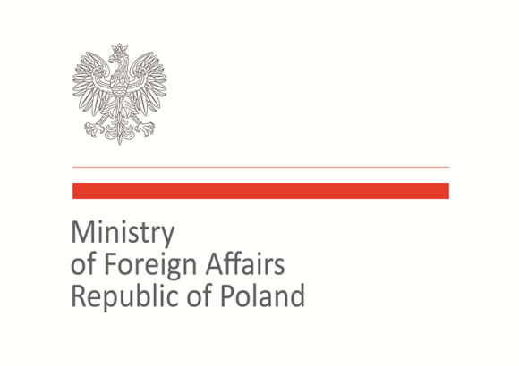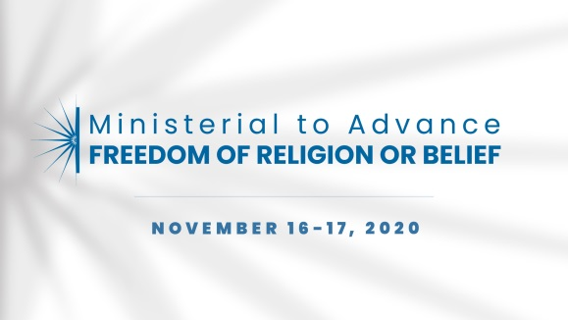

2020 Ministerial to Advance Freedom of Religion or Belief
Warsaw, November 16–17, 2020
Statement of Concern

Statement on use of technology and the protection of freedom of religion or belief

As representatives of the international community, we support new and emerging technologies as well as a free and open Internet, which provide many opportunities for individuals to exercise the right to freedom of expression and freedom of religion or belief (FoRB) and sharing of religious and other beliefs.
We acknowledge the power of Internet and technology in combating crimes, abuses and cases of discrimination. We note at the same time that the new global digital ecosystem is being misused for terrorist purposes and to violate and restrict FORB.
On one hand, it is being used by different actors for facilitating the dissemination of disinformation, propaganda, hate speech and violent extremism. On the other hand, there are many efforts and initiatives undertaken to counter its misuse. As much as it is a challenge to many governments to keep the Internet open for the exchange of ideas, it is particularly concerning when some governments use it as a tool for oppression.
We are concerned about the arbitrary or unlawful use of new technologies for the purpose of surveillance. The result is a global increase in the abuse of human rights and fundamental freedoms and shrinking online space. Therefore new digital instruments should be created with respect of human rights and fundamental freedoms, including FORB, in mind.

Therefore we commit to work collectively:
- To support research and studies on the ways the use of Internet, social media, new technologies and surveillance tools affect religious communities and individuals;
- To increase efforts to use the Internet and social media to raise awareness and provide positive communication tools for the purpose of increasing respect for FORB;
- To facilitate new partnerships between companies, governments and civil society for dialogue and best practices sharing.

Co-signatories:
Armenia, Australia, Azerbaijan, Brazil, Canada, Georgia, Hungary, Japan, Kosovo, Malta, Morocco, North Macedonia, Poland, Slovakia, Togo, Trinidad and Tobago, Ukraine, United States of America

