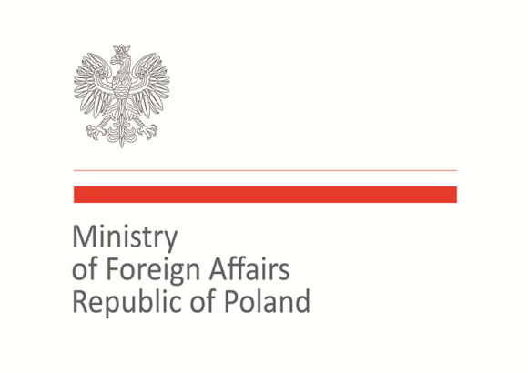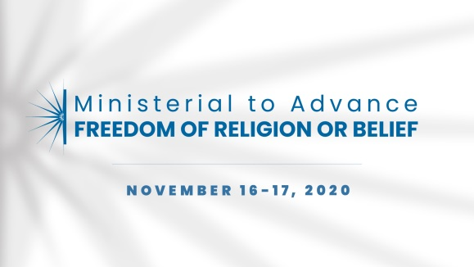

2020 Ministerial to Advance Freedom of Religion or Belief
Warsaw, November 16–17, 2020
Statement of Concern

Statement on the interlinkages between SDGs and freedom of religion or belief
As representatives of the international community we believe that there is a strong and positive relationship between freedom of religion or belief (FoRB) and sustainable development as embodied in the Sustainable Development Goals (SDGs). We underline that social development should not only focus on economic growth but also should create conditions to enjoy various freedoms, including freedom of religion or belief.
Freedom of religion or belief is a key foundation to peace and stability, which are of paramount importance for achieving sustainable development – the more stability exists, the more opportunities to eradicate poverty, foster education, build a stable health care system, ensure equal access to justice, and conduct responsible business.
Freedom of religion or belief provides positive contributions to sustainable development in many ways including by active engagement of faith-based organizations in SDGs implementation, including in crucial areas of social development like health, education, peace and justice; promoting and supporting tolerance and understanding for different faiths and beliefs; influencing the moral-political climate by supporting social justice; and engagement of religious actors in activities in support of peace and reconciliation.
We are convinced that development should be built on a dialogue with civil society, including faith-based organizations and religious actors. Therefore, governments and leaders while formulating their strategies and development policies should take into consideration inputs from religious communities that serve as important providers of social needs.

Therefore we commit to work collectively:
- To take into consideration the link between FORB and SDGs in our implementation efforts, as well as to recognize FORB in broader efforts for Agenda 2030;
- To support dialogue with FORB actors on SDGs and to encourage dialogue and cooperation between FORB actors and those dealing with SDGs issues;
- To leave no one behind in the implementation of SDGs;
- To dedicate attention to religious minority groups in national action plans for the SDGs.

Co-signatories:
Australia, Azerbaijan, Bangladesh, Brazil, Canada, Croatia, Georgia, Hungary, Japan, Kazakhstan, Kosovo, Malta, North Macedonia, Poland, Slovakia, Togo, Trinidad and Tobago, Ukraine, United Arab Emirates, United Kingdom, United States of America, Uzbekistan

