List of assets offered for sale with photographs
No. | Item | Inventory No. | Estimated wear / date of Purchase | Unit Value /reserve price (EUR) | Technical condition | Asset category (surplus / worn-out) | Protographs of the item’s current condition
1 | HP EliteBook 820G2 no disc (Windows10) + docking station + charger  Number: 5CG5425GMG | 04/57 | 2015 | 70,00 | Visible signs of usage | Worn-out | 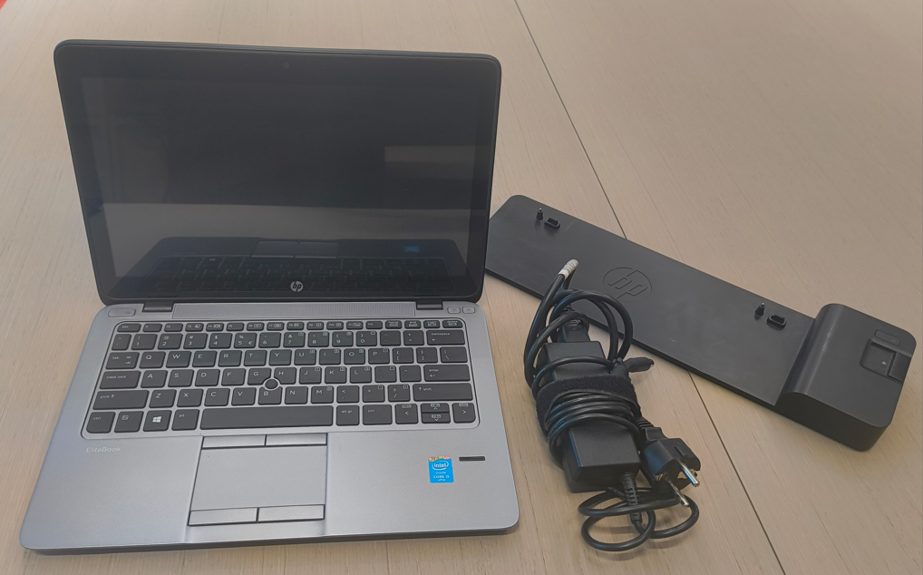  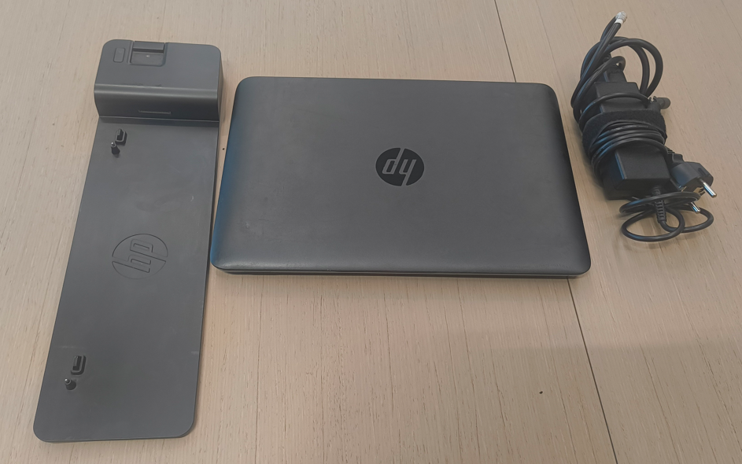
2 | HP EliteBook 820G2 no disc (Windows10) + docking station + charger  Numer fabryczny:  5CG5425NCJ | 803-0035 | 2015 | 70,00 | Visible signs of usage | Worn-out | 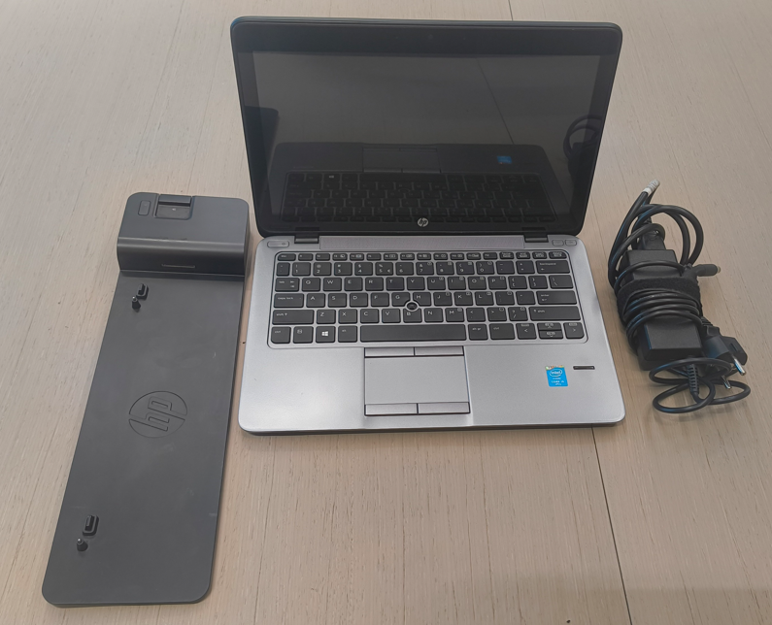  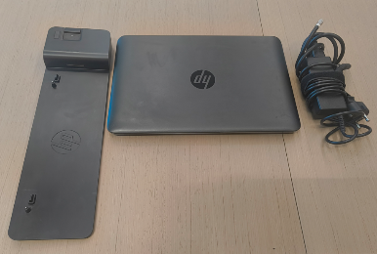
3 | HP EliteBook 820G2 no disc (Windows10) + docking station + charger  Numer fabryczny: 5CG6354Q63 | 803-0043 | 2015 | 70,00 | Visible signs of usage | Worn-out | 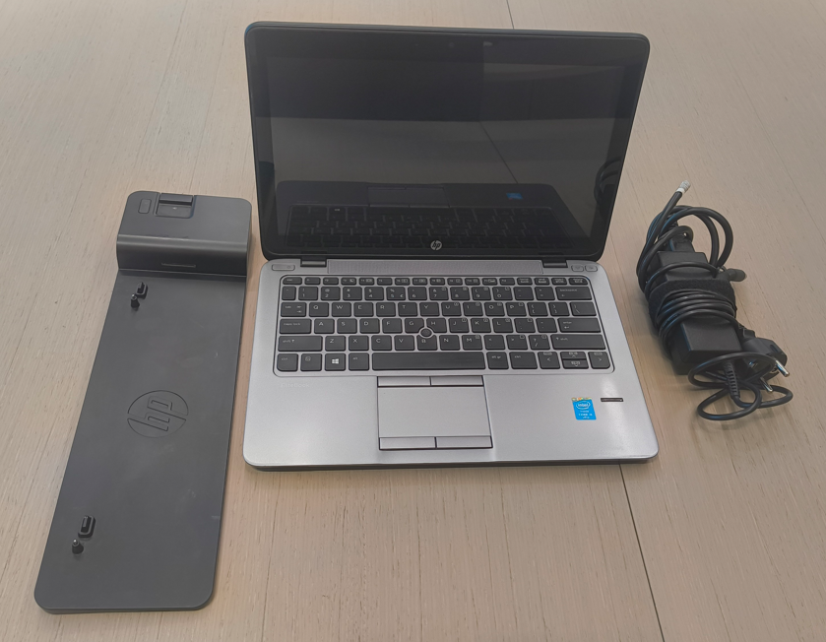  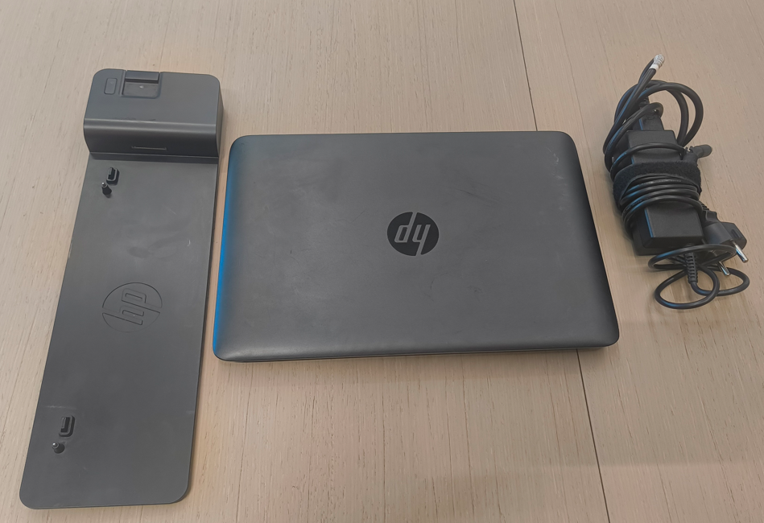
4 | HP EliteBook 820G2 no disc (Windows10) + docking station + charger  Numer fabryczny: 5CG54264GK | 004-0055 | 2015 | 70,00 | Visible signs of usage | Worn-out | 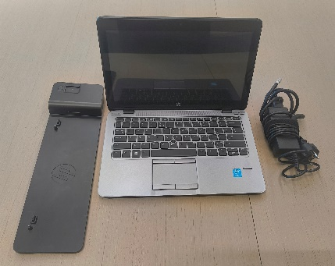  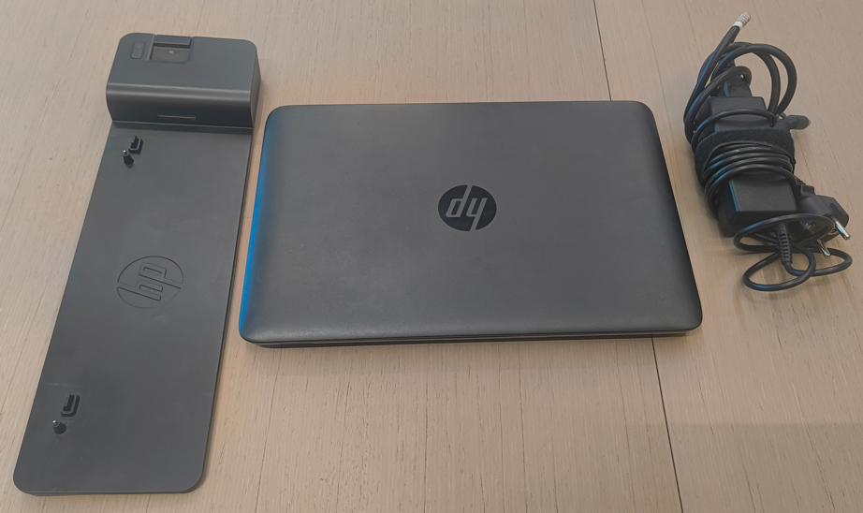
5 | HP EliteBook 820G2 no disc (Windows10) + docking station + charger  Numer fabryczny: 5CG5425QXS | 809-0302 | 2015 | 70,00 | Visible signs of usage | Worn-out | 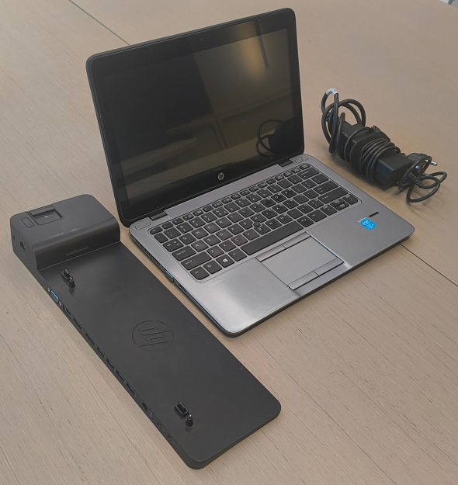  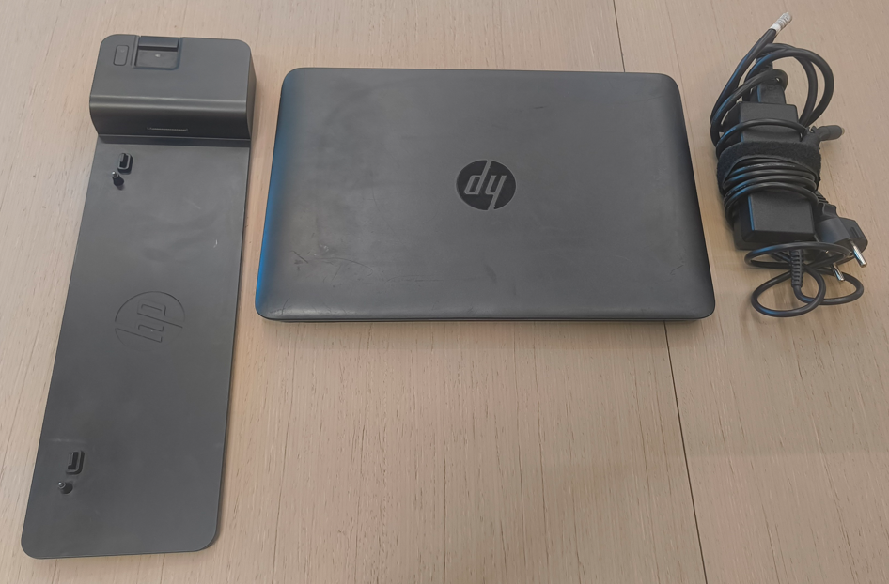
6 | HP EliteBook 820G2 no disc (Windows10) + docking station + charger  Numer fabryczny: 5CG5425X9X | brak | 2015 | 70,00 | Visible signs of usage | Worn-out | 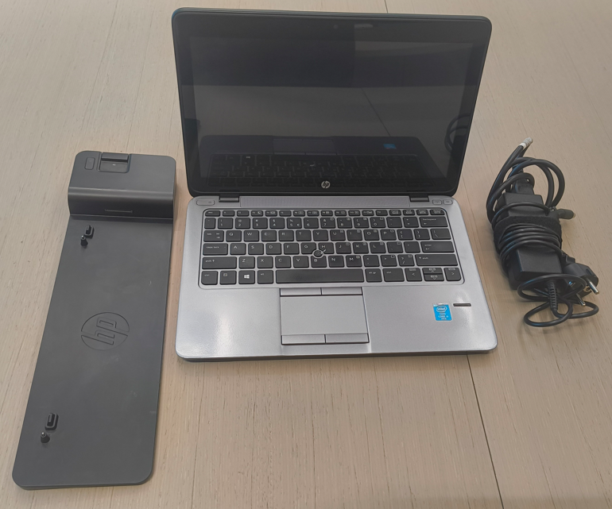  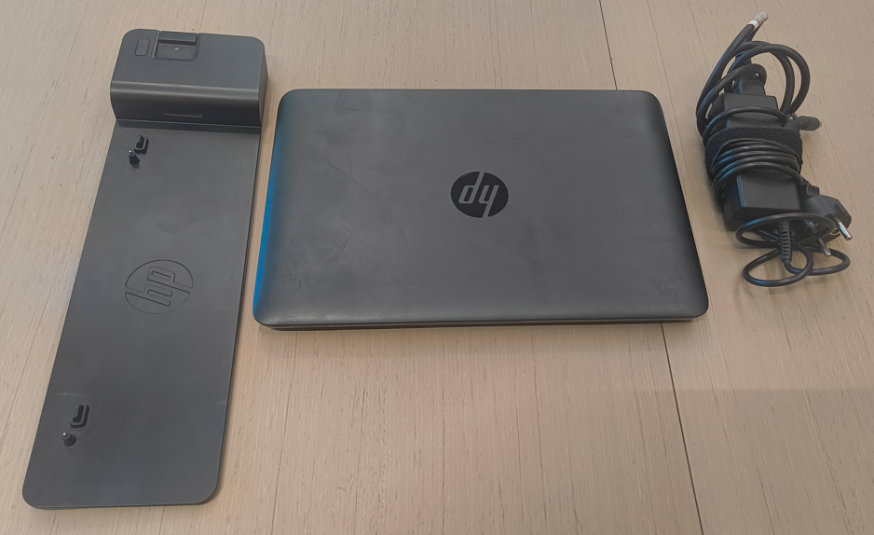
7 | HP EliteBook 820G2 no disc (Windows10) + docking station + charger  Numer fabryczny: 5CG5425XJ1 | brak | 2015 | 70,00 | Visible signs of usage | Worn-out | 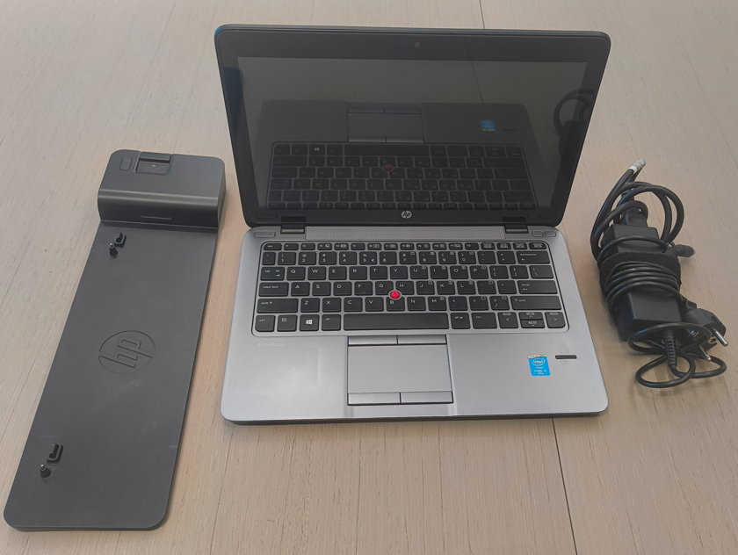  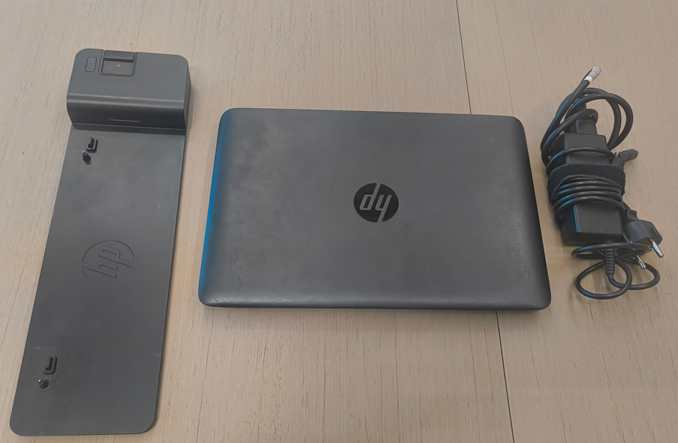
8 | iPad 2014 | 487-0020 | 2014 | 70,00 | good | Worn-out | 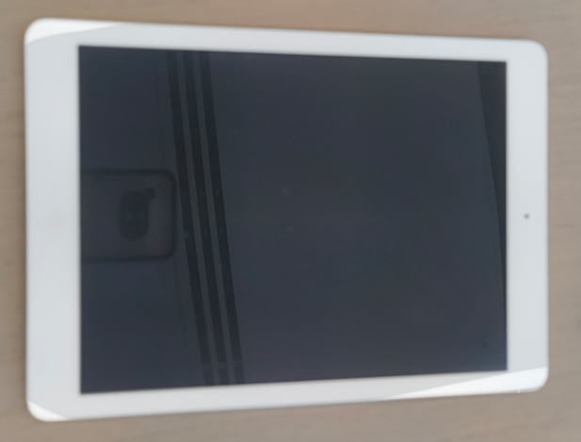  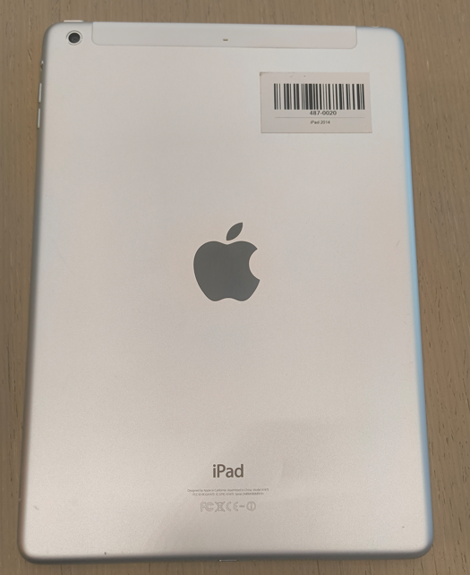
 |  | Łączna wartość |  | 630,00

