

Delegations will find attached document SWD(2021) 166 final - PART 1/3.

Encl.: SWD(2021) 166 final - PART 1/3



Table of Contents

[1. Mandate to design a long term Vision for EU Rural Areas 4](#_Toc74239473)

[2. Process of designing a long term Vision for EU Rural Areas 5](#_Toc74239474)

[3. EU rural areas analysis 7](#_Toc74239475)

[Introduction: Methodological note 7](#_Toc74239476)

[- Introducing the analysis of rurality at three geographical levels 7](#_Toc74239477)

[- Considerations on remote rural areas and regions 9](#_Toc74239478)

[- Calculation of rural advantages and disadvantages 12](#_Toc74239479)

[3.1. Area 13](#_Toc74239480)

[- Rural areas represent 83% of the EU territory 13](#_Toc74239481)

[- The use of agricultural land contributes to food security, but faces different challenges (high value agricultural land vs. land abandonment) 14](#_Toc74239482)

[- Forests and natural areas are the basis for key eco-system services 16](#_Toc74239483)

[3.2. Demography 18](#_Toc74239484)

[- People in rural areas and regions are on average older than in urban ones 18](#_Toc74239485)

[- More young women leave rural regions than young men 19](#_Toc74239486)

[- Rural regions lose more population due to natural change and gain less population through migration compared to urban ones 21](#_Toc74239487)

[- Remote regions, in particular rural ones, are losing population 26](#_Toc74239488)

[- Depopulation 27](#_Toc74239489)

[- The rural working age population is shrinking, mainly due to the age structure of its population 30](#_Toc74239490)

[- Demographic projections 31](#_Toc74239491)

[- Conclusions and outlook 33](#_Toc74239492)

[3.3. Labour and education 34](#_Toc74239493)

[- Employment and unemployment have improved in rural areas since 2012 34](#_Toc74239494)

[- The employment gap between men and women is wider in rural areas than in cities 37](#_Toc74239495)

[- Early leavers and young people neither in employment nor in education or training are more in rural areas than in cities 38](#_Toc74239496)

[- Tertiary education and digital skills are lower in rural areas than in cities 41](#_Toc74239497)

[- Conclusions 44](#_Toc74239498)

[3.4. Economic development 46](#_Toc74239499)

[- GDP per head in rural regions is lower than in urban regions but catching up 46](#_Toc74239500)

[- Agriculture, forestry and fishery provide a significant share of employment in rural regions, while the structure of rural economies is changing and agriculture modernising 48](#_Toc74239501)

[- Tourism is important for rural economies 51](#_Toc74239502)

[- Farming is restructuring, but its importance for rural areas remains 54](#_Toc74239503)

[- Conclusions 56](#_Toc74239504)

[3.5. Social inclusion 58](#_Toc74239505)

[- The risk of poverty or social exclusion in rural areas is slightly higher than in towns and suburbs and cities 58](#_Toc74239506)

[- Different societal groups are particularly affected by challenges linked to social inclusion 61](#_Toc74239507)

[- Social inclusion in rural areas is linked to challenges and opportunities stemming from other thematic domains 63](#_Toc74239508)

[- Conclusions 64](#_Toc74239509)

[3.6. Local infrastructure 66](#_Toc74239510)

[- The proximity to a large number of people, which is among the factors influencing access to services and infrastructure, varies among types of areas and Member States 66](#_Toc74239511)

[- Rural residents have to drive longer distances to reach services 66](#_Toc74239512)

[- Road performance is lower in rural areas, but road networks are longer 67](#_Toc74239513)

[- Rail performance is low in most rural areas 69](#_Toc74239514)

[- Access to passenger flights is higher in rural areas close to a city 70](#_Toc74239515)

[- Fixed broadband covers almost everyone, but high-speed broadband access lags in rural regions 71](#_Toc74239516)

[- Conclusions 73](#_Toc74239517)

[3.7. Local democracy 74](#_Toc74239518)

[- Rural residents are less likely to trust their national government and the EU than city residents 74](#_Toc74239519)

[- Rural residents are less satisfied with their national democracy and less likely to vote in national elections 76](#_Toc74239520)

[- Rural residents are more likely to trust local and regional authorities 77](#_Toc74239521)

[- Conclusions 79](#_Toc74239522)

[3.8. Bioeconomy 80](#_Toc74239523)

[- The EU bioeconomy offers many opportunities – it could reach up to EUR 3 trillion by 2050 - but there is a need to better integrate primary producers 80](#_Toc74239524)

[- Conclusions 81](#_Toc74239525)

[3.9. Innovation, cooperation and networks 83](#_Toc74239526)

[- Rural areas are innovative, even more when they cooperate 83](#_Toc74239527)

[- Weaker enabling conditions make it challenging to express rural innovation potential 84](#_Toc74239528)

[- Green transition, digitalisation, social challenges: three powerful drivers for rural innovation, cooperation and networking 87](#_Toc74239529)

[- A swift improvement of enabling conditions is imperative for rural innovation to transform trends into positive outcomes 89](#_Toc74239530)

[- Conclusions 91](#_Toc74239531)

[3.10. Climate, environment, ecosystem services, biodiversity, nature-based solutions 93](#_Toc74239532)

[- Rural areas are affected by climate change, the depletion of natural resources and biodiversity decline and are part of the solution 93](#_Toc74239533)

[- Rural communities are potentially exposed to greater costs associated with climate and environment transition 96](#_Toc74239534)

[- The green transition presents a wide range of potential opportunities for rural communities 97](#_Toc74239535)

[- Expected trends 98](#_Toc74239536)

[- Conclusions 99](#_Toc74239537)

[3.11. Integrated territorial development 101](#_Toc74239538)

[- Places are connected and interdependent in many ways 101](#_Toc74239539)

[- Spatial relations encounter different challenges 102](#_Toc74239540)

[- Rethinking what’s vital to society brings opportunities to revalue rural areas 103](#_Toc74239541)

[- Conclusions 105](#_Toc74239542)

[3.12. Women in rural areas 107](#_Toc74239543)

[- Opportunities for women in rural areas 108](#_Toc74239544)

[- Conclusions 110](#_Toc74239545)

[4. EU initiatives, policies and funding in rural areas 111](#_Toc74239546)

[4.1. EU policies and initiatives for rural areas 111](#_Toc74239547)

[4.1.1. The Common Agricultural Policy (CAP) 111](#_Toc74239548)

[- The Common Agricultural Policy post 2020 115](#_Toc74239549)

[4.1.2. Cohesion Policy and Regional policy 117](#_Toc74239550)

[4.1.3. Maritime and Fisheries policy 120](#_Toc74239551)

[4.1.4. Employment, social affairs and inclusion policy 122](#_Toc74239552)

[4.1.5. Cross-cutting attention for Inclusion and gender 124](#_Toc74239553)

[4.1.6. European Green Deal/Climate and Environment Policy 127](#_Toc74239554)

[4.1.7. Bioeconomy 128](#_Toc74239555)

[4.1.8. Energy policy 129](#_Toc74239556)

[4.1.9. Home affairs and security policy 130](#_Toc74239557)

[4.1.10. Enlargement and Neighbourhood Policy 131](#_Toc74239558)

[4.1.11. Digital policy 132](#_Toc74239559)

[4.1.12. Space policy 134](#_Toc74239560)

[4.1.13. Transport policy 134](#_Toc74239561)

[4.1.14. Health policy 135](#_Toc74239562)

[4.1.15. Education policy 137](#_Toc74239563)

[4.1.16. Cultural policy 139](#_Toc74239564)

[4.1.17. Industrial strategy policy 139](#_Toc74239565)

[4.1.18. Competition policy 141](#_Toc74239566)

[4.1.19. Research and innovation policy 141](#_Toc74239567)

[4.1.20. Data and statistics 143](#_Toc74239568)

[4.2. The importance of coordination between EU funds for rural areas 145](#_Toc74239569)

[4.2.1. Current and future EAFRD support beyond agriculture and forestry 145](#_Toc74239570)

[4.2.2. Support for rural areas under Cohesion Policy and other policies and improved coordination 149](#_Toc74239571)

[4.3. The response to the crisis following the outbreak of the COVID-19 pandemic 155](#_Toc74239572)

[4.3.1. A recovery plan for Europe: NextGenerationEU 156](#_Toc74239573)

[5. Foresight for rural areas 158](#_Toc74239574)

[5.1. Setting the scene for 2040 158](#_Toc74239575)

[5.2. ENRD/TG – JRC: Scenarios for rural areas 161](#_Toc74239576)

[5.2.1. Participatory approach 161](#_Toc74239577)

[5.2.2. Drivers of change for EU rural areas 161](#_Toc74239578)

[5.2.3. Scenarios 165](#_Toc74239579)

[5.3. Insights from European research and innovatio projects 179](#_Toc74239580)

[5.3.1. Drivers and trends analysis 180](#_Toc74239581)

[5.3.2. Visions & enablers 185](#_Toc74239582)

[5.4. Elements for the EU vision and path towards 2040 187](#_Toc74239583)

[5.4.1. Green dimension 187](#_Toc74239584)

[5.4.2. Social and economic elements 188](#_Toc74239585)

[5.4.3. Connectivity (digital/mobility) 189](#_Toc74239586)

[5.4.4. Democracy/governance 189](#_Toc74239587)

[5.4.5. Mutually supportive stepping stones 190](#_Toc74239588)

[5.4.6. Conclusion 191](#_Toc74239589)

# Mandate to design a long term Vision for EU Rural Areas

President Von der Leyen’s [political guidelines](https://ec.europa.eu/commission/sites/beta-political/files/political-guidelines-next-commission_en.pdf)[[1]](#footnote-2)highlight that rural areas are a core part of our identity and our economic potential and that we will cherish and preserve our rural areas and invest in their future. The mission letters to [Vice-President Šuica](https://ec.europa.eu/commission/sites/beta-political/files/mission-letter-dubravka-suica_en.pdf), [Commissioner Wojciechowski](https://ec.europa.eu/commission/sites/beta-political/files/mission-letter-janusz-wojciechowski_en.pdf) and [Commissioner Ferreira](https://ec.europa.eu/commission/sites/beta-political/files/mission-letter-elisa-ferreira_en.pdf) underline the need for designing a long term Vision for rural areas.

Various EU policies currently support and play important roles in rural areas, and are therefore key in developing the long-term vision for rural areas. Those include the Common Agricultural Policy, Regional, Cohesion and Social policies and a number of other EU policies such as those dealing with energy, transport, connectivity, employment, environment or climate.

The vision belongs to the Democracy and Demography work strand and follows the Report on the impact of demographic change[[2]](#footnote-3) and the Green paper on ageing[[3]](#footnote-4). However, the rural vision is much broader than demography issues; it embraces all the aspects that are relevant for the future of rural areas. Therefore, links with other key Commission policies and initiatives are also ensured, including the European Green Deal[[4]](#footnote-5) and the related Farm to Fork strategy[[5]](#footnote-6), a Europe Fit for the Digital Age[[6]](#footnote-7), the European Pillar of Social Rights[[7]](#footnote-8) and the Conference on the future of Europe[[8]](#footnote-9). The vision should also build on the “Next Generation EU” Recovery Plan[[9]](#footnote-10).

According to the mandate, the vision should contribute to enable rural areas to make the most of their potential and support them in facing up to their own unique set of issues, from demographic change to connectivity, from the risk of poverty to limited access to services but also their potential to deliver innovative, inclusive and sustainable solutions.

Rural areas can offer a range of social and economic opportunities to rural dwellers and the society as a whole, with a unique quality of life, job opportunities in many and diverse business areas. In addition to their role in food security, they have a special role to play in the transition to a green and sustainable Europe, by mitigating climate change, providing alternatives to fossil fuels, reversing the biodiversity crisis, using resources sustainably and developing the circular economy. In addition, the COVID-19 crisis could lead to significant changes to society, which rural areas could benefit from and in which they are implicated.

In the mission letters to Vice-President Šuica, [Commissioner Wojciechowski](https://ec.europa.eu/commission/sites/beta-political/files/mission-letter-janusz-wojciechowski_en.pdf) and [Commissioner Ferreira](https://ec.europa.eu/commission/sites/beta-political/files/mission-letter-elisa-ferreira_en.pdf), there was a specific request to ensure that people living in rural areas, as well as local and regional authorities, are consulted in the development of the vision and for this reason the Commission paid particular attention to public consultation activities.

# Process of designing a long term Vision for EU Rural Areas

The following actions have been carried out in order to elaborate the Vision:

- A **joint letter** to the Member States by the Vice-President and the two Commissioners has kicked off the exercise. It followed the adoption of the Report on demographic change. The objective was to draw attention to rural areas in the ongoing phase of preparation of the CAP Strategic plans and the Cohesion and Regional programmes.

**- A public consultation** with citizens, especially people living in rural areas, as well as local and regional authorities. The Commission also ensured consistency and explored links with other consultation activities. Events with the European Parliament, the Committee of the Regions, or the European Economic and Social Committee have also taken place, and synergies found with the ongoing corporate communication campaign on rural areas. The Commission has made the most of the Rural network(s) and their membership as a platform for **exchanges and discussions** in order to benefit from the long experience and direct contacts with stakeholders at local level throughout the EU. A **conference** (Rural Vision Week) took place at the end of the consultation process, with a view of taking stock on the outcomes of the public consultation, commenting and complementing its results and making additional input to the Communication. Further details about the public consultation are included in the Synopsis report accompanying the Communication. [[10]](#footnote-11)

**- Analytical work** has been carried out in 2020 and in the first quarter of 2021 regarding challenges and opportunities of rural areas and actions taken at EU/National/Regional level, including governance aspects (e.g. rural proofing). The analysis considered relevant evaluation studies, the latest statistical information available as well as the outcomes of related research projects and the thematic work by the European Network for Rural Development (ENRD). Further details are provided in chapter 3 of the Staff Working Document.

- Since it will be a ***long-term* vision**, **foresight[[11]](#footnote-12)** is indispensable to help identifying how rural areas might evolve and the trends and drivers of change that will shape European rural areas in 2040. This exercise was built on ongoing Horizon2020 (H2020) research projects and on contributions from the Commission’s Joint Research Centre, prepared in conjunction with the work of the ENRD Thematic Group on the Long Term Rural Vision including experts from all around the EU. Further details are provided in chapter 5.

- A dedicated **inter-service group** of representatives of the relevant Directorates-Generals of the European Commission under the umbrella of the already existing Inter-Service Steering Group on Demography was also established to ensure that the long-term Vision takes on board all inputs from the different EU policies relevant for rural areas.

The Commission Communication takes into account the outcomes of these work streams as a basis for short and long-term actions and policy development. Further details are provided in this Staff Working Document as well as on the Synopsis report of the public consultation, accompanying the Communication.

# EU rural areas analysis

## Introduction: Methodological note

### Introducing the analysis of rurality at three geographical levels

When people speak of ‘rural areas’ they usually refer to different geographical entities depending on their own perception. But also for statistical and analytical purposes there is not one single understanding what ‘rurality’ means.

This document indeed investigates rurality at three geographical levels. The most detailed geographical level consists of **1** **km square grid cells**, followed by the **local administrative unit (LAU)** or municipality level and finally the **NUTS-3[[12]](#footnote-13) level regions**. Depending on the aspect that is analysed, one level can be more relevant than another. The lowest level at which administrative decisions are taken is the municipality or LAU level. Moreover, certain indicators are only available for one of these geographical levels so that not all thematic aspects can be analysed at the same (desired) degree of granularity. For instance, detailed data on demography, economy (gross domestic product per capita, gross value added per capita, employment by sector), and accessibility to fixed-line broadband are not available at LAU level. As a result, a combination of information from these levels is needed to provide a comprehensive picture of rurality in the EU.

The analysis in this document hence uses data which mainly relate to two geographical levels:  **rural areas** (a classification of the LAU level) and of a **predominantly rural region** (a classification of NUTS-3 level regions). Both rural areas and predominantly rural regions are defined in the same way: they have the majority of their population living in rural grid cells. The classification of LAUs is called the **Degree of Urbanisation** and the classification of NUTS-3 level regions refers to the **Urban-Rural regional typology**.[[13]](#footnote-14)

As an example, Map 1 shows the three geographical levels for Spain and Portugal. From these three maps, it is clear that the amount of land classified as ‘rural’ will differ significantly between the three geographical scales. In Spain, the share of land covered by rural grid cells is 98%, by rural areas is 90% and 17% by predominantly rural regions. The impact on population is more limited, but still significant. It changes from 17% of the Spanish population in rural grid cells, to 27% in rural areas and 4% in predominantly rural regions.

Map 1 Urban-rural classification at grid level, Degree of Urbanisation at local administrative unit level and the urban-rural regional typology in Spain and Portugal

|  |  |  |
| --- | --- | --- |
| Grid cell classification | Degree of Urbanisation, local administrative unit level | Urban-rural regional typology |
| CH00M02_TT2018 |  | CH00M06_TT2018 |
| The EU contains over 4 million 1 km2 grid cells | The EU contains over 100,000 local administrative units. | The EU has 1 166 NUTS-3 regions. |

*Source: Eurostat, JRC and DG REGIO*

Table 1 Share of land area using different typologies (% of land area)



*Source: JRC and DGREGIO based on Eurostat data (demo\_r\_d3area) /* *GISCO*

Note: The 2011 population grid is the most recent official grid. The official grid for 2021 will be published in early 2023.

Table 2 Share of population using different typologies (% of population)



*Source: JRC and DGREGIO based on Eurostat data (GEOSTAT, Census Hub, demo\_r\_pjanaggr3)*

Note: The 2011 population grid is the most recent official grid. The official grid for 2021 will be published in early 2023.

### Considerations on remote rural areas and regions

Some issues are influenced by how far rural areas or regions are located from the nearest city. Both the degree of urbanisation and the urban-rural regional typology can incorporate this dimension of remoteness (Map 2, Map 3). The criterion is simple and identical for both definitions: **if the majority of the population in an area or a region live more than a 45-minute drive by car[[14]](#footnote-15) from the nearest city, it is classified as remote**. Other areas and regions are classified as close to a city. Cities and predominantly urban regions are by definition close to a city.

|  |  |
| --- | --- |
| Map 2 LAU’s Degree of Urbanisation including remoteness (45 min)  Degree_of_urbanisation_including_remoteness_LAUs_45m_EU28_A4P_20M  Source: DG REGIO | Map 3 Urban-Rural NUTS-3 typology including remoteness (45 minutes)  Urban_rural_NUTS3_typology_including_remoteness_45m_EU28_A4P_20M |

Figure 1 EU Population by Degree of Urbanisation (LAU areas) and remoteness, 2011, in %

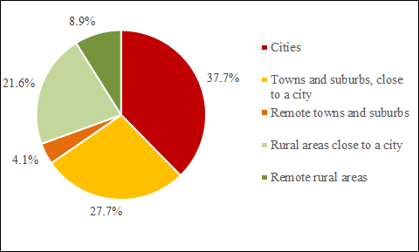

Source: JRC-REGIO based on GEOSTAT 2011

Figure 2 EU Population by urban-rural regional (NUTS-3) typology and remoteness, 2019, in %

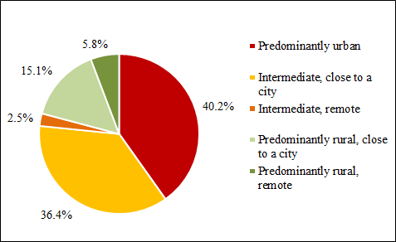

Source: JRC-REGIO based on Eurostat table demo\_r\_pjanaggr3

### Calculation of rural advantages and disadvantages

Some of the graphs presented in this document classify rural areas depending on their advantage or disadvantage compared to cities.

Advantages and disadvantages were calculated in a step-by-step process.

Step 1

We calculated the gap as the difference between the indicator value recorded for cities and the value recorded for rural areas.

Step 2

For positively formulated indicators (for e.g. employment rate) a positive gap was evaluated as advantage and a negative gap as a disadvantage.

For negatively formulated indicators (for e.g. unemployment rate) a positive gap was evaluated as disadvantage and a negative gap as an advantage.

Step 3

For each Member State (MS) we calculated a Z score. This was done according to the following formula:

Z 𝑠𝑐𝑜𝑟𝑒 𝑓𝑜𝑟 𝑀𝑆 = 𝑀𝑆 gap / 𝑠𝑡𝑎𝑛𝑑𝑎𝑟𝑑 𝑑𝑒𝑣𝑖𝑎𝑡𝑖𝑜𝑛 of the 27 𝑀𝑆 gaps

Step 4

Then the distributions of scores are analysed. The gap of each Member State is assessed and classified on the basis of the resulting z-scores against pre-defined thresholds.

A Z score with an absolute value above 1 is considered high, a Z score with an absolute value between 1 and 0.5 is considered moderate. A Z score with an absolute value between 0.5 and 0 is considered neutral.

Table 3 Z scores of advantages and disadvantages of rural areas compared to cities

|  |  |  |  |  |  |
| --- | --- | --- | --- | --- | --- |
|  |  |  | Z scores |  |  |
|  | **Z < -1** | **-1 ≤ Z < -0.5** | **-0.5 ≤ Z < 0.5** | **0.5 ≤ Z < 1** | **Z > 1** |
| **Positively formulated indicator** | high rural disadvantage | moderate rural disadvantage | on average | moderate rural advantage | high rural advantage |
| **Negatively formulated indicator** | high rural advantage | moderate rural advantage | on average | moderate rural disadvantage | high rural disadvantage |

Source: Eurostat

## Area

As a starting point for the analysis of EU rural areas, this chapter describes their importance in terms of EU land area, the different land uses that mark them, and the challenges and opportunities that rural areas are facing in this regard.

### Rural areas represent 83% of the EU territory

**Rural areas[[15]](#footnote-16)** account for 341 million hectares (m ha), which **represent 83% of the total EU land area**. More than half of this rural land area is remote, meaning that it is located far from cities. Cities, towns and suburbs account all together for 17% of the EU land area (70.3 m ha).

Table 4 EU land area by Degree of Urbanisation level 1 and remoteness in 2018



\* Total land is based on the 2018 LUISA Base Map (EC-JRC)

*\*\*: Population density is based on the 2018 population, using LAU 2011 delineation*

*\*\*\*, \*\*\*\*: Shares are computed per each Degree of Urbanisation*

Source: JRC and JRC-GEOSTAT 2018

Besides remoteness, rural areas are very diverse depending whether they are located in mountain areas, in islands, in outermost regions, in border regions, in coastal areas or in inland regions. These geographical factors play an important role in the land use, in population movements and policy interventions.

**Agricultural land, forest and natural areas account for 90% of the territory of rural areas**[[16]](#footnote-17). Agricultural land is the dominant land use in rural areas close to a city (52.5%) whereas in remote rural areas, most of the territory is composed of forest and natural areas (53.6%). The ‘Other land-use’ class plays an important role in rural areas, especially in the remote ones, mainly due to the presence of water bodies, wetlands and other natural open spaces.

Figure 3 Main land-use groups by categories from Degree of Urbanisation and remoteness in 2018, in thousand hectares

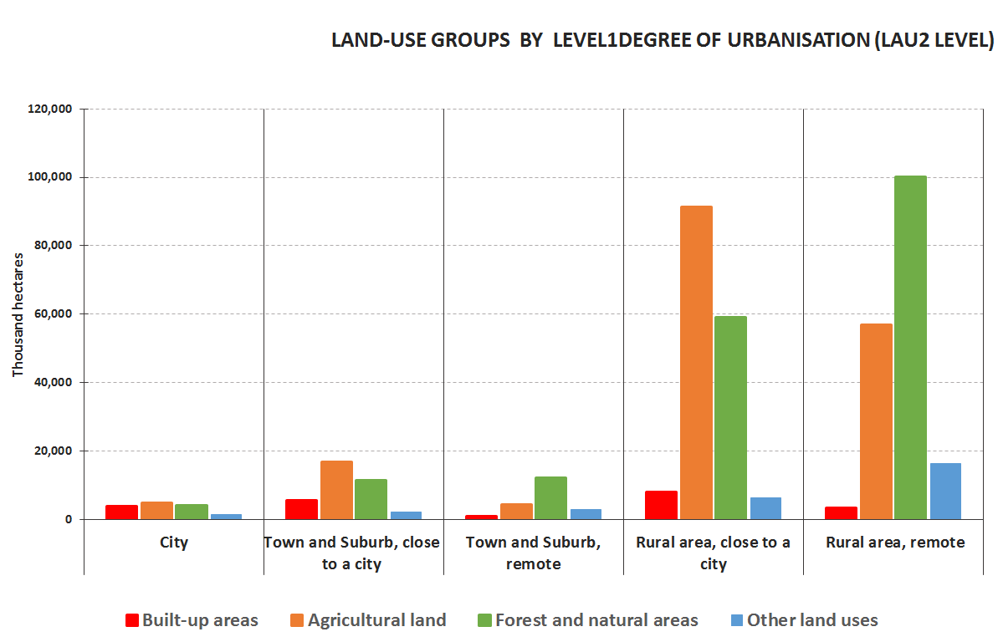

Source: 2018 LUISA Base Map (EC-JRC)

### The use of agricultural land contributes to food security, but faces different challenges (high value agricultural land vs. land abandonment)

**As agricultural land** is concentrated in rural areas, one of the functions of rural areas is food production, ensuring food security. Dependency on land can bring about different challenges for rural areas and the agricultural sector. In **high valuable areas**, availability of agricultural land and high land prices (in addition to difficult access to credit) affects young farmers in accessing land for agricultural production.[[17]](#footnote-18) Other areas, however, are facing **land abandonment** that can lead to multiple negative ecological, economic and social consequences. Loss of biodiversity and important bird habitats, rural landscape degradation and increased risks of soil erosion and wildfires are a few examples. Negative economic outcomes include the destruction of drainage systems, a decrease in agriculture land value, loss in profits from agriculture activities, loss of cash flow through the local economy, and a lack of employment and recreational tourism.[[18]](#footnote-19) Especially in rural areas located in remote regions, land abandonment might also occur where ageing and the lack of economic and social opportunities lead to population decline.[[19]](#footnote-20)

Changes in management practices such as agricultural intensification and specialisation might lead to high productivity in more fertile areas, while producing marginalisation and abandonment in some others[[20]](#footnote-21). Agricultural intensification can also lead to higher pressure on biodiversity and natural resources, as well as transforming landscapes to become more uniform, less diverse and less nature- rich.[[21]](#footnote-22) On the other hand, a sustainable agriculture can help to safe-guard ecological systems in danger and contribute to the development of rich varieties of wetlands or woodlands. Sustainable agricultural management practices can play an important role in protecting the environment.

In the **next two decades, agricultural land is expected to decrease in most of the EU regions** (NUTS-3). At EU level, the decrease is expected to be of 1.6%. However, agricultural land is projected to increase slightly in some regions, e.g. in Sweden, Spain, the South of Italy, Greece and Finland as well as Latvia and Croatia (Map 4).

Map 4 Trend of agricultural land at NUTS-3 level and by Urban-Rural typologies, 2020 - 2040

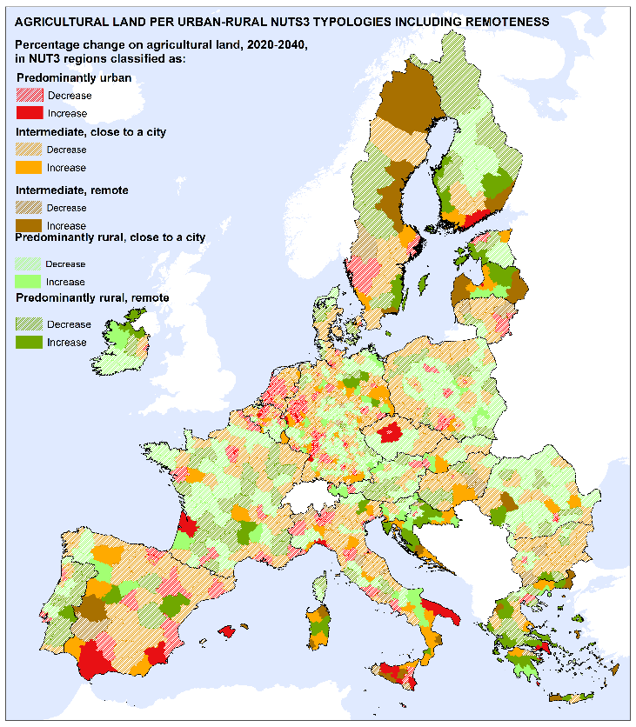

Source: LUISA land-use map projections (EC-JRC)

### Forests and natural areas are the basis for key eco-system services

Rural areas landscapes covered by **forests and natural areas** help regulate water flows, capture carbon and air pollutants from the atmosphere, prevent soil erosion and provide recreational services. Landscapes where open water and wetlands predominate are evidently important providers of water and water regulating services, mainly located in rural areas.[[22]](#footnote-23)

**By 2040, forest and natural areas are projected to increase by almost 1% at EU level** (Map 5). The fastest increase is expected in rural areas close to a city (about 2%).  Forest lands and natural areas will increase in most of the regions in Portugal, central and eastern part of Spain, France and central European countries as well as northern and eastern countries; however, north and south of Italy along with Croatia, south of Greece, Latvia and more disperse regions in Romania, western Germany and Belgium will experience a decline in forest and natural areas.

Map 5 Trend of forest and natural areas at NUTS-3 level and by Urban-Rural typologies, 2020 - 2040

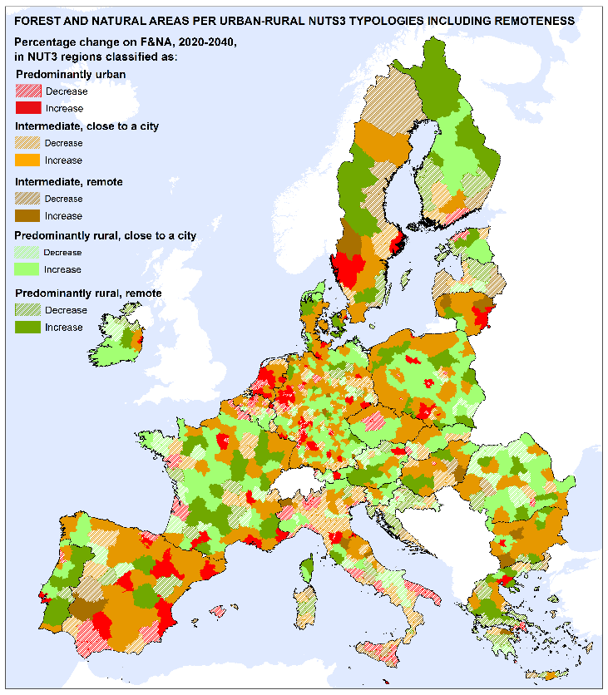

Source: LUISA land-use map projections (EC-JRC)

By 2040, built-up land is expected to grow by 3.4% in rural areas close to cities and by 1.7% in remote rural areas.

Figure 4 Percentage change between 2020 and 2040 by land-use group and Degree of Urbanisation

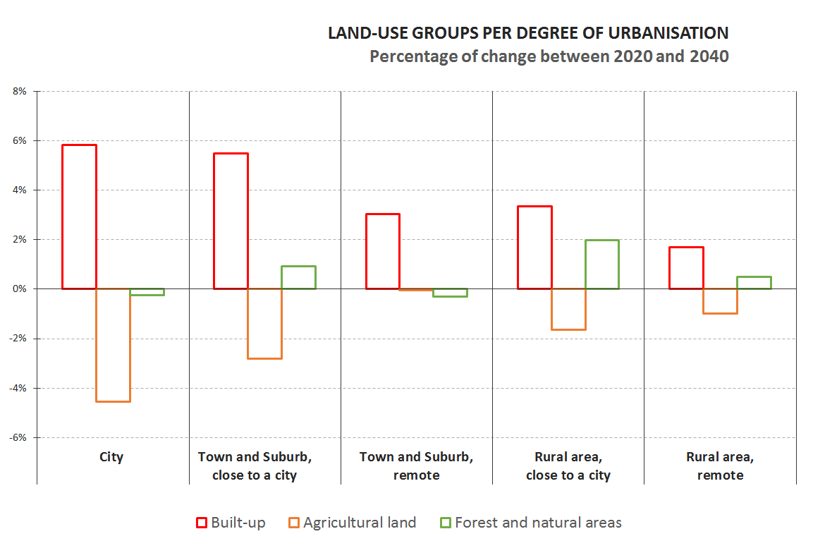

Source: LUISA land-use map projections (EC-JRC)

Rural areas are traditionally characterised as the places of natural resources, where they can be collected, pre-treated and pre-processed, and finally transported to major urban centers. This has put significant pressure on natural resources in rural areas where the (land-use) competition between the production of food, feed, timber and (bio)energy, together with urbanisation processes and environmental services, is considerably high.[[23]](#footnote-24) The urban pressure also increases the consumption of the rural landscape, primarily by the housing sector but also by new economic activities, tourism/recreational or transport sectors. All these sectors claim rural space and might be a threat for the quality and identity of rural landscapes in some particular places (RURBAN project[[24]](#footnote-25)).

## Demography

### People in rural areas and regions are on average older than in urban ones

In the EU, **rural areas have on average a significantly older population than towns and suburbs and especially cities**.[[25]](#footnote-26) Cities in the EU have a higher share of the age classes 0 to 40, while rural areas have a higher share among the age classes of 50 and higher (Figure 5). This is even more pronounced in remote rural areas, which have lower shares of population below 50 than rural areas close to the city and higher shares of population of 50 and over.

The share of people in their 20s in rural areas is lower than the share of people in their 10s or 30s. This is likely due to people leaving rural areas to find their first job, explore different opportunities to pursue their career or to gain a tertiary education.

Towns and suburbs occupy an intermediate position between cities and rural areas with one clear exception. The population share of people in their 40s is the highest in towns and suburbs close to a city, which may be due to the appeal of suburban living for households with children.

Figure 5 Population share by age group and by Degree of Urbanisation including remoteness in the EU, 2011

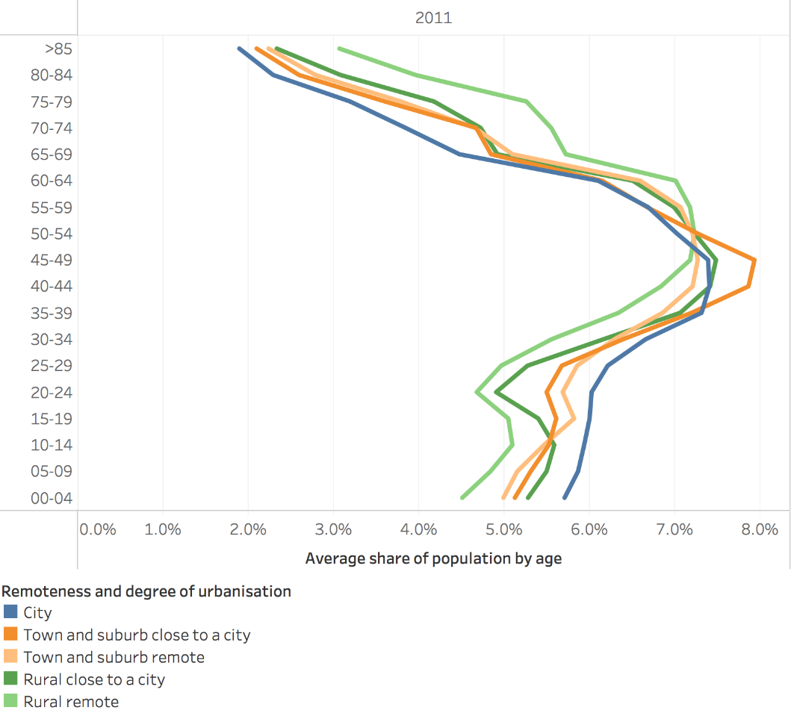

Source: Aurambout J.P., et al., Demographic landscape of EU territories, 2021.

All the types of area also show a clear bulge in the population distribution with much higher shares of population in their 30s and 40s compared to younger age groups. This means that as the population ages, it will shrink because the younger cohorts are smaller. However, taking into account the population structure (Figure 5), this is likely to affect remote rural areas relatively more than other areas.

Regional data confirms the **rural population is significantly older than the urban population**. In 2019, the median age in rural regions was 45 years, two years higher than in urban regions in the EU (Figure 6). Within almost all Member States[[26]](#footnote-27), rural regions had a higher median age than urban regions in 2019. Eurostat projections suggest that the median age will increase almost by four years in all the types of regions between 2020 and 2040.

Figure 6 Median age by urban-rural regional typology, 2019 (years)

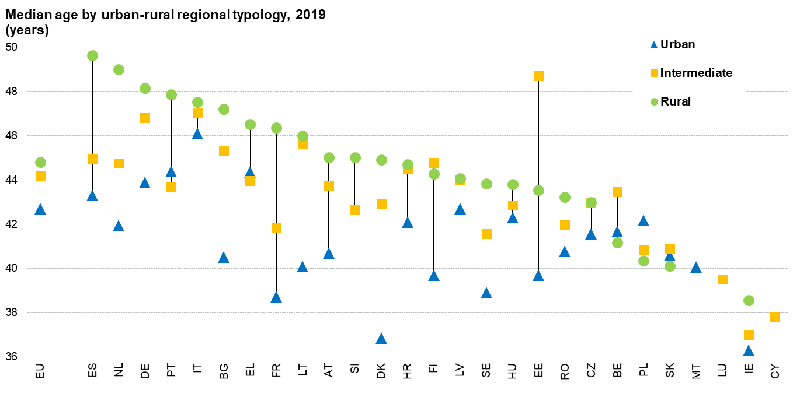

Source: Source: (online data table: demo\_r\_pjanind3)

### More young women leave rural regions than young men

**Women aged between 20 and 44 are more likely to move out of rural regions and intermediate regions than men are** (Table 5). As a result, per 100 women in that age group there were 106 men in rural regions and 104 men in intermediate regions. Remote intermediate regions have slightly more men in that age group relative to women compared to intermediate regions close to a city. For rural regions, remoteness does not seem to affect the balance between men and women in this age group. Since 2014, this skewed distribution of young men and women has become more pronounced. In both intermediate and rural regions, for every 100 women aged 20-44, the number of men grew by one, while in urban regions number of men in this age group remained equal to the number of women (Table 5).

Table 5 Men aged 20-44 per 100 women of that age by urban-rural regional typology in the EU, 2014 and 2019



Source. : (online data table: demo\_r\_pjangrp3)

The higher number of men aged 20 to 44 per 100 women of that age in rural regions as compared to urban region can be observed in all Member States[[27]](#footnote-28), but the intensity varies. In Ireland, the difference between the rural and urban region for this ratio is just one man, while in Estonia it is 19 men (Figure 7).

Figure 7 Men aged 20-44 per 100 women of that age by urban-rural regional typology, 2019

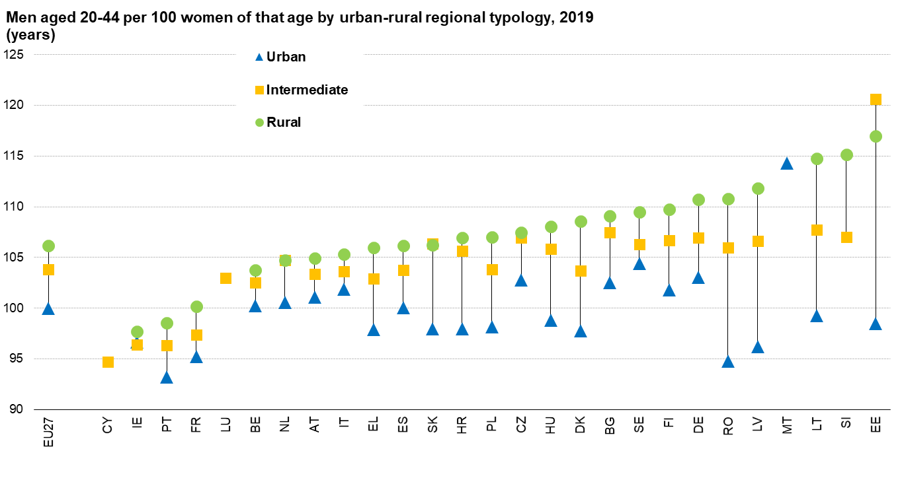

Source: (online data table: t demo\_r\_pjangrp3)

Note: ranked on rural, if not available on intermediate, if not available on urban value

### Rural regions lose more population due to natural change and gain less population through migration compared to urban ones

Between 2014 and 2019, average annual natural population change[[28]](#footnote-29) in rural regions was -2.3 per 1000 residents compared to -1.2 in intermediate regions and +1.0 in urban ones (Figure 8). In all the Member States[[29]](#footnote-30), except Poland, natural population growth was lower in rural regions than in urban ones. Between 2014 and 2019, natural change was positive in rural regions in only three Member States compared to 10 Member States for intermediate regions and 13 Member States for urban regions.

Figure 8 Average annual natural population change between 1 January 2014 and 2019 (per mille change by urban-rural regional typology)



Source: Eurostat (online data table: demo\_r\_gind3)

Note: ranked on rural, if not available on intermediate, if not available on urban value.

Net migration[[30]](#footnote-31) presents a different picture (Figure 9). Between 2014 and 2019, average annual net migration was positive in all three types of regions, but was lower in rural regions (0.6 per 1000 residents) than in urban regions (3.4). Net outmigration in rural regions occurred in 12 Member States (9 eastern Member States, Spain, Portugal and Finland), which among other factors, may be due to gap in GDP per head between urban and rural regions in those eastern Member States. Net outmigration was also quite common in intermediate regions, affecting 10 Member States, while relatively rare for urban regions affecting only 3 Member States (France, Greece and Latvia).

Figure 9 Average annual net migration rate between 1 January 2014 and 2019 (pro mille change by urban-rural regional typology)



Source: Eurostat (online data table: DEMO\_R\_GIND3)

Note: ranked on rural, if not available on intermediate, if not available on urban value

**Between 2014 and 2019, rural regions lost more population due to natural change and gained less population through net migration compared to urban ones**. Rural regions lost population because positive net-migration was not high enough to offset the negative natural change(Figure 10). On the national level, it is often the same Member States whose rural regions face negative natural change and negative net migration at the same time. Intermediate regions gained population because their net migration was higher and their natural population change was less negative as compared to rural regions. Urban regions experience the highest population growth through a combination of positive natural change and positive net migration.

Figure 10 Average annual population change between 1 January 2014 and 2019 (pro mille change by urban-rural typology)



Source: Eurostat (online data table: DEMO\_R\_GIND3)

Note: ranked on rural, if not available on intermediate, if not available on urban value

Map 6 Average annual crude population growth rate in NUTS-3 regions, 2014-2019

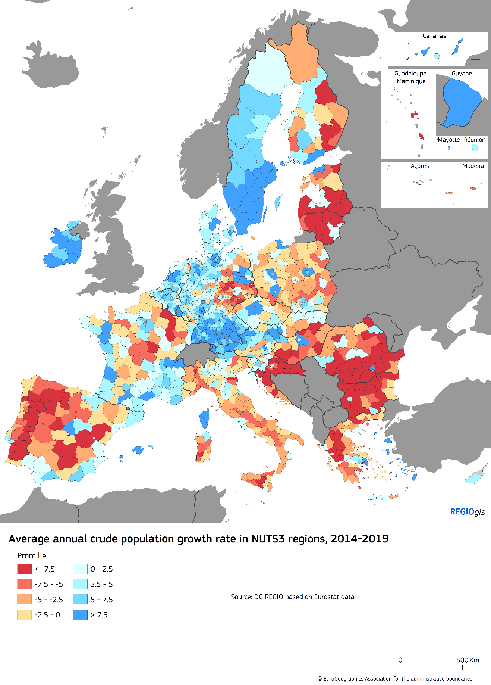

Source: Eurostat (online data table demo\_r\_gind3)

### Remote regions, in particular rural ones, are losing population

Between 2014 and 2019, **population in remote rural regions reduced faster than in rural regions close to a city did** (-0.3% a year compared to -0.1%). Intermediate regions close to a city gained population over this period, while remote intermediate regions saw their population shrink (Figure 11).

Figure 11 Average annual population change by urban-rural regional typology and remoteness, 2014 - 2019

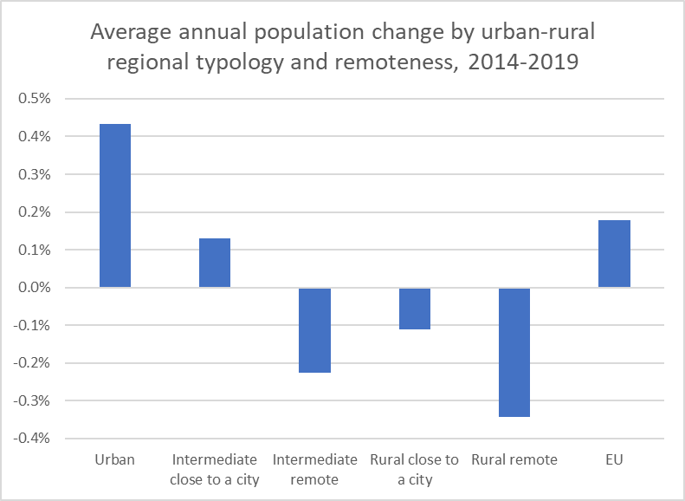

Source: Eurostat (online data table: demo\_r\_gind3)

Table 6 Demographic indicators by urban-rural regional typology including remoteness



Source: (online data table: demo\_r\_pjangrp3, demo\_r\_gind3)

The population reductions in remote regions between 2014 and 2019 are mainly due to negative natural changes. In remote rural regions, annual average natural change is -3.4 per thousand and -0.1 for net migration. In both cases this is clearly less favourable than for urban or intermediate regions. In remote intermediate regions is the impact of natural change (-1.6) is also bigger than of net-migration (-0.6).

In rural regions close to a city, net-migration is positive (0.8) but not high enough to offset the negative natural change (-1.9). By contrast, net-migration (2.4) in the intermediate regions close to a city is high enough to offset negative natural change (-1.1).

The median age in remote rural regions (45.9) is 1.5 years higher than in rural regions close to a city (44.4) and 3.2 years higher than in urban regions (42.7). Changes in the median age in the two types of rural regions have been similar (1.7) and remote intermediate regions experience a similar increase (1.8).

Measuring the impact of remoteness at the local level reveals an even greater impact. The population in rural areas close to a city saw a small reduction of 0.03% a year between 2011 and 2018, while population in remote rural areas reduced by 0.49% a year (Figure 12). Remoteness also had a clear impact on towns and suburbs, with population growth of 0.29% a year in the ones close to a city compared to a reduction of 0.13% a year in the remote ones.

Figure 12 Average annual population change by Degree of Urbanisation and remoteness, 2011-2018

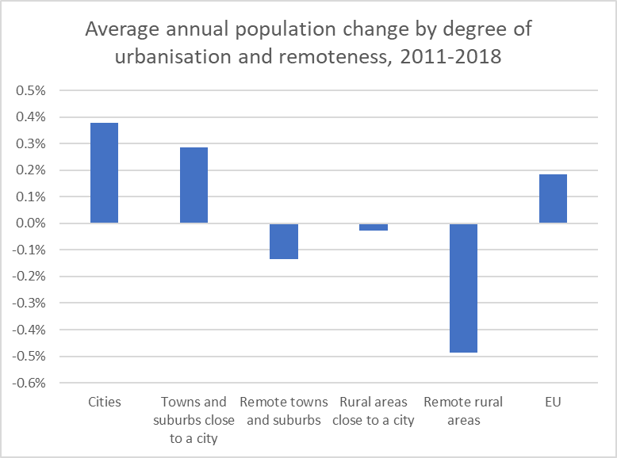

Source: JRC and DG REGIO based on Eurostat and JRC data (Census Hub)

### Depopulation

The European Commission report on the impact of demographic change[[31]](#footnote-32) highlighted that slow changes in population are less costly to adapt to than fast changes. It also highlighted that rapid population reductions were more common in (poor) rural regions than in other regions.

To identify a region that is **depopulating**, in the sense of experiencing **a *sustained and substantial* *reduction of its population***, this document uses the threshold of an average annual crude population change per 1000 residents of -7.5 for the period 1/1/2014 to 1/1/2019. This level ensures that only regions that have lost population every year during that five year period are defined as depopulating. To identify local administrative units (LAU) that are depopulating, this document uses an average annual crude population change per 1000 residents of -10.0 for the period 1/1/2011 to 1/1/2018[[32]](#footnote-33).

Remote rural regions and remote intermediate regions are far more likely to experience a reduction in population and depopulation. Around 70% of the population in a remote region lives in a shrinking region and around 25% lives in a depopulating region. In the EU as a whole, 39% of the population lives in a shrinking region and 7% lives in a depopulating region. At the same time, ‘rurality’ also plays a role as the depopulation phenomena is similar in remote rural and intermediate regions, but stronger in rural regions close to a city than in intermediate regions close to a city (and in all cases stronger than in urban regions).

Rapid population growth, i.e. of more than 7.5 per 1000 residents a year, is more prevalent in urban regions (30% of the urban population), but is also affects rural regions close to a city (9%), albeit clearly less than all other categories of regions.

Figure 13 Population by type of population change and urban-rural regional typology and remoteness, 2014-2019

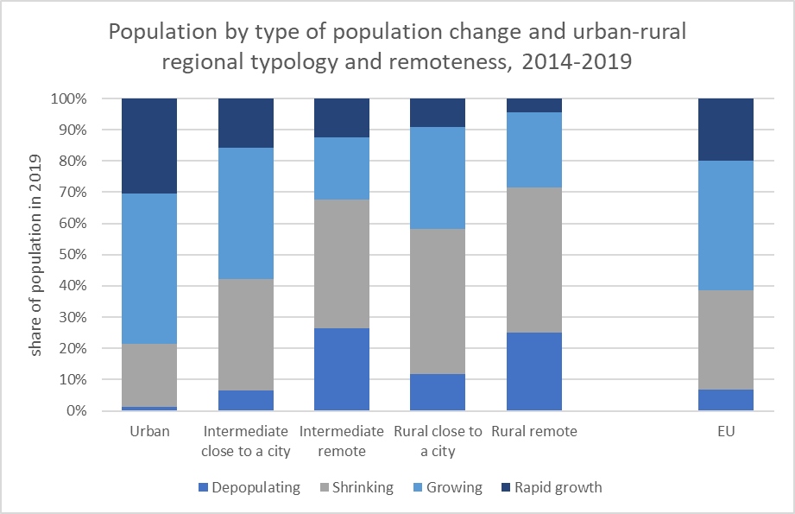

Source: JRC and DGREGIO based on Eurostat data (demo\_r\_pjanaggr3)

At the local level, the same pattern can be observed. Remote areas are more likely to experience population reductions and depopulation (Figure 14). Of the remote rural area population, 25% lives in a depopulating area. The risk of depopulation for remote towns and suburbs and rural areas close to a city is similar (Figure 14), but remote towns and suburbs are slightly more like to lose population. At the same time, ‘rurality’ also plays a role as the depopulation phenomena is stronger in remote rural areas than in remote towns and suburbs and, likewise, stronger in rural areas close to a city than in towns and suburbs close to a city (as well as cities).

Figure 14 Population by type of population change and Degree of Urbanisation including remoteness, 2011-2018

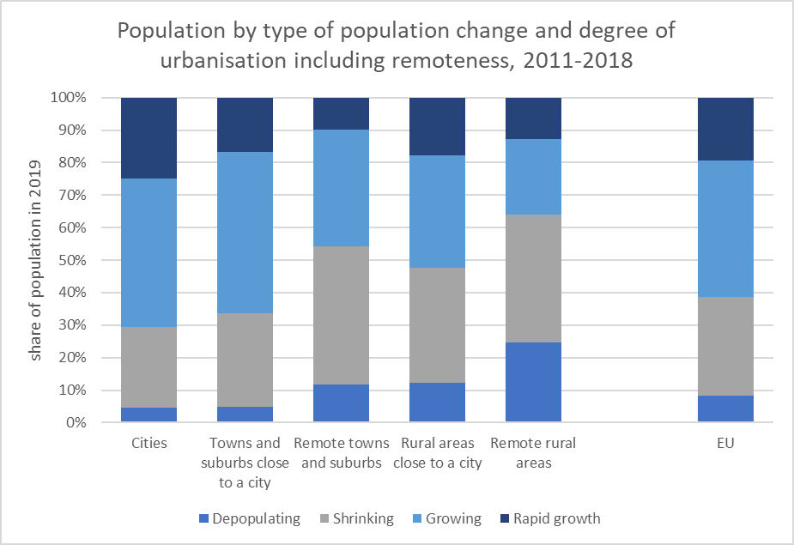

Source: Eurostat and JRC-GEOSTAT 2018 (Census Hub)

The type of population change has an impact on several key demographic indicators. For example, remote rural areas that are depopulating have a lower median share of children, of working age population and a higher median share of elderly and old age dependency ratio compared to remote rural areas that have a slowly shrinking population or a (rapidly) growing one. This pattern can also be seen in the other areas (Figure 15). This underlines that demographic changes affect all areas.

Figure 15 Median values for main demographic indicators (2020) across LAUs classified by depopulation, Degree of Urbanisation and remoteness

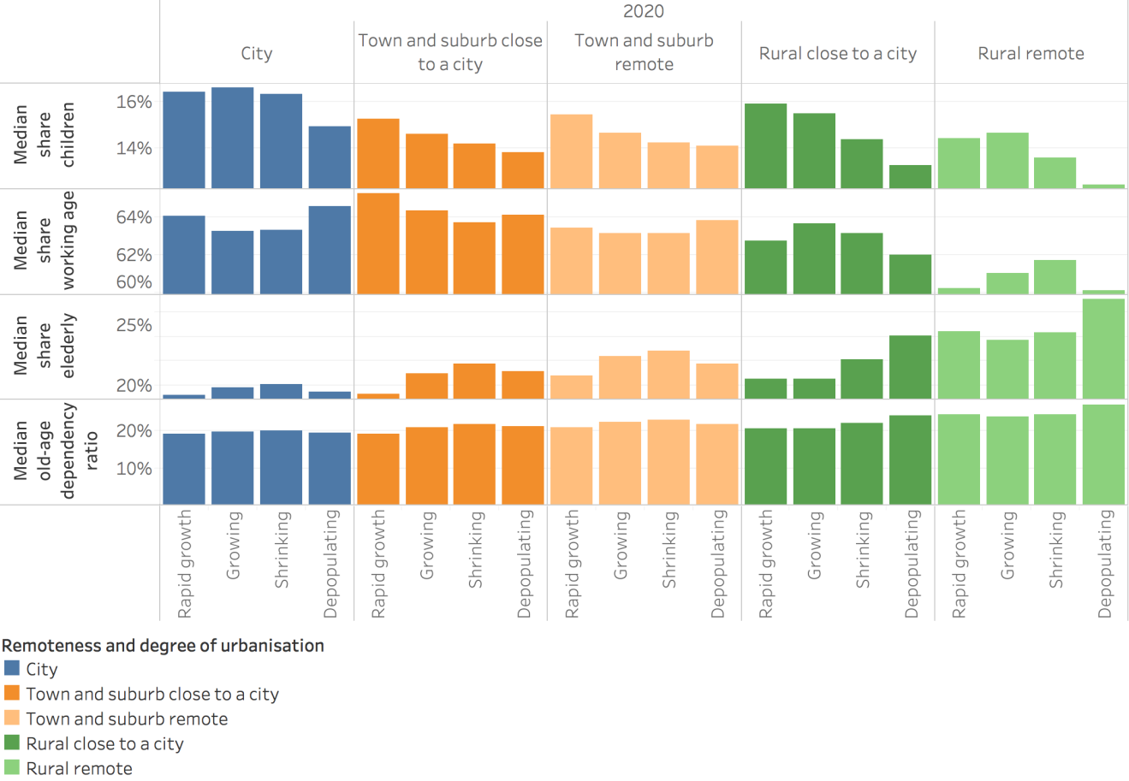

Source: JRC elaboration based on the LUISA demographic projections

Note: Local depopulation is defined as average annual percentage difference between 2018 and 2011 lower than -1%. The Degree of Urbanisation and remoteness are defined according to the 2011 classification. The 2020 data is estimated on the basis of demographic projections at high spatial resolution starting from the Census data of 2011.

### The rural working age population is shrinking, mainly due to the age structure of its population

The working age population has been shrinking at the EU level for a decade[[33]](#footnote-34). As a result, the majority (61%) of the EU population lives in a region that experienced a reduction in its working age population between 2015 and 2019 (Table 7). The rural population, however, is almost twice as likely to live in a region with shrinking working age population as the urban population (83% vs 44%).

In urban, intermediate and rural regions, a reduction of the working age population is mostly due to the negative impact of the age structure and much less due a negative effect of migration. Remoteness again comes into the picture as in the remote regions with a shrinking working age population, more people live in a region with a negative effect of both migration and the age structure compared to the non-remote regions. A bigger share of the rural population lives in a region where the working age population shrinks due to the negative impact of both the age structure and migration (20%) as compared to intermediate (12%) and urban regions (10%).

Of the population in rural regions, 17% lives in regions with a growing working age population, compared to 56% in urban regions and 32% in intermediate regions. The growth of working age population is primarily due to the positive effect of migration; a positive impact of the age structure is quite rare.

Table 7 Population share in regions by type of working age population change, 2015-2019



Source: JRC calculations based on Eurostat data

### Demographic projections

The most recent Eurostat population projections (Table 8) indicate that the EU population is roughly stable and is likely to start shrinking from 2025 onwards. This general trend will in turn affect rural, intermediate and urban regions. Rural regions were already losing population during the last two decades and are projected to continue to do so for at least the next forty years. The population in intermediate regions is still growing, but it is projected to start shrinking from 2025 onwards. The population of urban regions is last to start shrinking, with reductions occurring from 2045 onwards. Remote intermediate and rural regions are shrinking faster than regions close to a city and these differences are projected to continue.

Table 8 Population change by urban-rural regional typology including remoteness, 2014-2060



Source: Eurostat (online data tables: demo\_r\_pjangrp3 and proj\_19rp3)

These different demographic trends will lead to a lower rural population share in 2060 (-2 pp), lower intermediate population share (-1 pp) and higher urban population share (+3 pp) (Table 9). These small changes in the urban and rural population shares over a period forty years show the continuation of a slow process of urbanisation in the EU.

Table 9 Population share by urban-rural regional typology in the EU 1961-2060, in %



Source: Eurostat (online data table: demo\_r\_pjangrp3, proj\_19rp3) and JRC-GEOSTAT

The EU population is projected to shrink from 2026 onwards. As a result the share of the EU population living in a region that lost population in the five preceding years will increase from around 40% in 2020 to 75% in 2060. (Figure 16).

Figure 16 EU population by type of demographic change, 2025-2060

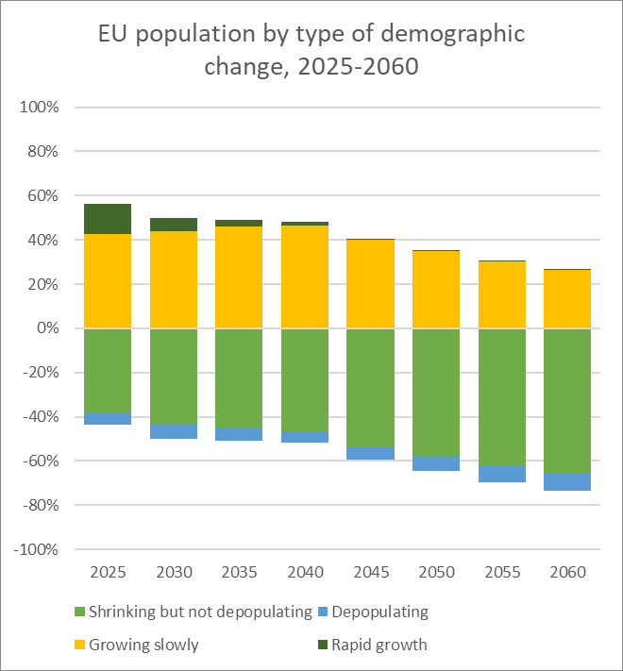

Source: Eurostat (online data table proj\_19rp3)

Note: rapid growth (>7.5 per mille a year), growing slowly (0 – 7.5), shrinking but not depopulating (-7.5 – 0), depopulating (<-7.5).

The consequences of these EU level changes can be seen in all three types of regions with a steady increase over time of the share of people living in a shrinking region. Up to 2060, rural regions maintain the highest share of population in regions with a shrinking population and in depopulating regions.

Figure 17 EU population in urban, intermediate and rural regions by type of population change, 2025-2060

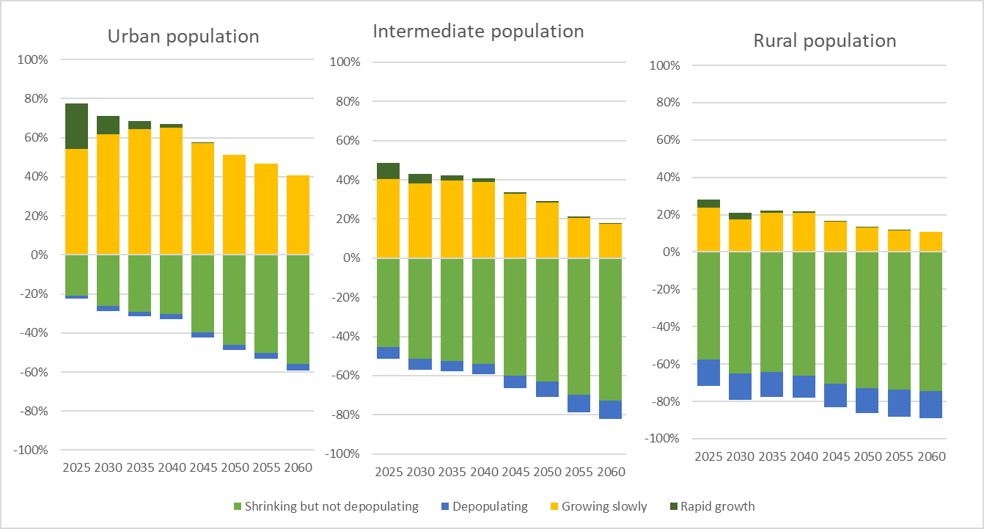

Source: Eurostat (online data table proj\_19rp3)

Note: rapid growth (>7.5 per mille a year), growing slowly (0 – 7.5), shrinking but not depopulating (-7.5 – 0), depopulating (<-7.5).

### Conclusions and outlook

The EU population is expected to continue to age and to start shrinking during the next decade. Rural regions today already have an older population than the other regions do and are more likely to have a shrinking population, due to (higher) negative natural change in population and a less positive net migration rate. Remote rural regions face a particularly difficult situation. In many ways, rural regions are ahead of the demographic curve at the EU level because over the next decades more and more other regions will also experience ageing and population decreases.

Rural regions will have to develop policies that manage population changes and ensure that they do not affect their quality of life or hurt their economy and social systems. Innovative technological and organisational solutions in terms of digitalisation or green mobility may help regions to manage demographic changes, while contributing to perspectives for people to stay in rural areas or discover them as attractive living spaces, to minimise disruptions to their economy and to maintain a high quality of life or improve it.

## Labour and education

This section describes the situation of rural regions with regard to employment, unemployment, education and training, including a comparison with urban areas and analysis of gender.[[34]](#footnote-35)

### Employment and unemployment have improved in rural areas since 2012

Since 2012, the employment rate for the population aged 20-64 in rural areas increased in all Member States. At the EU level, it increased from 68% to 73% in 2019. At the same time, the unemployment rate in rural areas dropped in all Member States. At the EU level, it dropped from 10.4% to 5.7%.

At EU level, there was no difference in the employment rates (20–64) in rural areas and cities in 2019 (both 73%). This is a result of very diverse situations in the Member States. The biggest rural advantage was registered in Belgium, followed by Austria; while the largest rural disadvantage was registered in Bulgaria, followed by Lithuania. This situation has been relatively stable at the EU level since 2012, but in some Member States, rural areas improved relative to cities while in others they deteriorated (in particular in Romania and Croatia).

Figure 18 Gap analysis - Employment rate of people aged 20-64 years in rural areas compared to cities in 2012 and 2019

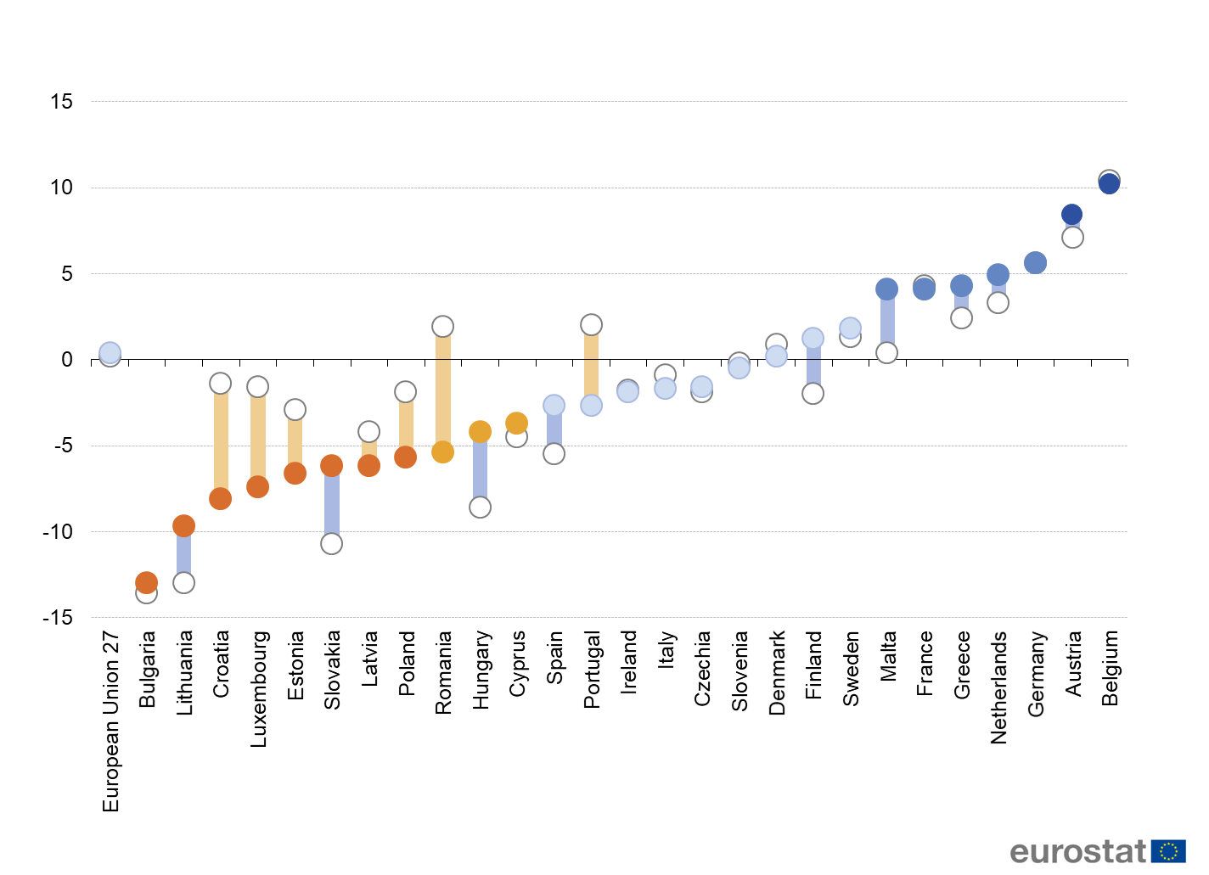

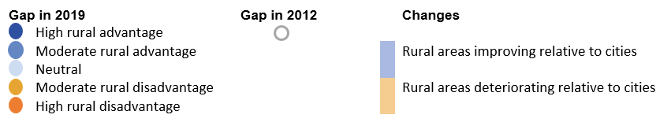

(percentage point difference between rural areas and cities)

Source: Eurostat (online data code: lfst\_r\_ergau)

At the EU level, the unemployment rate (15-74) was lower in rural areas than in cities in 2019. Eleven Member States showed a moderate to high rural advantage in comparison to cities in terms of unemployment rates, while only 6 Member States showed a moderate to high rural disadvantage. This rural advantage has increased slightly since 2012. This aggregate picture, however, hides changes in both directions. For example, Romania switched from a rural advantage in 2012 to a rural disadvantage in 2019.

Figure 19 Gap analysis - Unemployment rate of people aged 15-74 in rural areas compared to cities in 2012 and 2019

(percentage point difference between rural areas and cities)

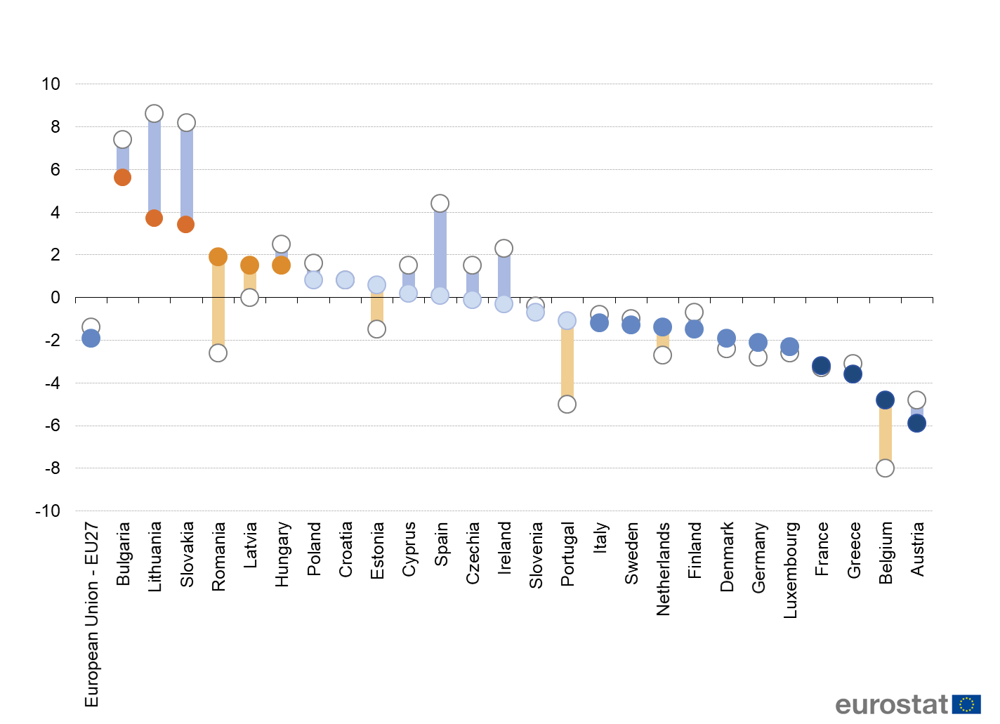

Source: Eurostat (online data code: lfst\_r\_urgau)

These favourable overall dynamics mask different realities, notably a very diverse situation in the Member States and the situation **of young people**,who have a higher unemployment rate compared to the general working age population, also in rural areas. Unemployment for young people (15-24) in rural areas was 13.4% for 2019, while the EU-27 rural unemployment rate (15-74) was 5.7%.[[35]](#footnote-36)

### The employment gap between men and women is wider in rural areas than in cities

The EU rural employment rate (for people aged 20-64) was 67% for women and 80% for men in 2019, which translates to a gender employment gap of 13 percentage points (pp). The gap was above 20 pp in Malta, Romania, Greece and Italy. The smallest gap was registered in Baltic and northern Member States. Since 2012, this gap has remained fairly stable at the EU level, but the trend at the Member State level varies with significant increases in the gap in Bulgaria, Hungary and Romania. By contrast, the gap shrunk especially in Belgium, Luxembourg, Malta, Slovakia and Germany.

Figure 20 Gender employment gap in rural areas in 2012 and 2019

(percentage points difference, male employment rate minus female employment rate, based on people aged 20-64 years)

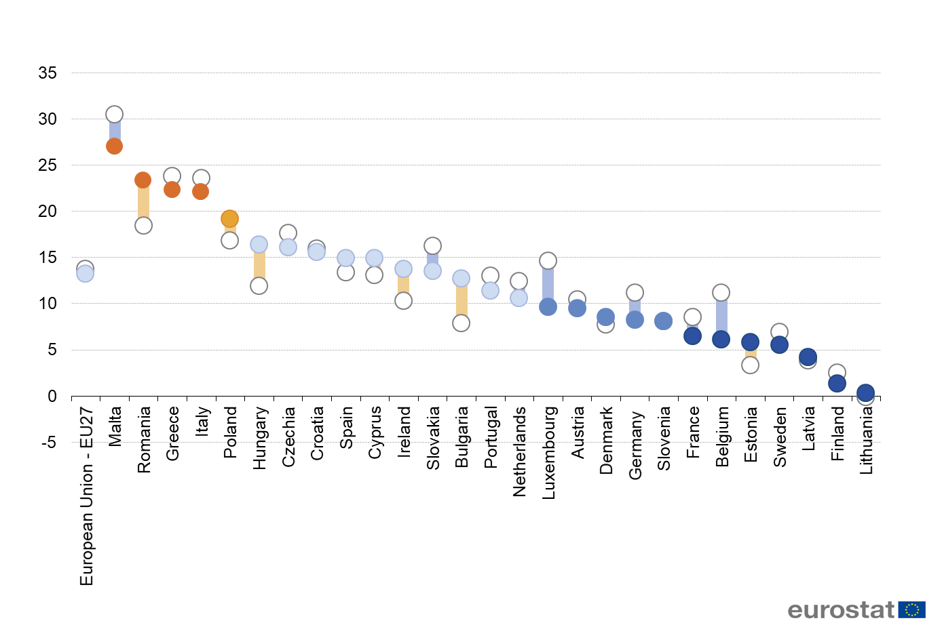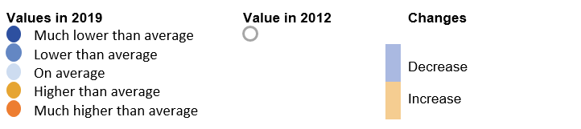

Source: Eurostat (online data code: tepsr\_lm230)

In 2019, the employment rate of city residents (for people aged 20-64) was 68% for women and 78% for men which translates to a gender employment gap of 10 pp[[36]](#footnote-37). The gender employment gap in cities was smaller than in rural areas because women are more likely to work in cities than in rural areas, while the opposite holds for men. Most Member States have a wider gender employment gap in rural areas than cities.

Despite overall increases in employment rates, this difference between the gender employment gap in cities and rural areas has not changed since 2012.

### Early leavers and young people neither in employment nor in education or training are more in rural areas than in cities

The OECD[[37]](#footnote-38) Programme for International Student Assessment (PISA) 2018 shows that the **reading performance of 15-year-olds students** attending schools **in rural areas is significantly lower** than in cities.[[38]](#footnote-39)The gap israther large in many Member States. In Hungary, Bulgaria, Romania, Slovakia and Portugal it even exceeds 100 PISA score points, corresponding to approximately 2-3 years of schooling.

Figure 21 Reading performance by school location, PISA 2018

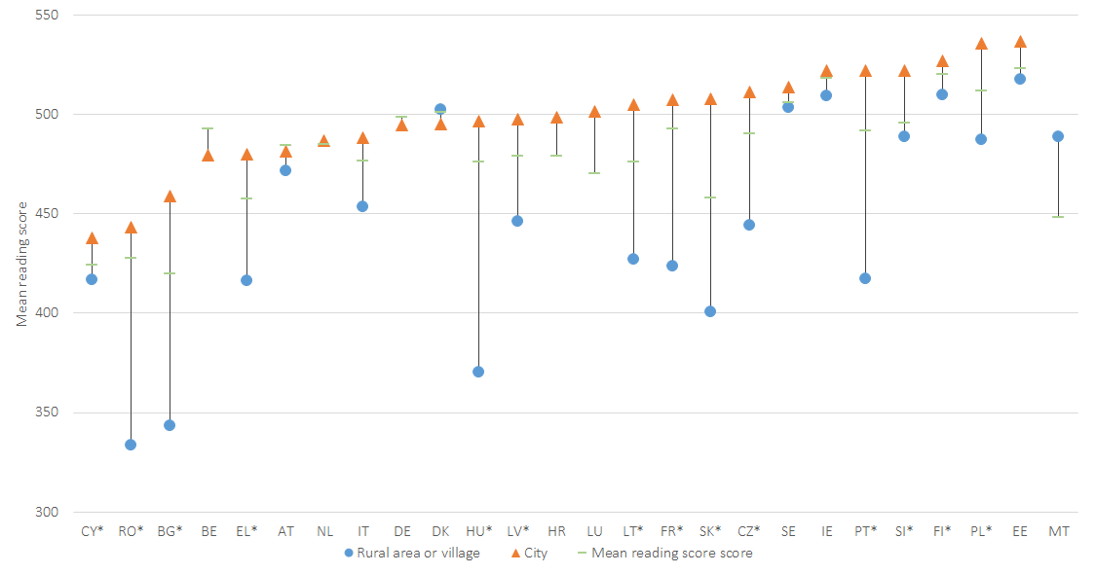Source: OECD, PISA 2018 (2019).

Note: 40 score points in PISA test is equivalent to about one year of schooling. Data for ES not available. Countries are marked by \* when the urban-rural gap is statistically significant.

In 2019, **10.7% of young people** (aged 18-24) in EU rural areas were **early leavers** **from education and training**, in other words, they had completed at most a lower secondary education and were not in further education or training during the four weeks preceding the survey. Among the EU Member States, the proportion of early leavers in rural areas in 2019 ranged from 4.4% in Austria to 24.5% in Bulgaria. Since 2012 the rate has decreased in almost all Member States, with the largest decreases in Greece, Spain, Portugal and Romania.

Figure 22 Early leavers from education and training in rural areas in 2012 and 2019

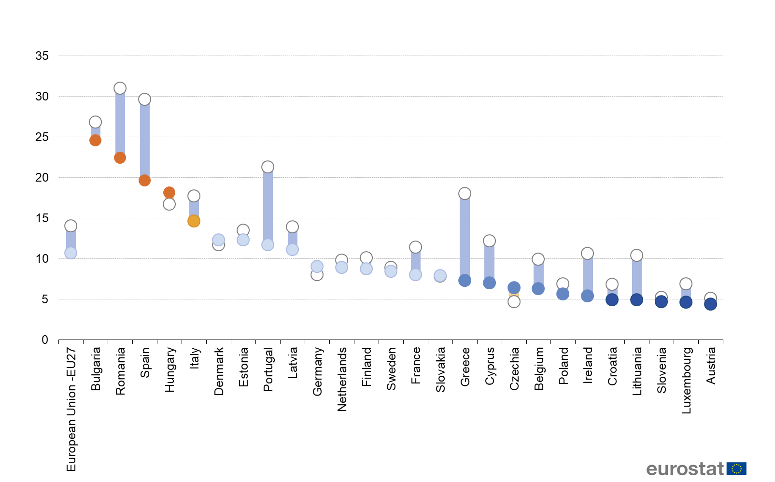



Note: Value for Malta is unreliable.

Source: Eurostat (online data code: edat\_lfse\_30)

At the EU level, **the early leaving rate was higher in rural areas (10.7%) and towns (11.2%) than in cities (9.1%) in 2019**. The gap is significant in Romania (where it reaches 18.1 pp), Bulgaria, Hungary and Latvia. In a few Member States the gap is negative, for instance, in Austria (-7.3 pp) and Belgium, which means that more young people in these Member States leave education prematurely in cities than in rural areas.

Figure 23 Gap analysis - Early leavers from education and training in rural areas in 2012 and 2019

(percentage point difference between rural areas and cities)

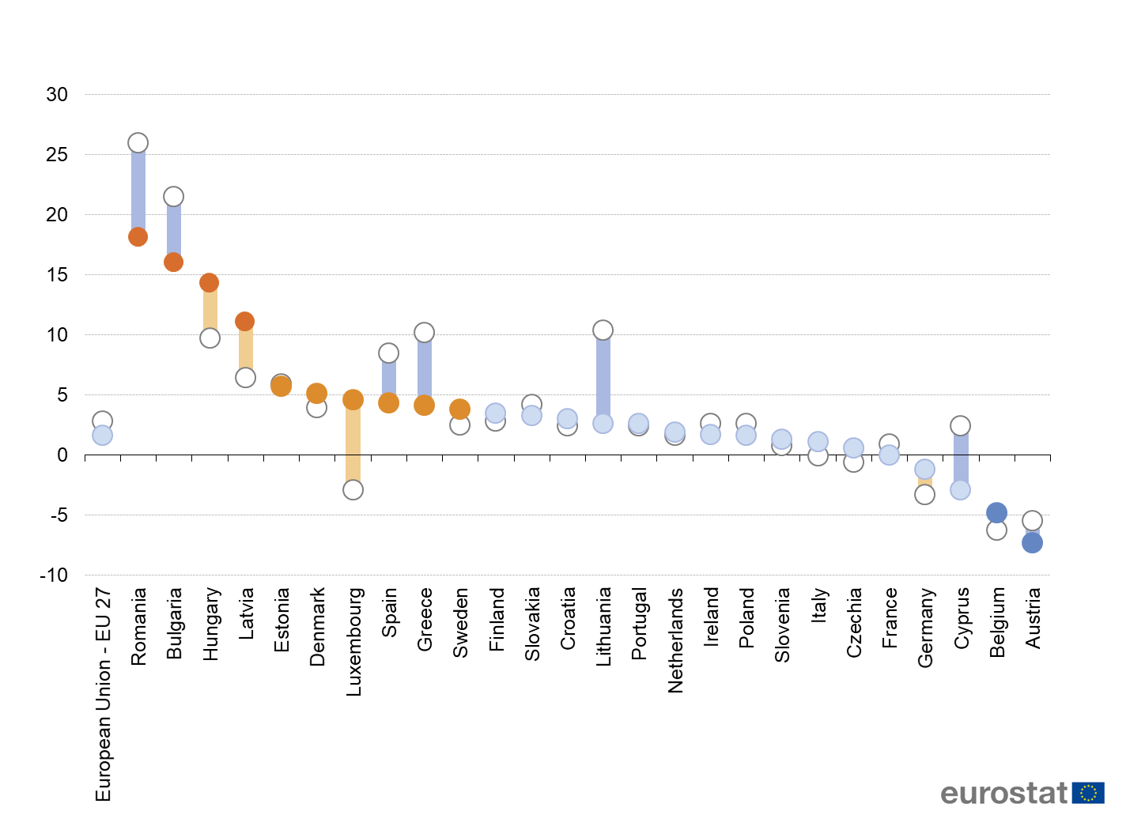



Note: Value for Malta is unreliable.

Source: Eurostat (online data code: EDAT\_LFSE\_30\_)

The share of young people aged 15-29 years neither in employment nor in education or training (**NEET**) was highest in rural areas (13.6%) and lowest in cities in 2019 (11.7%). In 18 Member States the lowest rate was registered in cities[[39]](#footnote-40); these figures may reflect, to some degree, the concentration of educational establishments and job opportunities in cities.

### Tertiary education and digital skills are lower in rural areas than in cities

**The share of population aged 25-64 in rural areas with a tertiary education has increased** over time from 18% in 2012 to 22% in 2019. The same pattern can be observed in all Member States, with all rural areas showing increase in the share of tertiary educated. The size of the increase however varied with big increases in Austria, Malta and Lithuania compared to very small increases in rural areas in Germany, Bulgaria and Romania. Despite these increases, however, the share of the tertiary educated is still significantly lower than in cities (where the share is 41%).

Figure 24 Tertiary education of 25–64-year-olds in rural areas in 2012 and 2019

(%, share of people aged 25-64 years)

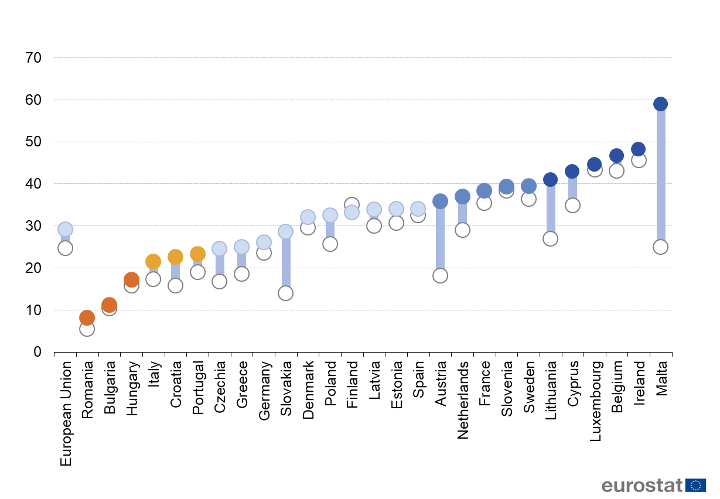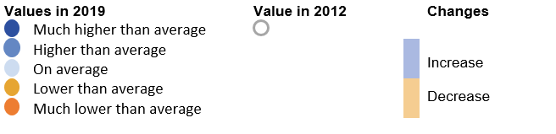

Source: Eurostat (online data code: edat\_lfs\_9913)

Since the increase was even higher in cities, the gap between rural areas and cities increased from 17 pp in 2012 to 19 pp in 2019. Also at the Member State level, most experience a stable or a growing gap in terms of tertiary education between rural areas and cities.

Figure 25 Gap analysis - Tertiary education of 25–64-year-olds in rural areas in 2012 and 2019

(percentage point difference between rural areas and cities)

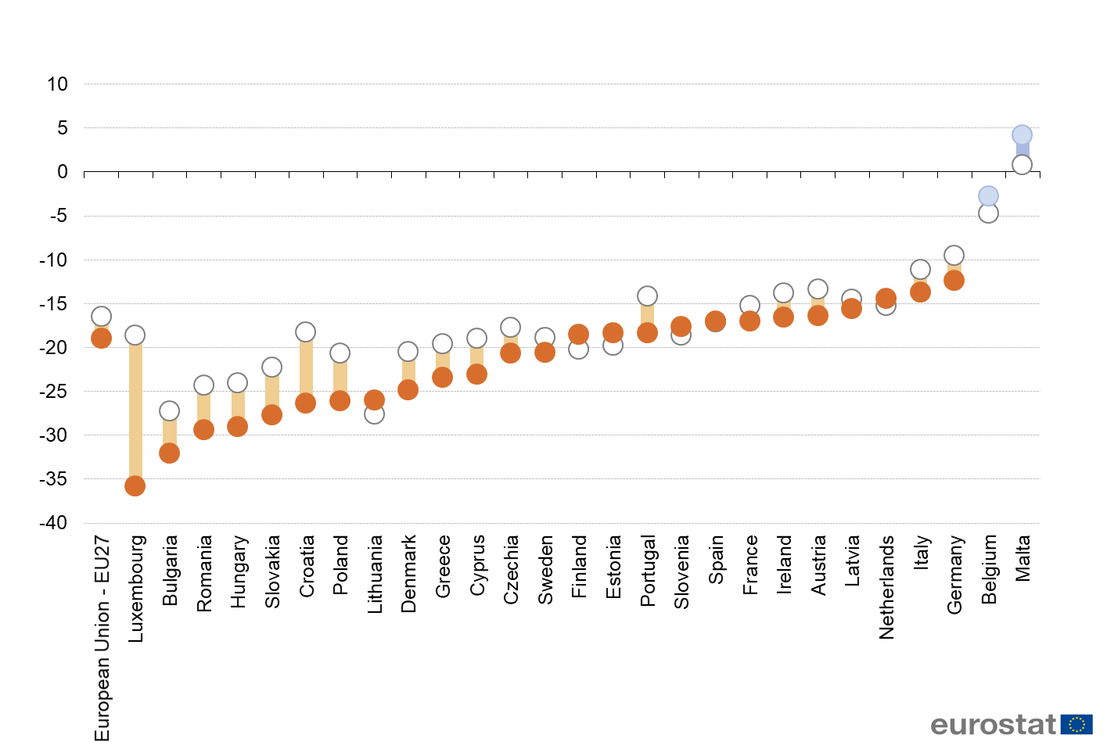



Source: Eurostat (online data code: edat\_lfs\_9913)

Of the women aged 25-34 in rural areas, 35% have a tertiary education compared to 22% for men that age in 2019. In cities, women of that age group are also more likely to have a tertiary education compared to men of that age, but the difference is smaller: 55% vs 45%, a gap of 10 pp vs 13 pp.[[40]](#footnote-41)

**About half of the EU rural population has at least basic digital skills**. There is a big variation between Member States. The highest rate – recorded in the Netherlands – is more than four times bigger than the lowest rate recorded in Bulgaria.

Figure 26 Individuals aged 16-74 who have basic or above basic overall digital skills in rural areas in 2015 and 2019

(% of population aged 16-74)

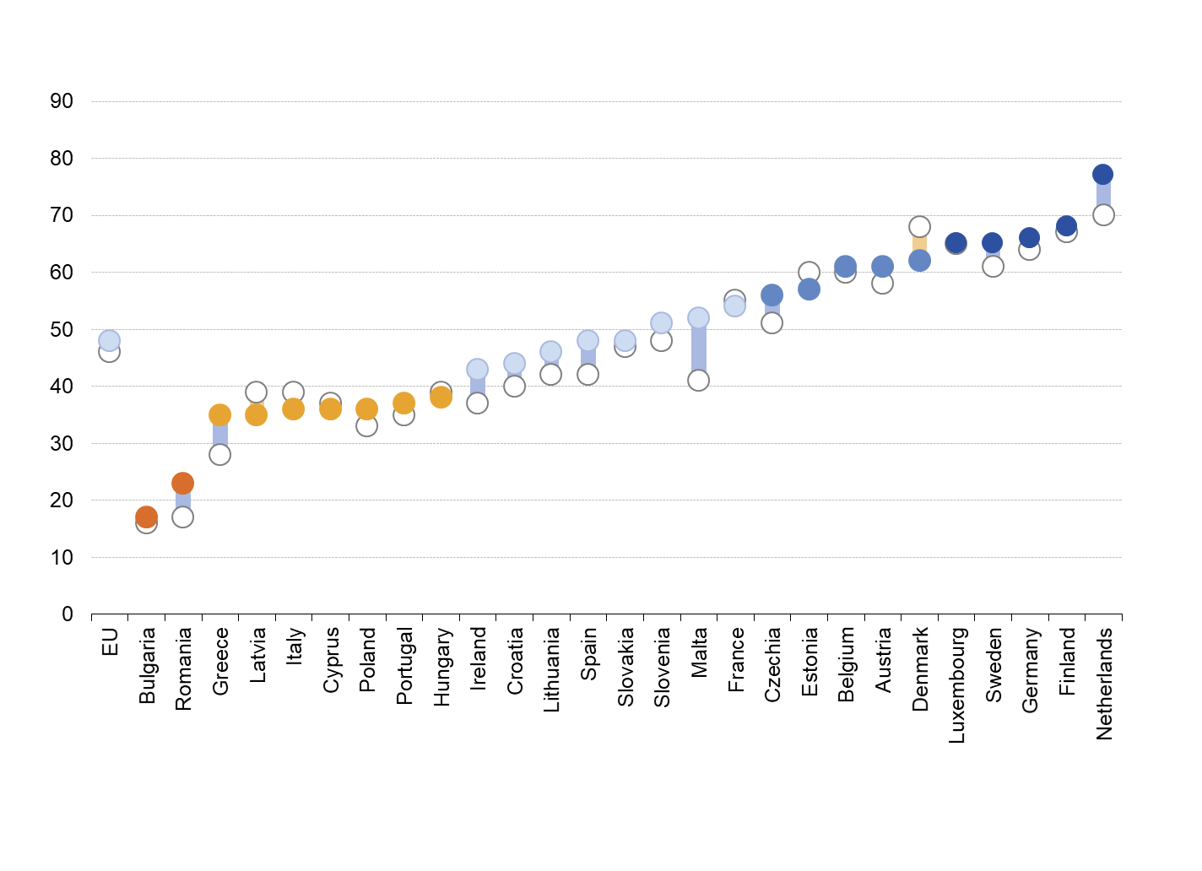



Source: Eurostat (online data code: isoc\_sk\_dskl\_i)

Note: Malta and Sweden: 2019, low reliability. Luxembourg 2019 only.

As with tertiary education, **the gap between rural areas and cities is wide and present in virtually all Member States**. In the EU, the share of rural residents that have at least basic digital skills is 14 pp lower than of city residents (48% vs 62%) in 2019. This gap has furthermore not changed since 2015. The lower level of digital skills in rural areas may limit the uptake of e-services and the potential to work remotely. This also depends on the availability and affordability of high-speed infrastructure.

Figure 27 Gap analysis - Individuals aged 16-74 who have basic or above basic overall digital skills in rural areas compared to cities in 2015 and 2019

(percentage point difference between rural areas and cities)

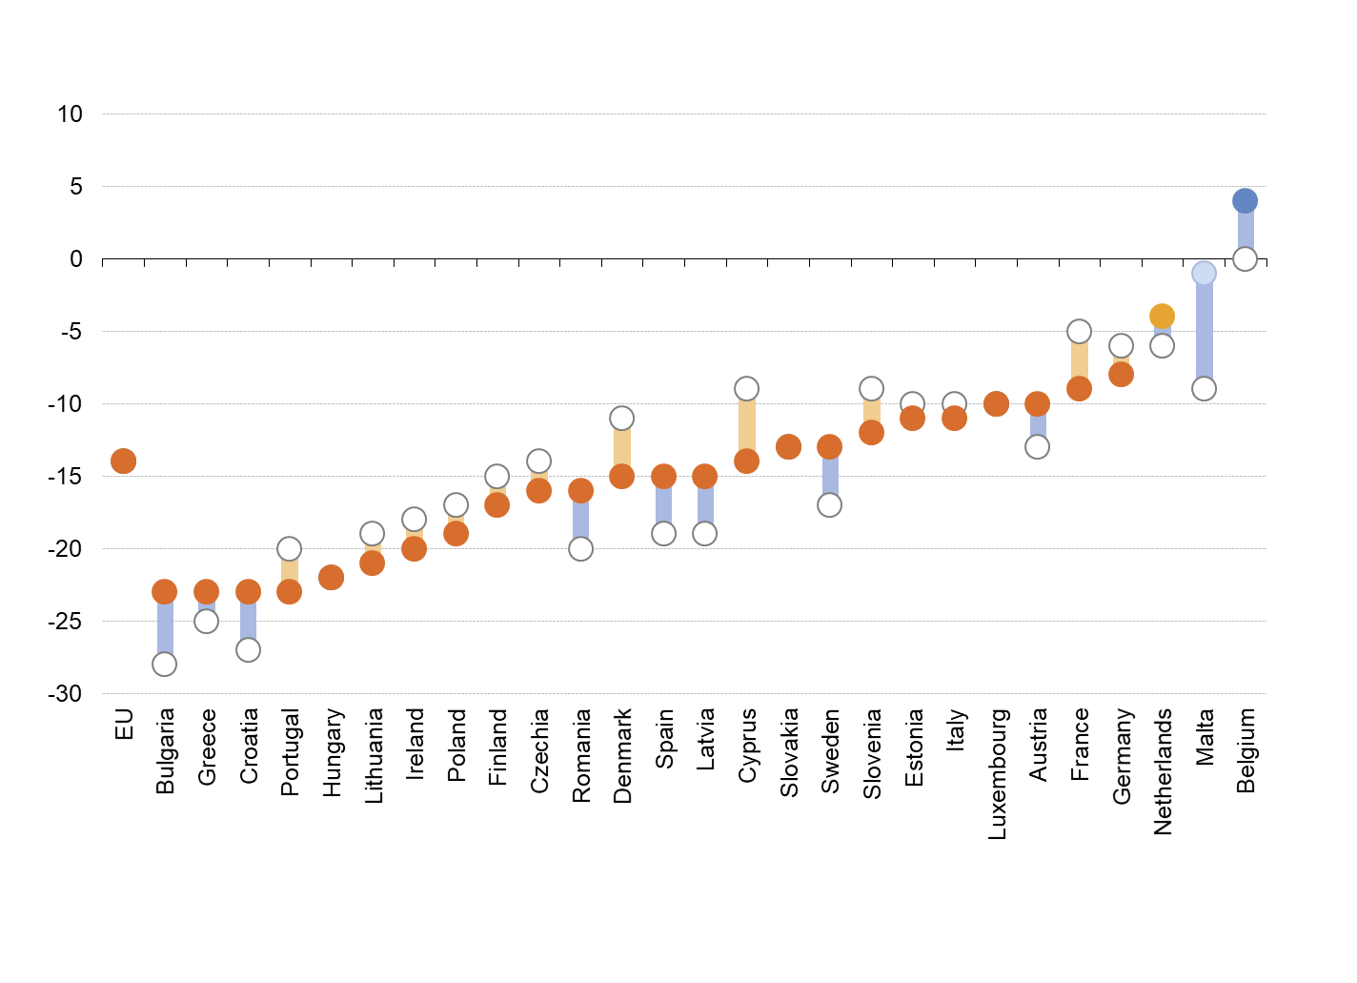



Source: Eurostat (online data code: isoc\_sk\_dskl\_i)

Note: Malta and Sweden: 2019, low reliability. Luxembourg 2019 only.

### Conclusions

At EU level, the rural employment rate was the same as in cities, albeit with clear differences at Member State level, while the rural unemployment rate was even lower than in cities in 2019. The reduction of active age population impacts also the employment rates, with some areas, also rural ones, facing more lack of workforce than unemployment problems.[[41]](#footnote-42) At the same time, the gap between male and female employment rates is larger in rural areas than in cities in the EU, has barely changed since 2012 and is very high in some Member States.

The educational divide between cities and rural areas is large and has grown over time. Although the share of population aged 25-64 with a tertiary education has increased in rural areas, it increased more in cities where the share is almost double (41% in cities vs 22% rural areas). The educational divide depends not only on access to tertiary education, but also to jobs that demand these types of qualifications. If more specialised jobs become available in rural areas, for example through teleworking, this divide may shrink. If specialised jobs remain or become more concentrated in (large) cities, the divide may well grow over time. Moreover, the percentage of young people without a job, not in education or training is higher in rural areas than elsewhere.

The growing share of working age women with a tertiary education in rural areas may reduce the gender employment gap over time. However, if some of the young women in rural areas with a tertiary education cannot find quality jobs and do not have access to social services including early childhood education and care facilities in rural areas, they will move elsewhere to find a job which fits their qualifications. Remote working possibilities might represent new opportunities also to women, accessing more easily high quality jobs while living in rural areas.

The share of population with at least basic digital skills is lower in rural areas than in cities and this gap has not changed since 2015, which may hinder the use of online services and the capacity for teleworking.

1. Political guidelines for the next European Commission 2019-2020, A Union that Strives for more. <https://ec.europa.eu/info/sites/info/files/political-guidelines-next-commission_en_0.pdf> [↑](#footnote-ref-2)
2. COM (2020) 241 Communication on the impact of the demographic change. In April 2021 the [*Atlas of Demography*](https://knowledge4policy.ec.europa.eu/atlas-demography_en) was launched as a new interactive tool which helps visualise, monitor and anticipate demographic change in Europe. [↑](#footnote-ref-3)
3. COM (2021) 50 Communication on the Green paper on Ageing. [↑](#footnote-ref-4)
4. COM (2019) 640 Communication The European Green Deal. [↑](#footnote-ref-5)
5. COM (2020) 381 Communication A Farm to Fork Strategy. [↑](#footnote-ref-6)
6. European Commission*,* A future fit for the digital age. <https://ec.europa.eu/info/strategy/priorities-2019-2024/europe-fit-digital-age_en> [↑](#footnote-ref-7)
7. COM (2021) 102 Communication The European Pillar of Social Rights Action Plan. [↑](#footnote-ref-8)
8. European Commission, Conference of the Future of Europe. <https://ec.europa.eu/info/strategy/priorities-2019-2024/new-push-european-democracy/conference-future-europe_en> [↑](#footnote-ref-9)
9. European Commission, *Recovery plan for Europe*. <https://ec.europa.eu/info/strategy/recovery-plan-europe_en> [↑](#footnote-ref-10)
10. SWD (2021) 167 *Stakeholder consultation- Synopsis Report Accompanying the Communication A long-term Vision for the EU's Rural Areas - Towards stronger, connected, resilient and prosperous rural areas by 2040*. [↑](#footnote-ref-11)
11. Foresight is the discipline of exploring, anticipating and shaping the future to anticipate developments and better prepare for change. European Commission, *Strategic Foresight Report- Charting the course towards a more resilient Europe*, 2020. [↑](#footnote-ref-12)
12. NUTS - Nomenclature of territorial units for statistics [↑](#footnote-ref-13)
13. Eurostat, *Methodological manual on territorial typologies,* 2018. <https://ec.europa.eu/eurostat/web/products-manuals-and-guidelines/-/ks-gq-18-008> [↑](#footnote-ref-14)
14. This analysis does not take into account connections by public transport. [↑](#footnote-ref-15)
15. For the definition of rural areas and rural regions, see the Methodological note in the introduction. [↑](#footnote-ref-16)
16. The data presented in this chapter are based on the 2018 LUISA Base Map (Pigaiani et al., *The LUISA Base Map 2018 - A geospatial data fusion approach to increase the detail of European land use/land cover data*, Publications Office of the European Union, Luxembourg, 2021.) which is a high-resolution land use/land cover map produced in 2020 by the Joint Research Centre of the European Commission. The LUISA Base Map can be used for multiple purposes and applications owing to its fine spatial and thematic detail of land use/land cover consistently for Europe. It is used as the starting point in the LUISA Territorial Modelling Platform for land use projections (Jacobs-Crisioni et al., *A Technical Description. Publications Office of the European Union*, Luxembourg, 2017). For the land accounting statistics and projections reported hereinafter, we used a simplified legend consisting of the four main land use/cover categories aggregated from the 100 metres version. LUISA platform also integrated demographic projections in its framework as described in Jacobs-Crisioni et al., *Development of the Luisa Reference Scenario 2020 and Production of Fine-Resolution Population by 5 Year Age Group*, Publications Office of the European Union, Luxembourg, 2021. and Perpiña Castillo C., et al., *A demographic assessment on the EU remote areas by 2050,* Policy Brief*. European Commission*, Publications Office of the European Union, Luxembourg, 2021. [↑](#footnote-ref-17)
17. European Commission, *Brief No. 7. Structural change and generational renewal*, CAP Specific objectives explained. <https://ec.europa.eu/info/sites/info/files/food-farming-fisheries/key_policies/documents/cap-briefs-7-structural-change_en.pdf> [↑](#footnote-ref-18)
18. Perpiña Castillo, et al., *Modelling agricultural land abandonment in a fine spatial resolution multi-level land-use model: an application for the EU, Environmental Modelling and Software*, 2021.

    Abolina E., Luzadis V.A., *Abandoned agricultural land and its potential for short rotation woody crops in Latvia, Land Use Policy*, Volume 49, 2015. [↑](#footnote-ref-19)
19. Eurostat, *Eurostat regional yearbook 2017*, Publications office of the European Union, Luxembourg, 2017. [↑](#footnote-ref-20)
20. Baumann, M., et al., *Patterns and drivers of post-socialist farmland abandonment in Western Ukraine*, Land Use Pol. 28, 552–562, 2011. [↑](#footnote-ref-21)
21. EEA, *The European environment — state and outlook 2020 - Knowledge for transition to a sustainable Europe*, 2020. <https://www.eea.europa.eu/publications/soer-2020> [↑](#footnote-ref-22)
22. Maes J., et al., *More green infrastructure is required to maintain ecosystem services under current trends in land-use change in Europe*, Landsc Ecol 30:517–534, 2015. [↑](#footnote-ref-23)
23. Hart K., et al., *Land as an Environmental Resource*, Report prepared for DG Environment, Institute for European Environmental Policy, London, 2013. [↑](#footnote-ref-24)
24. Overbeek, M., Terluin, I.J., *Rural areas under urban pressure*, The Hague, Agricultural Economics Research Institute, LEI Wageningen UR. Report 7.06.01., 2006. [↑](#footnote-ref-25)
25. Aurambout J.P., et al., *Demographic landscape of EU territories, challenges and opportunities in diversely ageing regions*, Goujon A., et al. (eds.), Publications Office of the European Union, JRC123046., 2021. <https://publications.jrc.ec.europa.eu/repository/handle/JRC123046> [↑](#footnote-ref-26)
26. With both an urban and a rural region. [↑](#footnote-ref-27)
27. With both an urban and a rural region. [↑](#footnote-ref-28)
28. Natural change equals births minus deaths. [↑](#footnote-ref-29)
29. With both an urban and a rural region. [↑](#footnote-ref-30)
30. Net migration should be calculated as people moving in minus people moving out. In the context of the annual demographic balance however, Eurostat produces net migration figures by taking the difference between total population change and natural change; this concept is referred to as net migration plus statistical adjustment. [↑](#footnote-ref-31)
31. COM (2020)241 *Communication on the impact of demographic change*. [↑](#footnote-ref-32)
32. Because annual LAU population data is not available, a longer time period had to be used. Because population changes at the local level have higher variability, a higher threshold had to be used. [↑](#footnote-ref-33)
33. Eurostat online data table (demo\_pjanbroad) [↑](#footnote-ref-34)
34. The analysis was conducted using data available on 1 March 2021. More recent Labour Force Survey data has since been published and can be found here: <https://ec.europa.eu/eurostat/web/degree-of-urbanisation/data/database>

    For the analysis of employment in 2020 see European Commission, *Employment and Social Developments in Europe 2021 Annual Review*, 2021. *forthcoming* [↑](#footnote-ref-35)
35. Youth unemployment rates are higher than general unemployment rates throughout the EU, and in all types of areas. (online data code: lfst\_r\_urgau) [↑](#footnote-ref-36)
36. Eurostat (online data code: tepsr\_lm230) [↑](#footnote-ref-37)
37. Organisation for Economic Cooperation and Development (OECD) [↑](#footnote-ref-38)
38. For further details on school education in rural areas, see OECD, *Delivering Quality Education and Health Care to All: Preparing Regions for Demographic Change*, OECD Rural Studies, OECD Publishing, Paris, 2021. <https://doi.org/10.1787/83025c02-en>. [↑](#footnote-ref-39)
39. Source: Eurostat (online data code: edat\_lfse\_29) [↑](#footnote-ref-40)
40. Source: Eurostat (online data code: edat\_lfs\_9913) [↑](#footnote-ref-41)
41. Brons, M. Dijkstra, L. and Ibanez, J-N., *Do more roads increase accessibility in the EU? Comparing road length, accessibility and performance for cities, towns and rural areas*, REGIO working paper, 2021. - Forthcoming [↑](#footnote-ref-42)