NATO UNCLASSIFIED Releasable to North Macedonia

PERMANENT DELEGATION OF ROMANIA TO THE NORTH ATLANTIC TREATY ORGANISATION
DELEGATION PERMANENTE DE LA ROI .MANIŁ AL'PRES DE l/ORGA.MSA IION
PU TRAITE PE I/ATLAMIOLE NORP
NG BUILDING, NATO HQ, BOIJLEYARP LEOPOLD III, 1110 Br«xelles
Tel: 0032(21.707.9600 Pax: 0032(2).707.9602
E-mafl: Roinania.Scc@hq.nato.int

No. ROU N 5/ Date: 26.02.2020
To: - National Delegations of NATO member countries "at 28E"
Attn: Investment Advisor
Copy: - NATO Office of Resources
- Secretariat and Finance Branch -
- Capability Implementation Branch -
Prom: Roinanian Delegation to NATO
Subject: Notification of Intent to Invite Bids for National Competitive Bidding Plus (NCB+)
Refercnces: AC/4(PP)D/27840;
AC/4(PP)D/27829;
AC/4(PP)D/27909;
NOR(CI)(2018)0053;
NOR(CI)(2018)0033.
Please find attached the Notification of Intent (No!) to Invite Bids for a National Competitive Bidding with Nominations from Participating Nations (NCB+) for the following projects authorized by the Investment Committee at reference: 3AF35044 - Proride A CiSR Maintenance Apron, 3AF35045 - Provide Engine Test Apron for AG SR aircraft and 3AF35046 - JFSI Facility and Conneciing Pipeline.
In accordance with the attached Nol, Romania invites the eligible firms from your nation
intcrested in this NCB+ to submit their offers.
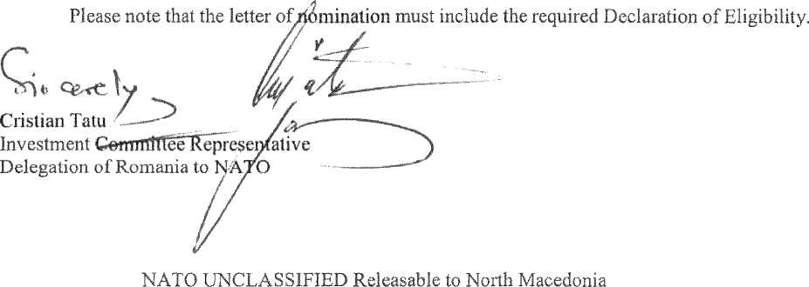

Rougfa Cost Estimate: Total: 788.508 euro
NATO: 521.213 euro (66.10 %)
National: 267.295 euro (33.90 %)
3AF35046 -JFSI Facility and Connecting Pipeline
The scope of the project consists of the provision a JFSI facility on-base fuel storage tank and associated infrastracture. The scope consists of the pro vis i on of truek loading/umloading stations, two storage tanks of 285 m³, a pump house and nianifbld house and associated access roads, platforms, fencing and civil works.
Rough Cost Estimate: Total: 4.000.679 euro
NATO: 3.109.863 euro (77.73 %)
National: 890.816 euro (22.27 %)
3. Total Rough Cost Estimate: 7.296.575 Euro - National and NSIP funding
  - The reference number of NATO Fuiids Commitment Document:
AC/4(PP)D/27840 AC/4(PP)D/27829 AC/4(PP)D/27909 NOR(CI)(2018)0053 NOR(CI)(2018)0033
  - Antłcipatcd Patc of Site Survcv
Up to the day before the Bid Closing Date.
  - Finał Date for Companics to express their desire to be inyited to the tender
Companies which are interested in participating in bidding niust submit their offer and Declaration of Eligibility in English and Rornanian language not later than: 27"' March 2020, 15.00 loeal hours.
  - Planned Tender Release Date (distribution of "Cahier des Charges"):
15th February 2020
  - Schcduled Bid Closing Date:
12th June 2020, 15.00 loeal hours
  - Anticipated Best Bidder Awartl Pate:
2"" July 2020
To ąualify for award of the Contract, bidders shalł meet the minimum ąualifying criteria as specified in the bidding documents. For the ąualified compantes, the criterion for awarding the contract is the best quality/pricc criteria. (70% pricc, 8% technical expcrts, 22% technical criteria)
18. Conipanics from NATO member countries specialized in the project subject need the approval from Government or qualified Authority of their country of origin by submitting 'DECLARATION OF ELIGIBILITY". which should bc forwarded in a form as specified in En ciosu re A.
Ali iiiformation are included in the Bidding Documents, ayailable online in Romanian language on littps://sicap-prod.e-licitatie.ro with identification no. CN 1018844/11.02.2020,
Reąuests for clarification are accepted until 21" March 2020,15JO iocal faours.

