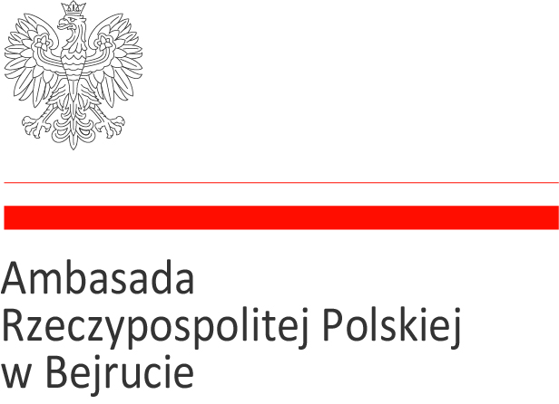
Beirut, 30.04.2025r.

Information from the Opening of Bids
in the public tender procedure for the sale of
tangible movable property
of the EMBASSY OF THE REPUBLIC OF POLAND IN BEIRUT
regarding consumables for multifunction devices
– concerning Announcement No. 1/2025 dated 15 April 2025

The Embassy of the Republic of Poland in Beirut presents the information from the opening of bids – no offers were submitted in this procedure. Therefore, the organizer announces the closure of the tender.
The subject of the procedure was the following assets of the Embassy of the Republic of Poland in Beirut.
1 | WORK CENTRE 6400 xerox TRANSFER BELT
2 | WORK CENTRE 6400 220V FUSER
3 | WORK CENTRE 6400 YELLOW IMAGING UNIT
4 | WORK CENTRE 6400 CYAN IMAGING UNIT
5 | WORK CENTRE 6400 YELLOW HIGH-CAPACITY
6 | WORK CENTRE 6400 WASTE CARTRIDGE
7 | WORK CENTRE 6400 CYAN HIGH-CAPACITY TONER CARTRIDGE
8 | WORK CENTRE 6400 BLACK HIGH- CAPACITY TONER CARTRIDGE
9 | WORK CENTRE 6400 MAGENTA HIGH CAPACITY TONER CARTRIDGE
10 | XEROX STAPLES
11 | WORK CENTRE 6400 BLACK IMAGING UNIT
12 | WORK CENTRE 6400 TRANSFER ROLLER AND OZONE FILTER
13 | BROTHER TONER CARTRIDGE TN-2130
14 | BROTHER TONER CARTRIDGE TN-8000
15 | WORK CENTRE 6400 DOCUMENT FEEDER ROLLER AND PAD - ADF Roller Kit
16 | HP Q6003A TONER PURPUROWY (magenta) FOR PRINTER HP Color LaserJet
17 | RICOH Black FT Toner Cartidge Type 2050
18 | RICOH Toner NGR DSm615 Black
19 | TONER CARTRIDGE HST-S300 B FOR USE IN SAMSUNG CLP 300 SCX 3160
20 | TONER CARTRIDGE HST-S300 B FOR USE IN SAMSUNG CLP 300 SCX 3160

At the same time, the Embassy of the Republic of Poland in Beirut informs that, pursuant to § 23 sections 1 and 2 of the Regulation of the Council of Ministers of 21 October 2019 on the detailed procedure for managing tangible movable assets of the State Treasury (Annex to the Announcement of the Prime Minister of 21 February 2025, Journal of Laws, item 228), a second public tender will be announced and conducted within 3 months from today's date.

