IMPLEMENTATION COMPLETION REPORT
FOR MEASURES SPECIFIED
IN THE LA&RAP

WORKS CONTRACT 1B.5/2

Reconstruction of bridge to ensure a minimum clearance – Road bridge 2.45 km Warta River,
Kostrzyn n/Odra

LAND ACQUISITION AND RESETTLEMENT ACTION PLAN

ODRA-VISTULA
FLOOD MANAGEMENT PROJECT

ISSUE | DATE | PREPARED BY | CHECKED BY | CLIENT'S APPROVAL | DESCRIPTION
1. | 20/06/2025 | Mariusz Ciaś | Monika Ratomska-Kaczmarek | 30/06/2025
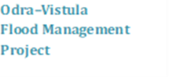


ODRA-VISTULA
FLOOD MANAGEMENT PROJECT
The Land Acquisition and Resettlement Action Plan has been prepared for the Works Contract implemented by STATE WATER MANAGEMENT POLISH WATERS – THE REGIONAL WATER MANAGEMENT AUTHORITY IN Szczecin
IMPLEMENTATION COMPLETION REPORT FOR MEASURES SPECIFIED IN THE LAND ACQUISITION AND RESETTLEMENT ACTION PLAN

SUBCOMPONENT 1B:
FLOOD PROTECTION ON MIDDLE AND LOWER ODRA RIVER

CONTRACT 1B.5/2:
Reconstruction of bridge to ensure a minimum clearance – Road bridge km 2.45 Warta River, Kostrzyn n/Odra

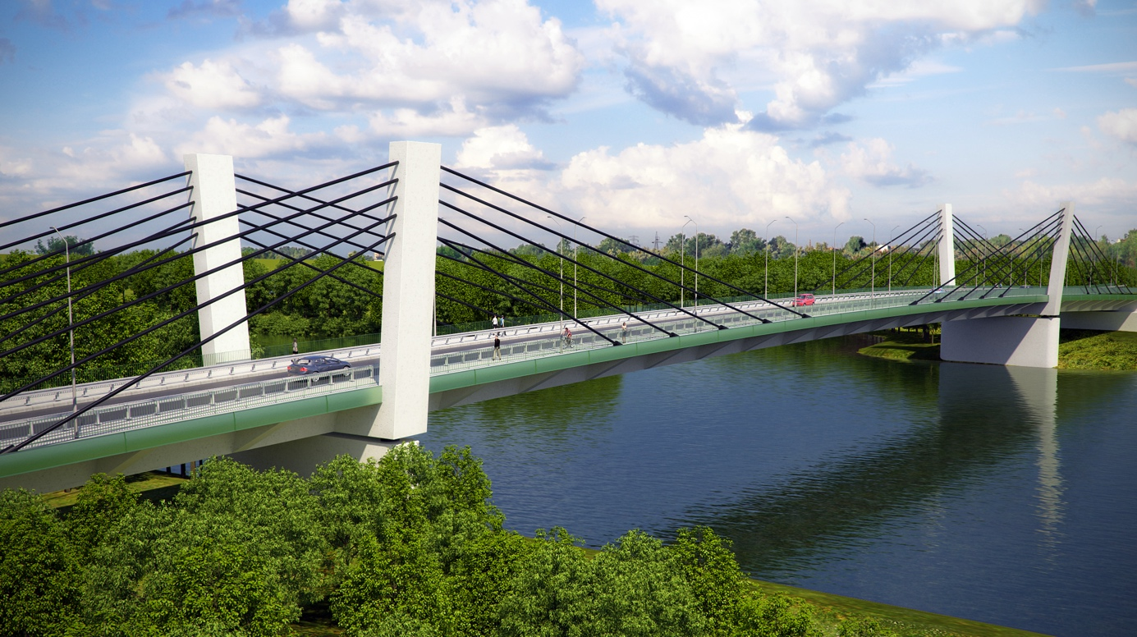
Project Implementation Unit:
State Water Management Polish Waters represented by
the Director of State Water Management Polish Waters
the Regional Water Management Authority in Szczecin
with its registered office at ul. Tama Pomorzańska 13 A, 70-030 Szczecin

Document prepared by:
State Water Management Polish Waters
Regional Water Management Authority in Szczecin
PIU of Odra–Vistula Flood Management Project
Technical Support Consultant SWECO Polska Sp. z o.o.

ODRA-VISTULA FLOOD MANAGEMENT PROJECT CO-FUNDED BY:
World Bank, Loan Agreement No. 8524 PL
Council of Europe Development Bank, Framework Loan Agreement No. LD 1866
State Budget

Szczecin – November 2025

Table of Contents
LIST OF ABBREVIATIONS USED IN THE DOCUMENT 5
1. SUMMARY: 7
2. INTRODUCTION 9
3. SUMMARY OF THE MAIN ACTIONS CARRIED OUT UNDER THE PROJECT 12
3.1. Project Goal Overview 12
3.2. Agreements on the project implementation concluded with GDDKiA 12
3.3. Preparing and adopting the Land Acquisition and Resettlement Action Plan for implementation 13
3.4. Adopted procedures for acquiring real property 13
3.5. Public consultation 14
3.8. Damages and compensations 17
3.9. Project assessment by PAPs 18
4. OPERATION OF THE GRM SYSTEM 20
4.1. System description 20
4.2. Summary of complaints 21
4.3. Conclusions 21
5. MONITORING 22
5.1. Description of the methodology 22
5.2. Summary of the indicators that were monitored 23
5.3. Impact of the Project on PAPs and other persons 24
5.4. Identified problems and solutions 25
5.4.1. Voluntary purchase of residential property: 25
5.4.2. Compensation for lost income 26
5.4.3. Remuneration for Project property expenditures 28
5.4.4. Regulation of the legal status of a property by establishing an easement 29
5.4.5. Implementation of additional works meeting PAP expectations 30
6. SUMMARY 31

LIST OF ABBREVIATIONS USED IN THE DOCUMENT
1B.5/2 | Designation of Works Contract 1B.5/2 – Reconstruction of a bridge to ensure minimum clearance – a road bridge at km 2.45 of Warta River in Kostrzyn nad Odrą
The World Bank (WB) | International Bank for Reconstruction and Development
PCU | Odra-Vistula Flood Management Project Coordination Unit
CEB | Council of Europe Development Bank (CEB)
GDDKiA | General Directorate for National Roads and Motorways – central office of the government administration responsible for the construction of national roads, express roads, and motorways
Project/Undertaking | Reconstruction of bridge to ensure a minimum clearance – Road bridge km 2.45 Warta River, Kostrzyn n/Odra
PIO | Project Implementation Office – a separate organisational unit within the PIU, responsible for the Project implementation
PIU/Employer | Project Implementation Unit – State Water Management Polish Waters The Regional Water Management Authority in Szczecin  ul. Tama Pomorzańska 13 A  70-030 Szczecin
Consultant Engineer | Sweco Polska sp. z o.o. – the legal entity that is employed by the Employer to perform the services (among others, those described herein)
CC | The Civil Code Act of 23 April 1964
Contract/Task/Project | Works Contract 1B.5/2
Structure | A functionally separated material scope being a part of Task 1B.5/2
Social impacts | Any direct loss, social or economic impacts, which arise out of real property expropriation or the permanent restriction in the manner of using or access to the real property.
OP 4.12 | Reference of the document including the principles of performing involuntary resettlement required when the Task is funded under a loan from the World Bank – Operational Policy 4.12 – Involuntary Resettlement.
PAP | Project Affected Person(s)
PGW WP | State Water Management Polish Waters
LA&RAP | Land Acquisition and Resettlement Action Plan
Project/OVFMP | Odra-Vistula Flood Management Project
EMP | Environmental Management Plan
Special Purpose Road Act | The Act of April 10, 2003 on special rules of preparing and executing projects involving public roads
Special Purpose Flood Act | Act of July 8, 2010 on special principles of preparation for the execution of projects in the field of flood-control structures
PR | A permanent restriction in using a real property
RPM Law | The Real Property Management Law of August 21, 1997
Replacement value | compensation for the loss of goods valued based on their replacement/market value, including any transaction costs (e.g. taxes and registration fees), the objective of which is to sufficiently effectively replace the lost goods (replacement value). Replacement value is the amount required to replace the lost assets, excluding the depreciation of arising out of the age, condition or another factor relating to the assets.
Contractor | Warbud Spółka Akcyjna – legal entity executing Works Contract 1B.5/2
RCC | Road Construction Consent

1. SUMMARY:
Task subject: | Reconstruction of bridge to ensure a minimum clearance – Road bridge km 2.45 Warta River, Kostrzyn n/Odra
Date of Project completion  (works completion): | October 13, 2025
Date of “NO” receipt  for the LA&RAP: | September 2, 2020
Date of Road Construction Consent | February 26, 2021
PAP number and category: | Total number: 7 (seven), including:  - owners of the property or perpetual usufructuaries: 2 (two) natural persons;  - owners of the property or perpetual usufructuaries: 2 (two) commercial law companies  - owners of the property or perpetual usufructuaries: 2 (two) public entities;  - contractless property user 1 (one) natural person
Total compensation: | PLN 1,385,939.86
Number of project properties: | A total of 20 (twenty) properties, including:  - 4 (four) plots of land owned or under perpetual usufruct by natural persons;  - 2 (two) plots of land owned or under perpetual usufruct by commercial companies  - 14 (fourteen) plots of land owned or under perpetual usufruct by public entities
Number of plots of land subject to expropriation | A total of 17 (seventeen) properties, including:  - 4 (four) plots of land owned or under perpetual usufruct by natural persons;  - 2 (two) plots of land owned or under perpetual usufruct by commercial companies  - 11 (eleven) plots of land owned or under perpetual usufruct by public entities
Number of plots of land under permanent restriction | 1 (one) property owned by a commercial law company
Number of plots of land under temporary restriction | 1 (one) property owned by a public entity
Number of resettled persons | 1
Complaints mechanism | 0
Key issues: | - expropriations and compensation payments  - entering into an agreement with the GDDKiA to ensure that the objectives of Policy O.P.4.12 are met  - voluntary resettlement of 1 PAP (detailed description: Chapter 5.4.1. Voluntary purchase of residential property)  - payment of compensation for lost income generated by PAP’s business activity as a result of Project implementation (detailed description: Chapter 5.4.2. Compensation for lost income  - payment of compensation for expenditure on property possessed without legal title (detailed description: Chapter 5.4.3. Remuneration for Project property expenditures)  - regulating the legal status of the property by establishing an easement (detailed description: Chapter 5.4.4. Regulation of the legal status of a property by establishing an easement)  - implementation of additional works meeting PAP expectations (detailed description: Chapter 5.4.5. Implementation of additional works meeting PAP expectations)
Key achievements: | - 100% of the objectives of Policy O.P.4.12 have been met (for a detailed description see Chapter 6. Summary)  - PAP voluntarily resettled to a new location by providing them with funding to build a new property (detailed description: Chapter 5.4.1. Voluntary purchase of residential property)  - compensation for lost income generated by PAP’s business activity was estimated and paid on the basis of an agreement (detailed description: Chapter 5.4.2. Compensation for lost income  - compensation was paid to entities subject to expropriation and to users of properties for loss of structures, plantings, and improvements to properties (detailed description – Chapter 3.7. damages and compensations)  - regulating the legal status of the property by establishing a utility easement (detailed description: Chapter 5.4.4. Regulation of the legal status of a property by establishing an easement)
Unresolved issues: | None

2. INTRODUCTION
This document has been prepared in accordance with the requirements set out in the Project Operations Manual and the Land Acquisition and Resettlement Policy Framework document (with 2 updates: Update No. 1 – Land Acquisition and Resettlement Policy Framework (June 2022) and Update No. 2 – Land Acquisition and Resettlement Policy Framework (November 2023)) to document the property acquisition process and assess whether it has met the requirements and guidelines of World Bank Operational Policy OP 4.12. Involuntary Resettlement and whether there are any gaps that should be filled or require the Employer's response.
This Implementation Completion Report is a report on the implementation of measures planned in the LA&RAP for Works Contract 1B.5/2 – Reconstruction of bridge to ensure a minimum clearance – Road bridge km 2.45 Warta River, Kostrzyn n/Odra.
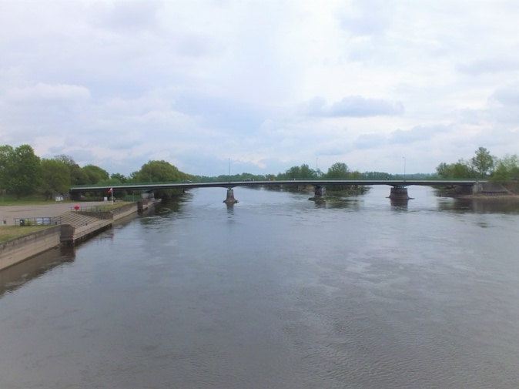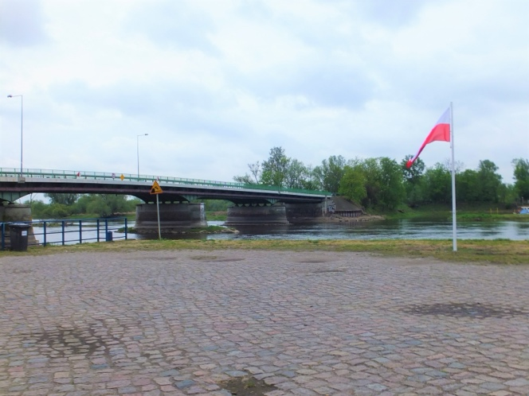
Photo number 1 and number 2: Reconstructed bridge in the state prior to the implementation of the Project
In accordance with the assumptions made in the Land Acquisition and Resettlement Action Plan, an ex-post evaluation should be carried out upon completion of the works under the Task. However, as all the planned measures have been carried out, it is now possible to confirm that its objectives have been met and properly documented. No further impact issues are currently diagnosed. Should the extent of the impacts change or additional impacts arise during the course of further construction works, a supplement to this document will be drawn up.
It is confirmed that all the measures described in the LA&RAP were implemented and that each entity affected by the undertaking (family, individual, public entities) received compensation and that their living conditions were improved or at least restored.
The Task included the widening of the DK 31 national road through demolition and construction of a road bridge to provide a minimum clearance to allow icebreakers to work and ice floes to progress unhindered. The new bridge will have a clearance of 5.25m above the level of HNW (Highest Navigable Water).
Key dates of Contract execution:
- Date of signing the agreement: July 16, 2021;
- Date of handing over the construction site: August 31, 2021
- Works completion date: October 8, 2025
- Quality Guarantee and Warranty Period end date: October 8, 2035

The reconstruction of the structure was accompanied by the adaptation of the road infrastructure and the construction of a pedestrian and cycling route. The construction works also included the reconstruction of the following systems: power, telecommunications, water, gas, stormwater drainage, as well as the construction of a stormwater drainage system in the area of the bridge structure.
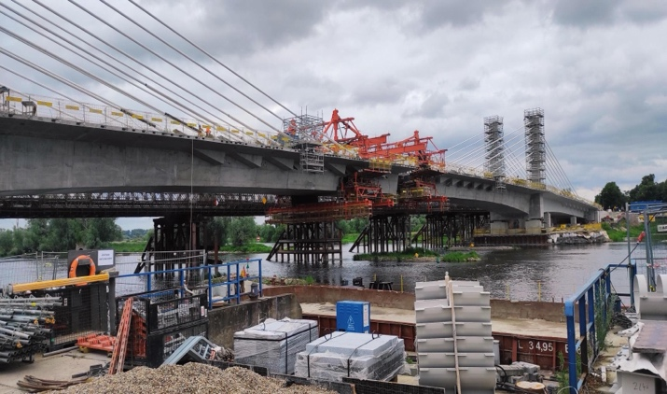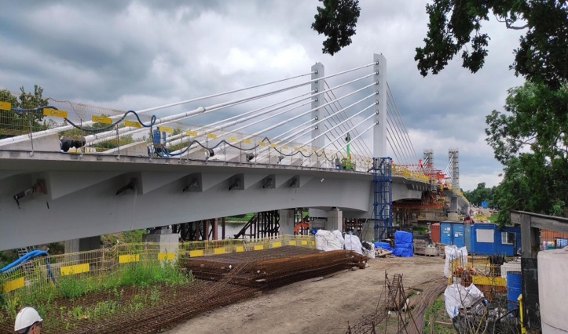
Photo number 3 and number 4: Photographs of the Project as at the date of the Implementation Completion Report
The material scope of the project did not change in relation to its characteristics specified in the Land Acquisition and Resettlement Action Plan for this Task. In addition, the scope of impacts did not change in relation to the scope provided for in the LA&RAP. The number and type of PAPs were the same as specified in the LA&RAP. However, during the implementation of the task, new circumstances were revealed, leading to a change in the type of compensation for one of the PAPs.. It was concluded that both the execution of the construction works and the subsequent operation of the residential building would significantly lower the conditions of use of the property compared to the condition priori to the Investment. As a result of finding an increase in the scope of impact, at the request of the PAP, a voluntary acquisition of the entire property including the residential building and associated development was made. A detailed description of the issue is included in Chapter 5.4.1. Voluntary purchase of residential property. Additionally, it was found that the implementation of the Project had a negative impact on PAP’s business activity conducted in the immediate vicinity of the construction site. During the initial period, the construction works limited and hindered the conduct of this activity. Subsequently, due to difficulties in accessing the property and frequent and repeated temporary access restrictions, it became impossible to continue the activity. Consequently, it was decided that, in accordance with the OP 4.12 Policy, the PAP should be compensated for the lost income. The Employer estimated the lost income, and the amount was accepted by the PAP. A detailed description of the proceedings is presented in Chapter 5.4.2. Compensation for lost income.
The Project was carried out on 20 properties. Prior to the commencement of the project, the Employer had the right to 2 (two) properties which were flowing waters and remained in the PGW WP's possession and the right to 1 (one) property constituting a national road in the possession of the Treasury. These properties did not require acquisition. The remaining 17 (seventeen) plots required acquisition, of which 6 (six) were under private ownership or perpetual usufruct. The remaining properties were owned by the Warta Mouth National Park (1 property) and the Town of Kostrzyn nad Odrą (10 properties). A detailed summary of project properties is included in Appendix No. 1. List of properties on which the Project was implemented. In addition, two RCC changes resulted in the temporary restriction on one property owned by a public entity. The take is temporary, for the construction of a working platform necessary in the course of the construction works. In addition to the project properties, 1 (one) private property owned by a commercial law company, which was permanently restricted by the establishment of an easement for the reconstruction of the power connection. The easement was established at the expense of the Employer for a public transmission entity conducting the business of energy distribution.
There were no residential buildings in the Task area that could be considered residential buildings within the meaning of the Construction Law Act. Residential development was located on properties adjacent to the road lane that constituted the project site. Residential development was approximately 10 (ten) metres from the project site. With the exception of voluntary resettlement (details described in Chapter 5.4.1. Voluntary purchase of residential property) no significant impediments or restrictions affecting the conditions of private use of properties were identified. The completed expropriations and implementation of the Contract did not have the effect of hindering business activities or reducing business income other than as described herein.
Below are the addresses of the websites where information on the implementation of the Project and on the preparation of the LA&RAP was made available:
- www.wszczecinie.pl;
- www.odrapcu.pl (previously: www.odrapcu2019.odrapcu.pl);
- www.gov.pl/wody-polskie-szczecin (previously: www.bs.rzgw.szczecin.pl);
- www.kostrzyn.pl
The paper version of the LA&RAP was also available at:
- RZGW in Szczecin,
- Kostrzyn nad Odrą Town Hall;
- The Project Implementation Office of the Odra-Vistula Flood Management Project (PIU).

3. SUMMARY OF THE MAIN ACTIONS CARRIED OUT UNDER THE PROJECT

3.1. Project Goal Overview
The main purpose of the OVFMP is to protect the persons residing at the floodplains situated in specified parts of the basins of the two largest Polish rivers (Vistula and Odra), against serious floods. As part of one of the subcomponents of the Project, this Task was carried out, which was aimed at flood protection in the Middle and Lower Odra, covering the areas most at risk of flooding, in order to enable effective and safe ice-breaking operations in the areas of the communes indicated in Chapter 1.

3.2. Agreements on the project implementation concluded with GDDKiA
The Task was implemented on the basis of the provisions of the Special Purpose Road Act. Pursuant to Article 11a of the Special Purpose Road Act, the voivodeship governor issues a decision to authorise the implementation of a road project at the request of the competent road manager, which in the case of the national road DK 31 was the GDDKiA. As the Employer was not, according to the provisions of Polish law, an entity entitled to apply for an RCC, an agreement regulating the principles of preparation and implementation of the Project was concluded on August 7, 2018 between PGW WP and GDDKiA for formal reasons. On its basis, PGW WP undertook to finance all costs associated with the Project.
In order to establish rules for the financing of compensation costs for expropriation or restrictions on properties, a supplementary agreement was concluded on July 29, 2020 setting out the rules for the payment of compensation. It was agreed that, towards future costs, PGW WP would make an advance payment of PLN 924,200.00 to GDDKiA. The advance payment was to be used for all costs related to the determination and payment of compensation in the amounts agreed with the property owners or specified in the compensation decisions. Upon completion of the compensation payment process, any unused portion of the advance was refundable to PGW WP. Any shortfall was to be covered by PGW WP. In addition, the provisions of the agreement reaffirmed the obligation to apply in the compensation process the principles set out in the LA&RAP and the World Bank's Operational Policy OP 4.12.
The adopted method of proceeding and its justification are described in detail in the Land Acquisition and Resettlement Action Plan in Chapter 6.3. Acquiring properties – rules and procedures in view of the provisions of the Act of April 10, 2003 on special rules of preparing and implementing projects involving public roads (hereinafter: Special Purpose Road Act). The introduced solution was evaluated positively and received approval by means of a no objection clause for the LA&RAP.
The advance paid to the GDDKiA was partly used for compensation and the costs of drawing up appraisal reports determining the amount of compensation due. GDDKiA paid the total amount of PLN 584,197.50 from the advance payment. Each expense was incurred on the basis of a decision or agreement. All expenses were documented by providing the Investor with confirmation of transfers to PAPs.
In November 2024, following the completion of the compensation process, the advance settlement was made. The GDDKiA transferred the unused advance payment of PLN 340,002.50 to PGW WP.

3.3. Preparing and adopting the Land Acquisition and Resettlement Action Plan for implementation
For the Task, the Employer drafted the Land Acquisition and Resettlement Action Plan (LA&RAP) for Contract 1.B.5 – Task 1.B.5/2 – Reconstruction of bridge to ensure a minimum clearance – Road bridge km 2.45 Warta River, Kostrzyn n/Odra, carried out as part of the Odra-Vistula Flood Management Project (OVFMP), co-financed by the International Bank for Reconstruction and Development (World Bank) (the Loan Agreement of September 10, 2015), the Council of Europe Development Bank (CEB) (the Loan Agreement of May 24, 2016) and the State budget.
Once the work on the draft LA&RAP was completed and the World Bank's approval was obtained based on it (the World Bank's preliminary approval, the so-called “OK” for the draft LA&RAP was received), the public release procedure began. The document was subjected to public consultation in accordance with the principles described in Chapter 8. Public Consultation on the LA&RAP.
As part of the publication of the document, no requests or comments were submitted, and thus the LA&RAP was not supplemented. A World Bank "No objection" was obtained for the document on September 2, 2020 After obtaining the "No objection" clause of the WB, the final LA&RAP was made available to the interested parties, i.e., posted on the websites of the PIU and the Odra-Vistula Flood Management Project Coordination Unit, and remains there until the completion of the Contract implementation. The provisions of the LA&RAP were implemented both before the commencement and throughout the period of implementation of construction works.

3.4. Adopted procedures for acquiring real property
All the procedures adopted and described in the Land Acquisition and Resettlement Action Plan related to the acquisition of the property and the payment of compensation to PAPs were followed.
The project was not carried out on the basis of the Act of 8 July 2010 on special principles of preparation for the execution of projects in the field of flood-control structures, which details rules and conditions of preparing projects involving flood-control structures and meteorological radar stations. The project does not fall within the term ‘flood prevention structure’ as defined in the Act. In view of the above, any monetary damages or other forms of compensation were implemented on the basis of agreements or compensation decisions in accordance with the provisions of the Special Purpose Road Act. It should be noted that the procedure for the payment of compensation set out in the Special Purpose Road Act is essentially the same as that set out in the Special Purpose Flood Act.
The implementation of the Task required the acquisition of rights to 17 (seventeen) properties, of which only 6 (six) were owned or subject to the perpetual usufruct of private parties. The remaining properties which were necessary to acquire and on which the project was carried out were owned or in perpetual usufruct by public entities: Warta Mouth National Park (1 property) and the Town of Kostrzyn nad Odrą (10 properties).
According to the provisions of the Special Purpose Road Act, the acquisition of properties or parts thereof, as well as the permanent and temporary restriction of the use of properties or parts thereof, was done by means of a Road Construction Consent (RCC) decision. The decision in question was issued on February 26, 2021 by the Governor of Lubuskie Voivodeship, at the request of GDDKiA, which acted as the employer within the meaning of administrative law. The decision of the Lubuskie Voivodeship Governor has not been appealed.
Due to the need to temporarily take one additional property for the construction and use of a temporary structure – a working platform – applications have been made to amend the RCC decision. The subject of the amendment was a property that was owned by the Town of Kostrzyn nad Odrą. A review of the condition of the property confirmed that the property was not in use, nor was it subject to a lease or rental agreement. Taking into account the Employer's requests, the RCC decision was amended twice in the course of the Project to the following extent:
- The first amendment was based on Decision No. 1/2022 of May 23, 2022 issued by the Lubuskie Voivodeship Governor. The amendment was due to an increase in the number of piers of the temporary bridge and the construction of a temporary working platform. The change resulted in the temporary take of one additional property. The property was owned by a public entity – the Town of Kostrzyn nad Odrą. This entity was included in the PAP list.
- The second amendment was based on decision No. 4/2025 of May 5, 2025 issued by the Lubuskie Voivodeship Governor. The amendment was a consequence of a change in the environmental permit and the need to increase the area of temporary property take. The additional restrictions resulting from the amendment applied to the same property that was subject to the temporary restriction imposed by the first amendment to the RCC. Only the area of the plot was increased.
By operation of law, the RCC decision becoming final resulted, inter alia, in the following legal effects: acquisition by the State Treasury of the ownership of properties separated by the site demarcation lines established in the RCC decision, expiry of limited property rights on the property or the right of perpetual usufruct of that property, acquisition of the right of perpetual usufruct of land property and the right of ownership of buildings, other devices and premises located on that property, the obligation to determine the amount and payment of compensation in certain cases. Once the RCC became final, it was additionally a basis to disclose the title in the properties in the land and mortgage registers and in the cadastre.

3.5. Public consultation
The implementation of the Task was preceded by a socioeconomic survey and a socioeconomic study. Based on the data collected on the owners and users of project properties, a public consultation plan was drawn up to provide proposals for minimising impacts. Expectations noted during the public consultation were subject to technical analysis and subsequently forwarded for inclusion in the construction plans.

On December 14, 2018, a consultation meeting was held at the offices of the Town of Kostrzyn nad Odrą, to which entities with affected status, as well as entities that could potentially be among the affected entities, were invited. More than 30 people were invited to the meeting. The meeting had an open format, with the opportunity for any interested person to attend.
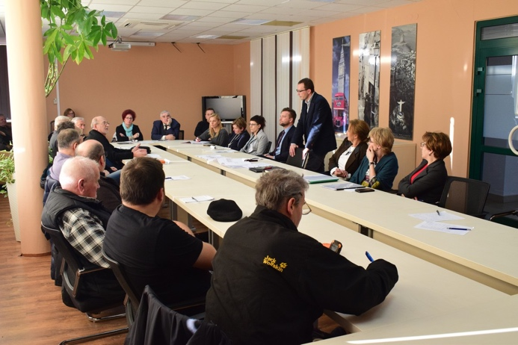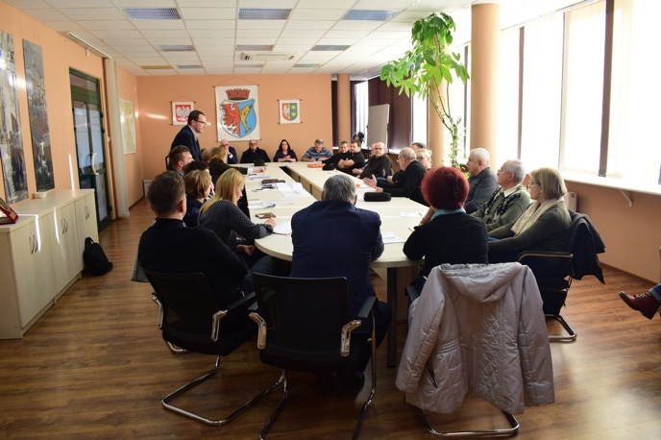
Photo number 5 and number 6: Meeting of December 14, 2018
During the meeting, demands and proposals for minimising the impact of the project were presented. The technical analysis made it possible to include them in the construction documentation because their object was mainly to ensure access to private individuals' properties during the period of construction work and the schedule of implementation of the various stages of the construction work being carried out.
Minimising measures, including public consultations, one-on-one meetings and phone calls, were offered to entities located or potentially located within the project's impact range. Throughout the Task implementation period, there was constant contact with PAP, meetings were organised, they were contacted by post and telephone. A detailed list of meetings and their subject matter is presented in Appendix 2 Summary of Meetings. Each of the PAPs was provided with contact details of the Consultant's representatives in order to facilitate the clarification of any doubts or the resolution of complaints. Interested parties were guaranteed the opportunity to obtain information about the Project, and this opportunity was used repeatedly. The expected information concerned the Project schedule, the impact of the Project on the economic situation, the stage of the compensation procedure or the negotiation of the amount of compensation.
It should be noted that part of the implementation period of the Project was during the COVID-19 pandemic period, during which numerous restrictions on meetings were in place. Despite this circumstance, mechanisms were created (telephone contact, information provided to PAPs by email, online public consultations) to guarantee ongoing provision of information about the Project so that there were no negative effects on the implementation of OP 4.12.
3.6. Requests filed during the LA&RAP publication period:
Direct conversations were conducted with 7 people affected by the project during the LA&RAP publication period.
A significant request received by the Employer concerned the acquisition of a property adjacent to the Project site (see: Chapter 5.4.1. Voluntary purchase of residential property.) Other issues of interest to PAPs concerned the schedule of works, access to the property during the construction period, and the principle of determining compensation. Each of the PAPs was provided with the expected information and the Employer committed to providing uninterrupted access to each property during the construction period. In implementing the assurances, the Employer imposed an obligation on the Works Contractor to implement traffic arrangement within the site in such a way as to allow access to each property with a residential building.
At the meetings, it was also discussed how to restore and regulate property fences. It was agreed that temporary fencing will be provided for the temporary demolition of the fences, and once the works are complete the fences will be reconstructed from the existing elements so that their aesthetic value is maintained. Detailed arrangements would be made immediately prior to the commencement of construction works to the extent that they affect the property.
3.7. Public consultations related to the public release of the LA&RAP:
After preparing the draft LA&RAP document and obtaining the approval of the World Bank for the commencement of the public release procedure on its basis, the document was the subject of public consultations, which were conducted in accordance with the operational policy of the World Bank OP 4.12 and the procedures provided for in the LA&RAP. The electronic version of the LA&RAP and a notice of public debate over the draft LA&RAP, its place and date has been posted on publicly available websites of:

- RZGW in Szczecin – https://www.gov.pl/web/wody-polskie-szczecin
- RZGW in Szczecin (Project website) – www.szczecin.wody.gov.pl (then: http://bs.rzgw.szczecin.pl/),
- Project Coordination Unit – www.odrapcu.pl (then: http://odrapcu2019.odrapcu.pl/),
- Town of Kostrzyn nad Odrą – www.kostrzyn.pl.

Paper version is available for viewing in the following premises:
- RZGW in Szczecin, ul. Tama Pomorzańska 13A, 70 – 001 Szczecin;
- Project Implementation Office, Teofila Firlika 19, 71 – 637 Szczecin (currently ul. Tama Pomorzańska 13A, 70-001 Szczecin)
- Municipal Office in Kostrzyn nad Odrą, Graniczna 2, 66-470 Kostrzyn nad Odrą.

Information on the possibility to review the document and to file requests and comments, along with specific contact details (e-mail and address of the place where the draft may be reviewed, office hours, phone number and name of the contact person) have been published in local press: Szczecin supplement to Gazeta Wyborcza and in "Kurier Szczeciński" as well as on the Employer’s website.

Due to the constraints on social life in Poland caused by the emergence of the SARS-CoV-2 virus causing COVID-19 disease, and taking into account the recommendations of the World Bank and the need to ensure safety of, it was decided that there would be no public consultation meeting. Carrying out the obligation to conduct public consultations and to provide PAPs with the opportunity to read the LA&RAP and to submit requests and comments, it was decided to conduct consultations by way of correspondence. As part of the consultation, all PAPs were sent a form for submitting proposals, comments and questions, as well as a cover letter that included:

- presentation and information brochure concerning the Project and the Contract for Task 1B.5/2,
- full name of the person handling the case,
- contact data – telephone number, e-mail address, correspondence address,
- information that after the expiry of the deadline for getting acquainted with the submitted project, which is 7 days, the designated person will contact PAP by phone or e-mail in order to discuss the content of the document and answer any questions.

The above documents were sent via email and registered mail.

The LA&RAP publication period started on June 22, 2020 with distributing the documents in the said manner, and lasted for 21 days until July 13, 2020. Seven days after the documents were submitted, the process of direct telephone conversations with PAP began, the aim of which was to present the impact of the project on their situation and to provide information on the properties occupied for the purposes of the Task, as well as to clarify any doubts regarding the content of the LA&RAP.

An online consultation meeting in the form of a webinar was held on 14 July 2020 from 3 p.m. to 4.30 p.m. A link to the webinar, as well as step-by-step instructions showing what steps you need to take to attend an online meeting, were made available on the Project website.

The public consultation, including the webinar, was recorded in a report describing its procedure and the reason of choosing this particular procedure; the report is attached hereto as Appendix No. 3. Report from public consultation on the LA&RAP for the Implementation Completion Report.
During the course of the Project, meetings were organised with PAPs as needed. A detailed summary of the meetings with their subject is attached as Appendix 2. Summary of meetings.

3.8. Damages and compensations
The implementation of the Task required the expropriation of properties, which was carried out on the basis of the procedure set forth in the Special Purpose Road Act. The object of expropriation was specified in the RCC decision issued by the Governor of the Lubuskie Voivodeship.
Under Task 1B.5/2, those eligible to receive compensation were the owners and perpetual usufructuaries of properties that were subject to expropriation and a person who used part of the project property without a legal title.

Table 1. – PAPs who received compensation
No. | PAP category | Compensation measures | Additional action | Compensation amount | Payment date
1. | Owner | Cash compensation for expropriation and lost income from business activity | No need for additional action | PLN 13,849.50  (expropriation)  PLN 29,000.00  (lost income) | August 10, 2021 to January 5, 2026
2. | Owner | Cash compensation | No need for additional action | PLN 806,670.00 | August 25, 2021  August 8, 2021
3. | Perpetual usufructuary | Cash compensation | No need for additional action | PLN 67,860.00 | December 23, 2022
4 | Perpetual usufructuary | Cash compensation | No need for additional action | PLN 95,738.00 | October 15, 2021  August 6, 2024
5. | Owner | Cash compensation | No need for additional action | PLN 340,800.00 | December 16, 2022  December 23, 2022
6. | Contractless user | Monetary compensation in the amount of the replacement cost of lost assets (fence) | No need for additional action | PLN 31,636.36 | October  31, 2025
7. | Owner | Cash compensation | No need for additional action | PLN 386.00 | December 19, 2023
Total: PLN 1,385,939.86

According to the above table, the compensation was paid to 7 (seven) entities, in the total amount of PLN 1,385,939.86. The value of all property compensation due to expropriation was determined on the basis of valuations prepared by property appraisers. The valuations were preceded by an inspection of the properties, during which photographic documentation was taken. For each entity, the amount of compensation was confirmed in decisions issued by the Lubuskie Voivodeship Governor. One of the PAPs (a commercial law company) appealed against the decision determining the amount of compensation in respect of two plots of land to which it had a right of perpetual usufruct. The procedure for payment of the undisputed part of the 70% compensation amount was applied to this entity. The remainder was paid out after the Lubuskie Voivodeship Governor reissued the compensation decisions. Compensation for lost income from business activity was estimated on the basis of documents provided by the PAP and specified in an agreement accepted by the PAP.

3.9. Project assessment by PAPs
As part of the implementation of the Project and socio-economic research, in order to determine and assess the impact of the Project on people who were affected by the effects of its implementation and on the local community, surveys were carried out twice – as part of the preparation of the LA&RAP and after the end of the project.
In 2018, the PAPs were surveyed about whether they considered it reasonable to implement Task 1B.5/2 and how they see its impact on their quality of life and economic standing (impact on revenue). The target group included in the surveys were people located, even potentially, at the site of the project impact, and leaders of the local community. None of the respondents have indicated that the Contract will adversely affect their economic standing or reduce their revenue. Respondents were satisfied with the reconstruction of the bridge and the target strengthening of flood protection in Kostrzyn nad Odrą. An additional benefit was the works to rebuild the road infrastructure. Residents signalled a problem due to the volume of traffic in the vicinity of the existing bridge and the poor condition of the pavements. In the Project, they saw an opportunity to solve traffic problems by making existing traffic networks more efficient.
Due to the small number of PAPs, telephone interviews were carried out at the stage of the Project Implementation Completion Report to solicit assessments on the subject matter of the Project and the principles of its implementation. The information provided during the telephone interviews was confirmed in notes. It was agreed that the implementation of the Project continues to be acceptable to the community. Every respondent confirmed the necessity of the project and saw the benefits that would follow the construction process. Each of the PAPs gave a positive assessment of the progress of the works and the principles of implementation of the LA&RAP. Acceptance of the compensation amounts awarded was maintained, with the amounts assessed as satisfactory and in line with their replacement values.
PAPs paid attention to and positively assessed primarily:
- measures taken by the Employer to provide information – PAPs said that they were very satisfied with the way they were informed about the project, planned activities, deadlines and conditions for compensation, as everything was clear and transparent, as well as with the meetings held;
- the need to implement the Project – PAPs indicated that such projects are very much needed and that they support their implementation;
- the amount, timeliness, and conditions of compensation payment – PAPs said that they have no objections as to the date and conditions of compensation payment. Each of the PAPs was also satisfied with the amount of compensation.
The results of the survey lead to the conclusion that PAPs are satisfied and content with the way the Project was implemented.

4. OPERATION OF THE GRM SYSTEM

4.1. System description
The mechanism for the submission of complaints and requests concerning all matters related to the execution of the Contract 1B.5/2 was established and implemented, in accordance with LA&RAP assumptions, at the beginning of the entire process and was valid for the duration of the execution, functioning, and closure of the Contract in question. All interested parties were entitled to file a complaint or request in one of the following three places:
- Directly in the main Project office, which will serve as a consultation point: Office of the Consultant Engineer:

SWECO Polska Sp. z o. o.
ul. Łyskowskiego 16
71–641 Szczecin

- Directly at the Employer's office:

State Water Management Polish Waters
RZGW in Szczecin
ul. Tama Pomorzańska 13 A
70-001 Szczecin

- Directly at the site office.

- In addition, complaints and requests may be submitted:

- by mail to the addresses indicated above
- via e-mail to the following addresses:
e-mail: projektBS@wody.gov.pl
e-mail: odra.szczecin@sweco.pl
- by phone at:
PIU: +48 91 441 12 00
Consultant: +48 605 071 242
Deadlines were set for considering complaints and requests:
- written confirmation of the complaint receipt: within 7 days from the complaint receipt;
- if the examination of a request or complaint required a previous explanation, the process included the collection of materials as well as analysis, studies, etc. In such an event, a reply to the complaint or request was to be given in 14 days from the date of submission;
- when it is not necessary to conduct an investigation procedure, a response to a complaint or a request would be provided within 7 days from the date of its submission;
- in particularly complex cases or if acceptance of the request or complaint requires amendments to the LA&RAP, the time limit for replying to the complaint or request was extended to 30 days.

In the organizational structures of RZGW in Szczecin and the Consultant, persons were appointed to handle complaints and contact the persons submitting complaints.

4.2. Summary of complaints
During the course of the Project, no complaints were received regarding the implementation of the LA&RAP. Consequently, there was no need to consider complaints.

4.3. Conclusions
Due to the correct implementation of the LA&RAP, quick and correct identification of all PAPs, and remaining in constant contact with PAPs from the moment of learning about the preparations for the commencement of the Project, and then continuous monitoring of the implementation of the LA&RAP allowed for getting acquainted with the needs of PAPs and their effective fulfilment, and consequently – none of the PAPs submitted a complaint in this scope. Ongoing monitoring of the Contractor's compliance with the project implementation rules was ensured, and contact was maintained with each PAP. Measures were taken to prevent PAP dissatisfaction which resulted in a lack of complaints. Each issue presented by the PAP was analysed and preventive measures implemented. Potential problems were monitored until the end of the Project.

5. MONITORING

5.1. Description of the methodology

The monitoring of LA&RAP implementation is an integral part of the Contract monitoring and management system. In consequence, the monitoring process used tools applied in monitoring the implementation of the Contract, aimed at reporting to sponsoring undertakings and delivering current information about any issues, contingencies and irregularities. The LA&RAP is an integral part of the project process, which allows for an immediate reaction in the event of problems or irregularities. It is also fundamentally important to ensure appropriate cooperation between the Consultant, PIU and PCU. The information flow within the monitoring is presented in the following diagram. General monitoring and assessment procedures are elaborated in the Land Acquisition and Resettlement Policy Framework (LA&RPF) and set out in detail for this Task in the LA&RAP.

It should be emphasized that during the implementation of the LA&RAP, telephone numbers and e-mail addresses of contact persons within the Consultant's structure were made available to PAPs. These people contacted PAPs with respect to all activities related to determining the amount and payment of compensation. Before receiving monetary compensation, PAPs relatively often contacted the representatives of the Consultant in order to obtain details regarding the determination of the amount of compensation, payment dates, or other activities directly affecting their lives. After the compensation was paid to the PAPs, they stopped contacting the Consultant and the Employer, including no complaints, requests for explanations, or requests for any action.

5.2. Summary of the indicators that were monitored

The LA&RAP includes a table containing the main indicators to be monitored during the implementation of the Project. Below is a table containing a summary of monitoring indicators used in the implementation of Task 1B.5/2 implemented by PGW WP – RZGW in Szczecin
Table 2. The main indicators that were monitored during the implementation of the Project (completed)
Indicator | Information source | Monitoring frequency | Progress indicator
Parameters assumed
The number of properties acquired | Civil-law contracts, Consultant's Records | Monthly/Quarterly | 17
The number of Project Affected Persons (PAP) | Land and Mortgage Registers, excerpts from land register, tenancy agreements concluded, visits on task site | Continuous updates during the arrangement and payment of compensations | 7
The amount of all expenses on resettlement, including compensations (paid) | Consultant's Records | Monthly/Quarterly | PLN 1,385,939.86
Parameters achieved
The amount of all expenses on resettlement, including compensations (actual) | Employer's financial records | Monthly/Quarterly | PLN 1,385,939.86
The amount of other expenses (other compensation measures) | Employer's financial records | Monthly/Quarterly | PLN 11,988.94
The number of properties acquired | Employer's/Consultant's Records | Monthly/Quarterly | 17
Performance indicators
Number of complaints | Employer's/Consultant's Records | Monthly/Quarterly | 0
Number of complaints examined | Employer's/Consultant's Records | Monthly/Quarterly | 0
Compensations paid, other | Employer's financial records | Monthly/Quarterly | PLN 1,385,939.86

Monitoring of the LA&RAP implementation under Task 1B.5/2 was carried out in accordance with the assumptions described in the LA&RAP. As part of the monitoring, the Consultant prepared monthly, quarterly, and annual reports, supplemented the registers and tables in the case of events for which a given register or table was created, and also reported on an ongoing basis. The Consultant, in cooperation with other representatives of the Consultant and the PIU, also developed action schedules and action plans.
As indicated in the LA&RAP, an essential role for monitoring the LA&RAP implementation was played by Consultant’s and PIU's recording of facts and events, in particular through a register of correspondence, register of complaints, register of progress in acquiring titles to dispose of the property for construction purposes, and register of progress in compensation payment. The information contained in the registers were taken into account when preparing a data summary on the quantity of acquired properties and the amount and type of compensations paid. Any changes were recorded in the registers. The registers were used to thoroughly monitor the following parameters:
a) the number of properties to be expropriated and already expropriated,
b) the number of persons to be resettled and already resettled,
c) the number of properties to be temporarily acquired (planned and achieved),
d) the amount of all expenses on the resettlement process (planned and achieved),
e) compensations paid for the loss of title to property,
f) compensations paid for the loss of income source,
g) other paid compensation related to project implementation,
h) degree and status of the execution of protective activities,
i) replacement real properties, obtained and assigned,
j) numb er of complaints.
Taking into account the above monitoring assumptions, it was possible to prepare table number 7 containing relevant data from the point of view of the LA&RAP.

The number of properties to be expropriated and already expropriated | The number of people in need of resettlement and displaced | The number of properties taken temporary (planned and achieved) | Compensation paid for loss of right to property | Compensation paid for loss of income
17/17 | 1/1 | 1/1 | PLN 1,356,939.86 | PLN 29,000.00

Impact of the Project on PAPs and other persons
Thanks to the implementation of the Contract, the residents of Kostrzyn nad Odrą, i.e., the area in which the Project was carried out, obtained an actual benefit. The implementation of the project was aimed at flood protection and enabling effective and safe icebreaking, which had a direct impact on the inhabitants of the entire town and region. As a consequence, it should be recognised that the beneficiaries of the Project were not only the residents of the Project area, but also the residents of the area located in the area of the Project, as this area is protected against floods and proper and safe icebreaking is possible. The implementation of the Contract directly increased the sense of security of the broadly understood local community.
The execution of the works has so far proceeded in cooperation with the residents.. This is the result of the correct implementation of the measures indicated in the Land Acquisition and Resettlement Action Plan for the Works Contract 1B.5/2 and the Contractor's implementation of works according to the recommendations of the Environmental Management Plan for the Works Contract 1B.5/2, i.e., mitigating measures – minimising the negative impacts, as well as continuous and ongoing monitoring.
The project involving the reconstruction of bridges to ensure a minimum clearance, has a real impact on the safety of residents throughout the region. Indirectly, the new infrastructure will also improve traffic at an important junction located in the border area. The completed new bridge provides greater traffic capacity and increases commuter comfort. In summary, the implementation of Contract 1B.5/2 will directly increase the sense of security of the local community, protect real estate/property against flooding, and indirectly improve the transport route for people using the new infrastructure.
Before the start of construction work, multiple inspections of the project site were conducted. As part of these activities, the people who used the properties were identified. A list of affected persons was therefore created, which included owners and perpetual usufructuaries. The Employer contacted each PAP and held a briefing with them. As compensation, each of the eligible entities received monetary damages determined by an administrative decision issued by the Governor of the Lubuskie Voivodeship. In implementing the O.P. 4.12 policy, the determination of the amount of damages was guided by the principle that damages should allow for the restoration of lost property. As a result, no PAPs were financially harmed, as any type of lost assets was subject to financial compensation. The described method of determining the amount of financial compensation was accepted by PAPs.
While monitoring the impact of the Project, the impact on the business activity conducted by the PAP in the immediate vicinity of the construction site was also determined. The Land Acquisition and Resettlement Action Plan did not initially identify a need to pay compensation for lost income. However, due to the ongoing impact assessment conducted as part of the Project it was concluded that compensation was justified and remained consistent with the objectives of the OP 4.12 Policy. A detailed description of the issue is provided in Chapter 5.4.2. Compensation for lost income.

Identified problems and solutions
During the implementation of the Project, no problems were identified that could threaten the implementation of the Project or that could result in an increase in negative impacts on PAPs or other people, including new PAPs being added to the PAP list.
However, there were four issues that required deeper analysis and a special approach:

Voluntary purchase of residential property:
The most significant issue during the implementation of the Task was considering the request for the purchase of a property with a residential building. The property in question consisted of three separate registered plots of land with a total area of 0.0893 ha. The whole formed a coherent development consisting of a dwelling house and two outbuildings and two garages. The property was located immediately adjacent to the construction site, to which it adjoined with two boundaries.
It was originally intended that only two of the three geodetic plots forming the residential property would be expropriated under the RCC. The expropriation area was to be 0.0169 ha which represented 18.92% of the property. However, due to the intensive development area of the property, the expropriation significantly restricted the spatial layout and use of the property. In addition, raising the elevation of the designed bridge, including the mixed use path, would result in an adverse change in ground levels. The residential building, left unchanged, would be significantly below the bridge structure which would disrupt the spatial order and would not provide privacy for the users of the residential property.
The granting of the request for voluntary purchase of the entire property also resulted in benefits for the Employer. The acquisition of the entire property, following the demolition of the buildings, meant it could be used as a storage yard for the contractor and it facilitated transportation within the site during the period of the works.
As a result, the decision was taken to purchase the property consisting of two separate geodetic plots. As the purchase, according to Polish law, should enter into the State Treasury's assets, it was necessary to conclude an additional agreement with the Starost of Gorzów District. To this end, an agreement was concluded on July 16, 2020 between PGW WP and the State Treasury – the Starost of Gorzów District to implement the acquisition of the property from PAP. On the basis of this agreement, PGW WP undertook to obtain all the necessary approvals for the conclusion of the property sale agreement and to fully cover the related costs, in particular the property purchase price.
The price of the property was determined on the basis of valuation reports. The amounts specified in the valuation reports were accepted by the PAP.
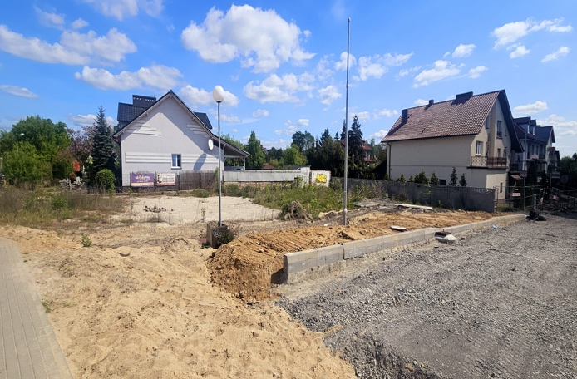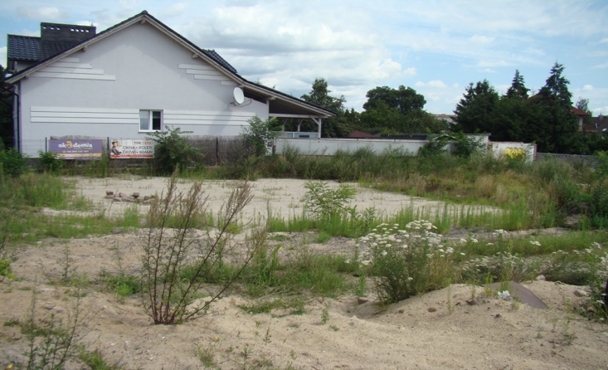
Photo number 7 and number 8: Property after demolition of a residential building
The acquisition of the PAP property occurred as a result of two actions. Two of the geodetic parcels forming the property were acquired under a RCC. The third plot was acquired on the basis of a separate agreement in the form of a notarial deed between PAP and the State Treasury represented by the Starost of Gorzów District. The compensation received by PAP and price was used to build a new dwelling house in a new location. For the duration of the construction of the new house, free use of the existing property was provided to the PAP. The property was finally released by PAP on April 3, 2023.

Compensation for lost income
The PAP who was the owner of a project property ran a sole proprietorship on the property, the scope of which was a hospitality business, i.e., room rental. The PAP rented four rooms, which could accommodate up to eight people. During the course of the Project, the PAP informed the Consultant about inconvenience related to Project implementation, i.e., increased noise, dust and other debris settling on the property intended for renting. Additionally, there were permanent (lasting several days) or temporary (lasting several hours, due to the transport of materials, the traffic of excavators and other construction machinery) restrictions on access to the property. Access to the property was therefore significantly impeded. The PAP pointed out that the above had a negative impact on their business activity, including a reduced revenue. The PAP also received complaints and negative feedback from renters related to disruptions to their stay in the rented rooms. Subsequently, it was determined that the commencement of the Project ultimately resulted in an actual suspension of business activity.
In the course of application verification, the Consultant obtained a considerable amount of information concerning the type of business activity, the revenue generated by the PAP, and the costs incurred before and after the commencement of the Project, which made it possible to assess the validity of the claims made. The inconvenience associated with the debris settling on the property intended for renting and the difficulties resulting from the inability to leave and enter the property described by the PAP were confirmed by means of photographic documentation. Based on the entries in the construction site log, the initial date of difficulties in accessing the property and the duration of the described inconvenience were determined.
The Consultant also received financial documents detailing the PAP’s financial situation before the start of the Project and during its implementation for the years 2022-2024. The analysis revealed a decline in revenue, which was closely related to the start of the Project in the vicinity of the property used for business activity. The provided financial documents made it possible to estimate the lost income. The lost income estimated were accepted by the PAP. As a result, on November 6, 2025 an agreement was signed regarding the voluntary payment by the Employer to PAP of compensation for lost income. The due date was set at 60 days from the date of signing the agreement. The agreed compensation was paid on 22 December 2025..
In accordance with the World Bank’s operational policy OP 4.12. Resettlement, a loss of or reduction in income from business activity resulting from the Project requires compensation. As indicated in the LA&RAP Chapter for Task 1B.5/2 on the inconsistencies between OP 4.12. and the Polish law, as well as the corrective instruments adopted in this regard, in the case of entrepreneurs (in the event of loss of or reduction in income), it is possible to apply the general mechanisms of the Civil Code (compensation for damage suffered and lost profit). Thus, the Employer, implementing the Project also based on the rules and guidelines resulting from Policy OP 4.12., was obliged to cover the damage. Following the determination of impact of the Project on the business activity conducted by PAP, the obligation to compensate them for lost income was recognized. The impact consisted in permanent (lasting as long as several days) or temporary (lasting several hours, due to the transport of materials and the traffic of excavators and other construction machinery) restrictions on access to the property where the PAP conducted its business activity, increased noise due to the work carried out on and near the property, accumulation of dust, dirt, and other debris on the property. This led to an obvious decrease in the attractiveness of the rented rooms, numerous complaints from customers, a deterioration in the reputation of the building, and a decline in interest in the offer. As a result, the PAP recorded a decline in revenue, which ultimately justified the award of the accepted amount of compensation.
The amount of compensation was determined following an analysis of PAP's historical incomes. Incomes generated prior to the commencement of the Investment were compared with incomes generated after the commencement of construction works. The amount of compensation took into account the period until the completion of the Investment. As the lost income from operations depended on many external factors (e.g. seasonality, weather), it was difficult to determine a specific amount. Therefore, average data was used for the valuation. As a result, a lump sum was estimated which, in the Investor's opinion, compensated for all lost income for the period of the Investment. PAP accepted the valuation methodology and its result.
It is important to note that the business activity was not PAP's primary source of income. It was an additional source of income for PAP, who lived on his pension.
Currently, income is expected to return to the level prior to the commencement of the Investment. Thanks to the Investment, access to the property and its direct development have been improved. This should have a positive impact on rental income, which may be higher in the future than before the commencement of the Investment. PAP has been informed that if new and additional negative circumstances related to the Investment arise, it has the right to re-submit a request for additional compensation. As at the date of this document, PAP has not raised any objections and has confirmed that the amount paid adequately compensates for the lost income.
Photo number 9, number 10, and number 11: condition of the property during Project works

Remuneration for Project property expenditures
A major part of the Project was carried out in the road lane area. Verification of the course of the boundaries between the lane and neighbouring properties revealed that the actual course of the boundary as confirmed by the existing fences is not in accordance with the legal status ( the case involved three properties). This meant that private owners were using part of the road lane within the existing fences without legal title. It was agreed with the owners of the properties bordering the lane during the LA&RAP consultation phase that there would be no regularisation of the legal status as part of the Task and thus the actual course of the fences would not change. The owners, however, undertook to provide access to the property in order to carry out works in the road lane within the limits of the existing fences. It was the Contractor's responsibility to restore the properties to their previous condition. The properties were made available without compensation because the private owners of the neighbouring properties did not own the project area. During the implementation of the Investment, the regulation of property boundaries was waived. No damage was caused during the works carried out on land occupied by private individuals, and the site was restored to its previous condition. This was possible because the interference was limited to the replacement of electrical installations.
Different conditions were agreed with the owner of one of the properties in the closest proximity to the bridge under construction. Due to the raising of the project site elevation while maintaining the private owner's elevation, the development of the site was significantly altered. Raising the project site elevation meant depriving the private property owner of privacy and worsening the property's connection with the road lane due to the creation of a steep exit. In addition, leaving the fence in its current location could have increased the risk of periodic flooding of the private property with stormwater coming from the bridge structure.
At the property owner's initiative, different land development rules were agreed. Three options were presented to the owner for further implementation of the works, from which they chose one. It was agreed that the Contractor would dismantle the fence and put in place additional stormwater protection. Instead, the Employer undertook to pay compensation equivalent to the replacement value of the fence. The fence is to be constructed in the future by the owner of the private property after making arrangements for the new course with the competent road manager.
A valuation was prepared, defining the value of the dismantled fence. The Investor provided the owner of the private property with verification of the proposed compensation amount. After agreeing on the final value, an agreement was concluded on the basis of which the Investor will make a payment. The entitlement to compensation is dependent on the qualification of the cost of the fence as expenditure on property used without legal title in accordance with the principles set out in O.P. 4.12. In determining the amount of compensation, the Employer is guided by the principle that the compensation should allow for the restoration of the lost assets. The lost goods and assets were classified as expenditure on the property, the value of which was determined using the replacement method. Such a decision will enable PAP to restore the assets they left on the project properties due to the inability to relocate them. As a result, the PAP was not financially harmed, as any type of lost assets was subject to financial compensation.

5.4.4. Regulation of the legal status of a property by establishing an easement

Monitoring of the implementation of the Project revealed a problem that arose with the routing of the reconstructed power connection involving the removal of an existing mains line and the installation of a new system. In one section of the planned network reconstruction, the rights to the property were held by the perpetual usufructuary who is a commercial law company, and the property was not included in the RCC. To this end, arrangements were made with the property's perpetual usufructuary regarding the rules for entering the property and carrying out the works. The terms of the encumbrance of the property through the establishment of a utility easement were also agreed. The easement was established for a transmission company providing electricity distribution services.
On April 3, 2023, an agreement was concluded between the Employer and the perpetual usufructuary. It has been decided that the perpetual usufructuary will make the property available and that any work on the reconstruction of the connection will be carried out at the expense of the Employer. Upon completion of the works, the usufructuary established a utility easement on the property to regularise the legal status of the property. The costs associated with the establishment of the utility easement were paid by the Employer.

5.4.5. Implementation of additional works meeting PAP expectations

Section 5.4.1. Voluntary purchase of residential property describes the process of acquiring a property. Following the completion of the PAP's resettlement to the new location, a demolition of the residential building, together with the outbuildings on the property, was carried out. Upon completion of the demolition, it became apparent that the walls of the outbuildings simultaneously formed a fence with another private property. The construction of a new fence, however, was not envisaged as part of the Task. However, the existing condition was to the detriment of the neighbouring property owner, who was deprived of the fences of their own property as a result of the demolition of the outbuildings. This meant a reduction in the comfort of using their own property and increased the noise generated by traffic.
To resolve the revealed problem, a decision was taken to commission additional works, for the Contractor to build a new fence in place of the decommissioned outbuildings. The process of selecting materials and the height of the fence were agreed with the private property owner. The expectations presented by him specifying the technical parameters of the fence and the visual elements were taken into account. Visualisations were presented to the owner prior to commencement of the works, which they accepted without reservations.
As of the date of the Implementation Completion Report, the construction of the fence has been completed and the result of the work has been positively received by the private property owner.

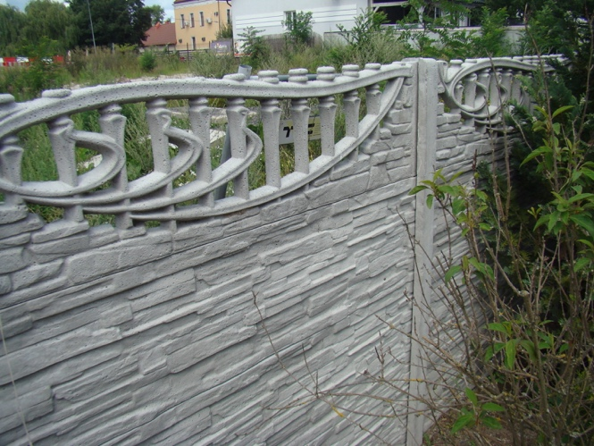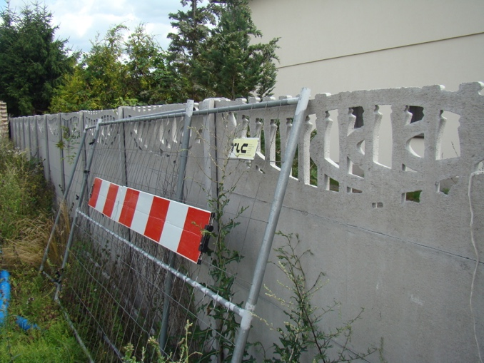
Photo number 12 and number 13: A part of the fence built as part of the Investment

SUMMARY
The main objective of the Project, in terms of Works Contract 1B.5/2, i.e., to protect residents in floodplains in certain parts of the Vistula and Odra river basins from serious floods and to enable effective and safe icebreaking operations, will be achieved upon completion of the reconstruction of the bridge to ensure minimum clearance enabling, as a consequence, free navigation of icebreakers in case of increased water levels. This will eliminate the need to incur financial expenses for the removal of flood damage.
In addition to the economic aspect, the non-measurable social aspect of the implementation of the project in question, consisting in ensuring a sense of security of the local community living in the communes where the Project was implemented, is equally important. As indicated by surveys conducted before the commencement of the Project, the local community was aware of the risks associated with flooding and the need to take specific measures to ensure flood safety.
Works contract 1B.5/2 included one voluntary resettlement. All conditions related to the relocation were agreed with the PAP. The Employer, as a result of the agreed mechanism, acquired the property previously used by PAP and paid the agreed amounts. The PAP were able to continue to reside on the property until they completed the construction of a new house funded with the funds paid to PAP. The impact of the Contract has not adversely affected other residents, businesses, or the conduct of business, other than as described in the Implementation Completion Report. There were also no impacts in terms of loss of jobs, access to infrastructure, loss of the ability to use natural assets/access to parks, reserves, access to educational institutions, cultural institutions. The amount and method of determining the amount of compensation were accepted by all PAPs. The project caused a temporary take of 1 property for a working platform. The temporarily taken property was owned by a public entity, the Town of Kostrzyn nad Odrą.
Throughout the duration of the Contract, interested parties had the opportunity to submit complaints and requests regarding the implementation of the LA&RAP. During the implementation of the Project no complaints were received in this regard.
Following the drafting of the Draft LA&RAP, public consultations were conducted – a process that was carried out in accordance with World Bank standards as well as Polish legislation.
During the works, the principles resulting from Polish legislation, the World Bank's OP 4.12 policy, and LA&RAP were observed. This concerned both the acquisition of real property necessary to implement the Contract and the manner of carrying out the works. The guiding principle of the measures was to achieve the effect of improving or at least restoring the living conditions of the PAP and ensuring long-term sustainable use of environmental resources in this area.
After the implementation of the Works Contract 1B.5/2, the standard of living of the local community was restored or improved. Despite the fact that, as at the date of the Implementation Completion Report, the construction works are still in progress, no risks or further negative impacts are diagnosed at the moment.
The key objective of the Land Acquisition and Resettlement Action Plan was also achieved, properties necessary to implement the Contract were acquired in accordance with Polish legislation and the World Bank's Operational Policy OP 4.12, including the Framework Document on Land Acquisition and Resettlement in a way that minimised the negative impacts on persons affected by the implementation of the project, which did not result in the physical or economic resettlement of households. During the execution of the Works, there were no significant impacts on PAPs. Thanks to the implementation of the measures indicated in the LA&RAP, it was possible to improve the living conditions of PAP's, who received monetary compensation, and long-term sustainable use of environmental resources in the area was ensured. As results from the conducted surveys, PAPs are satisfied with the implemented Project. Even before the start of the project, the respondents indicated that it was needed. After it was carried out, they emphasised that the area is currently very well developed. The degree of flood protection in Kostrzyn nad Odrą was increased, which in turn increased the sense of security of both PAPs and local residents. Each of the surveyed PAPs, when assessing the impact of the project on the PAP and their family, as well as the community in which they live, on a scale of 1 to 10, where 1 is “definitely negative” and 10 is “definitely positive”, rated both at 10.
By implementing the Task, all the objectives of World Bank policy OP 4.12 were achieved. In this regard, in particular:
- multiple site visits carried out prior to the commencement of construction works;
- the ongoing process of informing PAPs on the schedule and current stage of the project was implemented and executed;
- to the extent necessary, a timetable for the release of and access to expropriated properties was agreed with the property owners;
- compensation was determined based on valuations prepared by independent and authorised property appraisers;
- valuations took into account the replacement method to allow the parties who hold the relevant rights to restore their assets;
- PAPs were given the opportunity to comment on the valuations, all of which received approval from those entitled to compensation;
- resettlement has been carried out, allowing the PAP to build a new dwelling house while still being able to use their existing accommodation;
- compensation was paid for lost income from business activity;
- compensation was paid for expenditure on a project property to a contractless user of that property;
- additional works were carried out to make PAPs more comfortable with their own properties;
- the legal status of the property was regulated through the establishment of a utility easement at the Employer's expense for a public electricity supplier.
In the course of implementing the LA&RAP, no conflicts between the World Bank's O.P. 4.12 policy and Polish legislation were found. In order to fully meet the goals of O.P. 4.12, the legal instruments in force within the Polish legal order were applied, which ultimately made it possible to achieve the assumed goals.
The PAP's assessment confirms that the objectives of the Land Acquisition and Resettlement Action Plan were met. Property rights were acquired, and the persons affected by the Project received fair compensation in the amount allowing for the compensation of the impact. In the end, these people asses the Employer's activities undertaken in the course of the implementation of the undertaking, as well as the project itself, positively.

Appended:
Appendix No. 1. List of properties on which the Project was implemented.
Appendix No. 2. Summary of meetings
Appendix No. 3. A report on the public release of the LA&RAP

The implementation of the construction works remains ongoing. Date current at the date of the Implementation Completion Report. An amendment extending implementation to December 10, 2025 is in preparation.
The compensation paid to PAP number 2 comprised two parts. The first established in the compensation decision, the second in the property purchase agreement.
Then Sweco Consulting sp. z o.o.
Costs of notarial deeds and appraisal reports

