Norsk Energi -
Areas of Expertise

Norsk Energi is a leading consultancy in the fields of energy, environment and safety. We are actively engaged in a range of projects focusing on energy efficiency and greenhouse gas reductions, and assist both Norwegian and international clients with consulting, engineering, technology development and training.

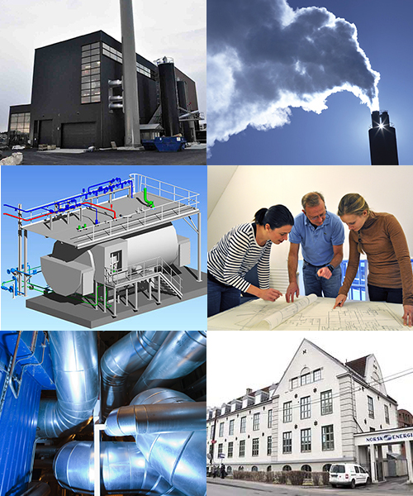
We are an independent consultancy organised as an association, with most of Norway’s heavy industry and energy production companies as our members. Norsk Energi was founded in 1916 under the name “Norwegian Steam Boiler Association”. We remain a centre of expertise on energy use and all topics connected with renewable energy. We are Norway’s leading experts on district heating and complex thermal energy systems. The association is “owned” by its purpose: «... to promote efficient, environmentally friendly and safe use of energy, for our members and clients. »
Most of our projects contribute to reduction of both energy consumption and polluting emissions, such as development of district heating based on renewable sources, energy efficiency improvement in the industry and transition to renewable energy.
Our staff is made up by engineers, including several Ph.Ds., mostly within energy, mechanical and chemical engineering. In total, Norsk Energy employs about 70 people in Oslo and other Norwegian cities. Every year, we conduct more than 500 assignments for more than 250 companies and governmental organs.
We have worked on projects in Poland since 2005, most recently Utilizing local energy resources by developing the concept of an urban energy cluster and Energy Management in Polish Industry with NAPE during the last round of Norway Grants.

Our services include:

Energy
- Building heating and cooling systems
- Energy audits (EED certified)
- Feasibility studies/Cost analysis
- District heating and cooling
- Energy management, including ISO50001
- Energy efficiency
- Energy recovery
- Renewable energy production (solar heat, bio, waste-to-energy, geothermal energy, heat pumps)
- Water borne heating systems and ventilation
- Thermal electricity generation
- Automation
- Steam and condensate systems
- Hot oil systems
- Ventilation systems

Environment and climate
- Climate accounting
- Climate strategy
- Consequence studies
- Environmental management, including ISO14001
- Environmental auditing
- Environmental risk analysis
- Pollution dispersion modelling
- Technical environmental analysis
- Waste
- Combustion optimization

Safety
- Risk analysis
- HAZOP
- Risk management
- Explosion protection
- Technical safety
- Safe Job analysis
- SHE and Quality control systems
- Reliability and availability
- Dispersion modelling for emergency emissions
- System auditing
- Emergency preparedness

For more information, please contact:

Idar Bergfjord

idar.bergfjord@energi.no

+47 48 17 79 93

or

Sergei Faschevsky

Sergei.faschevsky@energi.no

+47 93 06 04 82

or visit our website

www.energi.no/en

