For Sale Diplomatic Car
Embassy of the Republic of Poland
Toyota CAMRY 2.4 GLX SPLAT
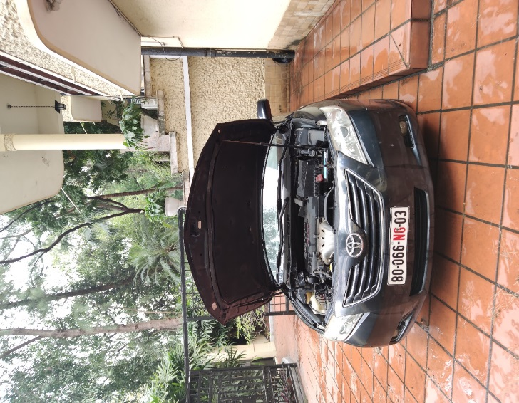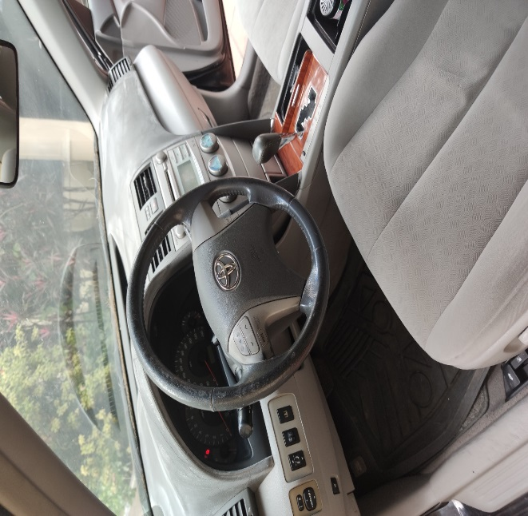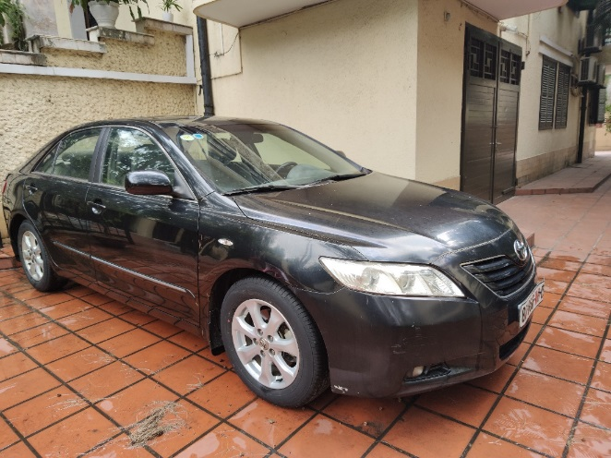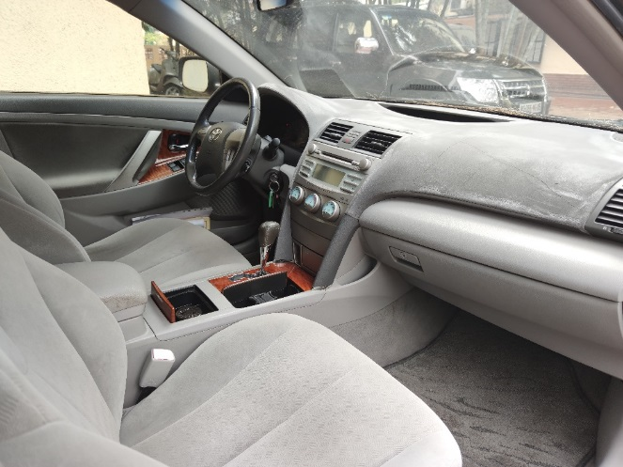

General information:
First Registration: 2006 Colour: Black
Gearbox: Automatic Engine : 2400 cm3
Seating capacity: 5 Mileage: 60 446 km
starting price: 3 000,00 USD
Please contact us if you are interested!
e-mail: beata.osinska@msz.gov.pl
mobile: 0962 985 475
All fees, taxes are paid by the buyer.

