Contents
1. Climate action: advances and challenges 4
1.1 Climate change impacts and greenhouse gas emissions: recent trends 4
1.2 Towards the climate objectives 9
1.3 Progress on climate policies and legislation 13
1.4 Progress in the Member States 15
1.5 Public opinion on climate change 21
2. The EU Emission Trading System 22
2.1 Cap on emissions under the EU ETS 22
2.2 Emission trends 23
2.3 Auction revenues 24
2.4 Aviation 25
2.5 Maritime transport 26
2.6 Buildings, transport and small industry 27
3. Effort sharing emissions 28
3.1 Effort sharing targets 29
3.2 Progress towards effort sharing targets 30
3.3 Emission trends by type of gas 32
3.4 Road transport 34
4. Land use sector 38
4.1 LULUCF target 39
4.2 Assessment of the progress 40
4.3 Action to step up land monitoring 41
4.4 Related initiatives relevant for agriculture and forestry 42
4.5 Incentives for carbon removals and sustainable practices 42
5. Industrial carbon management 43
6. Climate resilience and adaptation 45
6.1 Climate hazards and economic losses 45
6.2 EU action to boost climate resilience 48
6.3 Progress in the Member States on climate resilience and adaptation policies and legislation 49
6.4 Regional and local action 52
7. Investments in climate action 53
7.1 Investment needs 53
7.2 Mobilising private-sector investment 56
7.3 Funding from the EU Emission Trading System 59
7.4 Climate expenditure in the EU budget 62
8. International climate action 68
8.1 Multilateral engagement 68
8.2 Bilateral engagement 71
8.3 Climate finance and international cooperation 73

Why do we publish this report?
The European Commission monitors and assesses progress in meeting climate targets, as required by EU legislation. Under Articles 29(1) and 29(5) of the Governance Regulation, it must assess and report on progress annually by the end of October, starting from 2021. This Climate Action Progress Report serves as this assessment.

Climate action: advances and challenges
Key highlights
- In 2024, Europe once again experienced the devastating effect of climate change, with record-breaking temperatures and extreme weather events, affecting thousands of lives, the economy and underscoring the urgent need for climate action.
- The EU made progress by cutting net greenhouse gas emissions by 2.5% from 2023.
- This means the EU is on track to achieve its 2030 emission reduction target of a 55% decrease compared to 1990 levels provided existing and planned policy measures are fully implemented by the EU and Member States.
- The EU and Member States are also stepping up their efforts on climate resilience and adaptation.
- Europeans continue to voice concerns about climate change, with continued strong support for EU climate goals and policies.
- Global greenhouse gas emissions continued to rise in 2024, reaching 53.2 billion tonnes of CO₂ equivalent.

Climate change impacts and greenhouse gas emissions: recent trends
2024 was globally the warmest year on record and the first in which the average temperature exceeded 1.5°C above the pre-industrial level . Europe continues to be the fastest-warming continent and 2024 was marked by a clear east-west contrast in weather patterns. Eastern Europe was mostly warm, with many record-breaking temperatures, while the temperatures in western Europe were more variable, with some months cooler or close to average.
As climate change intensified, 2024 saw a surge in extreme weather events with severe and widespread impacts . South-eastern Europe faced its longest heatwave ever recorded. Wildfires affected over 40 000 people. In July, a large fire in eastern Attica, Greece, burned around 110 km² and in September, several large wildfires broke out in Portugal within a short period. Bulgaria and Romania experienced an above-average number of fires during the summer. It was also one of the ten wettest years in western Europe since 1950. Storms and flooding affected over 400 000 people, resulting in at least 335 deaths. A series of storms in May caused widespread flooding across eastern France, western Germany, Belgium, and the Netherlands. In September, Storm Boris swept through central and eastern Europe, and record-breaking rainfall in south-eastern Spain triggered catastrophic flooding in October, causing numerous fatalities and severe economic losses. Glaciers across Europe continue to melt, with those in the Alps among the fastest shrinking in the world.
These events and projections highlight the urgent need for continued, ambitious and coordinated climate action to reduce risks, protect people and the economy, and build resilience against the growing impacts of climate change.
Unless strong mitigation and adaptation measures are taken, climate change is projected to result in more temperature-related deaths in Europe, especially in the Mediterranean and eastern Europe . Rising global temperatures are also projected to expose growing fractions of the population to unprecedented climate extremes in their lifetimes .

Emissions trends in the EU
Provisional data for 2024 show that, in the EU, total net greenhouse gas emissions, including international maritime and aviation emissions under the EU target scope, decreased by 2.5% compared to 2023. Emissions continue on the downward path observed following the exceptional drop achieved in 2023. Emissions were 37.2% lower than in 1990 (or 39% when only domestic net emissions are considered), while GDP was 71% higher, meaning that economic growth continues to decouple from emissions .
Figure 1: EU GHG net emissions (2018-2024)
2024  -2.5%  2023  -8.5%  2022  -1.3%  The EU continues to reduce emissions in 2024 | 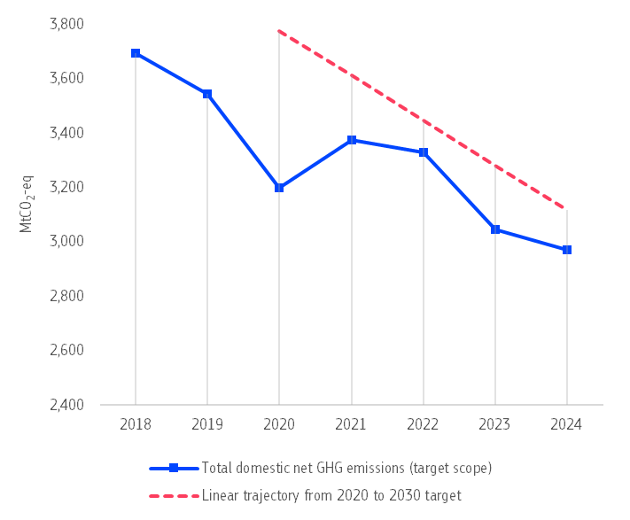
Note: These figures are based on the latest GHG emissions inventory including approximated values for 2024, as reported by the EU Member States. Emissions from international aviation and maritime activities, as regulated in EU law, are estimated by the European Commission (see Chapter 2 of the accompanying staff working document).
The most significant decrease in emissions was achieved in the energy sector, with emissions falling by 8.6% (equivalent to 66 MtCO₂-eq) compared with 2023 (Figure 2). A key factor in this decline was the power sector, where emissions from electricity production dropped by 10.7% compared with 2023 levels . This is largely due to an 8% increase in electricity generated from renewables and a 5% rise in nuclear power, coupled with a decrease in gas by 8% and coal by 12%. Within renewables solar power saw a remarkable growth of 19%, while hydropower increased by 12% . Wind-generated power increased more moderately by around 2%. Overall, electricity production increased by 2% in 2024.
Overall, total industrial emissions in 2024 remained broadly stable compared with 2023. The industrial sector has two main sources of emissions: fuel-combustion emissions for on-site heat, steam, and power; and non-energy related industrial-process emissions (e.g., cement clinker calcination, lime production, and metal or chemical manufacturing). While fuel-combustion emissions increased slightly by 0.4%, non-energy related process emissions decreased by 0.5%. This reflects the interplay between annual sectoral trends, industrial output trends (a 2.6% decline compared to 2023 ) and energy efficiency gains. The emissions from energy-intensive industries generally held steady, though with variations between sectors. For instance, emissions from industrial process in the chemical sector rose by 8.2% whereas those in the mineral sector, including cement, decreased by 2.5%, largely reflecting changes in production volumes.
The agriculture sector also contributed to the overall decline in emissions in 2024, showing a reduction of 1.2% (around 4 MtCO₂-eq) compared to the previous year, while emissions from building and waste stayed broadly unchanged. In contrast, emissions from the transport sector continued to rise, with domestic transport increasing by 0.7% and international maritime and aviation by 3%. As a result, transport is now Europe’s largest sectoral source of emissions.
Figure 2: Change in the EU greenhouse gas emissions in 2024 by sector
                Domestic and international transport increased its emissions in 2024 | 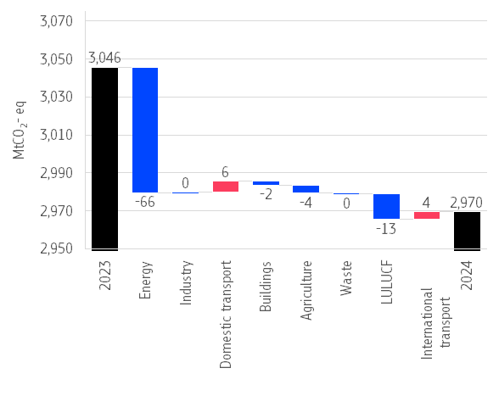
Notes: (1) Energy sector refers to electricity and heat production and petroleum refining (1.A.1 GHG inventory code). It also includes indirect CO₂ emissions, emissions from other sectors (1.A.5 GHG inventory code), and fugitive emissions (1.B GHG inventory code) (2) Industry includes fuel combustion in manufacturing and construction (1.A.2) and emissions in industrial processes and product use. (3) Buildings include emissions from energy use in residential and tertiary buildings, and energy use in agriculture and fishery sectors (1.A.4 GHG inventory code).
In 2024, the EU Emissions Trading System (EU ETS) achieved a further reduction in emissions from power and industry installations, with a 5.8% decrease compared to 2023 levels. This brings these emissions to around 50% below 2005 levels. Aviation emissions covered by the EU ETS rose compared to 2023 by around 15%, although around half of this increase was due to an enlarged geographical scope .
In the Effort Sharing sectors, emissions remained at a similar level compared with 2023. Provisional 2024 data for GHG emissions and removals from the land use, land-use change, and forestry (LULUCF) sector show an increase in net carbon sinks of around 7% (or 15 MtCO₂-eq) compared to 2023, although approximated data remain subject to revisions.

Global trends
According to the Commission’s 2025 EDGAR report, global greenhouse gas emissions continued to rise in 2024, reaching 53.2 billion tonnes of CO₂ equivalent (Figure 3). This is 1.3% higher than in 2023 and 4.7% higher than in 2019, before the pandemic.
In 2024, the power sector was the main driver of global emissions (+1.5%, or 235 MtCO₂-eq), due to higher demand for cooling, rising energy consumption in industry, the shift to electric transport and the growth of data centres . The second biggest source of higher emissions was for fuel combustion in industry (+2.1%, or 131 MtCO₂-eq) and then for transport (+1.2%, or 99 MtCO₂-eq).
Figure 3: Global GHG emissions (1990-2024)
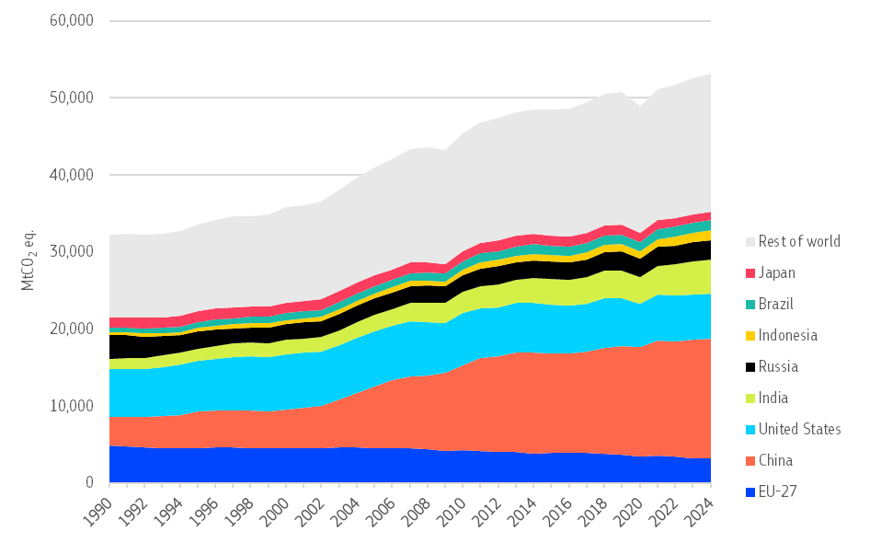
EDGAR GHG’s estimates differs from the officially reported GHG emissions (i.e. GHG inventories submitted by the parties to the UNFCCC) for different reasons:
- The source of data;
- The estimation methodology.
Of note, only the officially reported data submitted to the UNFCCC should be used to assess EU climate progress.
For more detailed information see comparative analysis of EDGAR and UNFCCC GHG emissions inventories.

Table 1: Annual change of global emissions (%, 2023-2024)
Country |  | GHG emissions
 |  | % change (2023-2024)
 | EU-27 | -1.8%
 | China | +0.8%
 | United States | +0.4%
 | India | +3.9%
 | Russia | +2.5%
 | Indonesia | +5.0%
 | Brazil | +0.2%
 | Japan | -2.8%
 | Rest of world | +1.8%
 | Global total | +1.3%
The largest emitters are China, with 29% of global emissions, the United States (11%), India (8%), the EU (6%), Russia (5%) and Indonesia, Brazil and Japan (all with 2%). Together, they produced 66% of global emissions in 2024.
Among these emitters, only the EU and Japan reduced their GHG emissions while Indonesia and India saw the fastest growth of emissions. The emissions produced in China and in the United States also increased but at a slower pace than in recent years (Table 1).

Towards the climate objectives
As set out in the European Climate Law, the EU aims to become climate neutral by 2050. This means that by then, the EU will not add any extra greenhouse gases into the atmosphere because emissions will either be reduced to zero or balanced out by removals.
To achieve this, the EU has set an intermediate target to reduce its emissions by 2030 and the Commission has proposed another target for 2040 to be enshrined in the Climate Law. The target for 2030 requires cutting total net greenhouse gas emissions in the EU by at least 55% below 1990 levels by 2030. The European Commission has proposed a target for 2040 that aims to at cutting net greenhouse gas emissions by 90% by 2040 (see Figure 4). The European Parliament and the Council are currently considering this proposal (the Council reached a General Approach on 5 November 2025).
Three main policies ensure the EU meets its target of reducing emissions by 55% by 2030:
- The EU Emissions Trading System (ETS) aims to cut emissions by 62% compared to 2005 levels (see Chapter 2).
- The Effort Sharing Regulation (ESR) sets a target of 40% reduction compared to 2005 levels (see Chapter 3).
- The Land Use, Land Use Change and Forestry (LULUCF) Regulation provides for an additional 42 MtCO₂-eq land-based net removal compared to the 2016-2018 average. However, the European Climate Law sets a maximum contribution to the EU economy-wide 2030 target of 225 MtCO₂-eq for land-based removals (see Chapter 4).
Other policies also support climate neutrality and intermediate targets:
- The emissions trading system for buildings and transport (ETS2) aims to cut emissions by 42% compared to 2005 levels (see Chapter 2), alongside other policies.
- Policies to cut emissions of hydrofluorocarbons (HFCs) by about 95% compared to 2015 levels (see Chapter 3).
- The CO₂ geological injection and storage capacity target of at least 50 million tonnes per year by 2030 (see Chapter 5).
Figure 4: Main EU climate targets
2050
CLIMATE NEUTRALITY
The EU aims to be climate neutral by 2050.
2030
-55%
The EU aims to reduce total net GHG emissions by at least 55% compared with 1990 levels by 2030.
2040
The European Commission proposed a target reduction of 90% compared with 1990 levels by 2040.
-90%









Figure 5: EU 2030 targets
The EU decreases its total net GHG emissions by at least 55% compared to 1990 by 2030.
225
The European Climate Law sets the maximum contribution of land-based removals by the land use, land use change and forestry (LULUCF) sector to 225 MtCO2eq.
Emissions under the Effort Sharing Regulation (ESR) decrease by 40% compared to 2005.
-40%
Emissions under the Emission Trading System (ETS) decrease by 62% compared to 2005.
-62%
2030
-55%

Towards the EU 2030 target
Overall, the EU is on track to achieve the 2030 target. The latest Member State’s projections from March 2025 show a gap close to 1 percentage point to the EU target, in line with the recent assessment of national climate and energy plans.
Achieving the EU target requires the EU and Member States to implement both current and additional policies and measures in full.
Projections based only on existing policies and measures continue to fall short by around 8 percentage points. Extrapolating the trend over the past five years to 2030 points to a 6 percentage-points gap. With only five years left until the interim target to climate neutrality, these findings highlight the critical importance of close monitoring, sustained action and sufficient investment for the EU to meet the 2030 target (Figure 6).
Figure 6: Projected emissions reduction in 1990–2030 and gap to target under the main policies
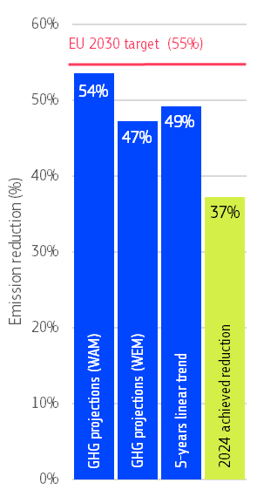 | 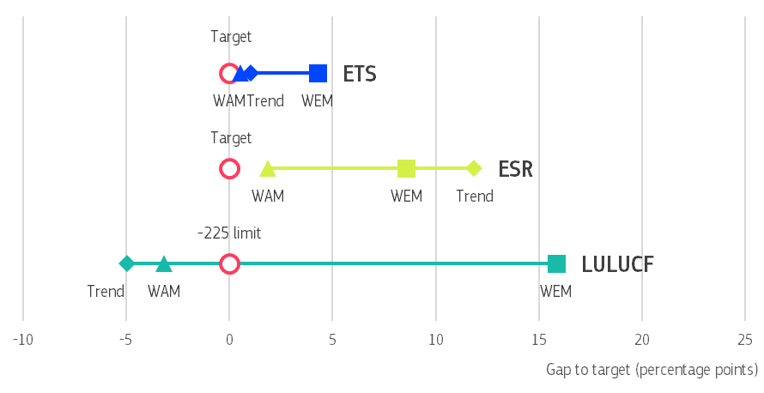
 | Notes: (1) Gaps to target are based on: i) Member States’ 2025 GHG projections, both ’with existing measures’ (WEM) and ‘with existing and additional measures’ (WAM) scenarios; and, ii) the linear extrapolation of past 5-years observed trend. (2) The EU 2030 target scope includes LULUCF net removals and emissions from international aviation and maritime activities regulated under EU Law. The latter are included in the EU ETS projected emissions. (3) For LULUCF the gap refers here to the maximum contribution of 225 MtCO₂-eq net removals as provided in the European Climate Law. Trend and WAM show higher sink than WEM. (4) Gaps to policy targets are presented as a range of projected values based both on GHG projections and on linear trends.
There are differences across sectors and policies. With the contribution from the LULUCF sink limited to 225 MtCO₂-eq by the European Climate Law , the projected gap to the EU 2030 target is mainly explained by the challenges and lack of ambition in reducing emissions in the sectors covered by the Effort Sharing Regulation (ESR), e.g. domestic transport, buildings, agriculture and waste. The projected gap ranges between 2 and 9 percentage points, considering the impact of existing and additional policies and measures and under current policies, respectively. The implementation of planned measures is crucial as the extrapolation of the past five years observed trend would point to even higher gap for ESR (12 ppt). The international aviation and maritime emissions covered under the EU ETS represent another acute challenge, as emissions from these sectors are rising and are hard to abate (see Chapter 3 of the Staff Working Document for more details).

Towards the EU climate neutrality and resilience
On 15 March 2025, EU Member States reported their progress toward the goals outlined in their national energy and climate plans (NECPR) . An increasing number of EU countries committed to achieve climate neutrality by 2050 or sooner . Member States have also set or updated national targets to reduce greenhouse gas emissions by 2050 . When these national targets are aggregated for the entire EU , they are 6 percentage points short of the net-zero greenhouse gas emissions target set for 2050.
In December 2023, the European Commission recommended that 10 Member States adjust their measures to make them more consistent with the climate-neutrality objective. The Commission issues such recommendations if Member State’s measures are inconsistent with the climate-neutrality objective.
The recommendations primarily urged Member States to step up action on climate mitigation and to align their policies with the climate-neutrality objective. Specific sectors like transport, agriculture, and land use (LULUCF) were highlighted for improvements in certain countries. In their following NECP progress reports, all Member States notified the Commission how they considered these recommendations. Some Member States introduced new measures, particularly focusing on renewable energy; others outlined a range of plans and strategies. Several Member States noted that they are in the process of revising their long-term strategies to align with EU objectives (more details in Chapter 3 of the accompanying staff working document).
In addition to the climate-neutrality related recommendations, the Commission issued recommendations to 26 Member States on climate resilience and adaptation within the same package. These span the full spectrum of adaptation policy aspects, from legislation, risk and vulnerability assessments, and the use of nature-based solutions, to policy coordination, funding and transparency.
Subsequently, most Member States confirmed that they will address these challenges as part of their ongoing efforts to upgrade their resilience and their adaptation policy planning and implementation. Many updated their risk assessments in 2023-2025 and an increasing number have prepared thematic and sectoral assessments. Better monitoring, reporting and evaluation frameworks are nevertheless needed at all levels to be able to more accurately assess the efficiency and effectiveness of resilience and adaptation policies and their implementation at Member State level (see Chapter 11 of the accompanying staff working document).

Progress on climate policies and legislation
With the adoption of the European Climate Law in 2021, the EU objective to reach net-zero emissions by 2050 became legally binding, as did the EU’s 2030 target to cut net greenhouse gas emissions by at least 55% compared to 1990 levels. The law also requires EU institutions and Member States to make continuous progress in adapting to climate change, strengthening resilience, and reducing vulnerability.
The focus in 2024 and 2025 has been on action to meet the 2030 target at Member State level, on setting an EU-wide target for 2040 as the next step on the path to climate neutrality and on ensuring decarbonisation is a powerful driver for a more competitive and resilient Europe.
In July 2025, the Commission adopted a proposal to amend the European Climate Law Regulation to set a 2040 target to reduce the EU’s net greenhouse gas (GHG) emissions by 90% by 2040 from 1990 levels, including the possible use of some international credits. This target will give people, businesses and investors greater predictability to plan ahead. The proposal is now being discussed by the co-legislators. In November 2025, ministers at the Environment Council agreed to a legally binding intermediate 2040 target of 90%, with a domestic target of 85% and up to 5% of international carbon credits.
Work began on a new integrated framework for climate resilience, with a public call for evidence issued at the end of July 2025. Implementation of the EU Adaptation Strategy progressed, reflecting the findings of the first European Climate Risk Assessment, and 2024 Communication on managing climate risks, supported by data and tools from Climate-ADAPT platform and the European Climate and Health Observatory.
In January 2025, the Commission set out a Competitiveness Compass highlighting how it planned to support the transition towards a decarbonised competitive and resilient economy. Accordingly, in February 2025, the Commission presented the Clean Industrial Deal, a joint roadmap for competitiveness and decarbonisation and transformational business plan to support EU industry. It aims to accelerate the process of decarbonisation, while securing the future of manufacturing in Europe. The Deal focuses mainly on two closely linked sectors: energy-intensive industries and clean tech. One of the already completed action is the Clean Industrial Deal State Aid Framework published in June 2025. An important element of the Clean Industrial Deal is the Action Plan for Affordable Energy, which contains specific measures to reduce energy costs in the EU. This initiative will have a significant impact on both industrial competitiveness and the cost of living. Additionally, the Union of Skills launched in March reinforces the goals of the Clean Industrial Deal by promoting development and investment in skills to address skills shortages and to ensure that no one is left behind in the context of the clean transition.
The Commission continued to prepare the implementing legislation stemming from the revision of the EU’s climate legislation as part of the ‘Fit for 55’ package.
This includes acts to implement:
- the Effort Sharing Regulation;
- the regulation on land use, land-use change, and forestry (LULUCF);
- the regulation on CO₂ emission standards for cars and vans;
- the EU ETS (including the revised rules for aviation) and to extend the scheme to cover the maritime sector, making the EU the first jurisdiction globally to put an explicit carbon price on emissions from the maritime sector;
- the ETS 2 for buildings and road transport; and
- the Social Climate Fund.
New regulations on fluorinated greenhouse gases and ozone-depleting substances entered into force in March 2024. They have put in place new measures that will eliminate an additional 500 MtCO₂-eq of emissions by 2050 compared to previously adopted measures on these chemicals. In 2025 the European Commission adopted secondary legislation to implement new rules on these substances, which are even more ambitious than the commitments made under the Montreal Protocol.
As part of its wider simplification agenda, in May 2025 the European Commission tabled a proposal to simplify, among others, the F-gas Regulation. The proposal will reduce the administrative burden on importers and exporters by limiting the registration requirements to importers of products and equipment containing F-gases above certain annual thresholds and to those exporters that export stationary equipment with relatively highly warming F-gases .
On 1 April 2025, as part of the Commission’s industrial action plan for the European automotive sector and following the Strategic Dialogue on the Future of the Automotive Industry, the Commission proposed to amend the regulation setting CO₂ emission performance standards for new cars and vans. This amendment brings in one-off additional flexibility in reaching the CO₂ targets in 2025-2027, while maintaining the overall level of ambition of the targets. In June, the amendment was adopted by the Parliament and Council and published.

Progress in the Member States

National energy and climate plans
National energy and climate plans (NECPs) are 10-year strategic documents in which Member States set out national targets, contributions and policies and the measures needed to reach EU climate goals. In May 2025, the Commission published its EU-wide assessment of the NECPs, following their updates to take into account the 2030 targets. The assessment was accompanied by a staff working document providing an individual assessment of the first 23 plans submitted. Subsequently, the Commission published its assessment of the final NECPs from Estonia and Slovakia in October 2025. Belgium submitted its final NECP in October 2025 and Poland is the last Member State that has not yet submitted its plan.
The assessment of the plans shows that their full implementation would bring the EU close to reaching its objectives, demonstrating that the EU is well on track to achieving the 2030 target of reducing net GHG emissions by at least 55% compared to 1990 levels. Overall, Member States are encouraged to implement additional measures in the transport and building sectors to meet their ESR targets, and to continue stepping up action in reducing emissions from aviation, the maritime sector, and to increase removals, or reduce emissions, in the LULUCF sector. Further efforts are needed to ensure a just transition and address the social impacts. The plans often lack comprehensive strategies for mobilising public and private finance for the required investments. On climate adaptation, only some plans sufficiently cover preparedness and resilience to climate impacts. A few plans include measures on water resilience (see Chapter 6).

European Semester
In June 2025, the European Commission published its Spring Package under the European Semester, which includes country reports and recommendations for each Member State. The Commission called on countries to support lead markets for clean decarbonised products and put in place plans for net-zero infrastructure, especially in areas like energy networks, carbon capture and storage, and hydrogen. It also highlights the urgent need to decarbonise industry and transport and to make it cleaner, and to step up actions to phase out fossil fuel subsidies. Water management, as part of climate change adaptation, remains a key priority for many Member States. Table 2 summarises the recommendations for each country.
Table 2: 2025 European Semester country specific recommendations by Member State
Member State |  | Country-specific recommendations
 |  | Renewables, energy networks | Fossil fuels | Energy efficiency | Transport | Industry, clean technology | Adaptation and water | Agriculture | Other
 | Belgium | 
 | Bulgaria
 | Czechia
 | Denmark
 | Germany
 | Estonia
 | Ireland
 | Greece
 | Spain
 | France
 | Croatia
 | Italy
 | Cyprus
 | Latvia
 | Lithuania
 | Luxembourg
 | Hungary
 | Malta
 | Netherlands
 | Austria
 | Poland
 | Portugal
 | Romania
 | Slovenia
 | Slovakia
 | Finland
 | Sweden
Note: Category Other includes emergency support, circularity and waste, support to coal regions, social support, green skills, taxation and strategic planning.

Technical support
In 2024, the Commission supported Member States through the Technical Support Instrument, providing expert help to design and carry out reforms. Projects focused on climate change adaptation and mitigation solutions, faster renewable energy permitting, application of the do-no-significant-harm principle, and renovation of buildings. The Commission also helped Member States implement the revised EU Emissions Trading System and prepare national Social Climate Plans under the Social Climate Fund.
In 2025, the Commission continues to support work on natural resource resilience, the Carbon Border Adjustment Mechanism, and modernising energy systems. The Commission is also helping to green and upskill public administrations, improve business sustainability reporting and advance carbon capture, utilisation and storage. The support also covers the implementation of the Net Zero Industry Act and the EU Nature Restoration Law.
 | Country factsheets provide a summary of completed and ongoing reform projects in each Member State.

Policies and measures
To achieve the climate objectives, a sharper focus is needed, both on EU-wide and in national policies and measures. Understanding how these policies work individually and together is essential. In 2025, as part of the National Energy and Climate Progress Reporting, EU Member States have reported progress on over 3.5 thousand individual policies and measures across the five dimensions of the Energy Union . This is a 16% increase compared to 2023, the last reporting year. The number of reported measures increased in most of the countries. The highest increases were reported by Austria, Bulgaria, Hungary and Lithuania. In some cases, this is due to the adoption of new measures between the two reporting years, but it can also be due to amendments, or design changes, of existing measures (Figure 7). Conversely, Malta, Spain and Denmark reported a significant lower number of measures, compared with 2023. However, the number of single policies and measures is not necessarily a good indicator of the past, current and future ambition of Member States. Belgium is the only country that has not made submission by the time of drafting this report. For this Member State, the report uses gap-filled information from the 2023 reporting year.
Around a third of all reported policies and measures have been newly implemented or planned from 2023 onwards. This high number might reflect the EU’s increased climate ambitions and Member States’s efforts to meet their 2030 climate and energy objectives . Most of the reported policies and measures have a decarbonisation objective, meaning that they aim at reducing GHG emission, enhancing carbon removals, or increase the use of renewable energy sources.
Figure 7: Total number of single policies and measures (all dimensions), 2025 and 2023 reporting years
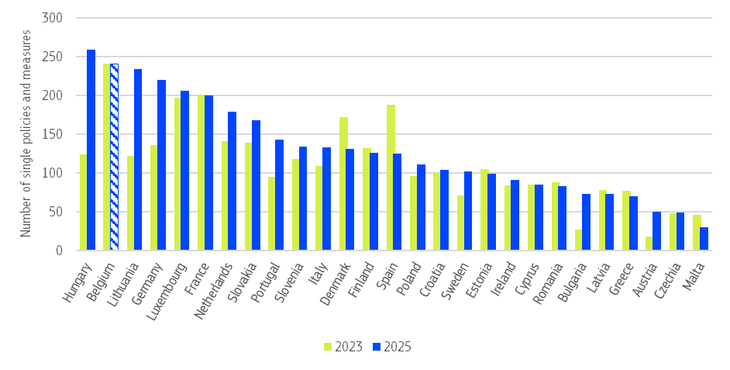

Note: data on policies and measures are based on a preliminary dataset of 2025 NECP progress reports (Annex IX). Due to a delay in the submission, the data for Belgium refer to the 2023 NECP progress reports.
Of these decarbonisation-related measures, the most are in energy supply (23%), energy consumption (22%) and transport (21%) sectors, reflecting the fact that these sectors are significant challenges and priorities for action (Figure 8). There are also many measures in the agriculture, land and forest sectors (19%). The situation varies across the Member States. Cyprus, Italy, Bulgaria, Portugal and Poland report the highest share of policies and measures affecting the energy supply sector. Energy consumption is specifically targeted in Ireland and Germany, while in Spain and France, the focus is more on the transport sector. Other Member States reported a relatively high numbers of policies and measures for the agriculture and land sector (e.g. Latvia, Lithuania and Slovakia).
Figure 8: Number of single policies and measures by affected sector (decarbonisation objective)
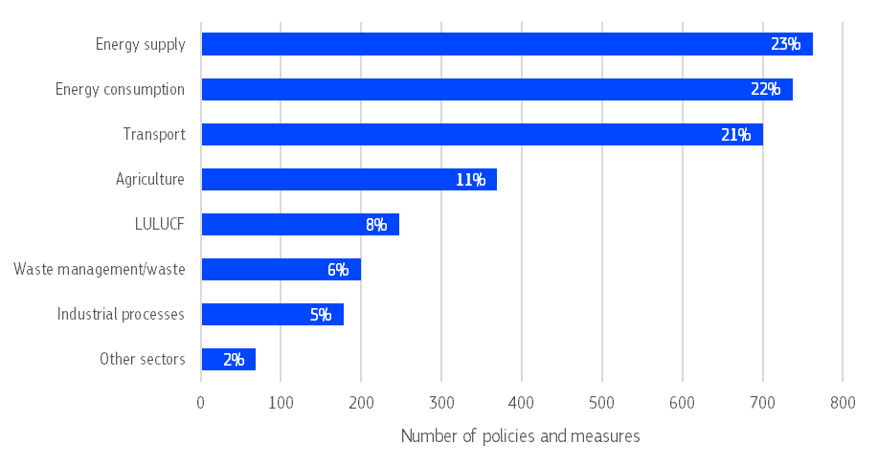
Note: figures on policies and measures are based on a preliminary dataset of 2025 NECP progress reports (Annex IX). They include policies and measures submitted by Belgium in the 2023 NECP progress reports.
In terms of policy instruments, over 34% of the policies and measures with a decarbonisation objective are economic (e.g. subsidies, feed-in tariffs, auctions, waste fees, congestion charges, etc), and 27% are regulatory (e.g. efficiency requirements, buildings regulations, eco-design standards, inspection procedures, etc). Relatively less measures are of planning (10%) (e.g. urban planning, etc), informative (9%) (e.g. labelling, awareness rising, etc) or fiscal (7%) type. However, there are notable differences between Member States. The Baltic countries, for example, have adopted a relatively high number of economic measures, while in Romania and Bulgaria, most measures are regulatory (Figure 9).
Overall, the completeness of reported information on national policies and measures has improved compared to previous reporting exercises. This improvement is attributed to increased dialogue with Member States, training for lead reporters, and efforts to enhance the clarity of both the guidelines and reporting tables, including the upgrade of existing warning and error checks into blockers in the reporting tool (automated quality checks in the tool that require the resolution of the issue before the dataflow can be released).
However, there is a clear need for improvement in the quantification of the impact of policies and measures. This includes both the achieved and expected effects on greenhouse gas emissions, as well as their costs and benefits. For example, as in 2023, only a fifth of reported policies and measures specify the expected emission reductions by 2030. Moreover, only in very few instances (Croatia, Ireland, Poland, Latvia) there is a broad consistency between the expected emission reductions from the reported measures and the GHG projections (with additional measure scenario) submitted by Member States. This lack of data makes it challenging to assess the overall impact of the measures implemented, highlighting the need for more systematic evaluation of policy effectiveness both before and after implementation (for more details, see the staff working document on the Assessment of progress towards the objectives of the Energy Union and Climate Action accompanying the State of the Energy Union 2025).
Figure 9: Total number of policies and measures by policy instrument type (decarbonisation dimension)
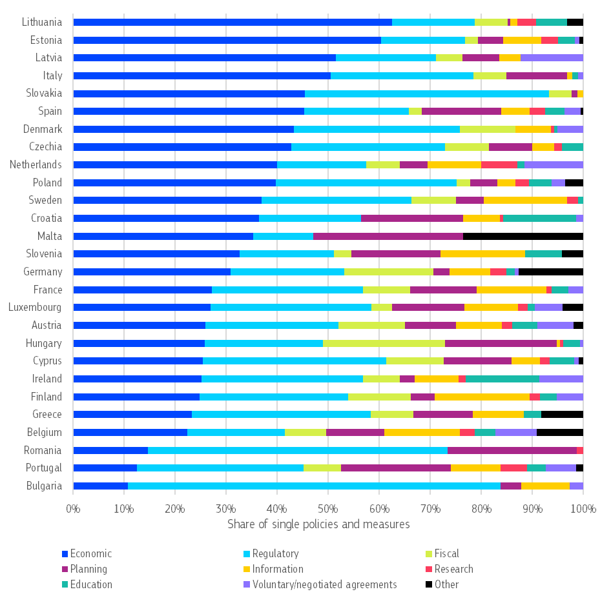
Note: data on policies and measures are based on a preliminary dataset of 2025 NECP progress reports (Annex IX). Data for Belgium refer to policies and measures reported in the 2023 NECP progress reports. The countries are listed in order of the share of policies and measures based on an economic instrument.

Public opinion on climate change
People across Europe have voiced strong concern about climate change and widespread support for climate action, following to the latest 2025 Eurobarometer survey. A significant majority (85%) of EU citizens believe climate change is a serious problem, indicating high levels of awareness and a clear sense of urgency. The concern is particularly pronounced among women and younger people (aged 15-24).
The survey also revealed that 84% of Europeans attribute climate change primarily to human activities, showing a shared understanding of the root causes of the issue.
Support for decisive climate policies remains strong. Overall, 81% of respondents back the EU’s objective of achieving climate neutrality by 2050. However, the level of support varies across countries, with Estonia standing out as the only Member State with less than half (46%) of citizens supporting this target.
The survey revealed resounding agreement (88%) that the EU should actively promote renewable energy and improve energy efficiency and that better preparation for climate impacts will improve daily life (83%).

The EU Emission Trading System
Key highlights
- By the end of 2024, the EU ETS had helped drive down emissions from the electricity and heat generation and industrial manufacturing by 50% compared to 2005 levels.
- Emissions from electricity and heat generation in 2024 continued to decrease year on year, largely due to a substantial increase in the share of renewables and nuclear in the electricity mix, mirrored by a reduced reliance of major fossil fuels such as natural gas and coal.
- The ETS has raised over EUR 245 billion in revenues with nearly EUR 39 billion in 2024 alone. These revenues primarily financed climate and energy measures through national budgets, but also via the Innovation Fund, the Modernisation Fund and the Recovery and Resilience Facility, in line with the RepowerEU Plan.
- In 2024, maritime transport emissions were included in the EU ETS for the first time. Compared to 2023, reported emissions increased by 13%, notably due to the impacts of the Red Sea crisis and subsequent re-routing.
- Urgent action is required to decarbonise the aviation sector. To support this, a dedicated system has been in place since 2024 to accelerate the adoption of sustainable aviation fuels.
- Compliance in the EU ETS has been very high, including for maritime sector in its first compliance cycle.
The EU Emissions Trading System (ETS) is a cornerstone of the EU’s climate action. It puts a cap on emissions from the electricity and heat generation, industrial manufacturing, aviation in Europe and maritime transport sectors, resulting in a price on emissions in line with the ‘polluter pays’ principle. The price creates an incentive for companies in these sectors to deploy solutions and invest in reducing emissions over time. The EU ETS also raises revenue to help fund these actions.

Cap on emissions under the EU ETS
The EU ETS is a market-based instrument. It sets a cap on emissions from the sectors covered by the scheme and every year the cap is lower, with a target of 62% reduction by 2030 compared with 2005 levels of emissions. The cap is expressed in allowances, which companies must surrender each year to cover their emissions. Companies primarily purchase allowances in auctions, which raise revenues for Member States to fund further climate action and energy transition. With the price of allowances set by the market, the EU ETS incentivises emission reductions where it costs the least to do so, in a technologically neutral way.
While auctioning is the primary method for distributing allowances in the EU ETS, a significant volume of allowances is allocated to installations for free to address the risk of carbon leakage . In certain EU ETS-covered industry sectors (cement, aluminium, fertilisers, hydrogen, iron and steel), the Carbon Border Adjustment Mechanism (CBAM) will gradually replace free allocation from 2026 onwards. These sectors represent approximately 54% of total free allocation in 2021-2025.
More information on the functioning of the EU ETS in the 2025 Carbon Market Report.

Emission trends
By the end of 2024, the EU ETS had helped drive down emissions from the electricity and heat generation and industrial manufacturing by 50% compared to 2005 levels. With this progress, the system is on track to achieve the 2030 target of 62% reduction.
In 2024, emissions from the power and industry sectors continued to decrease following a record annual drop in 2023. Emissions from electricity and heat generation dropped by 10.7% , largely due to a substantial increase in the share of renewables and nuclear in the electricity mix, coupled with a reduced reliance of major fossil fuels such as natural gas and coal. In 2024, renewables and biofuels were the leading source of electricity in the EU, capturing 47.2% of the share, with the overall renewable electricity output having increased by 7.6% in 2024. The drop in the power emissions in 2024 marks 30% reduction since 2021.
Emissions from industrial installations in 2024 decreased by 0.8% compared to 2023 . Several trends were noted to have been at play (in addition to the decarbonisation of the power supply) – reduction of output in industrial production in some sectors, recovery of output in energy-intensive sectors such as steel, fertilisers and chemicals and improvements in energy efficiency.
Figure 10: Emissions under the EU ETS in the EU by sector
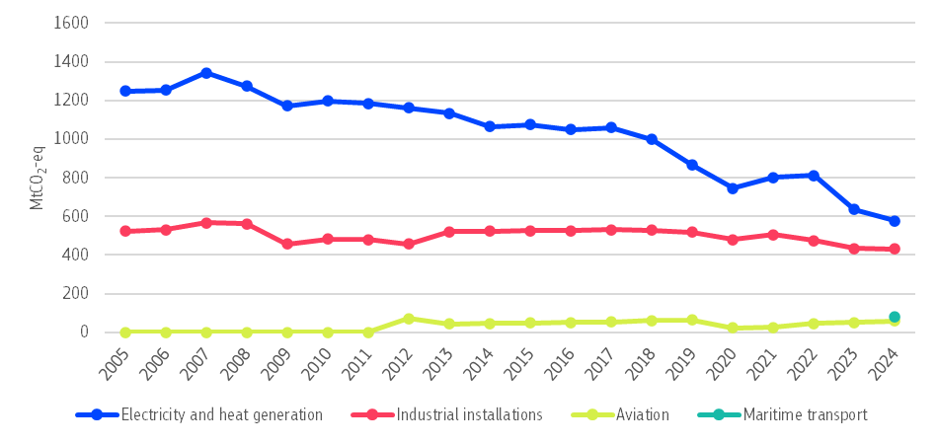
Source: EEA

Auction revenues
By mid-2025, the EU ETS had raised over EUR 245 billion through the sale of emission allowances. In 2024, ETS revenue reached nearly EUR 39 billion. This went primarily to national budgets (EUR 24.4 billion) but also funded the ETS programmes for a clean transition (i.e. the Innovation Fund and the Modernisation Fund) as well as part of the Recovery and Resilience Facility in line with RepowerEU Plan. In 2025, a portion of allowances from the EU ETS also started being auctioned to finance the Social Climate Fund (see Chapter 6).
Figure 11: Member States’ use of ETS revenues by different purposes as reported for 2024 (considering revenues disbursed)
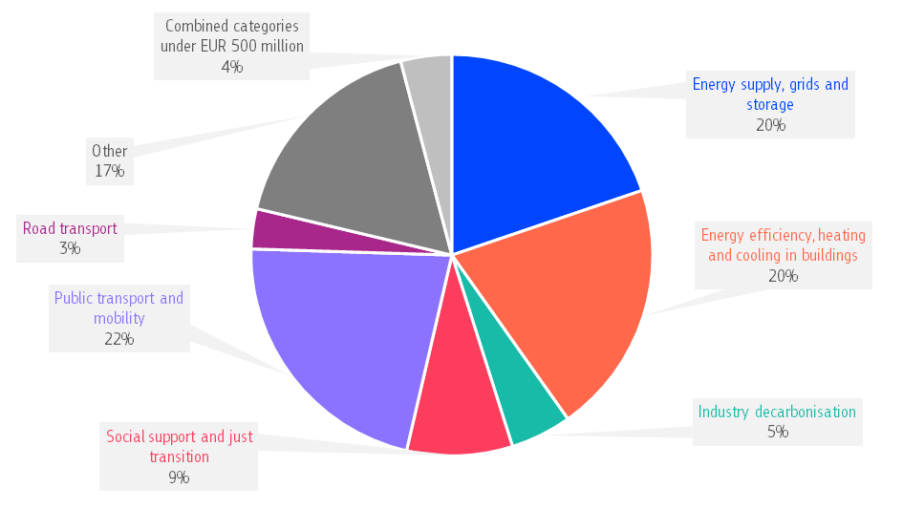
Member States must use all their ETS revenues (or an equivalent amount) to fund climate action and energy transformation, including measures to address social aspects. The only exception from this rule is the possibility for Member States to use ETS revenue to provide aid to for electricity-intensive industries for indirect carbon costs. In 2024, 15 Member States used their revenues for this purpose. Of EUR 24.4 collected in 2024, Member States used EUR 3.2 billion for indirect-cost compensation for energy-intensive industries. The remaining EUR 21.2 billion must be used for climate action and energy transformation but it does not need to be spent in one year .
Every year, Member States report to the Commission on how they used their ETS revenues. Member States directed most of their 2024 ETS revenues to projects in the deployment of renewable energy sources, grids and storage (20%), the improvement of energy efficiency in industries and buildings (20%) and the development of clean public transport and mobility (22%). Examples include grants for offshore wind and biogas upgrading in Denmark, deep-retrofit projects with at least 40% reduction in heat consumption in residential buildings in Lithuania and investments in rail transport and cycle paths in Slovenia.
For more information on how each Member State used their 2024 ETS revenue, see Chapter 8 in the accompanying staff working document. For the EU27 analysis, see the Carbon Market Report 2025.

Aviation
In 2024, aviation emissions under the ETS continued to rise, reaching 62.6 million tonnes CO₂. This is about 15% higher than in 2023 .
Decarbonising the aviation sector is therefore urgently needed. The ETS carbon price already gives an incentive of around EUR 200 per tonne of sustainable aviation fuel used, compared to fossil kerosene. However, in 2024 the Commission brought in an additional support mechanism under the EU ETS to promote the use of sustainable aviation fuels, the impact of which is not yet reflected in this report. A total of 20 million allowances (worth around EUR 1.5 billion) are reserved for this support and airlines can claim support of around EUR 500 up to EUR 7 000 for each tonne of eligible sustainable fuel used on an ETS route . In 2025, Commission distributed around EUR 100 million between 53 aircraft operators from EU Member States and two operators from Norway.
The Commission adopted new rules to monitor, report and verify emissions for flights of EU airlines which fall outside the scope of the EU ETS . Adoption of these rules underscores the EU’s commitment to apply the Carbon Offsetting and Reduction Scheme for International Aviation (CORSIA). The EU is one of the first jurisdictions in the world to put CORSIA into law. The purpose of CORSIA is to offset aviation emissions from international flights above a certain level . It is widely expected that this level was reached in 2024, so airlines expect to incur offsetting obligations under CORSIA for the first time for the share of 2024 emissions above the baseline.
Although the EU ETS currently covers only CO₂ emissions, the overall climate impact of aviation is currently estimated to be two to four times higher because of non-CO₂ emissions including nitrogen oxides (NOx) and sulphur oxides (SOx) . The EU is the first jurisdiction to introduce a monitoring, reporting and verification (MRV) framework for non-CO₂ effects in aviation. Since 1 January 2025, aircraft operators are required to monitor and report the impacts of non-CO₂ emissions per flight annually . By 31 December 2027, based on the results under the non-CO₂ monitoring framework, the Commission will submit a report and, where appropriate, a legislative proposal to mitigate the non-CO₂ effects in aviation.

Maritime transport
Maritime transport generates around 3-4% of the EU’s CO₂ emissions. 2024 was the first year that maritime transport was included in the EU ETS system. Total maritime emissions were 148,7 MtCO₂-eq under the MRV system considering all emissions from voyages involving ports in the EU, Iceland and Norway. Out of these, 89.8 MtCO₂ were covered by the ETS considering only 50% of emissions from voyages starting or ending outside the EU, Iceland and Norway .
Methane and nitrous oxide emissions were reported for the first year in 2024 under MRV scope, amounting to 1,6 MtCO₂-eq (for methane) and 2,2 MtCO₂-eq (for nitrous oxide) respectively .
When looking only at carbon dioxide, MRV emissions for 2024 are 13% higher than in 2023, mainly due to the increase in vessel activity, following rerouting prompted by the Red Sea crisis throughout 2024.
Compliance following the first year of application of ETS to maritime transport was high, as shipping companies surrendered allowances for more than 99% their emissions within the scope.
At international level, in April 2025, the EU welcomed the approval of the Net-Zero Framework to reduce greenhouse gas emissions from international shipping at the International Maritime Organization (IMO), which includes a global standard for gradually reducing the GHG intensity of marine fuels and a pricing element for GHG emissions from international shipping. The agreement, pending its adoption, is a meaningful step towards the goal of net-zero emissions from maritime transport by or around, i.e. close to, 2050 as set in the 2023 IMO GHG strategy. Discussions on the adoption of the agreement have been postponed to October 2026.

Buildings, transport and small industry
In 2023, a new emission trading system (ETS2) was agreed to cover emissions from fuel combustion in buildings, transport and small industry, which were not covered by the current EU ETS. While it is also a ‘cap and trade’ system, it is separate from the current EU ETS. It will help Member States achieve their emission reduction targets under the Effort Sharing Regulation (see Chapter 3).
Working in conjunction with other measures for these sectors, the cap in ETS2 is set to bring emissions down by 42% by 2030 compared to 2005 levels. All allowances will be sold in auctions with revenues going to national budgets and the Social Climate Fund. The carbon price will provide an incentive to invest in energy efficiency solutions, in building renovations and in zero-emission mobility, including public transport. The Social Climate Fund will support vulnerable households, transport users and micro-enterprises, with a focus to help them to finance those investments.
The ETS2 will cover emissions upstream. This means that fuel suppliers, not consumers, must track the emissions from the fuels they place on the market and buy allowances to cover them. The monitoring and reporting of emissions started in 2025, and the system will become fully operational in the coming years.

Effort sharing emissions
Key highlights
- In line with the assessment of the National Energy and Climate Plans, aggregated projected ESR emissions based on planned measures are expected to fall by around 38% in 2030 compared with 2005 levels, still short of the EU-wide 40% ESR emissions reduction target.
- Yet, the ESR was designed to provide flexibility to ensure that the target can be met cost effectively.
- Over 2021-2030, some Member States with planned policies expect to generate a surplus of around 125 to 175 MtCO2-eq emission allocations, which would allow all Member States to comply using the available flexibilities. It is now essential that Member States implement these measures fully.
- In 2024, provisional emissions from the effort sharing sectors remained relatively stable compared to 2023 and were around 20% lower than in 2005.
- Emissions increased by 1% in transport, the largest effort sharing sector. Emissions stayed at around the same level in buildings and waste, and declined by 1% in agriculture and small industry.
- One third of effort sharing emissions are non-CO₂ emissions, which have reduced by 23% between 2005 and 2023.
- In 2024, average CO2 emissions of new cars and vans slightly increased, but were still 28% and 8% below 2019 levels, for cars and vans respectively, mainly due to the uptake of zero-emission vehicles.
- In reporting period 2023, average CO2 emissions of new heavy-duty vehicles continued to decrease, with emissions at 11.4% below 2019 levels. The fuel quality directive requirements ensured that high-quality fuels were sold in the EU.
The Effort Sharing Regulation (ESR) covers greenhouse gas emissions from domestic transport, buildings, agriculture, small industry, and waste. Together, these emissions account for 66% of the EU’s domestic emissions.
In 2024, based on approximated data, emissions from these sectors remain at a similar level compared to 2023, which is 20% lower than in 2005 . 2024 is the first year where EU level emissions are above the aggregated EU emissions limit, exceeding it by 1.6%.
While EU level effort sharing emissions were broadly unchanged between 2023 and 2024, at sectoral level transport emissions increased by 1% and emissions from agriculture and small industry fell by 1%. Emissions from buildings and waste were relatively stable. In 2024, transport was the largest effort sharing sector, accounting for 39% of the EU’s ESR emissions, followed by buildings (22%), agriculture (18%), small industry (16%), and waste (5%).
Figure 12: Emissions in sectors covered by effort sharing legislation 2005-2030 and annual emission allocations, EU-27
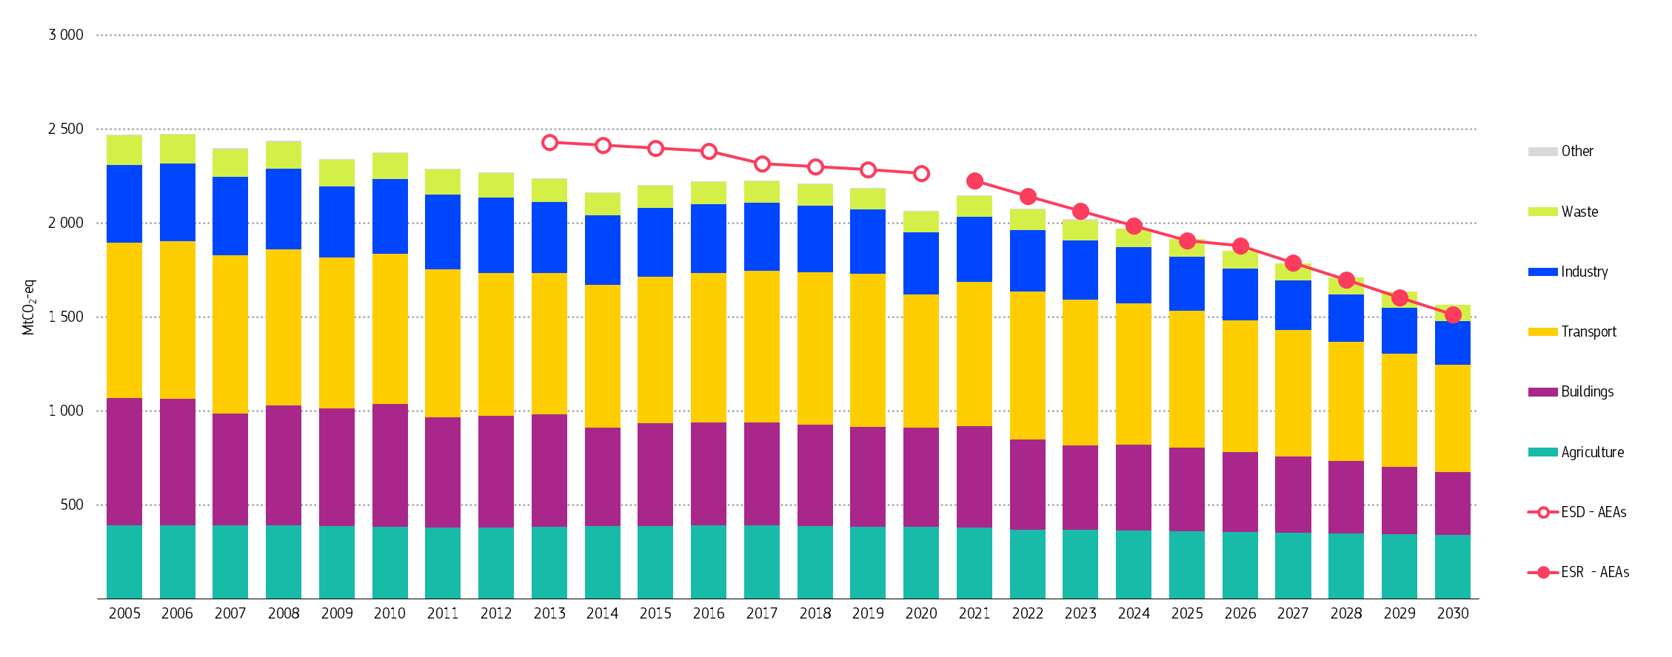
Note: the emissions data split between the Effort Sharing Regulation (ESR) sectors for 2021-2023 comes from the 2025 GHG inventory, for 2024 from approximated inventories, and 2025-2030 from projections reported by Member States in 2025 under Article 18 of the Governance Regulation. The annual emission allocations (AEAs) are the annual emission limits as set in the ESR and the ESR’s precursor the Effort Sharing Decision (ESD). The figure shows how the EU’s historic and projected effort sharing emissions are split between sectors and how they compare to the annual emission limits.

Effort sharing targets
The ESR sets the EU target to reduce emissions in the effort sharing sectors by 40% by 2030 compared with 2005 levels. This overall target translates into national targets for 2030 ranging from 10% to 50% reductions and GHG emissions limits from 2021 to 2030 expressed in annual emission allocations. The Commission will check whether Member States met their emission limits in two rounds – first in 2027 (for the years 2021-2025) and then in 2032 (for the years 2026-2030).
Member States can use, to a limited extent, flexibilities to stay within their annual emission limits and meet their 2030 targets. These flexibilities entail banking, borrowing, buying and selling emission allocations, using surplus (credits) from the land use, land use change and forestry (LULUCF) sector and for some Member States the option to cancel allowances from the EU ETS for ESR emission allocations (for more details see Chapter 9 of the accompanying staff working document).
Iceland and Norway have agreed to apply, with a few adaptations, the ESR, as adopted in 2018 . Their progress and developments are reflected in the annual Climate Progress Report prepared by the EFTA Surveillance Authority.

Progress towards effort sharing targets

Emission reduction targets for 2030
The ESR sets an emission reduction target for 2030 for the EU and each Member State (compared to 2005 levels). The Commission’s assessment of the final updated national energy and climate plans (NECPs) published in May 2025 shows that effort sharing emissions are expected to decrease by around 38% in 2030 compared to 2005, about 2 percentage points short of the EU target. This marks a substantial improvement compared to the EU wide gap of more than 6 percentage points shown in Commission’s assessment of the draft updated NECPs. It is crucial that the ambitious policies laid out in the NECPs are implemented in full and that Member States maintain their momentum and action to reach the ESR targets. In its assessment, the Commission provided targeted guidance to Member States to facilitate the swift implementation of the plans.
The above findings are confirmed by Member States’ latest projections of March 2025 (see Figure 13). Prior to any use of ESR flexibilities by Member States to meet their targets, Germany, Ireland and Malta show the largest projected gaps in 2030 whereas Bulgaria, Greece and Portugal show the largest overachievement of their 2030 targets.
To close those gaps, Member States have to step up action in addition to fully implementing all current and planned climate policies or use the scope for flexibilities available.
Figure 13: Projected change of ESR emissions and gap to target in 2030 (%)
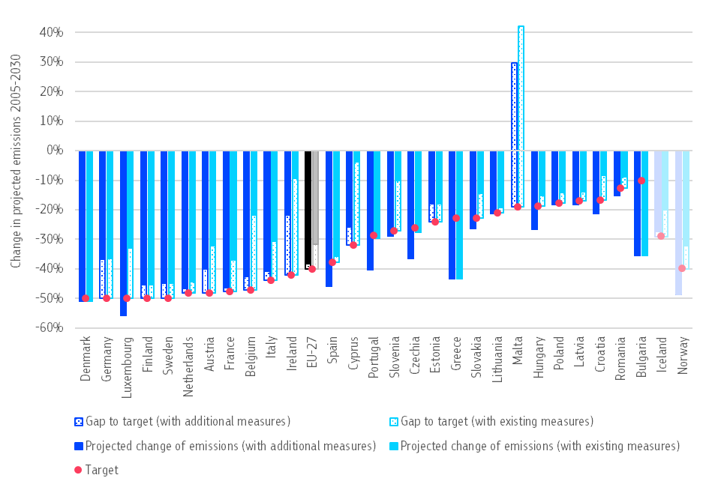
Note: Malta’s gap to target is 49 and 61 percentage points, exceeding its 19% reduction target. This means Malta is projected to emit more in 2030 than in 2005.

Emission reductions in 2021-2030
The ESR also sets for Member States emission limits for each year in the period 2021 to 2030, with flexibilities to meet these emission limits. The Commission has assessed Member States’ progress towards their ESR obligations by comparing emissions and allocations for each year in the period 2021-2030 based on the latest information and the potential use of some of the flexibilities available under the ESR.
The Commission assumes that Member States will implement their additional measures as included in their projections ‘with additional measures’ (WAM). Regarding the use of flexibilities, the Commission assumes that Member States will use emission allocations saved in one year for compliance in future years (banking) and use emission allocations from a future year if needed in the previous year (borrowing). It also assumes that the Member States that notified their intention to use ETS flexibility will do so when needed.
The Commission finds that 10 Member States would still exceed their limits in at least one year over the period 2021-2030. Cyprus, Croatia, Italy and Romania would already have excess emissions in the first compliance period (2021-2025), while Austria, Estonia, Germany, Malta, Ireland and Sweden are projected to have excess emissions in the second compliance period (2026-2030). The 17 Member States with no gap over the total period 2021-2030 generate more surplus than the 10 Member States would need to cover their gaps. Even if all Member States acquire emission allocations from others when needed, at EU level, a surplus of around 125 to 175 MtCO₂-eq allocations is expected over the 2021-2030 period.
The projected surplus of emission allocations in ESR from some Member States is sufficient to close the gaps from other Member States. The transfers of emission allocations between Member States enhances the cost-effective achievement of the EU objective in line with the architecture of the ESR. Given the size of the projected ESR surplus and the possibilities to trade surpluses under both the ESR and LULUCF Regulation, the Commission cannot, at this stage, conclude that Member States are not making sufficient progress to meet their ESR obligations.
In addition, another flexible arrangement to help Member States comply with the ESR involves transferring an overachievement in the LULUCF sector to cover a limited number of emissions in the effort sharing sectors . Some Member States have already reported their intention to use these flexibilities . However, the limited and preliminary data available on land use sector trends so far suggest that some Member States will have difficulties in reaching their LULUCF targets (see Chapter 4). These Member States could compensate the gap in LULUCF by using ESR emission allocations (Article 12 LULUCF Regulation), which will be automatic for the period 2021-2025 (Article 9 ESR).

Emission trends by type of gas
Two thirds of all emissions from the effort sharing sectors are CO₂ emissions, the remaining third are non-CO₂ emissions (Figure 14). Between 2005 and 2023, non-CO₂ emissions from the effort sharing sectors have reduced by 23%. Non-CO₂ greenhouse gases include methane (CH₄), nitrous oxide (N₂O), and fluorinated gases (NF₃, HFCs, PFCs, SF₆). While most of the emissions in the energy sector are covered by the EU ETS, methane emissions in this sector fall under the ESR.
Figure 14: Emissions under the ESR in 2005 and 2023 by gas type
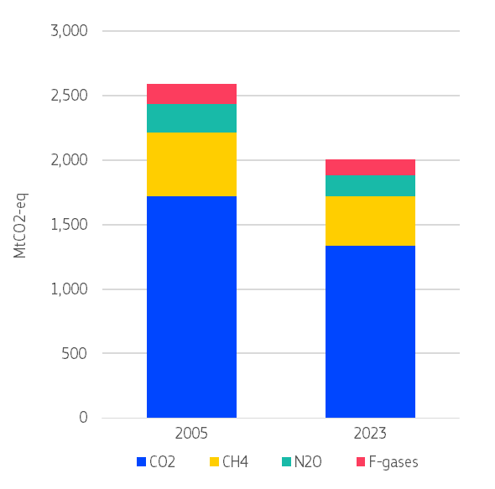
These non-CO₂ gases are emitted from a range of sectors and processes, and they all have much higher global warming potentials than CO₂ by degrees of tens to tens of thousands depending on the gas. As a result, non-CO₂ emissions have an important impact on climate change and are key sources of potential emission reductions in several sectors. Reducing non-CO₂ emissions is also crucial to achieve our targets under the ESR.
Over half of the non-CO₂ emissions come from the agriculture sector. All sectors have reduced non-CO₂ emissions from 2005 to 2023 but the most significant reductions were made in the non-ETS energy (‘other energy’), small industry and the waste sector. Over the same period, non-CO₂ emissions from agriculture, transport and buildings decreased only slightly. Most reductions were nitrous oxide emissions from non-ETS industry, and reductions in methane in the waste sector and non-ETS energy. The level of F-gas emissions has fallen but to a lesser extent (Figure 15).
The EU methane strategy aims to reduce methane emissions in the energy sector, agriculture and waste sectors, and thereby to support the achievement of the ESR targets.
Figure 15: Non-CO₂ emissions under the ESR in 2005 and 2023 by sector
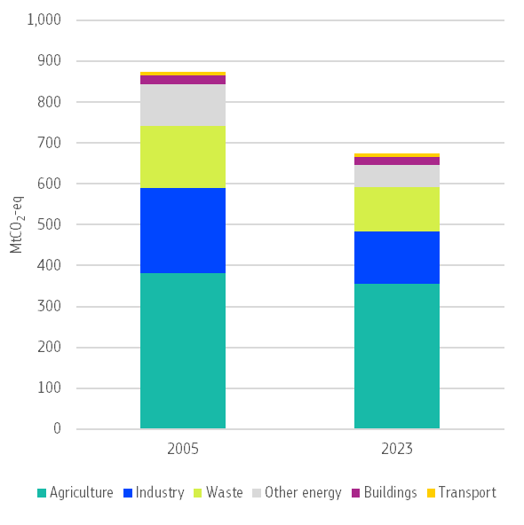

Fluorinated gases
Fluorinated greenhouse gases (F-gases) have the highest global warming potential of all greenhouse gases, meaning they cause the most harm to the climate. Among them, hydrofluorocarbons (HFCs) play a key role. HFCs are used in everyday products, equipment and processes, such as refrigeration, air conditioning, heat pumps, insulation, fire protection, power lines or industrial processes and they account for around 90% of all F-gas emissions.
Since 2015, total EU emissions from F-gases have been falling, mainly because new rules to phase down HFCs came into effect that year. By 2030, the amount of HFCs must be cut by about 95% compared to 2015, with a phase-out planned by 2050.
Between 2015 and 2023, in the EU total F-gas emissions fell by 32.8%, and HFCs emissions by 31.4%. From 2022 to 2023 alone, emissions fell by 7.4% for all F-gases and by 5.5% for HFCs. These reductions help Member States to meet their targets under the Effort Sharing Regulation.

Road transport
Transport emissions account for a quarter of all EU greenhouse gas (GHG) emissions and 39% of ESR emissions. Transport is the only major sector in the EU economy where emissions are still higher than they were in 1990 (+18%) and have only fallen marginally since 2005 (see Chapter 4 of the staff working document for more details). The decarbonisation of the transport sector must accelerate to achieve the EU’s climate goals for 2030 and 2050.
Road transport is the primary contributor to GHG emissions in this sector, generating about 95% of emissions, or 73% when including international aviation and maritime emissions. Over 70% of road transport emissions come from passenger cars and light commercial vehicles (vans). From 2005 to 2023, road transport emissions fell by less than 5%. This indicates that the gains in vehicle efficiency and the increase in zero-emission vehicles registered have been almost entirely offset by the ongoing increase in road transport activity.
The EU’s CO₂ emission standards for new cars, vans, and heavy-duty vehicles (i.e. lorries, buses, coaches and trailers) are key policies for gradually reducing road transport CO₂ emissions. They set EU fleet-wide emission reduction targets, from which annual specific emission targets are calculated for each individual manufacturer or pool. Compliance with the specific targets is assessed at the level of the fleet of vehicles registered in a given calendar year by a manufacturer or pool (not at individual vehicle level).
According to provisional monitoring data, the average CO₂ emissions from new cars and new vans registered in the EU, Iceland, and Norway slightly increased in 2024, for cars to 106.8 gCO₂/km, up from 106.4 gCO₂/km in 2023, and for vans to 185.4 gCO₂/km, up from 180.8 gCO₂/km in 2023.
The slight year-on-year increase in emissions is a small setback to the steep downward trend in CO₂ emissions of new cars and vans observed since 2020, when stricter CO₂ emission reduction targets came in. This increase occurred in the final calendar year before the stricter 2025 targets start applying. A similar increase in emissions was also recorded in the years before the stricter 2020 targets came into effect.
In 2024, average CO₂ emissions were below the EU targets (see Figure 16), marking a drop of 28% for cars and 8% for vans compared to 2019. This progress is mainly due to the rising number of zero-emission vehicles. In 2024, 14.5% of new cars and 7.2% of new vans had no tailpipe emissions – a sharp increase from just 2.2% and 1.4% in 2019. However, the rate of uptake of zero-emission vehicles varies widely across Member States (see Figure 17). In Denmark, nearly 52% of new passenger cars were zero-emission in 2024. By contrast, the share remained very low in several countries, for example only 2.3% in Slovakia, 2.8% in Croatia, and 3% in Poland.
Figure 16: Average CO₂ emissions (dots) and EU fleet-wide targets (lines) for cars and vans
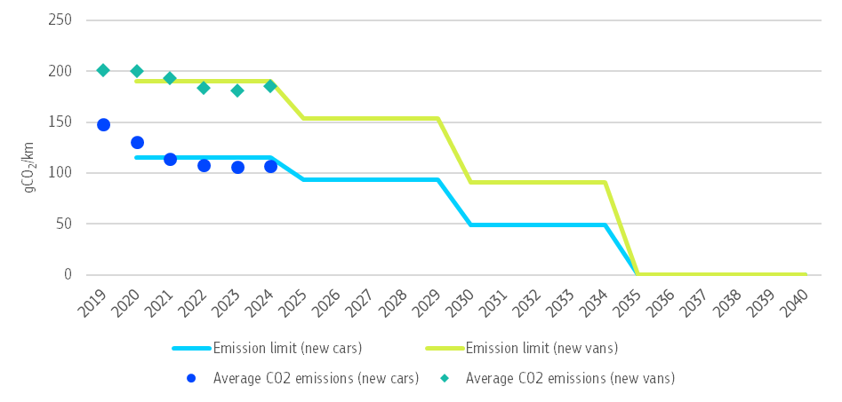
Figure 17: Share of zero-emission passenger cars in new passenger car registrations (%, 2024)
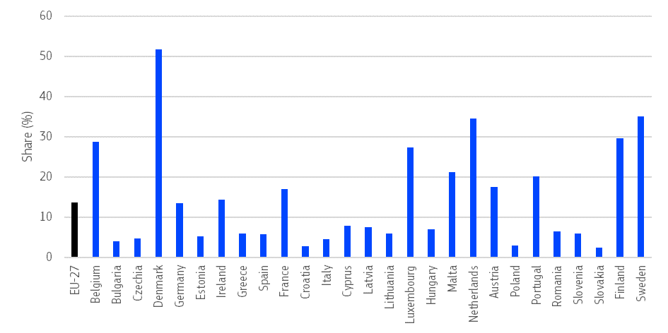
Source: Alternative Fuels Observatory
Despite the considerable progress made in recent years, further emission reductions are necessary for the EU to meet future targets. By 2030, average emissions must fall by 55% compared to the 2021 baseline for new cars (to 49.5 gCO₂/km) and by 50% for new vans (to 90.6 gCO₂/km).
Heavy-duty vehicles, such as lorries, buses, coaches and trailers, generate almost 30% of all CO₂ emissions from road transport. In 2024, the EU adopted revised CO₂ standards for new heavy-duty vehicles to further tighten existing standards and extend the scope to medium lorries, city buses, coaches, and trailers. The revised Regulation requires CO₂ emissions reductions of 15% by 2025 (unchanged by the revision), 45% from 2030, 65% from 2035, and 90% from 2040 onwards compared to the 2019 baseline. It also sets a 100% zero-emission target for new city buses from 2035.
In reporting period 2023, actually covering the period from June 2023 to July 2024, the average specific CO₂ emissions of new heavy-duty vehicles registered in the EU fell by 4.3%. This suggests that the trend of a more pronounced decline, which began in reporting period 2022 (-6.6%) after the only marginal reductions of the previous two reporting periods, is continuing (Figure 18) .
Overall, in reporting period 2023, emissions were 11.4% below 2019 levels. While this means that the fleet-wide 15% reduction target for 2025 is already within reach, further emissions reductions will be needed in the coming reporting periods, in particular in view of the more ambitious targets from 2030 onwards.
The number of new zero-emission lorries registered in reporting period 2023 has almost doubled with respect to the previous reporting period, however their share in the initially regulated vehicle groups remains still low, at 1.1%.
Figure 18: Average specific CO₂ emissions (dots) and EU fleet-wide targets (lines) for new heavy-duty vehicles of the initially regulated vehicle groups
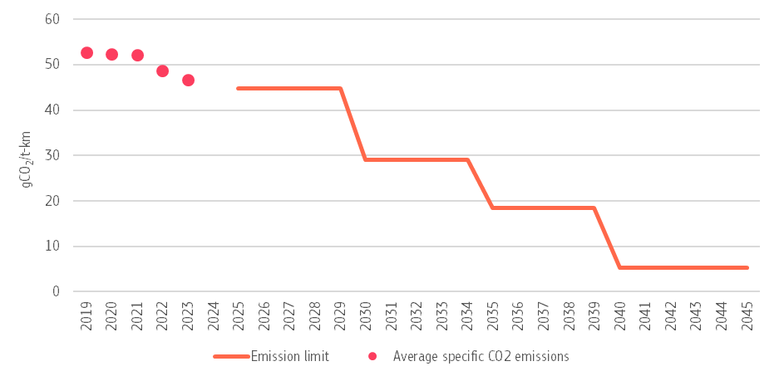
The Fuel Quality Directive contributes to reducing transport emissions by setting quality requirements for road transport fuels. Compliance with fuel quality limits is high in the EU. Almost all key fuel parameters in the samples taken in 2023 were reported to be within the tolerance limits (including the maximum sulphur content), and Member States reported the actions taken when non-compliant samples were identified. This confirms that the fuel quality monitoring system currently in place ensures that high-quality fuels are sold in the EU and that they meet the requirements of the Fuel Quality Directive.
Until 2023, Member States were also required to report on the 6% life cycle GHG emission intensity target for road transport fuels (measured against 2010 levels). Since 2023, the decarbonisation targets have been incorporated in the revised Renewable Energy Directive. The average GHG intensity of fuels supplied in 2023 was 6.3% lower than in 2010.
For more information on fuel quality, see Chapter 6 of the accompanying staff working document.
Fuel combustion in road transport will also be subject to a new emissions trading system (ETS2). The aim of this change is to bring emissions down by 42% by 2030 compared to 2005 levels (see Chapter 2 for more details).

Land use sector
Key highlights
- Carbon removals from the land use sector have been on the decline, with a slight improvement recently, resulting in a net carbon sink of −198 MtCO₂-eq in 2023.
- Latest available Member State projections still show a gap at the EU level of 40-55 MtCO₂-eq from the EU 2030 target.
- More investment in the land use sector and a better monitoring system is needed to enable reaching the land use sector’s climate target and ensure resilient bioeconomy value chains.
In the EU, the land use, land-use change, and forestry (LULUCF) sector absorbs more greenhouse gases than it emits, removing significant volumes of carbon from the atmosphere. The sector therefore plays a major role in achieving the EU’s climate policy goals, helping to enhance removals and boosting the resilience of agriculture and forestry sectors.
As a key pillar for the EU’s bioeconomy, the sector plays an equally important role for the transition to a climate-neutral and resilient economy, for instance in providing food and materials that replace fossil or carbon-intensive materials.
Net removals increased by 15 Mt in 2023 compared to 2022, resulting in a total net sink of −198 MtCO₂-eq in 2023. Despite this improvement, however, the carbon removal sink has been declining at a worrying speed over the last decade. This trend is mainly driven by increased harvesting and slower forest growth. This is in turn due to climate change which has had an increasing impact. More frequent and severe forest fires, wind damages, droughts, and insect and fungus outbreaks are reducing forest’s ability to absorb carbon. In some cases, ageing forests are also a factor. The future capacity of EU forests to remove carbon is therefore uncertain, and the EU may be at risk of losing its ability to balance carbon emissions from other sources.
Currently, land used for settlements, cropland, wetlands and grassland are the main sources of LULUCF emissions (See Figure 19).
Figure 19: Land sector emissions and removals in 1990-2023 by main land use category (EU-27)
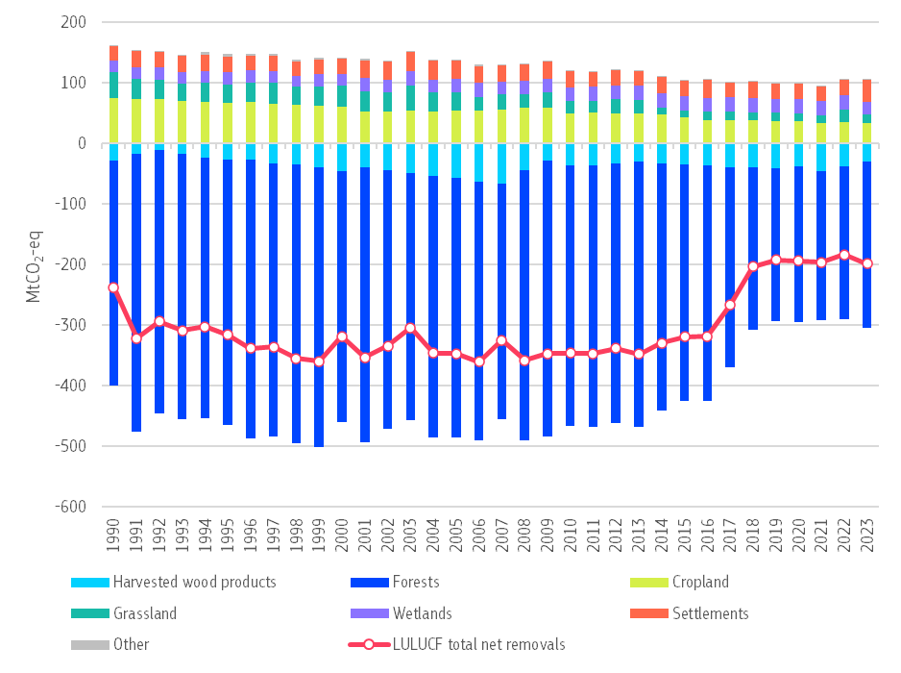

LULUCF target
The LULUCF target is to increase land-based net removals in the EU by an additional −42 MtCO₂-eq by 2030 compared to reference period 2016-2018 .
For the period 2021-2025, specific accounting rules apply for different land accounting categories, which consider historical benchmarks (such as the forest reference level). Member States are to follow the ‘no-debit’ rule, meaning that ‘accounted’ emissions must not exceed ‘accounted’ removals.
For the period 2026-2030, reporting is simplified, with the accounting rules and corresponding benchmarks abolished. The additional −42 MtCO₂-eq target covers all LULUCF reporting categories and is distributed among Member States through individual targets, based on their share of total managed land area. The national 2030 targets require each Member State to increase its climate ambition and implement additional agriculture and forestry policies. For more details, see Chapter 10 of the accompanying staff working document.

Assessment of the progress
The negative trend of shrinking net removals observed in recent years persists. Both the preliminary numbers for the compliance period 2021-2025 as well as Member States’ projections for the compliance period 2026-2030 indicate a gap to target.
Based on the 2025 GHG inventory submissions, the provisional ‘accounted’ balance for the period 2021 to 2023 shows an EU total debit of 52 MtCO₂-eq. The ‘no-debit’ commitment is therefore projected not to be met at the EU level, according to currently available figures. These, however, are subject to changes in the next years due to expected methodological improvements of the greenhouse gas inventories. These changes, and any flexibilities available to Member States, will then be taken into account before the compliance check for 2021-2025 that will be carried out in 2027 .
Based upon data for three years within the compliance period (2021-2023) and excluding flexibilities, 11 Member States showed accounting debits. They may therefore face challenges meeting the commitment in 2025, with Germany, Finland and Portugal showing the biggest net debit . On the other hand, 16 Member States are in line with the ‘no-debit’ commitment, as accounted removals are higher than accounted emissions. Italy, Romania and Spain show the largest net credit . Again, it is important to note that these figures are subject to change due to expected methodological improvements.
The latest projections provided by Member States show that the EU as a whole is not on track to meet its target of generating additional 42 MtCO₂-eq net removals by 2030, leaving a gap of around 40-55 MtCO₂-eq. Sweden, Finland and Spain project the biggest gap to their national 2030 targets, while France, Slovenia and Portugal project to have the biggest surplus compared to their respective 2030 targets (Figure 20).
Figure 20: Projected gap to the national 2030 targets with additional measures, based on Member States’ projections for 2030 (MtCO₂-eq)
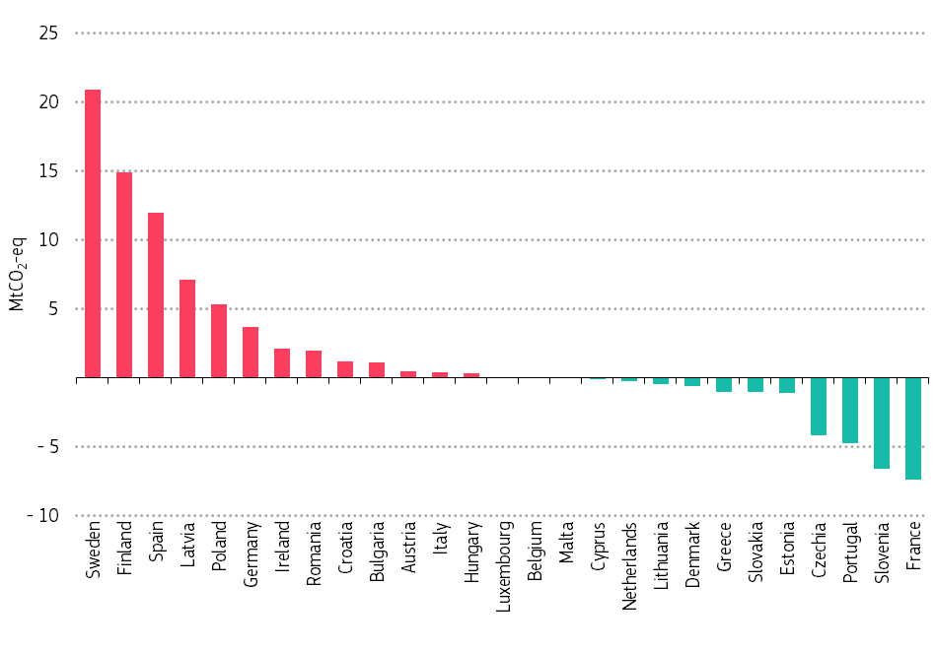
Note: The gaps to the 2030 LULUCF target have been calculated taking into account the latest Member States’ GHG inventories data and projections (both submitted in 2025), including a re-adjustment to take into account possible discrepancies between the inventory data and projections. As Member States continuously improve their methodologies for GHG inventory data and projections in terms of accuracy, the gap calculations are susceptible to changes in the future.
It is paramount that Member States swiftly design and implement adequate policies to put them firmly on track to reaching their climate targets. This should include measures to assist farmers, foresters and other groups concerned in building sustainable business models in line with these targets.

Action to step up land monitoring
The LULUCF Regulation requires that all Member States set up systems to monitor soil and biomass carbon stocks, among other things.
Member States’ GHG inventories underpin climate action and are subject to continuous development. More accurate and timely data on land, soil and forests will help identify measures that unlock the highest climate benefits. Comprehensive and comparable monitoring systems for land, reaping the benefits of advanced technologies such as modelling and satellites, are key for cost-efficient decision-making and investment into the land sector, both in the Member States and along the bioeconomy value chains. The Commission is assisting Member States in these efforts, such as through Horizon Europe programme and the Copernicus satellite programme.

Related initiatives relevant for agriculture and forestry
The EU Carbon Removals and Carbon Farming Regulation adopted in 2024 is designed to facilitate and speed up the deployment of high-quality carbon removals and emission reductions. It includes three distinct types of activities:
- permanent removals;
- carbon farming; and
- carbon storage in long-lasting products.
By certifying carbon storage products, such as wood-based construction, the regulation will also provide land managers with new business opportunities and support the growth of the sustainable circular bioeconomy. This will support Member States in meeting their LULUCF targets.

Incentives for carbon removals and sustainable practices
Many funding mechanisms and incentives are available or are being developed to encourage carbon removals, through public or private sources.
The EU provides funding under the common agricultural policy, cohesion policy funds, and other EU programmes such as LIFE or Horizon Europe (in particular the Soil Mission). In 2023, the Commission adopted guidance on EU funding opportunities for healthy soils.
Member States can also support the uptake of sustainable management practices under State aid rules, which have been revised and allow to support forest ecosystem services such as climate regulation and biodiversity restoration. The Commission guidance on payment schemes for forest ecosystem services provides further information for interested groups. The common agricultural policy and State aid also cover funding for investments and measures such as training, advice or cooperation, which help maximise effects.
Private-sector initiatives linked to voluntary carbon markets, or a combination of different funding options can supplement and further promote the large-scale deployment of carbon farming.

Industrial carbon management
Key highlights
- Capturing and storing CO₂ emissions permanently is necessary to achieve climate neutrality by 2050.
- In 2024, the European Commission drawn up a strategy to enable industrial carbon management.
- The EU has a CO₂ injection capacity target for 2030 and obligates oil and gas companies to achieve this target.
The 2040 climate target impact assessment shows that up to 300 million tonnes of CO₂ would need to be captured and approximately 200 million tonnes of CO₂ stored by 2040 to meet the proposed 2040 target to reduce greenhouse gas emissions by 90%. Approximately 450 million tonnes of CO₂ would need to be captured and roughly 250 million tonnes of CO₂ stored by mid-century. The Industrial Carbon Management strategy sets out a vision and proposes a list of actions to reach these targets.
CO₂ can be captured to prevent it from being released into the atmosphere, and then either stored or used. These practices are known as carbon capture and storage (CCS) and carbon capture and utilisation (CCU). Most of the CO₂ expected to be captured should come from industrial processes (e.g. waste incineration or clinker plants) feedstocks.
Captured CO₂ can also be of a biogenic or atmospheric origin. Biogenic CO₂ is produced through biological processes and can be captured from biomass power plants or waste-to-energy plants, for instance. Atmospheric CO₂ is found naturally in the atmosphere. Capturing and permanently storing CO₂ of biogenic or atmospheric origin is a practice known as permanent carbon removals.
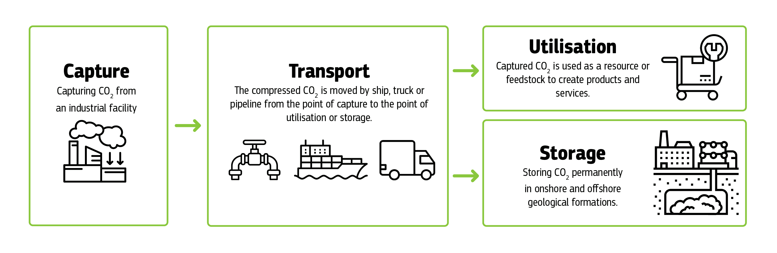
Figure 21: Scheme of carbon capture, utilisation and storage
Capture
Capturing CO₂ from an industrial facility
Transport
The compressed CO₂ is moved by ship, truck or pipeline from the point of capture to the point of utilisation or storage.
Utilisation
Captured CO₂ is used as a resource or feedstock to create products and services.
Storage
Storing CO₂ permanently in onshore and offshore geological formations.

The Industrial Carbon Management strategy is an important step towards a more homogenous deployment of carbon capture and storage (CCS), carbon capture and utilisation (CCU) and permanent carbon removals in Europe. The strategy supports the creation of a single market for CO₂ transport and storage services throughout Europe by 2030.
Adopted in late 2024, the Carbon Removal Certification Framework sets EU rules to measure and verify high-quality carbon removal activities. It is intended to support the voluntary market and could provide a basis for the future integration of domestic permanent removals into the EU ETS. The 2025 Clean Industrial Deal ties climate goals to industrial competitiveness, prioritising carbon capture, utilisation and storage for hard-to-abate sectors and signalling a possible EU ETS change to reward permanent CO₂ storage.
Since December 2024, Member States must submit an annual progress report on carbon capture, transport and storage needs. This report contains:
- ongoing CO₂ capture, storage and transport projects,
- corresponding needs for injection and storage capacities,
- national support measures, strategies, and targets on the CO₂ capture.
All Member States annual reports are available on the carbon storage target website.
The EU aims to create an EU market for CO₂ storage services. To achieve that, the Net-Zero Industry Act sets an EU CO₂ injection capacity target of at least 50 million tonnes per year by 2030 and obligates 44 EU oil and gas producers to achieve this target. These producers must develop annual CO₂ injection capacity in the EU by 2030 . From 2025, the European Commission will publish an annual report on progress towards reaching the target.
By 30 June 2025, producers had to submit a detailed plan to the Commission explaining how they are preparing to contribute to the EU’s 2030 CO₂ injection capacity target. These plans should confirm the volume of new CO₂ storage and injection capacity they aim to have ready by 2030 and specify the methods and intermediate targets they will use to achieve this. As of 30 June 2026, oil and gas producers must report annually to the Commission, detailing their progress towards the target. The Commission will make these reports publicly available.

Climate resilience and adaptation
Key highlights
- Climate hazards are undermining Europe’s competitiveness, security and prosperity. Climate resilience should urgently become an integral part of all European policies.
- Work is ongoing to create an integrated EU framework for climate resilience to be proposed in 2026.
- Resilience by design is a central principle. It means all investment vulnerable or exposed to climate impacts must be designed to face and withstand climate risks that could materialise in their lifetime, without unacceptable loss of their value or utility.
- EU Member States made significant progress in developing resilience and adaptation policy over the last year, albeit not yet measuring up to the required transformational changes.
- Significant further attention is needed to prepare and implement adaptation actions in all sectors.
The impacts of climate change are here. Storms, heatwaves, droughts, wildfires and floods are damaging homes, roads, nature, finances and the wider economy across all the EU countries. EU law requires the EU and its Member States to make progress on:
- building capacity to adapt: learn what’s coming and plan accordingly;
- strengthening resilience: help people, places, and systems to withstand disruptions and recover quickly; and
- reducing vulnerability: cut the exposure of communities and assets to climate harm.
Although progress has been made, EU and national measures are still falling short of what is needed at this stage.

Climate hazards and economic losses
In 2024, the EEA published the first European Climate Risk Assessment. This assessment revealed that 34 of 36 major climate risks across five risk clusters (ecosystems, health, infrastructure, food and economy and finance) could reach critical or even catastrophic levels during this century under high warming scenarios. The results of the 2024 European State of the Climate report also found that those risks are threating the lives, livelihoods and wellbeing of many Europeans.
Since the 1980s, Europe has been warming twice as fast as the global average, making it the fastest‑warming continent. 2024 was the warmest year on record in Europe, as tracked in all datasets, with record‑high annual temperatures in nearly half (around 48%) of the continent. The annual average sea and lake surface temperature for Europe in 2024 also reached the highest level on record, slightly above the previous record set in 2023. The glaciers in Scandinavia experienced their highest recorded mass loss and the largest globally.
In Europe, extreme heat causes about 95% of all climate-related deaths . Over the past 20 years, heat deaths have risen by about 30%, hitting people living in dense cities the hardest due to the urban heat island effect .
Wildfires burnt over 400 000 hectares (4 000 km²) in 2024 in 21 of 27 EU countries and affecting 42 000 people. This is slightly above the average over the period 2006-2023, but less than during the previous three years . However, serious wildfires broke out early in the main season, in July, on several Greek islands and in Madeira, Portugal. In only in one week, Portugal’s wildfires burnt over 100 000 hectares of land, some 32% of all burnt surface in Europe . In Bulgaria, the total recorded burnt area was the highest for more than a decade, with 256 fires burning 45 000 hectares of land. By the end of August 2025, almost one million hectares had burnt since the beginning of the year, more than three times the average rate of 293 000 hectares during 2006-2024 .
Alongside warmer than average temperatures, the prolonged lack of rainfall across most of south-eastern Europe affected river flows and impacted agriculture, ecosystems and energy production. As an example, information from several sources show that in Sicily reservoirs were below alert levels in early July 2024, with volumes 45% lower than the previous year . Many municipalities issued water-saving regulations as drought caused losses to agricultural production. This severely affected crops of citrus fruits, wheat and vineyards, with economic damages estimated at EUR 2.7 billion .
In 2024, while south-eastern Europe experienced the most severe dry conditions and had its driest summer for 12 years, September saw the wettest conditions in central Europe since 1979, due to extreme precipitation from Storm Boris falling over eight Member States. The resulting widespread severe flooding affected an estimated 413 000 people in 2024, resulting in the loss of 335 lives or more.
Damage from storms and flooding across Europe in 2024 is estimated to have cost at least EUR 18 billion and the insured losses due to flooding in 2024 were the second highest ever . Of all the natural disasters that hit Europe in 2024, the three costliest were caused by floods. Ranked by overall losses, Spain’s flash flood caused EUR 10 billion in losses, with less than half of the assets insured. The flash floods in Germany, Poland, Italy, Austria and Czechia caused overall losses of EUR 5 billion, with only 2 billion insured. The floods caused by Storm Boris in Czechia, Austria, Poland, Italy, Slovakia, Romania, Hungary caused losses of EUR 4 billion, half of which was insured . Climate change has been the cause of over third of all weather-related insurance losses over the last 20 years . In 2023, only about a quarter of economic losses in the EU were insured and the share was below 5% in some EU countries .
The increase in the frequency and intensity of many of these extreme weather events also poses heightened risks to the built environment and infrastructure in Europe, and to the services they provide. A Commission’s study shows that climate change will accelerate corrosion in older reinforced concrete buildings, with repair costs projected at EUR 76 billion to 883 billion by 2100.
Extreme heatwaves and fires, heavy rainfall and flooding, heavy snowfall and thunderstorms severely test the resilience of the transport system, impacting operational and economic functionality and resulting in accidents, incidents and rail transport service delays or cancellation. Marine heatwaves also have significant socio‑economic consequences, particularly for industries such as fisheries, aquaculture and tourism. Climate change is having an impact on specific groups of people and cultures in Europe too. For example, in northern Europe, climate change is having profound impacts on the livelihoods of the Saami people, threatening the culture and wellbeing of the Indigenous communities in Europe.
The extent of future economic losses will depend both on the action taken to mitigate climate impacts, to implement climate adaptation actions and to increase the resilience of exposed assets. Across all scenarios, EU’s annual losses could reach 2.2% of GDP by 2070, and a quarter of EU regions could experience GDP losses greater than 5% . If global warming stays more permanently above the 1.5 degrees threshold set under the Paris Agreement, the cumulative additional loss in GDP for the EU could amount to EUR 2.4 trillion from 2031 to 2050 .
The European Commission recently carried out a study on labour productivity losses caused by rising heat stress in EU regions. The study shows that heat stress from climate change will reduce labour productivity and GDP across Europe, with southern and south-eastern regions being the most affected. By 2050, productivity losses may reach around 0.9%, and GDP losses up to 0.7% in the most affected regions, relative to a future without heat stress impacts. These losses are projected to deepen by 2080, with a loss in productivity reaching 2.5% and GDP losses exceeding 1.5%. If adaptation action is not taken, and the worst-case climate scenarios materialise, labour productivity losses could exceed 6% in a few regions, and GDP losses could exceed 4%.

EU action to boost climate resilience
Given the wide range of climate hazards, it is essential to boost climate resilience across our economy, society and infrastructure to maintain core societal functions and ensure wellbeing of people. Climate resilience and risk management are vital for a competitive, secure, and prosperous EU.
The Preparedness Union strategy aims to enhance the EU’s civilian and military preparedness and readiness for future crises so that everyone is ready and capable of responding quickly and effectively if needed. The strategy will help national preparedness action by stepping up coordination and efficiency under existing strategies and by fostering a culture of resilience to all types of future crises.
The strategy recognises that climate risks are part of the key crisis landscape. It stresses the importance of anticipation and prevention, and the need to tackle risks and threats in a comprehensive manner, considering how they interact and produce cascading effects. With this main aim, the strategy commits to develop a comprehensive cross-sectoral EU-level risk and threat assessment. The strategy also explicitly sets out to embed ‘climate resilience by design’ and ‘preparedness by design’ into all EU policies and actions. Using common climate reference scenarios, this would ensure better climate-proofing of policies so as to head off future crises and strengthen proactive climate, environment and water risk management across the EU.
In 2024, the focus has been on launching work on an integrated framework for climate resilience, including a public call for evidence. The European Environment Agency has led the preparation of a second European Climate Risk Assessment. The integrated framework will seek to ensure that all investments vulnerable to the impacts of climate change are designed to tackle the climate risks that could materialise in their lifetime (‘resilience by design’).
Fully aligned with the above policies, the Competitiveness Compass asks the EU and Member States to regularly update climate risk assessments and improve critical infrastructure based on the resilience by design principle. The Competitiveness Compass sets out options to avoid supply chains and production sites getting compromised by hazardous events, including action to integrate climate resilience in urban planning, deploying nature-based solutions, and developing nature credits and adaptation in agriculture while preserving food security.
The Vision for EU Agriculture and Food depicts the impacts of extreme weather events and changing precipitation patterns for farmers. To reduce their vulnerability and exposure to risks, incentives will be increased to fund adaptation at farm level and for risk sharing via producer organisations or cooperatives. Under the strategy, the future common agriculture policy will provide more targeted for measures and investments that make the agricultural sector more resilient to the changing conditions. More ambitious transformational changes will be needed in places where current production is not sustainable over the longer term, involving for example new local strategies, research and innovation.
As highlighted in the water resilience strategy, another important aspect of strengthening the EU’s resilience is support for public authorities, businesses and the public in preparing for future climate risks. This may include support for the use of digital tools for EU real-time early warning and monitoring systems. The strategy calls for action to empower people and communities to adapt and protect themselves from risks. A first step towards building societal resilience is to make sure information is widely available on the specific risks that people, businesses, land and, infrastructure face. Although, there may already be many tools to protect the population from climate-related disasters or mitigate the impact, they are not always sufficiently known or used. The EU and Member States must therefore strengthen the links between existing risk management tools at European level (such as the early warning tools of the Copernicus Emergency Management Service) and the tools available at national and local levels.
Embedding climate-related risks in fiscal policy is also key to strengthening resilience. As the economic and fiscal costs of climate change are rising and transition efforts accelerate, it becomes essential to assess the macro-fiscal impacts of climate change and integrate them into national budgetary frameworks. Significant progress was made in 2024 with amendments to the directive on requirements for budgetary frameworks of the Member States, adopted as part of the revised EU Economic Governance Framework. From 2026, all EU Member States are required to assess and report in their budget documents, to the extent possible, on how the macro-fiscal risks from climate change may affect the medium- and long-term sustainability of public finances, on disaster- and climate-related contingent liabilities and on the fiscal costs incurred due to disasters and climate-related shocks. These provisions aim to strengthen the understanding and management of climate-related fiscal impacts, foster more proactive and risk-informed budgeting practices, and support evidence-based policy and investment decisions.

Progress in the Member States on climate resilience and adaptation policies and legislation
The overall climate resilience and adaptation policy landscape and frameworks are well established across Europe . The Member States use a range of policies to tackle climate risks and aim to boost climate resilience and adaptation action, such as:
- dedicated climate adaptation laws;
- national climate laws and other legislative acts with adaptation rules;
- national adaptation strategies and plans; and
- sector-specific and regional adaptation plans.
Germany has adopted a specific, standalone climate adaptation law, and Lithuania is currently preparing one. A growing number of countries are putting adaptation rules into their national climate laws to give greater legal force to adaptation action. 13 Member States give adaptation full legal force this way.
National adaptation planning and up-to-date climate risk assessments are a prerequisite for policy implementation. EU law requires the Member States to adopt and implement national adaptation strategies and plans. Progress has been made on this front. In 2025, all EU countries have an adaptation strategy or plan in place (see Figure 22). Between 2023-2025, 11 Member States adopted or updated their strategy or plan.
EU countries are making progress in developing their national climate risk assessments. They are taking action to generate and update knowledge about climate-related hazards, vulnerabilities, impacts and risks, strengthening efforts for evidence-based policy making on adaptation. Nearly all Member States tackle climate risks in some form, ranging from thematic or sector-specific analyses to multi-risk and multi-sectoral, comprehensive climate risk assessments.
Six Member States have reported having completed their new or updated national climate risk assessment from 2023-2025. The number of Member States with a comprehensive and national assessment available has increased to 21. 13 Member States report new national, comprehensive assessments as planned or in progress.
At least one third of Member States have completed new thematic or sectoral climate risk assessments. Most Member States have at least some form of sectoral or thematic climate risk or vulnerability assessment available.
Even if the level of policy preparedness of the Member States has steadily risen at national level, more coherent policy and monitoring, reporting and evaluation frameworks are needed at all levels. Currently, there is no coherent data available on the implementation of adaptation policies in all Member States, but recent evaluations show that implementation and methods to evaluate adaptation efficiency and effectiveness are lagging. It is crucial to mainstream adaptation into sectoral policy. Despite the growing trend of sectoral and thematic adaptation policies at national level, more action is needed on sectoral policies, e.g. in the health sector.
National, regional and local governments are increasingly incorporating justice into their adaptation policymaking and planning. Similarly, at regional and local level, justice has increasingly been taken into consideration in urban adaptation planning. With many examples around Europe, participatory processes are being used to inform policy. Nevertheless, inclusion of vulnerable groups and justice still need attention (see Chapter 11 of the accompanying staff working document for further details).
The development described above is aligned with the Commission recommendations and the responses given to them by the Member States. In its assessment, In September 2023, the Commission found that Member States’ measures were often in need for improvements to become more consistent with the EU’s and the international agreements’ objectives to ensure continuous progress in enhancing adaptive capacity, strengthening resilience and reducing vulnerability to climate change. Following the assessment, the Commission issued tailored recommendations to 26 Member States, addressing a broad range of aspects across the policy cycle (see Chapter 11 of the accompanying staff working document for further details).
You can find more information about climate resilience and adaptation including country profiles, case studies, guidance, data and publications on Climate-ADAPT portal.
Figure 22: Adaptation strategies, plans and climate laws with adaptation provisions rules in the EU
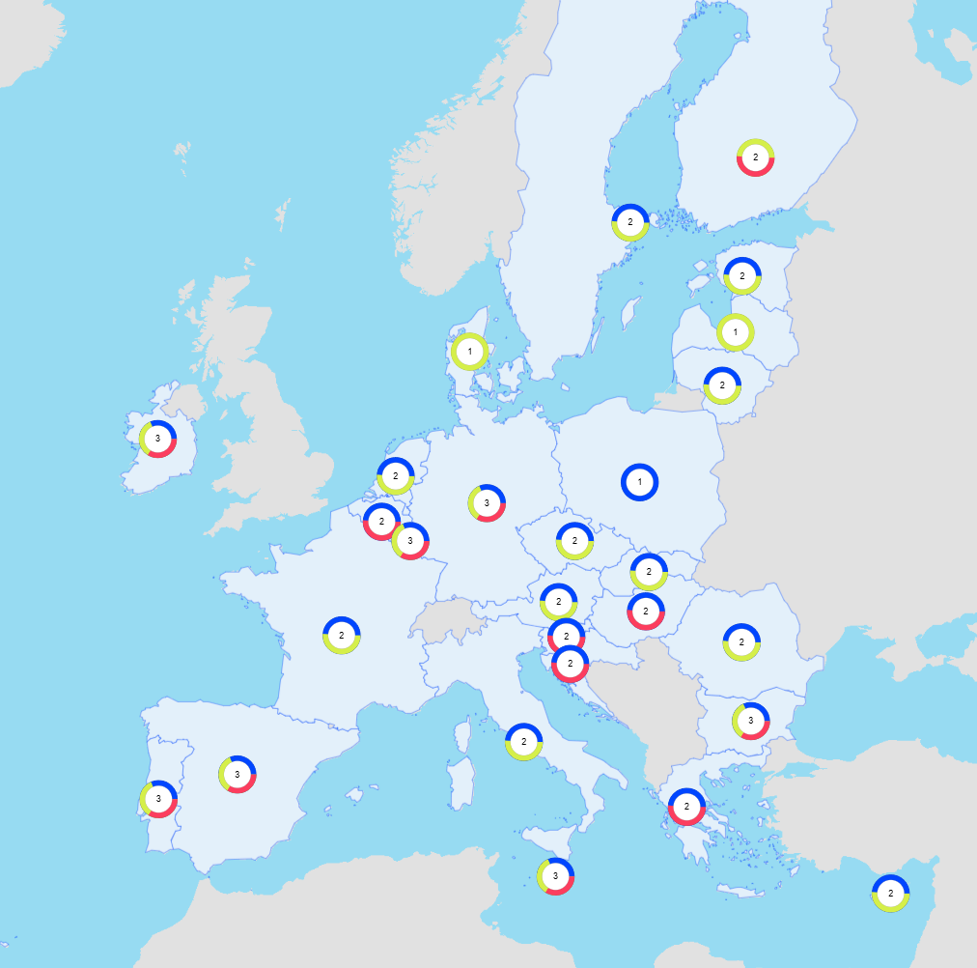
Legend: |  | National adaptation strategy |  | National adaptation plan |  | National or federal climate law with adaptation rules

Regional and local action
Across the EU, regions and cities are stepping up climate resilience and adaptation work. They are making progress on two tracks:
- Legal requirements. An increasing number of Member States now oblige regional and local authorities to prepare and implement climate adaptation plans. Countries that have these legal requirements often have strategies in place or are integrating resilience and adaptation into sector programmes, policies and regulations and are rolling out measures through multilevel coordination.
- Voluntary action. In countries without legal requirements, regions and cities are increasingly taking voluntary action, often under national adaptation plans or EU cross-border programmes. Governments often support this with incentives, guidance and joint initiatives.
Multilevel institutionalised networks are becoming more commonplace, supporting local, regional and national bodies in sharing knowledge and aligning policies. EU funds are helping regions and municipalities finance climate resilience and adaptation projects. (For more information, see Chapter 7).
The Covenant of Mayors initiative, created in 2008 and supported by the European Commission, brings together thousands of local governments seeking to secure a better future for their citizens. By joining the initiative, the local governments voluntarily commit to implementing EU climate and energy objectives. The initiative is a key enabler of local adaptation planning across Europe by providing tools, networks and peer-to-peer support. Over 10 000 local governments have committed to action under the three pillars of the covenant, including strengthening resilience and alleviating energy poverty.

Investments in climate action
Key highlights
- Investing now means saving tomorrow. Between 1980 and 2023, climate-related extreme events caused economic losses of EUR 738 billion in the EU, with EUR 162 billion in just 2021–2023. Accelerating green investment reduces future costs, creates jobs and strengthens Europe’s resilience and energy security.
- Significant investments are needed to meet EU climate and energy targets. Annual investment in the EU’s energy system must more than double to around EUR 565 billion per year in 2021–2030 compared with 2011–2020.
- Private capital is essential for the transition. The EU’s Sustainable Finance Framework is mobilising significant private investment for sustainable activities, with green bond issuance in the EU reaching a record EUR 314 billion in 2024.
- The EU budget mainstreams climate action across programmes. About EUR 662 billion (34% of the 2021–2027 budget) is earmarked for climate objectives through programmes such as the Recovery and Resilience Facility, cohesion policy, InvestEU and Horizon Europe.

Investment needs
Between 1980 and 2023, climate-related extreme events caused an estimated EUR 738 billion in economic losses across the EU. Strikingly, EUR 162 billion (22% of all losses) occurred between 2021 and 2023 alone . These rising costs show the urgency and importance of taking action to tackle climate change, to reduce GHG emissions and to prepare for increasing climate impacts. As well as reducing climate impacts, climate action brings wider economic and social benefits. These benefits include cleaner air, better public health, and lower healthcare costs. This is also an investment in the EU’s strategic independence – it not only saves money, but also reduces the EU’s dependency on imported energy and exposure to shocks. By switching to renewable energy, the EU could reduce the cost spent on importing fossil fuels by EUR 2.8 trillion between 2031 and 2050, compared with the 2011-2020 average .

Future needs
It is important to invest both in action to mitigate greenhouse gas emissions and in building our resilience to manage the growing climate impacts.
To limit climate change and meet the EU’s 2030 climate and energy targets, investment in the EU’s energy system must increase significantly to reach around EUR 565 billion a year between 2021 and 2030, up from the EUR 250 billion invested per year in the previous decade . It does not include investments to decarbonise the transport sector.
Shifting away from fossil fuels and meeting rising demand for electricity will require major investments in strengthened and modernised low-emission electricity systems. Investment in new power generation, mainly wind and solar, and upgrading existing power plants will need to more than double, from about EUR 45 billion to EUR 90 billion annually.
The largest required increase on the supply side is in power grids. Investment in transmission and distribution infrastructure must triple to ensure reliable and efficient delivery of electricity.
On the demand side, investments must also more than double. The residential sector has the highest absolute needs, with an estimated needs of EUR 215 billion a year to renovate buildings and replace heating systems and appliances. This is nearly twice the average investment made in 2011-2020.
The sharpest relative increase is needed in industry. Although annual needs are lower in absolute terms, estimated at about EUR 40 billion, they represent a sixfold increase compared to the previous decade. Investments are especially needed to modernise and decarbonise energy-intensive sectors such as steel, cement, and chemicals.
Estimating the investment gap in climate adaptation requires more work. Currently, many investments assume that historic climatic conditions will continue in the future. An approach is needed that properly factors in expected future climatic developments for all investments exposed to physical risks (the principle of climate resilience by design, as explained in Section 6.2).
Table 3: Average annual investment needs in the energy system (EUR 2023, billion)
Sector | 2011-2020 | 2021-30
Energy supply side | 80 | 200
Power grid | 20 | 60
Power plants | 45 | 90
Other | 20 | 45
Energy demand side | 170 | 365
Industrial sector | 5 | 40
Residential | 115 | 215
Services | 30 | 80
Agriculture | 15 | 30
Total | 250 | 565

Progress made
Recent trends show encouraging signs that investment in the climate and energy transition is picking up. The total installed capacity of wind and solar power generation increased by almost fivefold between 2010 and 2024 and by 70% between 2020 and 2024. The rapidly falling cost of solar panels has led to an annual increase in installed capacity in excess of 20% in 2022-2024, and a 15% annual increase in wind power over the same period. In 2024, the combined installed capacity of solar and wind power generation amounted to 535 gigawatt, around 47% of total installed capacity.
Figure 23: Wind and solar power generation capacity
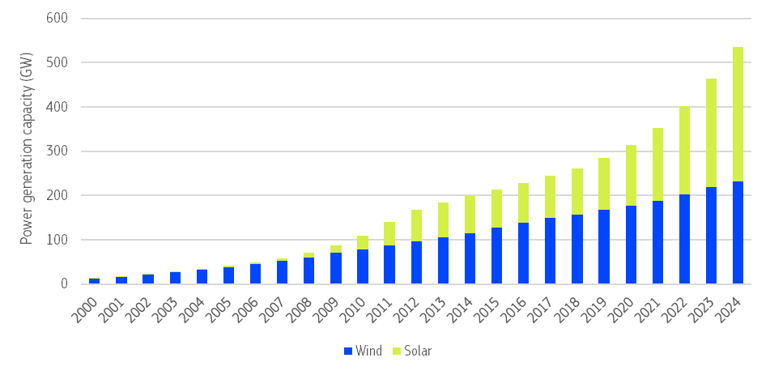
Source: Eurostat (IRENA for 2024)
New registrations of battery-electric cars and plug-in hybrids have also picked up significantly in recent years, to reach 1.5 million and 0.8 million, respectively, in 2024. Investment in heat pumps has also gathered momentum over the past few years, although not as rapid an increase as for solar and wind power generation as hurdles remains in terms of consumer acceptance and installation capacity, among others.
Figure 24: New car registrations (battery electric cars and plug-in hybrids)
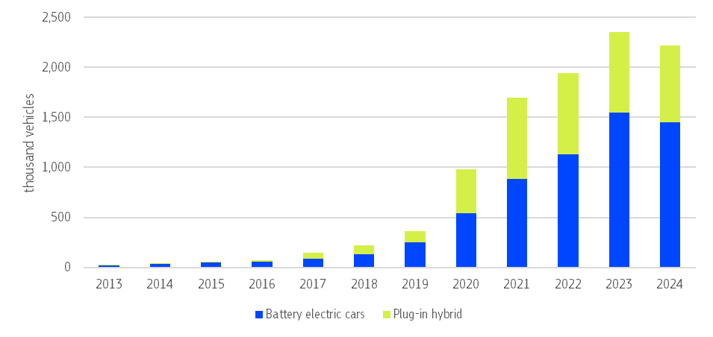
Source: Eurostat
Figure 25: Heat pump installed capacity
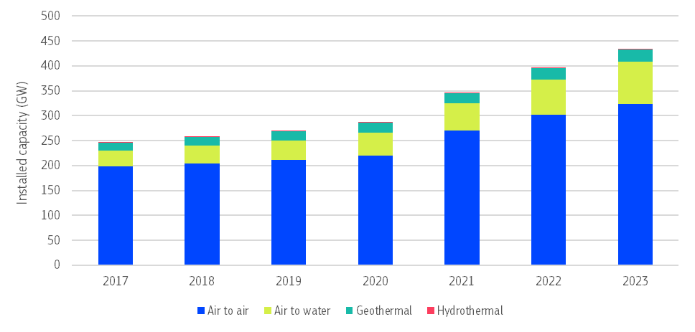
Source: Eurostat

Mobilising private-sector investment
Given the scale of investment needs, private-sector contributions to financing both climate resilience and climate mitigation need to be substantial. This is why the EU put together a policy framework that aims to facilitate private-sector investments in sustainable activities. The Sustainable Finance Framework provides investors with robust definitions of sustainable activities (the EU Taxonomy) and requires companies and banks to disclose their impact on the environment and climate (Corporate Sustainability Reporting Directive, Sustainable Finance Disclosure Regulation). The rules governing sustainable finance are currently being simplified to reduce their administrative burden on companies, while making the framework more workable and impactful. In February 2025, the Commission put forward legislative proposals to reduce the volume of sustainability reports and the number of companies that need to report this information. The Commission is also considering other simplification measures.
Over the past years, the corporate and financial sectors have channelled significant resources towards green objectives in the EU. For instance, according to the latest report from the Platform on Sustainable Finance, Taxonomy-aligned capital expenditure from large listed European companies reached EUR 250 billion in 2023 .
In the financial sector, certain instruments have emerged as a fundamental tool to mobilise private capital. Figure 26 presents the annual amounts of ESG (environmental, social or corporate governance) bonds in the EU, until the first half of June 2025. Green bonds (i.e. bonds financing green projects) continue to dominate the ESG market. The volume of new green bond issuance amounted to EUR 314 billion in 2024, its highest level since the first issuance of a green bond in 2007. In contrast, sustainability-linked bonds (i.e. bonds for which issuers pay a higher interest if they do not meet their pre-defined ‘sustainability’ objectives) continue to decrease, amounting only to EUR 26 billion in 2024, compared to EUR 66 billion in 2021 and EUR 45 billion in 2022. This decrease reflects the more rigorous approach to sustainability taken by investors. Similarly social bonds (i.e. bonds financing social projects) and sustainability bonds (i.e. bonds financing a combination of green and social projects) both saw a decrease, reinforcing the prevalence of green bonds.
Figure 26: Annual issued volumes in the EU – ESG bonds
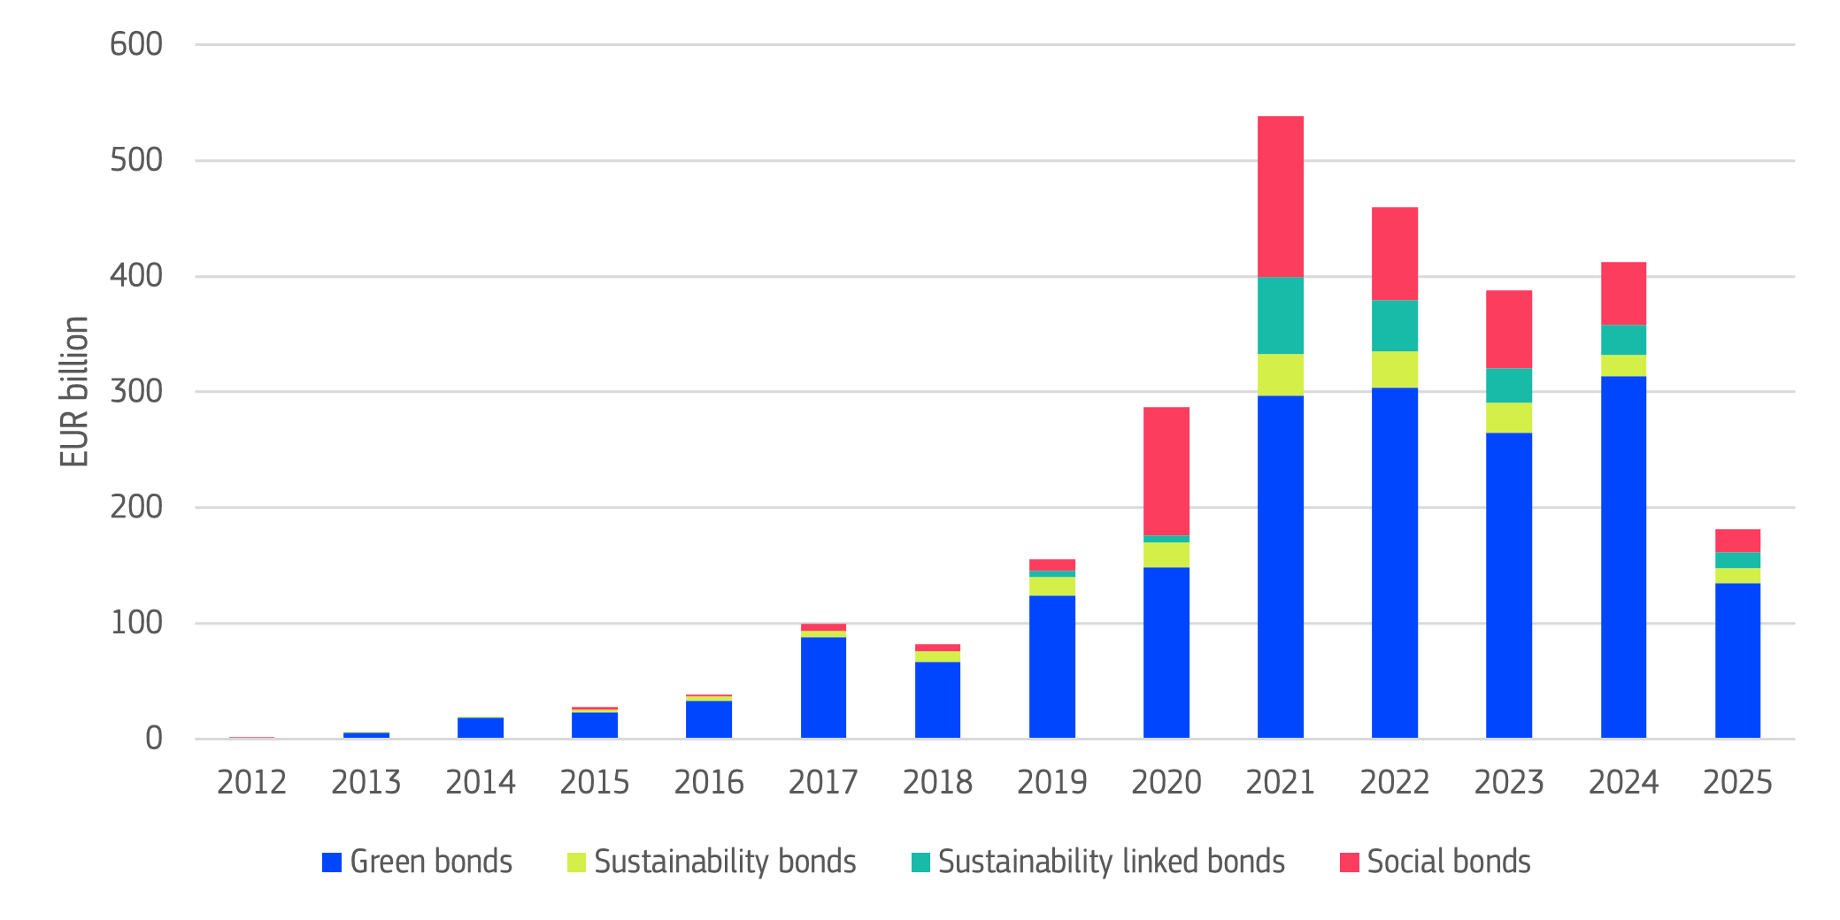
Source: LSEG, JRC calculations. Data as at15 June 2025.
The EU is a global leader in the green bonds market (see Figure 27). In every year between 2021 and 2024 they accounted for over 3% of all bond issuances (touching 2.7% in mid-2025), remarkably higher than the non-EU share of green bonds at less than 0.5%.
To bring greater transparency and credibility to these financial instruments, the EU adopted as of December 2024 the European Green Bond Regulation, a voluntary framework for issuers who wish to label their bonds as European Green Bonds. This standard is based on the detailed criteria of the EU taxonomy to define green economic activities, ensuring transparency levels that align with market best practices. It also brings in supervision for companies conducting pre- and post-issuance reviews at European level.
Figure 27: Annual issued volumes and green bond share – all bond types
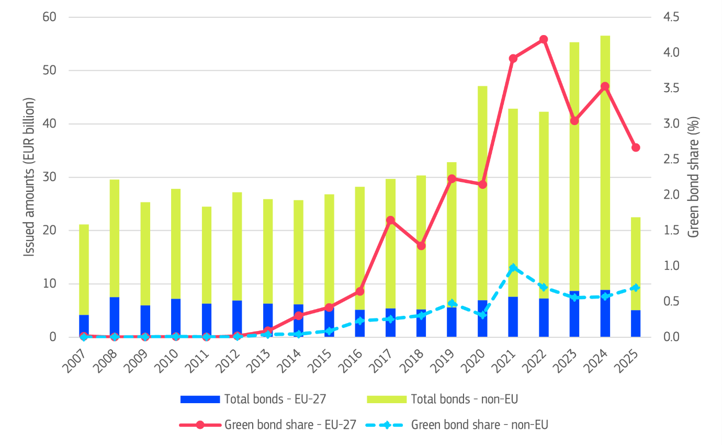
Source: LSEG, JRC calculations. Data as at 15 June 2025.
The market for ESG loans (defined as a club deal, a syndication or a bilateral transaction) is traditionally less well defined than the ESG bond market, with no EU regulation. Green loan issuances have steadily increased since 2016, reaching EUR 71 billion in 2024, up from EUR 53 billion in 2023 (see Figure 28).
Figure 28: Annual issuance of ESG loans in the EU
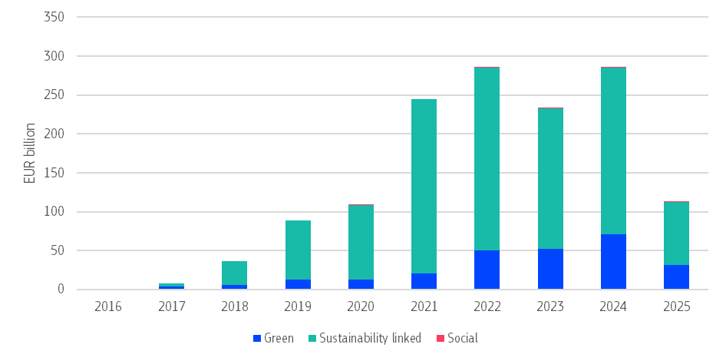

Source: LSEG, JRC calculations. Data as at 16 June 2025
To facilitate and accelerate the corporate transition to net zero, the Commission will also develop sector-specific transition pathways, with the direct involvement of key industries. These pathways should enable more informed investment decisions and help mobilise more capital for the transition.
The upcoming integrated framework for climate resilience will include action to mobilise climate resilience financing to ensure that all investments vulnerable to the impacts of climate change are designed to face climate risks that could materialise in their lifetime (‘resilience by design’).

Funding from the EU Emission Trading System
Three funds use revenues from the EU Emission Trading System to support clean technologies, renewable energy and energy efficiency:
- Innovation Fund;
- Modernisation Fund; and
- Social Climate Fund.
Moreover, the Recovery and Resilience Facility is partially financed by ETS revenues.

Innovation Fund
The Innovation Fund is one of the world’s largest funding programmes for the deployment of low-carbon technologies. The goal is to bring to market new clean energy and industrial technologies so the EU can reduce emissions, reach climate neutrality and stay competitive. The fund has an estimated budget of EUR 40 billion between 2020 and 2030 (based on a carbon price of EUR 75 per tonne). Projects from the EU, Iceland, Liechtenstein and Norway can apply for support from the fund.
Since 2020, the Commission has launched 11 calls for proposals, including two auctions under the European Hydrogen Bank. The Innovation Fund now backs about 190 large- and small-scale ongoing projects with funding totalling around EUR 10.8 billion.

Calls for proposals in 2024
The Commission opened three calls for proposals in December 2024 with a budget of EUR 4.6 billion.
- Net-zero technologies. This call for proposals had a budget of EUR 2.4 billion and received 359 proposals from 28 countries when it closed in April 2025. The Commission has just published the results of the evaluation and the list of projects pre-selected for grant agreement preparation.
- Batteries. For the first time, this call for proposals will support the manufacturing of electric vehicle battery cells. The call had a budget of EUR 1 billion and received 14 proposals from 8 countries in April 2025. In July 2025, it was announced that six projects were awarded funding: two from France and Germany and one from Sweden and Poland receiving a combined EUR 852 million of support. These projects will have a combined battery manufacturing capacity of around 56 gigawatt-hours (GWh) of EV battery cells per year.
- Hydrogen auction. This call for proposals was for the second round of the European Hydrogen Bank auction for the production of renewable hydrogen. The budget was EUR 1.2 billion, including a new allocation of EUR 200 million specifically earmarked for projects in the maritime sector. The auction closed in February 2025 with 66 bids from 11 countries and 15 projects in 5 different countries receiving support. These projects are expected to produce nearly 2.2 million tonnes of renewable hydrogen over 10 years, avoiding more than 15 million tonnes of CO₂ emissions.
As announced in the Clean Industrial Deal communication, the Innovation Fund will launch new call for proposals to support clean technology, battery manufacturing and renewable hydrogen at the end of 2025. It will also launch a new auction for decarbonising heat in industrial processes.
All projects, country fiches and interactive dashboards are available in Innovation Fund Project Portfolio.

Innovation Fund services
The Innovation Fund provides several services that let additional projects receive financing even after the initial budget of a call for proposals has been allocated.
Germany, Austria and Spain have all made contributions under the ‘auctions-as-a-service’ mechanism, deploying up to EUR 836 million to support promising projects that did not receive funding in the last hydrogen auction.
The Commission is working to set up a similar feature for the regular calls for proposals, called ‘grants-as-a-service’.
Both features enable Member States to use the Innovation Fund evaluation procedures and avoid unnecessary administrative and financial burdens to develop and run new support schemes for the same technologies.
Support from the Innovation Fund goes beyond public financing. In particular, small-scale projects or projects from lower-income countries can receive Project Development Assistance. The European Investment Bank offers tailored technical and financial advisory to improve the maturity of innovative projects and ensure balanced spread of Innovation Fund support across regions and sectors.

Modernisation Fund
The Modernisation Fund uses revenue from the EU ETS to help lower-income Member States meet their 2030 climate and energy targets. 13 Member States: Bulgaria, Croatia, Czechia, Estonia, Greece, Hungary, Latvia, Lithuania, Poland, Portugal, Romania, Slovakia and Slovenia can benefit from this support.
The Fund finances renewable energy sources, modernisation of energy networks, and energy efficiency in buildings and industry. These investments speed up the clean transition and keep the whole EU competitive.
The Modernisation Fund has an estimated budget of EUR 57 billion from 2021 to 2030, assuming an average carbon price of EUR 75 /tCO₂. Since 2021, EUR 19.1 billion has already been disbursed to 12 beneficiary Member States.
The latest disbursements include EUR 2.7 billion in December 2024 and EUR 3.7 billion in June 2025. The latter is the largest disbursement since the Fund was created. These recent disbursements saw the first ever funds invested in Slovenia (December 2024) and Greece (June 2025).

Social Climate Fund
The Social Climate Fund was set up together with the ETS2 (see Chapter 2), the EU’s emissions trading system for fuel used in buildings, road transport, and small industry. Its main goal is to help reduce the social and economic impact of this new system by providing help to the most affected people, especially households and microenterprises struggling with higher costs of energy and transport. Together with a mandatory contribution from Member States it should provide at least EUR 87 billion in public support from 2026 to 2032, ensuring no one is left behind as we shift to a cleaner economy.
A description of how the funding from the Social Climate Fund will be spent is contained within Social Climate Plans to be adopted by Member States and that need to be positively assessed by the Commission. These plans must identify the most vulnerable groups in relation to energy and transport poverty as well as ETS2 impacts, and describe the measures and investments to support them. In designing their plans, Member States must conduct public consultation, involving a range of stakeholders broadly defined: regional and local authorities, representatives of economic and social partners, relevant civil society organisations, youth organisations, etc. A summary of the consultation as well as an explanation of how input has been integrated should also be included in the plan. The involvement of regional and local actors continues in the implementation of investments on the ground and throughout the duration of the fund, so to ensure tailored and effective action.
So far Sweden and Latvia have submitted their draft Social Climate Plans to the Commission. The European Commission has started reviewing the plans and a final decision is expected within the five-month legal deadline following their submission. The Commission is also in close contact with remaining Member States to help finalise and submit all plans.
If a Member State’s plan is positively assessed, funding can begin on 1 January 2026. However, only countries that fully convert the ETS2 into their national law will be able to access the fund.

Climate expenditure in the EU budget
The EU budget – both the EU’s ‘multiannual financial framework’ covering the 2021-2027 period and the post-Covid recovery instrument NextGenerationEU – is a key driver of the green transition.
Current budget commitments suggest that in 2021-2027 the EU will spend around EUR 662 billion on climate action. This is 34% of the whole EU budget and above the 30% target.
With 78 % of its budget going to climate, the Connecting Europe Facility (CEF) has one of the highest shares of spending on climate of any EU programme. The LIFE programme and the Recovery and Resilience Facility (RRF) also spend a large share of their budgets on climate projects (see Figure 29).
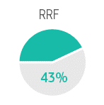
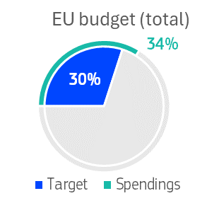
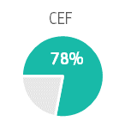
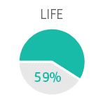
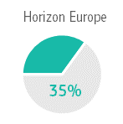
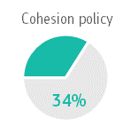
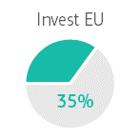
Figure 29: Expected share of the EU budget and of selected funds and policies spent on climate (%, 2021-2027)
Source: Budget commitments on climate. Climate mainstreaming - European Commission
All these funds deliver tangible results. For example:
- 45 gigawatt-hours of estimated energy efficiency savings per year from private and public buildings;
- 98 million tonnes of carbon dioxide equivalent avoided per year, of which more than half was through Next Generation EU green bond investment. Additionally, 452 million tonnes of carbon dioxide reduction are expected from the Innovation Fund over the first 10 years of operation.
- 543 additional gigawatt-hours of renewable energy capacity installed.
The Commission’s July 2025 proposals for the multiannual financial framework 2028-2034 include a 35% spending target on climate and environment objectives. This would mobilise over EUR 700 billion to support green investments. The proposal also envisages applying the ‘do no significant harm’ principle across the entire budget to ensure that EU funding does not run counter to EU climate and environmental objectives. The proposal also includes a ‘climate resilience by design’ principle, which would be applied for the first time to EU funding.

Connecting Europe Facility
The Connecting Europe Facility (CEF) is the EU’s funding scheme for transport, energy and digital infrastructure. The facility has total budget of EUR 33 billion, of which 60% is earmarked for climate action. It comfortably exceeds that target, with 78 % of the budget, almost EUR 26 billion, going to climate related investments such as electricity transmission upgrades, alternative fuel supply points and new or improved railway lines.

Recovery and Resilience Facility
The Recovery and Resilience Facility is a temporary fund and the main part of NextGenerationEU, the EU’s plan to recover after the recent crises: the COVID-19 pandemic and the energy crisis triggered by Russia’s invasion of Ukraine. It has a budget of up to EUR 650 billion and enables Member States to significantly increase climate-related investments .
All Member States committed to spend more than required 37% on climate, with some Member States projected to spend well over half of their allocation on climate action. Collectively Member States plan to spend 42.5% of their allocations on climate (EUR 276 billion). By September 2025, climate-related disbursements had reached EUR 62 billion.
Substantial progress has been made and several success stories have materialised on the ground. However, since the RRF sets deadlines for spending this temporary fund (all payments to be made by end 2026), it will be essential to accelerate and finalise implementation over the coming year.

InvestEU
The InvestEU uses an EU budget guarantee to help international and national promotional banks finance sustainable investment, innovation and job creation. One of the four priority ‘windows’ is sustainable infrastructure, which supports clean transport, renewable energy, energy efficiency and other clean technologies.
The programme aims to trigger EUR 372 billion in investment, with at least 30% going to climate action. By the end of 2024, it had already mobilised EUR 300 billion, 38% of which was climate related. For 2021-2027, it expects to invest EUR 110 billion into climate projects, roughly 35% of all investments.

Horizon Europe programme
The Horizon Europe framework programme is the EU’s key funding programme for research and innovation. It tackles climate change, helps to achieve the UN’s Sustainable Development Goals and boosts the EU’s competitiveness and growth.
The Horizon Europe programme has a total budget of EUR 95.5 billion for the whole 2021-2027 timeframe. The programme must contribute at least 35% of expenditure to climate objectives – this is equivalent to EUR 34.8 billion in funding over the 2021-2027 timeframe.
Given the budget allocated to climate for the years 2021-2024, and the estimates for 2025-2027, the programme is on track to meet the overall commitment of 35%. By end of 2024, nearly EUR 20 billion have already been earmarked to research and innovation activities supporting climate action . This demonstrates the programme’s commitment to tackling climate change and advancing sustainability goals.
Horizon Europe supports climate research and innovation activities in areas such as climate science and climate adaptation, renewable energy and energy storage, industry decarbonisation, circularity, sustainable mobility, buildings upgrades and bio-based solutions.
Horizon Europe includes several timebound ‘missions’ that target major challenges such as adapting to climate change, improving soil health and creating climate neutral cities. One such mission, adaptation to climate change, aims to make at least 150 European regions and communities climate resilient by 2030. So far it has awarded EUR 517 million to 61 projects. By handing resources and decisions to local and regional bodies, the mission speeds up action and stimulates innovation and nature-based, digital and other systemic solutions. The mission on climate-neutral cities supported 92 cities through contracts that include a commitment as well as an action and investment plan.

LIFE programme
The LIFE programme is the EU fund for environment, energy and climate. LIFE projects focus on innovative industrial solutions to reduce GHG emissions, carbon removals in agricultural and forests, climate adaptation in urban and rural areas and greater preparedness for extreme weather events. With an overall budget of EUR 5.4 billion for the 2021-2027 period, the LIFE programme has a specific subprogramme on climate change mitigation and adaptation.
61% of the total budget should be spent on climate action. The programme is slightly below this target at 59%.
Since the beginning of the programming cycle in 2021, the climate subprogramme has financed 117 projects providing EUR 367 million. Under the 2024 calls for proposals, the subprogramme awarded 23 projects including two strategic integrated projects, for a total EUR 25 million.

Cohesion policy
Cohesion policy is the cornerstone of balanced and fair development across EU regions. Its main goal is to ensure that everyone, no matter where they live, gets the same chance to succeed. This is important because it helps create fair opportunities and reduces inequalities across the EU.
Cohesion policy also drives climate action. It finances projects that reduce energy consumption, boost renewable energy, improve public transport, protect nature and strengthen local and regional resilience to extreme weather. By linking regional growth with clean and green solutions, cohesion policy helps the EU reach its climate goals while ensuring no region is left behind.
In September 2025, based on the Commission’s mid-term review, new rules were adopted to make it easier for Member States to support the EU’s strategic priorities. For example, new rules would allow the European Regional Development Fund to fund large businesses in key areas such as decarbonisation or strategic technologies.
Figure 30: Share of cohesion policy funds allocated to climate action by thematic area
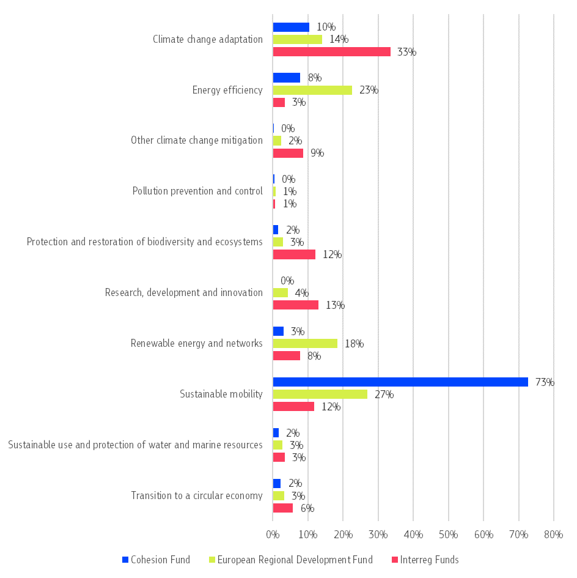
All data, interactive charts and illustrative stories on cohesion policy are available on the Cohesion Open Data Platform.

European Regional Development Fund, Cohesion Fund and Interreg
Member States’ have allocated about 57% (EUR 22.29 billion) of their Cohesion Fund and 33% (EUR 70.63 billion) of their European Regional Development Fund allocations to climate action. Additionally, about 24.5% of the EUR 10.7 billion of programmes focused on European regional cooperation (Interreg funds) financed by the EU are expected to support climate-relevant measures. Combined, these investments will not only significantly reduce GHG emissions and boost adaptation to climate change, but they will also create jobs, increase competitiveness, enhance mobility and maintain balanced regional development across the EU. Figure 30 shows the funding allocated to climate relevant policy areas as a share of total spending from the European Regional Development Fund, the Cohesion Fund and Interreg on climate action.
By 30 June 2025, some 45% of the European Regional Development Fund and 61% of Cohesion Fund for the 2021-2027 period had been allocated to specific projects.

Just Transition Fund
The Just Transition Fund provides EUR 19.7 billion to help people and regions the most affected by the transition to climate neutrality, such as areas where coal mines are closing or heavy industry is transforming. Currently, it supports 96 coal and carbon-intensive regions with tailored just transition plans, for example by supporting diversification of the local economy, and helping people acquire new skills. Up to 120 000 unemployed people will benefit from the measure and almost 200 000 people will gain new skills.
The Just Transition Fund is moving forward: 47% of the fund had already been assigned to projects by June 2025, up from 22% a year before. There are notable differences in progress. Estonia and Malta have selected all projects and Luxembourg, Sweden and the Netherlands have selected almost all projects to be financed. On the other hand, Belgium, Hungary and Bulgaria have assigned less than 10% of the total budget.

European Social Fund
In the 2021-2027 programming period, the European Social Fund Plus is investing EUR 5.7 billion in green skills and jobs and in measures and reforms supporting the green economy. This includes upskilling and reskilling of workers, support to displaced workers or workers working for enterprises affected by the green transition or training of employed and unemployed people in green skills.

International climate action
Key highlights
- The EU played an important role at COP29 in Azerbaijan to reach an agreement on the new post-2025 collective quantified goal on climate finance and on finalising the Paris agreement rules for international carbon markets.
- The EU submitted its first biennial transparency report in November 2024, providing a leading example under the Paris Agreement’s Enhanced Transparency Framework and on implementation of ambitious climate action.
- The EU climate ministers agreed on an EU nationally determined contribution ahead of COP30, with an indicative 2035 target of reduction in net GHG emissions of between 66.25% and 72.5% compared to 1990 levels.
- The EU strengthened its climate dialogue with key countries around the world including China, Brazil, India, South Africa and Canada.
- In 2024, the Commission committed to provide EUR 4.6 billion in climate finance. Of this amount, 27% were committed to adaptation, 46% to mitigation, and 27% to cross-cutting actions addressing both mitigation and adaptation priorities.
The EU plays a significant role in advancing global action to achieve the Paris Agreement goals by working both at international and bilateral level. Its impact encompasses financial support, negotiations under the United Nations Framework Convention on Climate Change (UNFCCC) and the Paris Agreement, diplomatic engagement, capacity building, and regulatory leadership.

Multilateral engagement
The past year has seen the EU engaging in several high-level and technical international meetings to push for a higher level of ambition at global level in climate negotiations, to increase transparency, mobilise resources and to share knowledge on climate action amid an increasingly volatile geopolitical context.
In October 2025, the Commission and the High Representative presented an international strategy for securing Europe's place in global markets. The new EU global climate and energy vision presents the EU's offer to the world: using diplomacy to protect our core interests, promoting standards for a fair transition by assisting our partners to develop theirs, and addressing the new security threats and challenges that endanger both European interests and those of our partners.

Implementing the Paris Agreement
The EU engaged constructively at COP29 in Azerbaijan to achieve the main mandates set for the conference. Parties agreed on a new post-2025 collective quantified goal on climate finance, which outlines that developed will take the lead in providing and mobilising at least USD 300 billion per year by 2035 for developing countries for climate action, from a wide variety of sources, with developing countries encouraged to make contributions on a voluntary basis. The new goal is complemented by a call to all actors to work together to enable the scaling up of finance for developing countries from all public and private sources, to at least USD 1.3 trillion annually.
Another key outcome was the finalisation of the rulebook for carbon markets (under Article 6 of the Paris Agreement). In promoting transparent and high-integrity cooperations, these rules will help countries raise and achieve their climate targets.
On 21 November 2024, the EU submitted its first biennial transparency report. The report details the progress made to reach the 2030 target and progress in assessing the effects of EU climate policies and measures in reducing greenhouse gas emissions and building resilience to climate change. It also details the contributions made to international capacity building and climate finance. See Chapter 5 of accompanying staff working document for more details.
The Biennial Transparency Report is available on the UNFCCC website.
Under the UNFCCC mitigation work programme, the EU shared best practices and mitigation solutions for buildings and urban systems (4th Global Dialogue and Investment Focused Events in October 2024) and for the forest sector (5th Global Dialogue and Investment Focused Events in May 2025). As part of the Just Transition Work programme, the EU participated in two Just Transition Dialogues to share experiences and good practices on just climate resilience and just energy transition pathways.
On climate adaptation, the EU actively engaged with other countries to make progress under the UAE-Belém work programme on adaptation indicators. This is needed to implement the ‘UAE Framework for Global Climate Resilience’ adopted at COP28 in 2023 and to achieve the Global Goal on Adaptation.
To prepare for the 30th Conference of Parties (COP30) in Belém in November 2025, the EU constructively advocates in the negotiations for successful decisions on the outcomes described in the mandates. These include delivering on the indicators to track progress towards the Global Goal on Adaptation, reaching an agreement on the gender action plan and actively participating in the discussions on the Baku to Belém Roadmap to USD 1.3 trillion, which aims to scale up climate finance flows to developing countries. The EU also continues to participate in the constituted bodies set up to support the parties and the intergovernmental process under the UNFCCC, with a view to achieve the outcomes stated in the mandates.

Implementation of the first Global Stocktake Outcomes and the EU’s nationally determined contribution
Building on the outcomes of the first global stocktake, and to keep the momentum of the milestone collective agreement on the energy transition, the EU led the launch of the Global Energy Transitions Forum in January 2025. The forum unites leaders, ministers and stakeholder groups and aims to ensure that the commitments to accelerate the clean energy transition by tripling renewable energy capacity and doubling energy efficiency are integrated into the next round of nationally determined contribution.
The EU has also agreed to submit its nationally determined contribution, ahead of COP30, with an indicative 2035 target between 66.25% and 72.5% reduction in net GHG emissions compared to 1990 levels.

Engaging in other multilateral and plurilateral fora
The EU’s work with the United Nations and its agencies continues to promote a clean transition and high climate ambition. The adoption of the Pact for the Future at the 79th session of the Unites Nations General Assembly reaffirmed the need for stronger action against climate change. At the 80th session of the United Nations General Assembly, the EU highlighted its climate commitments and ambition at leaders’ high-level event on Climate Action and shared its vision on the deployment of renewable energy in the Global Renewables Summit.
The EU remains leading participant in the G7 and G20, with a view to further climate action. Despite geopolitical pressures progress was made in these fora over the past year. The G7 called for fast, deep emission cuts by major economies, including through the phase out of unabated coal power in the first half 2030, while the G20 endorsed a “enhanced ambition agenda” to keep 1.5c within reach. The EU has encouraged both fora to agree on concrete steps to carry out the Paris Agreement and the Global Stocktake.
The EU remains active in the Climate Club, a high-level forum for industry decarbonisation. The Club’s activities focus mainly on decarbonising steel and cement production. In 2024, the club launched a Global Matching Platform designed to fast-track the decarbonisation of heavy-emitting industries in emerging and developing economies by connecting to technical and financial solutions.
The EU has also worked with the OECD to further climate action in member and candidate countries. It has participated in the climate change work of multiple bodies such as the Environment Policy Committee and the Working Parties on Climate Change and on Finance and Investment for Environmental Goals. It has also engaged in the Inclusive Forum on Carbon Mitigation Approaches and in the Carbon Market Platform, launched by under the OECD as a fora to discuss mitigation policies and carbon pricing and markets policies freely.
As part of the Clean Energy Ministerial, the Commission has launched a campaign promoting sustainable lifestyles and fairness to reduce emissions, which includes a high-level declaration endorsed by several countries, such as China, India, and Brazil.
The EU continues to invest in initiatives to tackle the effects of climate change and environmental degradation that accentuate threats to peace, stability, security and risks undermining European defence. In 2025, the EU published a progress report on implementation of the joint communication on climate and security. The report highlights how, among others, the impact of environmental degradation and climate change on peace and security and defence now features prominently in exchanges with non-EU countries, regional organisations and organisations such as NATO – and how this new focus is leading to tangible initiatives.

Bilateral engagement
Bilateral engagement creates opportunities to exchange with third countries on how we collectively meet the Paris Agreement goals, to share knowledge and experiences on mitigation and adaptation, to provide technical insight drawn from the EU’s extensive experience with climate policy, including carbon pricing. Climate-security concerns are also part of the EU’s bilateral engagement and regular contacts with regional and civil-society partners.
In 2024 and 2025, bilateral engagement with non-EU countries focused on the delivery of ambitious new nationally determined contributions by COP30, which took place in November 2025. Several events were organised in Latin America, Asia and Africa to exchange with countries’ stakeholders and governments on modelling and NDC ambition.
Carbon pricing is a cornerstone of EU climate policy and at the heart of the EU’s climate diplomacy. Building on its experience, the EU works with partners to enhance carbon pricing policies such as emissions trading systems or carbon taxes.
Following the finalisation of the rulebook for carbon markets at COP29, the EU also aims to work closely with partner countries to harness the benefits of high integrity international carbon markets.
The EU has initiated cooperation with countries such as Brazil which adopted its carbon market legislation in December 2024, India, countries in the Association of Southeast Asian Nations, etc. It complements the existing engagement with countries such as China and Canada where carbon pricing schemes are already established.
The EU is also engaging with the countries that are candidates to join the EU to ensure they swiftly align with the EU’s climate legislation. Particular emphasis is on making progress on carbon pricing and the alignment with the rules of EU emission trading system. The enlargement process is moving faster than at any point in the last 15 years. In September 2025, the EU formally opened accession negotiations with Albania on green and sustainable connectivity policies, including environment and climate. During the reporting period, the EU also screened Moldova’s and Ukraine’s legislations to check how ready they are to follow EU climate laws.
Progress was also made in implementing existing Green Alliances (Japan, Norway and Canada) and Green Partnerships (Morocco and South Korea) with strengthened dialogue and cooperation in areas of relevance to the green transition. In January 2024, a four-year EU-Korea Green Partnership Programme was launched in South Korea. The aim of the programme is to step up the EU’s green diplomacy, promote bilateral cooperation while supporting the implementation of the Green Partnership. A similar programme, the Green Alliance facility, is also running in Japan since July 2024.
In the context of the EU-China High Environment and Climate Dialogue, the EU has exchanged with China on various policies to accelerate the green transition, including on China’s emissions trading system (inspired by the EU’s system), on modelling of emissions and the impact of climate change, measuring and controlling methane emissions and stimulating finance for resilience. Through its climate diplomacy, from top political levels to technical levels, the EU has encouraged China to contribute its share to supporting global climate action. A Joint declaration on climate was published following the EU-China Summit in July 2025.
The EU boosted relations with India by a College visit in spring 2025. This led to the publication of a new EU-India strategic agenda in September 2025 which, among other things, focuses on the green transition, clean technologies and climate resilience. Technical cooperation on carbon pricing and climate modelling is also growing.
In September 2025, the first ministerial dialogue on climate and environment between the EU and the Association of Southeast Asian Nations took place. The dialogue confirmed joint commitment to the multilateral climate agenda and strong political engagement to cooperate for ambitious climate action.
A financing cooperation mechanism, the Just Energy Transition Partnerships, is gaining positive momentum in Indonesia. The partnership takes the form of a USD 20 billion agreement to decarbonise Indonesia’s coal-powered economy. So far, some USD 1.2 billion has already been approved in loans and grants, including support for a 60 MW floating solar power plant in West Java.
The EU has the same partnership with Senegal, South Africa and Vietnam. Under its USD 15 billion partnership, Vietnam is also making progress on climate action and major renewable projects are close to the approval stage.
Under the EU’s Global Gateway strategy, climate and energy are key priorities in Africa. The EU’s approach is already delivering concrete results. In March 2025, the EU launched a EUR 4.4 billion investment package to support clean energy projects in South Africa. The EU also opened negotiations on a new type of trade and climate deal with South Africa - the clean trade and investment partnership. These initiatives will help EU companies diversify their green supply chains, strengthen EU’s competitiveness and support South Africa in reducing its emissions.
In September 2025, the second Africa Climate Summit showcased the EU’s commitment to work with African partners to pursue objectives of the Paris Agreement and EU’s support to Africa’s green transition and climate resilience. It also paved the way to the EU-African Union summit, which will take place in November 2025 in Angola.
Calls for more cooperation to increase climate action feature at the agenda and outcomes of all EU bilateral Summits with third countries, such as the EU-Canada, EU-Japan, EU-Central Asia Summits in 2025.
The EU Climate Dialogues programme is a key instrument to drive policy dialogue and cooperation on climate policy between the EU and representatives from governments, business, academia, and social and economic organisations in non-EU countries, with the ultimate goal to implement commitments under the Paris Agreement the Paris Agreement. A new EUR 30 million phase started in January 2025 and will run until mid-2029, supporting climate policy talks in 26 priority countries.

Climate finance and international cooperation
Together with climate finance from private sources, international public climate finance plays an important role in helping developing countries to implement the Paris Agreement.
Overall, the EU, its Member States and financial institutions, are the leading contributor of development assistance and the world’s biggest climate finance contributor, accounting for about a third of global public climate finance. In 2024, the EU and its Member States contributed EUR 31.7 billion in climate finance from public sources and mobilised an additional EUR 11.0 billion of private finance to support developing countries to reduce their greenhouse gas emissions and adapt to the impacts of climate change (with a 50/50 share between mitigation and adaptation). Two-thirds of the financial support the EU provided directly to other countries came with special, more favourable terms, with nearly one-quarter supporting least developed countries.
In 2024, the Commission committed to provide EUR 4.6 billion in climate finance. Of this amount, 27% were committed to adaptation, 46% to mitigation, and 27% to cross-cutting actions addressing both mitigation and adaptation priorities (see Table 4).
Table 4: Committed climate finance (2024)
 | Sum of committed  (EUR million) | % of committed total
Adaptation | 1 221 | 27%
Cross-cutting | 1 252 | 27%
Mitigation | 2 087 | 46 %
Total | 4 560 | 100%
The Commission continues to support partner countries through its financing instruments. For instance, at least 30% of the Neighbourhood, Development and International Cooperation Instrument (NDICI – Global Europe) is dedicated to climate action. This includes actions in fragile, and conflict affected settings in recognition of the complex interdependencies between climate change, environmental degradation, fragility and conflict.
The Global Gateway is a EUR 300 billion strategy to boost smart, clean, and secure infrastructure in partner countries, focusing on digital, climate, energy, and transport. It also invests in people, education, research, and health. One concrete example is EUROCLIMA, part of the Global Gateway, which builds partnerships between the EU and Latin America and the Caribbean to drive a green and just transition.
The Instrument for Pre-Accession Assistance (IPA III) also sets a climate change spending target of 18%, rising to 20% by 2027. This is an unprecedented investment of EUR 4 billion in reducing emissions and in helping EU candidate countries build resilience to the effects of climate change.
To address concerns of Small Island Developing States and Least Developed Countries about climate finance, the European Commission, together with the UK, France, Ireland and Spain, held a ministerial dialogue during the Fourth Finance for Development Conference in Seville (30 June – 4 July 2025). Ministers, senior officials and key partners identified the foundations of a long-term partnership to improve both the volume and accessibility of climate finance for these vulnerable countries.
The EU and its Member States also remain active on loss and damage support, pledging more than USD 400 million to the Fund for responding to Loss and Damage, with over USD 25 million coming from the European Commission. The EU also actively participates in the operationalisation of the fund, as a member of the board.
Efforts are also ongoing to promote the involvement of the private sector in climate action through the European Fund for Sustainable Development Plus (EFSD+). The EFSD+ provides a comprehensive set of tools, including guarantees, grants and technical assistance, to mobilise private sector investments for sustainable development in partner countries. It contributes, among others, to climate change mitigation, adaptation and environmental protection and management. Offering a variety of risk-sharing instruments of up to EUR 40 billion, the EFSD+ has the potential to mobilise more than half a trillion euros in investments for 2021-2027, largely from the private sector.
The Commission continues cooperation on sustainable aviation through dedicated support to feasibility and business implementation studies for sustainable aviation fuels in several African countries and India. Furthermore, the Commission continues supporting many countries in Africa and Latin America on advance clean urban mobility, including the promotion of clean and efficient transport technologies (rail and buses). The EU also backs the capacity building in shipping under Net-Zero Framework of the International Maritime Organisation and supports the establishment of green maritime corridors and exploring opportunities on the production and use of renewable and low carbon fuels in the sector.

World Meteorological Organisation (WMO), State of the Global Climate 2024, 2025. https://wmo.int/publication-series/state-of-global-climate-2024
Copernicus Climate Change Service (C3S) and World Meteorological Organisation (WMO), 2025: European State of the Climate 2024. https://climate.copernicus.eu/esotc/2024
Masselot et al., ‘Estimating future heat-related and cold-related mortality under climate change, demographic and adaptation scenarios in 854 European cities’, Nature Medicine, 2025, https://doi.org/10.1038/s41591-024-03452-2
Grant et al., Global emergence of unprecedented lifetime exposure to climate extremes, Nature, 2025, https://doi.org/10.1038/s41586-025-08907-1
The figure for the overall change in emission relative to the 1990 baseline for 2024 emissions in this report appears very similar to the figure in last year’s CAPR, even though emissions fell by 2.5% between 2023 and 2024. This is primarily due to the 2025 revision of the EU GHG inventory data, which lowered the 1990 net emission baseline (by about 15 MtCO2-eq) and increased net emissions for recent years (up to 60 MtCO2-eq) compared to the 2024 GHG inventory used in the Climate Action Progress Report 2024. This is due mainly to significant adjustments to the historical LULUCF data in the 2025 GHG inventory (for more details, see the box on the 2025 GHG inventory revisions in chapter 3 of the accompanying staff working document). Note that if the former, 2024 GHG inventory had been used as the basis (i.e. as for the CAPR of last year), the reduction between 2023 and 2024 would have resulted in a total net emissions reduction under the EU target scope of 38.5% relative to 1990.
Based on emissions from electricity and heat generation in the EU ETS (data extracted from the Union Registry on 30 September 2025). 2% of this decrease is also justified by data inconsistencies affecting the split between the power and the industrial emissions, not by market trends. See Carbon Market Report 2025 for details.
Based on Eurostat dataset ‘Net electricity generation by type of fuel - monthly data’, [nrg_cb_pem].
Based on Eurostat dataset ‘Production in industry - annual data’ [sts_inpr_a].
Re-inclusion of non-domestic flights to and from airports in outermost regions.
IEA (2025), Global Energy Review 2025.
Article 4 of the European Climate Law (Regulation (EU) 2021/1119).
For more details, see the staff working document on the Assessment of progress towards the objectives of the Energy Union and Climate Action accompanying the State of the Energy Union 2025.
Bulgaria, Cyprus, Malta, the Netherlands, and Romania have formally reported, for the first time, a target year to achieve climate neutrality. Romania set an early target of 2045.
As reported under Annex I, Table 1 of Commission Implementing Regulation (EU) 2022/2299 of 15 November 2022. See SWD on the Assessment of progress towards the objectives of the Energy Union and Climate Action accompanying the State of the Energy Union 2025.
Where available, missing NECPR values were replaced by national GHG targets previously submitted by Member States to the Commission (e.g. for the 2023 NECPR or national long-term strategies).
The latter would normally be covered by an export prohibition, for which an exemption to that prohibition is applied.
This figure includes 241 policy and measures submitted by Belgium in 2023, the previous reporting year.
For more details, see the staff working document on the Assessment of progress towards the objectives of the Energy Union and Climate Action accompanying the State of the Energy Union 2025.
Over the 2021-2030 period, up to 57% of the general allowances will be auctioned, while the remaining allowances will be allocated for free.
Based on emissions from electricity and heat generation in the EU ETS (data extracted from the Union Registry on 30 September 2025). 2% of this decrease is also justified by data inconsistencies affecting the split between the power and the industrial emissions, not by market trends. See Carbon Market Report 2025 for details.
Based on emissions from industrial manufacturing in the EU ETS (data extracted from the Union Registry on 30 September 2025). See Carbon Market Report 2025 for details.
For 2024, EUR 16.4 billion was reported as disbursed.
This includes flights within the European Economic Area (EEA) (domestic and between EEA countries) and departing flights from the EEA to Switzerland and the UK. It includes non-domestic flights from an EEA country to and from an outermost region (e.g. Finland – Canary Islands).
In 2023, the sector generated emissions totalling 54.4 million tonnes CO₂. Data extracted from the Union Registry and Swiss Registry on 30 September 2025.
The ETS ‘zero-rates’ these fuels, meaning that they pay no carbon price. By contrast, kerosene has an emissions factor of 3.16 tCO₂/tonne: ETS price x 3.16 = price incentive, so for an ETS carbon price of EUR 70, this is a EUR 221 price incentive per tonne of fuel used.
This support system covers all or part of the remaining price difference between fossil kerosene and the eligible aviation fuels used by individual commercial aircraft operators on their flights covered by effective carbon pricing through the EU ETS, encouraging these aircraft operators to use cleaner fuel options.
The EU ETS covers flights within the EEA (EU27, Norway, Iceland), and departing flights to Switzerland and the UK. This means the new rules cover EU airlines flights from the EEA to countries outside the EEA, and their flights between two countries outside the EEA.
The level above which airlines should start to offset emissions is set as 85% of 2019 CO₂ emissions for the years 2024-2035 (where 2019 was the year with the highest ever international aviation emissions).
Aviation and the Global Atmosphere, IPCC, 1999, https://www.ipcc.ch/site/assets/uploads/2018/03/av-en-1.pdf
The MRV system covers flights to, from and within Europe. To facilitate the start, reporting is mandatory only for flights within Europe. In 2025 and 2026 voluntary reporting on all routes is however encouraged. From 2027, the reporting obligation automatically applies to all flights. Implementing legislation: Emissions trading system (ETS) Monitoring and Reporting Regulation amendment in response to the ETS revision (europa.eu).
Total maritime emissions are covered by Regulation (EU) 2015/757.
The EU ETS scope for maritime has several other exemptions and differences from the maritime MRV scope. For more information about the relevant scope definition see Section 2.3 of the General guidance document for shipping companies: https://climate.ec.europa.eu/document/download/31875b4f-39b9-4cde-a4e2-fbb8f65ee703_en?filename=policy_transport_shipping_gd1_maritime_en.pdf
Nitrous oxide and methane emissions will be included in the EU ETS scope for maritime starting in 2026.
The 2024 ESR emissions are approximated and are 19.9% lower than 2005 levels. The 2023 ESR emissions were established in 2025 after a comprehensive review and are 19.8% lower than 2005 levels. In the Climate Action Progress Report 2024, the 2023 ESR emissions were approximated and showed a smaller reduction of 19.2% compared to 2005 levels.
Iceland and Norway have not yet incorporated the changes following the revision of ESR in 2023.
For more details on the flexibilities available under the ESR see the Chapter 9 of the accompanying staff working document.
Denmark, Lithuania and Poland reported the intention to use LULUCF flexibility and Croatia reported an intention to trade emission allocations. Finland also reported that it may use ESR flexibilities as appropriate, including to trade emission allocations. These are intentions and do not bind Member States.
The vehicle groups 4, 5, 9 and 10 within the scope of the initial CO₂ standards before the abovementioned revision comprise certain types of heavy lorries. The following analysis refers to these currently regulated vehicle groups.
Due to a change in the simulation method to determine the emissions of new heavy-duty vehicles, the decline in reporting period 2022 is somewhat overestimated, with the real decline estimated to be around 4%. This effect is much less relevant for reporting period 2023.
The average yearly net removals for the years 2016, 2017 and 2018, as reported in the 2020 greenhouse gas inventory submission, plus the additional −42 MtCO₂-eq net removals result in total net removals of −310 MtCO₂-eq at the EU level. Any methodological adjustments due to improvements in the inventory data reporting will be considered in the compliance check against the 2030 target.
Member States continuously improve their methodologies for greenhouse gas inventory reporting in terms of accuracy of data. Recalculations based on better data are reflected in the inventories over time. Consequently, some historic benchmarks used for accounting, such as the forest reference levels, will need to be updated accordingly. In addition, there are specific flexibilities available in the LULUCF Regulation, such as for natural disturbances, that may be used by Member States. These aspects will have to be taken into account before the compliance check against the ‘no-debit’ commitment for the compliance period 2021-2025. The Commission has set up a process to assist Member States and facilitate the preparation of these updates in the coming months.
Member States with debits in decreasing order of magnitude: Germany, Finland, Portugal, France, Czechia, Austria, Sweden, Estonia, Latvia, Belgium, Cyprus.
Member States with credits in increasing order of magnitude: Malta, Luxembourg, Slovenia, Lithuania, Netherlands, Greece, Croatia, Slovakia, Bulgaria, Ireland, Poland, Hungary, Denmark, Spain, Romania, Italy.
Commission Decision (EU) 2025/1479 of 22 May 2025 specifying the pro rata contributions to the EU CO₂ injection capacity objective by 2030 from entities holding an authorisation as defined in Article 1, point 3, of Directive 94/22/EC of the European Parliament and of the Council.
Unless stated otherwise, all data in this section are based on this report.
Economic losses from weather- and climate-related extremes in Europe | European Environment Agency's home page
Extreme weather and human health | Copernicus
This numbers represent around 80% of the amount recorded in 2023 and only half of 2022’s total. Advance report on forest fires in Europe, Middle East and North Africa 2024 - Publications Office of the EU (p.10)
Wildfires | Copernicus
EFFIS - Statistics Portal
Persistent droughts: critical water shortages and crops threatened - European Commission
Persistent droughts: critical water shortages and crops threatened - European Commission
Hurricanes, severe thunderstorms and floods drive insured losses above USD 100 billion for 5th consecutive year, says Swiss Re Institute | Swiss Re
Munich Reinsurance Company 2024 Factsheet
Climate change accounts for over a third of insured weather losses this century and rising - Insure Our Future Global
EIOPA and ECB joint paper: Towards a European system for natural catastrophe risk management - EIOPA
2024 Rail Environmental Report | European Union Agency for Railways (p. 76)
World Bank Group, 2024. Climate Adaptation Costing in a Changing World. Economics for Disaster Prevention and Preparedness
EC. 2024. Europe’s 2040 climate target and path to climate neutrality by 2050 building a sustainable, just and prosperous society
From adaptation to action: insights into progress and challenges across Europe. EEA 2025.
Preliminary assessment of the 2025 Governance Regulation dataset / subnational adaptation
European Environment Agency (2024). Economic losses from weather- and climate-related extremes in Europe.
2040 target impact assessment (SWD(2024) 63 final)
All numbers are based on 2040 target impact assessment (SWD(2024) 63 final) and Net Zero Industry Act impact assessment (SWD(2023) 68 final).
Platform on Sustainable Finance report: Monitoring capital flows to sustainable investments
In 2023 and 2024, Member States complemented their recovery and resilience plans with new chapters on REPowerEU in response to the energy crisis caused by Russia’s invasion of Ukraine. New or scaled-up reforms and investments in Members States to help phase out the EU’s dependence on Russian fossil fuels and accelerate the clean energy transition are supported by additional financial power (EUR 19 billion of new grants, transfers from other funds and use of remaining Next Generation EU loans).
Preliminary figures

