Diplomatic car for sale
Seller Polish Institute in Bucharest
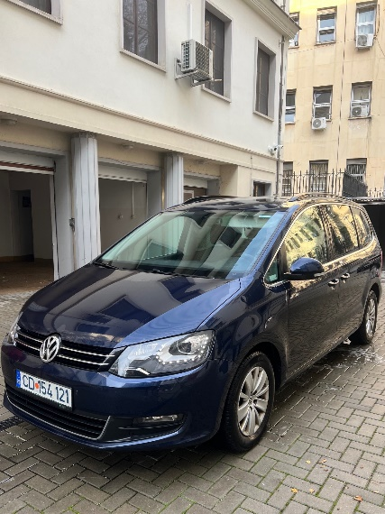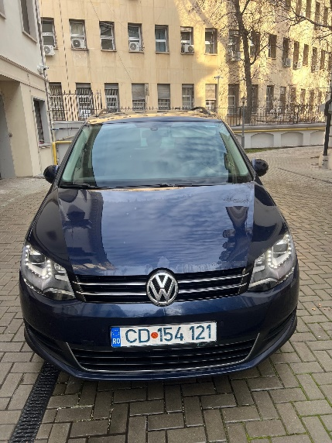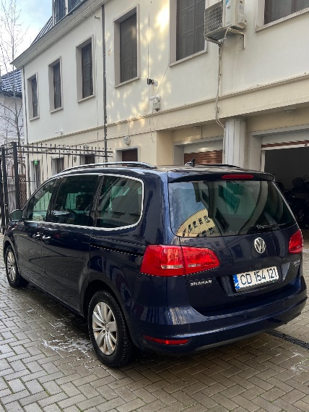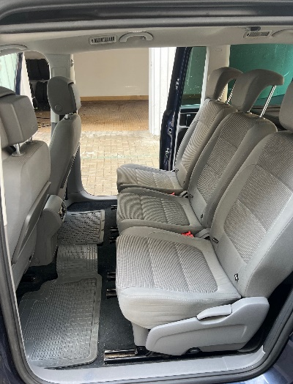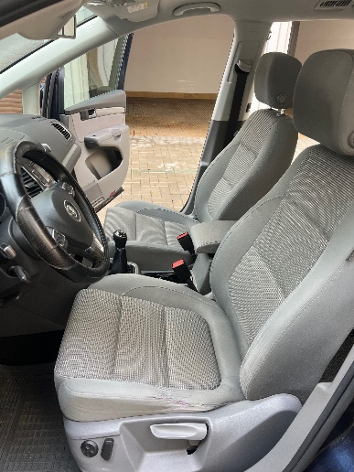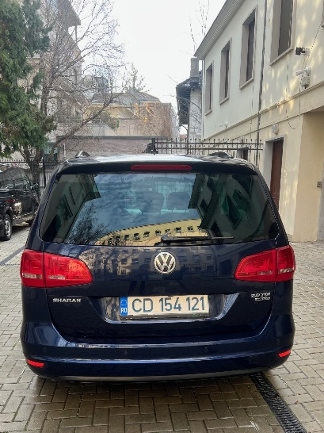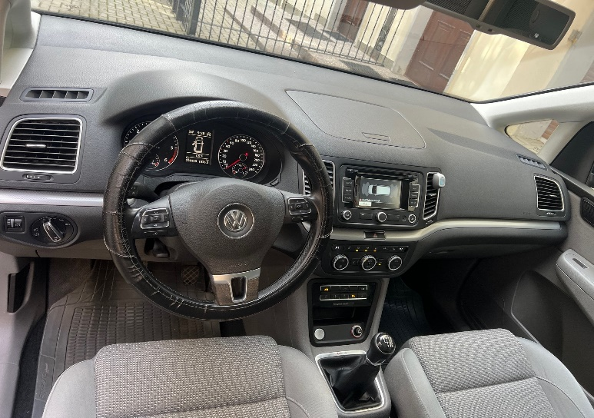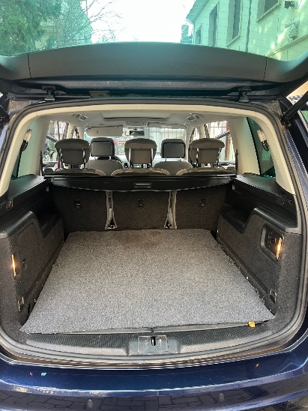
Starting price: 8.591,00 EURO netto
Contact: e-mail bukareszt@instytutpolski.pl
Tel. 021 30 82 251
Date of first registration.: 2014 Color: navy
Transmission: manual Engine: 1968 cm3
Seats: 7

